

ORACLE DATA INTEGRATION
Application Registration
Product Design Documentation | Implementation Guide | Training Material | Technical Reference | Troubleshooting Handbook

Scope
This manual focuses strictly on registering applications in Oracle Fusion Cloud EPM Data Integration, including EPM Local, EPM Cloud, Data Source, Data Export and Dimensions categories, plus the controls needed to make registrations production-ready.

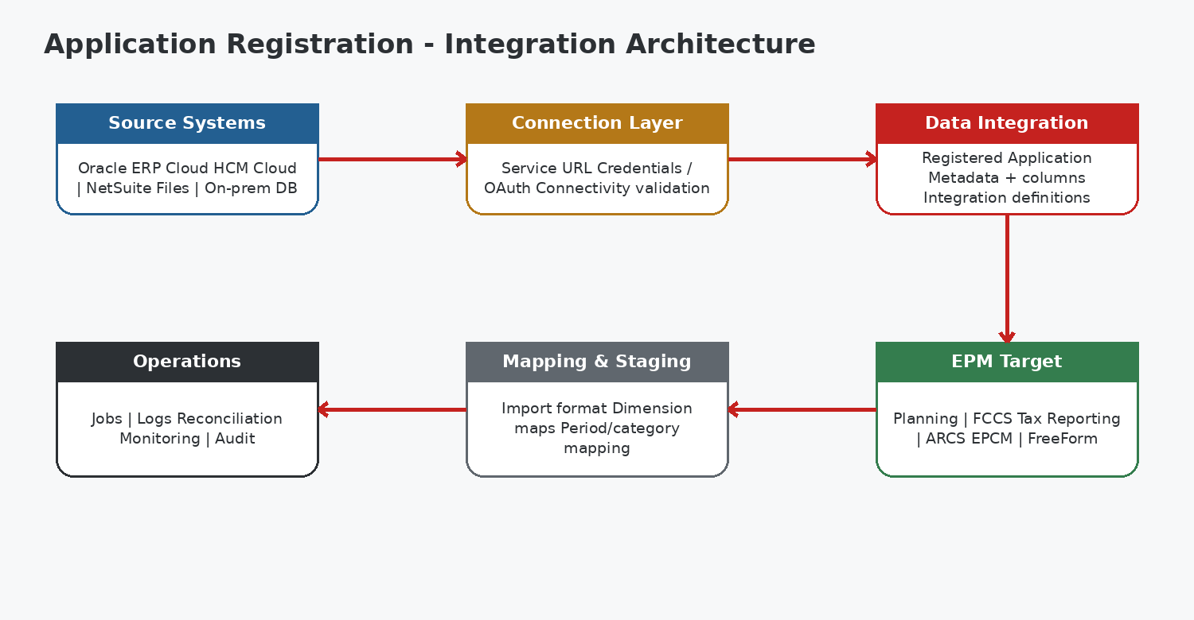
Document Attribute | Value
Audience | Advanced students, EPM implementers, integration developers, administrators
Coverage | Beginner to advanced - design, setup, validation, operations and troubleshooting
UI approach | Oracle-inspired training mockups; exact labels can vary by monthly Cloud EPM release
Brand | BISP Trainings
Contact | www.bisptrainings.com | +91 769-4095-404

Table of Contents
1. Executive overview and learning outcomes
2. Core concepts and terminology
3. Application category decision framework
4. Architecture and control model
5. Navigation and UI concepts
6. Prerequisites and security
7. Registering EPM Local applications
8. Registering EPM Cloud applications
9. Registering Data Source applications
10. Registering Data Export applications
11. Registering Dimensions applications
12. Application details and metadata validation
13. Implementation scenarios
14. Production design and best practices
15. Common mistakes and anti-patterns
16. Troubleshooting handbook
17. Logs and error examples
18. Technical checklist and runbook
19. Interview questions
20. Certification-style MCQs
21. Cheat sheet and summary
22. Oracle documentation references

1. Executive Overview and Learning Outcomes
Application Registration is the design-time step that makes a source or target system available to Data Integration. Before an integration can import, map, validate and export data, Data Integration needs a registered application definition that describes what the application is, how it is reached, and how its dimensions or data columns will participate in staging and mapping.
Oracle principle
Oracle documentation positions application registration before integration definition. The selected application category determines the information you provide and the integration patterns available afterward.

1.1 Learning outcomes
- Differentiate EPM Local, EPM Cloud, Data Source, Data Export and Dimensions categories.
- Navigate to Applications from Data Integration and interpret the registration workspace.
- Register local, remote and source-system applications with appropriate connection prerequisites.
- Validate dimension classification and staging-column metadata after registration.
- Design naming, security, testing and deployment controls for enterprise implementations.
- Diagnose connectivity, duplicate-name, metadata and credential problems using a structured troubleshooting flow.

1.2 Why registration matters
Design concern | Why it matters | Risk if ignored
Identity | Provides a stable application object for integrations | Wrong source/target selected
Connectivity | Connects remote EPM or source systems | Import fails before staging
Metadata | Exposes dimensions and staging columns | Mappings point to wrong fields
Governance | Supports naming and lifecycle control | Duplicate or ambiguous registrations
Operations | Anchors jobs and troubleshooting | Hard-to-audit failures

2. Core Concepts and Terminology
Term | Practical meaning
Application | A registered source or target definition that Data Integration can reference.
Application Category | High-level registration class: EPM Local, EPM Cloud, Data Source, Data Export or Dimensions.
Type | A category-specific subtype, such as Oracle Cloud ERP Trial Balance or Data Export to File.
Connection | Reusable endpoint and authentication definition required for remote EPM or source systems.
Cube / Plan Type | The EPM cube associated with a local application registration; controls the model participating in the integration.
Prefix | Optional text used to make an application name unique; useful in multi-environment or multi-source designs.
Dimension Classification | Semantic role assigned to an application dimension, such as Account or Entity.
Data Table Column Name | Staging-table column associated with an application dimension. This mapping is critical for imports and mapping rules.
Integration | A configured data movement definition that references a registered source and target application.
Staging | Intermediate area where imported records are stored before validation and export.
Metadata Refresh | Activity used where supported to synchronize application metadata with the current source or target definition.

Important control
After registration, avoid casually changing Dimension Classification or Data Table Column names. Oracle documentation specifically warns against modifying these for Cloud EPM applications because downstream mapping behavior can be affected.

3. Application Category Decision Framework
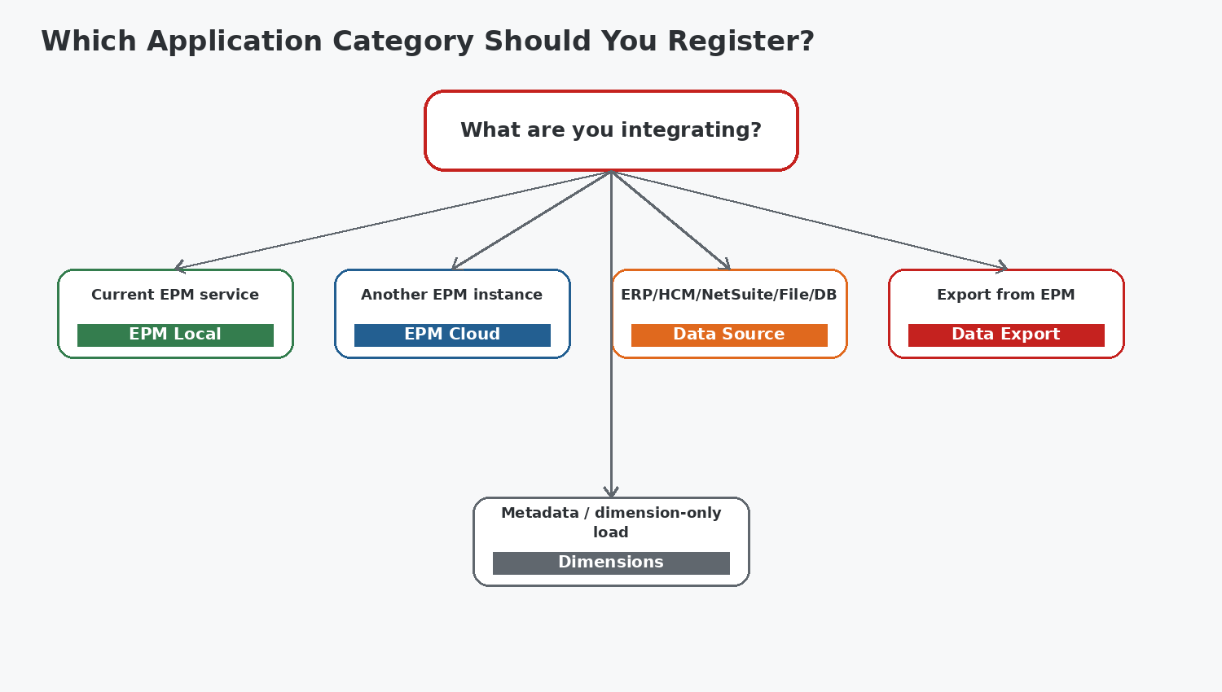
Figure: Category selection decision tree
Category | Use when | Typical example | Key registration inputs
EPM Local | Integrating within the current Cloud EPM service | Planning input cube -> reporting cube | Application, cube(s), optional prefix
EPM Cloud | Integrating with another Cloud EPM business process/service | Planning -> FCCS in another instance | Remote connection, application, cube/options, prefix
Data Source | Importing from ERP/HCM/NetSuite/file/database sources | Oracle ERP Cloud trial balance | Type, connection/file, prefix
Data Export | Writing EPM data to a file or supported external target | Planning data -> flat file | Type, file definition, prefix
Dimensions | Loading metadata by dimension class/type | Account/Entity metadata load | Target application, unique prefix

Rule of thumb
Choose the category from the business flow, not from the technology name alone. For example, an EPM-to-EPM cross-instance flow is EPM Cloud, while a same-instance cube-to-cube flow is EPM Local.

4. Architecture and Control Model

Figure: Registration architecture

4.1 Control layers
Layer | Controls | Evidence
Identity & naming | Unique application name/prefix; correct category/type | Application inventory
Connectivity | HTTPS URL, connection test, credentials, network access | Successful connection test
Metadata | Dimension classification, staging columns, cube selection | Application Details review
Integration | Correct source/target pairing, dimension maps | Integration design record
Operations | Job monitoring, logs, reconciliation | Runbook and issue log

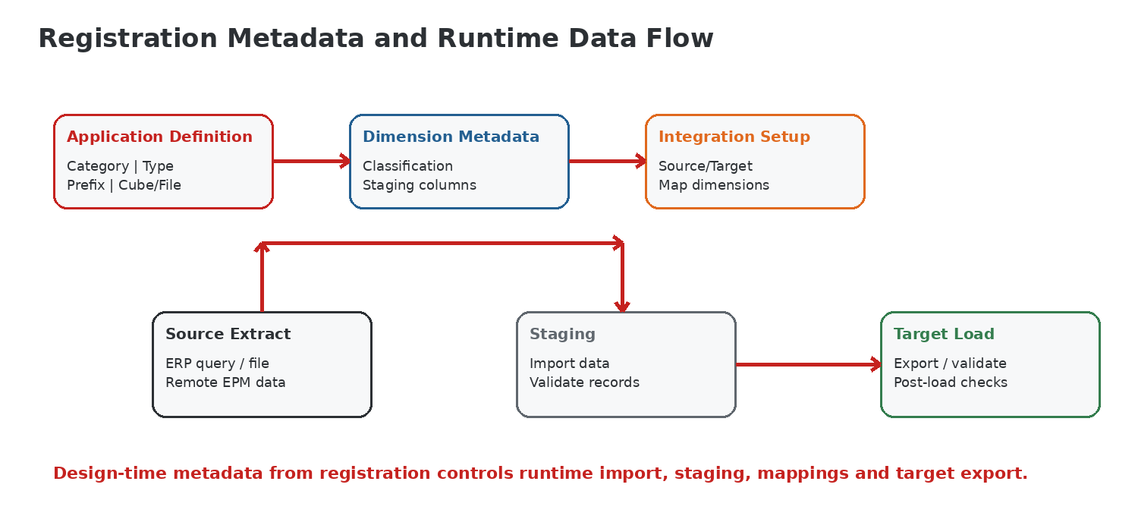
Figure: Design-time metadata and runtime data flow

5. Navigation and Oracle-Inspired UI Concepts
A common navigation path in current Cloud EPM Data Integration is: Home -> Data Exchange -> Data Integration. From the Data Integration home page, use Actions -> Setup -> Applications. Oracle periodically evolves Cloud EPM UI labels, so implementations should validate the exact menu path in the current monthly update.
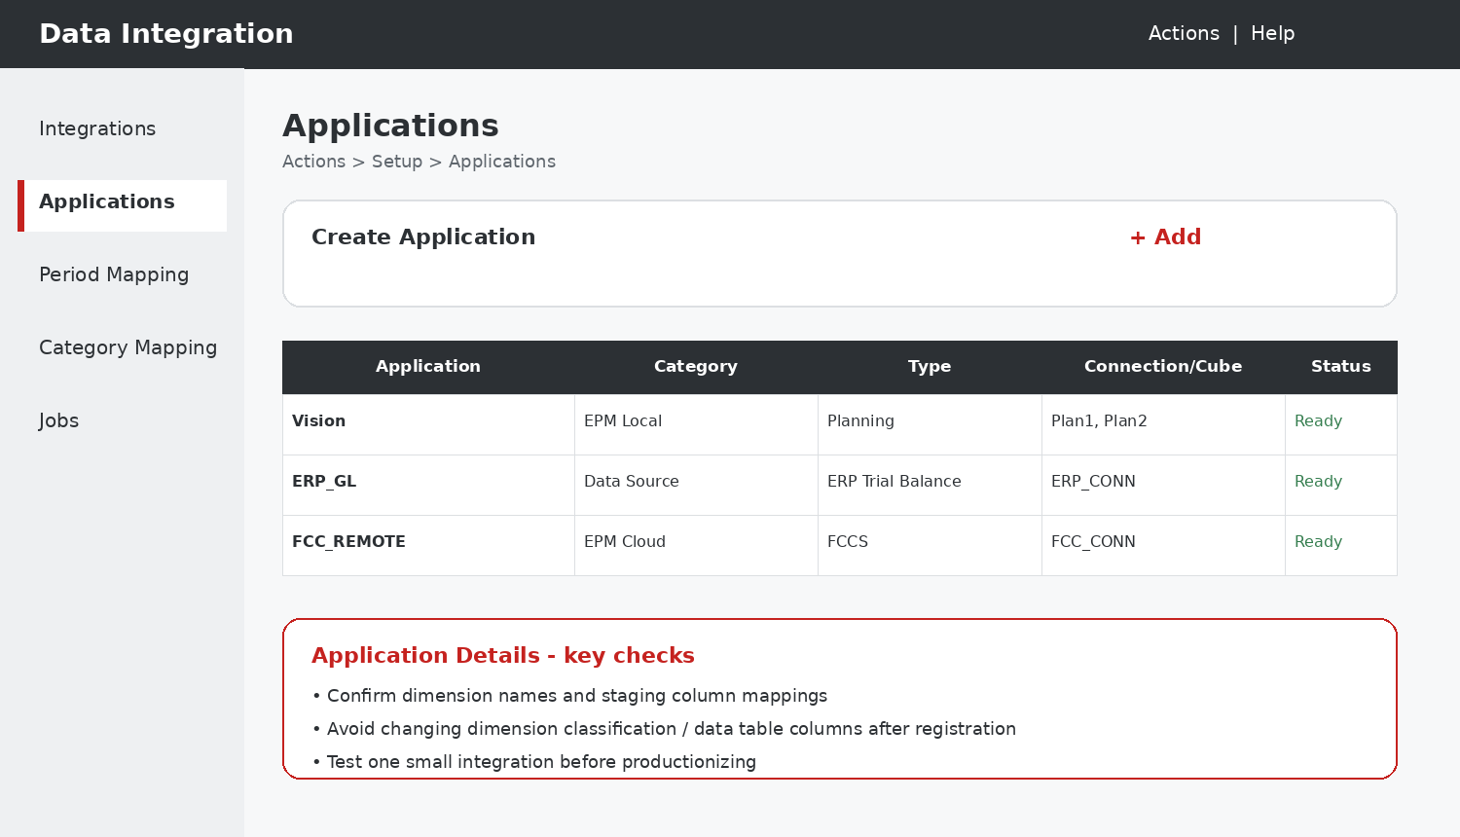
Training mockup - not an Oracle screenshot

5.1 What to inspect on the Applications page
- Application name and category
- Type and related connection/cube/file
- Status/readiness
- Application Details: dimensions, classifications and staging columns
- Actions for create, edit, refresh or delete where available

6. Prerequisites and Security
Prerequisite | Check | Implementation note
Role access | User can access Data Integration and setup features | Use least privilege and separate admin/test operators
Source credentials | Account is active and authorized for required data | ERP integrations need data access to relevant ledgers or subject areas
Secure endpoint | HTTPS service URL for Cloud EPM / Oracle Cloud ERP | Avoid non-secure URLs
Connection test | Connection validates before registration | Fix connectivity before debugging mappings
Target readiness | Target cube/dimensions are available | Confirm plan type and expected dimensions
Naming standard | Prefix and environment conventions approved | Example: PRD_ERP_GL, TST_FCC_REMOTE

Security pattern
Do not use personal administrator credentials for production integrations. Use managed integration identities where your organization supports them, document ownership, and include credential rotation in the operations calendar.

7. Registering EPM Local Applications
Use EPM Local when the application being registered belongs to the current Cloud EPM service. This pattern is commonly used to synchronize data between cubes or plan types in the same business process.

7.1 Step-by-step procedure
- Open Data Integration and navigate to Actions -> Setup -> Applications.
- Choose Create Application / Add.
- Set Category to EPM Local.
- Select the current service application.
- Select the cube(s) required for the integration. For training labs, select only the input/reporting cubes that are genuinely needed.
- Optionally enter a unique Prefix when the naming standard requires it.
- Confirm the registration and wait for the application to appear.
- Open Application Details and verify dimensions and Data Table Column Name assignments.
- Create a small integration and perform a smoke test before building full mappings.

7.2 Example - Planning input cube to reporting cube
Field | Sample value | Reason
Category | EPM Local | Same EPM instance
Application | Vision | Current Planning application
Cubes | Plan1 / Reporting | Move/synchronize between cubes
Prefix | LAB_ | Keeps training registration distinct

Design note
Oracle notes that only one EPM Local application can exist per instance. Treat deletion/recreation as a controlled change because integrations can depend on the application object.

8. Registering EPM Cloud Applications
Use EPM Cloud when the source or target is another Cloud EPM business process or service instance. A remote connection must be available so Data Integration can discover and register the remote application.

8.1 Step-by-step procedure
- Create or verify a Cloud EPM connection with the remote service URL and approved authentication.
- Test the connection successfully.
- Navigate to Applications and create a new application.
- Set Category to EPM Cloud.
- Select the remote connection and the remote application/business process.
- Select any applicable cube/plan type options.
- Add a prefix when duplicate names could occur across environments.
- Complete registration and inspect Application Details.
- Create a controlled test integration and validate source/target dimensionality.

8.2 Cross-instance scenario
Design element | Example
Source | Planning - Forecast
Target | FCCS - Management Reporting
Connection | FCCS_PRD_CONN
Registration | EPM Cloud / FCC_REMOTE
Key validation | Periods, Scenario mapping, Entity/Account compatibility
Operational control | Both EPM business processes at compatible release level

Release compatibility
Oracle documentation notes that business-process-to-business-process integrations should be at the same release level. Include monthly patch alignment in your integration change calendar.

9. Registering Data Source Applications
Data Source applications represent systems that provide data to EPM. Oracle Data Integration supports multiple source families, including Oracle Cloud ERP, HCM Cloud, NetSuite, on-premises database/file patterns and other supported adapters. The exact registration fields vary by source type.

9.1 Oracle Cloud ERP - prepackaged query example
- Configure the Oracle Cloud ERP connection and test it.
- Open Applications and choose Create Application.
- Set Category to Data Source.
- Select the required Oracle Cloud ERP type, such as Trial Balance, Trial Balance - Average, Payables Transactions or Receivables Transactions.
- Optionally enter a unique Prefix.
- Complete registration.
- Validate that the application appears and can be selected in an integration.
Oracle Cloud ERP type | Typical use
Trial Balance | General ledger balances for EPM planning/consolidation
Trial Balance - Average | Average balance requirements
Payables Transactions | AP-level analysis/forecasting
Receivables Transactions | AR-level analysis/forecasting
Custom | BI Publisher extract for non-prepackaged data

9.2 File-based source
A file-based source can be used without a complex source-system registration. The actual file is selected in the integration/file browser flow. Standardize headers, delimiters, encoding, date formats and data quality rules before mappings are built.
ERP security
For Oracle Cloud ERP integrations, the integration user must have the privileges and data access required for the ledgers and business data being extracted. A technically valid connection does not guarantee adequate data authorization.

10. Registering Data Export Applications
Use Data Export when EPM data must be written to a file or other supported export destination. The registration describes the export application that an integration will target.

10.1 Data Export to File procedure
- Navigate to Actions -> Setup -> Applications.
- Choose Create Application.
- Set Category to Data Export.
- Set Type to Data Export to File.
- Use File Browser to specify the export file/application definition as required by the workflow.
- Optionally use Prefix to keep the application name unique.
- Complete registration and verify the application is selectable as a target.
Design choice | Recommendation
File naming | Include environment, business purpose and frequency
Delimiter/format | Document consumer requirements and encoding
Data volume | Test representative production volume
Security | Control access to inbox/outbox locations
Reconciliation | Capture record counts and totals after export

11. Registering Dimensions Applications
Dimensions category registrations are used for metadata loads where the target application is a dimension class/type rather than a normal data cube load. Oracle documentation describes automatically created dimension applications including Account, Entity, Custom, Scenario, Version and Smartlist.

11.1 Procedure
- Open Applications and choose Add/Create Application.
- Set Category to Dimensions.
- Select the target application.
- Enter a unique Prefix.
- Confirm the registration.
- Use the resulting dimension application in a metadata integration.
Metadata constraint
Oracle documentation states that only Generic-type dimensions are allowed for metadata/dimensions target applications. Source fields can be mapped to Attribute columns, but Attribute columns do not behave like ordinary LOOKUP mapping dimensions.

Multiple custom dimensions
If more than one custom dimension must be imported, design a separate integration per dimension and set the required dimension name in integration options rather than assuming a single registration can load all custom dimensions.

12. Application Details and Metadata Validation
Registration is not complete from an implementation perspective until the resulting metadata is reviewed. Application Details provides the bridge between logical dimensions and staging-table columns used during import and mapping.
Validation | Expected result | Failure symptom
Dimension count | Matches selected cube/source model | Missing mapping dimensions
Classification | Account/Entity/etc. are semantically correct | Mappings behave unpredictably
Staging column | Unique and expected data-table column mapping | Import/mapping file mismatch
Cube selection | Only intended cube(s) participate | Wrong data scope
Prefix/name | Unique and documented | Duplicate/ambiguous applications
Connection | Still tests successfully | Runtime import failure

12.1 Validation smoke test
- Create a minimal integration using the new registration.
- Import a very small controlled source dataset.
- Confirm staging columns are populated as expected.
- Run mapping/validation with a limited POV.
- Export to target or file.
- Reconcile row count and one or two financial/control totals.
- Record evidence before promoting to production configuration.

13. Implementation Scenarios
Scenario A - ERP GL to Planning
Register Oracle Cloud ERP Trial Balance as Data Source; register/confirm Planning EPM Local target; build period/category/dimension mappings; load one ledger and one period first.

Scenario B - Planning to FCCS
Register FCCS as EPM Cloud using a tested remote connection; map Account, Entity, Scenario, Period and movement-related dimensions; schedule only after reconciliation proves stable.

Scenario C - Cube-to-cube synchronization
Use EPM Local with required cubes; keep same-instance data movement simple; validate Smart List/dimension compatibility where relevant.

Scenario D - Metadata load
Register Dimensions application with a unique prefix; create one integration per custom dimension when required; validate parent/child and attribute fields.

Scenario E - Data export
Register Data Export to File; document downstream consumer schema; test format, delimiter, decimals and negative-number conventions.

13.1 Implementation pattern: DEV -> TEST -> PROD
Stage | Registration focus | Exit criteria
DEV | Fast setup, naming convention, metadata discovery | Smoke test passes
TEST | Production-like connections, security and mappings | Volume + reconciliation passes
PROD | Controlled registration, managed credentials, monitoring | Runbook + approvals + rollback documented

14. Production Design and Best Practices
- Adopt a naming convention: <ENV>_<SOURCE/TARGET>_<PURPOSE>. Example: PRD_ERP_TB.
- Use prefixes deliberately to avoid collisions, especially across remote instances and repeated source types.
- Separate connection ownership from mapping ownership; document who rotates credentials.
- Validate application metadata immediately after registration and again after significant source/target metadata change.
- Keep a registration inventory with category, type, endpoint, owner, purpose and dependent integrations.
- Start with small POV/data sets and build toward production volume.
- Reconcile imports and exports using record counts plus meaningful financial/control totals.
- Use scheduled monitoring and alerting for credential expiry, connectivity failures and recurring job failures.
- Treat deletion/recreation of an application as a change-management event because dependent integrations may break.
- Align monthly Cloud EPM release testing across cross-instance integrations.
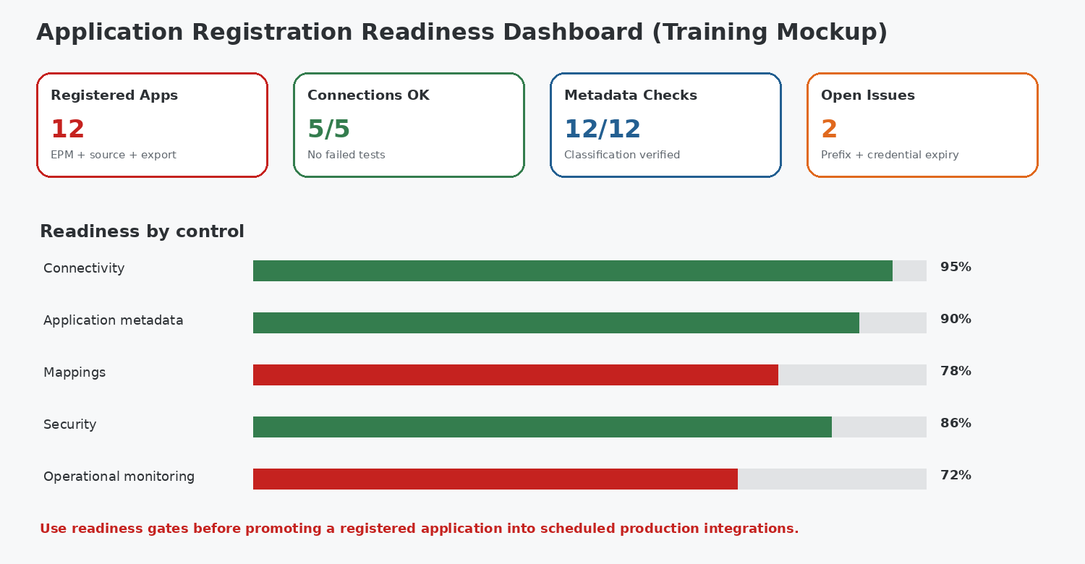
Training dashboard mockup for readiness governance

15. Common Mistakes and Anti-Patterns
Mistake | Why it fails | Better approach
Wrong category selected | Application fields and runtime patterns do not match the flow | Use the category decision tree
Skipping connection test | Registration appears blocked by downstream errors | Test endpoint/authentication first
Using personal admin credentials | Creates ownership and rotation risk | Use managed integration identity
Changing staging columns after mappings exist | Mapping files/rules can point to wrong columns | Freeze metadata design after validation
No unique prefix | Duplicate or confusing application names | Standardize prefixes
Testing full production volume first | Makes failures hard to isolate | Use small controlled smoke test
Ignoring release alignment | Cross-instance behavior may be inconsistent | Include monthly release validation
Deleting a registration casually | Dependent integrations may break | Assess dependencies and rollback

16. Troubleshooting Handbook

16.1 Decision flow
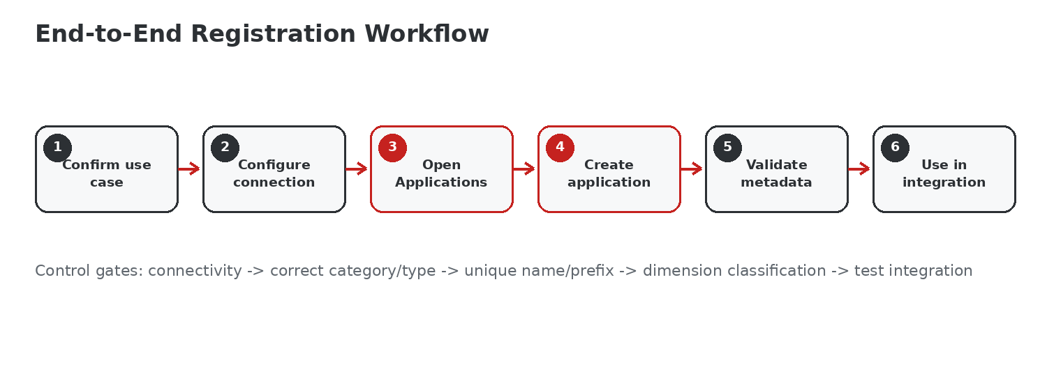
Use the same flow as a troubleshooting sequence: connection -> registration -> metadata -> integration -> runtime
Symptom | Likely cause | Checks | Resolution
Application not listed | Registration did not complete or wrong category/filter | Applications page, job/status, permissions | Retry registration after validating access
Remote app unavailable | Connection/credentials/URL issue | Connection test, HTTPS URL, account status | Correct endpoint or credentials
Dimension missing | Wrong cube selected or stale metadata | Application Details, cube choice | Re-register/refresh where supported after change review
Mapping file column mismatch | Data Table Column Name changed or differs from expected | Compare mapping file to Application Details | Update mapping artifact or restore approved metadata
ERP import returns no data | User lacks ledger/data privileges or POV filters wrong | ERP roles, ledger access, parameters | Grant appropriate access; retest narrow query
Duplicate application name | Existing registration conflicts | Inventory and prefix | Use a unique prefix/name
Cross-instance integration fails after update | Release/configuration mismatch | Monthly release level, integration tests | Align release validation and retest

17. Log and Error Examples
Example 1 - Authentication failure
ERROR: Unable to connect to remote application. Authentication failed for connection FCC_PRD_CONN.
Action: verify account status, password/token, domain/identity details, URL and network policy. Re-run connection test before retrying application registration.

Example 2 - Duplicate name
ERROR: Application already exists for the requested name.
Action: search the registration inventory, determine whether the existing object should be reused, or apply an approved prefix such as TST_ or PRD_.

Example 3 - Mapping column mismatch
VALIDATION WARNING: Source mapping references UD3 but application dimension is assigned to UD4.
Action: compare Application Details with import/mapping files. Correct the artifact rather than randomly changing application metadata.

Example 4 - ERP access
IMPORT COMPLETED: 0 records returned for ledger filter.
Action: distinguish "no source data" from "no permission." Validate ledger privileges, report/query parameters, period and source filters with the ERP owner.

17.1 Log triage order
- Confirm exact timestamp and environment.
- Identify whether failure is connection, registration, metadata, mapping, import or export stage.
- Capture application name/category/type and connection name.
- Reproduce using the smallest possible test.
- Compare with last known successful run/configuration.
- Apply one controlled change at a time.
- Record root cause and preventive control.

18. Technical Checklist and Runbook
# | Control | Owner | Evidence / sign-off
1 | Business flow and source/target identified | Solution Architect | Design note
2 | Category/type selected using decision framework | Integration Lead | Design review
3 | Connection created and tested | Platform Admin | Connection test result
4 | Application name/prefix approved | Integration Lead | Registration inventory
5 | Registration completed | EPM Admin | Application page
6 | Application Details validated | Developer | Dimension/staging review
7 | Smoke test integration passed | Developer | Job log + reconciliation
8 | Security and credential ownership documented | Security/Admin | Runbook
9 | Monitoring/alerting assigned | Operations | Support model
10 | Promotion/change approvals complete | Release Manager | Deployment record

18.1 Suggested configuration record
Field | Example
Application Name | PRD_ERP_TB
Category | Data Source
Type | Oracle Cloud ERP (Trial Balance)
Connection | ERP_PRD_CONN
Purpose | Actual GL balances to Planning
Owner | EPM Integration Team
Dependent Integrations | GL_ACTUAL_MONTHLY
Last validated | Monthly release smoke test
Rollback | Disable schedule; revert integration to prior registration if retained

19. Interview Questions
1. What is Application Registration in Oracle EPM Data Integration and why must it precede integration design?
Suggested answer points: define the concept, state the relevant category/control, then give one implementation example and one risk/control.
2. Explain the difference between EPM Local and EPM Cloud application categories.
Suggested answer points: define the concept, state the relevant category/control, then give one implementation example and one risk/control.
3. When would you use Data Source versus Data Export?
Suggested answer points: define the concept, state the relevant category/control, then give one implementation example and one risk/control.
4. What is the purpose of the Prefix field?
Suggested answer points: define the concept, state the relevant category/control, then give one implementation example and one risk/control.
5. Why are Data Table Column Name mappings important?
Suggested answer points: define the concept, state the relevant category/control, then give one implementation example and one risk/control.
6. What checks would you perform after registering an EPM Local application?
Suggested answer points: define the concept, state the relevant category/control, then give one implementation example and one risk/control.
7. How would you troubleshoot a remote EPM application that is not visible during registration?
Suggested answer points: define the concept, state the relevant category/control, then give one implementation example and one risk/control.
8. What special considerations apply to Oracle Cloud ERP source registrations?
Suggested answer points: define the concept, state the relevant category/control, then give one implementation example and one risk/control.
9. Why should dimension classification changes be tightly controlled?
Suggested answer points: define the concept, state the relevant category/control, then give one implementation example and one risk/control.
10. Describe a DEV-to-PROD promotion strategy for registered applications.
Suggested answer points: define the concept, state the relevant category/control, then give one implementation example and one risk/control.
11. What are the operational risks of using a personal admin account for a production connection?
Suggested answer points: define the concept, state the relevant category/control, then give one implementation example and one risk/control.
12. How would you validate a Dimensions application used for metadata loading?
Suggested answer points: define the concept, state the relevant category/control, then give one implementation example and one risk/control.
13. Why can a connection test succeed while an ERP integration still returns zero records?
Suggested answer points: define the concept, state the relevant category/control, then give one implementation example and one risk/control.
14. What evidence would you require before scheduling a newly registered application in production?
Suggested answer points: define the concept, state the relevant category/control, then give one implementation example and one risk/control.
15. How do monthly Cloud EPM releases affect cross-instance integration governance?
Suggested answer points: define the concept, state the relevant category/control, then give one implementation example and one risk/control.

20. Certification-Style MCQs
1. Which category is most appropriate for a same-instance Planning cube-to-cube flow?
A. EPM Cloud
B. Data Source
C. EPM Local
D. Data Export
Answer: EPM Local
2. Which category is used to register another Cloud EPM business process in a remote service?
A. Dimensions
B. EPM Cloud
C. EPM Local
D. Data Export
Answer: EPM Cloud
3. What is the main purpose of Prefix during registration?
A. Encrypt the connection
B. Select a period
C. Make the application name unique
D. Refresh metadata
Answer: Make the application name unique
4. For Oracle Cloud ERP Trial Balance, which category is selected?
A. Data Source
B. Data Export
C. Dimensions
D. EPM Local
Answer: Data Source
5. Which item should be validated after EPM Local registration?
A. Browser cache only
B. Dashboard color
C. SMTP server
D. Office locale
Answer: Dimension and staging-column assignments
6. What protocol should Cloud EPM/ERP connection URLs use?
A. FTP
B. HTTP only
C. HTTPS
D. Telnet
Answer: HTTPS
7. Which category is designed for dimension-class metadata loads?
A. Data Export
B. Dimensions
C. EPM Cloud
D. EPM Local
Answer: Dimensions
8. What is the best first step when remote application discovery fails?
A. Change dimension classification
B. Delete all mappings
C. Run a full data load
D. Test the connection and credentials
Answer: Test the connection and credentials
9. Why should staging column assignments not be changed casually?
A. They change the UI theme
B. They control licensing
C. Mappings can depend on them
D. They disable security
Answer: Mappings can depend on them
10. What is a good smoke-test approach?
A. Load all years immediately
B. Skip validation
C. Use a small controlled data set and reconcile
D. Delete logs after run
Answer: Use a small controlled data set and reconcile
11. An ERP connection succeeds but returns zero records. What should also be checked?
A. Accent color
B. Browser zoom
C. Word template
D. Printer settings
Answer: ERP data privileges and query parameters
12. What should be done before deleting a registered application?
A. Nothing; deletion is isolated
B. Assess dependent integrations and rollback
C. Only clear browser cache
D. Change dashboard layout
Answer: Assess dependent integrations and rollback

21. Cheat Sheet and Summary
Need | Choose | Remember
Same EPM instance / cube flow | EPM Local | Select correct cube(s); validate Application Details
Another Cloud EPM service | EPM Cloud | Remote connection must work; align releases
ERP/HCM/NetSuite/File/DB source | Data Source | Type determines fields; source privileges matter
Export EPM data | Data Export | Define consumer format and reconciliation
Dimension metadata load | Dimensions | Unique prefix; Generic-dimension constraints

21.1 Five-minute implementation checklist
- Business flow known?
- Correct category/type?
- Connection tested?
- Unique name/prefix?
- Cube/file selected correctly?
- Application Details verified?
- Small smoke test passed?
- Reconciliation captured?
- Owner and credential rotation documented?
- Dependencies recorded before scheduling?
Summary
Application Registration is not a clerical setup step; it is the contract between source/target identity, connectivity, metadata and runtime integration behavior. Production quality comes from choosing the correct category, validating the resulting metadata, proving a small end-to-end test, and governing the registration through naming, security, monitoring and change management.

22. Oracle Documentation References
This guide is based on current Oracle Fusion Cloud Enterprise Performance Management Data Integration documentation available at the time of preparation. UI wording and supported adapters can change with monthly Cloud EPM updates; always validate critical production steps against the current Oracle documentation.
Reference | URL
Administering Data Integration for Oracle Enterprise Performance Management Cloud | https://docs.oracle.com/en/cloud/saas/enterprise-performance-management-common/diepm/GUID-824F7AF7-0A09-4566-9EA1-BC52DC44AF80.pdf
Loading Data Using Data Integration - Registering Applications tutorial | https://docs.oracle.com/en/cloud/saas/enterprise-performance-management-common/int-tutorial-filebased-integration/index.html
Registering Cloud EPM Local Applications | https://docs.oracle.com/en/cloud/saas/enterprise-performance-management-common/diepm/integrations_epm_local_applications_100xfd656461.html
Registering Cloud EPM Applications | https://docs.oracle.com/en/cloud/saas/enterprise-performance-management-common/diepm/integrations_epm_cloud_applications_102xfdf78444.html
Registering Oracle Cloud ERP Applications | https://docs.oracle.com/en/cloud/saas/enterprise-performance-management-common/diepm/integrations_erp_cloud_data_106x0218cf0d.html
Registering a Data Export File Application | https://docs.oracle.com/en/cloud/saas/enterprise-performance-management-common/diepm/integrations_data_export_file_110x000b0afe.html
Registering an Application for a Class of Dimensions or Dimension Type | https://docs.oracle.com/en/cloud/saas/enterprise-performance-management-common/diepm/integrations_registering_metadata_target_application.html

BISP Trainings
Training and implementation documentation: www.bisptrainings.com | Call Us: +91 769-4095-404

