
BISP TRAININGS
CFA LEVEL I PRACTICE WORKBOOK
Ethics Application
Apply Standards I-VII • Diagnose facts • Quantify impact • Choose the ethical action • Practice • Assess • Certify
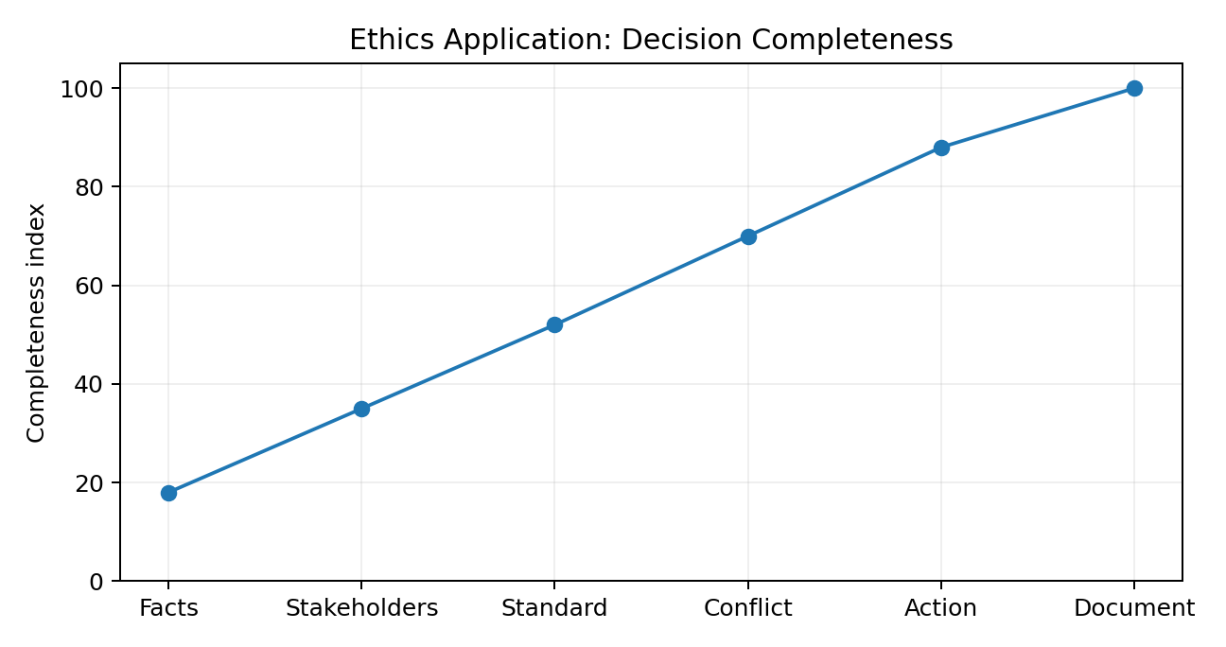
ADVANCED LEARNER EDITION
Designed for scenario-based CFA Level I ethics practice. Numerical illustrations quantify fees, allocation, client impact, conflicts and misstatements; ethical conclusions remain principles-and-facts driven.
www.bisptrainings.com | +91 769-4095-404

Student Information & Study Contract
Field | Details
Student Name | ________________________________________
CFA Candidate / Student ID | ________________________________________
Batch / Cohort | ________________________________________
Trainer | ________________________________________
Start Date | ________________________________________
Target Exam Window | ________________________________________
Diagnostic Score | _______ / 20
Final Score | _______ / 20
Study contract
I will identify the facts before selecting a Standard, state the stakeholder duty, separate disclosure from consent, quantify economic impacts when useful, and reattempt every missed ethics scenario after 48 hours.

Learning Outcomes
- Apply a structured facts → stakeholder → Standard → conflict → action → documentation process.
- Recognize common Standards I–VII triggers in realistic vignettes.
- Use calculations to quantify fees, trade allocation, client impact, referral economics and performance distortions.
- Distinguish accounting-reporting requirements from CFA professional-conduct obligations.
- Build exam discipline for “most appropriate / least appropriate” ethics questions.
1. Learn  Standards map | 2. Diagnose  Facts + duty | 3. Quantify  Economic effect | 4. Practice  10 / 100 cases | 5. Assess  20 / 100 MCQs | 6. Certify  Record score

Workbook Roadmap
Section | Module | Purpose
1 | Ethics Application in One View | Decision framework and Standards I-VII map
2 | Application Playbook | MNPI, fair dealing, suitability, conflicts, employer duties, records
3 | Visual Learning | SmartArt-style flows and charts
4 | 20 Quantitative Illustrations | Basic to Advanced+ with step-by-step calculations
5 | Historical CFA-Style Reconstructions | Original practice, not verbatim exam content
6 | IAS / IFRS / US GAAP Context | Reporting context vs professional conduct
7 | Practice 10 / 100 | Randomly selected solved cases
8 | Assessment 20 / 100 | Randomized MCQs and explanations
9 | BISP Exam Strategy | Revision and error-log plan
10 | Printable Certificate | Completion evidence
Copyright note
CFA Institute exam questions are proprietary. This workbook does not reproduce prior exam questions verbatim. “Historical” questions are original reconstructions based on recurring Ethics application themes. CFA® and Chartered Financial Analyst® are trademarks of CFA Institute; BISP Trainings is not affiliated with CFA Institute.

1. Ethics Application in One View
Facts  What happened? | Stakeholders  Client / employer / market / CFA Program | Information  Public? material? confidential? | Standard  Identify exact duty | Conflict  Disclosure / consent / priority? | Action  Prevent / refuse / dissociate / correct | Evidence  Document + supervise
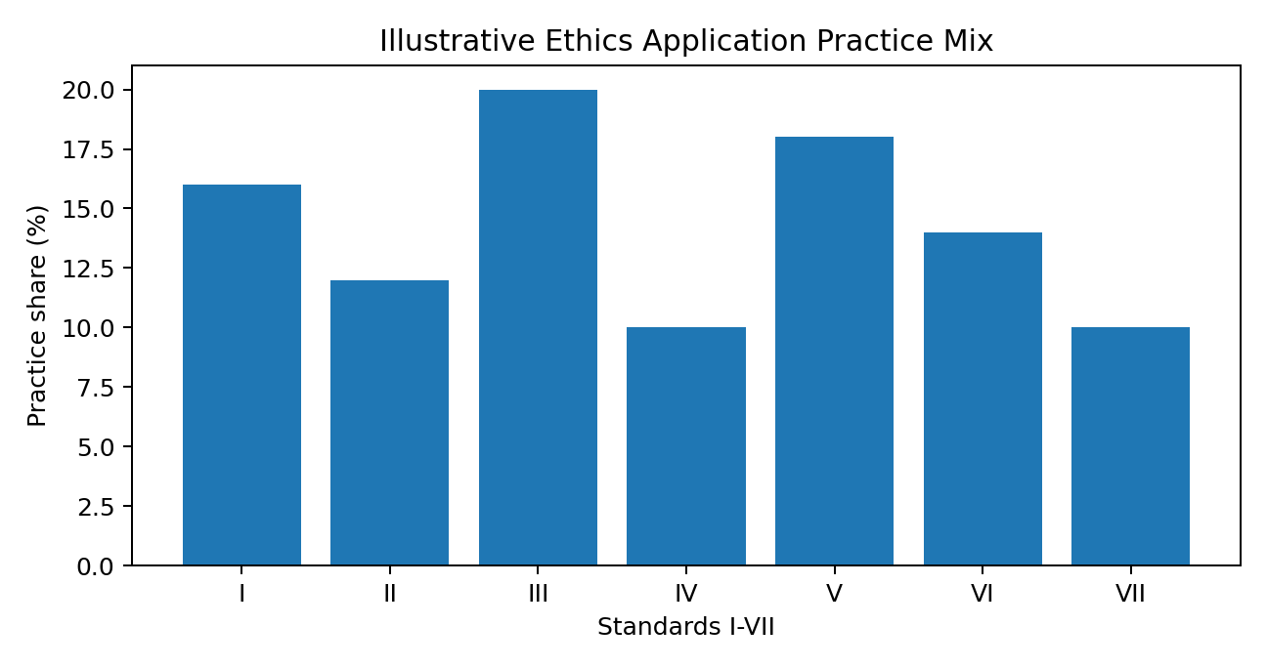

Standards I-VII Application Map
Std. | Category | Core topics | Application question
I | Professionalism | Law, independence/objectivity, misrepresentation, misconduct | Is professional judgment compromised or communication false/misleading?
II | Integrity of Capital Markets | MNPI, manipulation | Is information material/nonpublic or is market activity intended to distort?
III | Duties to Clients | Loyalty/care, fair dealing, suitability, performance, confidentiality | Are client interests, fairness, mandate and confidentiality protected?
IV | Duties to Employers | Loyalty, additional compensation, supervisors | Is employer interest protected and are systems reasonably supervised?
V | Analysis, Recommendations, Actions | Diligence, communication, records | Is there reasonable basis, clear communication and evidence trail?
VI | Conflicts of Interest | Disclosure, transaction priority, referrals | Could another interest impair duty, and is it disclosed/managed?
VII | CFA Member/Candidate Responsibilities | Program conduct, references | Does conduct protect CFA Program integrity and avoid exaggeration?

2. Application Playbook
Trigger | How to apply | Standards
MNPI / Mosaic | Ask whether information is both material and nonpublic. If yes: do not trade/tip; restrict, escalate, document. Mosaic analysis may combine public information with nonmaterial nonpublic information. | II(A)
Fair Dealing | Use a pre-established dissemination/allocation process. Fair does not always mean equal; it means no favoritism and a reasonable opportunity for clients. | III(B)
Suitability | For advisory relationships, understand client objectives/constraints. For discretionary accounts, act consistently with the written mandate/IPS. | III(C)
Performance Presentation | Do not cherry-pick accounts, periods, benchmarks or results. Clearly state fees and material limitations. | III(D), I(C)
Employer Duties | Do not harm employer while employed, obtain written consent for conflicting compensation, and establish reasonable supervisory procedures. | IV(A-C)
Research & Communication | Investigate sources, have reasonable basis, separate fact from opinion, explain material assumptions/risks, and retain records. | V(A-C)
Conflicts & Personal Trading | Prominently disclose conflicts, give client/employer transactions priority, and disclose referral arrangements/consideration. | VI(A-C)
CFA Program Conduct | Do not share confidential exam information or imply superior performance because of candidacy/designation. | VII(A-B)

Decision Trees
Information received  Source + content | Material?  Would a reasonable investor care? | Nonpublic?  Broadly disseminated? | Both yes  Do not trade/tip | Mosaic?  Public + nonmaterial nonpublic may support analysis | Evidence  Document + compliance
Conflict found  Personal / employer / referral / issuer | Can it be avoided?  Remove / recuse | If retained  Prominent disclosure | Need consent?  Obtain where required | Priority  Clients/employer first | Monitor  Preclearance + records
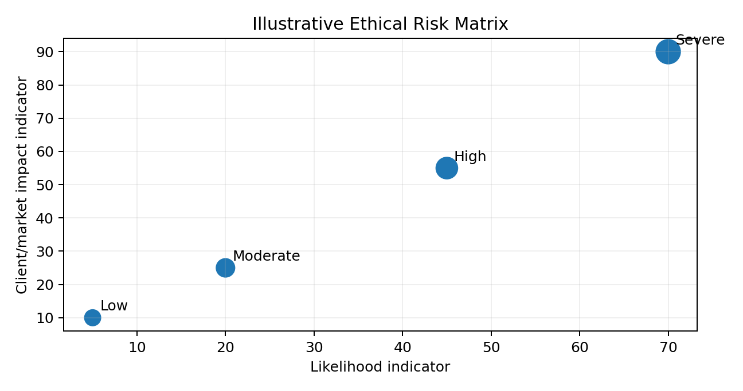

3. Chart View & SmartArt-Style Visual Learning
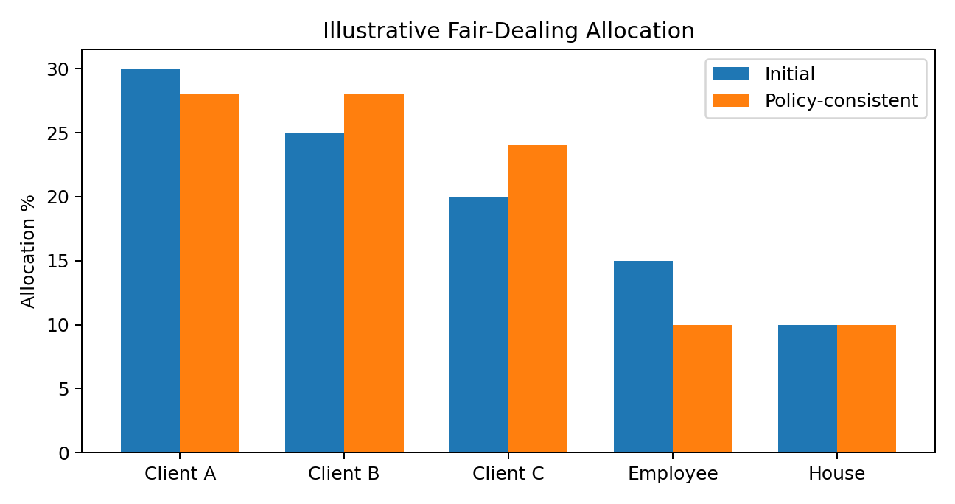
Chart interpretation
A fair-dealing process should use policy-consistent allocation and avoid favoring the employee/house account. The exact method depends on mandate, order type and firm procedures.

Animation-ready Word sequence
Microsoft Word does not provide PowerPoint-style object animation. This workbook therefore uses step panels that can be revealed sequentially during instructor-led teaching or converted to slides later.

4. Twenty Quantitative Ethics Applications
How to use the numericals
Ethics is not a calculation-heavy CFA topic. These calculations make hidden incentives, distortions and client impacts visible. Always finish with the relevant Standard and the appropriate professional action.

Example 1: Fair allocation after partial fill
Difficulty: Basic
Scenario | Formula / method
Client A requests 6,000 shares and Client B 4,000. Only 7,500 shares are filled. Allocate pro-rata. | Allocation = Fill × Client order / Total orders
Step | Working
Step 1 | Total demand = 10,000 shares
Step 2 | A = 7,500×6,000/10,000 = 4,500
Step 3 | B = 7,500×4,000/10,000 = 3,000
Answer
A 4,500; B 3,000
Ethics application
III(B) Fair Dealing. Two retirement clients participate in the same block order.

Example 2: Referral-fee rate
Difficulty: Basic
Scenario | Formula / method
An adviser receives ₹24,000 for referrals that generated ₹800,000 of advisory revenue. | Referral rate = Fee / Referred revenue
Step | Working
Step 1 | 24,000/800,000 = 0.03
Step 2 | 0.03×100 = 3%
Answer
3.0%
Ethics application
VI(C) Referral Fees. A client can evaluate the economic incentive behind a recommendation.

Example 3: Gross-to-net performance
Difficulty: Basic
Scenario | Formula / method
A portfolio earns 12.0% gross and pays a 1.5% annual management fee. Use simple subtraction for an illustrative net return. | Approx. net = Gross - Fee
Step | Working
Step 1 | 12.0%-1.5% = 10.5%
Answer
10.5%
Ethics application
III(D) Performance Presentation; I(C) Misrepresentation. A manager compares what the strategy earned before and after fees.

Example 4: Trade-error restitution
Difficulty: Basic
Scenario | Formula / method
A client should have bought 900 shares at ₹120 but the firm error caused execution at ₹124. | Direct difference = Shares×Price difference
Step | Working
Step 1 | Price difference = ₹4
Step 2 | 900×₹4 = ₹3,600
Answer
₹3,600 direct difference
Ethics application
III(A) Loyalty, Prudence, and Care. A brokerage desk corrects a preventable client execution error.

Example 5: Misstatement percentage
Difficulty: Basic+
Scenario | Formula / method
A presentation reports AUM of ₹540 million; verified AUM is ₹525 million. | Overstatement % = (Reported-Actual)/Actual
Step | Working
Step 1 | Difference = ₹15m
Step 2 | 15/525 = 2.857%
Answer
2.86% overstatement
Ethics application
I(C) Misrepresentation. Marketing copy must not exaggerate firm assets.

Example 6: Personal-trade client impact
Difficulty: Intermediate
Scenario | Formula / method
An employee buys 1,200 shares before a client order; market price rises ₹3 before the client executes. Compute illustrative overlap impact. | Impact = Shares×Price move
Step | Working
Step 1 | 1,200×₹3 = ₹3,600
Answer
₹3,600
Ethics application
VI(B) Priority of Transactions. Personal trading should not disadvantage client execution.

Example 7: Suitability concentration
Difficulty: Intermediate
Scenario | Formula / method
A client portfolio is ₹3,200,000 and employer stock is ₹1,120,000. | Concentration = Holding/Portfolio
Step | Working
Step 1 | 1,120,000/3,200,000 = 0.35
Answer
35%
Ethics application
III(C) Suitability. A planner checks whether one employer stock dominates a client portfolio.

Example 8: Soft-dollar research attribution
Difficulty: Intermediate
Scenario | Formula / method
Research costing ₹180,000 supports four strategies; Strategy X uses 35% of it. | Attributed cost = Total×Usage share
Step | Working
Step 1 | 180,000×35% = ₹63,000
Answer
₹63,000
Ethics application
III(A), V(A). A manager documents how client brokerage supports investment research.

Example 9: Best-execution all-in cost
Difficulty: Intermediate
Scenario | Formula / method
Broker A buy price ₹250.10 plus ₹0.05 fee/share; Broker B ₹250.00 plus ₹0.12 fee/share. Compare 4,000 shares. | All-in cost = Shares×(Price+Fee)
Step | Working
Step 1 | A = 4,000×250.15 = ₹1,000,600
Step 2 | B = 4,000×250.12 = ₹1,000,480
Step 3 | Difference = ₹120
Answer
Broker B lower by ₹120
Ethics application
III(A) Loyalty, Prudence, and Care. Best execution considers total value, not commission alone.

Example 10: Gift-to-compensation ratio
Difficulty: Intermediate
Scenario | Formula / method
An analyst receives a client gift worth ₹15,000 and annual compensation is ₹1,500,000. | Ratio = Gift/Compensation
Step | Working
Step 1 | 15,000/1,500,000 = 1%
Answer
1.0%
Ethics application
I(B) Independence and Objectivity. Compliance evaluates whether benefits could influence judgment; no numeric threshold alone decides the ethics issue.

Example 11: Pro-rata IPO allocation
Difficulty: Intermediate+
Scenario | Formula / method
Eligible client orders total 50,000 shares: A 20k, B 15k, C 15k. Fill is 30,000. | Client fill = Total fill×Client demand/Total demand
Step | Working
Step 1 | A = 30,000×20/50 = 12,000
Step 2 | B = 30,000×15/50 = 9,000
Step 3 | C = 9,000
Answer
12,000 / 9,000 / 9,000
Ethics application
III(B) Fair Dealing. A hot issue is allocated using a pre-established fair method.

Example 12: Research claim correction
Difficulty: Intermediate+
Scenario | Formula / method
A report says 45 of 50 quarters were positive and calls this “95% positive.” | Actual % = Positive/Total
Step | Working
Step 1 | 45/50 = 90%
Step 2 | Claim exceeds actual by 5 percentage points
Answer
90%; 5-point overstatement
Ethics application
I(C), V(B). A fact-check catches an exaggerated performance claim.

Example 13: Fee impact on ending wealth
Difficulty: Intermediate+
Scenario | Formula / method
₹5,000,000 grows 9% gross. A 1.2% fee is charged on ending gross assets. | End gross = Start×(1+r); Fee = End gross×fee rate
Step | Working
Step 1 | Gross end = 5,000,000×1.09 = ₹5,450,000
Step 2 | Fee = 5,450,000×1.2% = ₹65,400
Step 3 | Net end = ₹5,384,600
Answer
₹5,384,600
Ethics application
III(D), V(B). A client sees the rupee effect of fees rather than only a percentage.

Example 14: Supervisory exception rate
Difficulty: Advanced
Scenario | Formula / method
Compliance samples 320 communications and finds 12 documentation exceptions. | Exception rate = Exceptions/Sample
Step | Working
Step 1 | 12/320 = 0.0375
Step 2 | ×100 = 3.75%
Answer
3.75%
Ethics application
IV(C) Responsibilities of Supervisors. A supervisor uses monitoring metrics while still investigating every material exception.

Example 15: MNPI economic-benefit proxy
Difficulty: Advanced
Scenario | Formula / method
A trader buys 2,500 shares at ₹96 before unreleased material news; after release price is ₹108. | Price gain = Shares×Price change
Step | Working
Step 1 | Price change = ₹12
Step 2 | 2,500×₹12 = ₹30,000
Answer
₹30,000
Ethics application
II(A) Material Nonpublic Information. The amount illustrates economic benefit; materiality/nonpublic status still depends on facts.

Example 16: Selective composite omission effect
Difficulty: Advanced
Scenario | Formula / method
Eight included accounts average 8%. Two omitted accounts returned -6% and -10%. Assume equal weights and compute all-account average. | All-account average = Sum returns/10
Step | Working
Step 1 | Included sum = 8×8% = 64%
Step 2 | Add omitted: 64-6-10 = 48%
Step 3 | 48%/10 = 4.8%
Answer
4.8% vs presented 8.0%
Ethics application
III(D), I(C). Excluding poor accounts can materially distort performance presentation.

Example 17: Conflict economics from referral split
Difficulty: Advanced
Scenario | Formula / method
A ₹300,000 referral payment is split 65% to firm and 35% to representative. | Share = Total×Split
Step | Working
Step 1 | Firm = 300,000×65% = ₹195,000
Step 2 | Representative = ₹105,000
Answer
₹195,000 / ₹105,000
Ethics application
VI(C) Referral Fees. Specific economic incentives should be disclosed to relevant parties.

Example 18: Client priority in oversubscribed issue
Difficulty: Advanced
Scenario | Formula / method
Eligible client demand is 90,000 shares and house demand 30,000. Only 54,000 shares are available and policy gives clients priority. | Client satisfaction = Available/Client demand
Step | Working
Step 1 | 54,000/90,000 = 60%
Step 2 | House allocation = 0 under the simplified policy
Answer
60% client demand satisfied
Ethics application
VI(B), III(B). Client interests take priority over house interests in the simplified policy.

Example 19: Mispricing of a performance claim
Difficulty: Advanced+
Scenario | Formula / method
A strategy says ₹10m became ₹12.1m in 2 years and advertises 10.5% annualized. Compute actual annualized return. | Annualized = (Ending/Beginning)^(1/n)-1
Step | Working
Step 1 | 12.1/10 = 1.21
Step 2 | sqrt(1.21)=1.10
Step 3 | 1.10-1 = 10.0%
Answer
10.0%; claim overstated by 0.5 point
Ethics application
I(C), III(D). Marketing must annualize returns correctly.

Example 20: Integrated ethics impact score
Difficulty: Advanced+
Scenario | Formula / method
A compliance review scores probability 40%, client impact ₹200,000, and remediation factor 1.5. Compute an illustrative risk exposure index. | Index = Probability×Impact×Factor
Step | Working
Step 1 | 0.40×₹200,000 = ₹80,000
Step 2 | ₹80,000×1.5 = ₹120,000
Answer
₹120,000 illustrative index
Ethics application
IV(C), risk-based supervision. A compliance team prioritizes cases quantitatively; the index does not replace Standards analysis.

5. Historical CFA-Style Ethics Application Reconstructions
Copyright-safe section
The following are original CFA-style scenarios based on recurring ethics themes. They are not reproduced previous-year CFA Institute exam questions.

Reconstruction 1
An analyst accepts an issuer-paid luxury weekend immediately before publishing coverage.
Answer & rationale
I(B) Independence and Objectivity. Evaluate whether the benefit compromises or appears to compromise objective judgment; refuse or manage it according to policy.

Reconstruction 2
A supplier privately tells an analyst that a listed company lost its largest contract. The news would likely move the share price.
Answer & rationale
II(A) Material Nonpublic Information. Do not trade or cause others to trade; escalate and restrict.

Reconstruction 3
A manager sends a buy recommendation to one favored institutional client two hours before all other suitable clients.
Answer & rationale
III(B) Fair Dealing. Dissemination should provide clients a fair opportunity, not preferential timing.

Reconstruction 4
A discretionary client asks the manager to buy a highly speculative token even though the IPS prohibits such exposure.
Answer & rationale
III(C) Suitability. Do not execute an unsuitable discretionary trade merely because the client requested it informally; follow the mandate/update process.

Reconstruction 5
A candidate leaves an employer and takes copies of proprietary research and client records.
Answer & rationale
IV(A) Loyalty and V(C) Record Retention. Employer records should not be misappropriated.

Reconstruction 6
An analyst relies on a third-party model but never checks assumptions, inputs, or source quality.
Answer & rationale
V(A) Diligence and Reasonable Basis.

Reconstruction 7
A manager owns a material stake in a company strongly recommended to clients, but the conflict is buried in generic boilerplate.
Answer & rationale
VI(A) Disclosure of Conflicts requires full, fair and prominent disclosure.

Reconstruction 8
An employee buys stock after deciding to recommend it, before client orders have a chance to execute.
Answer & rationale
VI(B) Priority of Transactions. Clients/employer have priority.

Reconstruction 9
A wealth adviser receives a referral payment from a tax consultant but says nothing to clients.
Answer & rationale
VI(C) Referral Fees. Disclose the arrangement and consideration.

Reconstruction 10
A Level I candidate states that passing Level I proves superior portfolio-management skill.
Answer & rationale
VII(B) Reference to CFA Institute, the CFA designation, and the CFA Program. The statement exaggerates the implications of participation.

6. IAS / IFRS / US GAAP Context for Ethics Application
Scope boundary
CFA Standards govern professional conduct; IAS/IFRS and US GAAP govern financial reporting. Ethical application often requires analysts to use reported information accurately, investigate valuation assumptions, communicate limitations, and disclose conflicts. Accounting compliance is contextual—it does not substitute for CFA Standards.
Standard | Topic | Application linkage | CFA Standards
IFRS 7 | Financial Instruments: Disclosures | Risk/liquidity/credit disclosures support diligent analysis and clear client communication. | V(A), V(B)
IFRS 9 | Financial Instruments | Classification, impairment and hedge accounting can materially affect reported results; analysts must understand and communicate relevant assumptions. | V(A), V(B), I(C)
IFRS 13 | Fair Value Measurement | Valuation hierarchy and inputs highlight model/data limitations and the need for reasonable basis. | V(A), V(B)
IAS 1 | Presentation of Financial Statements | Material presentation/omission concepts reinforce accurate use of facts and avoidance of misleading communication. | I(C), V(B)
IAS 24 | Related Party Disclosures | Related-party information can reveal conflicts and governance risks. | VI(A), V(A)
IAS 33 | Earnings per Share | Analysts should use EPS measures accurately and distinguish reported from adjusted measures. | I(C), V(B)
US GAAP ASC 820 | Fair Value Measurement | Comparable valuation context for diligence and communication. | V(A), V(B)
US GAAP ASC 825 | Financial Instruments | Measurement/disclosure context can affect investment analysis. | V(A), V(B)
US GAAP ASC 850 | Related Party Disclosures | May identify economic relationships relevant to conflicts and diligence. | VI(A), V(A)
US GAAP ASC 260 | Earnings Per Share | Accurate per-share calculations and communication reduce misrepresentation risk. | I(C), V(B)

7. Practice Bank: 100 Ethics Application Cases

Case Bank Index C001-C025
Case ID | Primary trigger | Required task | Difficulty
C001 | Performance Presentation | identify the missing disclosure | Moderate
C002 | Record Retention | diagnose a misleading claim | Advanced
C003 | Misrepresentation | select the least appropriate action | Basic
C004 | Confidentiality | identify the violation | Moderate
C005 | Conflict Disclosure | calculate a fair allocation | Advanced
C006 | MNPI | identify the documentation requirement | Basic
C007 | Employer Loyalty | choose the most appropriate action | Moderate
C008 | Priority of Transactions | calculate the client impact | Advanced
C009 | Market Manipulation | decide whether consent is required | Basic
C010 | Additional Compensation | identify the governing Standard | Moderate
C011 | Referral Fees | identify the missing disclosure | Advanced
C012 | Loyalty/Care | diagnose a misleading claim | Basic
C013 | Supervision | select the least appropriate action | Moderate
C014 | CFA Program Conduct | identify the violation | Advanced
C015 | Fair Dealing | calculate a fair allocation | Basic
C016 | Reasonable Basis | identify the documentation requirement | Moderate
C017 | CFA Reference | choose the most appropriate action | Advanced
C018 | Suitability | calculate the client impact | Basic
C019 | Client Communication | decide whether consent is required | Moderate
C020 | Independence/Objectivity | identify the governing Standard | Advanced
C021 | Performance Presentation | identify the missing disclosure | Basic
C022 | Record Retention | diagnose a misleading claim | Moderate
C023 | Misrepresentation | select the least appropriate action | Advanced
C024 | Confidentiality | identify the violation | Basic
C025 | Conflict Disclosure | calculate a fair allocation | Moderate

Case Bank Index C026-C050
Case ID | Primary trigger | Required task | Difficulty
C026 | MNPI | identify the documentation requirement | Advanced
C027 | Employer Loyalty | choose the most appropriate action | Basic
C028 | Priority of Transactions | calculate the client impact | Moderate
C029 | Market Manipulation | decide whether consent is required | Advanced
C030 | Additional Compensation | identify the governing Standard | Basic
C031 | Referral Fees | identify the missing disclosure | Moderate
C032 | Loyalty/Care | diagnose a misleading claim | Advanced
C033 | Supervision | select the least appropriate action | Basic
C034 | CFA Program Conduct | identify the violation | Moderate
C035 | Fair Dealing | calculate a fair allocation | Advanced
C036 | Reasonable Basis | identify the documentation requirement | Basic
C037 | CFA Reference | choose the most appropriate action | Moderate
C038 | Suitability | calculate the client impact | Advanced
C039 | Client Communication | decide whether consent is required | Basic
C040 | Independence/Objectivity | identify the governing Standard | Moderate
C041 | Performance Presentation | identify the missing disclosure | Advanced
C042 | Record Retention | diagnose a misleading claim | Basic
C043 | Misrepresentation | select the least appropriate action | Moderate
C044 | Confidentiality | identify the violation | Advanced
C045 | Conflict Disclosure | calculate a fair allocation | Basic
C046 | MNPI | identify the documentation requirement | Moderate
C047 | Employer Loyalty | choose the most appropriate action | Advanced
C048 | Priority of Transactions | calculate the client impact | Basic
C049 | Market Manipulation | decide whether consent is required | Moderate
C050 | Additional Compensation | identify the governing Standard | Advanced

Case Bank Index C051-C075
Case ID | Primary trigger | Required task | Difficulty
C051 | Referral Fees | identify the missing disclosure | Basic
C052 | Loyalty/Care | diagnose a misleading claim | Moderate
C053 | Supervision | select the least appropriate action | Advanced
C054 | CFA Program Conduct | identify the violation | Basic
C055 | Fair Dealing | calculate a fair allocation | Moderate
C056 | Reasonable Basis | identify the documentation requirement | Advanced
C057 | CFA Reference | choose the most appropriate action | Basic
C058 | Suitability | calculate the client impact | Moderate
C059 | Client Communication | decide whether consent is required | Advanced
C060 | Independence/Objectivity | identify the governing Standard | Basic
C061 | Performance Presentation | identify the missing disclosure | Moderate
C062 | Record Retention | diagnose a misleading claim | Advanced
C063 | Misrepresentation | select the least appropriate action | Basic
C064 | Confidentiality | identify the violation | Moderate
C065 | Conflict Disclosure | calculate a fair allocation | Advanced
C066 | MNPI | identify the documentation requirement | Basic
C067 | Employer Loyalty | choose the most appropriate action | Moderate
C068 | Priority of Transactions | calculate the client impact | Advanced
C069 | Market Manipulation | decide whether consent is required | Basic
C070 | Additional Compensation | identify the governing Standard | Moderate
C071 | Referral Fees | identify the missing disclosure | Advanced
C072 | Loyalty/Care | diagnose a misleading claim | Basic
C073 | Supervision | select the least appropriate action | Moderate
C074 | CFA Program Conduct | identify the violation | Advanced
C075 | Fair Dealing | calculate a fair allocation | Basic

Case Bank Index C076-C100
Case ID | Primary trigger | Required task | Difficulty
C076 | Reasonable Basis | identify the documentation requirement | Moderate
C077 | CFA Reference | choose the most appropriate action | Advanced
C078 | Suitability | calculate the client impact | Basic
C079 | Client Communication | decide whether consent is required | Moderate
C080 | Independence/Objectivity | identify the governing Standard | Advanced
C081 | Performance Presentation | identify the missing disclosure | Basic
C082 | Record Retention | diagnose a misleading claim | Moderate
C083 | Misrepresentation | select the least appropriate action | Advanced
C084 | Confidentiality | identify the violation | Basic
C085 | Conflict Disclosure | calculate a fair allocation | Moderate
C086 | MNPI | identify the documentation requirement | Advanced
C087 | Employer Loyalty | choose the most appropriate action | Basic
C088 | Priority of Transactions | calculate the client impact | Moderate
C089 | Market Manipulation | decide whether consent is required | Advanced
C090 | Additional Compensation | identify the governing Standard | Basic
C091 | Referral Fees | identify the missing disclosure | Moderate
C092 | Loyalty/Care | diagnose a misleading claim | Advanced
C093 | Supervision | select the least appropriate action | Basic
C094 | CFA Program Conduct | identify the violation | Moderate
C095 | Fair Dealing | calculate a fair allocation | Advanced
C096 | Reasonable Basis | identify the documentation requirement | Basic
C097 | CFA Reference | choose the most appropriate action | Moderate
C098 | Suitability | calculate the client impact | Advanced
C099 | Client Communication | decide whether consent is required | Basic
C100 | Independence/Objectivity | identify the governing Standard | Moderate

Practice 10 / 100 - Randomly Selected & Fully Solved

Practice 1: C011 - Referral Fees
Eligible client orders total 50,000 shares: A 20k, B 15k, C 15k. Fill is 30,000.
Try before reading
Write: (1) facts, (2) stakeholder duty, (3) exact Standard, (4) calculation if any, (5) best action.
Calculation step | Working
Step 1 | A = 30,000×20/50 = 12,000
Step 2 | B = 30,000×15/50 = 9,000
Step 3 | C = 9,000
Numerical answer
12,000 / 9,000 / 9,000
Ethics solution
III(B) Fair Dealing. A hot issue is allocated using a pre-established fair method.

Practice 2: C025 - Conflict Disclosure
₹5,000,000 grows 9% gross. A 1.2% fee is charged on ending gross assets.
Try before reading
Write: (1) facts, (2) stakeholder duty, (3) exact Standard, (4) calculation if any, (5) best action.
Calculation step | Working
Step 1 | Gross end = 5,000,000×1.09 = ₹5,450,000
Step 2 | Fee = 5,450,000×1.2% = ₹65,400
Step 3 | Net end = ₹5,384,600
Numerical answer
₹5,384,600
Ethics solution
III(D), V(B). A client sees the rupee effect of fees rather than only a percentage.

Practice 3: C026 - MNPI
Eight included accounts average 8%. Two omitted accounts returned -6% and -10%. Assume equal weights and compute all-account average.
Try before reading
Write: (1) facts, (2) stakeholder duty, (3) exact Standard, (4) calculation if any, (5) best action.
Calculation step | Working
Step 1 | Included sum = 8×8% = 64%
Step 2 | Add omitted: 64-6-10 = 48%
Step 3 | 48%/10 = 4.8%
Numerical answer
4.8% vs presented 8.0%
Ethics solution
III(D), I(C). Excluding poor accounts can materially distort performance presentation.

Practice 4: C038 - Suitability
A report says 45 of 50 quarters were positive and calls this “95% positive.”
Try before reading
Write: (1) facts, (2) stakeholder duty, (3) exact Standard, (4) calculation if any, (5) best action.
Calculation step | Working
Step 1 | 45/50 = 90%
Step 2 | Claim exceeds actual by 5 percentage points
Numerical answer
90%; 5-point overstatement
Ethics solution
I(C), V(B). A fact-check catches an exaggerated performance claim.

Practice 5: C057 - CFA Reference
Broker A buy price ₹250.10 plus ₹0.05 fee/share; Broker B ₹250.00 plus ₹0.12 fee/share. Compare 4,000 shares.
Try before reading
Write: (1) facts, (2) stakeholder duty, (3) exact Standard, (4) calculation if any, (5) best action.
Calculation step | Working
Step 1 | A = 4,000×250.15 = ₹1,000,600
Step 2 | B = 4,000×250.12 = ₹1,000,480
Step 3 | Difference = ₹120
Numerical answer
Broker B lower by ₹120
Ethics solution
III(A) Loyalty, Prudence, and Care. Best execution considers total value, not commission alone.

Practice 6: C059 - Client Communication
A trader buys 2,500 shares at ₹96 before unreleased material news; after release price is ₹108.
Try before reading
Write: (1) facts, (2) stakeholder duty, (3) exact Standard, (4) calculation if any, (5) best action.
Calculation step | Working
Step 1 | Price change = ₹12
Step 2 | 2,500×₹12 = ₹30,000
Numerical answer
₹30,000
Ethics solution
II(A) Material Nonpublic Information. The amount illustrates economic benefit; materiality/nonpublic status still depends on facts.

Practice 7: C066 - MNPI
Eight included accounts average 8%. Two omitted accounts returned -6% and -10%. Assume equal weights and compute all-account average.
Try before reading
Write: (1) facts, (2) stakeholder duty, (3) exact Standard, (4) calculation if any, (5) best action.
Calculation step | Working
Step 1 | Included sum = 8×8% = 64%
Step 2 | Add omitted: 64-6-10 = 48%
Step 3 | 48%/10 = 4.8%
Numerical answer
4.8% vs presented 8.0%
Ethics solution
III(D), I(C). Excluding poor accounts can materially distort performance presentation.

Practice 8: C072 - Loyalty/Care
Compliance samples 320 communications and finds 12 documentation exceptions.
Try before reading
Write: (1) facts, (2) stakeholder duty, (3) exact Standard, (4) calculation if any, (5) best action.
Calculation step | Working
Step 1 | 12/320 = 0.0375
Step 2 | ×100 = 3.75%
Numerical answer
3.75%
Ethics solution
IV(C) Responsibilities of Supervisors. A supervisor uses monitoring metrics while still investigating every material exception.

Practice 9: C087 - Employer Loyalty
A strategy says ₹10m became ₹12.1m in 2 years and advertises 10.5% annualized. Compute actual annualized return.
Try before reading
Write: (1) facts, (2) stakeholder duty, (3) exact Standard, (4) calculation if any, (5) best action.
Calculation step | Working
Step 1 | 12.1/10 = 1.21
Step 2 | sqrt(1.21)=1.10
Step 3 | 1.10-1 = 10.0%
Numerical answer
10.0%; claim overstated by 0.5 point
Ethics solution
I(C), III(D). Marketing must annualize returns correctly.

Practice 10: C099 - Client Communication
A trader buys 2,500 shares at ₹96 before unreleased material news; after release price is ₹108.
Try before reading
Write: (1) facts, (2) stakeholder duty, (3) exact Standard, (4) calculation if any, (5) best action.
Calculation step | Working
Step 1 | Price change = ₹12
Step 2 | 2,500×₹12 = ₹30,000
Numerical answer
₹30,000
Ethics solution
II(A) Material Nonpublic Information. The amount illustrates economic benefit; materiality/nonpublic status still depends on facts.

8. Master MCQ Bank: 100 Questions

MCQ Bank Index Q001-Q025
Question ID | Core stem / concept | Key | Difficulty
Q001 | Employer loyalty / departing employee issue. | IV(A) | Moderate
Q002 | CFA Program integrity/security issue. | VII(A) | Advanced
Q003 | Performance is selectively or misleadingly presented. | III(D) | Basic
Q004 | Personal transaction precedes client/employer. | VI(B) | Moderate
Q005 | Clients are not treated fairly. | III(B) | Advanced
Q006 | Records supporting analysis/actions are missing. | V(C) | Basic
Q007 | Activity is intended to distort price/volume. | II(B) | Moderate
Q008 | Research lacks diligence/reasonable basis. | V(A) | Advanced
Q009 | A claim is false, exaggerated, or misleading. | I(C) | Basic
Q010 | Outside compensation creates conflict. | IV(B) | Moderate
Q011 | CFA candidacy/designation is misrepresented. | VII(B) | Advanced
Q012 | Confidential client information is involved. | III(E) | Basic
Q013 | Referral consideration is not disclosed. | VI(C) | Moderate
Q014 | Recommendation/action may not fit mandate. | III(C) | Advanced
Q015 | Conflict disclosure is absent/inadequate. | VI(A) | Basic
Q016 | Client loyalty/prudence/care is at issue. | III(A) | Moderate
Q017 | Communication omits material assumptions/risks. | V(B) | Advanced
Q018 | Information is material and nonpublic. | II(A) | Basic
Q019 | Supervisory system or response is inadequate. | IV(C) | Moderate
Q020 | A benefit threatens independence/objectivity. | I(B) | Advanced
Q021 | Employer loyalty / departing employee issue. | IV(A) | Basic
Q022 | CFA Program integrity/security issue. | VII(A) | Moderate
Q023 | Performance is selectively or misleadingly presented. | III(D) | Advanced
Q024 | Personal transaction precedes client/employer. | VI(B) | Basic
Q025 | Clients are not treated fairly. | III(B) | Moderate

MCQ Bank Index Q026-Q050
Question ID | Core stem / concept | Key | Difficulty
Q026 | Records supporting analysis/actions are missing. | V(C) | Advanced
Q027 | Activity is intended to distort price/volume. | II(B) | Basic
Q028 | Research lacks diligence/reasonable basis. | V(A) | Moderate
Q029 | A claim is false, exaggerated, or misleading. | I(C) | Advanced
Q030 | Outside compensation creates conflict. | IV(B) | Basic
Q031 | CFA candidacy/designation is misrepresented. | VII(B) | Moderate
Q032 | Confidential client information is involved. | III(E) | Advanced
Q033 | Referral consideration is not disclosed. | VI(C) | Basic
Q034 | Recommendation/action may not fit mandate. | III(C) | Moderate
Q035 | Conflict disclosure is absent/inadequate. | VI(A) | Advanced
Q036 | Client loyalty/prudence/care is at issue. | III(A) | Basic
Q037 | Communication omits material assumptions/risks. | V(B) | Moderate
Q038 | Information is material and nonpublic. | II(A) | Advanced
Q039 | Supervisory system or response is inadequate. | IV(C) | Basic
Q040 | A benefit threatens independence/objectivity. | I(B) | Moderate
Q041 | Employer loyalty / departing employee issue. | IV(A) | Advanced
Q042 | CFA Program integrity/security issue. | VII(A) | Basic
Q043 | Performance is selectively or misleadingly presented. | III(D) | Moderate
Q044 | Personal transaction precedes client/employer. | VI(B) | Advanced
Q045 | Clients are not treated fairly. | III(B) | Basic
Q046 | Records supporting analysis/actions are missing. | V(C) | Moderate
Q047 | Activity is intended to distort price/volume. | II(B) | Advanced
Q048 | Research lacks diligence/reasonable basis. | V(A) | Basic
Q049 | A claim is false, exaggerated, or misleading. | I(C) | Moderate
Q050 | Outside compensation creates conflict. | IV(B) | Advanced

MCQ Bank Index Q051-Q075
Question ID | Core stem / concept | Key | Difficulty
Q051 | CFA candidacy/designation is misrepresented. | VII(B) | Basic
Q052 | Confidential client information is involved. | III(E) | Moderate
Q053 | Referral consideration is not disclosed. | VI(C) | Advanced
Q054 | Recommendation/action may not fit mandate. | III(C) | Basic
Q055 | Conflict disclosure is absent/inadequate. | VI(A) | Moderate
Q056 | Client loyalty/prudence/care is at issue. | III(A) | Advanced
Q057 | Communication omits material assumptions/risks. | V(B) | Basic
Q058 | Information is material and nonpublic. | II(A) | Moderate
Q059 | Supervisory system or response is inadequate. | IV(C) | Advanced
Q060 | A benefit threatens independence/objectivity. | I(B) | Basic
Q061 | Employer loyalty / departing employee issue. | IV(A) | Moderate
Q062 | CFA Program integrity/security issue. | VII(A) | Advanced
Q063 | Performance is selectively or misleadingly presented. | III(D) | Basic
Q064 | Personal transaction precedes client/employer. | VI(B) | Moderate
Q065 | Clients are not treated fairly. | III(B) | Advanced
Q066 | Records supporting analysis/actions are missing. | V(C) | Basic
Q067 | Activity is intended to distort price/volume. | II(B) | Moderate
Q068 | Research lacks diligence/reasonable basis. | V(A) | Advanced
Q069 | A claim is false, exaggerated, or misleading. | I(C) | Basic
Q070 | Outside compensation creates conflict. | IV(B) | Moderate
Q071 | CFA candidacy/designation is misrepresented. | VII(B) | Advanced
Q072 | Confidential client information is involved. | III(E) | Basic
Q073 | Referral consideration is not disclosed. | VI(C) | Moderate
Q074 | Recommendation/action may not fit mandate. | III(C) | Advanced
Q075 | Conflict disclosure is absent/inadequate. | VI(A) | Basic

MCQ Bank Index Q076-Q100
Question ID | Core stem / concept | Key | Difficulty
Q076 | Client loyalty/prudence/care is at issue. | III(A) | Moderate
Q077 | Communication omits material assumptions/risks. | V(B) | Advanced
Q078 | Information is material and nonpublic. | II(A) | Basic
Q079 | Supervisory system or response is inadequate. | IV(C) | Moderate
Q080 | A benefit threatens independence/objectivity. | I(B) | Advanced
Q081 | Employer loyalty / departing employee issue. | IV(A) | Basic
Q082 | CFA Program integrity/security issue. | VII(A) | Moderate
Q083 | Performance is selectively or misleadingly presented. | III(D) | Advanced
Q084 | Personal transaction precedes client/employer. | VI(B) | Basic
Q085 | Clients are not treated fairly. | III(B) | Moderate
Q086 | Records supporting analysis/actions are missing. | V(C) | Advanced
Q087 | Activity is intended to distort price/volume. | II(B) | Basic
Q088 | Research lacks diligence/reasonable basis. | V(A) | Moderate
Q089 | A claim is false, exaggerated, or misleading. | I(C) | Advanced
Q090 | Outside compensation creates conflict. | IV(B) | Basic
Q091 | CFA candidacy/designation is misrepresented. | VII(B) | Moderate
Q092 | Confidential client information is involved. | III(E) | Advanced
Q093 | Referral consideration is not disclosed. | VI(C) | Basic
Q094 | Recommendation/action may not fit mandate. | III(C) | Moderate
Q095 | Conflict disclosure is absent/inadequate. | VI(A) | Advanced
Q096 | Client loyalty/prudence/care is at issue. | III(A) | Basic
Q097 | Communication omits material assumptions/risks. | V(B) | Moderate
Q098 | Information is material and nonpublic. | II(A) | Advanced
Q099 | Supervisory system or response is inadequate. | IV(C) | Basic
Q100 | A benefit threatens independence/objectivity. | I(B) | Moderate

Assessment: 20 Random MCQs out of 100

1. Q002 (Advanced)
CFA Program integrity/security issue. Which response is most appropriate?
A. Protect integrity/security of CFA Institute programs and confidential exam information
B. Discuss exact exam questions after leaving the test center
C. Share recall notes if no answers are included

2. Q016 (Moderate)
Client loyalty/prudence/care is at issue. Which response is most appropriate?
A. Put client interests first and exercise prudence/care
B. Maximize firm revenue first
C. Favor accounts with higher fees

3. Q021 (Basic)
Employer loyalty / departing employee issue. Which response is most appropriate?
A. Protect employer interests while employed and avoid misappropriation
B. Take employer research when resigning because you helped create it
C. Solicit employer clients secretly before departure

4. Q023 (Advanced)
Performance is selectively or misleadingly presented. Which response is most appropriate?
A. Present results fairly, accurately, with relevant context
B. Show only best-performing accounts
C. Use gross results without fee context when fees are material

5. Q024 (Basic)
Personal transaction precedes client/employer. Which response is most appropriate?
A. Give client/employer transactions priority over beneficial-owner trades
B. Trade personally first if the position is small
C. Priority rules apply only to IPOs

6. Q025 (Moderate)
Clients are not treated fairly. Which response is most appropriate?
A. Treat all clients identically in every circumstance
B. Use fair, objective dissemination/allocation procedures
C. Always prioritize largest accounts

7. Q034 (Moderate)
Recommendation/action may not fit mandate. Which response is most appropriate?
A. Evaluate objectives/constraints and act consistently with mandate
B. Buy any security a client mentions
C. Suitability matters only for equities

8. Q035 (Advanced)
Conflict disclosure is absent/inadequate. Which response is most appropriate?
A. Provide full, fair, prominent conflict disclosure
B. Use generic boilerplate regardless of conflict
C. Disclose only if the client asks

9. Q039 (Basic)
Supervisory system or response is inadequate. Which response is most appropriate?
A. Establish reasonable compliance procedures and act on red flags
B. Supervision is unnecessary for experienced staff
C. A written policy alone always satisfies the duty

10. Q046 (Moderate)
Records supporting analysis/actions are missing. Which response is most appropriate?
A. Maintain records supporting analysis, recommendations, and actions
B. Delete notes after a recommendation is sent
C. Keep only records that support successful calls

11. Q048 (Basic)
Research lacks diligence/reasonable basis. Which response is most appropriate?
A. Have diligence and reasonable basis for analysis/recommendations
B. Rely on third-party research without evaluation
C. Use rumors if several people repeat them

12. Q054 (Basic)
Recommendation/action may not fit mandate. Which response is most appropriate?
A. Evaluate objectives/constraints and act consistently with mandate
B. Buy any security a client mentions
C. Suitability matters only for equities

13. Q056 (Advanced)
Client loyalty/prudence/care is at issue. Which response is most appropriate?
A. Put client interests first and exercise prudence/care
B. Maximize firm revenue first
C. Favor accounts with higher fees

14. Q071 (Advanced)
CFA candidacy/designation is misrepresented. Which response is most appropriate?
A. Describe membership/designation/candidacy accurately without exaggerating implications
B. Claim superior performance because of the CFA Program
C. Use “CFA Level I” as a professional designation

15. Q072 (Basic)
Confidential client information is involved. Which response is most appropriate?
A. Protect client confidentiality subject to lawful exceptions
B. Share client data with friends if names are omitted
C. Confidentiality ends when a client becomes inactive

16. Q073 (Moderate)
Referral consideration is not disclosed. Which response is most appropriate?
A. Disclose nature and consideration of referral arrangements
B. Disclose only referral arrangement existence, never amount/nature
C. Referral fees are never allowed

17. Q079 (Moderate)
Supervisory system or response is inadequate. Which response is most appropriate?
A. Establish reasonable compliance procedures and act on red flags
B. Supervision is unnecessary for experienced staff
C. A written policy alone always satisfies the duty

18. Q081 (Basic)
Employer loyalty / departing employee issue. Which response is most appropriate?
A. Protect employer interests while employed and avoid misappropriation
B. Take employer research when resigning because you helped create it
C. Solicit employer clients secretly before departure

19. Q094 (Moderate)
Recommendation/action may not fit mandate. Which response is most appropriate?
A. Evaluate objectives/constraints and act consistently with mandate
B. Buy any security a client mentions
C. Suitability matters only for equities

20. Q095 (Advanced)
Conflict disclosure is absent/inadequate. Which response is most appropriate?
A. Provide full, fair, prominent conflict disclosure
B. Use generic boilerplate regardless of conflict
C. Disclose only if the client asks

Assessment Answer Key & Explanations
Question | Answer | Standard | Why
1. Q002 | A | VII(A) | Protect integrity/security of CFA Institute programs and confidential exam information
Question | Answer | Standard | Why
2. Q016 | A | III(A) | Put client interests first and exercise prudence/care
Question | Answer | Standard | Why
3. Q021 | A | IV(A) | Protect employer interests while employed and avoid misappropriation
Question | Answer | Standard | Why
4. Q023 | A | III(D) | Present results fairly, accurately, with relevant context
Question | Answer | Standard | Why
5. Q024 | A | VI(B) | Give client/employer transactions priority over beneficial-owner trades
Question | Answer | Standard | Why
6. Q025 | B | III(B) | Use fair, objective dissemination/allocation procedures
Question | Answer | Standard | Why
7. Q034 | A | III(C) | Evaluate objectives/constraints and act consistently with mandate
Question | Answer | Standard | Why
8. Q035 | A | VI(A) | Provide full, fair, prominent conflict disclosure
Question | Answer | Standard | Why
9. Q039 | A | IV(C) | Establish reasonable compliance procedures and act on red flags
Question | Answer | Standard | Why
10. Q046 | A | V(C) | Maintain records supporting analysis, recommendations, and actions
Question | Answer | Standard | Why
11. Q048 | A | V(A) | Have diligence and reasonable basis for analysis/recommendations
Question | Answer | Standard | Why
12. Q054 | A | III(C) | Evaluate objectives/constraints and act consistently with mandate
Question | Answer | Standard | Why
13. Q056 | A | III(A) | Put client interests first and exercise prudence/care
Question | Answer | Standard | Why
14. Q071 | A | VII(B) | Describe membership/designation/candidacy accurately without exaggerating implications
Question | Answer | Standard | Why
15. Q072 | A | III(E) | Protect client confidentiality subject to lawful exceptions
Question | Answer | Standard | Why
16. Q073 | A | VI(C) | Disclose nature and consideration of referral arrangements
Question | Answer | Standard | Why
17. Q079 | A | IV(C) | Establish reasonable compliance procedures and act on red flags
Question | Answer | Standard | Why
18. Q081 | A | IV(A) | Protect employer interests while employed and avoid misappropriation
Question | Answer | Standard | Why
19. Q094 | A | III(C) | Evaluate objectives/constraints and act consistently with mandate
Question | Answer | Standard | Why
20. Q095 | A | VI(A) | Provide full, fair, prominent conflict disclosure

9. How BISP Can Help You Crack CFA Level I Ethics
- Scenario deconstruction: convert long vignettes into facts, stakeholder, Standard, conflict, action.
- Trigger-word drills for MNPI, fair dealing, suitability, additional compensation, conflicts, transaction priority and CFA Program conduct.
- Calculation-supported ethics: quantify fee, allocation and misstatement impacts without losing the principles-based conclusion.
- Error-log coaching: classify every wrong answer as fact error, Standard error, exception error, disclosure/consent error, or wording error.
- Timed mixed sets: practice “most appropriate / least appropriate” wording under exam conditions.
- Revision checkpoints: 48-hour reattempt, 7-day mixed review, final formula/trigger sheet.

7-Day Ethics Application Revision Sprint
Day | Focus
Day 1 | Standards I-II + 20 trigger cards
Day 2 | Standard III client duties + fair-dealing drills
Day 3 | Standards IV-V employer/research + records
Day 4 | Standards VI-VII conflicts + CFA Program conduct
Day 5 | 20 numericals + error-log reattempt
Day 6 | Practice 10/100 + mixed vignettes
Day 7 | Assessment 20/100 + weak-area review

Quick Ethics Application Checklist
1  Identify exact facts | 2  Name stakeholder duty | 3  Choose substandard | 4  Check exception | 5  Disclosure vs consent? | 6  Best preventive action | 7  Document / supervise

10. Printable Certificate of Completion

CERTIFICATE OF COMPLETION
CFA Level I Practice - Ethics Application
Student Name: ______________________________________________
Trainer / Batch: ______________________________________________
Completion Date: ______________________________________________
Assessment Score: ______ / 20 | Practice Cases Completed: ______ / 10
Completion statement
This certificate confirms completion of the BISP Trainings educational practice workbook and is not a CFA Institute credential, certification, designation, or exam result.
Trainer Signature: ____________________________ Student Signature: ____________________________
BISP Trainings | www.bisptrainings.com | +91 769-4095-404

