Task 1
Draw the V-Model diagram on paper or using any digital tool, and clearly label each phase with both the developer and tester roles involved at each step.

Answer:

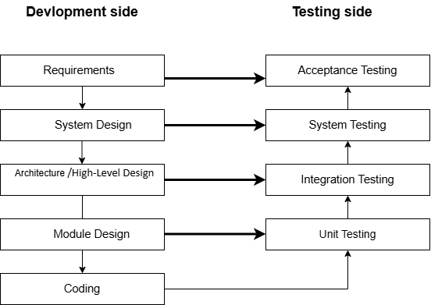

Developer and Tester Roles
Phase | Developer Role | Tester Role
Requirements | Understand and analyze the requirements. | Review requirements and identify whether they are testable.
System Design | Design the overall system structure. | Plan system-level testing based on the requirements.
Architecture / High-Level Design | Design modules and their interactions. | Plan integration testing between modules.
Module Design | Design individual modules/components. | Plan tests for individual modules.
Coding | Write and implement the code. | Prepare test cases, test data and testing requirements.
Unit Testing | Fix defects found in individual modules. | Test individual modules/components.
Integration Testing | Integrate modules and fix integration defects. | Test interactions between integrated modules.
System Testing | Fix defects found in the complete system. | Test the complete system against requirements.
Acceptance Testing | Fix final issues and support the release. | Verify that the system meets business/user requirements.

Task 2
Question:
Pick any app you use daily (like Zomato, Instagram, or Paytm) and write a short table mapping each SDLC phase (Requirement, Design, Coding, Testing, Deployment, Maintenance) to a real activity that would happen for that app.

Answer:
Example: Zomato
SDLC Phase | Real Activity in Zomato
Requirement | Decide that users should be able to search restaurants, view menus, add food to the cart and place orders.
Design | Design the user interface for restaurant search, menu, cart, payment and order tracking.
Coding | Developers write code for login, restaurant search, cart, payment and order placement features.
Testing | Testers check login, restaurant search, cart, payment and order placement.
Deployment | The tested application or new version is released for users.
Maintenance | Bugs are fixed and features are improved based on user feedback and new requirements.

Task 3
Question:
For each phase of the V-Model, list one specific testing activity that should be performed, using examples from a food delivery app (like Swiggy or Zomato).
Hint: For example, during 'System Testing', you might test if the order placement works end-to-end.

Answer:
Example: Zomato/Swiggy
V-Model Phase | Testing Activity | Example
Requirements | Requirement Review | Check whether the order placement requirement is clear, complete and testable.
System Design | System Test Planning | Plan tests for the complete food-ordering process.
Architecture / High-Level Design | Integration Test Planning | Plan testing between restaurant, cart, payment and order modules.
Module Design | Unit Test Planning | Identify test conditions for individual modules such as cart calculation.
Coding | Unit Test Preparation | Prepare test cases and test data for individual components such as calculating the cart total.
Unit Testing | Unit Testing | Check whether the cart correctly calculates the total price of selected food items.
Integration Testing | Integration Testing | Check whether successful payment correctly updates the order status.
System Testing | End-to-End Testing | Search restaurant → select food → add to cart → make payment → place the order.
Acceptance Testing | User Acceptance Testing | Verify that a user can successfully place an order according to business requirements.
Note: In the V-Model, testing activities are planned alongside the corresponding development phases rather than waiting until the entire development is finished.

Task 4
Question:
Compare the V-Model and RAD Model by listing 3 strengths and 2 weaknesses of each, focusing on how testing is handled in both models.

Answer:
Model | Strengths | Weaknesses
V-Model | 1. Testing is planned from the beginning of development. | 1. Changing requirements are difficult to accommodate.
 | 2. Each development phase has a corresponding testing phase. | 2. It is less flexible when frequent changes are required.
 | 3. Testing is systematic and well-structured.
RAD Model | 1. Testing and user feedback can happen frequently during rapid development. | 1. Fast development can put pressure on testing time.
 | 2. Frequent prototypes help identify requirement and usability issues early. | 2. Frequent changes can make test cases and test plans difficult to maintain.
 | 3. Continuous user involvement helps validate features quickly.

