YuvaIntern – Week 1
Strategic Planning and Data Exploration in Logistics
Practical Project Report

1. Executive Summary
This practical project applies strategic planning and data exploration to a hypothetical logistics operation. A reproducible synthetic dataset of 1,200 delivery orders was created and analyzed with Python. The overall on-time delivery rate is 90.75%, average delivery time is 2.76 hours, average delivery cost is INR 673.23, and average vehicle-capacity utilization is 60.37%. These figures are synthetic demonstration results, not real company performance.

2. Problem Definition
The logistics operator must balance delivery service, transportation cost, route distance and vehicle capacity across multiple zones. The project uses operational data to identify performance differences and potential areas for better planning.

3. Objectives
- Measure logistics performance using KPIs.
- Compare delivery performance and cost across zones.
- Explore relationships among distance, load, traffic, weather, cost and delivery time.
- Assess vehicle-capacity utilization.
- Demonstrate how analytics can support strategic planning.

4. Dataset and Methodology
The dataset contains 1,200 simulated orders with date, zone, distance, vehicle type, capacity, load, traffic, weather, delivery time, delivery cost and on-time status. A fixed random seed makes the analysis reproducible.
Field | Purpose
Delivery_Zone | Geographic comparison
Distance_KM | Route distance
Vehicle_Type | Vehicle usage
Vehicle_Capacity_KG | Available capacity
Load_Weight_KG | Shipment load
Traffic_Level | Operating condition
Weather | Operating condition
Delivery_Time_Hours | Service duration
Delivery_Cost_INR | Cost
On_Time | Service indicator

5. KPI Results
KPI | Result
Total Orders | 1200
On-Time Delivery Rate (%) | 90.75
Late Delivery Rate (%) | 9.25
Average Delivery Time (hours) | 2.76
Average Delivery Cost (INR) | 673.23
Average Distance (km) | 66.88
Average Capacity Utilization (%) | 60.37

6. Exploratory Analysis
Zone comparisons, monthly delivery volume and average delivery cost were analyzed. The visualizations below provide evidence for strategic interpretation.

On-Time Delivery by Zone
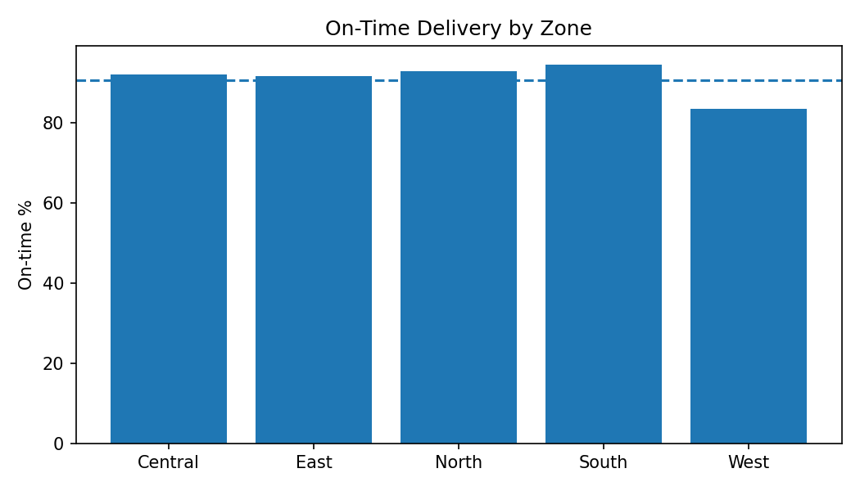

Monthly Delivery Volume
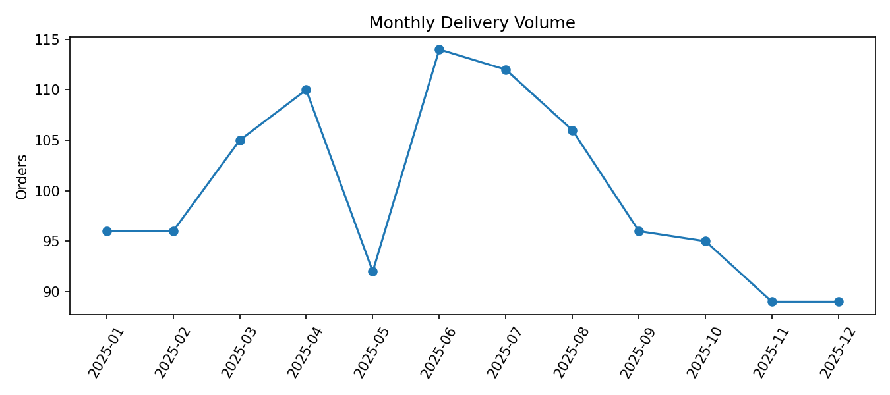

Average Delivery Cost by Zone
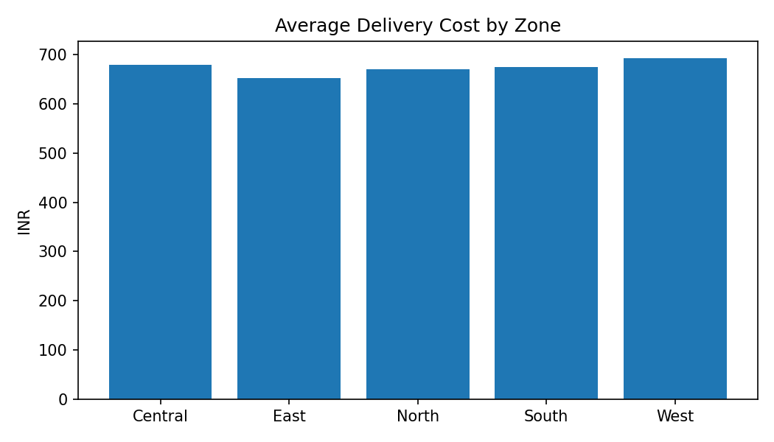
In the synthetic sample, South has the highest on-time rate (94.5%), while West has the lowest (83.5%). West has the highest average delivery cost (INR 692.42). These are dataset-specific observations only.

7. Analytical Extension
A simple Linear Regression model estimates delivery time from distance, load, traffic, weather and capacity utilization. On a held-out 20% test sample, it achieved R²=0.868 and MAE=0.297 hours. This is an analytical demonstration, not a production model.

8. Strategic Recommendations
- Monitor zone-level service performance.
- Review high-cost zones for route and vehicle-allocation opportunities.
- Track capacity utilization to identify inefficient allocation.
- Collect consistent historical operational data for future modeling.
- Use KPI trends to support management decisions.

9. Limitations
- The dataset is synthetic.
- Results depend on simulation assumptions.
- The regression model is intentionally simple.
- Real planning requires additional factors such as fuel cost, driver availability, route restrictions and service windows.

10. Conclusion
The project demonstrates a complete practical Task 1 workflow: defining a logistics problem, creating a usable dataset, calculating KPIs, exploring operational patterns, applying a simple analytical extension and translating findings into strategic recommendations.

