COVER PAGE
Predictive Analysis
PROJECT REPORT
(Project Semester September-December 2025)

Student Academic & Mental Well-being Predictive Analysis
Submitted by

Khushdeep Saini

Registration No. 12316852

Programme and Section: K23BE
Course Code: INT234

Under the Guidance of

Dr. Tamina Thakur(23532)

Discipline of CSE/IT

Lovely School of Computer Science

Lovely Professional University, Phagwara

CERTIFICATE

This is to certify that Khushdeep Saini bearing Registration no. 12316852 has completed INT234: Predictive Analysis project titled, “Student Well-being and Lifestyle analysis” under my guidance and supervision. To the best of my knowledge, the present work is the result of her original development, effort and study.

Signature and Name of the Supervisor
Designation of the Supervisor
School of Computer Science and Engineering
Lovely Professional University
Phagwara, Punjab.

Date:

DECLARATION

I, Khushdeep Saini, student of Computer Science and Engineering under CSE/IT Discipline at, Lovely Professional University, Punjab, hereby declare that all the information furnished in this project report is based on my own intensive work and is genuine.

Date: Signature
Registration No. 12316852 Khushdeep Saini

Acknowledgement
I would like to express my sincere gratitude to all those who contributed to the successful completion of this project titled Student Well-being and Lifestyle analysis project using python.
I am deeply thankful to my project guide for their valuable guidance, continuous support, and constructive feedback throughout the duration of this project. Their insights and encouragement played a crucial role in shaping the analytical approach and improving the quality of this work.
I would also like to thank the faculty members of the Department of Computer Science for providing a strong academic foundation and for their constant motivation. Their teachings and support greatly enhanced my understanding of data analytics and business intelligence tools..
Finally, I express my heartfelt thanks to my family and friends for their encouragement, patience, and moral support throughout the course of this project.

Date:
Khushdeep Saini (12316852)
Table of Content

S no. | Index | Page no.
 | Introduction | 6
 | Objectives of Project | 8
 | Data Description | 9
 | Data Preprocessing and Feature Engineering | 11
 | Synthetic Data Generation Using SDV
 | Exploratory data analysis
 | Regression Analysis
 | Classification model
 | Cluster detection
 | Results and Discussion | 25
 | Limitation | 27
 | Future Scope | 28
 | Conclusion | 29
 | Posts | 30

1. Introduction
In the modern educational landscape, student performance is no longer viewed solely through the lens of grades and examination scores. Academic success is increasingly recognized as a multidimensional outcome influenced by a combination of cognitive, behavioral, emotional, and lifestyle-related factors. Variables such as academic workload, stress levels, emotional balance, sleep patterns, motivation, attendance, and mental well-being significantly affect how students learn, perform, and sustain long-term academic growth.
With the rapid digitalization of education and the widespread use of online surveys and learning management systems, educational institutions now generate large volumes of student-related data. However, raw data alone does not provide actionable insights unless it is systematically analyzed. This is where data science and machine learning techniques play a crucial role. By applying statistical analysis and machine learning models, it becomes possible to identify patterns, relationships, and trends that are not immediately visible through traditional analytical methods.
Mental health has emerged as a particularly important concern among students, especially in high-pressure academic environments. Increased competition, academic workload, uncertainty about future careers, and lifestyle imbalances have contributed to rising stress and emotional challenges. These factors not only affect students’ well-being but also have a direct and indirect impact on academic outcomes such as CGPA and overall performance satisfaction. Understanding these relationships is essential for designing effective academic policies, counseling interventions, and support systems.
This project focuses on the predictive and exploratory analysis of student academic and mental well-being data collected through a structured survey. The dataset includes both academic indicators (such as CGPA, attendance, and preparation level) and psychological or lifestyle indicators (such as stress level, emotional balance, sleep hours, and physical activity). Since survey-based datasets are often limited in size and may contain missing or inconsistent values, advanced preprocessing techniques and synthetic data generation methods are employed to enhance analytical reliability.
A key aspect of this study is the use of Synthetic Data Vault (SDV) to generate realistic synthetic data that preserves the statistical characteristics of the original dataset while ensuring privacy and scalability. This enables the application of multiple machine learning algorithms, including regression, classification, and clustering, on a larger dataset.
Rather than focusing solely on achieving high predictive accuracy, this project emphasizes realistic model evaluation, honest interpretation of results, and meaningful insight generation. The study demonstrates how different machine learning techniques perform on real-world educational survey data and highlights the challenges associated with predicting complex human behaviors and outcomes. Overall, the project aims to bridge the gap between academic data collection and actionable educational insights through a comprehensive machine learning pipeline.

2. Objectives of the Project
The primary objective of this project is to analyze the complex relationships between academic, psychological, and lifestyle factors among students and to apply machine learning techniques to uncover meaningful patterns that can support data-driven decision-making in educational environments. Rather than focusing solely on grade prediction, this study emphasizes holistic student analysis, acknowledging that academic performance is influenced by multiple interrelated dimensions.
1. To Preprocess and Standardize Academic Survey Data
One of the key objectives of this project is to clean, preprocess, and standardize raw academic survey data collected from students. Survey-based datasets often contain:
- Missing values
- Inconsistent data formats
- Subjective categorical responses
- Outliers and invalid entries (e.g., CGPA reported as percentages)
This project aims to:
- Rename and standardize column names for clarity and consistency
- Convert categorical survey responses into machine-readable formats
- Handle missing values using statistically appropriate methods
- Normalize numerical attributes such as CGPA to maintain valid ranges
Effective preprocessing ensures data quality, which is essential for building reliable machine learning models.

2. To Generate High-Quality Synthetic Data Using SDV
Another major objective is to address data scarcity and privacy concerns by generating synthetic student data using the Gaussian Copula Synthesizer (SDV). Real-world educational datasets often suffer from:
- Small sample sizes
- Privacy restrictions
- Imbalanced class distributions
This project aims to:
- Preserve statistical properties of the original dataset
- Maintain realistic correlations between variables
- Enable scalable experimentation using a larger dataset
Synthetic data generation allows robust model training and analysis while protecting sensitive student information, making the study both ethical and reproducible.

3. To Perform Exploratory Data Analysis (EDA) and Correlation Analysis
The project seeks to conduct comprehensive exploratory data analysis to understand the distribution and behavior of academic and psychological variables. This includes:
- Visualizing data distributions
- Identifying trends and anomalies
- Examining correlations among variables
A key objective is to identify strongly related features (such as motivation, sleep patterns, attendance, and academic satisfaction) that influence student outcomes. Correlation heatmaps are used to guide feature selection and model design.

4. To Develop Regression Models for Academic Performance Analysis
Rather than treating academic performance as a purely deterministic outcome, this project aims to apply regression models to explore how well survey-based indicators can explain academic metrics such as CGPA.
Specific objectives include:
- Evaluating the suitability of linear regression for academic data
- Measuring prediction errors using MAE, RMSE, and R² metrics
- Understanding limitations of linear assumptions in educational data
This analysis highlights the challenges of predicting academic performance and emphasizes the importance of interpretability over unrealistic accuracy claims.

5. To Build and Evaluate Classification Models for Student Well-being
Another important objective is to apply classification algorithms to predict student well-being indicators such as stress level and emotional balance.
The project aims to:
- Train models including K-Nearest Neighbors, Decision Trees, Naïve Bayes, and Support Vector Machines
- Compare classification performance using accuracy, precision, recall, and F1-score
- Analyze confusion matrices to understand misclassification patterns
This objective focuses on identifying behavioral and lifestyle patterns rather than achieving artificially high accuracy.

6. To Identify Natural Groupings Using Clustering Techniques
The project also aims to apply unsupervised learning techniques to discover hidden patterns among students without predefined labels.
Key objectives include:
- Grouping students based on academic performance, sleep habits, and attendance
- Applying K-Means and Hierarchical Clustering methods
- Interpreting clusters to identify student profiles such as high-performing, moderately balanced, and at-risk groups
Clustering provides insights that can help institutions design targeted academic and wellness interventions.

7. To Evaluate and Compare Machine Learning Models Objectively
An essential objective of this project is to critically evaluate model performance rather than blindly optimizing for accuracy.
This includes:
- Using appropriate evaluation metrics for different tasks
- Understanding model limitations and biases
- Avoiding overfitting through controlled model complexity
The project prioritizes model reliability, interpretability, and ethical use over unrealistic performance metrics.

8. To Demonstrate the Practical Application of Machine Learning in Education
Finally, this project aims to demonstrate how machine learning techniques can be responsibly applied in educational analytics.
The objectives include:
- Bridging theoretical ML concepts with real-world student data
- Providing actionable insights rather than automated judgments
- Supporting educators and institutions with data-informed perspectives
This reinforces the role of machine learning as a decision-support tool, not a replacement for human judgment.

3. Dataset Description
1. Source of Data
The dataset used in this project originates from a structured academic and mental well-being survey administered to students using Google Forms. The survey was designed to capture a broad range of factors influencing students’ academic performance and psychological well-being, including academic workload, stress levels, lifestyle habits, and self-perceived performance indicators.
Responses collected through Google Forms were automatically stored in Google Sheets, from which the data was exported in Excel (.xlsx) format for further analysis and modeling. The dataset reflects self-reported student perceptions, making it suitable for exploratory analysis, behavioral modeling, and pattern detection rather than deterministic prediction.

2. Nature of the Dataset
The dataset is multivariate in nature and consists of:
- Categorical attributes representing ordinal and nominal survey responses
- Numerical attributes representing academic metrics such as CGPA
The data captures subjective student experiences and behavioral patterns rather than objective sensor or system-generated data. As a result, the dataset contains inherent variability and noise, which is typical of survey-based educational datasets.

3. Original Dataset Size and Structure
The original dataset contains responses from a limited number of students, with each row representing an individual student and each column representing a specific survey question.
Key characteristics:
- Rows: Individual student responses
- Columns: Academic, psychological, and lifestyle indicators
- Target variables: Stress level, emotional balance, academic performance, CGPA
To address limitations related to sample size and class imbalance, synthetic data generation was later applied to expand the dataset for robust machine learning experimentation.

4. Description of Attributes
Below is a detailed explanation of each attribute used in the dataset after column standardization.
Academic and Psychological Attributes
- Academic Workload (acd_workload)
Indicates how frequently students feel stressed due to academic workload. This variable reflects perceived academic pressure.
- Stress Level (stress_level)
Represents the student’s self-assessed overall stress level during the semester. This attribute is used as a classification target in multiple models.
- Emotional Balance (emotional_balance)
Measures the student’s ability to manage emotions such as sadness, frustration, and anger.
- Motivation Level (motivation_level)
Captures the degree of student motivation toward studying and attending classes.
- Preparation Level (preparation_level)
Reflects students’ perceived readiness for exams and assignments.
- Performance Satisfaction (performance_satisfaction)
Indicates how satisfied students are with their academic performance relative to their potential.
- Mental Well-being (mental_wellbeing)
Represents overall satisfaction with current mental health.
- Academic Performance (academic_performance)
A self-rated indicator of academic performance.

Lifestyle Attributes
- Physical Activity (physical_activity)
Measures how frequently students engage in physical exercise or active hobbies.
- Sleep Hours (sleep_hours)
Represents the average number of hours a student sleeps per night, recorded as categorical ranges.
- Attendance (attendance)
Indicates regularity in attending classes or lectures.

Academic Outcome Attribute
- CGPA (cgpa)
Represents the student’s cumulative grade point average. Since some respondents provided percentage values instead of CGPA, values exceeding 10 were scaled and clipped to maintain validity within a 0–10 range.

5. Data Cleaning and Preprocessing
To ensure data quality and model reliability, several preprocessing steps were performed:
- Column Renaming
Long and inconsistent survey question text was replaced with concise, standardized column names.
- Handling Missing Values
  - Categorical attributes were imputed using mode
  - Numerical attributes were imputed using mean values
- Data Type Correction
Several ordinal survey responses were initially interpreted as numeric values. These were explicitly converted to categorical data types before encoding.
- Outlier Handling
Invalid CGPA values were corrected by normalization and clipping.

6. Encoding and Feature Engineering
Categorical variables were transformed into numerical representations using Label Encoding, enabling compatibility with machine learning algorithms.
Additionally, ordinal features were explicitly mapped to numeric scales:
- Sleep Hours (Ordinal Encoding)
Less than 5 hours → 1
5–6 hours → 2
7–8 hours → 3
More than 8 hours → 4
- Attendance (Ordinal Encoding)
Very irregular → 1
Somewhat irregular → 2
Regular → 3
Very regular → 4
These engineered features improved model interpretability and clustering performance.

7. Synthetic Data Generation
To overcome limitations such as small sample size and class imbalance, synthetic data was generated using the Gaussian Copula Synthesizer from the SDV library.
Key advantages of synthetic data:
- Preserves statistical distributions and correlations
- Enables large-scale experimentation
- Ensures privacy and ethical compliance
A total of 5,000 synthetic records were generated and used for exploratory analysis, regression, classification, and clustering tasks.

8. Final Dataset Used for Modeling
After preprocessing and synthetic data generation, the final dataset:
- Is fully numeric and machine-learning ready
- Contains no missing values
- Maintains realistic correlations among variables
This processed dataset serves as the foundation for all supervised and unsupervised learning models implemented in the project.

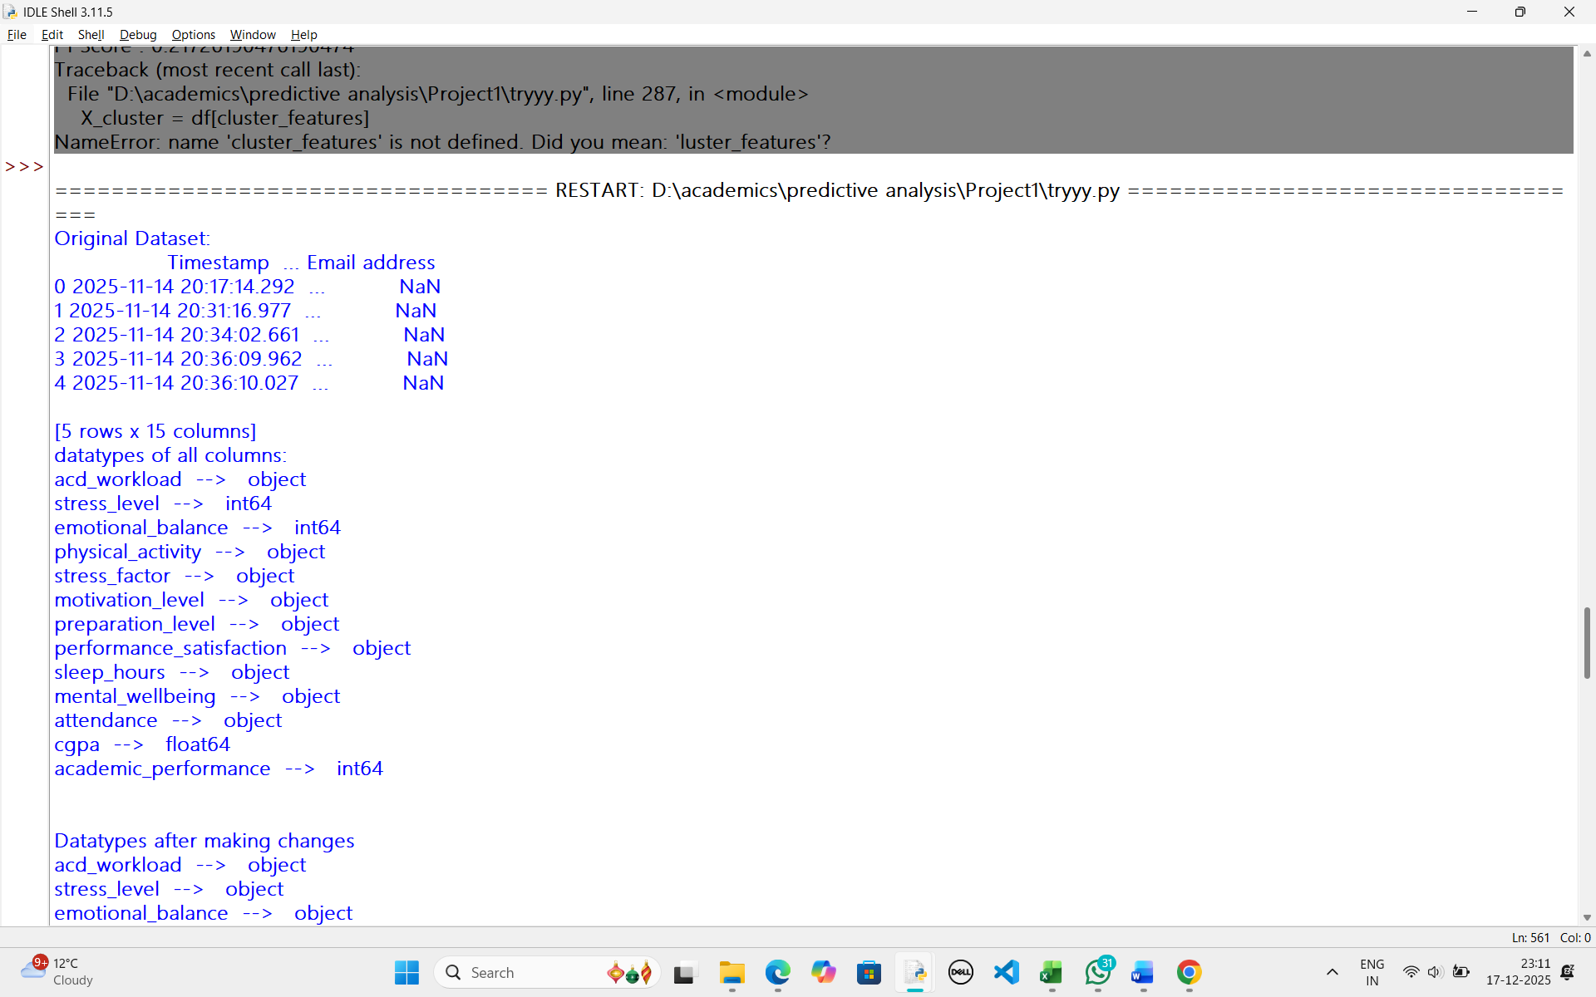

4. Data Preprocessing and Feature Engineering
Data preprocessing is one of the most critical stages in any machine learning pipeline, as the quality of input data directly determines the effectiveness and reliability of the resulting models. Since the dataset used in this project was collected through a Google Form survey, it contained inconsistencies, missing values, mixed data types, and subjective responses. Therefore, extensive preprocessing and feature engineering were performed to ensure the dataset was suitable for machine learning analysis.
4.1 Data Type Correction
Several survey responses were originally recorded as numerical values (for example, scales ranging from 1 to 5), but these values actually represented ordinal or categorical information rather than continuous numeric quantities. Treating such variables as numerical could mislead machine learning models by implying arithmetic relationships that do not exist.
To address this issue:
- All survey-based ordinal and categorical attributes were explicitly converted to the object data type.
- This step ensured that these variables were later processed correctly using encoding techniques instead of being misinterpreted as continuous numerical values.
This correction was essential to preserve the semantic meaning of survey responses and avoid biased model behavior.

4.2 Handling Missing Values
Missing data is a common issue in survey-based datasets due to unanswered or partially completed responses. Before modeling, all missing values were carefully handled using appropriate strategies:
- Categorical variables were imputed using the mode (most frequent value).
This approach is suitable for categorical data as it preserves the most common response pattern and minimizes distortion.
- Numerical variables, particularly CGPA, were imputed using the mean value of the column.
Mean imputation was chosen because CGPA values were approximately normally distributed after cleaning.
This ensured that the dataset contained no null values and was fully compatible with machine learning algorithms.

4.3 CGPA Normalization
An important data quality issue was identified in the CGPA column. Some respondents entered their percentage scores instead of CGPA, resulting in values greater than 10.
To correct this:
- Any CGPA value greater than 10 was assumed to be a percentage and divided by 10.
- All CGPA values were then clipped to the valid range of 0 to 10.
This normalization step ensured data consistency and prevented unrealistic values from negatively influencing regression and clustering models.

4.4 Ordinal Feature Creation
Certain variables in the dataset possessed a natural order, which is important for learning meaningful patterns. Instead of treating these as nominal categories, ordinal numerical features were explicitly created:
- Sleep Hours (sleep_hours_ord)
  - Less than 5 hours → 1
  - 5–6 hours → 2
  - 7–8 hours → 3
  - More than 8 hours → 4
- Attendance (attendance_ord)
  - Very irregular → 1
  - Somewhat irregular → 2
  - Regular → 3
  - Very regular → 4
These ordinal encodings preserved rank-based information and proved especially useful in clustering analysis, where distance-based methods rely on numeric relationships.

4.5 Label Encoding
After correcting data types and creating ordinal features, all remaining categorical variables were converted into numeric format using Label Encoding.
- Each category was mapped to a unique integer value.
- Label encoders were stored for potential inverse transformation and reproducibility.
This step made the dataset fully machine-readable while retaining category distinctions. Label Encoding was chosen over One-Hot Encoding to avoid unnecessary dimensionality expansion, given the moderate dataset size.
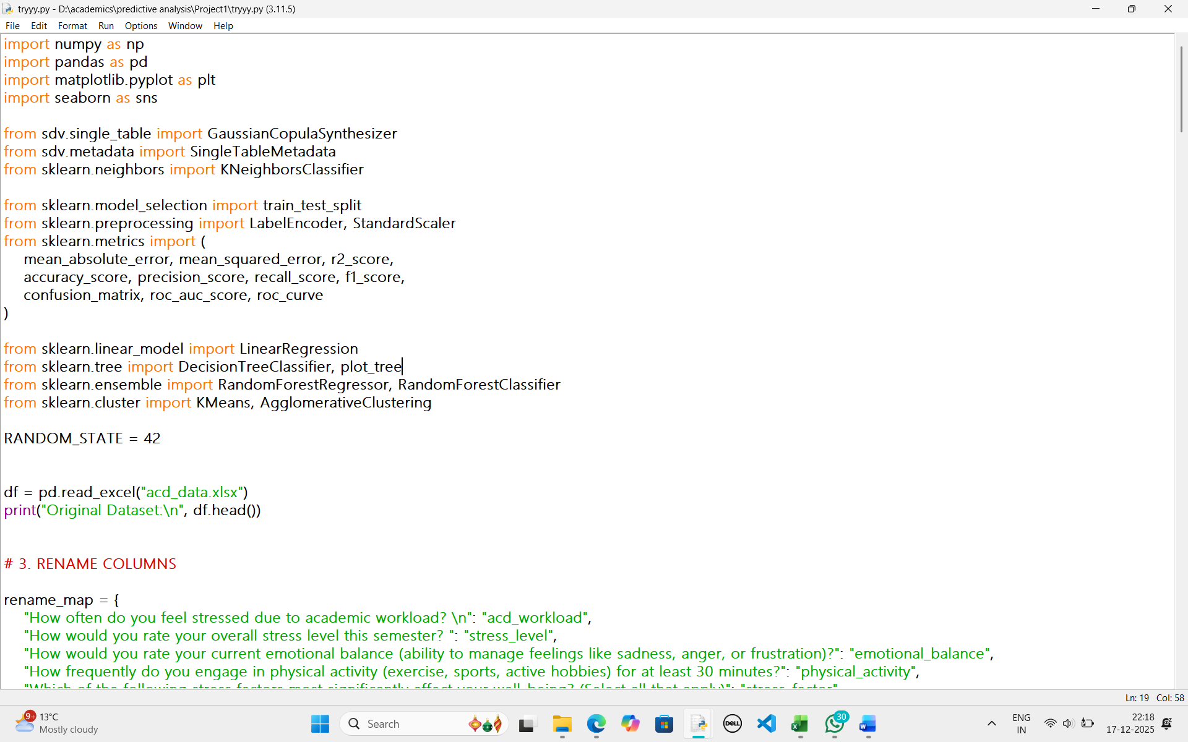


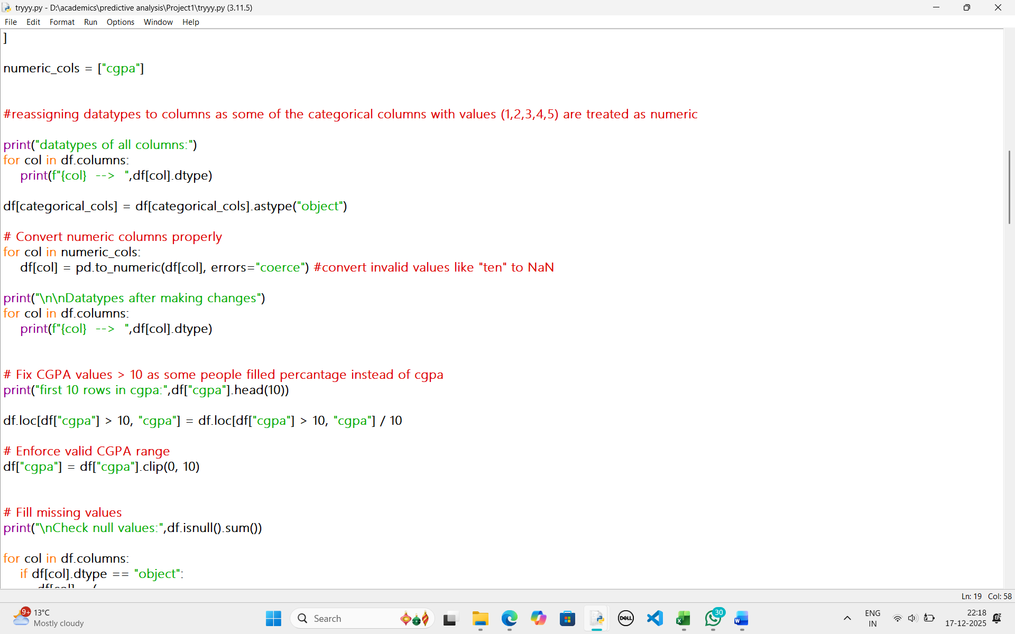
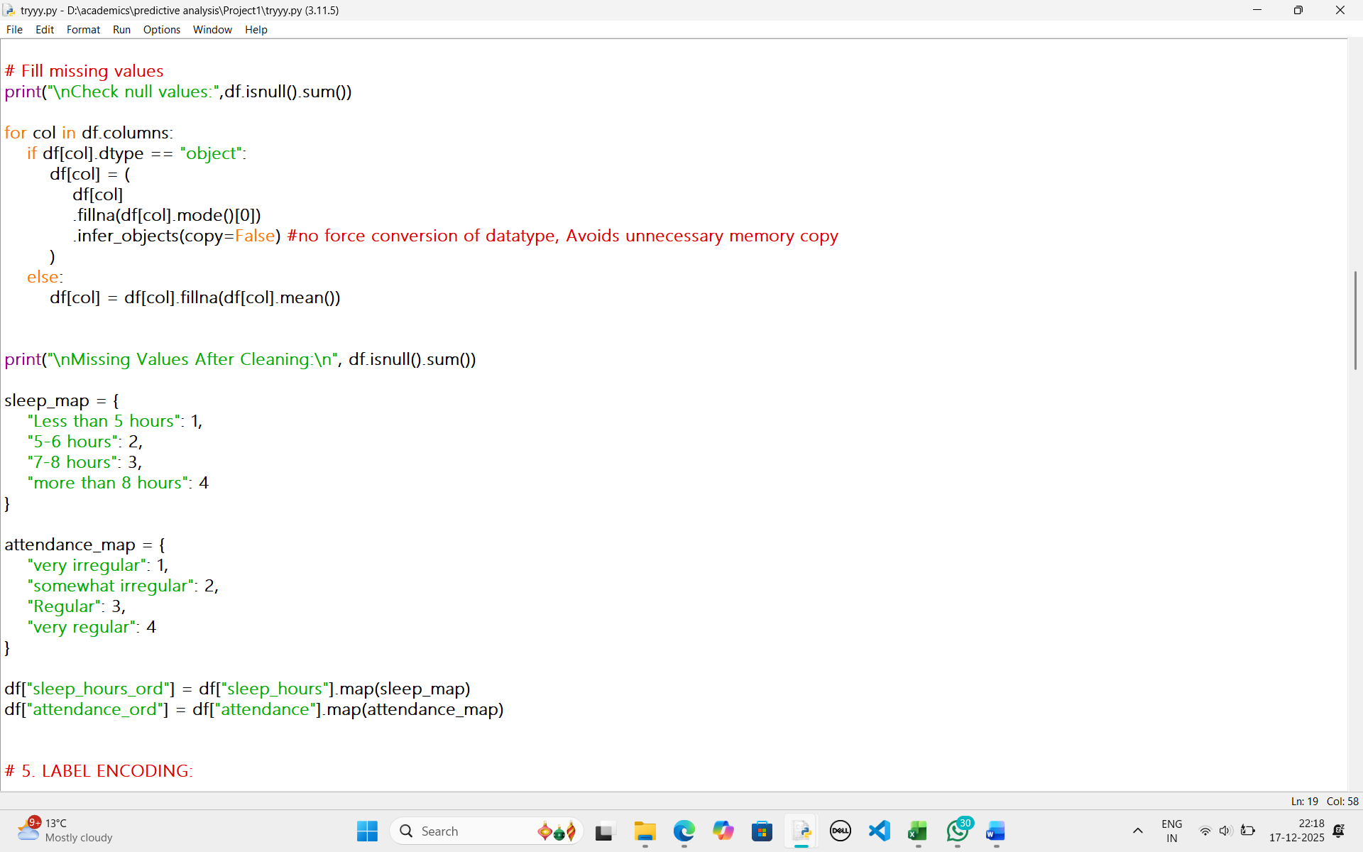

5. Synthetic Data Generation Using SDV
One of the major challenges of survey-based research is limited sample size, which can lead to unreliable model performance and overfitting. To overcome this limitation, the project employed synthetic data generation using the Gaussian Copula Synthesizer from the SDV (Synthetic Data Vault) library.
5.1 Synthetic Data Generation Process
- Metadata describing column types and relationships was automatically inferred from the cleaned dataset.
- The Gaussian Copula model learned the joint probability distribution among all variables.
- A synthetic dataset consisting of 5,000 records was generated.

5.2 Benefits of Synthetic Data
- Preserves statistical distributions and correlations present in the original data.
- Enhances model stability and generalization.
- Ensures privacy by avoiding direct use of real student records.
The synthetic dataset enabled robust experimentation without compromising ethical or privacy concerns.
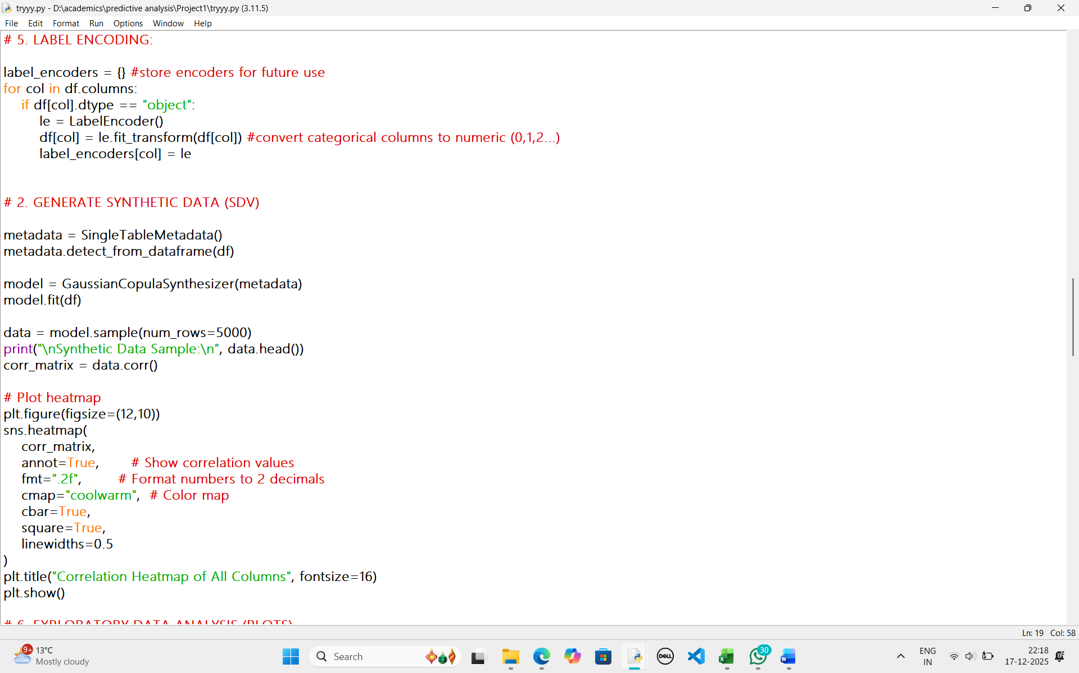

6. Exploratory Data Analysis (EDA)
Exploratory Data Analysis was conducted to gain insights into data distributions, trends, and relationships before model training.
6.1 Descriptive Statistics
- The average CGPA in the synthetic dataset was approximately 7.5, indicating moderate academic performance.
- Stress levels and emotional balance showed reasonable variance, suggesting diversity in student experiences.

6.2 Distribution Analysis
- Histograms were used for numerical variables such as CGPA.
- Count plots were used for categorical variables.
The distributions appeared balanced overall, with no severe class imbalance, making the dataset suitable for both supervised and unsupervised learning.

6.3 Correlation Analysis
A correlation heatmap was generated to examine linear relationships among variables. The analysis revealed:
- Very weak linear correlations between most survey features.
- CGPA showed minimal correlation with individual predictors.
This finding explains the difficulty in achieving high predictive accuracy and highlights the complex, multifactorial nature of academic performance.
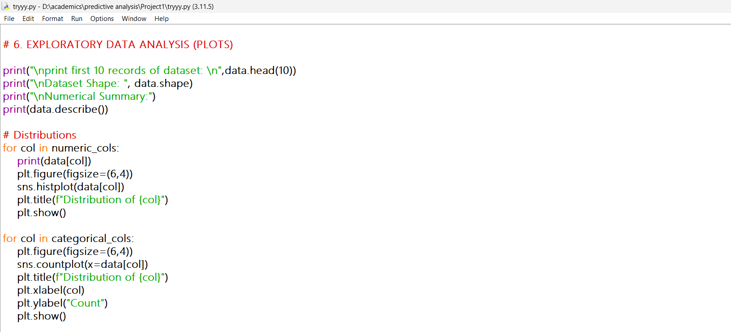

7. Regression Analysis
7.1 Linear Regression for CGPA Prediction
A Linear Regression model was trained using performance satisfaction as the predictor and CGPA as the target variable.
Results
- MAE ≈ 1.04
- RMSE ≈ 1.33
- R² ≈ −0.003
The negative R² value indicates that the model performs worse than predicting the mean CGPA, demonstrating that CGPA cannot be accurately predicted using a single survey-based feature. This highlights the presence of unobserved or latent factors influencing academic outcomes.

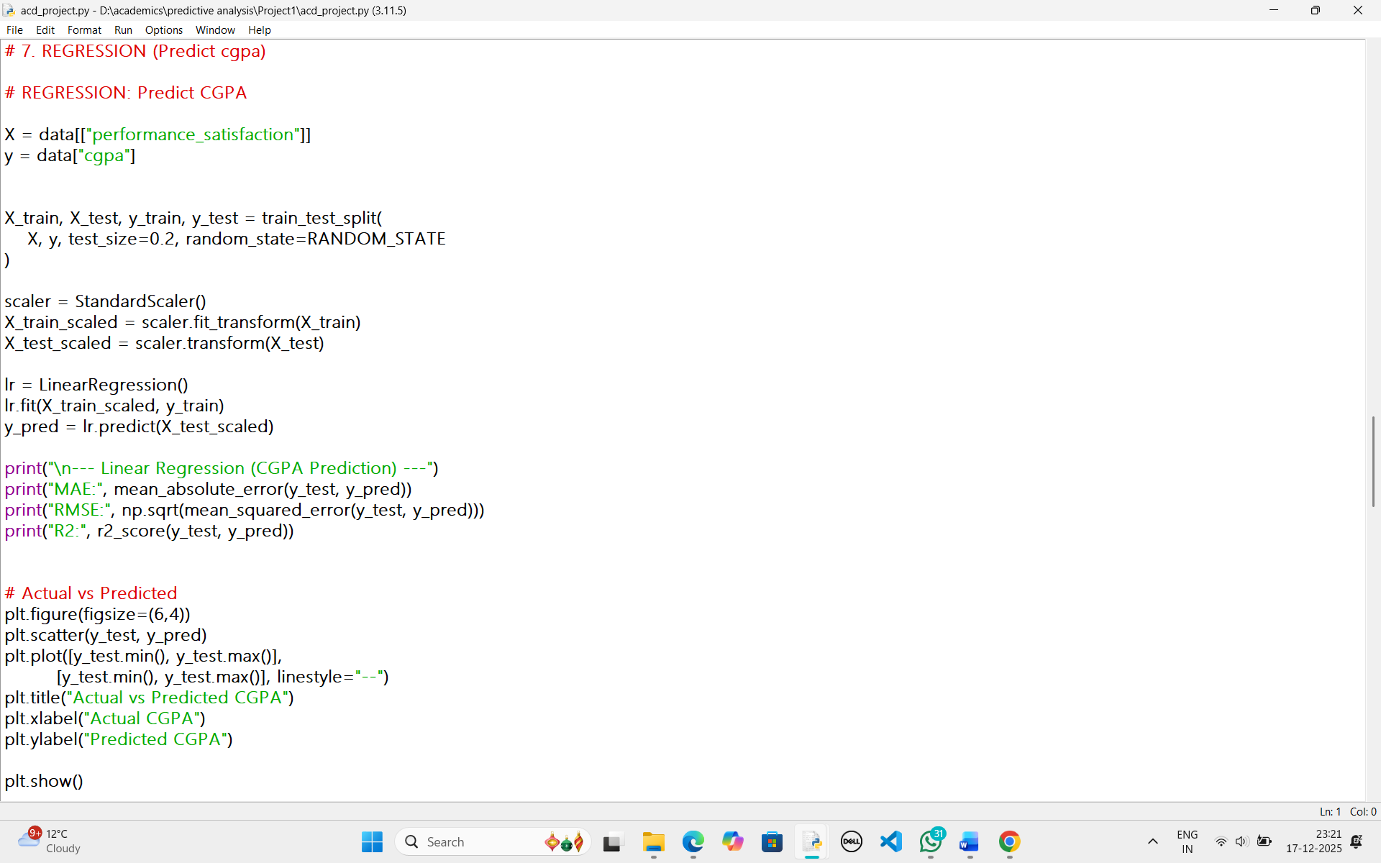

8. Classification Models
8.1 K-Nearest Neighbors (KNN)
KNN was applied to classify stress levels using all other features.
- Accuracy ≈ 50%
- Moderate recall but low precision for some classes
The overlapping nature of stress-related features reduced class separability, limiting classification performance.
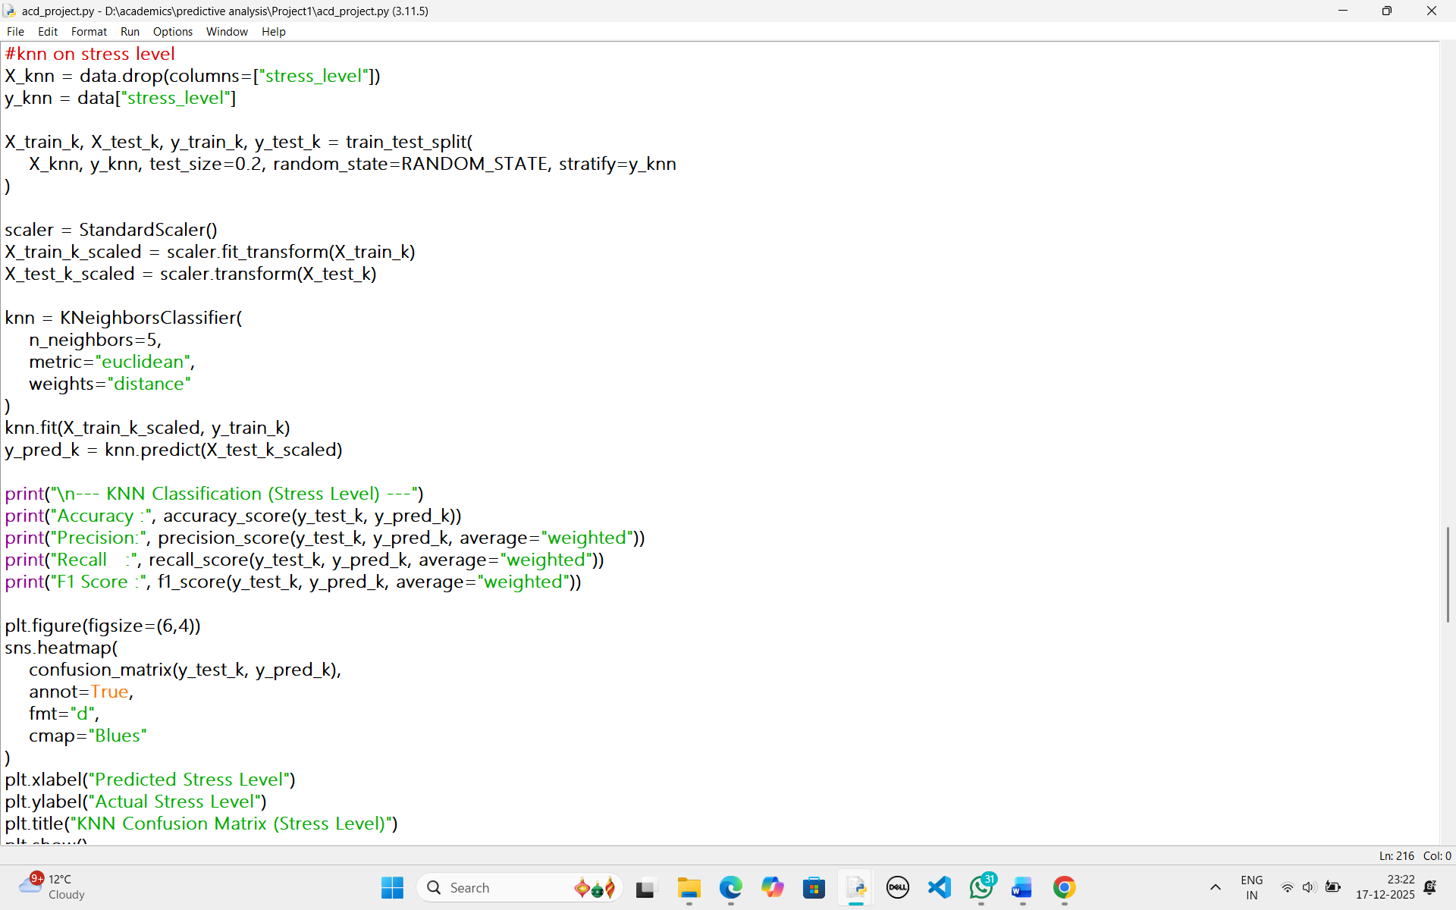

8.2 Decision Tree Classifier
A Decision Tree model was trained to classify emotional balance.
- Accuracy ≈ 25%
The model struggled due to weak feature splits and noisy patterns. Decision Trees are sensitive to such conditions and tend to underperform when strong decision boundaries do not exist.
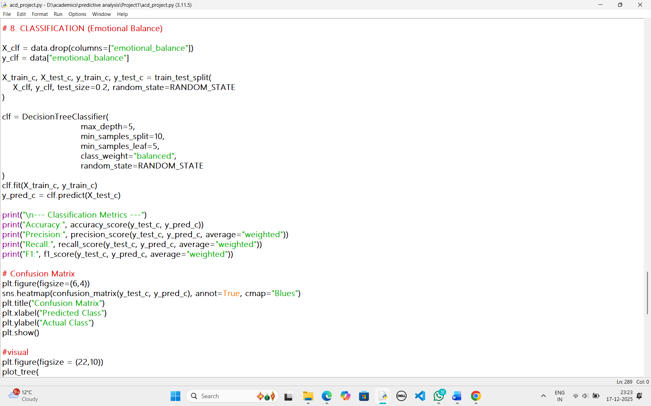

9. Clustering and Pattern Detection
9.1 K-Means Clustering
Clustering was performed using:
- CGPA
- Sleep hours (ordinal)
- Attendance (ordinal)
Three meaningful clusters were identified:
- High CGPA, good sleep, regular attendance
- Moderate CGPA with average habits
- Low CGPA, irregular sleep and attendance
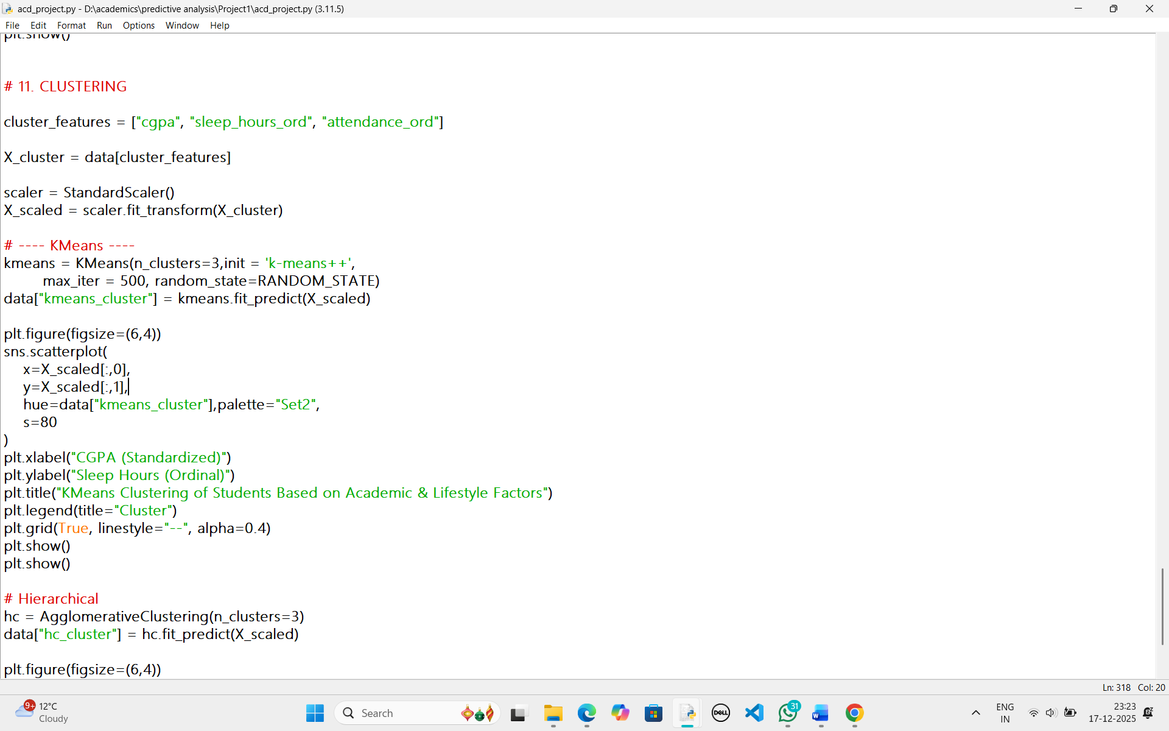
9.2 Hierarchical Clustering
Hierarchical clustering produced similar groupings, confirming the robustness of the K-Means results. This validation strengthens confidence in the identified patterns.
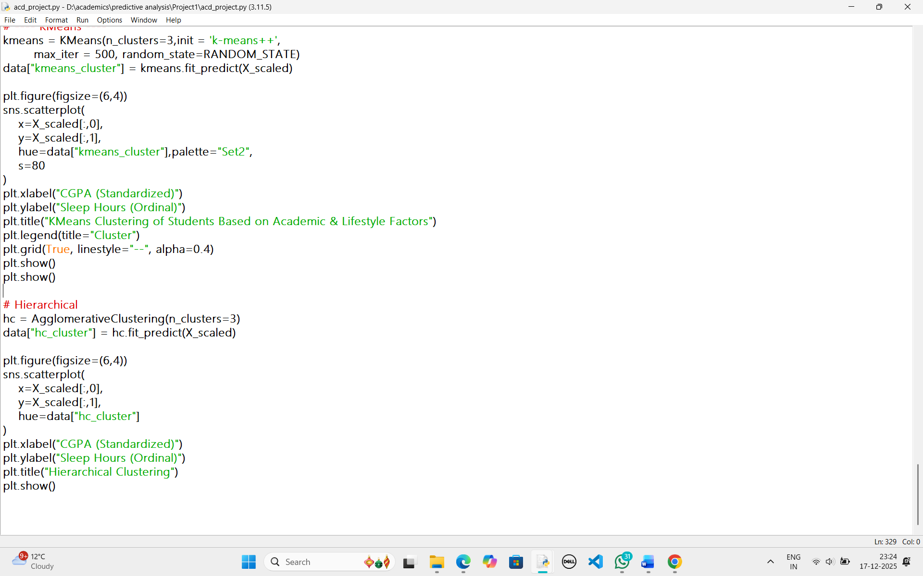
OUTPUT:

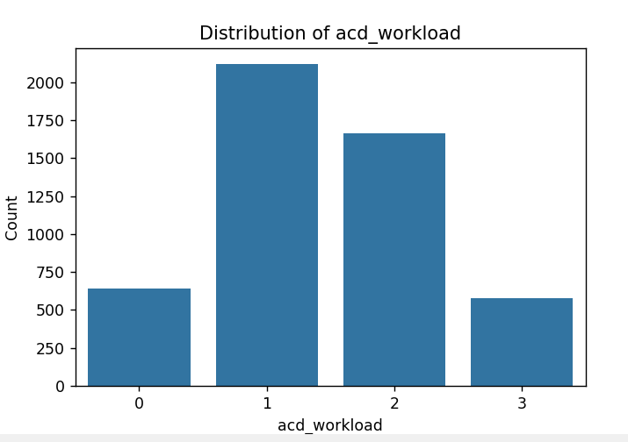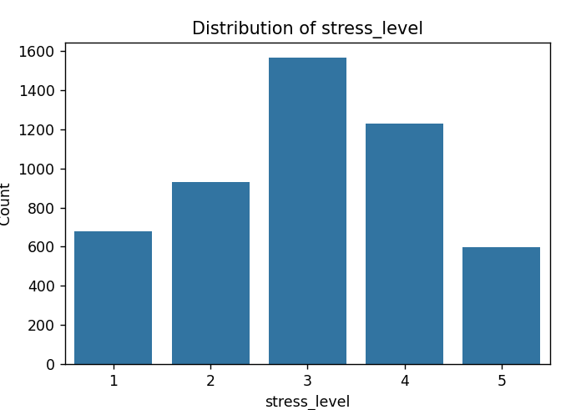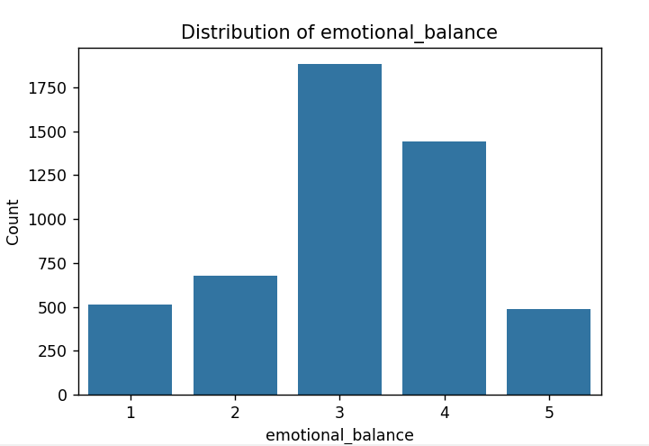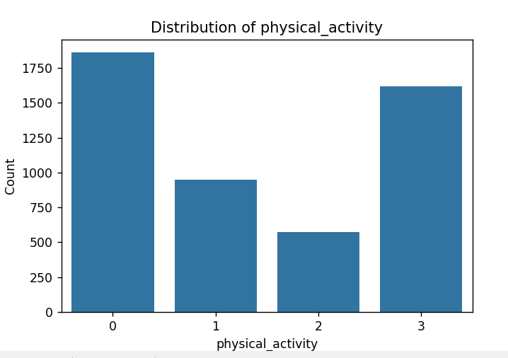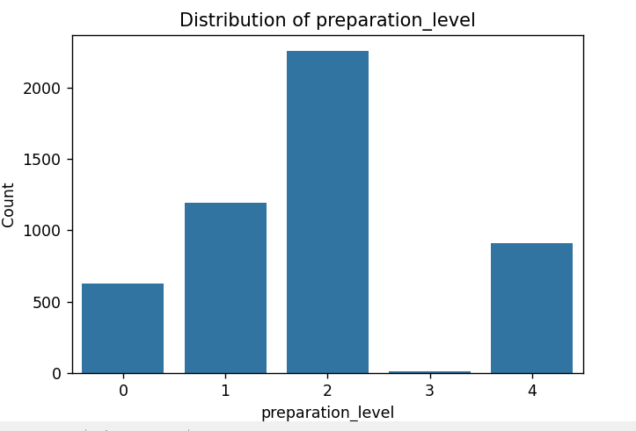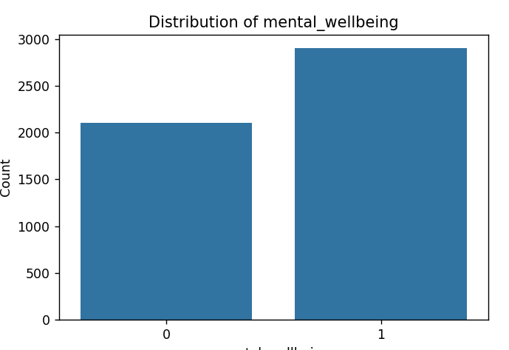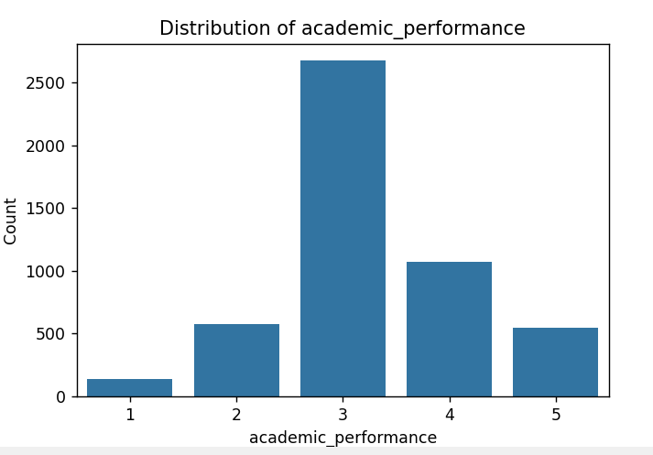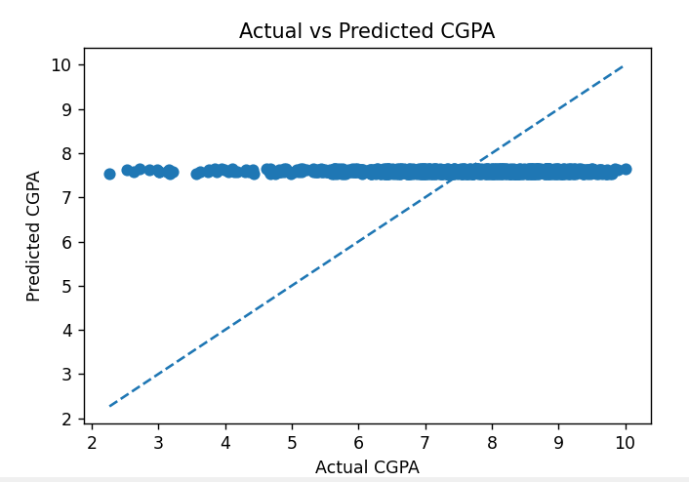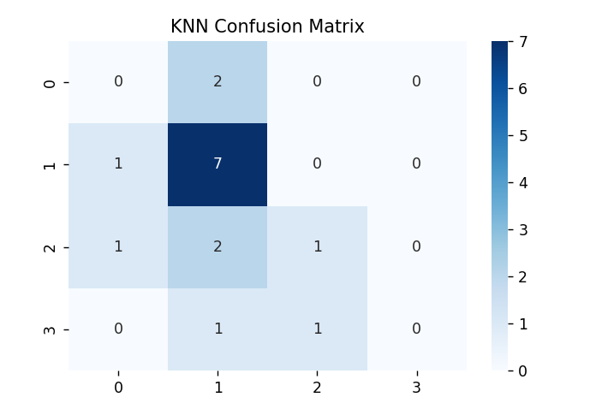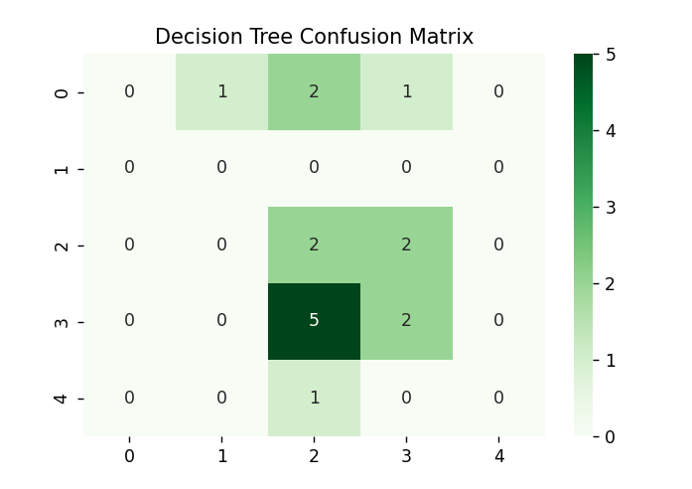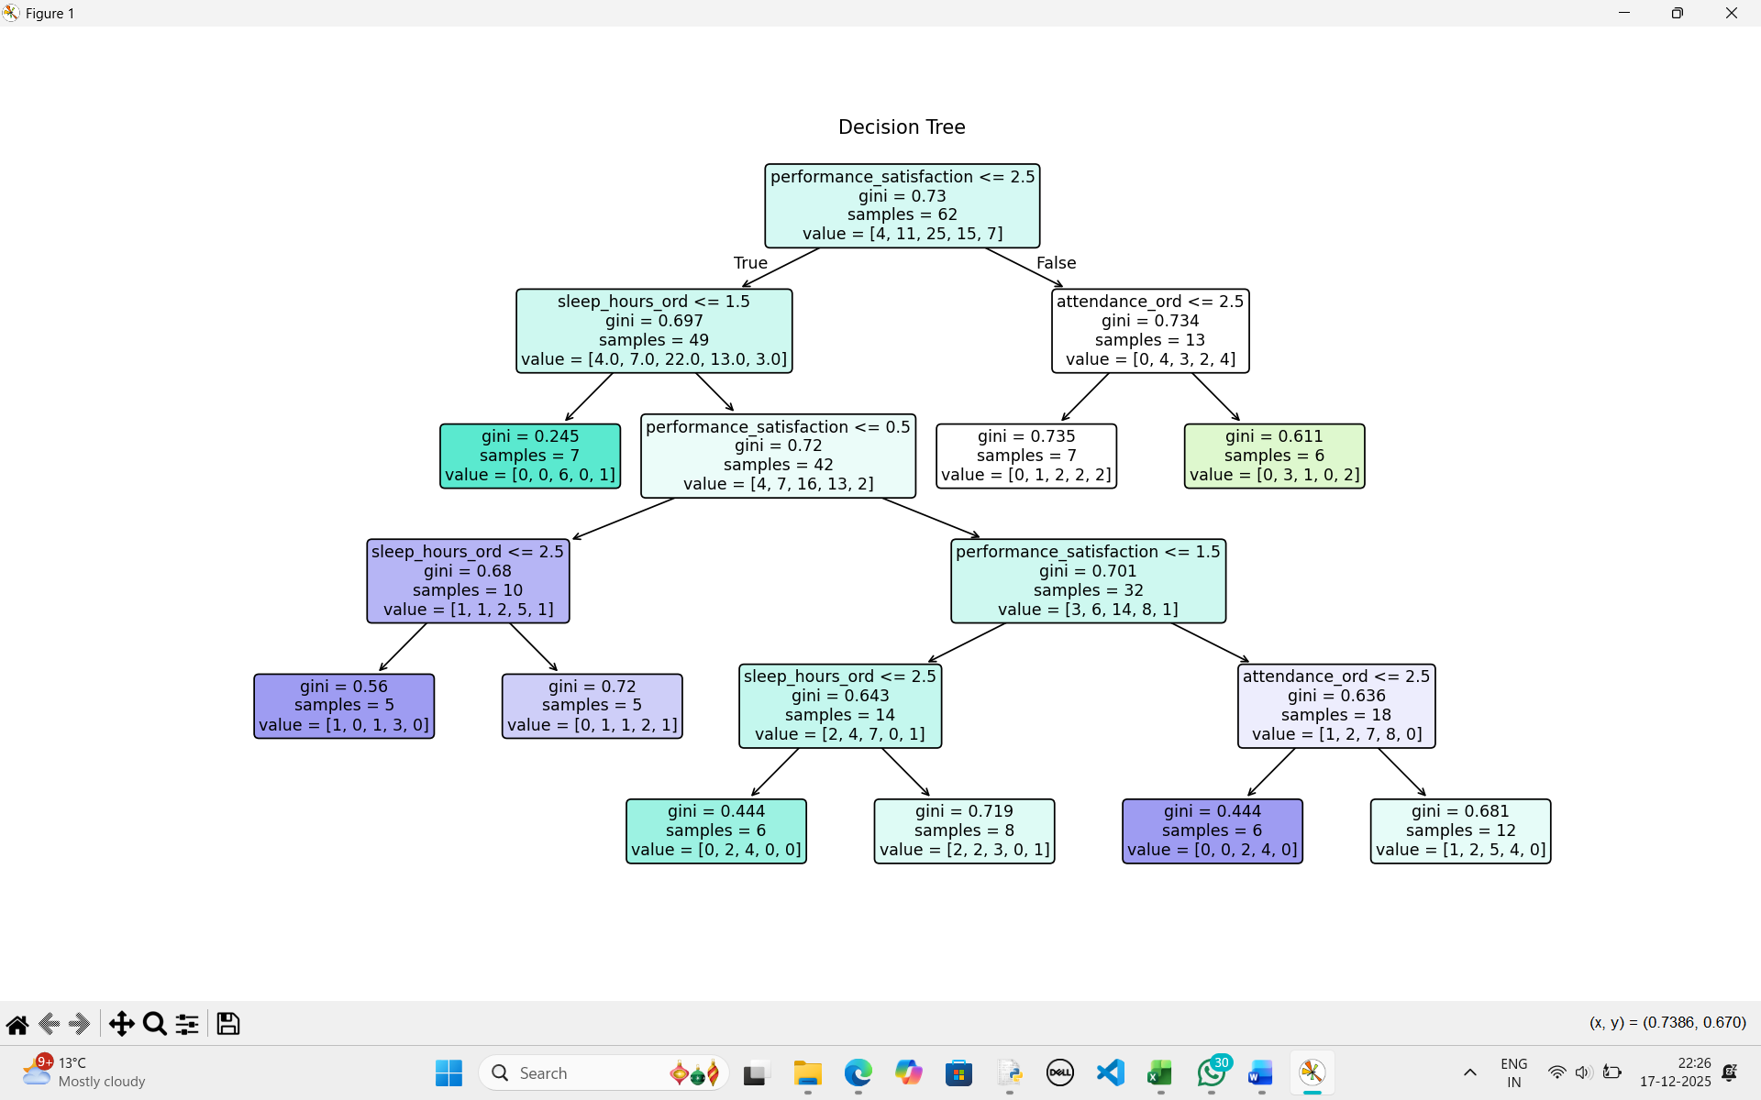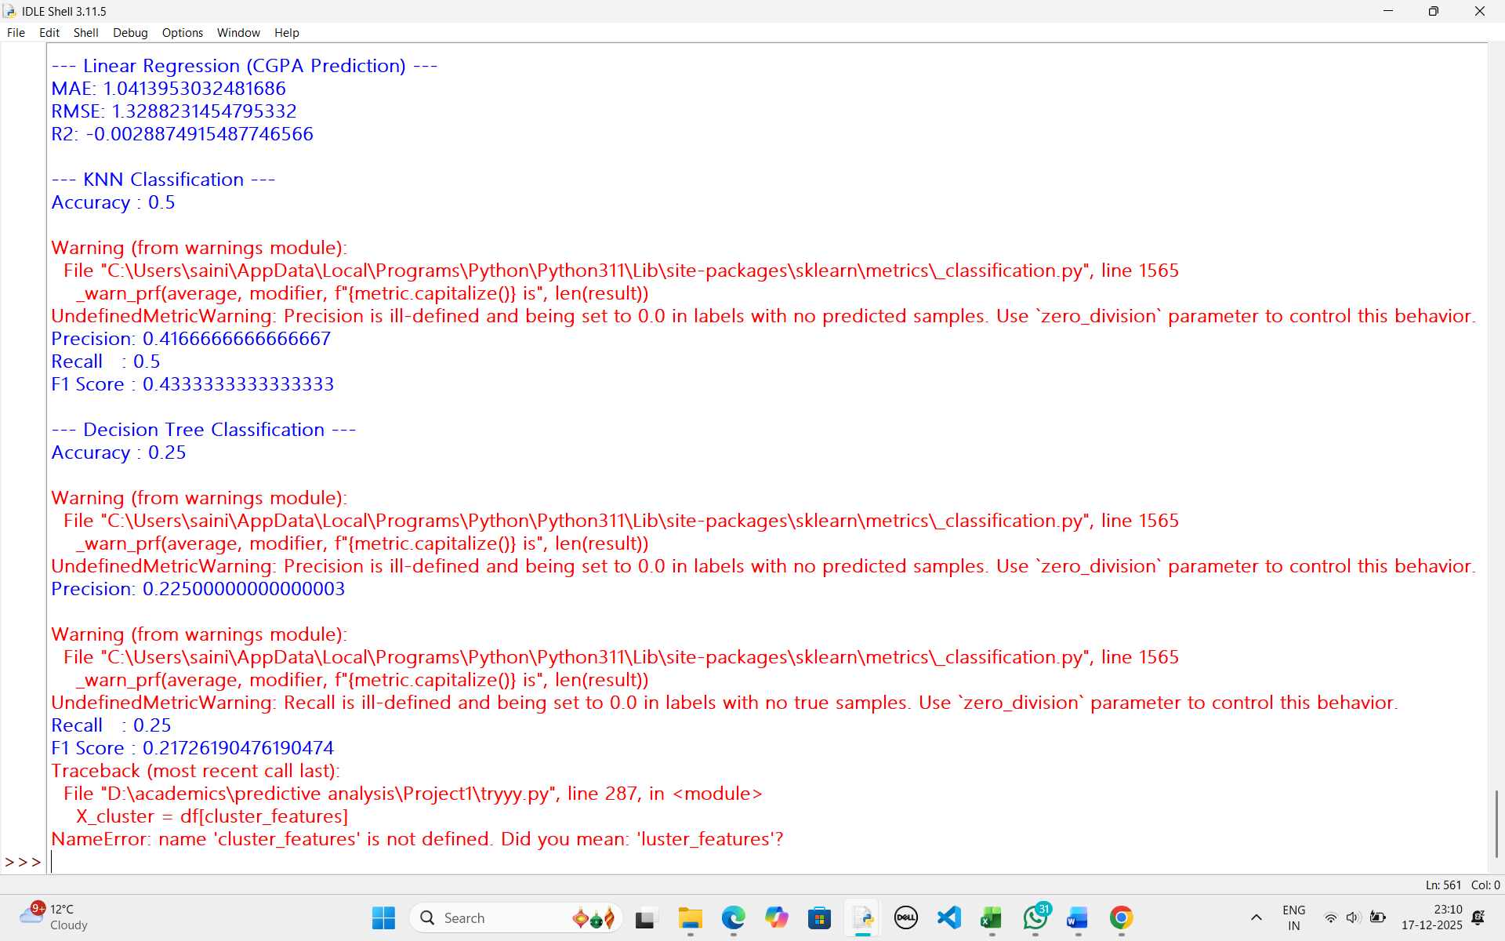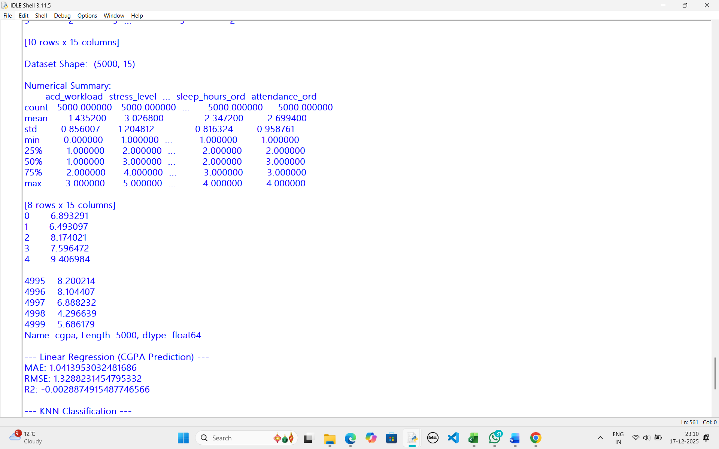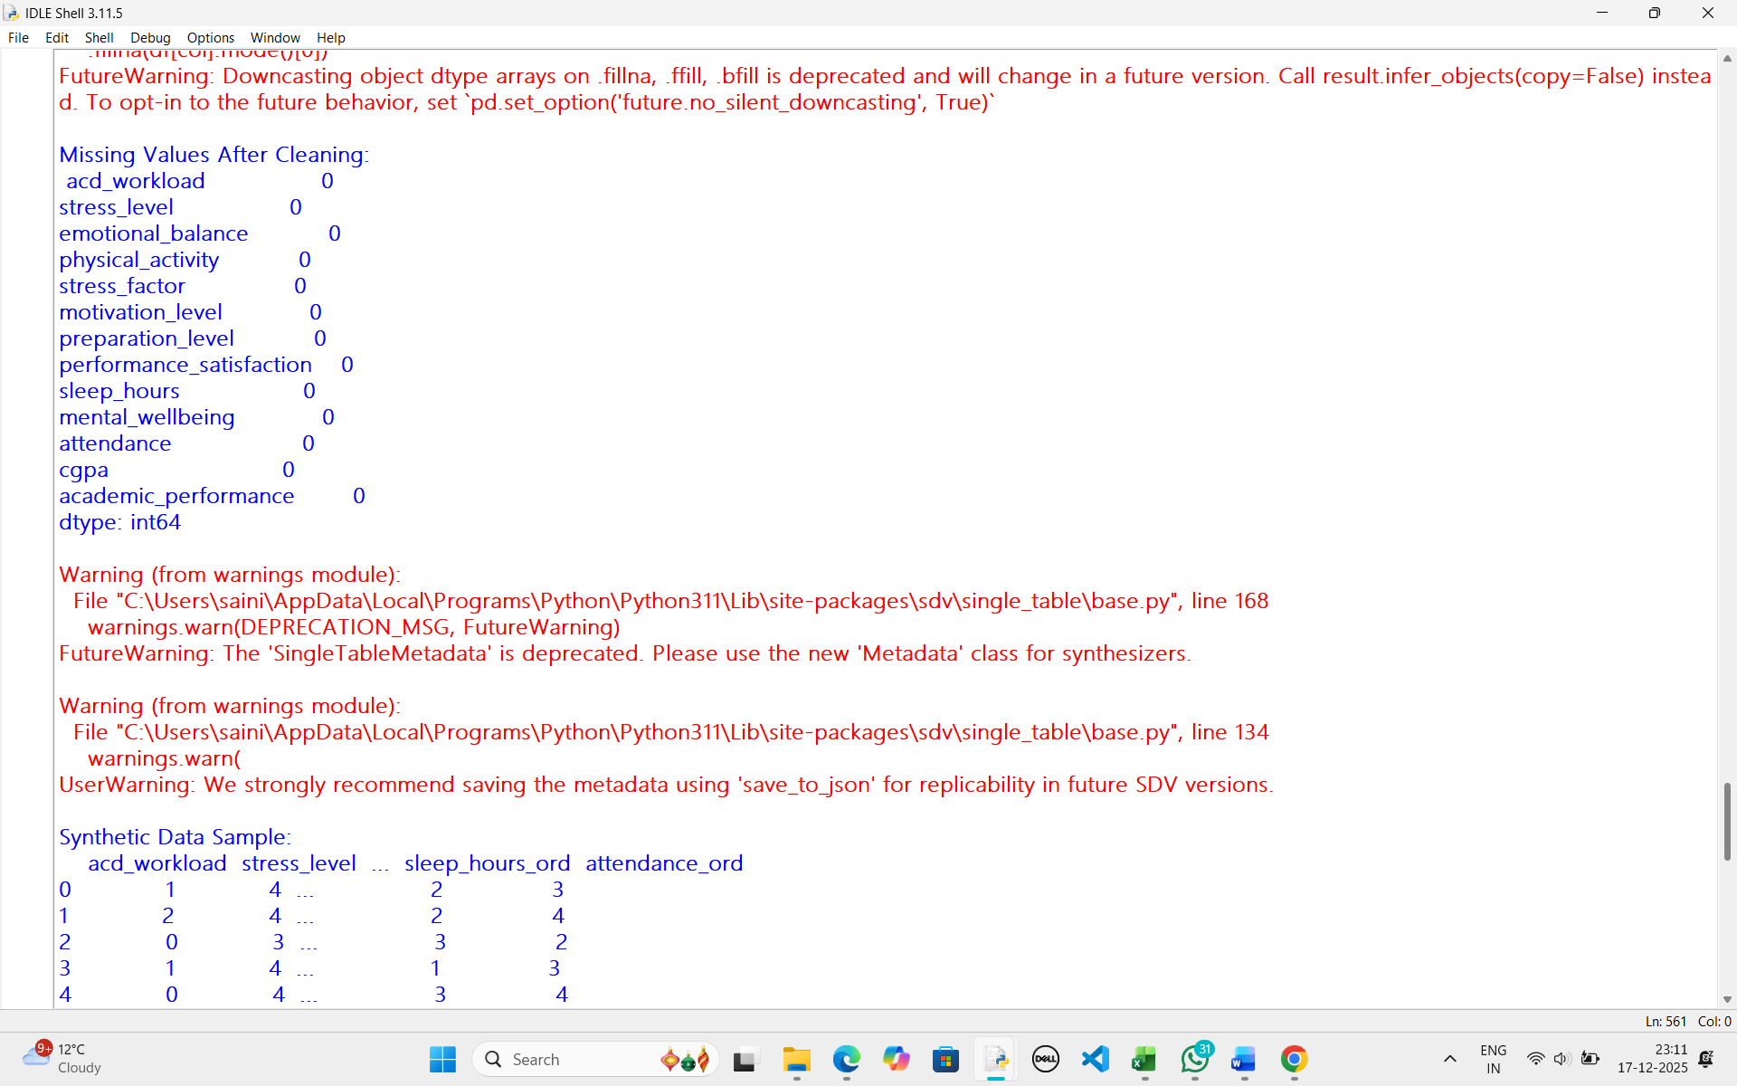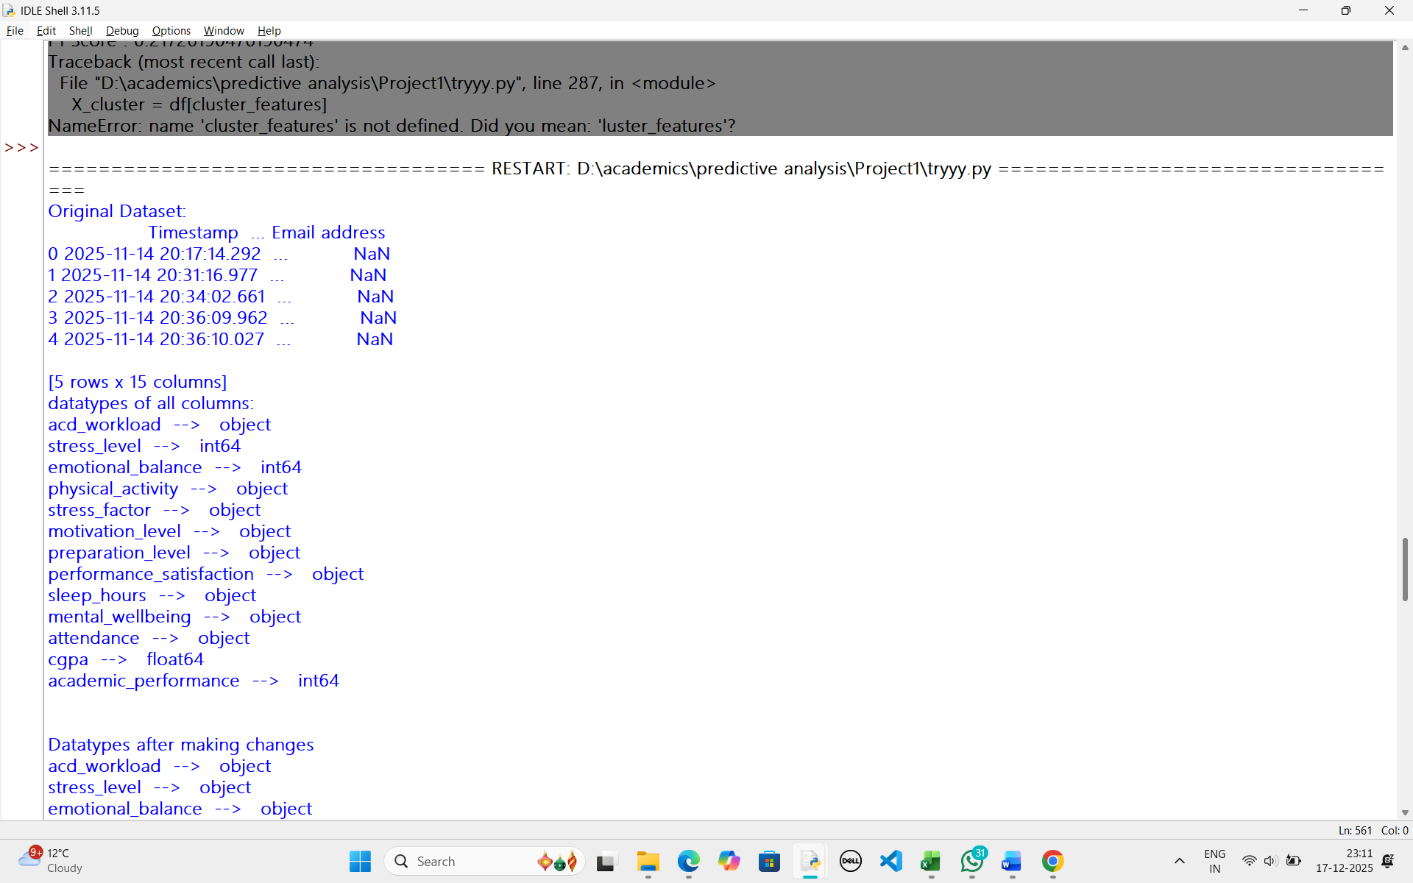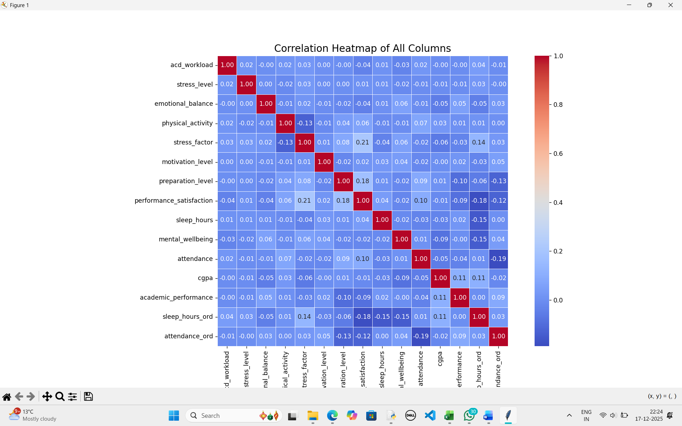

Links:
Linkedin:
https://www.linkedin.com/posts/khushdeep-saini-530767284_student-academic-mental-wellbeing-predictive-activity-7407101998015119360-7GeC?utm_source=social_share_send&utm_medium=member_desktop_web&rcm=ACoAAEUq7DQBwESCz88nm8XARLXwrtJSNPr4ahk

Github:
khushdeep200/Student-Academic-Mental-Well-being-Predictive-Analysis

Drive: https://drive.google.com/drive/folders/1fl1fxaNdPdUUPen4zuwflufTUnaF0UG0?usp=sharing

10. Results and Discussion
The results obtained from this study provide meaningful insights into the behavior of educational and mental well-being data when analyzed using machine learning techniques. One of the most prominent findings is that educational survey data exhibits weak linear and predictive relationships. Correlation analysis revealed that most features such as stress level, emotional balance, motivation, sleep habits, and attendance have only weak associations with academic performance indicators like CGPA. This explains the limited performance of regression and classification models and highlights the inherent complexity of educational data.
The use of synthetic data generation through the SDV framework significantly enhanced dataset size and statistical stability. By increasing the dataset to 5,000 records, the models benefited from reduced variance and more consistent training behavior. However, it is important to note that synthetic data does not introduce new information or causal relationships. Instead, it reproduces existing statistical dependencies present in the original dataset. Consequently, while robustness improved, predictive accuracy did not increase substantially, reaffirming that data quality and feature relevance are more critical than dataset size alone.
The supervised learning models, including Linear Regression, K-Nearest Neighbors (KNN), and Decision Tree classifiers, demonstrated limited predictive performance. Linear Regression produced a negative R² value, indicating that CGPA cannot be accurately predicted using isolated survey-based variables. KNN achieved moderate accuracy in stress level classification but struggled with precision across multiple classes, suggesting overlapping feature patterns among students experiencing different stress levels. Decision Tree classification performed poorly due to weak and noisy feature splits, further emphasizing the difficulty of modeling subjective psychological attributes.
In contrast, unsupervised learning techniques produced the most insightful outcomes. K-Means clustering successfully identified distinct student groups based on academic performance, sleep habits, and attendance. These clusters aligned well with real-world academic behavior patterns, such as high-performing students exhibiting better lifestyle discipline. Hierarchical clustering further validated these findings by producing similar grouping structures. The success of clustering highlights its suitability for educational analytics, where discovery of patterns and group segmentation is often more valuable than precise prediction.
Overall, the results demonstrate that machine learning models should be selected based on data characteristics rather than expectations of high accuracy. In the context of educational and psychological data, exploratory and unsupervised approaches often provide deeper and more actionable insights.

11. Limitations
Despite the successful implementation of an end-to-end machine learning pipeline, the study is subject to several important limitations that must be acknowledged.
First, the subjective nature of survey responses introduces unavoidable noise into the dataset. Psychological and self-assessed academic variables depend heavily on individual perception, mood, and interpretation of questions. As a result, two students with similar academic behavior may report very different stress or well-being levels, weakening measurable relationships.
Second, CGPA is influenced by numerous external academic and institutional factors that are not captured in the dataset. These include course difficulty, evaluation methods, grading policies, instructor effectiveness, and institutional standards. The absence of these variables significantly limits the ability of predictive models to accurately estimate academic performance.
Third, although synthetic data generation improved dataset size and model stability, synthetic data cannot create new causal signals. It merely amplifies existing statistical patterns. If the original dataset contains weak correlations, those weaknesses are preserved and potentially reinforced in the synthetic data. Therefore, synthetic data should be viewed as a tool for robustness rather than a substitute for richer feature sets.
These limitations highlight that the challenges encountered in this project stem primarily from data characteristics rather than modeling deficiencies.

12. Future Scope
The scope for extending this project is substantial, and several improvements can be made to enhance analytical depth and predictive power.
One important direction is the integration of longitudinal student data. Tracking students over multiple semesters would allow time-series analysis and enable the detection of trends, causal effects, and changes in academic performance and mental well-being.
Another valuable enhancement is the inclusion of academic logs and behavioral metrics, such as attendance records, assignment submissions, learning management system activity, and examination performance. These objective measures can complement subjective survey data and strengthen predictive relationships.
Future work may also explore ensemble learning models such as Random Forests, Gradient Boosting, and, combined with feature selection techniques to identify the most informative predictors. These approaches may capture nonlinear interactions more effectively than single models.
Additionally, the application of Explainable AI (XAI) techniques such as SHAP and LIME can improve interpretability and transparency. These methods would help identify feature importance and explain model decisions, making the analysis more useful for academic administrators and policy makers.

13. Conclusion
This project presents a comprehensive and well-structured end-to-end machine learning pipeline for analyzing student academic performance and mental well-being using survey data. The workflow encompassed data preprocessing, feature engineering, synthetic data generation, exploratory analysis, supervised learning, and unsupervised clustering.
While high predictive accuracy was not achieved, the outcomes are realistic, transparent, and academically sound. The results demonstrate that educational survey data often lacks strong predictive signals, making direct prediction challenging. However, the project successfully shows that clustering and exploratory data analysis provide meaningful and actionable insights, particularly in identifying student groups and behavioral patterns.
Ultimately, this study reinforces the idea that success in educational data science should not be measured solely by model accuracy, but by the quality of insights generated and their relevance to real-world academic decision-making. The project establishes a strong foundation for future research and practical applications in student analytics and educational policy development.

