R code

**Steps:-**

1. First the data is chosen or read in the system using a built in function.

> library(MASS)

> datamining<-read.csv(choose.files(),header=TRUE)

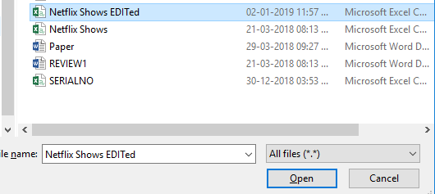

2. The N/A values that are in the data are omitted.

> datamining[datamining=='NA']<-NA

> datamining<-na.omit(datamining)

3. Creating the model

> model<-lm(ratingDescription~user.rating.size+user.rating.score,data=datamining)

> print(model)

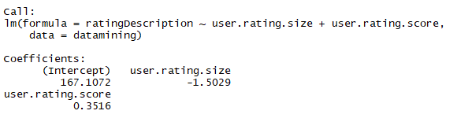

4. Finding the coefficients

> Xsize<-coef(model)[2]

> Xrating<-coef(model)[3]

> Xintercept<-coef(model)[1]

> print(Xsize)

user.rating.size

-1.50289

> print(Xrating)

user.rating.score

0.351638

> print(Xintercept)

(Intercept)

167.1072

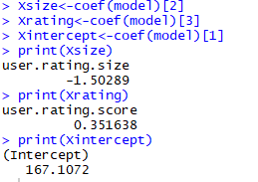

5. Assigning values

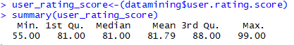

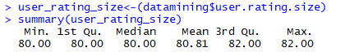

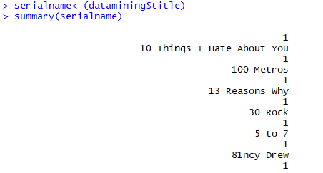

6. Applying the equation of Regression Model for predicting New Values



### 7. Defining Classes

**Class A:(Y value between 0 to 74.99)**: if the linear regression model

Y=Xintercept+Xsize*user_rating_score[1]+Xrating*user_rating_size[1]

Having value between 0 to 74.99 then it comes under class A . which means web serials which comes under this category is less popular among viewer .

**Class B:(Y value between 75 to 79.99)**: if the linear regression model

Y=Xintercept+Xsize*user_rating_score[1]+Xrating*user_rating_size[1]

Having value between 75 to 79.99 then it comes under class B . which means web serials which comes under this category is hit serials but not extremely popular among viewer .

**Class C:(Y values more then 80 )**: if the linear regression model

Y=Xintercept+Xsize*user_rating_score[1]+Xrating*user_rating_size[1]

Having value more then 80 then it comes under class c . which means web serials which comes under this category is extremely popular among viewer .

**5. CODE**

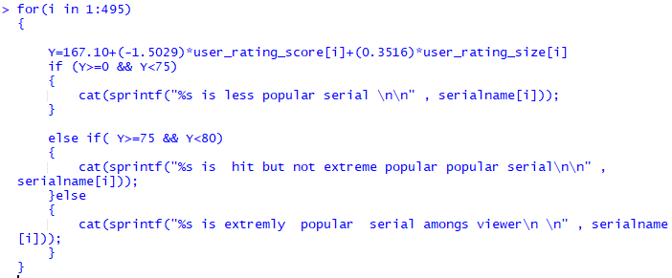

### 6. RESULTS AND DISCUSSIONS

### 6.2. Output

### For the Regression Model:

### 

**Showing the popularity of various shows**

