Sentimental Analysis

#  Install Requried Packages

install.packages("SnowballC")

install.packages("tm") (used for text mining)

install.packages("twitteR")

install.packages("syuzhet") (contains 4 sentiment dictionaries)

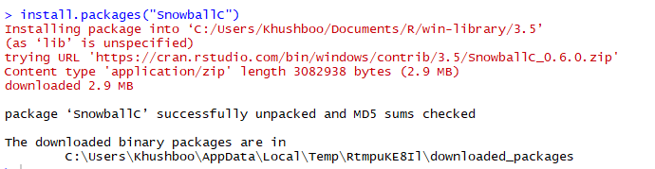

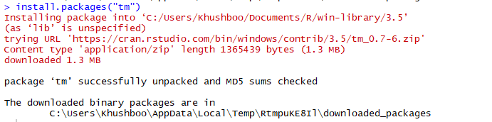

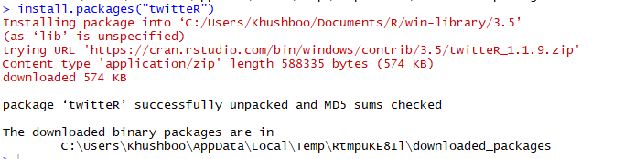

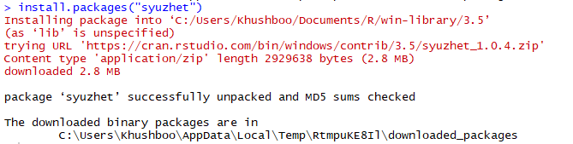

# Load Requried Packages

library("SnowballC")

library("tm")

library("twitteR")

library("syuzhet")

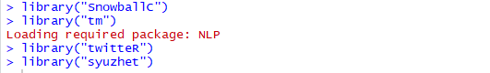

library(MASS)

#Choosing the netflix shows csv file

datamining<-read.csv(choose.files(),header=TRUE)

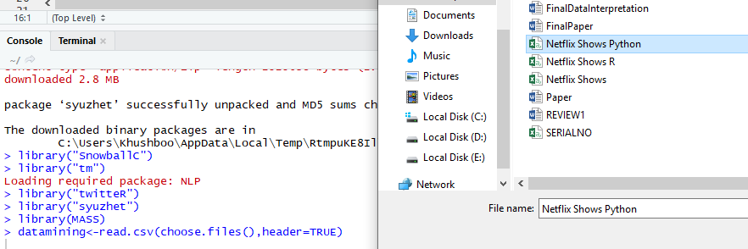

#Head means top 6 rows

head(datamining$ratingLevel)

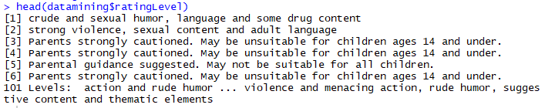

#this is calculate something please check internet

word.df <- as.vector(datamining$ratingLevel)

emotion.df <- get_nrc_sentiment(word.df)

emotion.df2 <- cbind(datamining$ratingLevel, emotion.df)

head(emotion.df2)

sent.value <- get_sentiment(word.df)

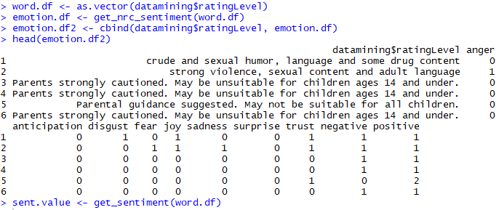

#calculating most positive accoding to the vaue

most.positive <- word.df[sent.value == max(sent.value)]

most.positive

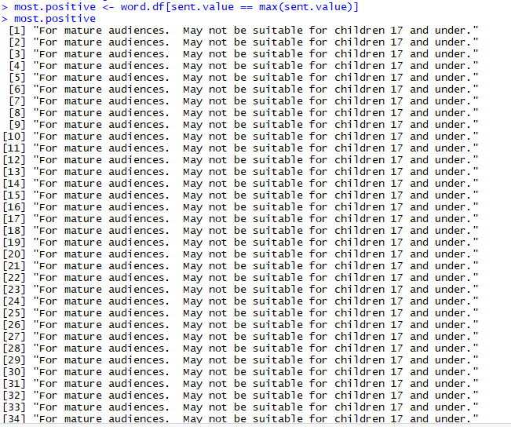

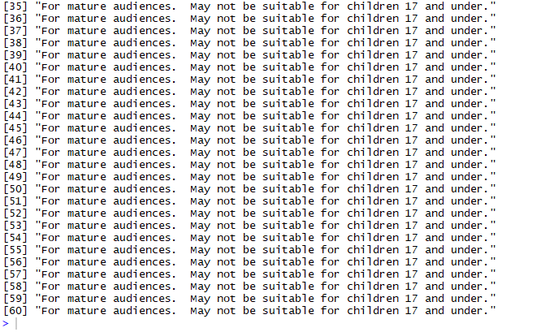

most.negative <- word.df[sent.value <= min(sent.value)]

most.negative



positive.review <- word.df[sent.value > 1]

head(positive.review)

positive.review

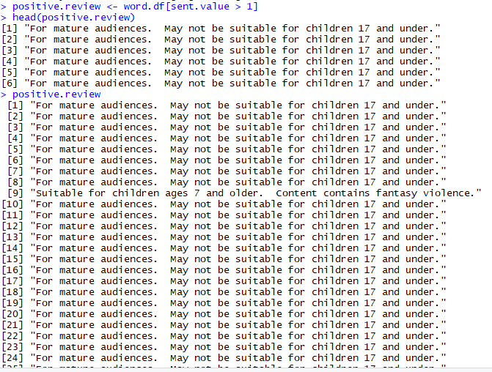

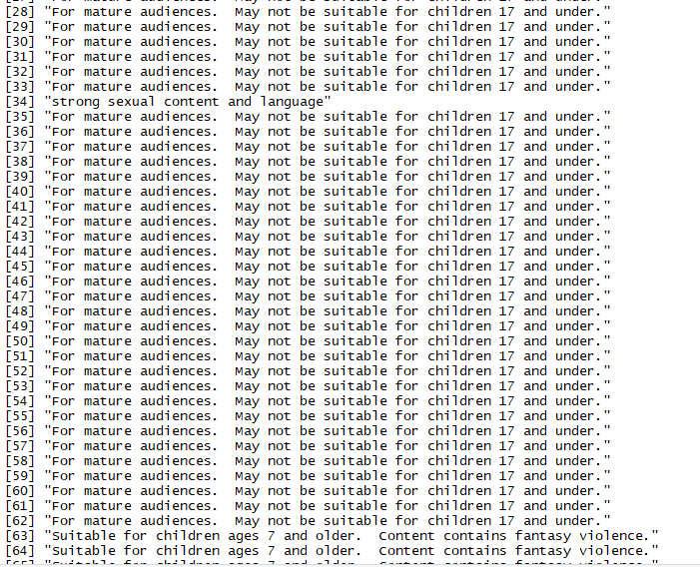

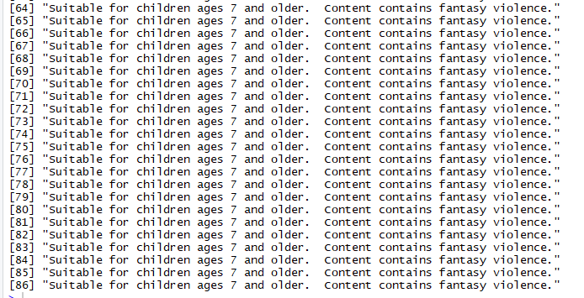

negative.review <- word.df[sent.value < 0]

head(negative.review)

negative.review

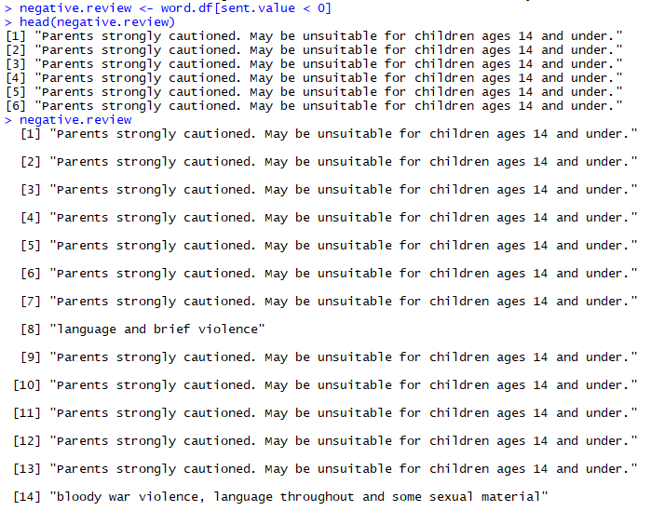

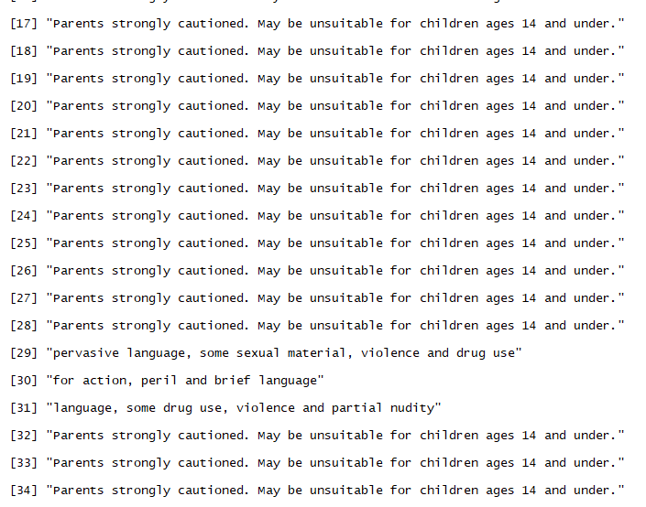

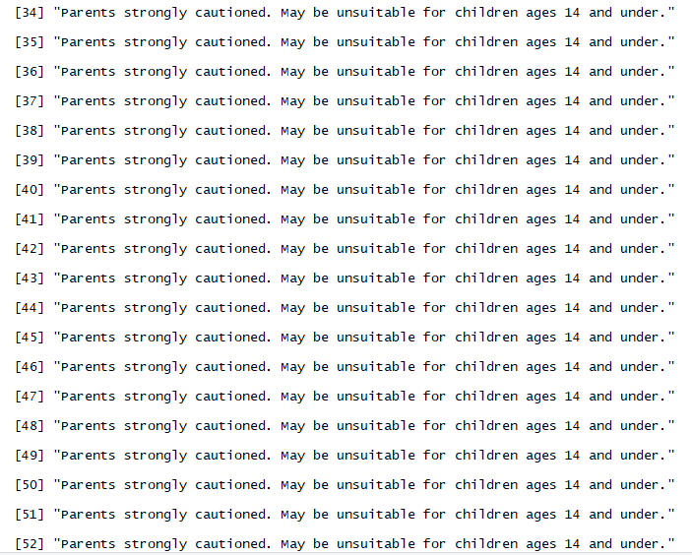

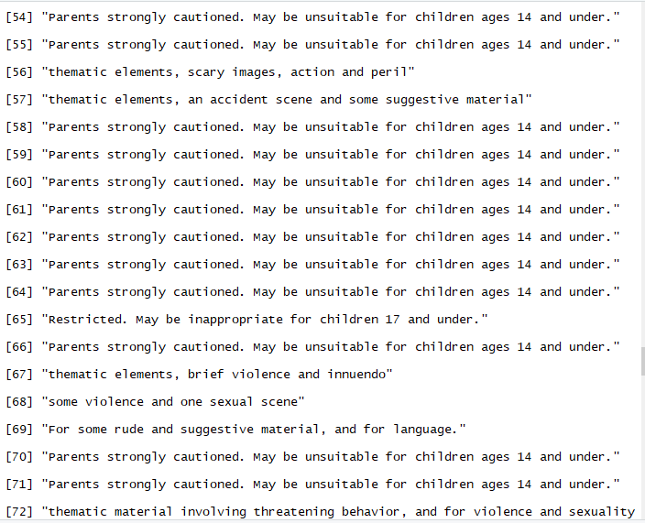

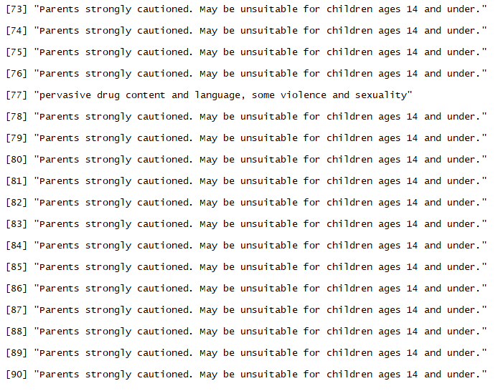

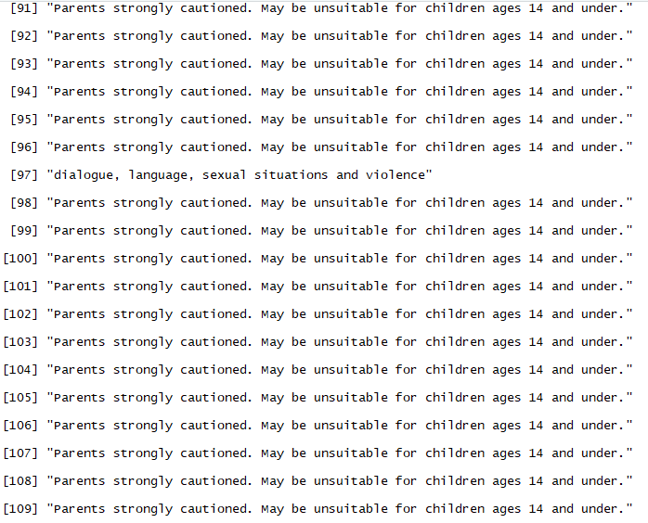

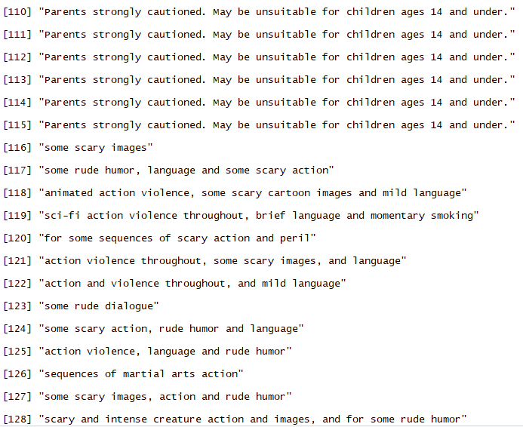

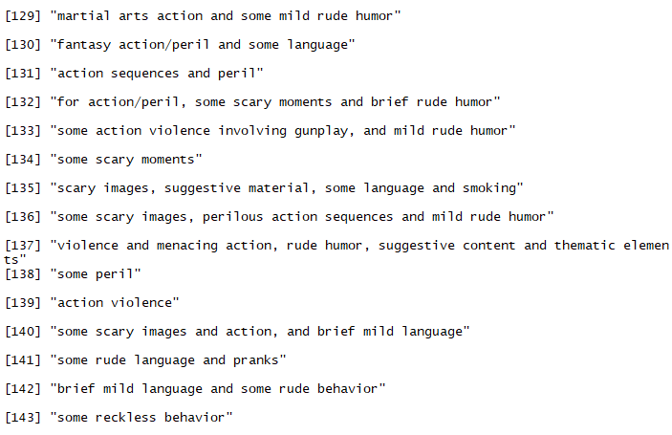

neutral.review <- word.df[sent.value == 0]

head(neutral.review)



# Alternate way to classify as Positive, Negative or Neutral reviews

category_senti <- ifelse(sent.value < 1, "Negative", ifelse(sent.value > 0, "Positive", "Neutral"))

head(category_senti)

category_senti

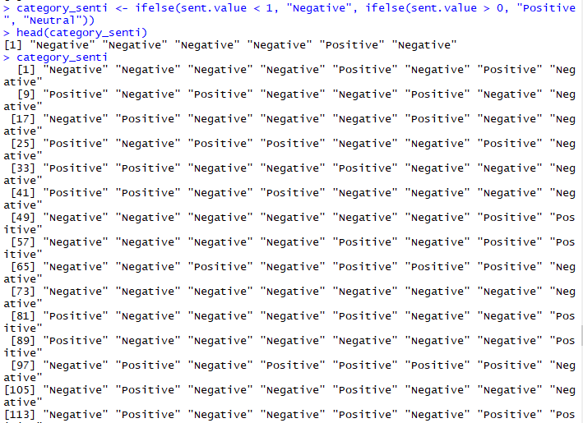

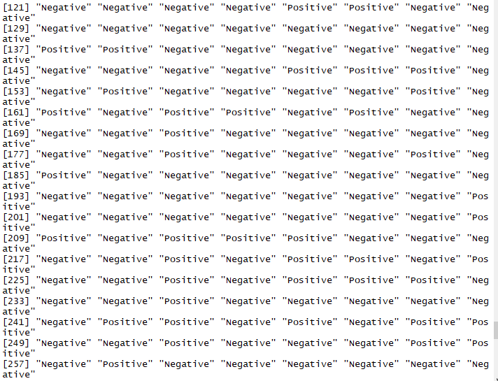

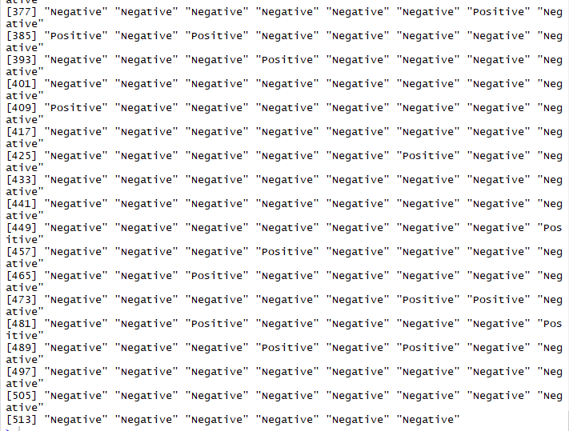

ratinglevel<-(datamining$ratingLevel)

category_senti2 <- cbind.data.frame(ratinglevel,category_senti,sent.value)

category_senti2

