Video Game Sales & Engagement Analytics Project Report

1. Project Topic
The project aims to analyze and visualize video game sales and engagement data to uncover trends in game popularity, user behavior, and platform performance. By merging sales and engagement data, we seek to offer insights into how game features, platforms, and genres influence sales, wishlists, and ratings. SQL will be used to structure and store the data, while Power BI dashboards will be developed to guide decision-making for game developers, marketers, and publishers.

2. Introduction
The gaming industry is highly competitive and constantly evolving. A game’s success does not depend only on its release, but also on how players interact with it before and after launch. User engagement factors such as ratings, wishlist counts, number of plays, and reviews play a major role in shaping a game’s commercial performance. At the same time, platform availability (such as console or PC) and genre preferences strongly influence sales outcomes across different markets and regions.
Understanding how these factors connect to global sales is very important for strategic planning. Companies need to know which genres perform best, which platforms generate higher revenue, and whether strong user interest actually converts into sales. This project brings together cleaned game metadata and global sales data to study these relationships. By analyzing engagement patterns and financial performance together, the project aims to identify trends, highlight opportunities, and support better business decision-making in marketing, product development, and resource allocation.

3. Business Objectives
The primary objective of this study is to examine the relationship between video game attributes, user engagement metrics, and commercial performance in order to derive meaningful business insights. The specific objectives of the analysis are as follows:
- To evaluate overall global sales performance across different genres and platforms.
- To identify the genres and platforms that contribute most significantly to total revenue generation.
- To analyze the relationship between game ratings and commercial success.
- To assess the impact of wishlist volume and user engagement (plays, reviews) on sales outcomes.
- To investigate conversion efficiency by identifying games with high engagement but comparatively low sales performance.
- To measure revenue efficiency at the genre and platform levels (e.g., sales per title, sales per unit of demand).
- To examine the distribution of revenue across titles and determine whether sales are concentrated among a limited number of high-performing games.
- To identify underperforming segments that may present growth opportunities.
- To support strategic decision-making in marketing, product development, and resource allocation through data-driven insights.
- To develop interactive dashboards that facilitate ongoing performance monitoring and business analysis.

4. Project Approach
The project followed a structured analytics workflow:
1. Data Cleaning:
- Remove duplicates and handle null values in ratings, plays, and sales.
- Normalize genre, platform, and publisher names.
- Standardize formats for date and categorical fields.
2. SQL Database Setup:
- Create structured tables for game metadata, sales data, and merged information.
- Enforce foreign keys to maintain referential integrity.
3. Power BI Integration:
- Connect Power BI to the SQL database. ( USE ODBC CONNECTOR)
- Import relevant tables and create relationships.
- Build dynamic dashboards using filters, slicers, and drilldowns. (sales analysis, user engagement analysis, business insights and recommendations)

4. Data Visualization in Power BI: Create interactive reports that include:
- Bar charts: Top genres, publishers, and platforms.
- Heatmaps: Global sales and regional breakdowns.
- Line charts: Sales and wishlist trends over time.
- Scatter plots: Ratings vs. sales or wishlist.
- KPI indicators: Average rating, total plays, top-performing genres.
5. Exploratory Data Analysis (EDA): Use Python or Power BI to:
- Analyze ratings, plays, wishlists, and sales trends.
- Explore genre and platform popularity.
- Identify key success factors for high-selling games.

Dataset
- Dataset 1: games.csv
- Dataset 2 : vgsales.csv

4.1. Python Data Cleaning & Exploratory Data Analysis (EDA)
Data preprocessing was performed using Pandas and NumPy. Key steps included:
- Handling missing values
- Standardizing categorical variables
- Cleaning and exploding multi-genre entries
- Outlier detection
- Creating derived metrics
EDA included univariate, bivariate, and multivariate analysis using visualizations to understand distribution, correlation, and performance trends.
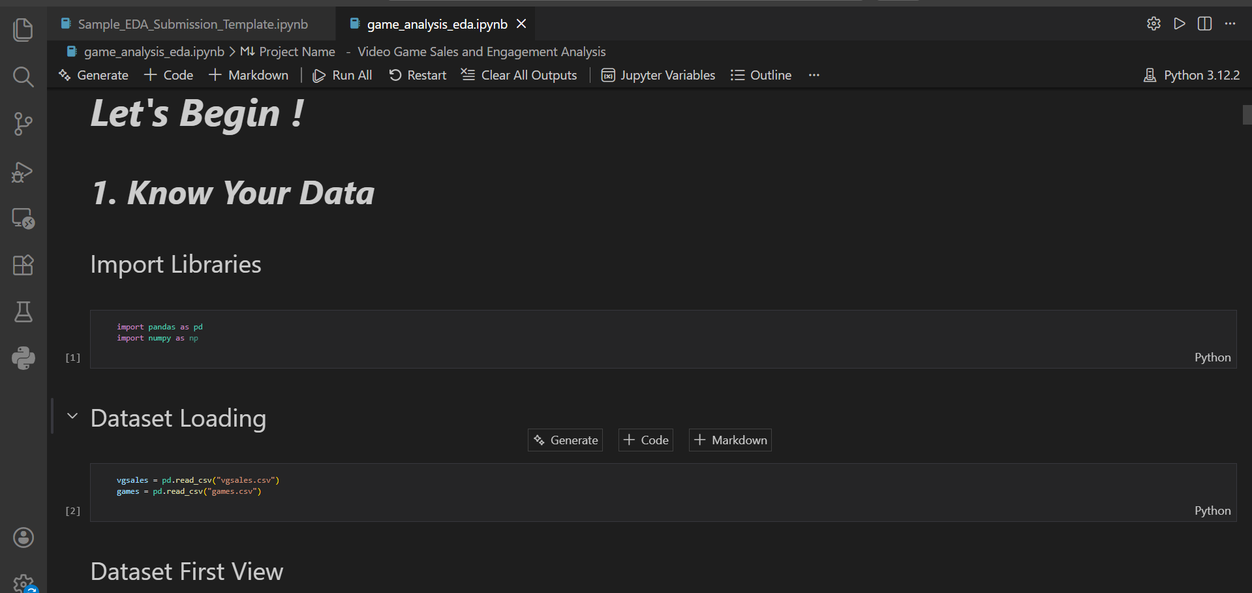
Fig1. Uploading both datasets in python
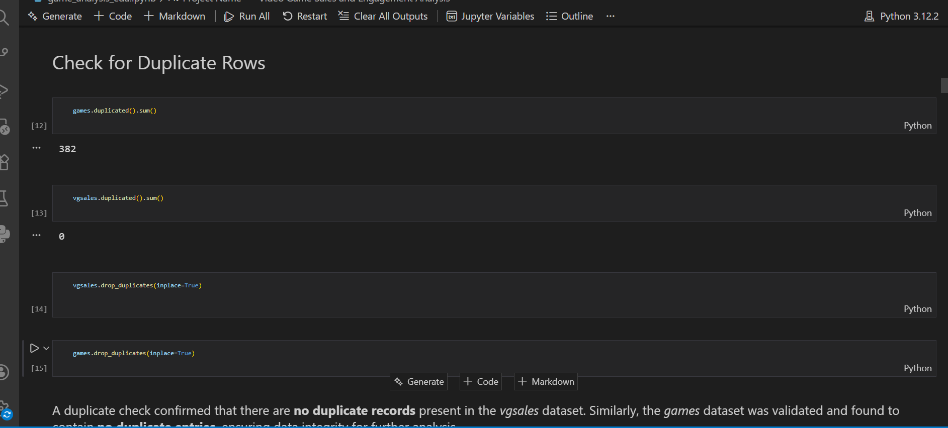
Fig2. Checking for duplicate values

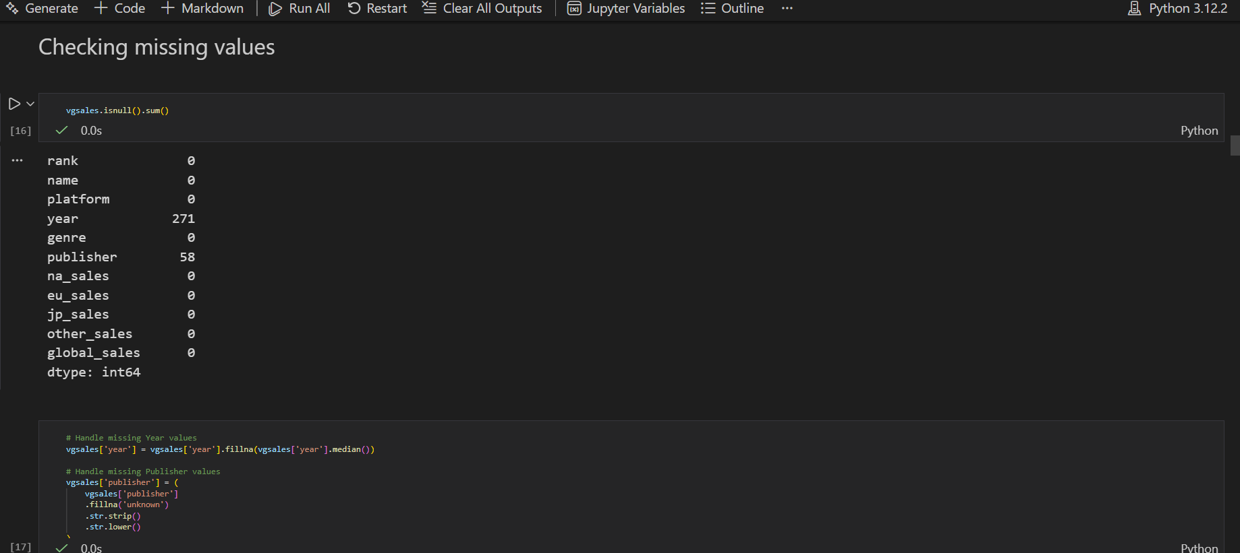
Fig3. Checking missing values
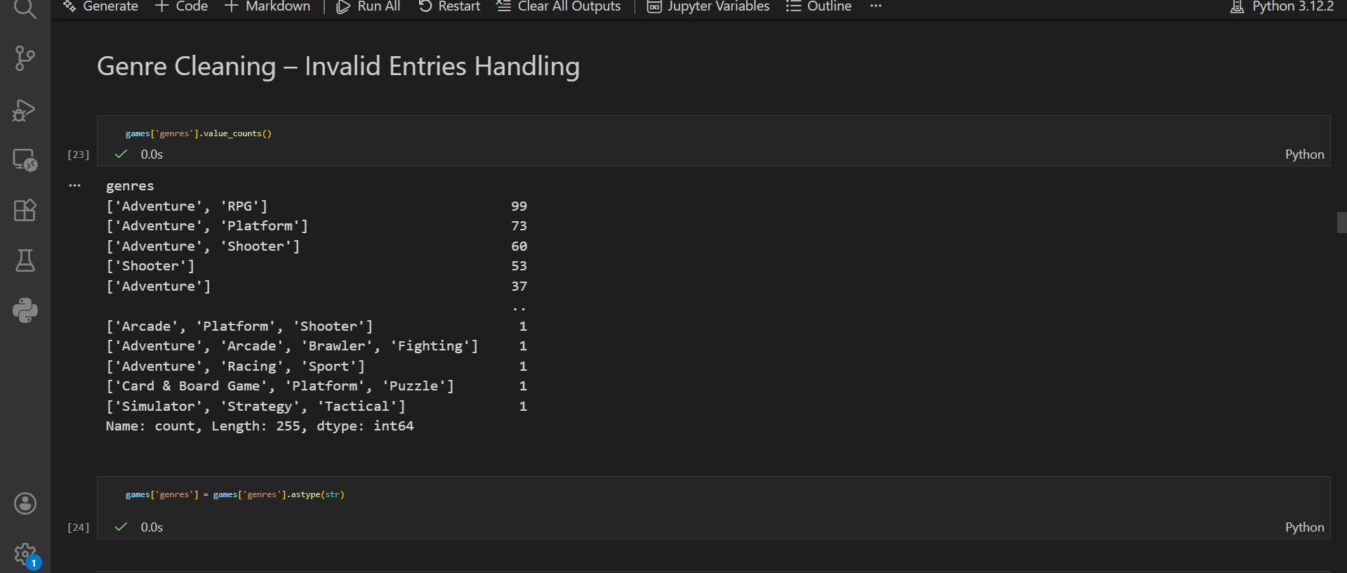
Fig4. Genre cleaning and expoding
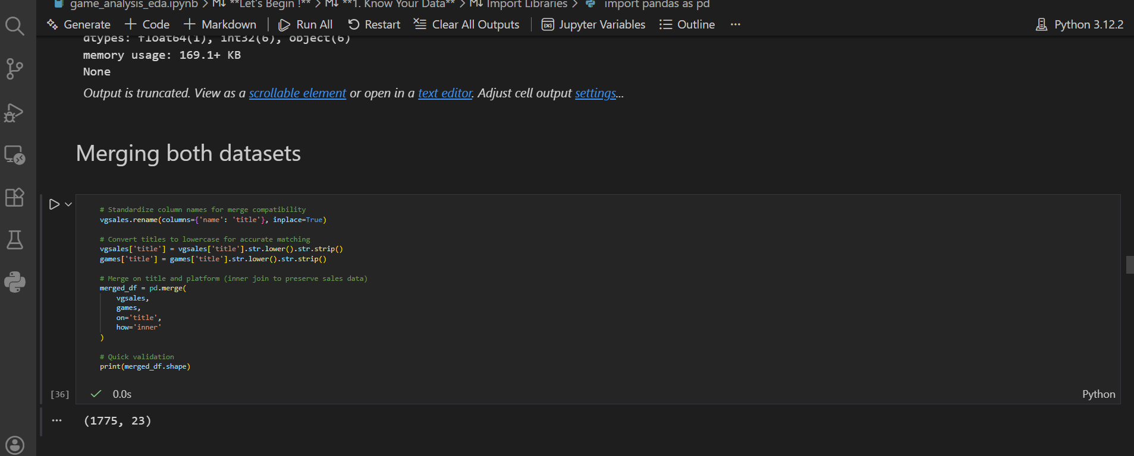
Fig5. Merging both datasets

DATA VISUALIZATION SNIPPETS:
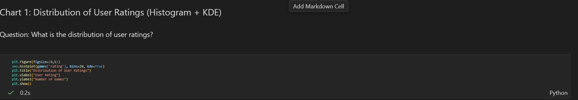
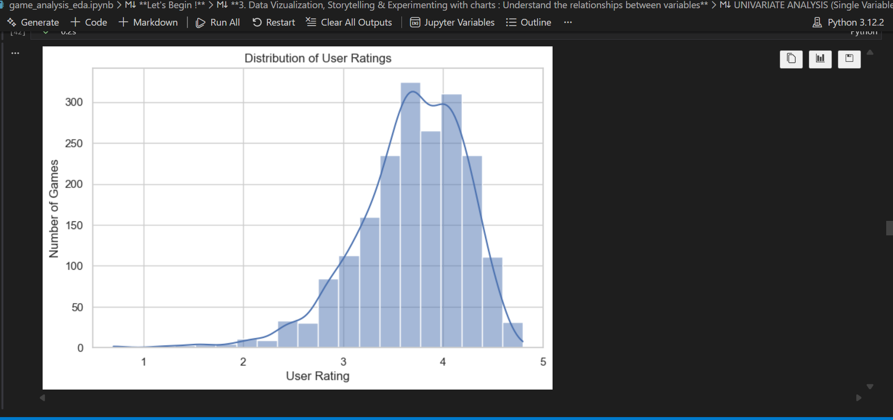
Fig6. Distribution of user ratings

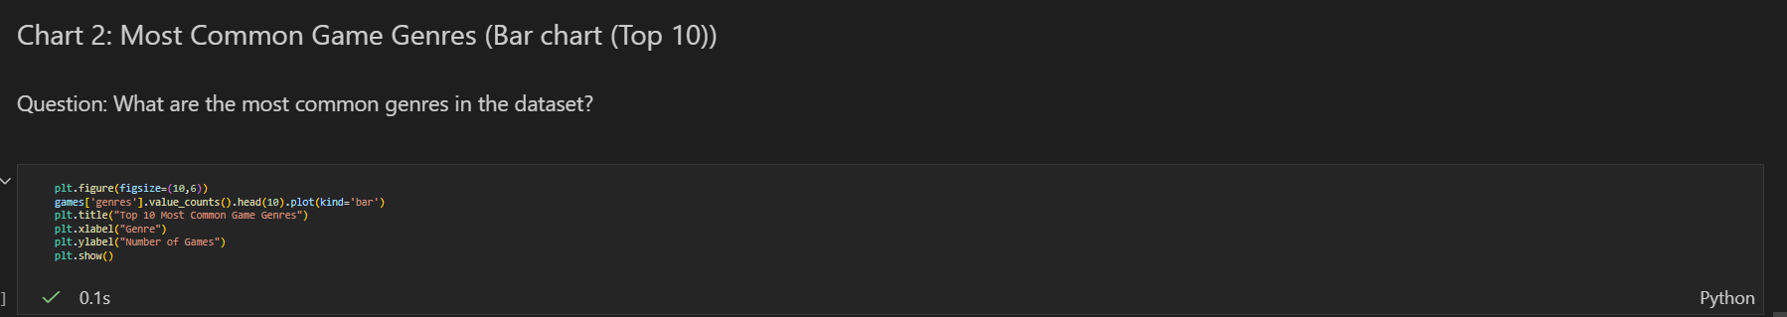
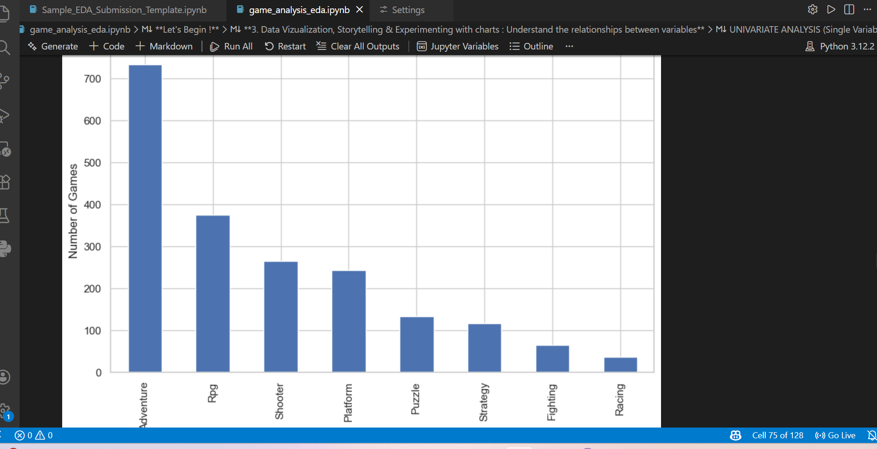
Fig7. Most common game genres

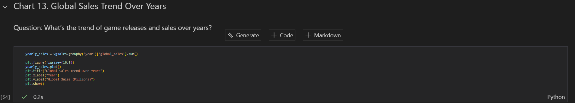
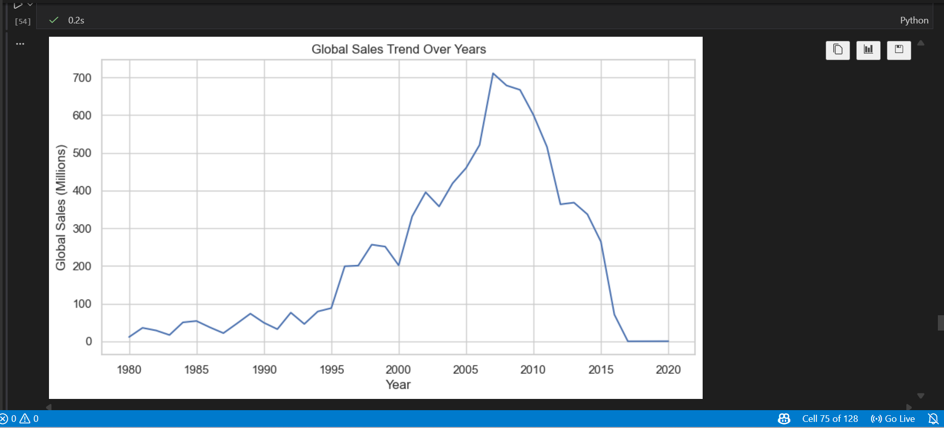
Fig8. Global sales trend over years

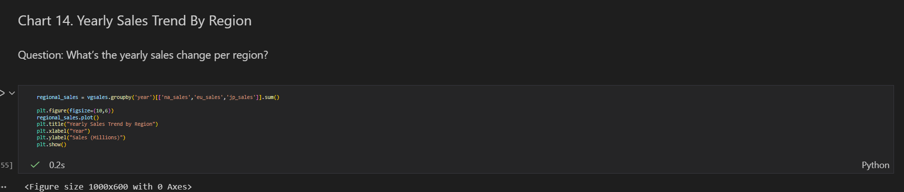
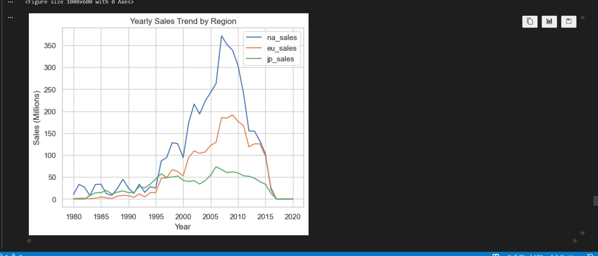
Fig9. Yearly sales trend by region
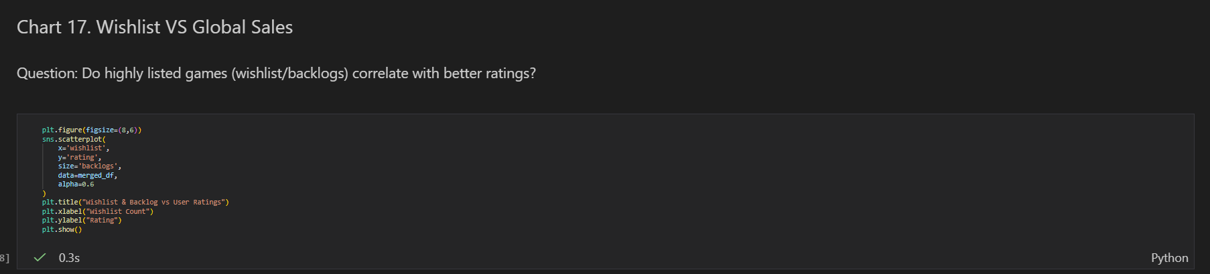
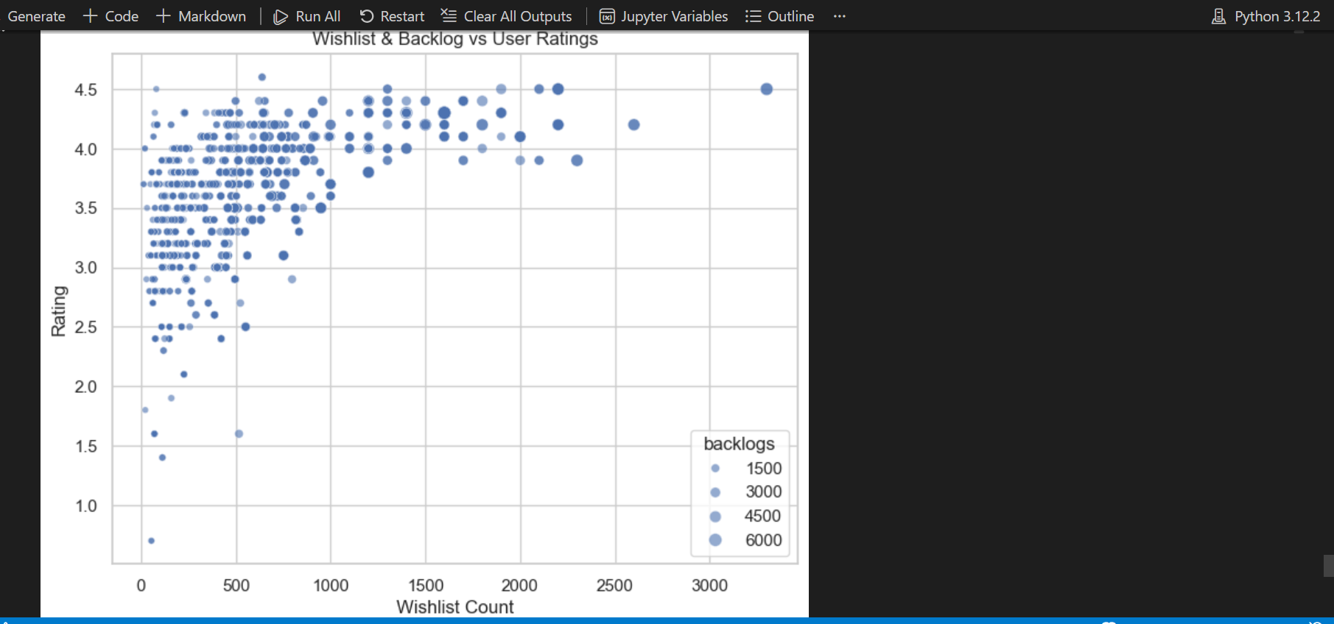
Fig10. Wishlist vs Global sales
4.2. SQL Database Implementation
Cleaned datasets were uploaded into MySQL using LOAD DATA LOCAL INFILE. Tables were created with appropriate data types and validated for integrity.
Key SQL processes included:
- CREATE TABLE statements
- Bulk data upload
- Referential integrity checks
- Foreign key constraints
- Validation queries for duplicates and orphan records

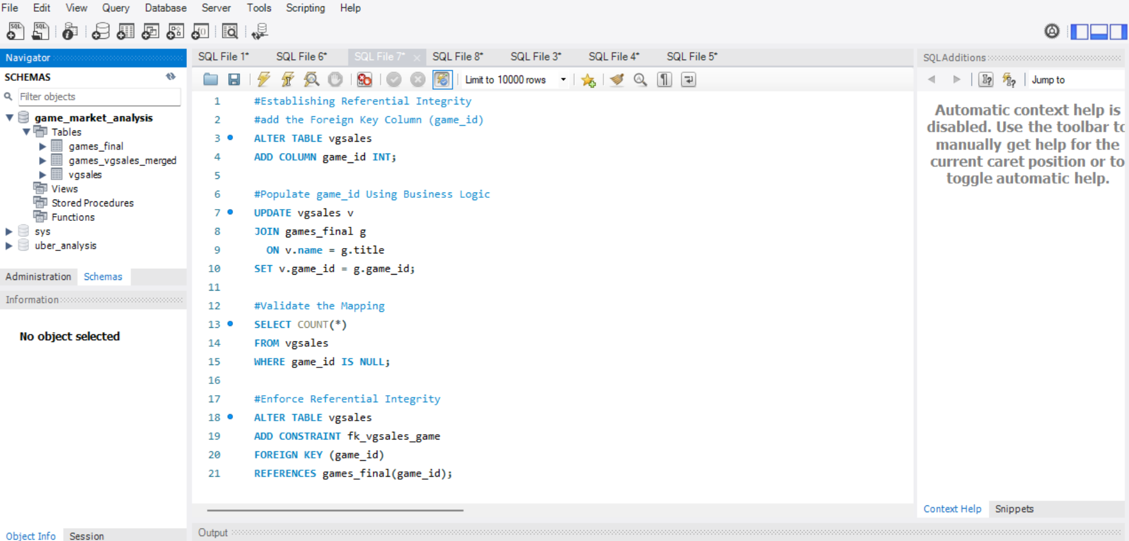
Fig11. Establishing Referential Integrity
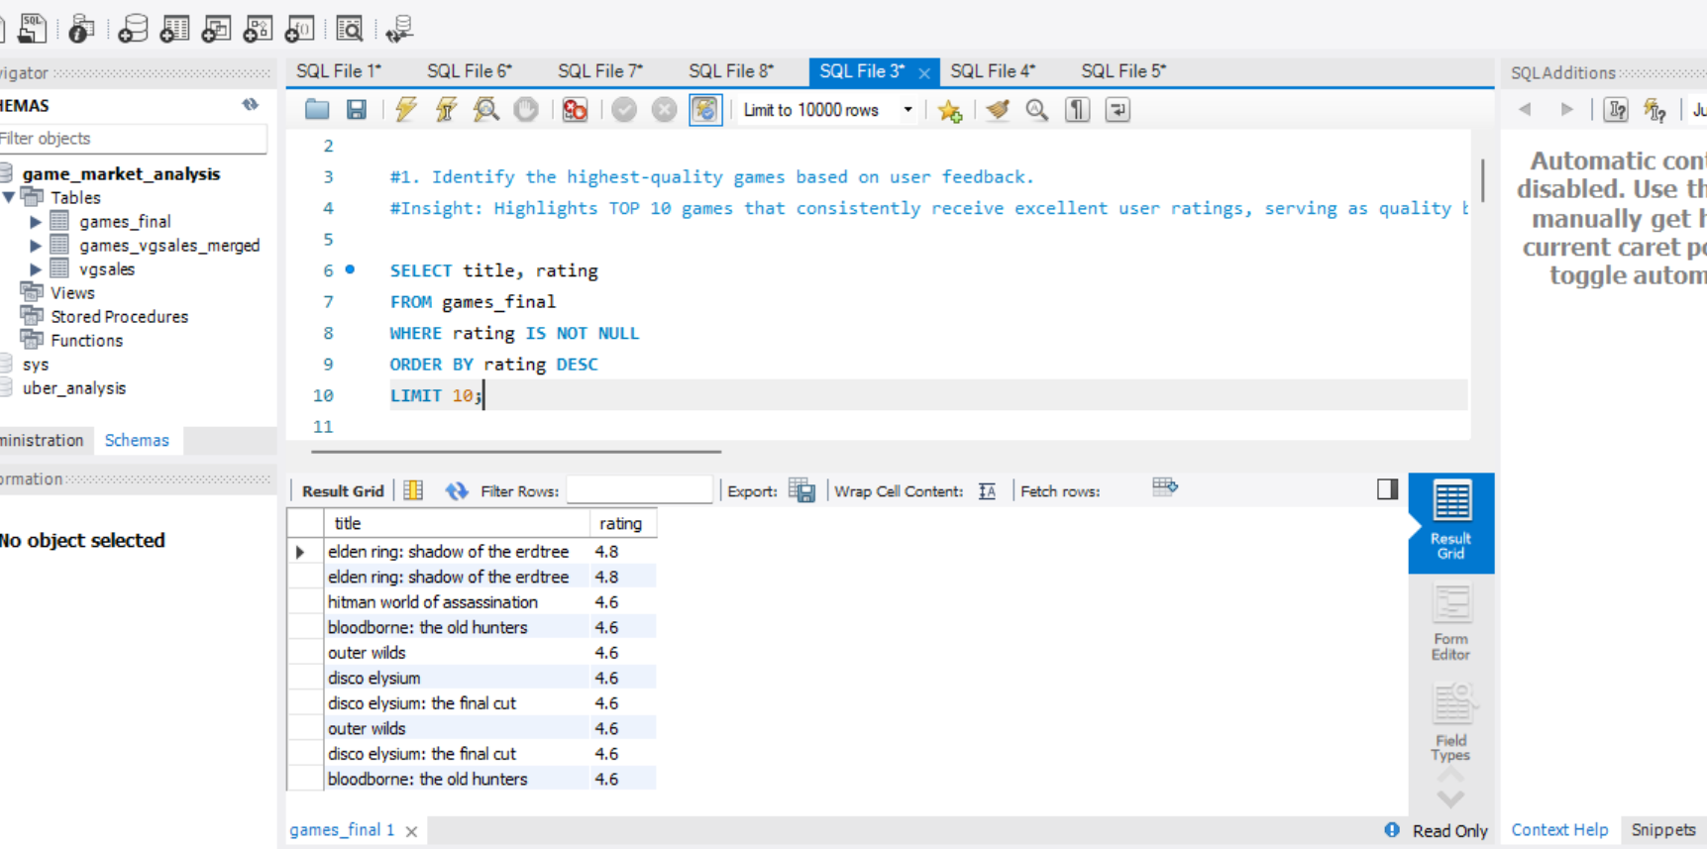
Fig12. Top 10 games based on rating
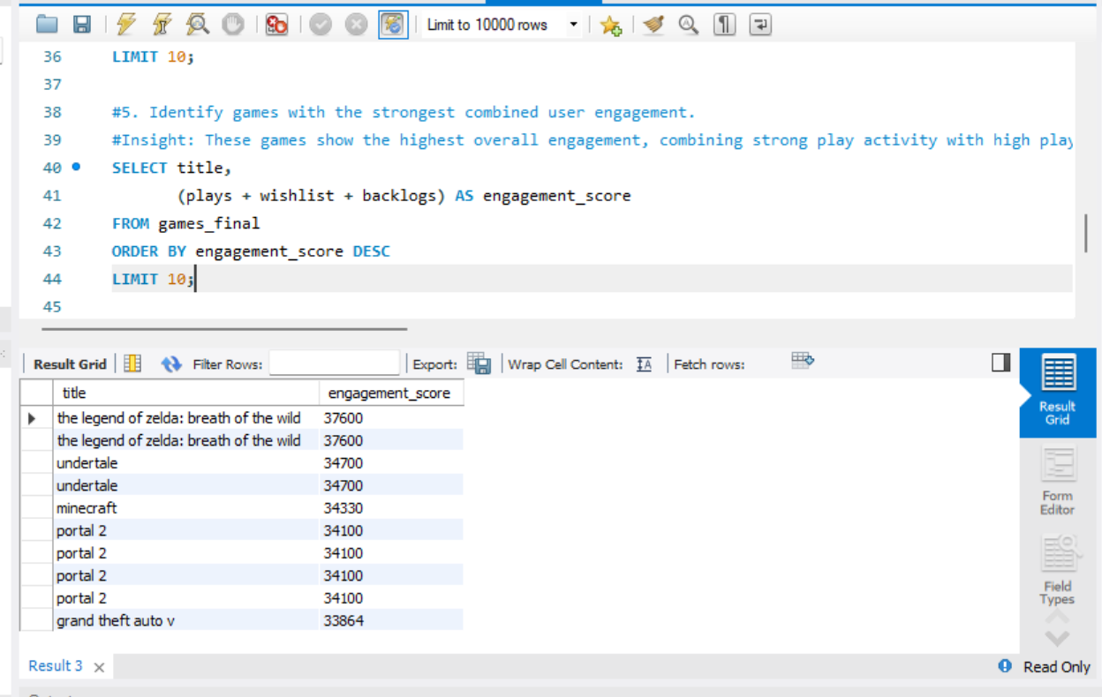
Fig13. Top 10 games based on total enagagement

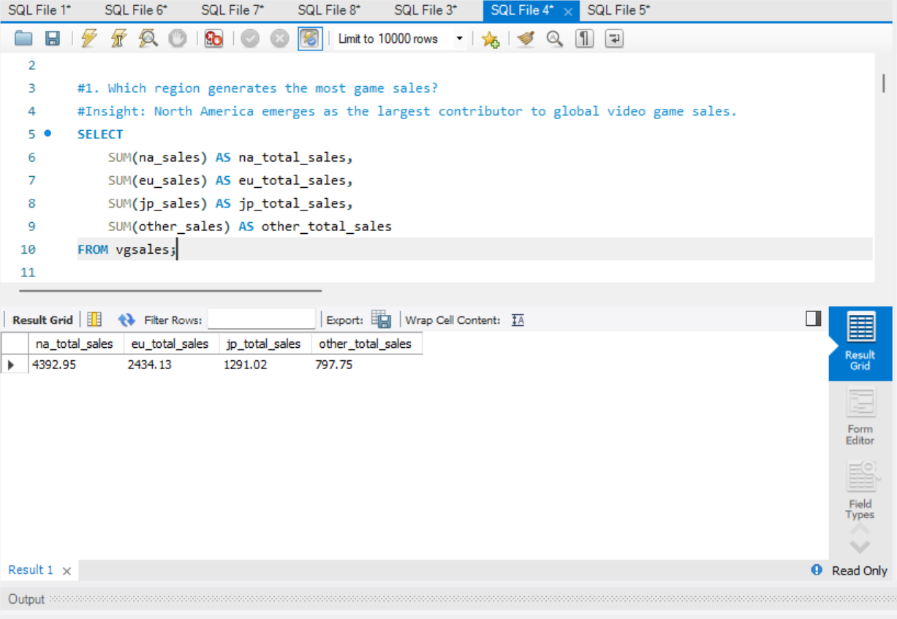Fig14. Region based sales distribution

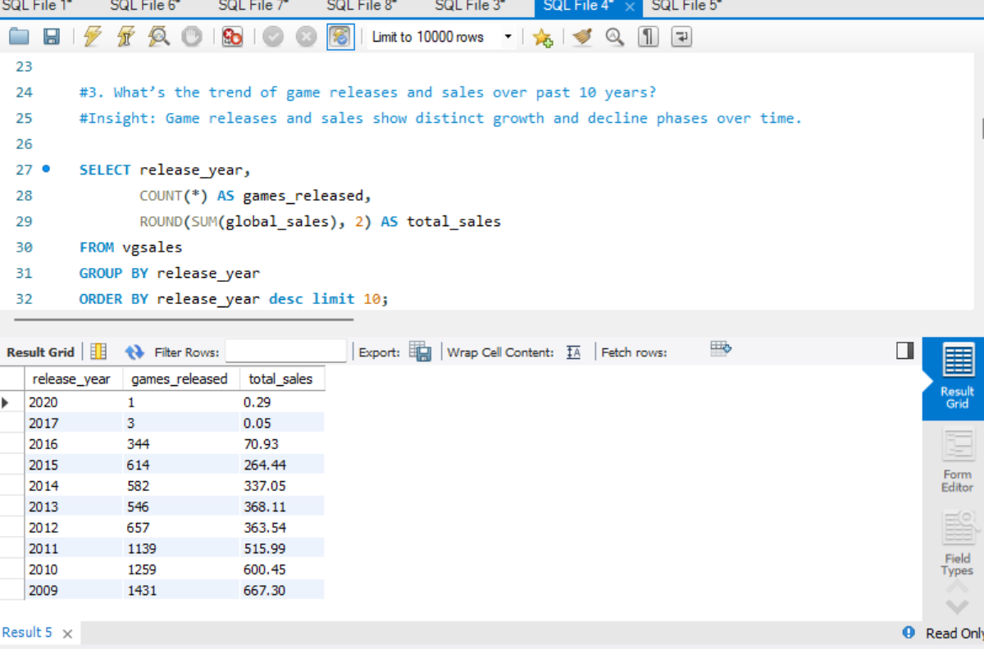
Fig15. Games released and their sales in past 10 years
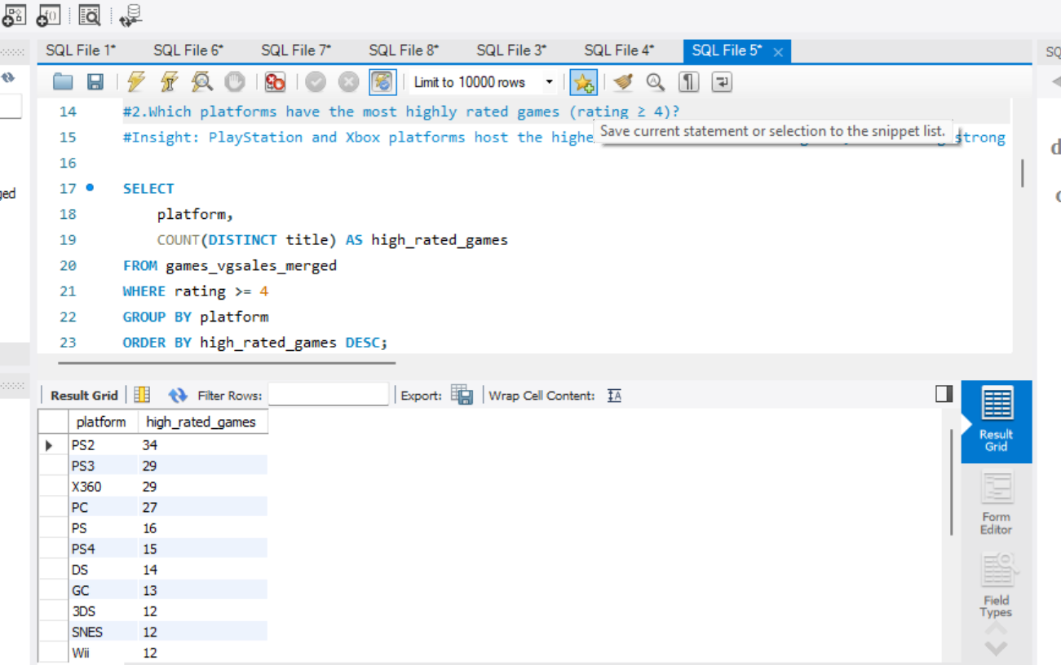
Fig16. Highest rated platforms

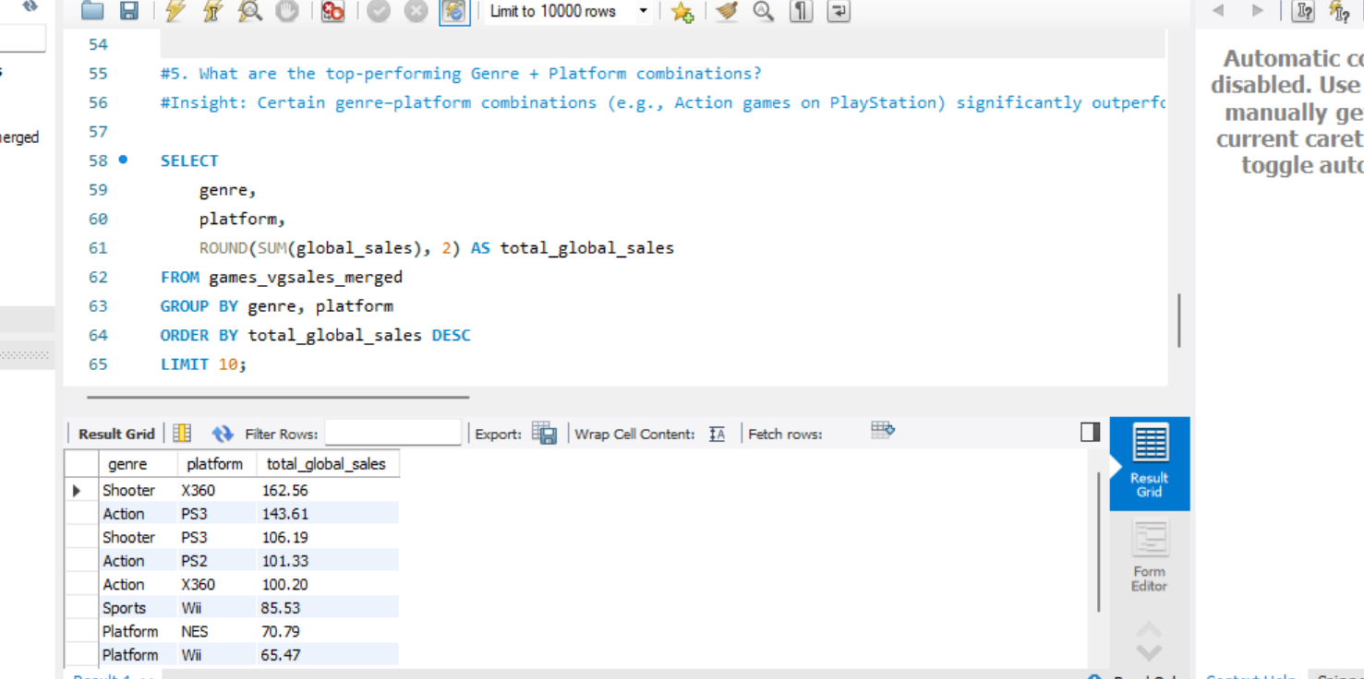
Fig17. Top 10 performing genres + platforms

4.3. Power BI Dashboard Development

Three interactive dashboards were developed:
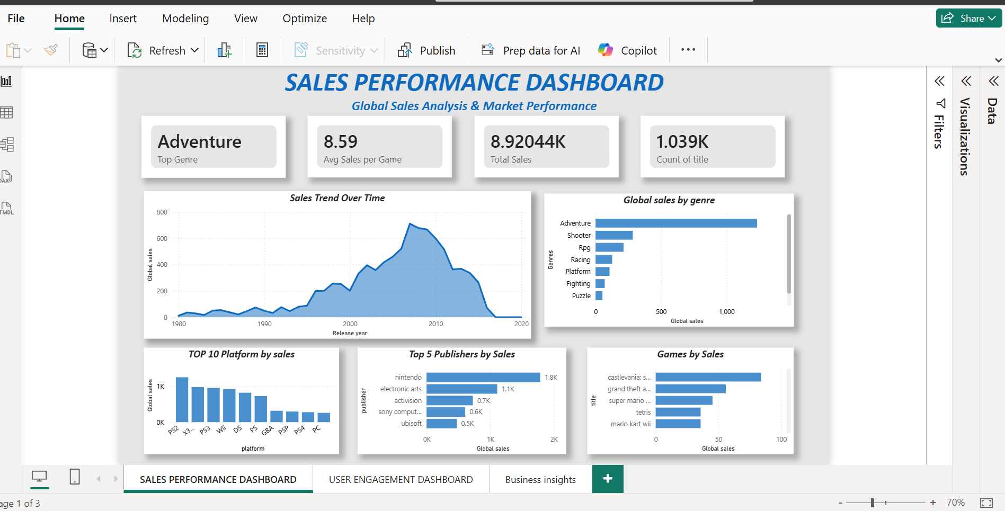
Fig 18. Dashboard 1 – (Sales Performance)
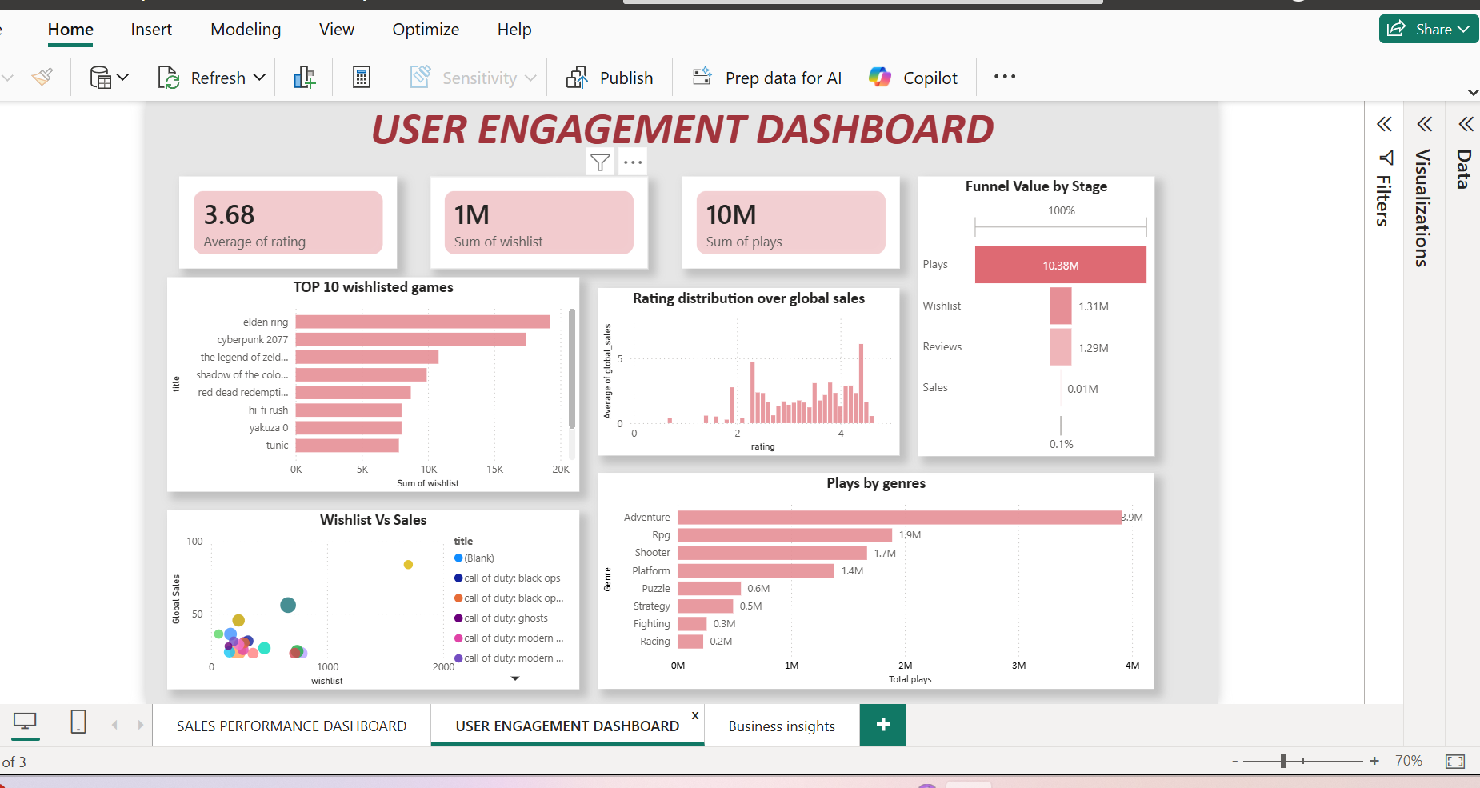
Fig 19. Dashboard 2 – (User Engagement)
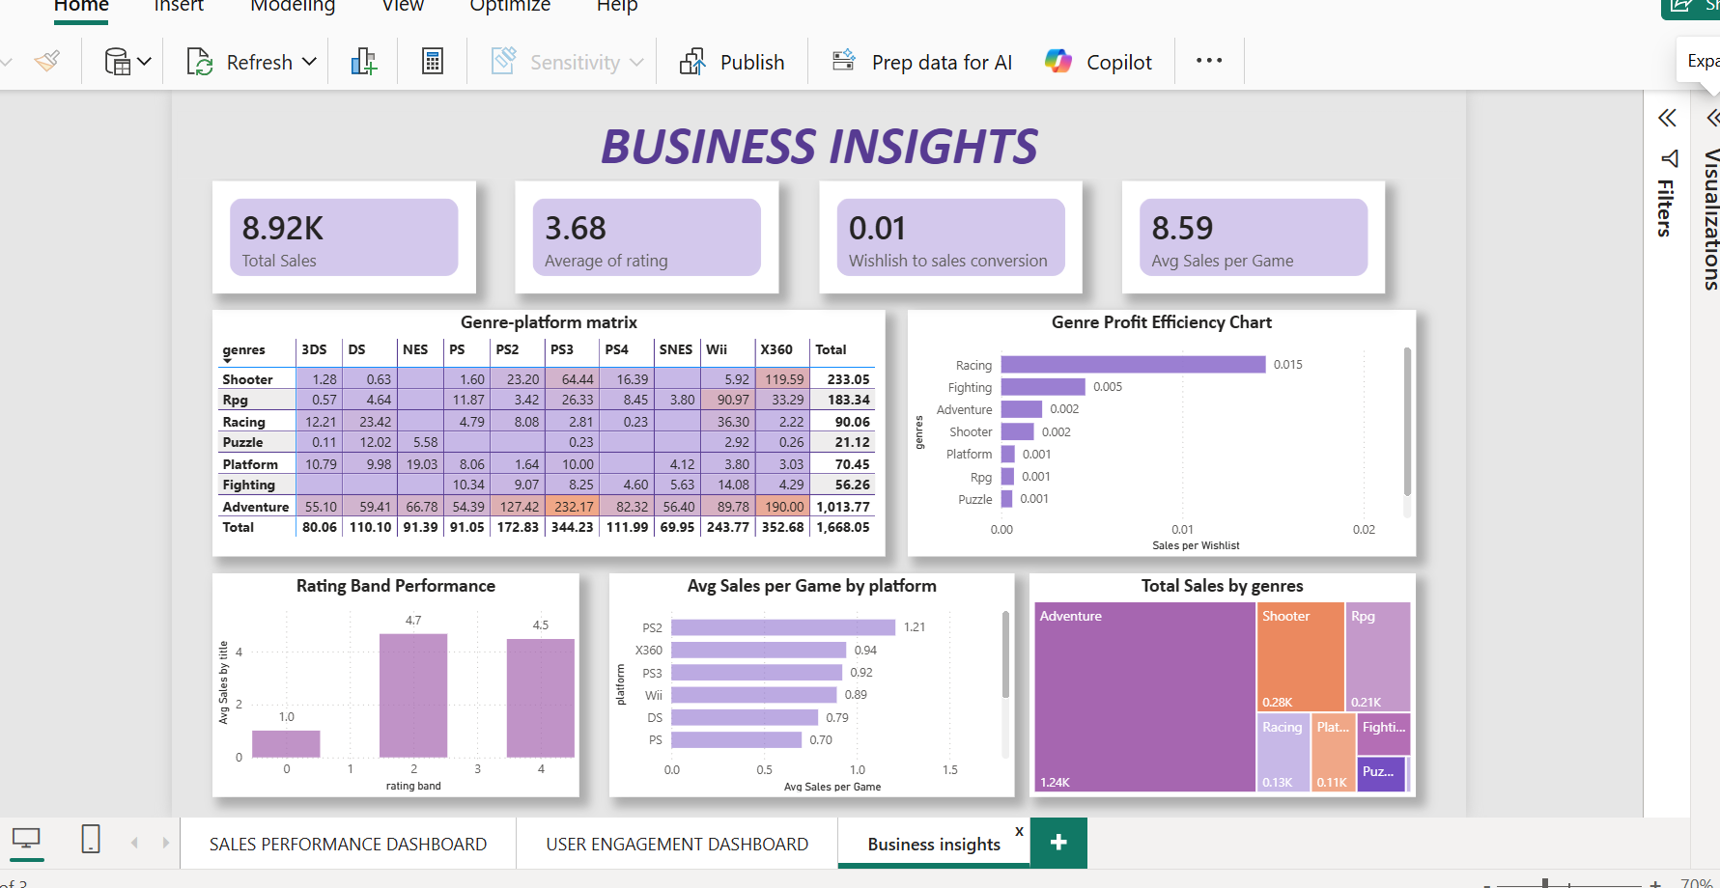
Fig 20. Dashboard 3 – (Business Insights)

5. Key Insights
1. Wishlist volume positively correlates with global sales.
Higher pre-launch interest generally translates into stronger commercial performance.
2. Revenue is concentrated within a limited number of genres.
A small group of genres contributes a disproportionately large share of total sales.
3. Higher-rated games achieve better average sales outcomes.
Game quality and user satisfaction significantly influence purchasing decisions.
4. Some high-engagement games underperform in sales.
Strong wishlist or play counts do not always convert into proportional revenue.
5. Platform choice significantly impacts revenue performance.
Certain platforms consistently generate higher sales per title.
6. Sales efficiency varies across genres.
Some genres convert user interest into revenue more effectively than others.
7. A small percentage of titles drive the majority of revenue.
Sales follow a Pareto-like distribution, increasing portfolio concentration risk.
8. User engagement metrics act as leading indicators of demand.
Wishlist and review activity can help forecast future sales trends.
9. Genre-platform combinations influence commercial success.
Performance depends not only on genre or platform individually, but their interaction.
10. Data-driven insights improve strategic resource allocation.
Analytical evaluation enables informed decisions in marketing, development, and investment planning.
6. Conclusion
This project demonstrates how an integrated data analytics approach can transform raw gaming data into actionable business insights. By using Python for data cleaning and exploratory analysis, SQL for structured data management and validation, and Power BI for interactive dashboard development, the study evaluated the relationship between game attributes, user engagement metrics, and commercial performance. The analysis revealed that wishlist volume and ratings significantly influence global sales, certain genres and platforms dominate revenue contribution, and revenue is often concentrated among a limited number of high-performing titles. Additionally, the identification of high-engagement but low-sales games highlights conversion gaps and strategic marketing opportunities. Overall, the project reinforces the importance of data-driven decision-making in optimizing marketing strategy, product development, and resource allocation within the gaming industry.

