Observations from the experiments

Following are the some of the plots which I got for different experimental setup

1. trials = 100
episodes = 15
lambda=0.9
gamma=0.95
epsilon=0.1
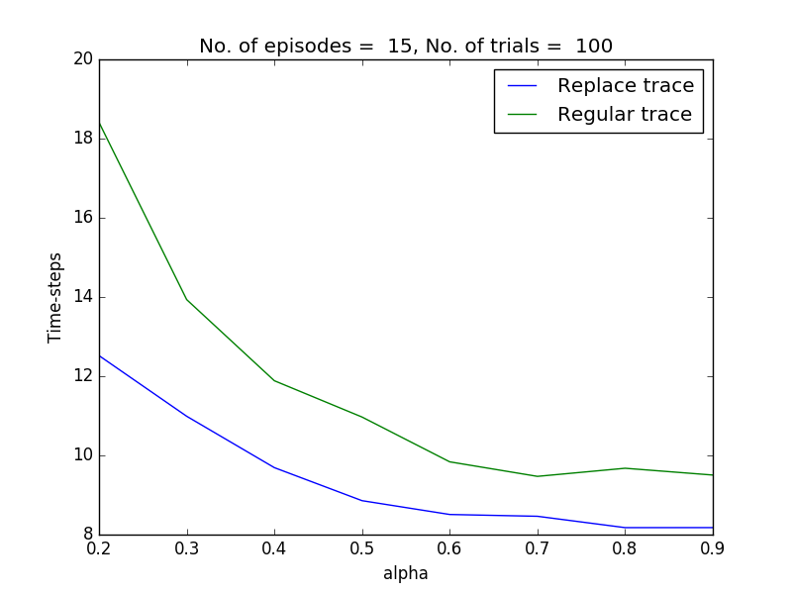
2. trials = 100
episodes = 15
lambda=0.9
gamma=0.9
epsilon=0.1

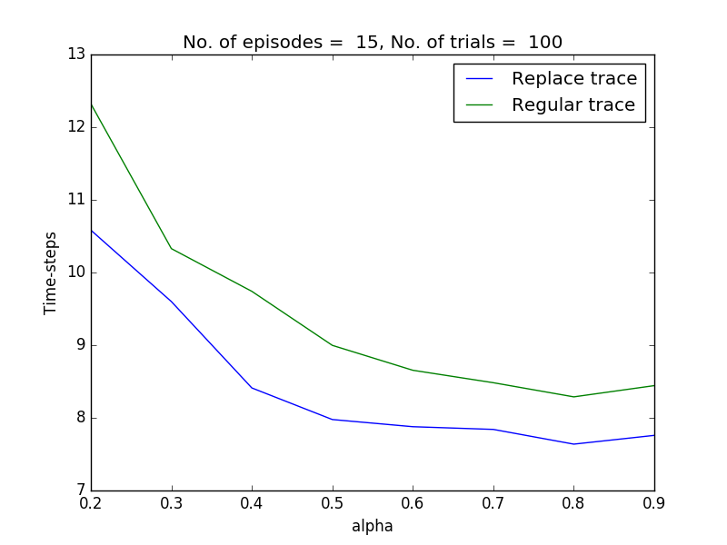
3. trials = 100
episodes = 15
lambda=0.9
gamma=0.75
epsilon=0.1
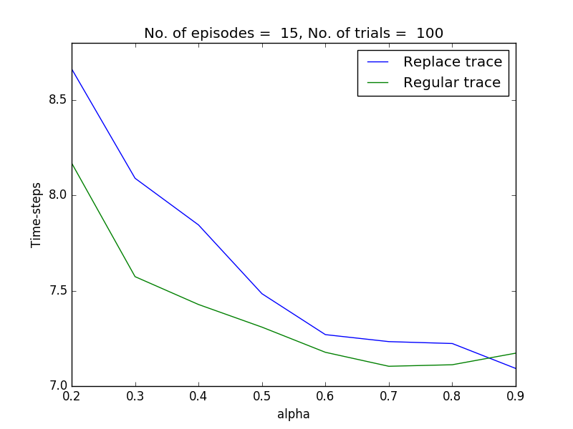

4. trials = 100
episodes = 15
lambda=0.9
gamma=0.3
epsilon=0.1
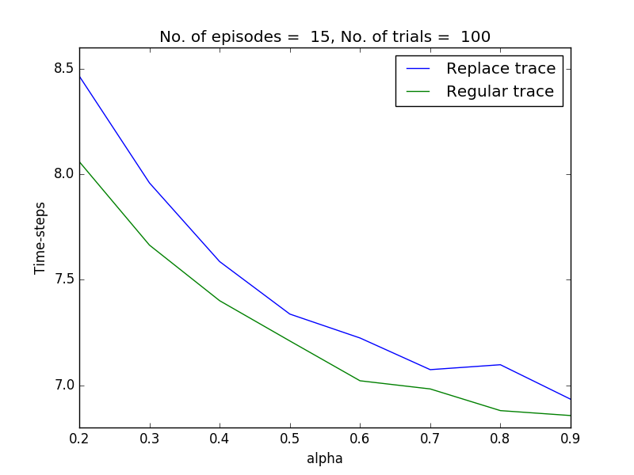

We can clearly see in the graph as we decrease gamma, the time steps required to reach terminal state from both the methods, is getting lesser.
Note: eventually if we reduce gamma further, the results get saturated, as in example 3 and 4.

Moreover, for higher values of alpha regular trace method is performing better than replacing trace method.

