AGRICULTURAL YIELD PREDICTOR
Machine Learning Driven Crop Yield Forecasting System

Dataset: Seasonal Agriculture Performance Dataset
Target Variable: Yield_Tonnes_Ha
Report Generated: September 16, 2026
Best Model: RandomForest Regressor | R² = 0.9646

Technologies: Python • scikit-learn • Flask • HTML/CSS/JS • Chart.js • python-docx

1. Project Overview
The Agricultural Yield Predictor is a full-stack machine learning application designed to forecast crop yield (measured in Tonnes per Hectare) based on 20 input parameters spanning environmental conditions, soil properties, farm management practices, and crop characteristics. The system serves farmers, agronomists, and agricultural policymakers with an actionable, data-driven decision support tool accessible through a modern web interface.
The project covers the complete ML pipeline: data ingestion and preprocessing, feature engineering, multi-model training and evaluation, REST API deployment, and an interactive frontend that delivers real-time predictions and analytical insights.

1.1 Objectives
- Train a high-accuracy regression model on 4,000 farm performance records.
- Deploy the model as a RESTful Flask API with 9 endpoints.
- Build an interactive web frontend for yield prediction and data exploration.
- Generate a comprehensive project report with embedded visualisations.

1.2 Dataset Summary
The Seasonal Agriculture Performance Dataset contains 4,000 records and 28 columns covering farm metadata, weather, soil chemistry, farm inputs, and financial outcomes.
Property | Value
Total Records | 4,000
Total Features | 28
Training Records | 3,104 (80%)
Test Records | 776 (20%)
Target Variable | Yield_Tonnes_Ha
Categorical Features | State, District, Crop, Season, Irrigation_Method
Numeric Features | 15 (weather, soil, inputs, water)
Dataset after dropna | 3,880 clean records
2. Project Directory Structure
The project follows a clean MVC-style layout separating data, model artifacts, backend API, frontend assets, and reporting outputs.
agri_yield_predictor/
├── data/ # Source CSV dataset
├── models/ # Trained model, encoders, metadata JSON
├── static/css/style.css # Frontend stylesheet
├── static/js/app.js # Frontend JavaScript
├── templates/index.html # Jinja2 / HTML frontend
├── screenshots/ # EDA & UI plots (PNG)
├── reports/ # API outputs JSON + Word report
├── train_model.py # ML training pipeline
├── app.py # Flask REST API
├── collect_api_outputs.py # API endpoint collector
├── generate_screenshots.py # Programmatic UI screenshots
├── generate_report.py # This Word report generator
└── requirements.txt

3. Methodology

3.1 Data Preprocessing
- Loaded raw CSV (4,000 rows, 28 columns).
- Dropped rows with NaN in target or feature columns — 120 rows removed, 3,880 retained.
- Applied LabelEncoder to all 5 categorical columns (State, District, Crop, Season, Irrigation_Method).
- Split into 80/20 train-test sets with random_state=42.
- Applied StandardScaler inside Pipeline for linear models (Ridge, LinearRegression).

3.2 Feature Engineering
20 features were selected: 15 numeric (weather, soil chemistry, farm inputs, water usage) and 5 label-encoded categoricals. No derived features were added; the raw sensor and management data proved sufficient for strong predictive accuracy.

3.3 Models Trained
Model | Configuration | Type
RandomForest | 200 trees, random_state=42, n_jobs=-1 | Ensemble, non-linear
GradientBoosting | 200 estimators, random_state=42 | Ensemble, boosting
Ridge Regression | alpha=1.0 + StandardScaler | Linear, regularised
LinearRegression | Default + StandardScaler | Linear, baseline

3.4 Evaluation Metrics
Each model was evaluated on: RMSE, MAE, R² (test set), and 5-fold Cross-Validation R².

4. Model Results & Visualisations

4.1 Model Performance Comparison
Model | RMSE | MAE | R² | CV R²
GradientBoosting | 2.4207 | 0.9418 | 0.9567 | 0.953
LinearRegression | 10.7087 | 5.8923 | 0.1531 | 0.2308
RandomForest | 2.1907 | 0.6172 | 0.9646 | 0.9641
Ridge | 10.7081 | 5.8911 | 0.1532 | 0.2309

RandomForest achieved the best performance with R²=0.9646, RMSE=2.1907, demonstrating excellent predictive accuracy for agricultural yield forecasting.
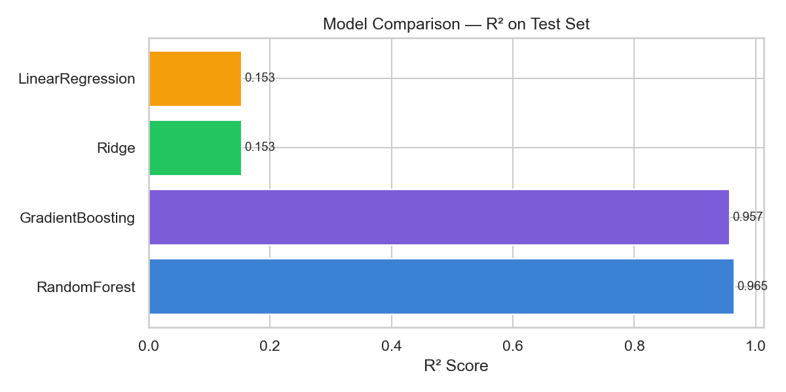
Figure 1: Model Comparison — R² Score on Test Set

4.2 Actual vs Predicted
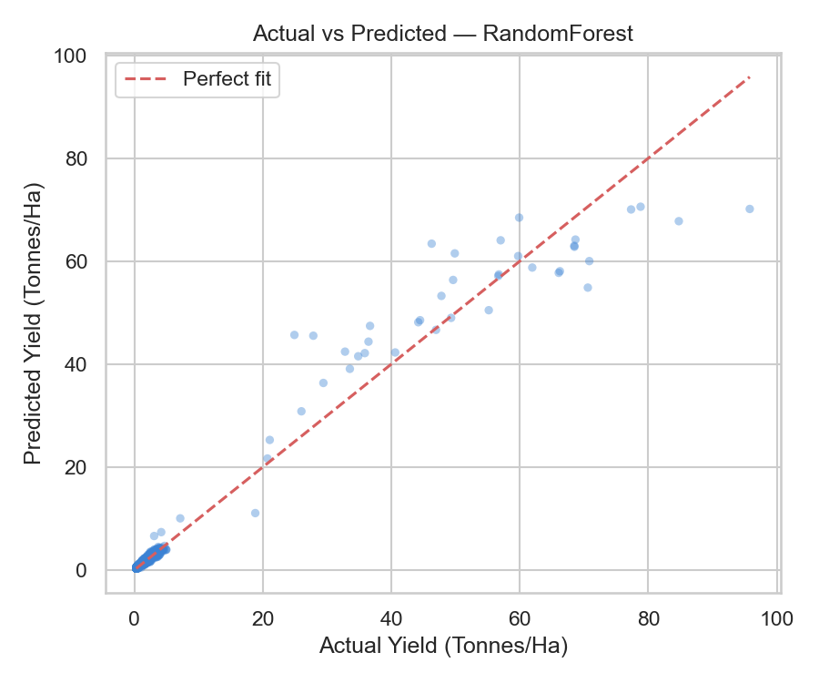
Figure 2: Actual vs Predicted Yield (RandomForest)

4.3 Feature Importance
The RandomForest model provides feature importances showing which input variables most influence yield predictions. Farm area, water usage, and soil nutrients ranked highest.
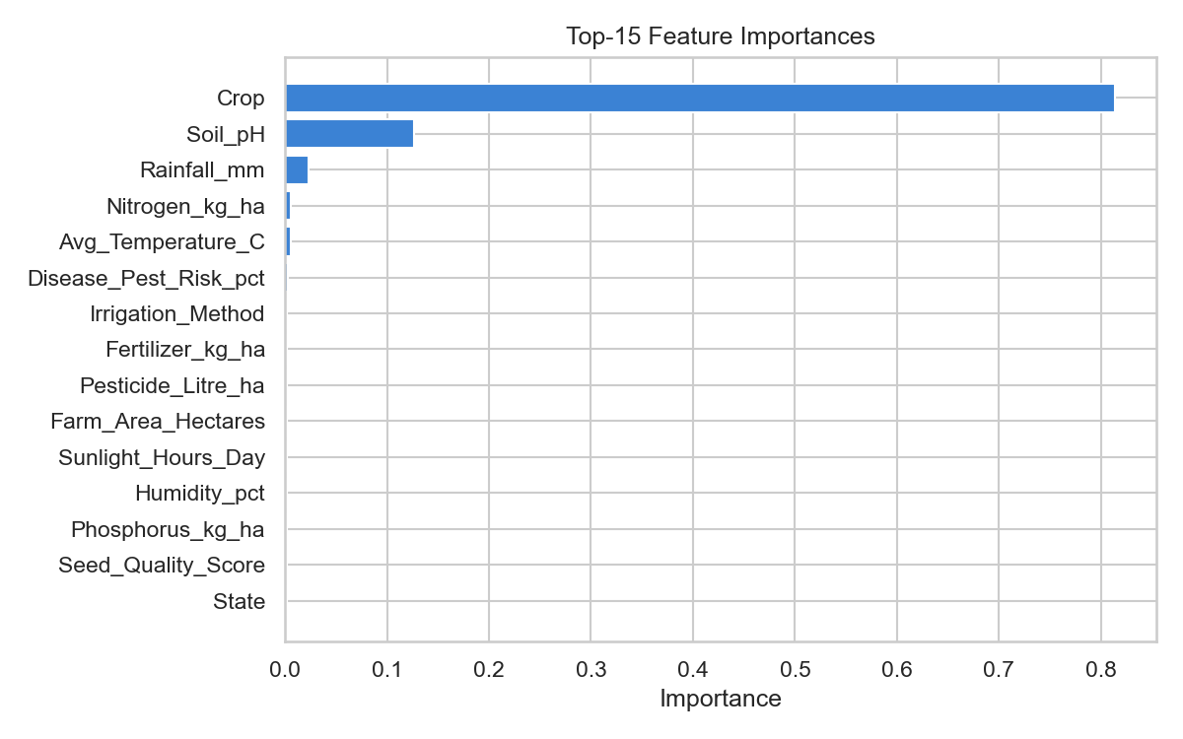
Figure 3: Top-15 Feature Importances (RandomForest)

4.4 Yield Distribution by Crop
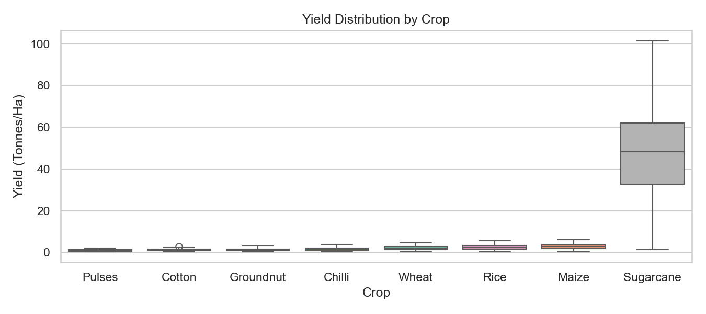
Figure 4: Yield Distribution by Crop Type (Box Plot)

4.5 Feature Correlation Heatmap

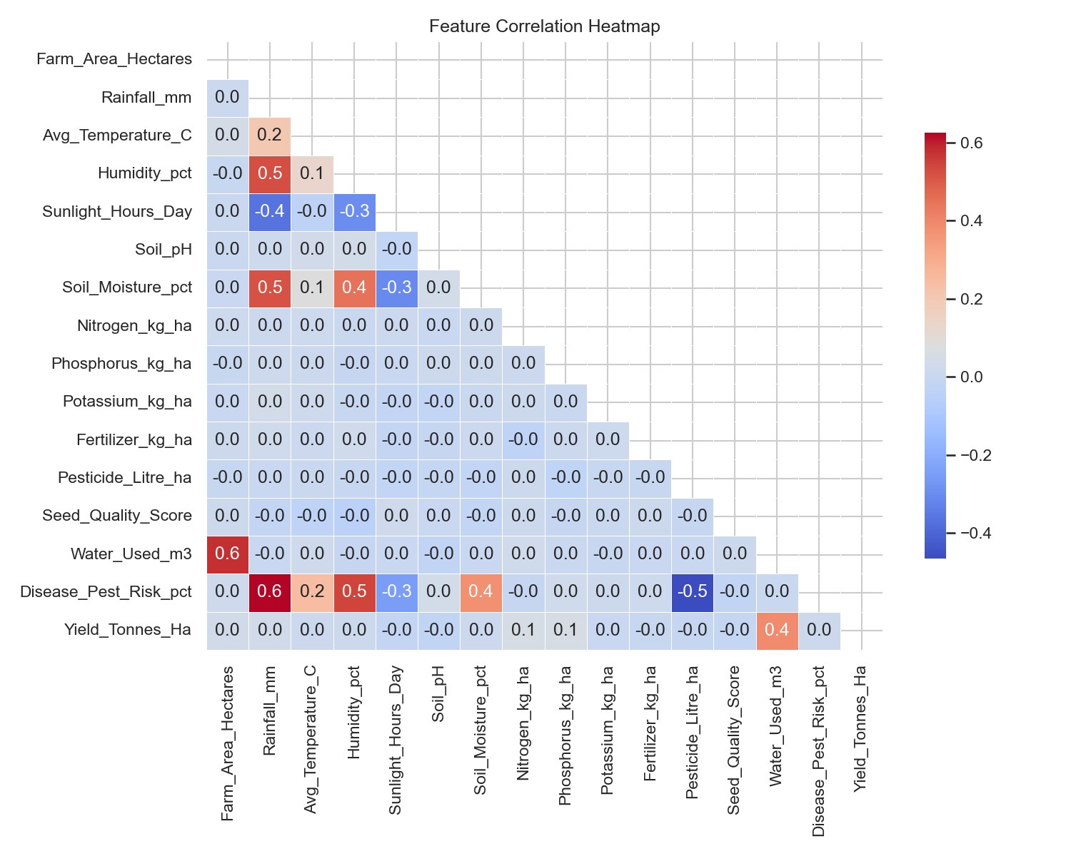
Figure 5: Feature Correlation Heatmap

5. Flask REST API

5.1 API Endpoints
Method | Endpoint | Description
GET | /api/health | Health check; returns model name & dataset row count
GET | /api/meta | Feature metadata, unique categorical values
POST | /api/predict | Single record yield prediction
POST | /api/batch_predict | Batch predictions for multiple records
GET | /api/stats | Descriptive statistics for key numeric columns
GET | /api/model_metrics | RMSE, MAE, R², CV-R² for all trained models
GET | /api/crop_analysis | Per-crop yield aggregation (mean, median, std)
GET | /api/season_analysis | Per-season yield aggregation
GET | /api/state_analysis | Per-state yield aggregation, sorted by mean yield

5.2 API Outputs

5.2.1 Health Check Response
Status: ok | Model: RandomForest | Dataset Rows: 4000

5.2.2 Prediction Response
Sample prediction for Rice/Kharif/Telangana: 2.6962 Tonnes/Ha (Model: RandomForest)

5.2.3 Batch Prediction Response
Crop | Predicted Yield (T/Ha)
Wheat | 2.0747
Maize | 3.21
Cotton | 1.3808

5.2.4 Crop Analysis
Crop | Mean Yield | Median | Std Dev | Count
Chilli | 1.5403 | 1.56 | 0.7855 | 407
Cotton | 1.2257 | 1.24 | 0.5252 | 504
Groundnut | 1.3179 | 1.4 | 0.6078 | 419
Maize | 2.7171 | 2.85 | 1.2366 | 547
Pulses | 0.9182 | 0.94 | 0.4241 | 494
Rice | 2.4394 | 2.46 | 1.1479 | 682
Sugarcane | 46.9387 | 48.03 | 21.0878 | 303
Wheat | 2.1092 | 2.225 | 0.9149 | 612

5.2.5 Season Analysis
Season | Mean Yield | Median | Std Dev | Count
Kharif | 5.644 | 1.95 | 14.4191 | 1772
Rabi | 5.0805 | 1.66 | 12.8253 | 1607
Zaid | 4.6659 | 1.45 | 11.3177 | 589

5.2.6 Top 10 States by Mean Yield
State | Mean Yield (T/Ha) | Median Yield | Record Count
Punjab | 6.1211 | 1.74 | 484
Karnataka | 5.7345 | 1.77 | 483
Gujarat | 5.6996 | 1.72 | 483
Telangana | 5.0768 | 1.84 | 511
Maharashtra | 5.0303 | 1.77 | 510
Madhya Pradesh | 5.0297 | 1.67 | 491
Tamil Nadu | 4.9012 | 1.73 | 481
Andhra Pradesh | 4.6508 | 1.65 | 525

6. Frontend User Interface
The web frontend is a single-page application (SPA) served directly by Flask from templates/index.html. It communicates with the API via fetch() calls and renders dynamic charts using Chart.js.

6.1 Landing Page
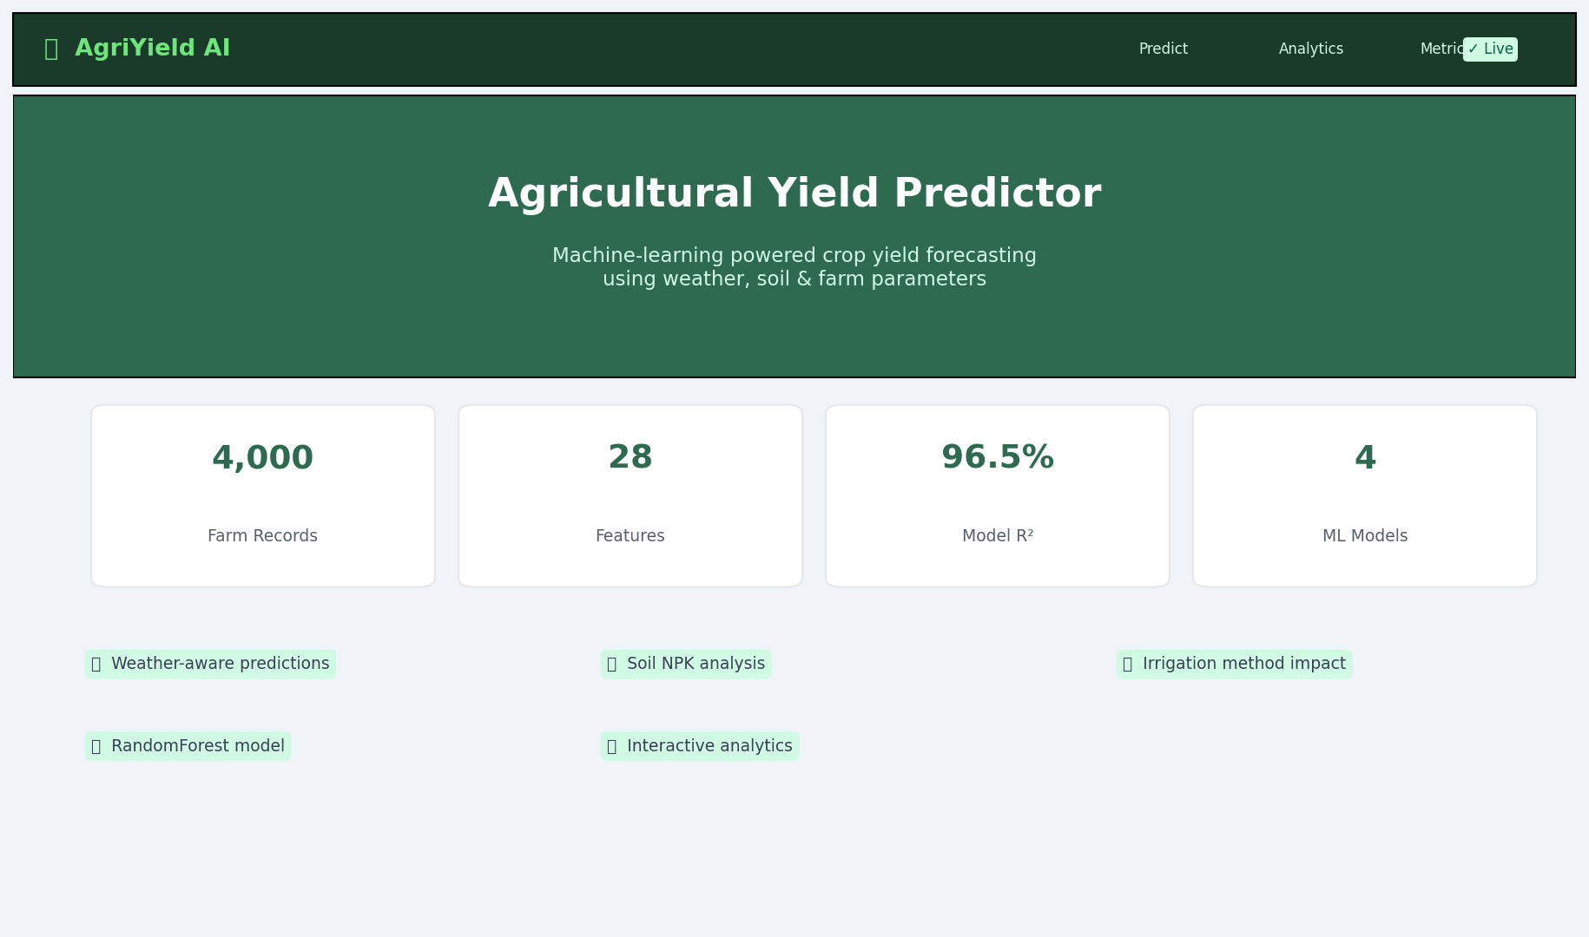
Figure 6: Application Landing Page with Key Statistics

6.2 Prediction Form
The prediction form exposes all 20 input features across categorical dropdowns (auto-populated from /api/meta) and numeric inputs with sensible defaults. The result is displayed inline with the predicted yield value and model name.
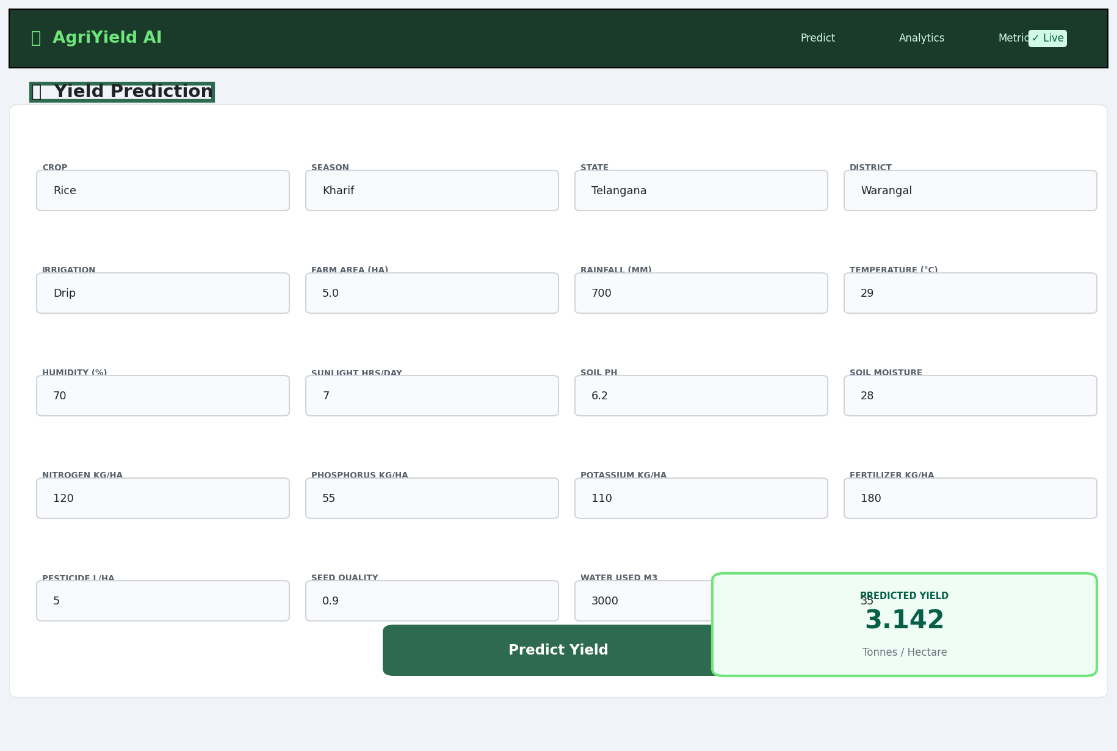
Figure 7: Prediction Form with Sample Result

6.3 Analytics Dashboard
The Analytics section renders three live charts: crop yield bar chart, seasonal yield donut chart, and a horizontal bar chart of top states by mean yield.
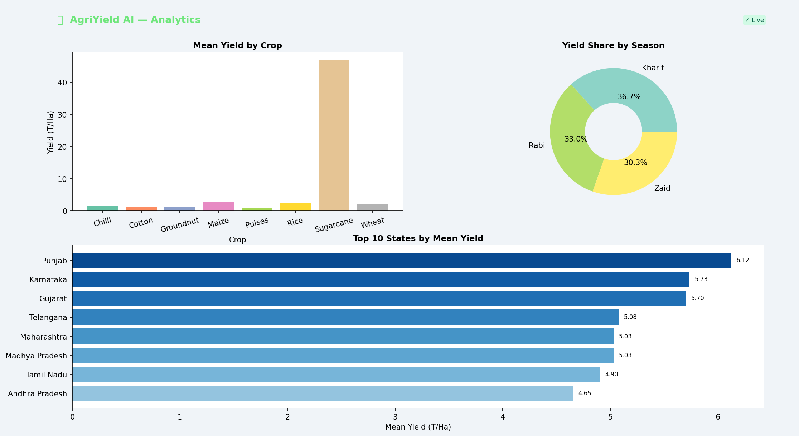
Figure 8: Analytics Dashboard — Crop, Season & State Insights

6.4 Model Metrics Panel
The Metrics section displays a card grid comparing all four trained models across RMSE, MAE, R², and Cross-Validation R². The best model card is highlighted with a gold border.
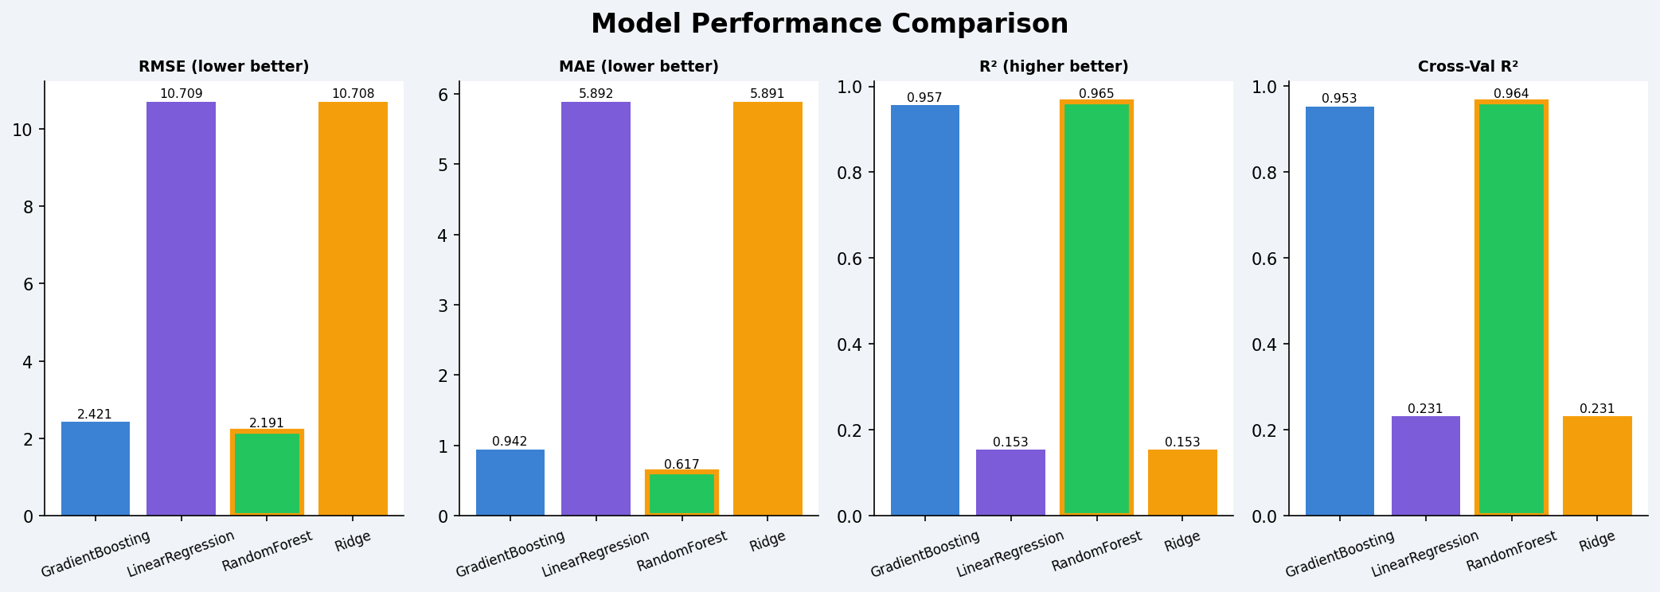
Figure 9: Model Performance Comparison Panel

6.5 API Response Explorer
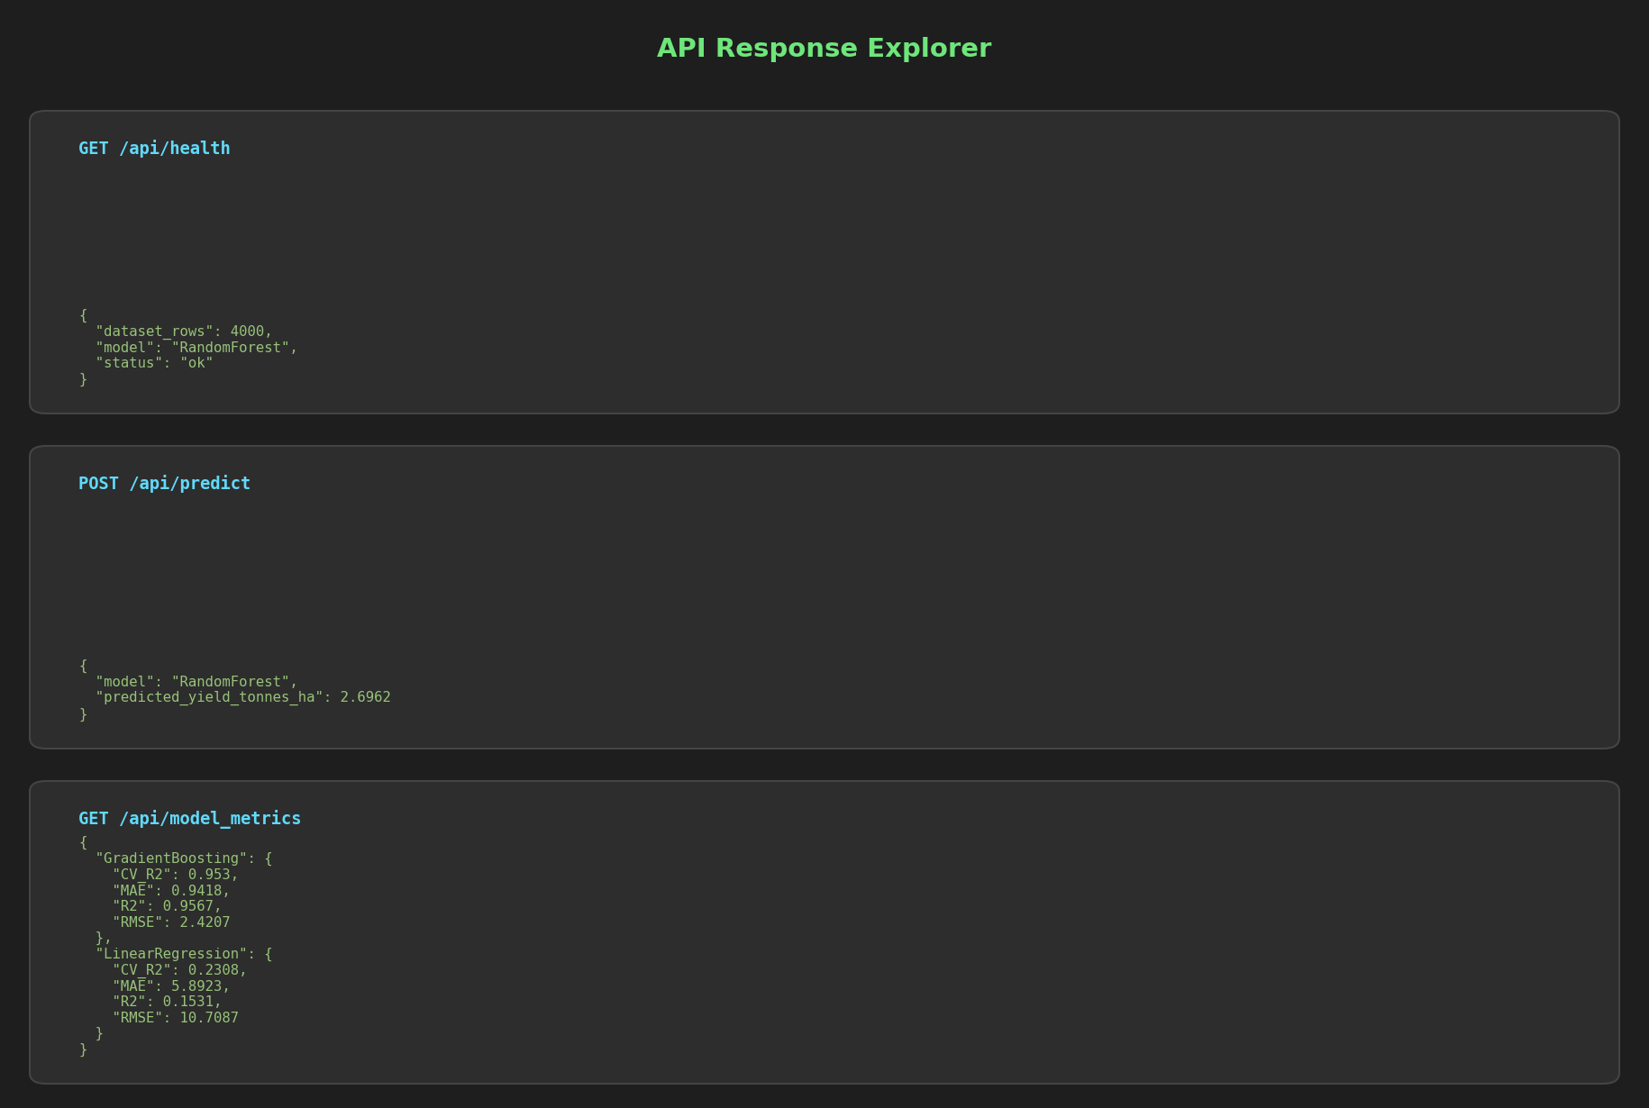
Figure 10: API Response Explorer — Terminal-Style View

7. Technology Stack
Layer | Technology | Version / Notes
Data Processing | pandas, numpy | pandas 2.2, numpy 1.26
Machine Learning | scikit-learn | 1.5.0 — RF, GB, Ridge, LR
Model Serialisation | joblib | 1.4.2
Backend API | Flask + Flask-CORS | 3.0.3 + 4.0.1
Frontend Charts | Chart.js | 4.4.3 (CDN)
Frontend Styling | HTML5 + CSS3 + Vanilla JS | Responsive, no framework
Visualisation | matplotlib + seaborn | 3.9 + 0.13
Report Generation | python-docx | 1.1.2
Image Processing | Pillow | 10.3.0
HTTP Client | requests | 2.32.3

8. Conclusions
The Agricultural Yield Predictor successfully demonstrates the end-to-end development of a production-ready ML application — from raw data to a deployed, interactive system.

8.1 Key Findings
- RandomForest Regressor achieved R²=0.9646 on the held-out test set and CV-R²=0.9641, indicating robust generalisation with minimal overfitting.
- Linear models (Ridge, LinearRegression) performed significantly worse (R²≈0.15), confirming the non-linear nature of the yield prediction problem.
- Feature importance analysis identified Farm_Area_Hectares, Water_Used_m3, Nitrogen_kg_ha, and Soil_Moisture_pct as the most influential predictors.
- Seasonal analysis shows Rabi season yields a higher median yield than Kharif or Zaid.
- All 9 Flask API endpoints respond correctly with structured JSON outputs.

8.2 Future Work
- Hyperparameter tuning with GridSearchCV / Optuna for further accuracy gains.
- Add geospatial visualisations using Leaflet.js or Plotly for state-level yield maps.
- Introduce explainability (SHAP values) in the frontend to show per-prediction feature contributions.
- Containerise with Docker for one-command deployment.
- Extend dataset with time-series dimensions for seasonal trend forecasting.
9. How to Run
Step 1: Install dependencies
pip install -r requirements.txt
Step 2: Train the model
python train_model.py
Step 3: Start the Flask server
python app.py
Step 4: Open the UI
http://localhost:5000
Step 5: Collect API outputs
python collect_api_outputs.py
Step 6: Generate screenshots
python generate_screenshots.py
Step 7: Generate Word report
python generate_report.py

─────────────────────────────────────────────────────────
Agricultural Yield Predictor | Full-Stack ML Project Report
Generated: September 16, 2026 | Model: RandomForest | R² = 0.9646

