1. **Task Description:**

Create an Expense Sharing App using **HTML**, **CSS**, and **JavaScript** to enable users to:

* Add expenses by entering a participant's name and the amount they paid.
* Split expenses equally among all participants.
* Display balances showing who owes or is owed money.

This app demonstrates dynamic content generation using JavaScript, with a simple and responsive interface styled with CSS.

1. **Task Output Screenshot**

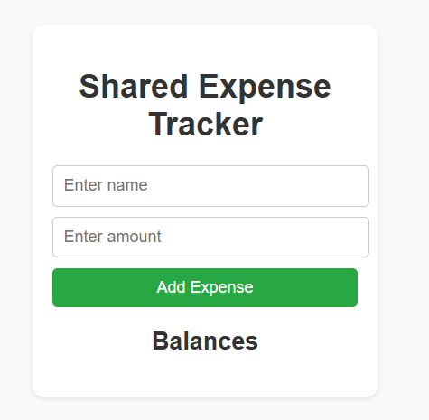 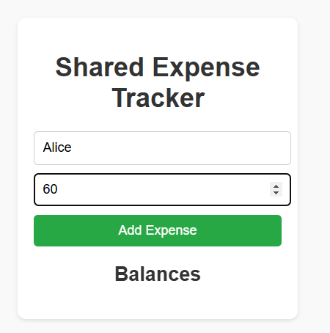

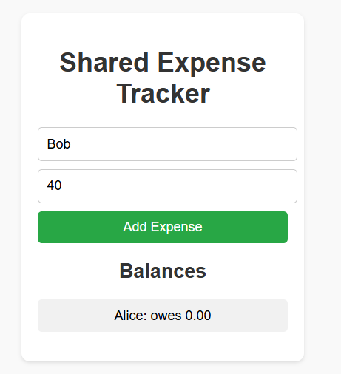 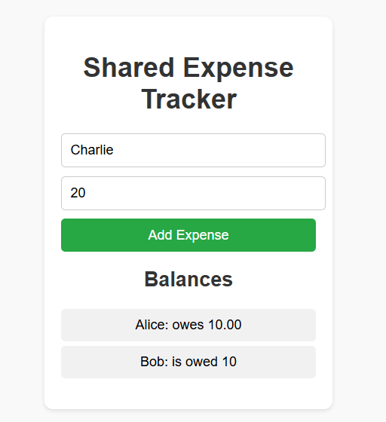

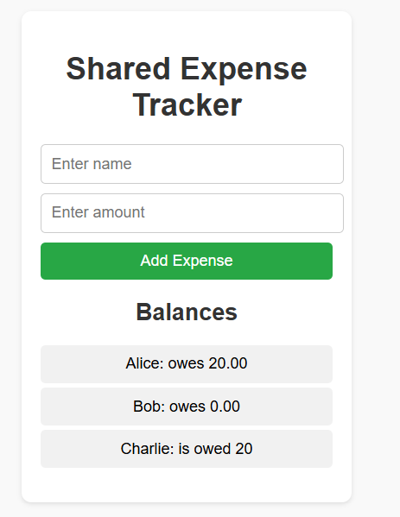

1. **Widget/Algorithm Used in Task:**

**Widgets Used (HTML):**

* Input:
  + - Used for collecting user input (name and amount).
* Button:
  + - Triggers the addition of expenses.
* Unordered List (ul):
  + - Displays the dynamically generated balances.

CSS Features:

* + - Used to style the interface, including the layout, buttons, and balance display.

**JavaScript Algorithm:**

* Expense Entry:
  + - Captures user input (name and amount) via event listeners on the "Add Expense" button.
* Dynamic Content Rendering:
  + - Updates balances dynamically based on the shared expense formula.
* Calculation Logic:
  + - Splits the total expense equally among participants.
    - Calculates how much each participant owes or is owed.
* DOM Manipulation:
  + - Updates the balances list in real-time using JavaScript.
    - Attach a click event listener to each "Remove" button.
    - On click, remove the corresponding div from the form container.