1. **Task Description:**

The task is to create a **Dynamic Form** using **HTML**, **CSS**, and **JavaScript**. The form enables users to:

* Add multiple input fields dynamically.
* Remove individual input fields when no longer needed.
* Submit the form with all user-entered data.

1. **Task Output Screenshot**

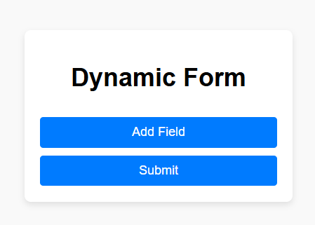

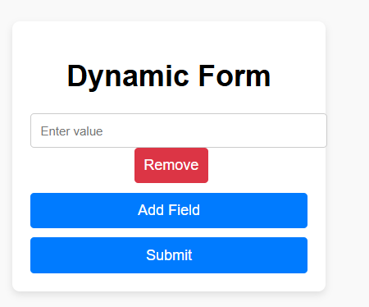

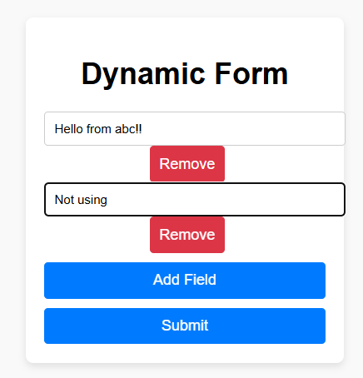

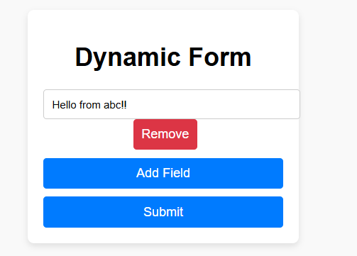

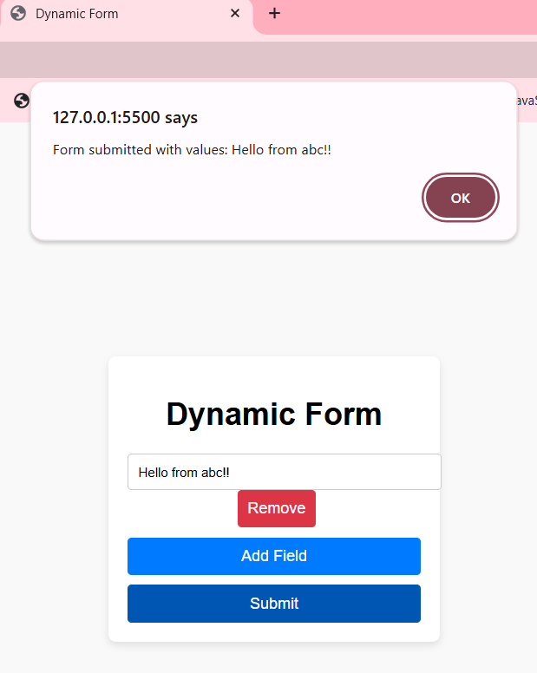

1. **Widget/Algorithm Used in Task:**

**Widgets Used:**

* + Input Fields: Used for user data entry.
  + Button:
    - "Add Field" button to dynamically add new input fields.
    - "Remove" buttons to delete specific input fields.
    - "Submit" button to finalize the form and collect data.
  + Div Container: Used to group input fields dynamically.

**Algorithm Used:**

* Adding Input Fields:
  + - Attach a click event listener to the "Add Field" button.
    - Each click creates a new div containing:
      * A text input field.
      * A "Remove" button to delete the field.
    - Append the new div to the form container.
* Removing Input Fields:
  + - Attach a click event listener to each "Remove" button.
    - On click, remove the corresponding div from the form container.
* Form Submission:
  + - Attach a submit event listener to the form.
    - Prevent default submission behavior.
    - Collect all input values using the FormData object.
    - Validate and display the data or process it as required.