1. **Task Description:**

The task involves creating a password strength validator using **HTML**, **CSS**, and **JavaScript**. The validator evaluates the strength of a password as the user types and displays feedback dynamically. The strength categories are:

* **Weak Password**: Less than 8 characters or lacking diversity in character types.
* **Good Password**: Between 8–11 characters with at least two-character types.
* **Strong Password**: Between 12–14 characters with all character types.
* **Excellent Password**: More than 15 characters with all character types and no common patterns or sequences.

1. **Task Output Screenshot**

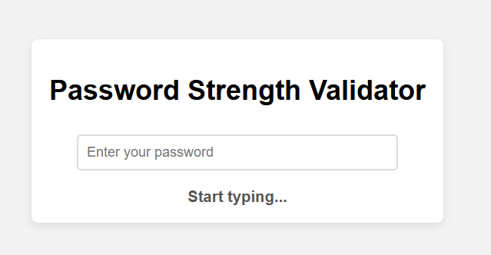

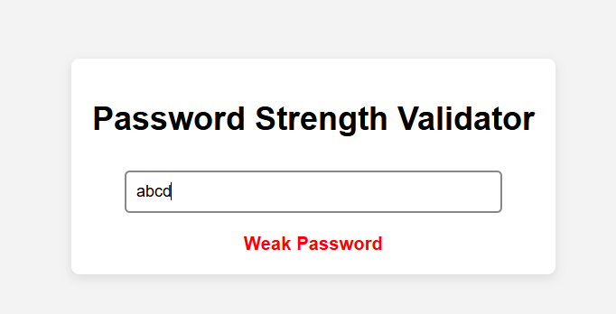

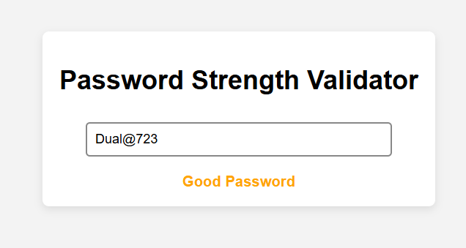

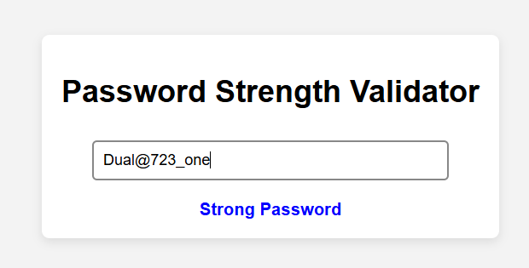

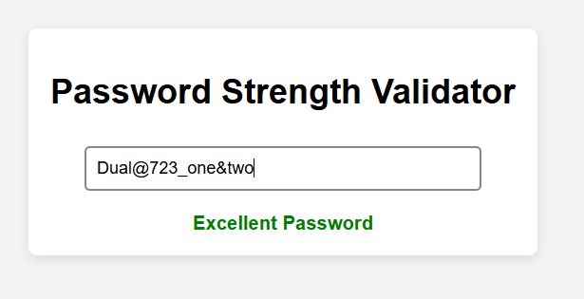

1. **Widget/Algorithm Used in Task:**

**Widgets Used**

1. HTML Input Field:
   * Used for entering the password (<input type="password">).
2. HTML Div Element:
   * Displays the password strength feedback (<div>).
3. CSS Classes:
   * Dynamically style the password strength as weak, good, strong, or excellent.

**Algorithm Used**

1. Input Event Listener:
   * Captures user input dynamically using JavaScript.
2. Password Strength Evaluation:
   * Checks the password length and diversity of character types (lowercase, uppercase, digits, special characters).
   * Identifies common patterns like sequential characters.
   * Determines the appropriate strength category based on conditions.
3. Dynamic DOM Manipulation:
   * Updates the content and class of the feedback element to reflect the evaluated password strength in real-time.