**OS Experiment-2**

LINUX COMMANDS

NAME: KHUSHI DALAL BATCH: A1

SAP: 60019210021

**Aim:** System calls for file manipulation

**PROCEDURE TO START LINUX TERMINAL:**

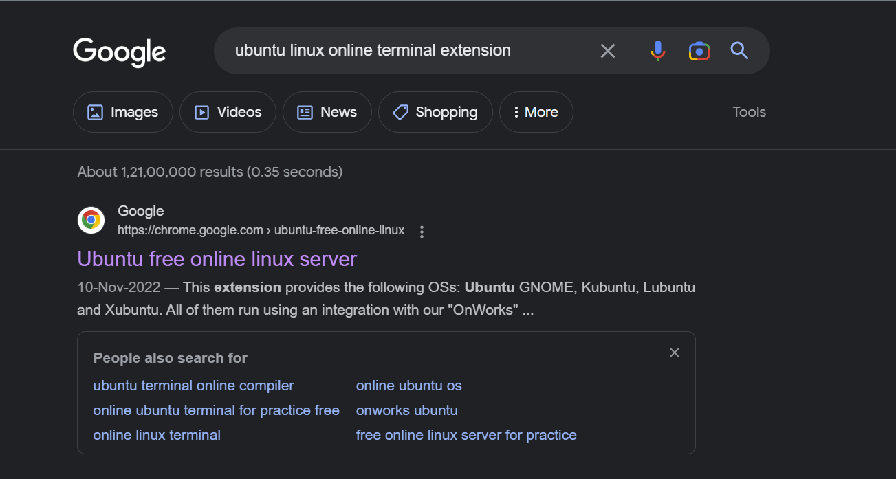

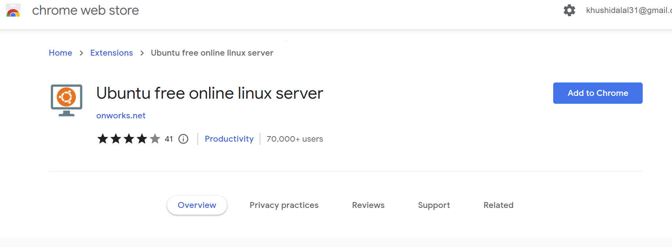

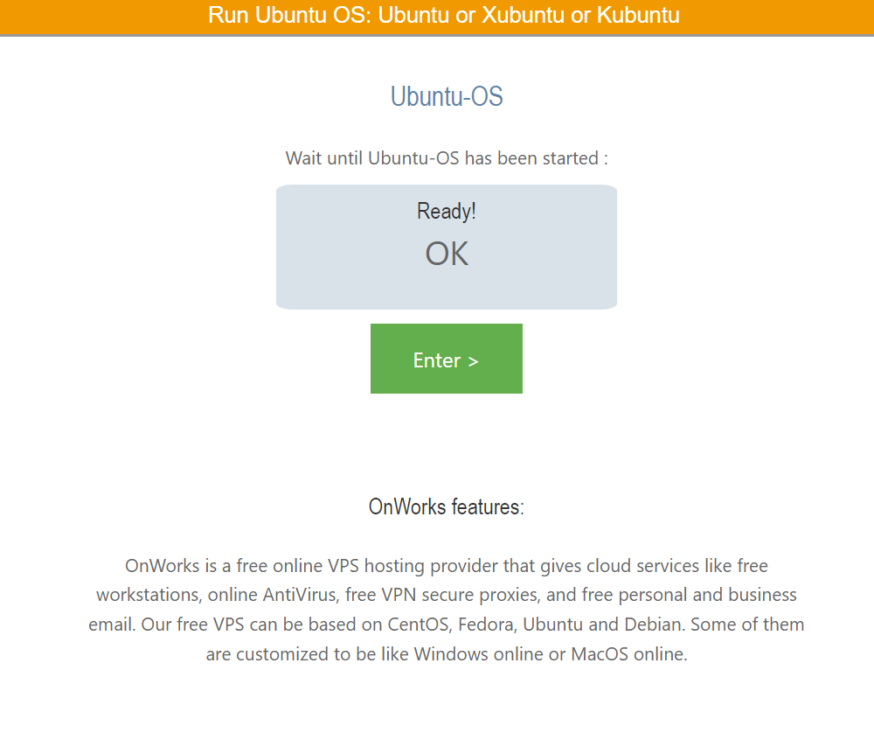

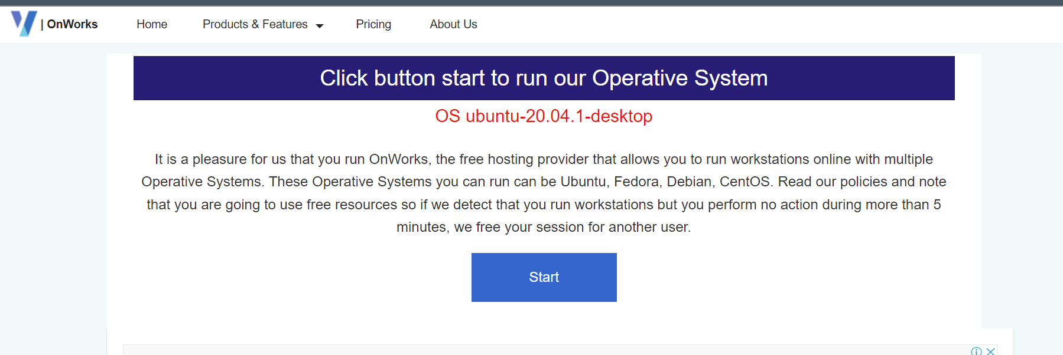

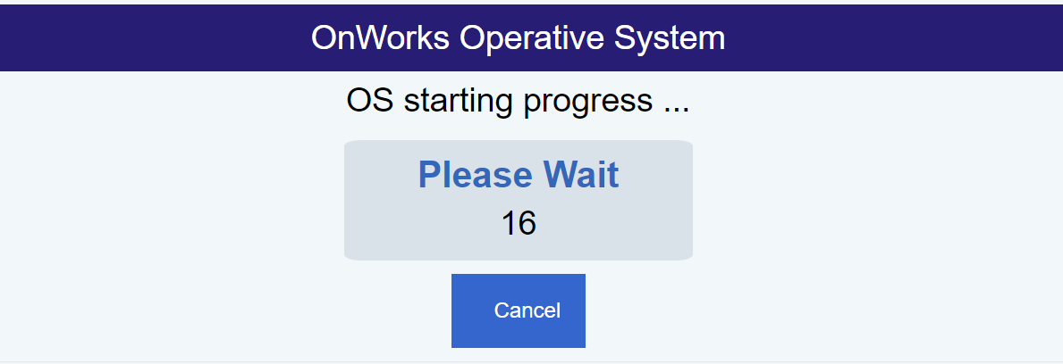

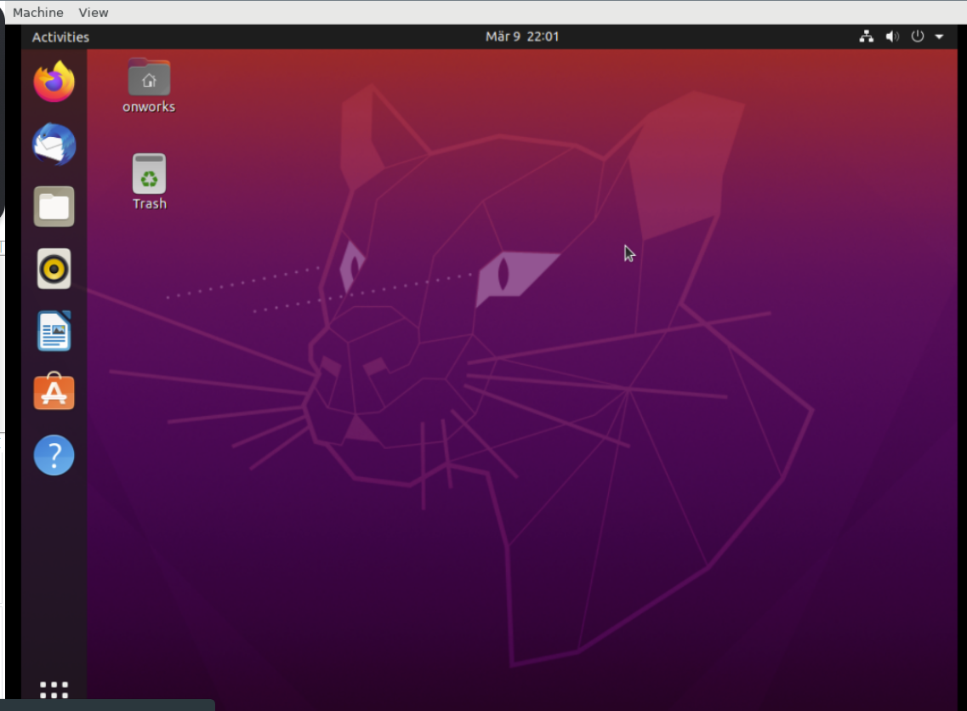

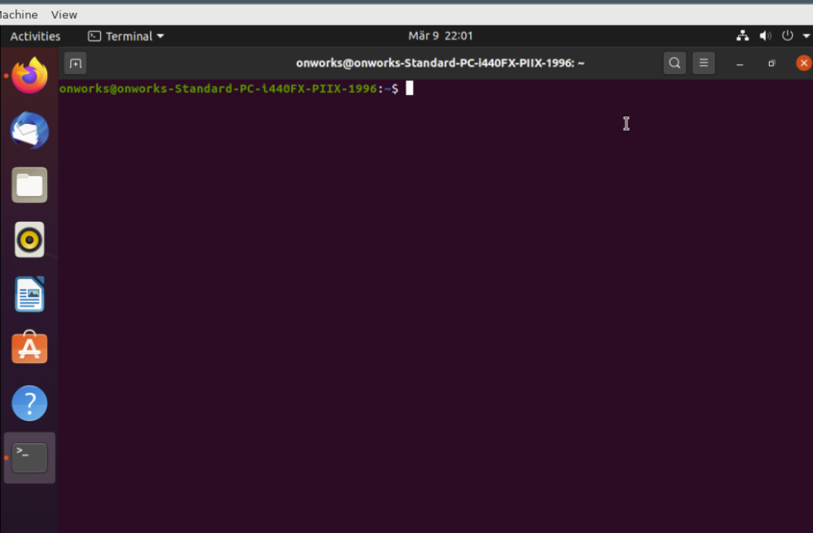

**Commands:**

1. pwd Command

This command displays the present working directory where you are currently in.

Syntax:

pwd [-options]

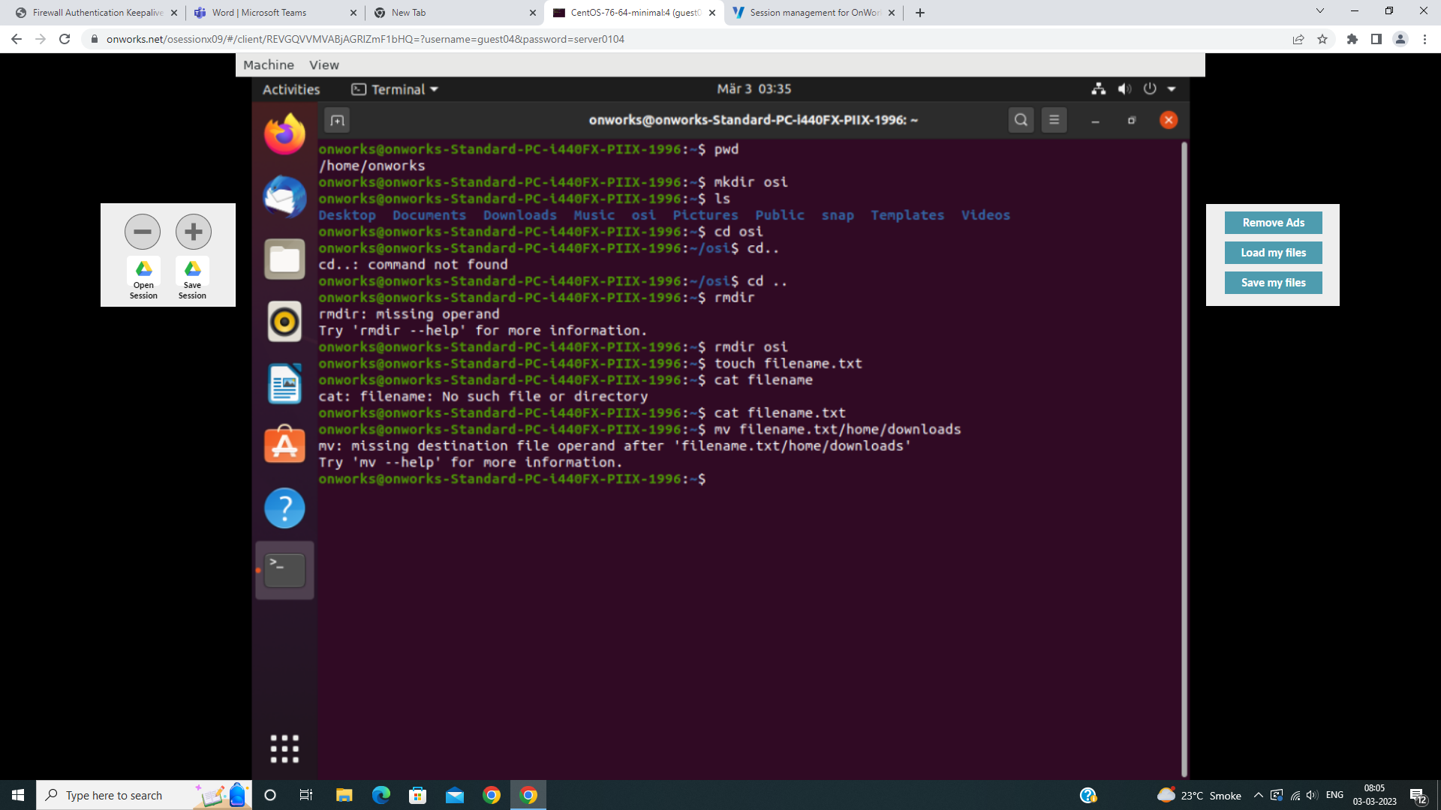

1. mkdir Command

This command will create a new directory, provided it doesn't exists.

Syntax:

mkdir –version



3. ls Command

This command will list the content of a directory.

Syntax:

ls



1. cd Command

This command is used to change directory.

In the following command we are moving to root directory.

$ cd /

In the following command we are moving to /var/www/html directory.

$ cd /var/www/html

cd ..

This command will take us one level up the directory tree.

$ cd ..

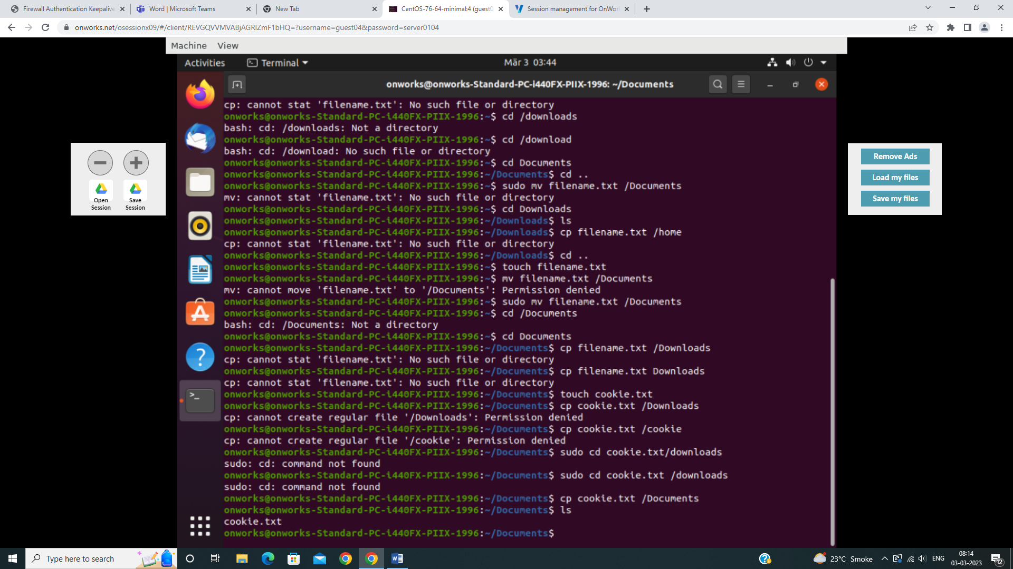

1. rmdir Command

This command will remove/delete an existing directory, provided it is empty.

In the following example will are removing/deleting an existing directory **example**.

$ rmdir example



1. touch Command

This command will creates a new file.

In the following example we are creating a new file **hello.txt**.

$ touch hello.txt



1. cat Command

This will print the content of a file.

In the following example we will get the content of the file **hello.txt** in the terminal.

$ cat hello.txt

The quick brown fox jumps over the lazy dog.

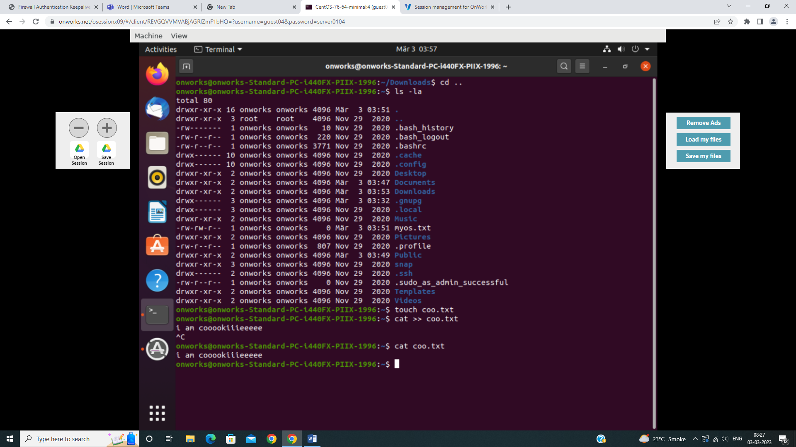

1. mv Command

stands for move files and directories

We can also use mv command to move files and directories.

Syntax:

mv [Option] source destination

In the following example we are moving file hello.txt from directory **example** to directory **awesome**.

$ mv /example/hello.txt /awesome/

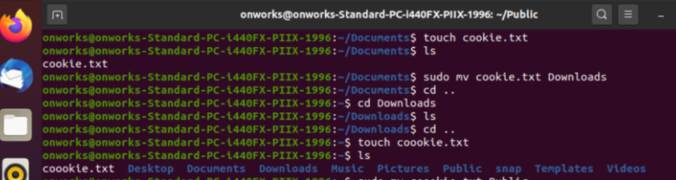

1. cp Command

This command copies the content of file **file1** into file **file2**.

If file **file2** doesn't exists then it is created. If it exists then its content is overwritten.

In the following example we are copying the content of file **hello.txt** to **hi.txt**.

$ cp hello.txt hi.txt



1. Deleting a File

This command will delete a file.

In the following example we are deleting a file by the name **hello.txt**.

$ rm hello.txt



**Conclusion:** Thus we implemented file manipulation commands on linux terminal.