Customer Churn Prediction Report
Automated churn analysis for subscription business | Telco Customer Churn Dataset

Executive Summary
This report analyzes 7043 customers to predict churn and identify key risk factors. The overall churn rate is 26.54%, resulting in a monthly revenue loss of $139,130.85. Retained customers show significantly higher lifetime value ($2,555.34) compared to churned customers ($1,531.80).

Key Performance Indicators
Metric | Value
Total Customers | 7,043
Churn Rate | 26.54%
Retention Rate | 73.46%
Monthly Revenue Loss | $139,130.85
Average CLV | $2,283.30
Avg CLV (Churned) | $1,531.80
Avg CLV (Retained) | $2,555.34

Machine Learning Models
Three classification models were trained using 5-fold stratified cross-validation. Logistic Regression achieved the highest ROC-AUC score.
Model | ROC-AUC | Accuracy | Precision | Recall | F1 Score
LogisticRegression (best) | 0.8422 | 0.8062 | 0.6593 | 0.5588 | 0.6049
RandomForest | 0.8259 | 0.7921 | 0.6355 | 0.508 | 0.5646
XGBoost | 0.8326 | 0.7935 | 0.6309 | 0.5348 | 0.5789

ROC Curves Comparison
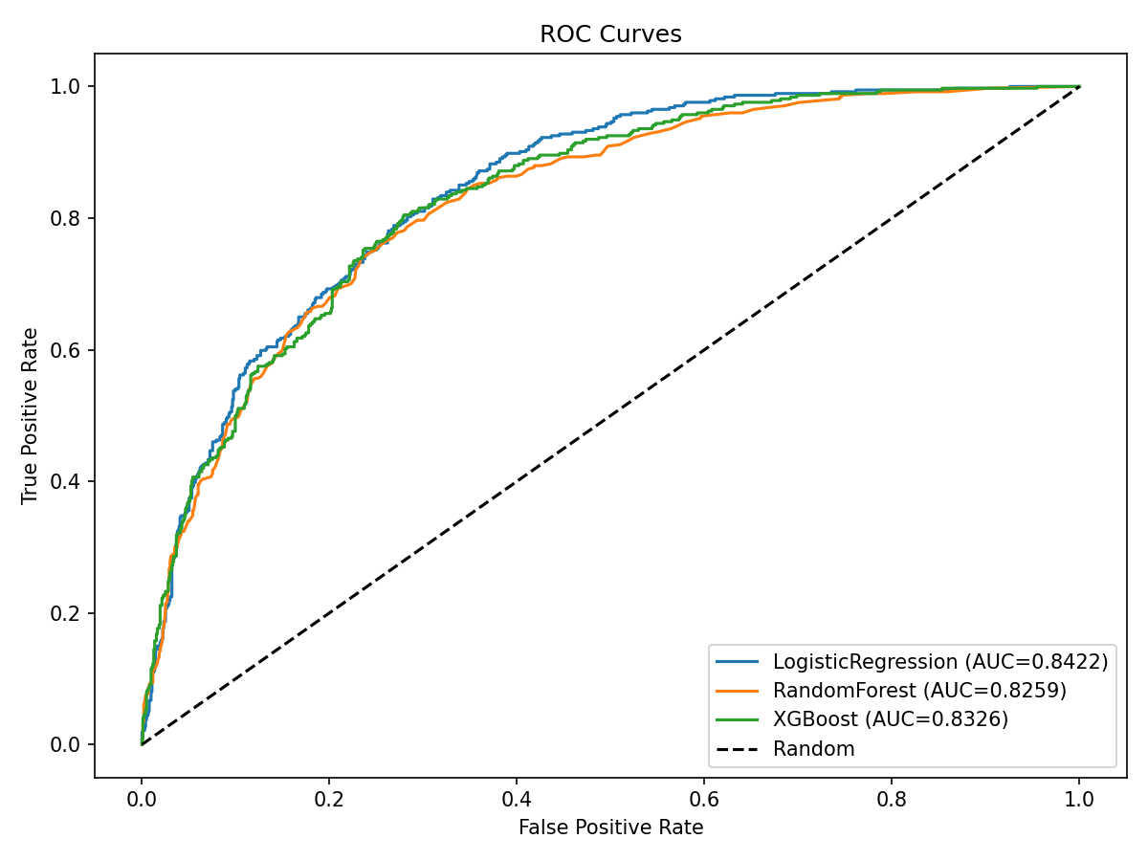

Confusion Matrices
LogisticRegression
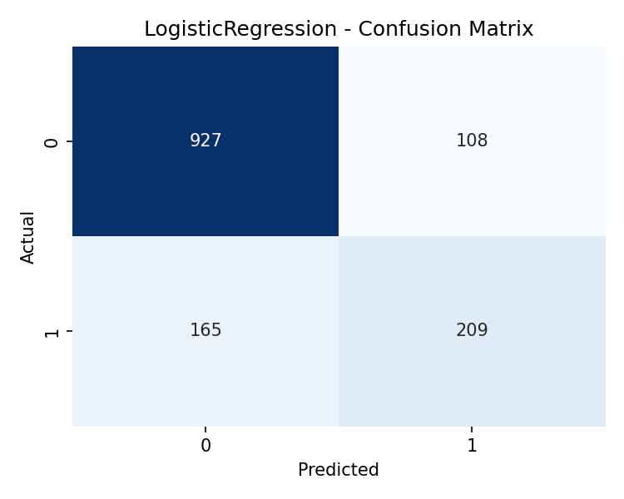

RandomForest
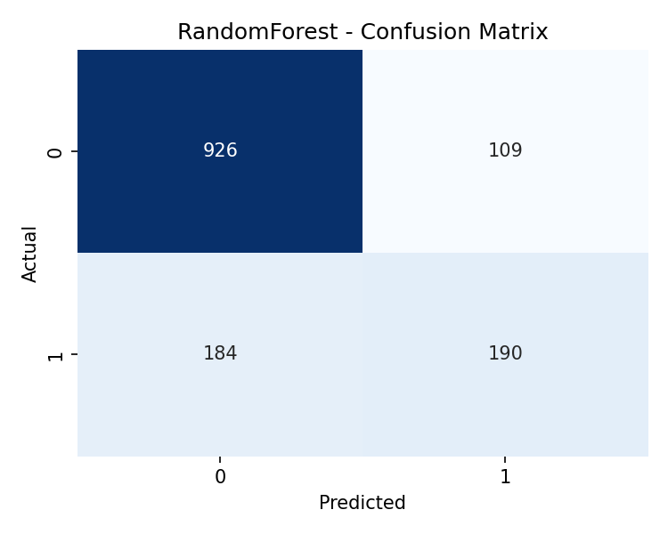

XGBoost
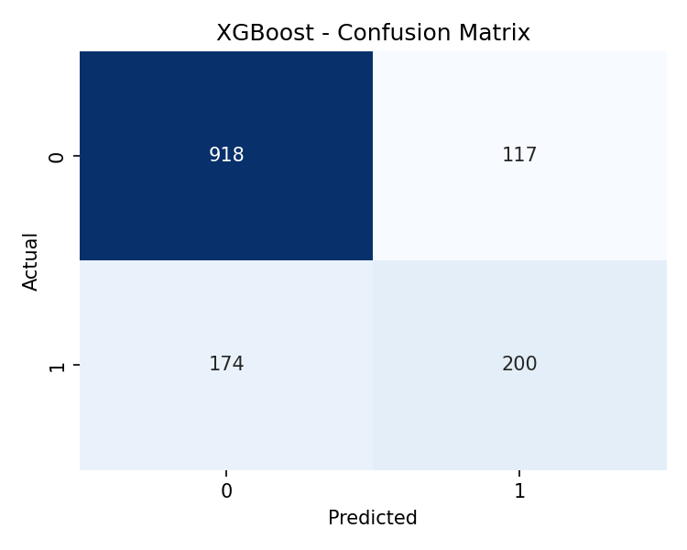

Feature Importance
Random Forest feature importance reveals the top predictors of churn. Tenure, MonthlyCharges, and TotalCharges dominate — customers who are newer, pay higher monthly fees, and have lower total charges are most at risk.
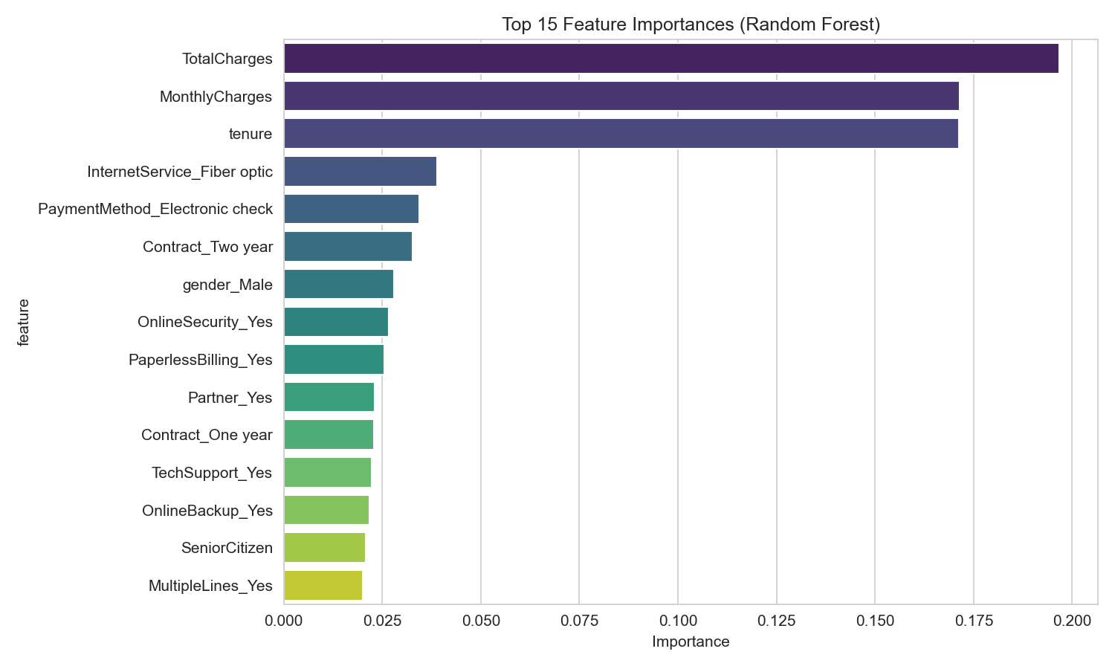

SHAP Analysis
SHAP summary plot (XGBoost) confirms that high MonthlyCharges and low tenure are the strongest drivers pushing customers toward churn. Fiber optic internet service and electronic check payment method also increase churn probability.
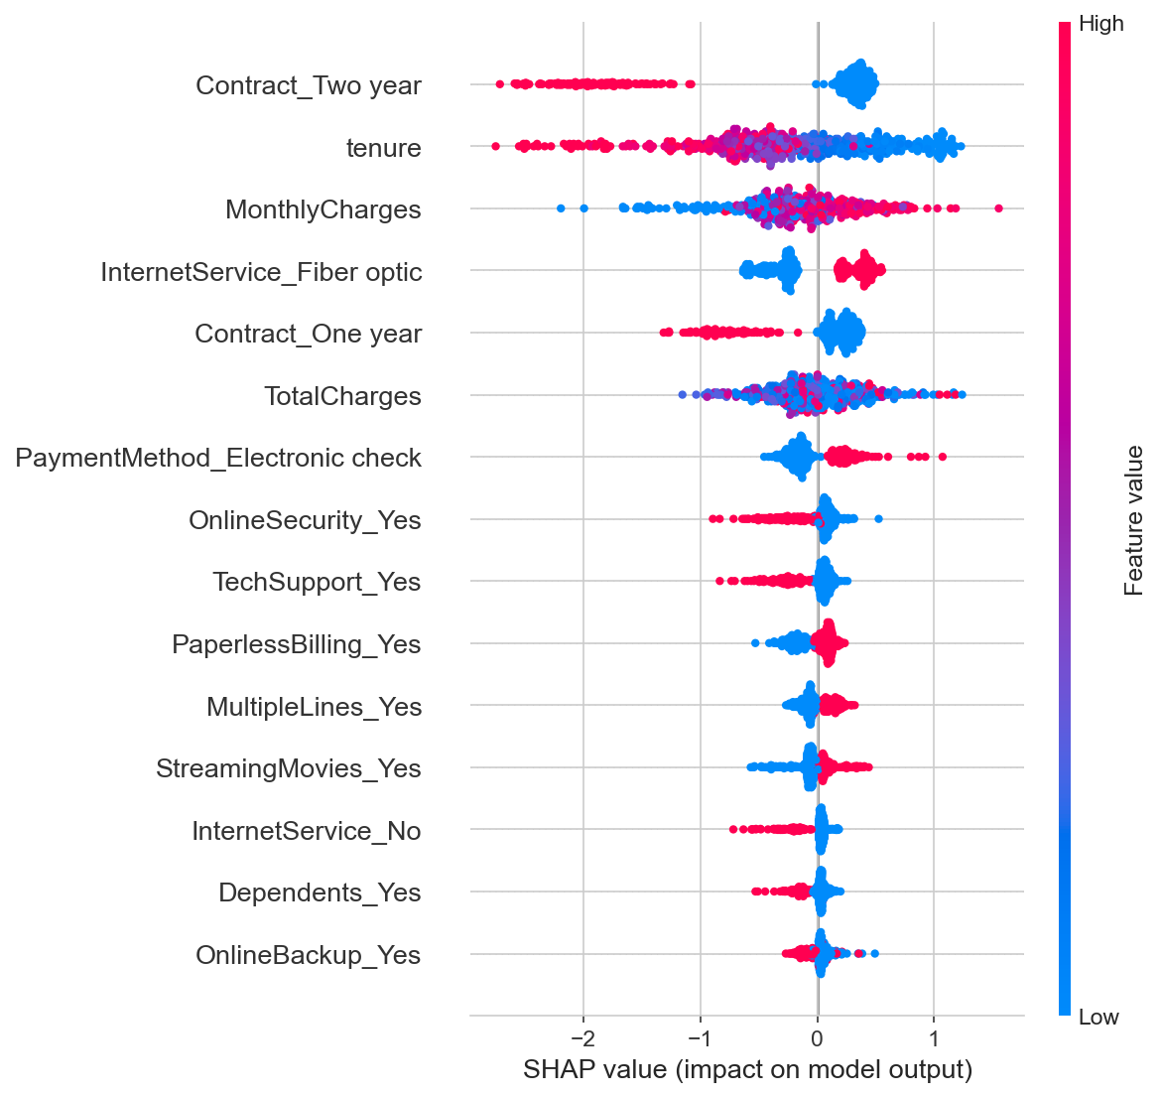

Customer Segmentation
K-Means clustering identified 4 distinct customer segments. Cluster 3 (short tenure, high charges) has the highest churn rate at ~48%, while Cluster 2 (long tenure, low charges) has the lowest at ~5%.
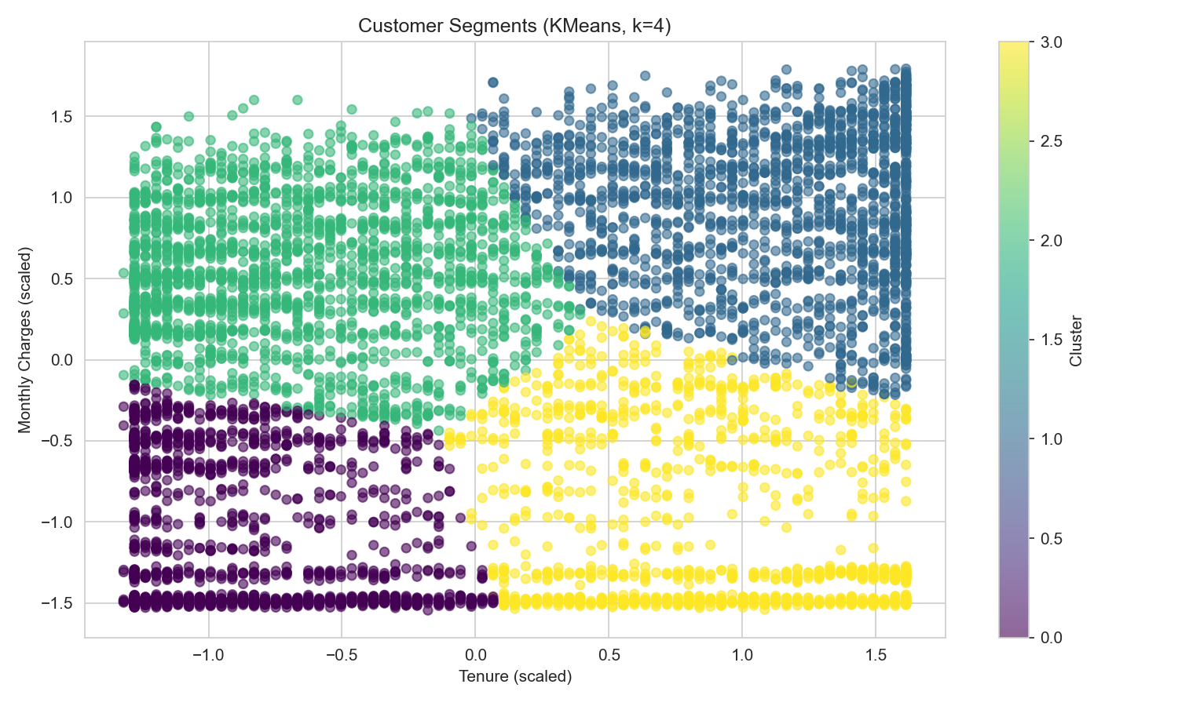

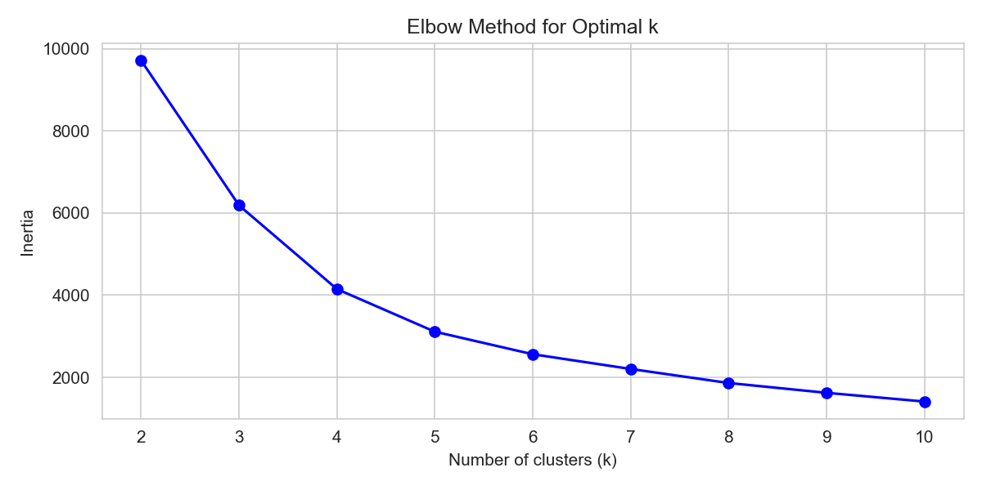

Key Insights & Recommendations
- Month-to-month contracts have the highest churn rate — promote annual/biannual plans.
- Customers with Fiber optic internet churn more than DSL — investigate service quality and pricing.
- High support ticket volume strongly correlates with churn — prioritize early intervention.
- Customers in the first 12 months of tenure are most vulnerable — implement onboarding engagement.
- Electronic check payment method correlates with higher churn — incentivize auto-pay.
- Cluster 3 (short tenure, high charges) represents the highest-risk segment — target retention offers.

SQL Analysis Queries
The following SQL queries analyze churn patterns across contract types, payment methods, tenure groups, and services:
-- 1. Churn rate by contract type
SELECT
Contract,
COUNT(*) AS total_customers,
SUM(CASE WHEN Churn = 'Yes' THEN 1 ELSE 0 END) AS churned,
ROUND(100.0 * SUM(CASE WHEN Churn = 'Yes' THEN 1 ELSE 0 END) / COUNT(*), 2) AS churn_rate_pct
FROM telco_churn
GROUP BY Contract
ORDER BY churn_rate_pct DESC;
-- 2. Churn rate by payment method
SELECT
PaymentMethod,
COUNT(*) AS total_customers,
SUM(CASE WHEN Churn = 'Yes' THEN 1 ELSE 0 END) AS churned,
ROUND(100.0 * SUM(CASE WHEN Churn = 'Yes' THEN 1 ELSE 0 END) / COUNT(*), 2) AS churn_rate_pct
FROM telco_churn
GROUP BY PaymentMethod
ORDER BY churn_rate_pct DESC;
-- 3. High-risk segments (tenure < 12 months, month-to-month contract, fiber optic)
SELECT
CASE
WHEN tenure < 6 THEN '0-6 months'
WHEN tenure < 12 THEN '6-12 months'
WHEN tenure < 24 THEN '12-24 months'
WHEN tenure < 48 THEN '24-48 months'
ELSE '48+ months'
END AS tenure_group,
COUNT(*) AS total_customers,
SUM(CASE WHEN Churn = 'Yes' THEN 1 ELSE 0 END) AS churned,
ROUND(100.0 * SUM(CASE WHEN Churn = 'Yes' THEN 1 ELSE 0 END) / COUNT(*), 2) AS churn_rate_pct
FROM telco_churn
GROUP BY tenure_group
ORDER BY tenure_group;
-- 4. Monthly revenue loss due to churn
SELECT
SUM(MonthlyCharges) AS total_monthly_revenue,
SUM(CASE WHEN Churn = 'Yes' THEN MonthlyCharges ELSE 0 END) AS monthly_revenue_loss,
ROUND(100.0 * SUM(CASE WHEN Churn = 'Yes' THEN MonthlyCharges ELSE 0 END) / SUM(MonthlyCharges), 2) AS revenue_loss_pct
FROM telco_churn;
-- 5. Internet service vs churn
SELECT
InternetService,
COUNT(*) AS total_customers,
SUM(CASE WHEN Churn = 'Yes' THEN 1 ELSE 0 END) AS churned,
ROUND(100.0 * SUM(CASE WHEN Churn = 'Yes' THEN 1 ELSE 0 END) / COUNT(*), 2) AS churn_rate_pct
FROM telco_churn
GROUP BY InternetService
ORDER BY churn_rate_pct DESC;
-- 6. Senior citizen churn analysis
SELECT
SeniorCitizen,
COUNT(*) AS total_customers,
SUM(CASE WHEN Churn
-- (truncated — see sql/churn_analysis.sql for full content)

Dashboard References
- Power BI Pages: Overview (KPIs), Risk Analysis (segments), Behavior Analysis (tenure/charges vs churn), Service Analysis (support tickets, internet service).
- Tableau Elements: Risk heatmap, customer segmentation clusters, funnel analysis.

