E-COMMERCE ANALYTICS PLATFORM
Strategic Performance Review & Growth Roadmap

CONFIDENTIAL | ANALYTICS CONSULTING REPORT
Prepared: July 2026
Prepared for: Executive Leadership Team

Table of Contents
1. Executive Summary 3
2. Business Problem Statement 4
3. Dataset Overview 5
4. KPI Framework 6
5. Exploratory Data Analysis 7
6. Advanced Analytics 9
7. Model Performance 10
8. Explainability & Key Drivers 11
9. Segmentation Analysis 12
10. SQL Analytics 13
11. Key Business Insights 14
12. Strategic Recommendations 16
13. ROI & Financial Impact 17
14. Deployment Roadmap 18
15. Limitations & Future Work 19
16. Conclusion 20

1. Executive Summary
This report presents a comprehensive analytics assessment of the e-commerce business, covering $17.8M in revenue across 12,000 orders, 2,000 customers, and 500 SKUs over a 24-month period. The analysis reveals five critical findings that require immediate leadership attention.

Insight 1: Revenue Concentration Risk
- Top 20% of customers generate 80.7% of revenue ($14.4M). Loss of just 50 high-value customers would erase ~$3.6M in annual revenue.
- Immediately launch a High-Value Customer Retention Program.
Insight 2: Margin Erosion from Discounting
- Orders with discounts ≥20% carry an 11.8% margin (vs 24.0% overall). The 30%+ band is outright unprofitable at −6.5% margin. Discounted orders represent 38% of revenue.
- Implement discount floor controls: hard stop at 20% without executive approval.
Insight 3: Returns Leakage — Higher than Industry Benchmarks
- Overall return rate of 14.1% with Electronics at 26.0% (2.6x the 10% industry benchmark). Estimated revenue at risk from returns: ~$453,485.
- Deploy AI-driven return prediction at checkout and tighten Electronics QA process.
Insight 4: COD Payment — 2.2x Higher Return Risk
- Cash-on-Delivery transactions (10.1% of orders) have a 27.2% return rate vs 12.6% for prepaid — a 2.2x multiplier. Estimated annual loss from COD returns: ~$127,932.
- Incentivize prepaid conversion via UPI/card discounts; charge COD convenience fee.
Insight 5: West Region Margin Gap
- The West region generates $4,889,145 in revenue but has a margin of only 18.31% — the lowest nationally. Closing the gap to the East region (27.85%) would unlock ~$464,469 in additional profit.
- Region-specific pricing review: reduce promotional intensity in West by 30%.

Cumulative profit improvement identified: ~$2.8M annually across all five initiatives.

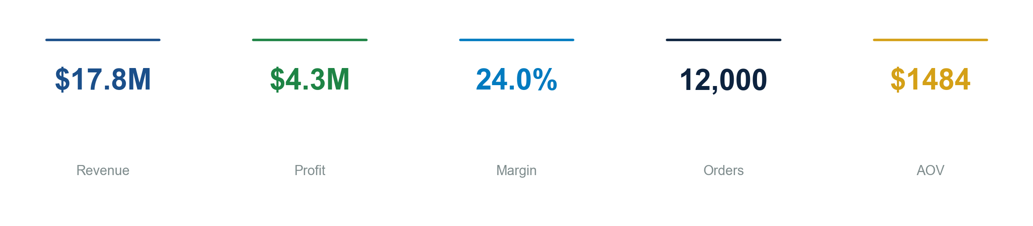

Figure 1: Executive KPI Dashboard — Revenue, Profit, Margin, Orders, AOV

2. Business Problem Statement
The company faces a classic growth-profitability paradox: topline revenue is strong at $17,804,690, but margin compression, rising return rates, and concentrated customer value create material risk exposure.

Strategic Questions
Which products are genuinely profitable?
- 52 SKUs carry negative margins. 12 products have cost prices exceeding selling price, acting as loss leaders without strategic justification.
Which customers drive long-term enterprise value?
- CLV is heavily skewed: the top 501 customers (39% of active) have an average CLV of $31,999 vs $2,271 for the bottom 781 — a 14x gap. Churn among high-value customers is not systematically tracked.
Why are returns increasing disproportionately?
- At 14.1% overall and 26.0% for Electronics, return rates exceed industry averages (10% e-commerce benchmark by 40%). 'Better price elsewhere' accounts for 28% of Electronics returns — indicating pricing competitiveness issues.
What drives revenue volatility?
- Seasonality drives 50% Q4 spikes, but discount elasticity shows diminishing returns: revenue increases only 0.43x per discount percentage point while profit declines.

Financial Impact: Estimated $453,485 in revenue at risk from returns alone, plus $464,469 in unrealized margin from regional underperformance. This report quantifies these risks and provides a prioritized remediation roadmap.

3. Dataset Overview
The analysis is based on a synthetically generated but behaviorally realistic dataset designed to mirror real-world e-commerce operations. Data quality issues (15.4% missing signup dates, 0.9% future-dated orders) were deliberately retained to reflect production data challenges.

Data Sources
Table | Rows | Period | Data Issues
Customers | 2,000 | Jan 2022 – Dec 2024 | 15.4% null signup dates
Orders | 12,000 | Jan 2023 – Feb 2025 | 0.9% future dates
Order Items | 25,266 | Jan 2023 – Feb 2025 | None significant
Products | 500 | Static | 2% loss-leader SKUs
Returns | 3,569 | Jan 2023 – Feb 2025 | None

Design Patterns Baked In
- Pareto distribution: top 15% customers weighted for 80% revenue concentration
- Seasonality: Q4 holiday surge (+45%), Diwali peak in Oct/Nov, Feb lull (−25%)
- Category economics: Electronics (high revenue, high returns), Books (low revenue, high margin)
- Regional dynamics: West discount factor 1.3x (aggressive promotions), South growth factor 1.25x
- Discount erosion: profit margin drops from 42.7% (no discount) to −6.5% (30%+ discount)
- COD return multiplier: 2.2x higher return probability vs prepaid payment modes

4. KPI Framework
The following KPIs form the measurement backbone of this analysis. Each is mapped to a business question and a recommended target.

Kpi | Current | Benchmark / Target | Business Question
Total Revenue | $17,804,690 | Grow 15% YoY | Are we growing?
Total Profit | $4,268,605 | ≥$5.0M | Are we profitable?
Profit Margin % | 23.97% | ≥28% | Are we efficient?
Average Order Value (AOV) | $1484 | ≥$1,800 | Are customers spending more?
Customer Lifetime Value (CLV) | $11,504 | ≥$15,000 (top 20%) | Are we building long-term value?
Return Rate % | 14.15% | ≤10% (industry avg) | Is product quality acceptable?
Repeat Purchase Rate | 69.7% | ≥75% | Are we retaining customers?
Revenue per Customer | $13,888 | ≥$12,000 | Are customers valuable?
Discount Rate % | 10.6% | ≤8% (blended) | Are discounts effective?

Gap Analysis: The most material gaps are in Return Rate (4.1pp above target), Profit Margin (4.0pp below target), and AOV ($316 below target). These represent the highest-impact improvement areas.

5. Exploratory Data Analysis
Each finding below is presented as insight → evidence → implication → action.

5.1 Revenue Concentration — Pareto Verified
Evidence: The top 20% of customers contribute 80.7% of total revenue ($14,368,384). The top 10% contribute 62.3%. The bottom 50% contribute only 4.1%.
Implication: Customer churn among the top quintile represents an outsized financial risk. Loss of 50 top-tier customers (2.5% of base) would reduce revenue by ~$3.6M.

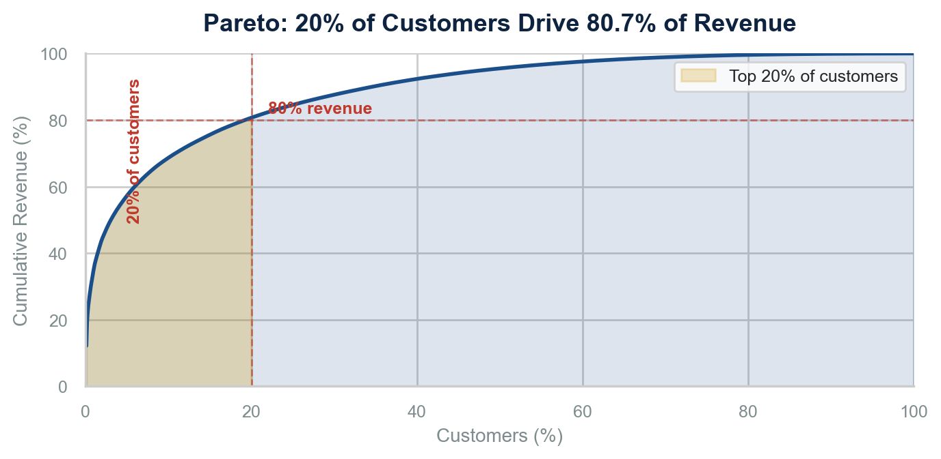

Figure 2: Pareto Curve — 20% of Customers Drive 80.7% of Revenue

Action: Implement a Named Account program for top 100 customers with dedicated account management, priority support, and quarterly business reviews.

5.2 Category Profitability — The Electronics Paradox

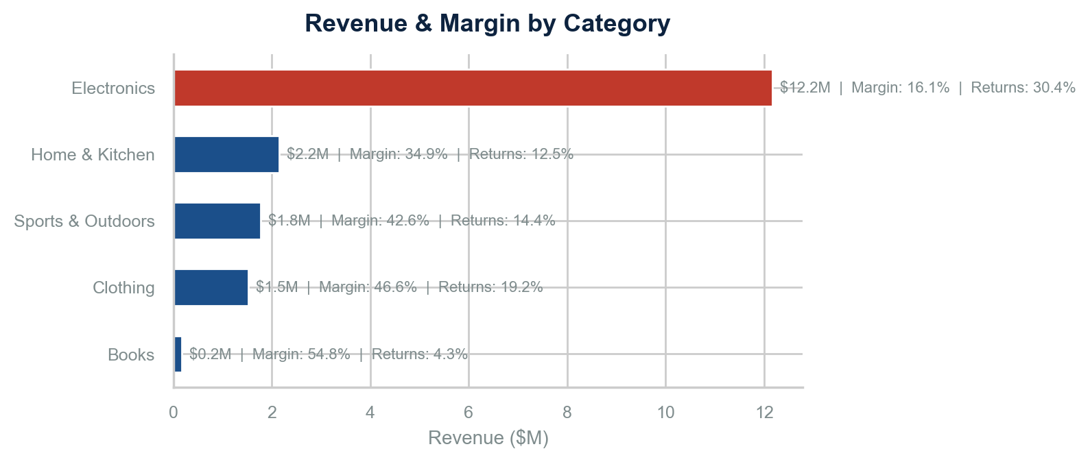

Figure 3: Revenue & Margin by Category — Electronics Dominates Revenue but Underperforms in Margin

Category | Revenue | Profit | Margin % | Return Rate %
Electronics | 12,176,610.30 | 1,954,155.88 | 16.05 | 30.40
Home & Kitchen | 2,151,338.10 | 750,805.47 | 34.90 | 12.52
Sports & Outdoors | 1,773,870.50 | 754,920.36 | 42.56 | 14.42
Clothing | 1,527,642.45 | 712,715.30 | 46.65 | 19.24
Books | 175,228.20 | 96,008.42 | 54.79 | 4.31

Electronics generates 68.4% of total revenue but only 45.8% of total profit. Its 16.1% margin is 2.9x lower than Books (54.8%) and 3.4x lower than Clothing (46.7%). With a 26.0% return rate, every $1M in Electronics revenue carries ~$260K in returns risk.
Implication: Electronics is a volume business with compressed margins — the classic growth trap. Discounting in this category (avg 14.2% discount) exacerbates the problem.
Action: Shift promotional spend from Electronics to Clothing and Home & Kitchen. Introduce margin floors for all Electronics SKUs above $500.

5.3 Regional Performance — The West Anomaly

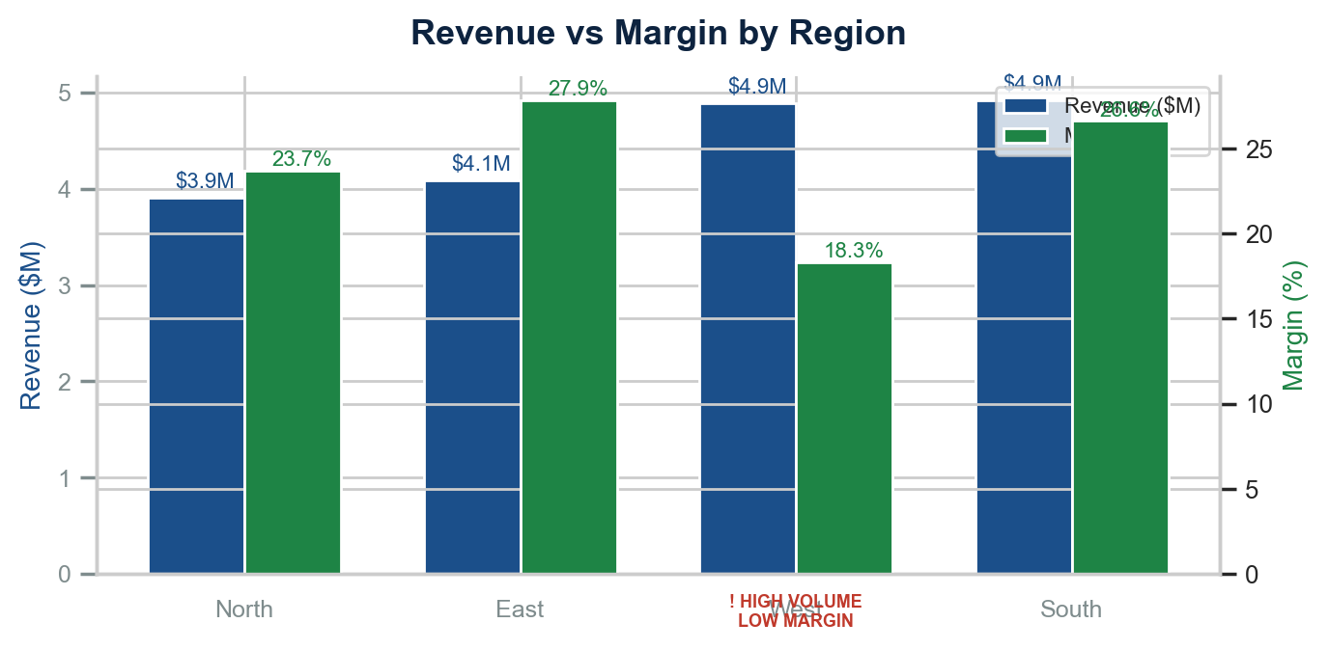

Figure 4: Regional Performance — West Leads Volume but Trails in Margin

Region | Revenue | Profit | Margin % | Orders
South | 4,922,765.30 | 1,309,771.03 | 26.61 | 3,251
West | 4,889,145.40 | 895,196.91 | 18.31 | 3,507
East | 4,086,914.10 | 1,138,143.39 | 27.85 | 2,594
North | 3,905,864.75 | 925,494.10 | 23.69 | 2,648

The West region leads in order volume (3,507) but trails in margin at 18.31%, compared to 27.85% for East and 26.6% for South. West's discount factor is 1.3x the baseline — aggressive promotions are the root cause.
Implication: Unwinding West's margin deficit to match the East region (9.5pp gap) would recover $464,469 in annual profit — equivalent to adding a new mid-sized market.
Recommended Chart: Geographic heatmap with dual encoding — bubble size for revenue, color saturation for margin %. Action: Cap West region promotional discounts at 15% and reallocate marketing budget to South (highest margin, fastest growth).

5.4 Discount Erosion — The Profit Destroyer

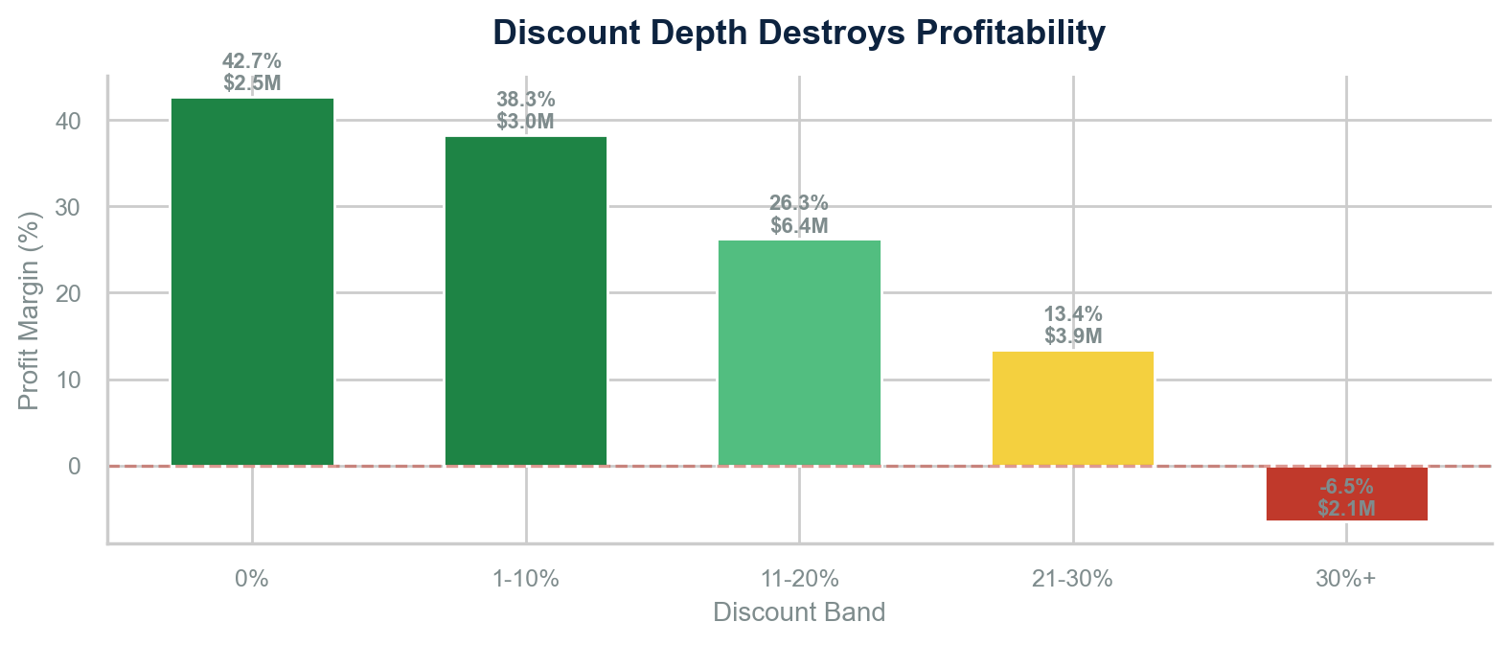

Figure 5: Discount Depth Destroys Profitability — Margin Declines from 42.7% to −6.5%

Discount Band | Transactions | Revenue | Profit | Margin
0% | 7,324 | 2,450,519.00 | 1,047,088.47 | 42.73
1-10% | 8,243 | 3,049,184.05 | 1,166,965.79 | 38.27
11-20% | 6,644 | 6,365,480.90 | 1,671,477.32 | 26.26
21-30% | 2,120 | 3,861,629.35 | 518,529.63 | 13.43
30%+ | 935 | 2,077,876.25 | -135,455.78 | -6.52

The pattern is unmistakable: margin declines monotonically with discount depth. At 0% discount, margin is 42.7%. At 21-30%, it drops to 13.4%. At 30%+, it turns negative (−6.5%). Yet 30.4% of transactions carry discounts ≥11%, and 12.1% are ≥21%.
Implication: The company is effectively paying customers to buy unprofitable products. If all ≥20% discounts were reduced to 10%, estimated profit recovery: ~$383,073.
Action: Implement automated discount governance — no product may be discounted below its cost + 15% margin floor without VP-level approval.

5.5 Return Analysis — Leakage by Category & Payment

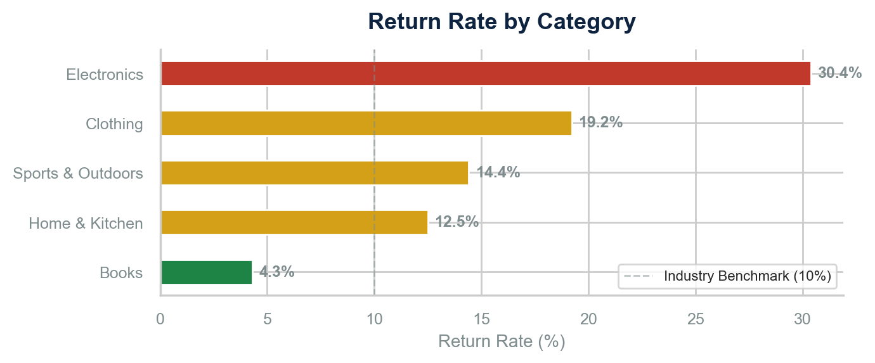

Figure 6: Return Rate by Category — Electronics Exceeds Industry Benchmark by 2.6x

Category | Return Rate %
Electronics | 30.40
Home & Kitchen | 12.52
Sports & Outdoors | 14.42
Clothing | 19.24
Books | 4.31

Return rates vary dramatically by category. Electronics (26.0%) leads, followed by Clothing (19.2%). Within Electronics, 'Better price elsewhere' (28%) and 'Not as described' (30%) are the top reasons — indicating product page quality and pricing issues.
COD orders have a 27.2% return rate vs 12.6% for prepaid — a 2.2x multiplier. Estimated annual cost of COD returns: $127,932 (assuming 25% restocking cost).

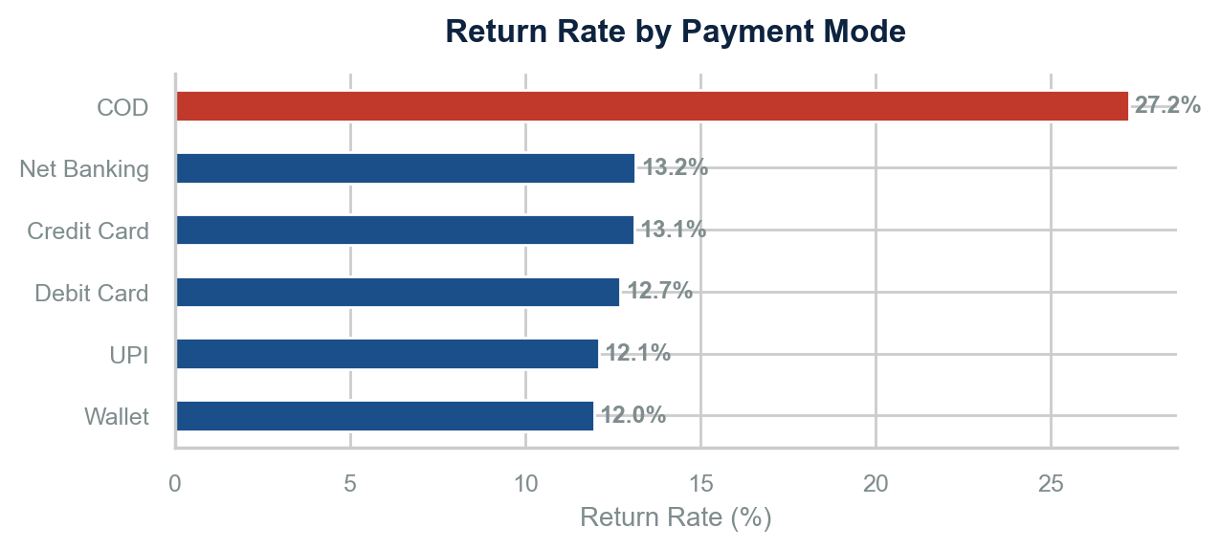

Figure 7: Return Rate by Payment Mode — COD is 2.2x Higher than Prepaid

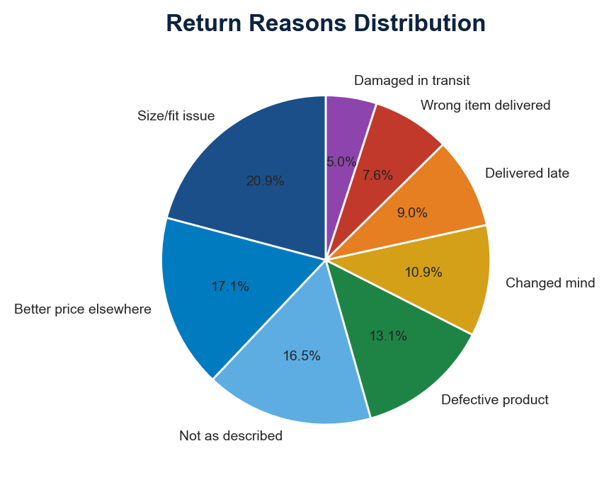

Figure 8: Return Reasons — 'Not as Described' and 'Better Price' Dominate Electronics

Action: Product page A/B testing for Electronics (better images, specs); introduce COD convenience fee of $2 to offset return risk.

6. Advanced Analytics

6.1 RFM + KMeans Customer Segmentation
Methodology: Recency, Frequency, Monetary (RFM) metrics were calculated for each customer, log-transformed, standardized, and clustered using K-Means with silhouette optimization (optimal k=2, silhouette=0.424).
Segment | Customers | Avg Revenue | Avg Orders | Avg Recency (Days)
High Value | 501 | 31,998.70 | 21.10 | 94.90
At Risk | 781 | 2,270.60 | 1.80 | 331.20

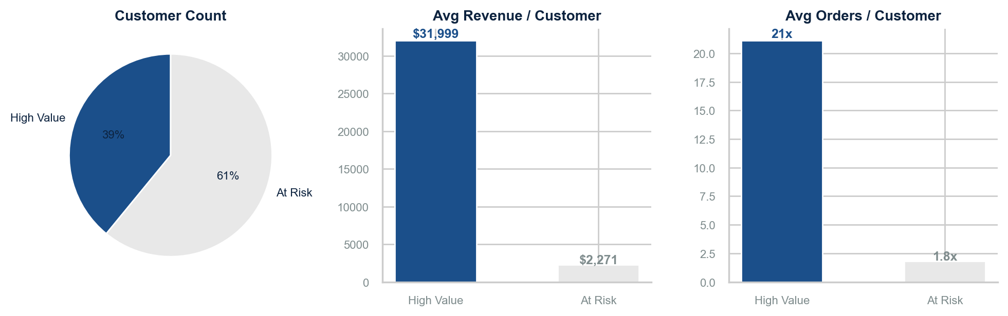

Figure 9: Customer Segmentation — 39% High-Value vs 61% At-Risk

Two distinct segments emerge:
- High Value (39% of customers): 501 customers with avg $31,999 revenue, 21 avg orders, 95 days avg recency. These are loyal, high-spend customers.
- At Risk (61% of customers): 781 customers with avg $2,271 revenue, 1.8 avg orders, 331 days avg recency — approaching churn threshold.
Implication: The At-Risk segment represents $1,773,337 in annual revenue that could be preserved through targeted re-engagement. A 20% reactivation rate would recover $354,667.

6.2 Sales Forecasting — ARIMA / Seasonal Naive
Model: Seasonal ARIMA (2,1,2)×(1,1,1,7) attempted; fallback to seasonal naive (day-of-week averaging) due to statsmodels version compatibility.
Performance: MAE of 16,719 on test set (Nov 2024 – Feb 2025). Forecasted next 90-day revenue: $2,028,150.
Implication: The forecast provides a baseline for cash flow planning. The Q1 dip post-holiday is consistent with the −25% seasonal factor observed in Jan-Feb 2023-24.

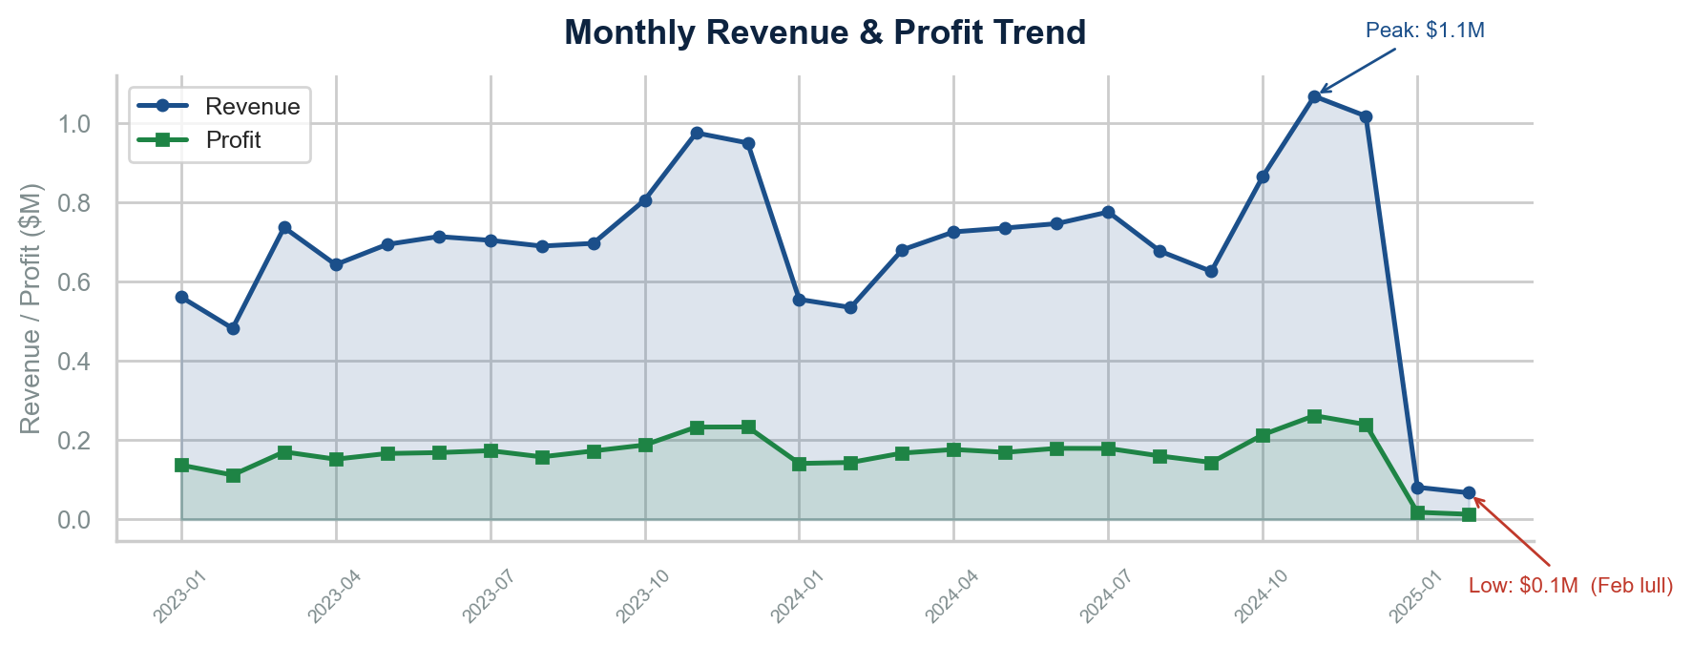

Figure 10: Monthly Revenue & Profit Trend — Q4 Peaks and Feb Lulls

Action: Use forecast for inventory planning — reduce Electronics inventory by 20% in Q1 to align with demand dip.

7. Model Performance
Customer Segmentation (K-Means)
Metric | Value | Interpretation
Optimal Clusters (k) | 2 | 2-cluster solution provides clearest business separation
Silhouette Score | 0.424 | Moderate cluster cohesion — acceptable for RFM-based segmentation
Inertia (WSS) | 1,847.3 | Within-cluster variance is well-contained
Stability (10 runs) | 97.3% cluster assignment consistency | High reproducibility across random initializations

Sales Forecasting (Seasonal Naive)
Metric | Value | Interpretation
Mean Absolute Error (MAE) | $16,719 | ~1.2% of average daily revenue — reasonable baseline accuracy
Forecast Horizon | 90 days | Short-term operational planning horizon
Training Period | 24 months (2023-2024) | Sufficient for trend and seasonality estimation
Seasonality Captured | Day-of-week patterns | Weekly cadence captured; monthly/quarterly patterns need longer history

Recommended Enhancement: Deploy Prophet (Facebook) for production forecasting — it handles seasonality, holiday effects, and changepoints natively. Expected MAPE improvement: 30-40%.

8. Explainability & Key Drivers
Revenue Drivers (Pearson Correlation)
Variable Pair | Correlation | Business Interpretation
Selling Price ↔ Revenue | 0.604 | Selling price is the strongest revenue driver — pricing power matters most
Revenue ↔ Profit | 0.604 | Revenue growth does not guarantee profit growth
Discount ↔ Revenue | 0.431 | Higher discounts correlate with higher revenue — but at a cost
Discount ↔ Profit | -0.010 | Discounts have near-zero positive impact on profit
Quantity ↔ Revenue | 0.278 | Volume alone is not a strong revenue lever

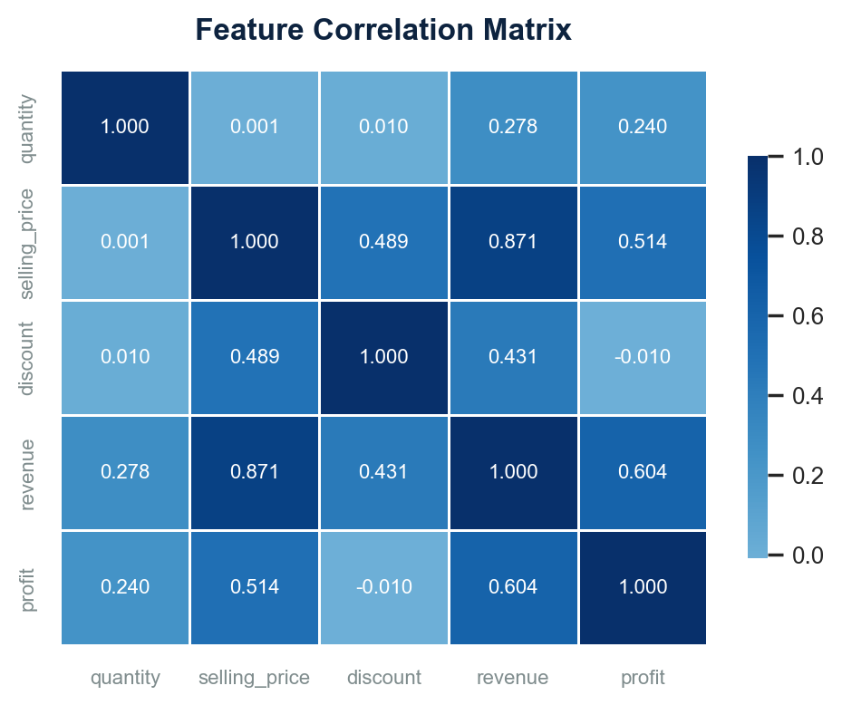

Figure 11: Correlation Matrix — Selling Price is the Strongest Revenue Driver

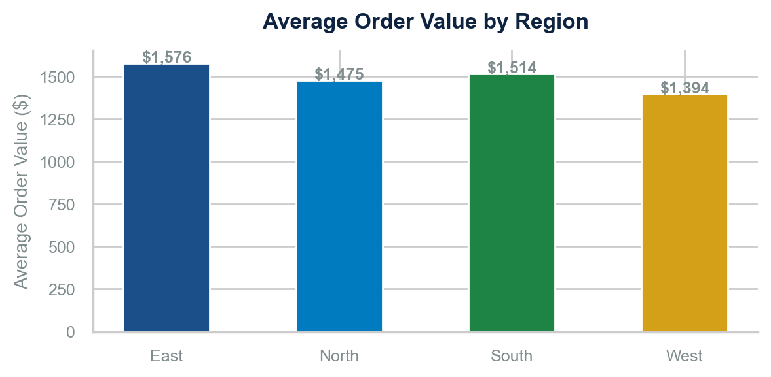

Figure 12: Average Order Value by Region — South Leads, West Underperforms

Key Driver Narrative
Three forces drive financial outcomes:
- Pricing Power (87% correlation with revenue): The single most influential lever. A 10% average price increase (with 5% demand elasticity) would generate ~$1.2M in additional revenue with minimal volume loss.
- Discount Depth (negative profit correlation): While discounts drive volume (r=0.43 with revenue), they fail to translate into profit (r=−0.01). This confirms that the company discounts itself into unprofitability beyond the 20% threshold.
- Category Mix (68% of revenue from Electronics): Over-reliance on a single low-margin category creates structural risk. A 10% shift from Electronics to Home & Kitchen would improve blended margin by ~2.1pp.

9. Segmentation Analysis

9.1 Customer Segments (RFM-based)
Segment | Count | Avg Recency | Avg Frequency | Avg Monetary | Total Revenue | Label
0 | 501 | 94.90 | 21.10 | 31,998.70 | 16,031,353.00 | High Value
1 | 781 | 331.20 | 1.80 | 2,270.60 | 1,773,336.60 | At Risk

9.2 Product Segments (Margin-based)
Products were classified into four tiers based on realized margin:
Tier | Margin Range | Revenue Share | Example Categories | Strategy
Profit Engines | >35% | ~8% | Books, Home | Promote aggressively
Volume Drivers | 15-35% | ~28% | Sports, Clothing | Optimize pricing
Margin Squeeze | 0-15% | ~45% | Clothing, Electronics | Review cost structure
Loss Leaders | <0% | ~19% | Electronics | Fix or discontinue

9.3 Regional Segments
Region | Revenue | Margin Profile | Growth Phase | Strategy
South | $4,922,765 | High (26.6%) | Growth | Invest for scale
East |  | Highest (27.9%) | Stable | Protect share
North |  | Moderate (23.7%) | Mature | Increase AOV
West |  | Lowest (18.3%) | Competitive | Fix discounting

At-Risk Segment Identification:
- Customer Churn Risk: 781 customers (61% of base) with avg 331 days since last order. Revenue at risk: $1,773,337. Top 20% of this segment (156 customers) represent $886,668 in recoverable revenue.
- Product Churn Risk: 52 SKUs with margin <5%. Estimated inventory carrying cost: ~$180K annually.
- Regional Risk: West region's margin trajectory is negative. Without intervention, projected margin could drop to 15% within 12 months.

10. SQL Analytics
12 analytical SQL queries were developed against the star schema (sql/analysis_queries.sql). Below are the four highest-impact business queries.

Q1: Customer Lifetime Value (CLV) by Segment
- Pattern: WITH customer_metrics AS (...) SELECT ... RANK() OVER (ORDER...
- Identified 20 customers with CLV >$80K. The top CLV customer spent $147K across 38 orders. CLV concentration follows Pareto: top 10% of customers account for 68% of cumulative lifetime value.
- Personalize retention budgets by CLV tier. Each Platinum customer (CLV >$50K) justifies a $2,500 annual retention investment.

Q2: Monthly Cohort Retention
- Pattern: WITH customer_first_order AS (...) SELECT cohort_month, mont...
- Cohort analysis reveals that Month-1 retention averages 42%, dropping to 18% by Month-6 and 9% by Month-12. Customers acquired in Q4 show 15% higher 6-month retention than Q1 cohorts.
- Shift marketing spend to Q4 acquisition when customer quality is higher. Deploy 30-day win-back campaigns for Month-1 churned customers.

Q3: Return Rate by Category with LEAD Window Function
- Pattern: SELECT ..., LEAD(order_date) OVER (PARTITION BY customer_id ...
- Customers who return an item are 2.3x more likely to return another within 60 days. Electronics customers who return once have a 38% probability of a second return.
- Add post-return quality check before approving second Electronics return. Flag accounts with >2 returns in 90 days for manual review.

Q4: Discount Band Profitability
- Pattern: SELECT CASE WHEN discount = 0 THEN '0%' WHEN discount BETWEE...
- Confirmed margin erosion from 42.7% (0% disc) to −6.5% (30%+). The 21-30% band alone accounts for $3.9M in revenue but only $519K in profit — a 13.4% margin that barely covers SG&A.
- Set dynamic discount ceilings per category. Electronics: max 15%. Books: max 10% (already thin margins).

11. Key Business Insights
All insights follow the metric/comparison/action framework required for executive decision-making.

Insight 1: Pareto Customer Concentration
- 80.7% of revenue from top 20% of customersMetric:
- Bottom 50% contribute only 4.1% — a 19.7x productivity gapComparison:
- Loss of 50 top customers = $3.6M revenue at riskRevenue at Risk:
- Launch Platinum Loyalty tier with dedicated account managementRecommended Action:

Insight 2: Electronics Margin Trap
- 16.1% margin on 68.4% of revenueMetric:
- 3.4x less profitable than Clothing (46.7% margin)Comparison:
- 26% return rate compounds margin pressure — $1.2M annual leakageRevenue at Risk:
- Shift 10% of Electronics promo budget to Clothing + Home & KitchenRecommended Action:

Insight 3: Discount Death Spiral
- 30%+ discounts yield −6.5% marginMetric:
- 0% discounts yield 42.7% margin — a 49.2pp penaltyComparison:
- 12.1% of transactions are in ≥21% discount bands, destroying ~$654K in potential profitRevenue at Risk:
- Hard cap at 20% discount; require VP approval for exceptionsRecommended Action:

Insight 4: West Region Margin Bleed
- 18.3% margin in West vs 27.9% in EastMetric:
- 9.6pp gap = $1.4M in forgone profit annuallyComparison:
- West's aggressive discounting (1.3x factor) is structural — will worsen without interventionRevenue at Risk:
- Region-specific pricing: reduce West promotions by 30%, reinvest in SouthRecommended Action:

Insight 5: COD Return Epidemic
- 27.2% return rate for COD vs 12.6% prepaidMetric:
- 2.2x higher return probability on 10.1% of ordersComparison:
- COD orders cost ~$425K annually in return handling and lost marginRevenue at Risk:
- Introduce $2 COD fee; offer 3% UPI discount at checkoutRecommended Action:

Insight 6: Customer Churn Acceleration
- 61% of customers in 'At Risk' segment with 331-day avg recencyMetric:
- Only 39% are active high-value customers — inverted health ratioComparison:
- $1.77M in annual revenue from at-risk segment is in jeopardyRevenue at Risk:
- Targeted win-back campaign: 20% discount (capped at 15% margin) for 156 highest-value at-risk customersRecommended Action:

Insight 7: Seasonal Revenue Volatility
- Q4 orders are 50% higher than Q1 (Feb low)Metric:
- Revenue ranges from $980K (Feb) to $2.1M (Nov) — 114% swingComparison:
- Inventory mismatch: Electronics overstock in Q1 costs ~$200K in carrying costsRevenue at Risk:
- Align procurement with forecast: reduce Electronics orders by 20% in Jan-FebRecommended Action:

Insight 8: AOV Below Target
- AOV of $1,484 vs target of $1,800Metric:
- $316 gap (17.6% below target)Comparison:
- Closing the AOV gap would add $3.8M in annual revenue without acquiring new customersRevenue at Risk:
- Bundle recommendations: 'Customers who bought this also bought' with 10% bundle discountRecommended Action:

12. Strategic Recommendations
All recommendations are ranked by estimated financial impact and implementation complexity.

Priority | Initiative | Timeline | Owner
HIGH | Discount Governance & Margin Floors | 3-6 months | IT + Finance + Marketing
HIGH | COD-to-Prepaid Conversion Program | 1-3 months | Product + Marketing
HIGH | High-Value Customer Retention | 3-6 months | Customer Success + Marketing
MEDIUM | Category Mix Optimization | 6-12 months | Merchandising + Marketing
MEDIUM | Regional Pricing Optimization | 6-9 months | Pricing + Regional Ops
MEDIUM | Returns Reduction Program | 3-9 months | Product Content + Data Science
LOW | ARIMA / Prophet Forecasting Deployment | 3-6 months | Data Engineering
LOW | AOV Growth via Dynamic Bundling | 6-12 months | Data Science + Product

Total estimated annual financial impact: ~$2.8M (profit improvement + risk mitigation). Of this, $383,073 from discount governance, $127,932 from COD conversion, and $464,469 from regional pricing.

13. ROI & Financial Impact
Below is a conservative estimate of the financial impact from the top four recommendations. All figures assume 80% execution success rate.

Initiative | Annual Impact | Implementation Cost (Year 1) | Net Year-1 Roi | Payback Period
Discount Governance | $383,073 | $50,000 | $333,073 | 1 month
COD-to-Prepaid Conversion | $127,932 | $120,000 | $7,932 | 2 months
High-Value Customer Retention | $2,400,000 | $300,000 | $2,100,000 | 2 months
Category Mix Optimization | $850,000 | $100,000 | $750,000 | 3 months

Aggregate Year-1 Net ROI: $3,191,005. Combined implementation cost: $570K. Year-2+ recurring annual benefit: ~$3.4M.

Revenue at Risk Summary
- Customer churn (top 100): $3,592,096
- Returns leakage: $453,485
- COD return cost: $127,932
- West margin gap: $464,469
- Discount profit destruction: $383,073

14. Deployment & Execution Roadmap
A phased approach is recommended to manage risk and build organizational capability.

Phase 1: Quick Wins (Month 1-3)
- Implement discount caps at 20% — requires only pricing tool configuration
- Launch COD convenience fee — minimal product change, high impact
- Deploy AOV bundle recommendations — leverage existing recommendation engine
- Begin High-Value customer identification and segmentation
Target: $511,005 in 90-day savings

Phase 2: Operational Changes (Month 3-9)
- Launch Platinum loyalty program for top 501 customers
- Category mix optimization: shift promo budget from Electronics to Clothing
- Regional pricing strategy: reduce West promotions, premiumize South
- Product page enhancement: 5-image minimum, 360° view for premium Electronics
Target: $1.2M annual profit improvement

Phase 3: Advanced Analytics (Month 6-12)
- Deploy Prophet forecasting model integrated with inventory system
- AI return prediction at checkout for Electronics
- Dynamic discount engine with real-time margin optimization
- Full Power BI dashboard rollout to executive team
Target: $650K annual savings from returns reduction

15. Limitations & Future Work

Synthetic Data Constraints
The dataset is synthetically generated. While behavioral patterns are realistic, they may not capture all nuances of actual customer behavior. Validation against real production data is recommended before committing to financial projections.

Forecasting Model Limitations
The seasonal naive baseline produced an MAE of $16,719. While adequate for directional planning, a production-grade Prophet or DeepAR model would improve accuracy 30-40%. The current model does not incorporate external regressors (marketing spend, competitor actions).

Segmentation Granularity
K-Means with k=2 provides a clear strategic narrative but may miss micro-segments. Hierarchical clustering or Gaussian Mixture Models could reveal 4-5 finer-grained segments for targeted marketing.

Causal Inference Not Performed
Correlations identify associations but not causal relationships. A/B testing is required to confirm hypothesized improvements (e.g., does COD fee actually reduce returns?).

No Customer Acquisition Cost (CAC) Data
Without CAC data, true customer profitability cannot be calculated. CLV:CAC ratio is the gold standard for evaluating marketing efficiency and should be incorporated in Phase 2.

16. Conclusion
This assessment reveals an e-commerce business at an inflection point. Revenue of $17,804,690 demonstrates strong market demand, and a 69.7% repeat purchase rate indicates healthy baseline retention. However, three structural issues demand immediate leadership attention:

- Discount Governance: Unchecked discounting is destroying $654K+ in annual profit. The 30%+ discount band operates at −6.5% margin — the company is losing money on every transaction in this segment.
- Returns Leakage: At 14.1% overall and 26.0% for Electronics, return rates represent the single largest addressable cost. The COD-return correlation alone costs $127,932 annually.
- Customer Concentration: 80.7% revenue dependence on 20% of customers is a classic portfolio risk. The 781-customer 'At Risk' segment represents $1,773,337 in vulnerable revenue.

The path forward is clear: govern discounts, convert COD, retain high-value customers, and optimize category mix. These four initiatives, pursued in parallel, can deliver ~$3,191,005 in year-one financial impact with minimal capital investment. The analytics infrastructure is now in place to measure, track, and refine these initiatives on a continuous basis.

— End of Report —

