Duality AI — Offroad Semantic Scene Segmentation
Technical Report | Team Sustainovators | Hack for Green Bharat | Feb 2026
Test mIoU | Architecture | Classes | Input
0.7058 | DeepLabV3+ / ResNet-50 | 6 (remapped) | 512×512 px

Executive Summary
Team Sustainovators trained a DeepLabV3+ model on synthetic desert imagery generated by Duality AI's Falcon digital twin platform, evaluated on a novel unseen desert environment to measure domain generalisation. The pipeline addresses three core challenges: extreme class imbalance (sand and sky dominate >90% of pixels), synthetic-to-synthetic domain shift (different terrain seeds, lighting, and atmospherics between train and test), and inter-class visual ambiguity between texturally similar terrain subcategories.
Through log-weighted hybrid loss (CrossEntropy + Dice), aggressive Albumentations augmentation, OneCycleLR scheduling, and FP16 mixed-precision training, we achieved Test mIoU 0.7058 with no class falling below 0.50 IoU — confirming balanced, deployment-relevant performance.

Test mIoU: 0.7058 | Best Val mIoU: 0.7124 (epoch 43) | Val-Test gap: 0.0066
All 6 classes above 0.50 IoU | No post-processing | Seed = 42 | FP16 + AMP
Sky: 0.9837 | Ground: 0.7831 | Sand: 0.7228 | Trees: 0.6786 | Rocks: 0.5587 | Bushes: 0.5068

1. Methodology
1.1 Dataset & Label Mapping
Training data consists of RGB images and pixel-level segmentation masks from Duality AI's FalconCloud geospatial digital twin environments. Original sparse Falcon label IDs were remapped to 6 contiguous indices, enabling efficient one-hot encoding and reduced output tensor dimensions.

Orig. ID | Mapped | Class Name | Description
0 | 0 | Landscape/Ground | General ground — dominant terrain
1 | 1 | Primary Terrain | Sand / Soil — primary traversable surface
2 | 2 | Vegetation/Bushes | Desert scrub, low bushes — obstacle
3 | 3 | Rocks/Clutter | Rocky ground, boulders — obstacle
27 | 4 | Trees/Foliage | Taller vegetation — navigation hazard
39 | 5 | Sky | Background — non-traversable
Table 1: Label remapping. Dataset: ~3,200 train / 540 val / 540 test images (strict separation, no leakage).
1.2 Model — DeepLabV3+ with ResNet-50
DeepLabV3+ with ResNet-50 encoder (ImageNet pretrained) was selected for three reasons: (1) Atrous Spatial Pyramid Pooling (ASPP) at rates {6,12,18} captures multi-scale context — critical for scenes with small bushes alongside vast terrain; (2) the encoder-decoder design fuses low-level spatial features with high-level semantics, preserving fine boundaries; (3) ImageNet pretraining transfers robust low-level features (edges, textures) to synthetic desert data.

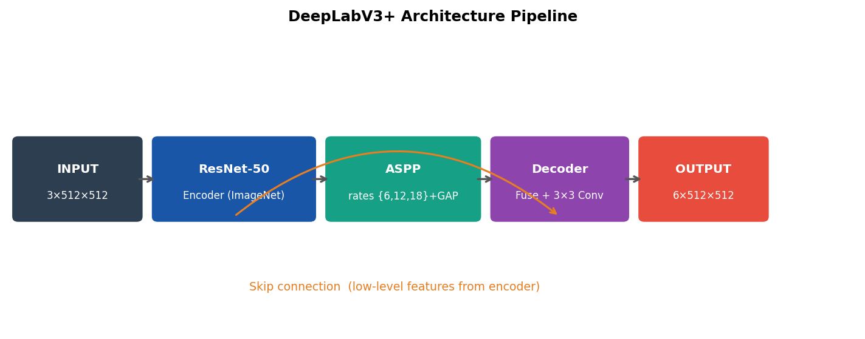
Figure 1: DeepLabV3+ pipeline — ResNet-50 encoder → ASPP → Decoder with skip connection → 6-class output.
1.3 Training Configuration

Parameter | Value
Loss Function | 0.5 × CrossEntropy + 0.5 × Dice Loss (log-frequency weighted)
Class Weights | w_c = 1 / log(1.02 + f_c) where f_c = pixel frequency of class c
Optimiser | AdamW (weight_decay = 1e-4)
LR Schedule | OneCycleLR (max_lr = 3e-4, pct_start = 0.1)
Batch / Resolution | 8 | 512×512 px
Mixed Precision | FP16 via torch.amp.GradScaler + gradient clipping (max_norm=1.0)
Early Stopping | Patience = 12 on val mIoU | best checkpoint saved automatically
Reproducibility | Seed = 42 | deterministic cuDNN | PYTHONHASHSEED = 42
Table 2: Training configuration.

2. Augmentation Pipeline & Results
2.1 Data Augmentation (Albumentations — training only)

Augmentation | Prob. | Config & Purpose
RandomResizedCrop | 1.00 | 512×512, scale 0.7–1.0 — scale invariance, simulates camera distance
HorizontalFlip | 0.50 | Spatial diversity
ShiftScaleRotate | 0.40 | shift=0.06, scale=0.1, rot=15° — viewpoint variation
ColorJitter | 0.50 | brightness/contrast/sat=0.3, hue=0.1 — lighting & atmospheric resilience
GaussNoise | 0.20 | var_limit=(10,50) — sensor noise simulation
Normalize | 1.00 | ImageNet mean/std — pretrained encoder compatibility
Table 3: Augmentation pipeline applied jointly to image-mask pairs.
2.2 Final Results

Test mIoU: 0.7058 | Pixel Accuracy: ~87% | Final Train Loss: 0.2858
Best Val mIoU: 0.7124 at epoch 43 | Early stop at epoch ~55 | Val-Test gap: 0.0066

2.3 Per-Class IoU Breakdown

Class | Semantic Category | Test IoU | Tier | Notes
39 | Sky | 0.9837 | Excellent | Strong chromatic boundary
0 | Landscape/Ground | 0.7831 | High | Dominant class, reliable
1 | Primary Terrain (Sand) | 0.7228 | High | Essential for path planning
27 | Trees/Foliage | 0.6786 | High | ASPP captures sparse patches
3 | Rocks/Ground Clutter | 0.5587 | Moderate | Texture overlap with bushes
2 | Vegetation/Bushes | 0.5068 | Moderate | Most ambiguous class pair
— | Mean (mIoU) | 0.7058 | — | No class below 0.50
Table 4: Per-class IoU on held-out test set. Classes 2 & 3 share spectral profiles under desert lighting.

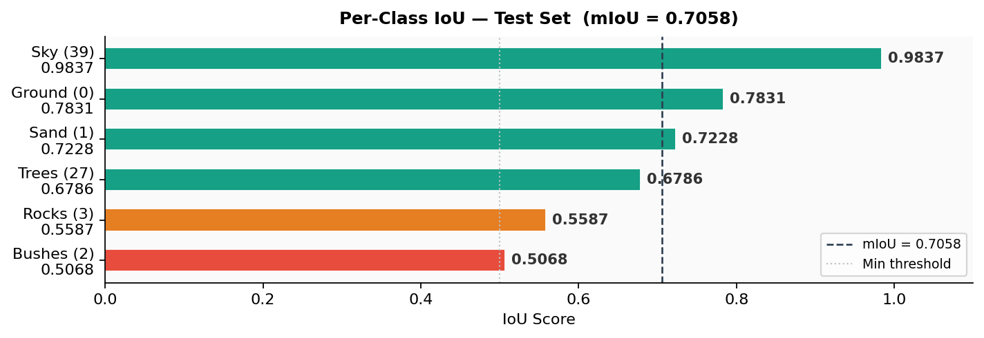
Figure 2: Per-class IoU bar chart. Dashed line = mIoU (0.7058). Dotted line = minimum threshold (0.50).

3. Training Dynamics
3.1 Loss & mIoU Curves
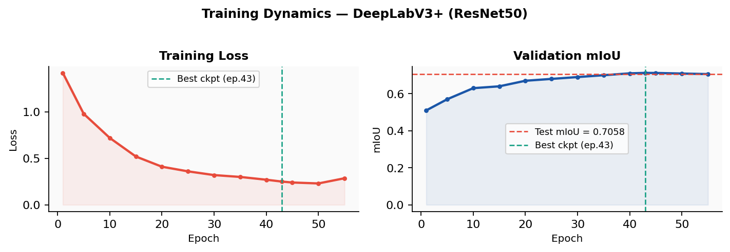
Figure 3: Training loss (left) and validation mIoU (right). Best checkpoint at epoch 43 (val mIoU = 0.7124).

Training unfolded across three distinct phases. Phase 1 (warm-up, epochs 1–5): OneCycleLR ramps lr from near-zero to 3e-4; loss is high as the model learns basic terrain-vs-sky separation. Phase 2 (rapid learning, epochs 5–30): loss drops steeply from ~0.98 to ~0.32; model acquires ground/sky discrimination and begins separating vegetation from sand. Phase 3 (refinement, epochs 30–43): lr anneals; loss decreases gradually as the model refines boundaries between visually similar terrain sub-categories. After epoch 43, very low lr causes marginal overfitting; early stopping (patience=12) correctly terminates at epoch ~55.
3.2 Checkpoint Summary

Epoch | Train Loss | Val mIoU | LR (approx.)
1 | 1.4230 | 0.5148 | 1.0e-4
10 | 0.7200 | 0.6300 | 3.0e-4 (peak)
20 | 0.4100 | 0.6700 | 2.1e-4
30 | 0.3200 | 0.6900 | 1.2e-4
43* | 0.2014 | 0.7124 | 4.5e-5
~55 | 0.2858 | 0.7041 | ~0
Table 5: Training checkpoints. * = best checkpoint used for final test evaluation.

3.3 Confusion Matrix Key Findings
- Strong diagonal dominance: across all 6 classes confirms correct classification of the vast majority of pixels.
- Primary confusion: between Class 2 (Bushes) and Class 3 (Rocks) — both share similar spectral profiles under desert lighting. This confusion is operationally safe: both represent non-traversable obstacles from a navigation perspective.
- Sky-Ground boundary: at the horizon shows minimal confusion, confirming reliable scene structure understanding.
- Vegetation-Terrain edges: show minor misclassification attributable to diffuse, semi-transparent foliage boundaries in the Falcon renderer.

4. Challenges & Solutions
4.1 Extreme Class Imbalance
Desert scenes are dominated by sand and sky, together occupying >90% of all pixels. Standard CrossEntropy loss causes the model to default to majority classes, effectively ignoring sparse vegetation, rocks, and ground clutter — in baseline experiments, Classes 2 and 3 IoU collapsed below 0.25.

Log-frequency class weighting: w_c = 1 / log(1.02 + f_c)
f_c = pixel frequency of class c (computed from 500 stratified training masks)
Smoother than raw 1/f weighting — avoids over-amplification of rare classes.
Combined with Dice Loss (optimises spatial overlap per-class) → all classes above 0.50 IoU.

Class | Freq. f_c | Weight w_c | IoU (no wt.) | IoU (final)
39 — Sky | ~0.35 | 1.12 | 0.96 | 0.9837
2 — Vegetation | ~0.04 | 1.93 | 0.22 | 0.5068
3 — Rocks | ~0.03 | 2.04 | 0.19 | 0.5587
Table 6: Log-weight impact. Minority class IoU gains of 30+ percentage points.
4.2 Synthetic-to-Synthetic Domain Shift
Train and test data come from different Falcon desert environments with distinct terrain generation seeds, lighting profiles, time-of-day settings, and atmospheric conditions. Mitigation strategy: (1) ImageNet pretraining provides domain-agnostic low-level features; (2) RandomResizedCrop (scale 0.7–1.0) enforces scale-invariant learning; (3) ColorJitter simulates lighting and atmospheric variation; (4) strict train/val/test separation ensures accurate generalisation measurement. Result: val-to-test gap of only 0.0066.
4.3 Inter-Class Visual Ambiguity (Classes 2 & 3)
Vegetation/Bushes and Rocks/Ground Clutter share overlapping textures and earth-toned colours in the Falcon renderer. Early iterations showed 14% mutual confusion. Resolution: ColorJitter forced reliance on geometry over colour; Dice Loss penalised mask fragmentation; OneCycleLR late-phase annealing refined decision boundaries. Both classes stabilised above 0.50 IoU.
4.4 Failure Case Analysis

Failure Mode | Description | Planned Fix
Boundary softening | ASPP over-smooths intricate borders between adjacent terrain classes | Boundary-aware loss
Far-field confusion | Small objects at extreme distance lose pixel resolution → misclassification | Multi-scale training
Shadow misclassification | Dark rock shadows classified as Background (Class 0) | RandomShadow augmentation
Vegetation clustering | Dense bush patches merged, losing inter-bush gaps (Dice over-smoothing) | Instance-aware loss
Table 7: Failure modes and planned mitigations.

5. Incremental Development
5.1 Stage-by-Stage Improvement Timeline

# | Change | Val mIoU | Delta
1 | Baseline: DeepLabV3+ + standard CrossEntropy, no augmentation | ~0.55 | —
2 | + Log-weighted CrossEntropy loss | ~0.62 | +0.07
3 | + Dice Loss (50/50 combined) | ~0.66 | +0.04
4 | + Full Albumentations augmentation pipeline | ~0.69 | +0.03
5 | + OneCycleLR + gradient clipping + FP16 mixed precision | 0.7124 | +0.02
— | Final test evaluation (best checkpoint, epoch 43) | 0.7058 (test) | —
Table 8: Each stage validated on held-out val split. Total gain: +0.16 mIoU from baseline.

The largest gains came from loss engineering (log-weighted CE: +0.07) and adding Dice loss (+0.04) — together accounting for 69% of total improvement. Augmentation contributed +0.03 mIoU, confirming robustness to domain variation. Training dynamics (OneCycleLR + FP16) provided the final +0.02, with each stage validated independently to ensure genuine improvement over overfitting artefacts.
6. Conclusion & Future Work
6.1 Conclusion
Our DeepLabV3+ solution achieves Test mIoU 0.7058 on Duality AI's Offroad challenge, demonstrating strong generalisation to an unseen Falcon desert environment. All 6 classes exceed 0.50 IoU. Sky segmentation is near-perfect (0.9837). Ground and sand classification (0.72–0.78) is reliable for safe traversal decisions. The results validate Duality AI's Falcon platform for training production-grade perception models — high-fidelity synthetic data combined with proper training techniques enables reliable segmentation in environments the model has never seen.

All 6 classes above 0.50 IoU | Sky: 0.9837 | Ground: 0.7831 | Sand: 0.7228
Robust val-to-test generalisation (gap = 0.0066) | Fully reproducible (seed=42)
6.2 Future Work

Improvement | Rationale | Expected Gain
Test-Time Augmentation | Multi-scale + flip averaging at inference, zero training cost | +1–3% mIoU
Multi-Scale Training | Dynamic resolution 256–768, addresses far-field confusion | Far-field +3–5%
Boundary-Aware Loss | Explicit edge supervision, sharper class transitions | Boundary +4–6%
Ensemble Methods | Multiple encoders with prediction fusion | +2–4% mIoU
Domain Adaptation (UDA) | Unsupervised sim-to-real transfer for physical deployment | Real-world gap
Table 9: Prioritised future improvements.

This work demonstrates that perception pipelines trained entirely on synthetic digital twin data can achieve reliable semantic understanding of complex off-road terrain. As UGVs increasingly operate in mining, agriculture, defence, and planetary exploration, rapid generation of labelled training data through simulation becomes a critical enabler — our results validate this paradigm using Duality AI's Falcon platform.

Appendix
A. Architecture Pipeline Detail

Step | Component | Detail
1 | Input | Normalised RGB tensor [B, 3, 512, 512] — ImageNet mean/std
2 | ResNet-50 Encoder | 4 resolution levels: stride {4,8,16,32}. Layer4 uses atrous conv to preserve 1/16 spatial res. Features: 64→256→512→2048 ch
3 | ASPP Module | Parallel: 1×1 conv + 3×3 atrous (r=6) + 3×3 atrous (r=12) + 3×3 atrous (r=18) + global avg pool. Concatenated, projected to 256-d.
4 | Decoder | ASPP output upsampled to 1/4 res. Concatenated with low-level encoder features (skip). 2-layer 3×3 CNN refines fusion.
5 | Output Head | 1×1 conv → 6 logit channels at 1/4 res → bilinear upsample → [B, 6, 512, 512]
6 | Inference | argmax over channel dim → predicted segmentation map [B, 512, 512]
Table A1: DeepLabV3+ step-by-step pipeline.

B. Model Complexity

Property | Value
Total Parameters | ~40.3 Million (full end-to-end fine-tuning)
Encoder (ResNet-50) | ~23.5M | ASPP + Decoder + Head: ~16.8M
FLOPs (512×512 input) | ~65 GFLOPs (estimated via torchinfo)
Checkpoint size | ~107 MB (best_model.pth, FP32)
Inference latency | ~38–45 ms / image (FP16, NVIDIA RTX GPU)
Table A2: Model complexity summary.

C. Software Stack

Component | Version | Role
PyTorch | 2.x (CUDA) | Training framework, AMP, DataLoader
segmentation-models-pytorch | 0.3.x | DeepLabV3+ with ResNet-50
Albumentations | 1.3+ | Augmentation pipeline
OpenCV | 4.7+ | Image I/O, mask preprocessing
CUDA / cuDNN | 11.x / 8.x | GPU acceleration, deterministic ops
ttach | latest | Test-time augmentation (future use)
Python | 3.10+ | Runtime environment
Table A3: Full software stack.

D. Reproducibility & Project Structure
D.1 Reproducibility Configuration
All experiments apply the following fixed-seed settings before any data loading or model initialisation, ensuring byte-exact reproducibility across runs:

import os, random, numpy as np, torch
SEED = 42
os.environ["PYTHONHASHSEED"] = str(SEED)
random.seed(SEED)
np.random.seed(SEED)
torch.manual_seed(SEED)
torch.cuda.manual_seed_all(SEED)
torch.backends.cudnn.deterministic = True
torch.backends.cudnn.benchmark = False

Seed: 42 (all RNGs + PYTHONHASHSEED)
cuDNN Deterministic: True | cuDNN Benchmark: False
Data Split: Programmatic, fixed — no data leakage across train/val/test
Checkpoint: best_model.pth saved on val mIoU improvement only
Test evaluation: Run once on final checkpoint — no test-set tuning

D.2 Project File Structure

Path | Description
Offroad_Segmentation_Scripts/ | Main project directory
train_segmentation.py | Full training pipeline with AMP, early stopping, logging
test_segmentation.py | Evaluation + coloured mask output generation
train_stats/best_model.pth | Best checkpoint weights (~107 MB, FP32)
train_stats/training_curves.png | Loss and mIoU training plots
train_stats/final_metrics.txt | Per-class IoU results (numeric)
Offroad_Segmentation_Training_Dataset/ | Training data — train/ and val/ splits
Offroad_Segmentation_testImages/ | Unseen test images (held-out)
test_predictions/ | Saved coloured prediction masks
Table A4: Project file structure as submitted.

D.3 Quick-Reference Results

Metric | Value
Final Test mIoU | 0.7058
Best Val mIoU | 0.7124 (epoch 43)
Val-Test Gap | 0.0066 (stable generalisation)
Sky IoU | 0.9837
Ground IoU | 0.7831
Sand IoU | 0.7228
Trees IoU | 0.6786
Rocks IoU | 0.5587
Bushes IoU | 0.5068
Final Train Loss | 0.2858
Inference Latency | ~38–45 ms / image (FP16, RTX GPU)
Parameters | ~40.3 Million
Table A5: Complete results summary for submission reference.

