DBMS - ASSESMENT

CREATE TABLE country (
id INT PRIMARY KEY,
country_name VARCHAR(100),
country_name_eng VARCHAR(100),
country_code VARCHAR(10)
);

CREATE TABLE city (
id INT PRIMARY KEY,
city_name VARCHAR(100),
lat DECIMAL(10,6),
longitude DECIMAL(10,6),
country_id INT,
CONSTRAINT fk_city_country FOREIGN KEY (country_id) REFERENCES country(id)
);

CREATE TABLE customer (
id INT PRIMARY KEY,
customer_name VARCHAR(100),
city_id INT,
customer_address VARCHAR(200),
next_call_date DATE,
ts_inserted DATETIME,
CONSTRAINT fk_customer_city FOREIGN KEY (city_id) REFERENCES city(id)
);

INSERT INTO country (id, country_name, country_name_eng, country_code) VALUES
(1, 'Deutschland', 'Germany', 'DEU'),
(2, 'Srbija', 'Serbia', 'SRB'),
(3, 'Hrvatska', 'Croatia', 'HRV'),
(4, 'United States of America', 'United States of America', 'USA'),
(5, 'Polska', 'Poland', 'POL'),
(6, 'España', 'Spain', 'ESP'),
(7, 'Rossiya', 'Russia', 'RUS');

INSERT INTO city (id, city_name, lat, longitude, country_id) VALUES
(1, 'Berlin', 52.520008, 13.404954, 1),
(2, 'Belgrade', 44.787197, 20.457273, 2),
(3, 'Zagreb', 45.815399, 15.966568, 3),
(4, 'New York', 40.730610, -73.935242, 4),
(5, 'Los Angeles', 34.052235, -118.243683, 4),
(6, 'Warsaw', 52.237049, 21.017532, 5);

INSERT INTO customer (id, customer_name, city_id, customer_address, next_call_date, ts_inserted) VALUES
(1, 'Jewelry Store', 4, 'Long Street 120', '2020-01-21', '2020-01-09 14:01:20'),
(2, 'Bakery', 1, 'Kurfuerstendamm 25', '2020-02-21', '2020-01-09 17:52:15'),
(3, 'Café', 1, 'Tauentzienstraße 44', '2020-01-21', '2020-01-10 08:02:49'),
(4, 'Restaurant', 3, 'Ulica lipa 15', '2020-01-21', '2020-01-10 09:20:21');

Task : 1
SELECT
c.country_name_eng,
ci.city_name,
cu.customer_name
FROM country c
LEFT JOIN city ci ON c.id = ci.country_id
LEFT JOIN customer cu ON ci.id = cu.city_id;
SELECT * FROM `country` WHERE 1
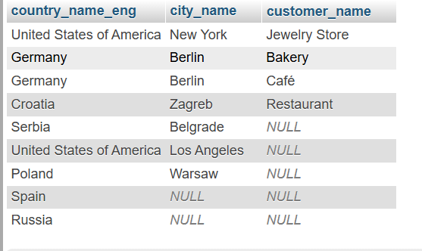

Task : 2

SELECT
c.country_name_eng,
ci.city_name,
cu.customer_name
FROM country c
INNER JOIN city ci ON c.id = ci.country_id
LEFT JOIN customer cu ON ci.id = cu.city_id;
