
PERSONALISED LEARNING RECOMMENDATION SYSTEM

A MACHINE LEARNING CLASSIFICATION AND RECOMMENDATION PROJECT
A PROJECT REPORT
SUBMITTED BY
STUDENT CODE | STUDENT NAME
BWU/BCA/24/074 | Nishant Kumar
Submitted as a practical project for the subject
MACHINE LEARNING PRACTICAL | SUBJECT CODE: BCA57205
In partial fulfillment of the requirements for the degree of
BACHELOR OF COMPUTER APPLICATION
DEPARTMENT OF COMPUTATIONAL SCIENCE
BRAINWARE UNIVERSITY
398, Ramkrishnapur Road, Barasat, North 24 Parganas, Kolkata - 700 125

ACKNOWLEDGEMENT
I would like to thank Brainware University and the Department of Computational Science for the opportunity to complete this Machine Learning Practical project. Working on the program helped me connect classroom concepts with a Python application.
I am grateful to the faculty members who introduced the fundamentals of data preparation, supervised learning, classification, model evaluation, and data visualization. Their guidance helped me understand how to explain the design and results of a small machine learning project.
I also acknowledge the open-source Python libraries used in the program, including pandas, scikit-learn, Matplotlib, and Seaborn. They provide tools for organizing data, training a model, measuring its predictions, and presenting the results.
Submitted by,
Nishant Kumar
BWU/BCA/24/074
Machine Learning Practical

ABSTRACT
This project documents a Python program that recommends study topics using a learner's marks, attendance, study hours, subject interest, and preferred learning style. It builds a small, fixed dataset of 20 examples, derives Beginner, Intermediate, and Advanced labels from marks, and trains a Decision Tree Classifier.
The program evaluates the model with a 75/25 train-test split, prints accuracy and a classification report, and displays six charts. It then asks the user to enter academic values and select an interest and learning style. The predicted level and selected interest determine four topic suggestions; the learning style determines a suggested format such as video tutorials, notes, or practical exercises.
The sample run reports 60% accuracy on only five held-out records. This is an educational demonstration rather than evidence of a reliable learning recommendation service. The target level is created directly from marks, and marks are also used as a model feature. Recommendations are fixed topic names without verified links, learner history, or stored feedback.
Keywords: personalised learning, topic recommendation, decision tree, learner profile, Python

INDEX
Section | Page
1. Introduction, problem, objectives, and scope | 5
2. Machine-learning concepts and existing approaches | 6
3. Requirements and project scope | 7
4. System design and workflow | 8
5. Dataset and feature description | 9
6. Methodology and recommendation rules | 10
7. Model training and evaluation | 11
8. User input and console interface | 12
9. Graphs and sample-data results | 13-14
10. Example program output | 15
11. Validation and limitations | 16
12. Conclusion, future enhancements, and references | 16
Appendix A. Complete Python source code | 17-22

LIST OF FIGURES
- Fig. 1. Processing workflow of the recommendation program.
- Fig. 2. Confusion matrix for the five held-out records.
- Fig. 3. Distribution of marks in the sample dataset.
- Fig. 4. Study hours and marks by derived learning level.
- Fig. 5. Counts of learner interests and learning levels.
- Fig. 6. Correlation heatmap for numeric and encoded fields.

1. INTRODUCTION
Learners may need help deciding what to study next and which learning format suits them. A recommendation system can use a learner profile to suggest topics at an appropriate level. This practical project demonstrates a simple version of that idea using academic inputs, subject interest, and learning style.

1.1 Problem statement
The program must take a learner's values from the console, estimate one of three learning levels, and show topic suggestions that match the selected interest. It should also demonstrate a complete introductory machine-learning workflow, from preparing examples to evaluating a model and displaying charts.

1.2 Objectives
- Organize sample learner data using pandas.
- Assign Beginner, Intermediate, or Advanced labels using the marks thresholds in the program.
- Train and evaluate a Decision Tree Classifier with scikit-learn.
- Accept marks, attendance, study hours, interest, and learning style from the user.
- Recommend a fixed topic list and a matching learning format.
- Use charts to explain the sample data and model output.

1.3 Project scope
The project covers one local console session. It supports four interests and three learning styles. It uses 20 built-in examples, prints evaluation results, and shows four topics for the selected interest and predicted level. It does not include live resources, a learner database, stored progress, consent management, or an interface beyond the console.

2. MACHINE-LEARNING CONCEPTS AND EXISTING APPROACHES

2.1 Classification
Classification predicts a category from input features. In this program, the categories are Beginner, Intermediate, and Advanced. The model learns from labeled examples and assigns one label to a new profile.

2.2 Decision tree
A decision tree separates examples using feature-based rules. The program uses scikit-learn's DecisionTreeClassifier with max_depth=4 and a fixed random seed. The depth limit restricts the number of levels in the tree.

2.3 Recommendation rules
The program uses a decision tree to predict a learning level, then a separate dictionary selects topics by interest and level. Learning style controls the resource-format message. The topic selection is rule-based and does not rank topics by learner history or measured usefulness.

2.4 Existing approaches
Learning systems may use a fixed course sequence, manually written rules, learner activity, or recommender models. Fixed rules are easy to explain but have limited personalization. Data-driven systems can adapt to patterns but require reliable records, a clear evaluation method, and safeguards for learner data.

2.5 Current limitations of the prototype
Approach | Typical strength | Limit in this program
Fixed topic lists | Simple and easy to explain | Topics are not ranked and have no resource links
Decision-tree prediction | Produces a category from profile features | Uses only 20 examples and a marks-derived target
Learning-style format rule | Changes the suggested format | Does not test whether the format improves learning

3. REQUIREMENTS AND SCOPE
Requirement | Details
Programming language | Python
Libraries | pandas, scikit-learn, Matplotlib, and Seaborn
Input | Console values for marks, attendance, study hours, interest, and learning style
Output | Dataset, accuracy, classification report, charts, predicted level, topics, and format
Storage | All sample and entered values stay in memory; the code does not save the profile
Environment | Python with required libraries and a graphical backend for chart windows

3.1 Functional requirements
- Create a table from 20 predefined records and calculate the learning level for each record.
- Encode interest and learning-style categories for use as model inputs.
- Split the data into training and testing portions and fit a decision tree.
- Display model evaluation measures and visual summaries.
- Accept a new learner profile and check numeric ranges and menu choices.
- Print a predicted level, topic list, and suggested learning format.

3.2 Non-functional considerations
The console design is lightweight and the code can be run as a single file. The data is illustrative and local. Reliability is limited by the small sample, the marks-derived target, and missing recovery for non-numeric text. Recommendations should not be used for high-stakes academic decisions.

4. SYSTEM DESIGN AND WORKFLOW
The program has three main parts: sample-data and model preparation, learner profile entry, and recommendation output. Training and evaluation occur before the interactive prompts. After input, the fitted model predicts a level; fixed rules then select topics and a format.
PROCESSING WORKFLOW
Run the
Python file
Create 20
example rows
Derive three
learning levels
Encode interest
and style
Split rows
train / 5 test
15
Train the
decision tree
Ask for a new
learner profile
Predict level and
show suggestions
Fig. 1. Processing workflow of the personalised learning recommendation program.

4.1 Data flow
The source creates a DataFrame from fixed lists. A function assigns each row's target level from marks. LabelEncoder converts interest and learning-style categories to numbers. The feature table contains marks, attendance, study hours, interest code, and style code. The program splits 75% of rows for training and 25% for testing, trains the tree, evaluates test predictions, collects a new profile, predicts its level, and prints recommendations.

4.2 Main modules
Module | Purpose | Result
Sample data | Builds 20 learner examples | pandas DataFrame
Level and encoding | Creates target labels and numeric category codes | Target and model inputs
Model and metrics | Fits the tree and compares test labels | Accuracy, report, confusion matrix
Plots and recommendations | Creates six charts and chooses fixed topics | Visuals and console suggestions

5. DATASET AND FEATURE DESCRIPTION
The script contains 20 illustrative records in Python lists. They are not measured institutional results and do not represent a verified learner population. Each record contains three numeric academic inputs and two category fields; the program derives the target learning level from marks.
Field | Meaning | Range in prompts
marks | Academic mark; also used to create the target label | 0-100
attendance | Attendance percentage | 0-100
study_hours | Daily study hours | 0 or more
interest | Programming, Database, Web Development, or Data Science | Menu 1-4
learning_style | Video, Notes, or Practical | Menu 1-3
level | Derived label: Beginner, Intermediate, or Advanced | Created from marks

Sample rows from the embedded dataset
Marks | Attendance | Study hours | Interest | Style | Level
85 | 92 | 5 | Programming | Video | Advanced
62 | 75 | 2 | Database | Notes | Intermediate
74 | 84 | 3 | Programming | Video | Intermediate
48 | 65 | 1 | Web Development | Practical | Beginner
90 | 95 | 6 | Data Science | Video | Advanced
The program accepts non-negative study hours without an upper limit, although the built-in examples range from 1 to 6 hours. Predictions for inputs far outside the examples may be unreliable.

6. METHODOLOGY AND RECOMMENDATION RULES

6.1 Data preparation
The code creates a pandas DataFrame, assigns levels using a marks rule, and uses LabelEncoder to convert the interest and learning-style fields to integer codes. It fits each encoder on the full 20-row table before making the train-test split.

6.2 Learning-level rule
marks < 60 -> Beginner
60 <= marks < 80 -> Intermediate marks >= 80 -> Advanced

6.3 Model preparation
Step | Implementation
Features | marks, attendance, study_hours, interest_code, style_code
Target | level
Split | train_test_split(test_size=0.25, random_state=42)
Classifier | DecisionTreeClassifier(max_depth=4, random_state=42)
Evaluation | Accuracy, classification report, and confusion matrix

6.4 Recommendation logic
The nested recommendation dictionary contains four topics for each combination of four interests and three levels, for 48 topic entries. The selected interest and predicted level choose the topic list. The learning style selects Video Tutorials, PDF/Study Notes, or Practical Exercises/Projects. The script does not provide external learning-resource links or use learner ratings.

7. MODEL TRAINING AND EVALUATION
The model uses 15 records for training and 5 for testing. The observed sample run produced 60.00% accuracy. The class report below is the run's output and is based on only five test records.
Class | Precision | Recall | F1-score | Support
Advanced | 0.00 | 0.00 | 0.00 | 1
Beginner | 0.67 | 1.00 | 0.80 | 2
Intermediate | 0.50 | 0.50 | 0.50 | 2
Overall accuracy |  |  | 0.60 | 5
Macro average | 0.39 | 0.50 | 0.43 | 5
Weighted average | 0.47 | 0.60 | 0.52 | 5
Accuracy is the share of held-out examples labeled correctly. Precision, recall, and F1-score describe performance by class. With five test rows, a single example can change these values substantially.
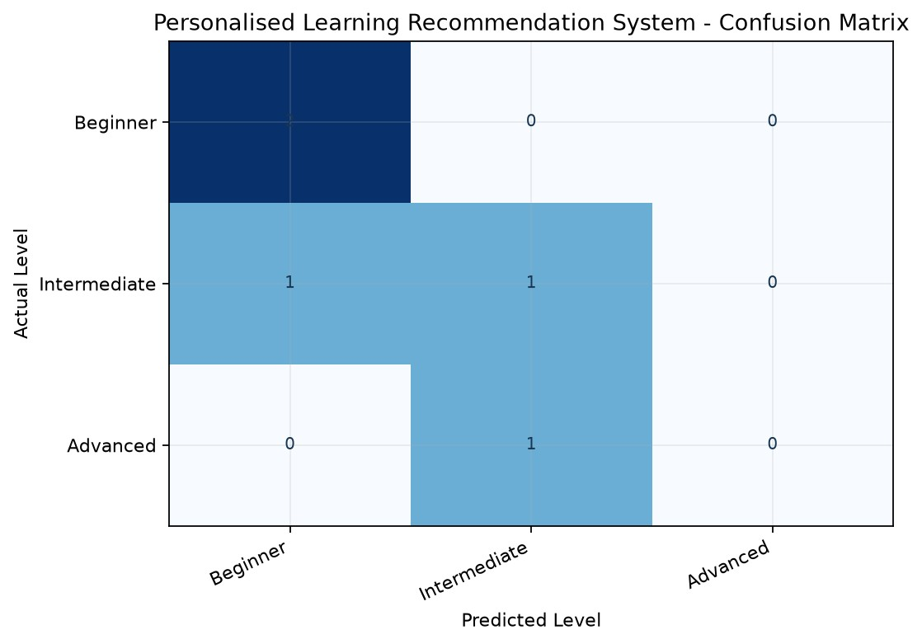
Fig. 2. Confusion matrix for the five held-out records. Rows are actual levels; columns are predicted levels.

Important interpretation
The target label is calculated from marks, and marks is also a model input. This means the task partly repeats a rule already written in the program. The 60% score is not evidence that the topic recommendations improve learning.

8. USER INPUT AND CONSOLE INTERFACE
The code asks the user to enter numeric academic information and select numbered menu options. It does not ask for the learner's name. The values are combined into one row with the same feature columns used during training.
Prompt | Accepted values
Marks | 0 through 100
Attendance percentage | 0 through 100
Daily study hours | Zero or more; no upper limit is coded
Interest | 1 Programming; 2 Database; 3 Web Development; 4 Data Science
Learning style | 1 Video; 2 Notes; 3 Practical

Input validation behavior
- Marks and attendance are checked to be between 0 and 100; study hours must not be negative.
- Menu choices outside their allowed range print an error message and stop the recommendation path.
- The code converts numeric text with float() and int() but does not catch conversion errors, so letters may stop the program.
- There is no profile file, database, consent prompt, or saved recommendation history.

8.1 Recommendation display
The console prints the submitted values, predicted learning level, four topic names, selected learning style, and a format suggestion. The user can run the program again and enter another profile, but past inputs are not retained.
To run the copied source file, install the libraries with python -m pip install pandas matplotlib seaborn scikit-learn and start it with python Personalised_Learning_Recommendation_System.py.

9. GRAPHS: SAMPLE DATA EXPLORATION
These figures are generated from the program's 20 embedded examples. They help describe this small sample only; they do not establish general relationships for a larger learner population.
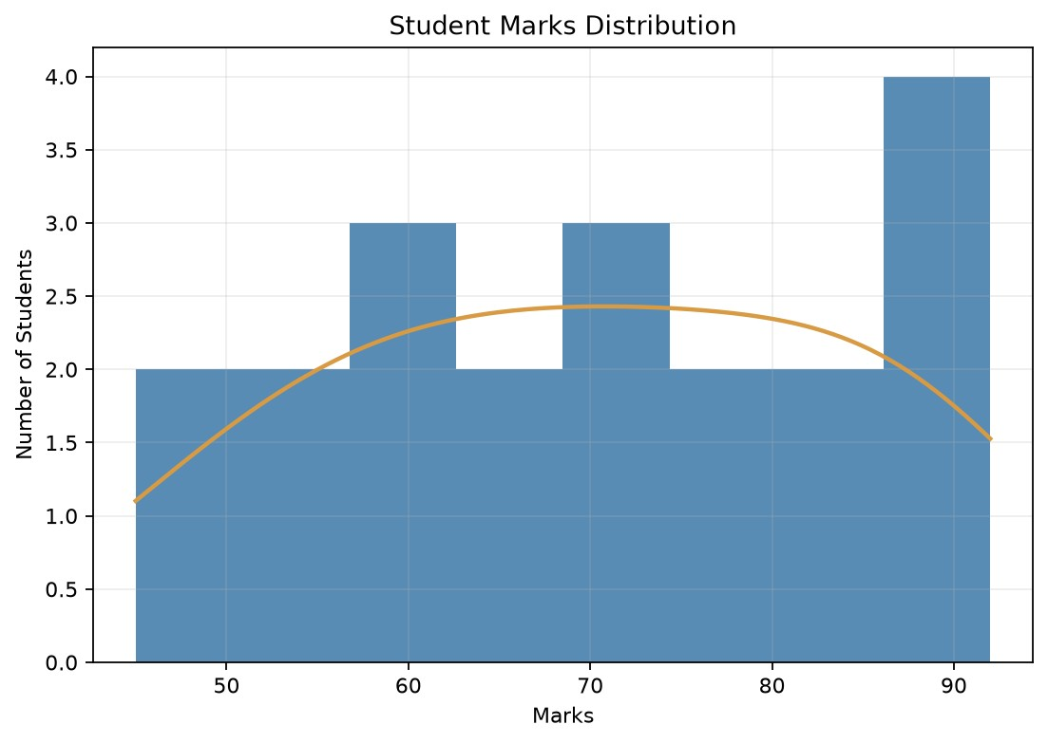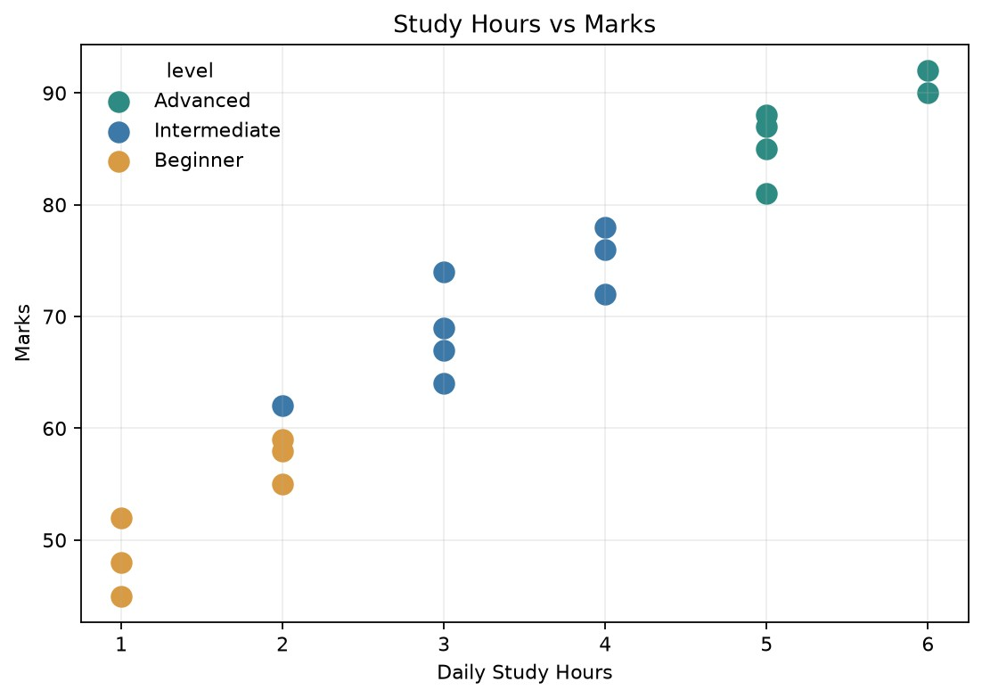
Fig. 3-4. Marks distribution and study hours versus marks by the derived learning level.

What the charts show
The sample includes marks from 45 to 92 and study hours from 1 to 6. Several examples with higher study hours have higher marks, but the sample is small and constructed. The plot should be read as a description of the embedded rows, not proof that study hours alone cause higher marks.
A histogram summarizes where the 20 marks fall. The scatter plot shows each row and colors it with the level assigned by the marks thresholds.

9. GRAPHS: INTERESTS, LEVELS, AND CORRELATION
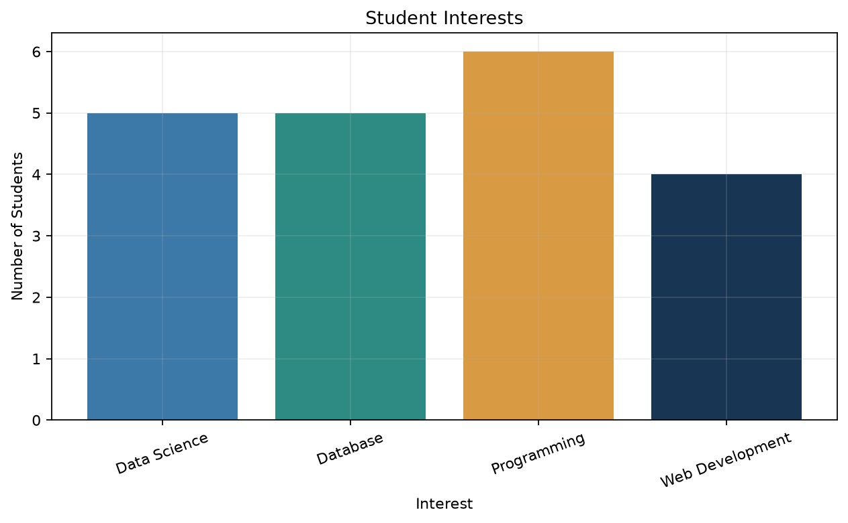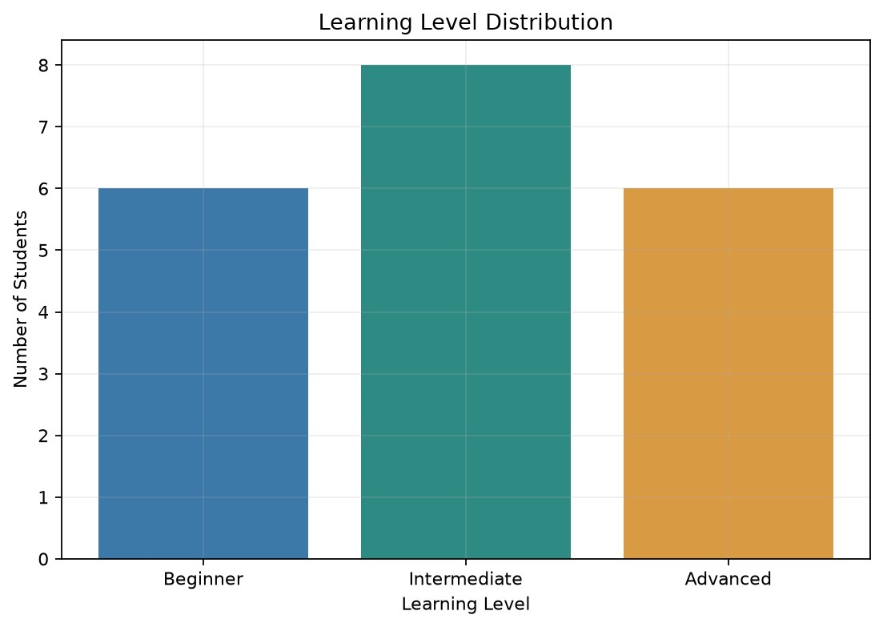
Fig. 5-6. Counts of interests and levels in the 20 example records.
The sample contains six Programming, five Database, four Web Development, and five Data Science interests. There are six Beginner, eight Intermediate, and six Advanced labels. These counts reflect only the hard-coded examples.
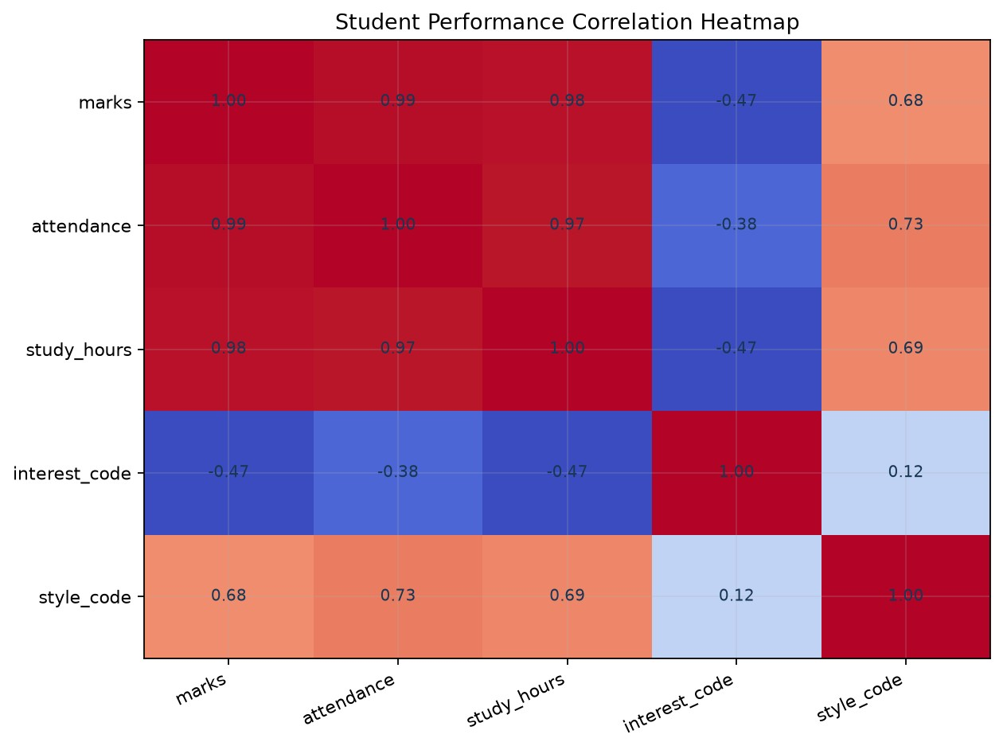
Fig. 7. Correlation heatmap for numeric columns and encoded categories.
Caution: interest_code and style_code represent categories. Their integer values are arbitrary labels, so correlations involving those codes can be misleading. The target is also derived from marks, making strong marks-level relationships expected by design.

10. EXAMPLE PROGRAM OUTPUT
The transcript below is from a sample run of the corrected Python copy. It uses marks 90, attendance 95, study hours 6, interest Data Science, and learning style Video. The printed model metrics come from the same 15/5 split.
========== PERSONALISED LEARNING RECOMMENDATION SYSTEM DATASET ========== marks attendance study_hours interest learning_style level 85 92 5 Programming Video Advanced
62 75 2 Database Notes Intermediate
74 84 3 Programming Video Intermediate
48 65 1 Web Development Practical Beginner
90 95 6 Data Science Video Advanced
55 70 2 Database Notes Beginner
78 88 4 Programming Practical Intermediate
67 80 3 Web Development Video Intermediate
45 60 1 Programming Notes Beginner
88 93 5 Data Science Practical Advanced
72 85 4 Programming Video Intermediate
59 68 2 Database Notes Beginner
81 90 5 Data Science Video Advanced
64 78 3 Web Development Practical Intermediate
92 96 6 Data Science Video Advanced
52 64 1 Database Notes Beginner
76 86 4 Programming Practical Intermediate
69 82 3 Web Development Video Intermediate
58 72 2 Database Notes Beginner
87 94 5 Data Science Practical Advanced
========== MODEL RESULT ==========
Model Accuracy: 60.0 %
Classification Report: precision recall f1-score support
Advanced 0.00 0.00 0.00 1
Beginner 0.67 1.00 0.80 2 Intermediate 0.50 0.50 0.50 2
accuracy 0.60 5 macro avg 0.39 0.50 0.43 5 weighted avg 0.47 0.60 0.52 5
====================================
PERSONALISED LEARNING RECOMMENDATION SYSTEM
====================================
Enter Your Academic Details
Enter your marks (0-100): 90
Enter attendance percentage (0-100): 95
Enter daily study hours: 6
Choose your interest:
- Programming
- Database
- Web Development
- Data ScienceEnter choice (1-4): 4
Choose your learning style:
- Video
- Notes
- PracticalEnter choice (1-3): 1
====================================
STUDENT RESULT
====================================
Marks: 90.0
Attendance: 95.0 %
Study Hours: 6.0
Interest: Data Science
Learning Style: Video
Predicted Learning Level: Advanced
========== LEARNING RECOMMENDATIONS ==========
Deep Learning
Neural Networks
Natural Language Processing Advanced Machine Learning
Preferred Learning Style: Video
Recommended Resource: Video Tutorials
====================================
PERSONALISED LEARNING RECOMMENDATION SYSTEM COMPLETED
====================================

11. VALIDATION AND LIMITATIONS
Input case | Program behavior
Marks outside 0-100 | Prints an invalid-input message and skips prediction.
Attendance outside 0-100 | Prints an invalid-input message and skips prediction.
Negative study hours | Prints an invalid-input message and skips prediction.
Menu value outside its listed range | Prints an error and does not continue to the result.
Letters at numeric prompts | May raise ValueError because conversion errors are not caught.
All fields valid | Predicts a level and prints fixed topics and a format suggestion.
- Only 20 illustrative examples are included; they are not a verified learner dataset.
- The target level is generated from marks, and marks is also a model input. This is target leakage for independent assessment.
- Only five held-out rows are used. Accuracy and per-class results are unstable at this size.
- The split is not stratified, so the test set may not represent all classes evenly.
- Category codes are arbitrary integers; correlation with those codes may not have a useful meaning.
- Topics are fixed names with no web links, ranking, ratings, learning outcomes, or persistence.

12. Conclusion and Future Enhancements
The program demonstrates data preparation, classification, a small evaluation split, console input, topic selection, and visualization. It accepts a new profile and prints four topic suggestions plus a format message. The prototype meets the aim of demonstrating a simple machine-learning recommendation workflow.

Future enhancements
- Use a larger, consented dataset and define learning outcomes independently from marks.
- Use a stratified evaluation or cross-validation and report uncertainty with the sample size.
- Add robust numeric parsing, clear retry messages, and a sensible study-hours limit.
- Provide verified learning resources with subject, level, format, and link metadata.
- Collect optional topic feedback and held-out learning outcomes to measure recommendation quality.
- Add an accessible interface and opt-in profile history with appropriate privacy controls.

REFERENCES
- Submitted source code: 1 (1).py; updated copy: Personalised_Learning_Recommendation_System.py.
- Brainware University. Bachelor of Computer Application syllabus, 2024. Machine Learning Practical, subject code BCA57205. Official syllabus PDF.
- scikit-learn developers. DecisionTreeClassifier API documentation.
- pandas developers. DataFrame API documentation.
- Seaborn developers. heatmap documentation. Matplotlib developers. Using Matplotlib.

APPENDIX A - COMPLETE SOURCE CODE (1/6)
This listing is the corrected copy of the supplied Python file. Its project labels use the requested project title; the prediction and recommendation logic is preserved.
# ==========================================
# PERSONALISED LEARNING RECOMMENDATION SYSTEM
# ==========================================
import pandas as pd
import matplotlib.pyplot as plt
import seaborn as sns
from sklearn.model_selection import train_test_split
from sklearn.tree import DecisionTreeClassifier
from sklearn.preprocessing import LabelEncoder
from sklearn.metrics import accuracy_score, classification_report, confusion_matrix
sns.set_theme(style="whitegrid")
# ------------------------------------------
# 1. CREATE DATASET
# ------------------------------------------
data = {
"marks": [85, 62, 74, 48, 90, 55, 78, 67, 45, 88,
72, 59, 81, 64, 92, 52, 76, 69, 58, 87],
"attendance": [92, 75, 84, 65, 95, 70, 88, 80, 60, 93,
85, 68, 90, 78, 96, 64, 86, 82, 72, 94],
"study_hours": [5, 2, 3, 1, 6, 2, 4, 3, 1, 5,
4, 2, 5, 3, 6, 1, 4, 3, 2, 5],
"interest": [
"Programming", "Database", "Programming", "Web Development",
"Data Science", "Database", "Programming", "Web Development",
"Programming", "Data Science", "Programming", "Database",
"Data Science", "Web Development", "Data Science", "Database",
"Programming", "Web Development", "Database", "Data Science"
],
"learning_style": [
"Video", "Notes", "Video", "Practical", "Video",
"Notes", "Practical", "Video", "Notes", "Practical",
"Video", "Notes", "Video", "Practical", "Video",
"Notes", "Practical", "Video", "Notes", "Practical"
]
}
df = pd.DataFrame(data)
# ------------------------------------------
# 2. CREATE LEARNING LEVEL
# ------------------------------------------
def get_level(marks):
if marks < 60:
return "Beginner"
elif marks < 80:
return "Intermediate"
else:
return "Advanced"
df["level"] = df["marks"].apply(get_level)
print("\n========== PERSONALISED LEARNING RECOMMENDATION SYSTEM DATASET ==========")
print(df.to_string(index=False))
# ------------------------------------------
# 3. DATA PREPROCESSING
# ------------------------------------------
encoder_interest = LabelEncoder()
encoder_style = LabelEncoder()
df["interest_code"] = encoder_interest.fit_transform(df["interest"])
df["style_code"] = encoder_style.fit_transform(df["learning_style"])
X = df[
["marks", "attendance", "study_hours",
"interest_code", "style_code"]

APPENDIX A - COMPLETE SOURCE CODE (2/6)
]
y = df["level"]
# ------------------------------------------
# 4. TRAIN AND TEST DATA
# ------------------------------------------
X_train, X_test, y_train, y_test = train_test_split(
X,
y,
test_size=0.25,
random_state=42
)
# ------------------------------------------
# 5. MACHINE LEARNING MODEL
# ------------------------------------------
model = DecisionTreeClassifier(
random_state=42,
max_depth=4
)
model.fit(X_train, y_train)
y_pred = model.predict(X_test)
# ------------------------------------------
# 6. MODEL EVALUATION
# ------------------------------------------
accuracy = accuracy_score(y_test, y_pred)
print("\n========== MODEL RESULT ==========")
print("Model Accuracy:", round(accuracy * 100, 2), "%")
print("\nClassification Report:")
print(classification_report(
y_test,
y_pred,
zero_division=0
))
# ------------------------------------------
# 7. CONFUSION MATRIX HEATMAP
# ------------------------------------------
cm = confusion_matrix(
y_test,
y_pred,
labels=["Beginner", "Intermediate", "Advanced"]
)
plt.figure(figsize=(7, 5))
sns.heatmap(
cm,
annot=True,
fmt="d",
cmap="Blues",
xticklabels=["Beginner", "Intermediate", "Advanced"],
yticklabels=["Beginner", "Intermediate", "Advanced"]
)
plt.title("Personalised Learning Recommendation System - Confusion Matrix")
plt.xlabel("Predicted Level")
plt.ylabel("Actual Level")
plt.tight_layout()
plt.show()
# ------------------------------------------
# 8. MARKS DISTRIBUTION
# ------------------------------------------
plt.figure(figsize=(7, 5))
sns.histplot(
df["marks"],
bins=8,

APPENDIX A - COMPLETE SOURCE CODE (3/6)
kde=True
)
plt.title("Student Marks Distribution")
plt.xlabel("Marks")
plt.ylabel("Number of Students")
plt.tight_layout()
plt.show()
# ------------------------------------------
# 9. STUDY HOURS VS MARKS
# ------------------------------------------
plt.figure(figsize=(7, 5))
sns.scatterplot(
x="study_hours",
y="marks",
data=df,
hue="level",
s=100
)
plt.title("Study Hours vs Marks")
plt.xlabel("Daily Study Hours")
plt.ylabel("Marks")
plt.tight_layout()
plt.show()
# ------------------------------------------
# 10. STUDENT INTEREST
# ------------------------------------------
plt.figure(figsize=(8, 5))
sns.countplot(
x="interest",
data=df,
hue="interest",
legend=False
)
plt.title("Student Interests")
plt.xlabel("Interest")
plt.ylabel("Number of Students")
plt.xticks(rotation=20)
plt.tight_layout()
plt.show()
# ------------------------------------------
# 11. LEARNING LEVEL DISTRIBUTION
# ------------------------------------------
plt.figure(figsize=(7, 5))
sns.countplot(
x="level",
data=df,
hue="level",
order=["Beginner", "Intermediate", "Advanced"],
legend=False
)
plt.title("Learning Level Distribution")
plt.xlabel("Learning Level")
plt.ylabel("Number of Students")
plt.tight_layout()
plt.show()
# ------------------------------------------
# 12. CORRELATION HEATMAP
# ------------------------------------------
plt.figure(figsize=(8, 6))
numeric_df = df[
["marks", "attendance", "study_hours",
"interest_code", "style_code"]

APPENDIX A - COMPLETE SOURCE CODE (4/6)
]
sns.heatmap(
numeric_df.corr(),
annot=True,
cmap="coolwarm",
fmt=".2f"
)
plt.title("Student Performance Correlation Heatmap")
plt.tight_layout()
plt.show()
# ------------------------------------------
# 13. RECOMMENDATION FUNCTION
# ------------------------------------------
def recommend(interest, level, learning_style):
recommendations = {
"Programming": {
"Beginner": [
"Python Basics",
"Variables and Data Types",
"Loops",
"Functions"
],
"Intermediate": [
"Object Oriented Programming",
"Data Structures",
"Algorithms",
"File Handling"
],
"Advanced": [
"Machine Learning",
"Advanced Algorithms",
"Artificial Intelligence",
"System Design"
]
},
"Database": {
"Beginner": [
"DBMS Basics",
"SQL Basics",
"Database Keys",
"ER Diagram"
],
"Intermediate": [
"Normalization",
"SQL Joins",
"Subqueries",
"Transactions"
],
"Advanced": [
"Database Optimization",
"Indexing",
"Distributed Databases",
"Database Security"
]
},
"Web Development": {
"Beginner": [
"HTML Basics",
"CSS Basics",
"JavaScript Basics",
"Web Page Design"
],
"Intermediate": [
"JavaScript DOM",
"React Basics",
"Node.js",
"REST API"
],
"Advanced": [
"Full Stack Development",
"Authentication",
"Cloud Deployment",
"Web Security"

APPENDIX A - COMPLETE SOURCE CODE (5/6)
]
},
"Data Science": {
"Beginner": [
"Python for Data Science",
"Statistics Basics",
"Pandas",
"Data Visualization"
],
"Intermediate": [
"Data Preprocessing",
"Exploratory Data Analysis",
"Machine Learning",
"Regression"
],
"Advanced": [
"Deep Learning",
"Neural Networks",
"Natural Language Processing",
"Advanced Machine Learning"
]
}
}
print("\n========== LEARNING RECOMMENDATIONS ==========")
topics = recommendations.get(interest, {}).get(level, [])
for topic in topics:
print("
✔
", topic)
print("\nPreferred Learning Style:", learning_style)
if learning_style == "Video":
print("Recommended Resource: Video Tutorials")
elif learning_style == "Notes":
print("Recommended Resource: PDF Notes / Study Notes")
else:
print("Recommended Resource: Practical Exercises / Projects")
# ------------------------------------------
# 14. USER INPUT
# ------------------------------------------
print("\n\n====================================")
print(" PERSONALISED LEARNING RECOMMENDATION SYSTEM")
print("====================================")
print("\nEnter Your Academic Details")
marks = float(input("\nEnter your marks (0-100): "))
attendance = float(input("Enter attendance percentage (0-100): "))
study_hours = float(input("Enter daily study hours: "))
if not (0 <= marks <= 100 and 0 <= attendance <= 100 and study_hours >= 0):
print("\nInvalid input! Please enter valid academic details.")
else:
print("\nChoose your interest:")
print("1. Programming")
print("2. Database")
print("3. Web Development")
print("4. Data Science")
choice = int(input("Enter choice (1-4): "))
interest_list = {
1: "Programming",
2: "Database",
3: "Web Development",
4: "Data Science"

APPENDIX A - COMPLETE SOURCE CODE (6/6)
}
if choice not in interest_list:
print("Invalid interest choice!")
else:
interest = interest_list[choice]
print("\nChoose your learning style:")
print("1. Video")
print("2. Notes")
print("3. Practical")
style_choice = int(input("Enter choice (1-3): "))
style_list = {
1: "Video",
2: "Notes",
3: "Practical"
}
if style_choice not in style_list:
print("Invalid learning style choice!")
else:
learning_style = style_list[style_choice]
# ------------------------------------------
# 15. PREDICT STUDENT LEVEL
# ------------------------------------------
interest_code = encoder_interest.transform([interest])[0]
style_code = encoder_style.transform([learning_style])[0]
user_data = pd.DataFrame(
[[marks, attendance, study_hours,
interest_code, style_code]],
columns=X.columns
)
predicted_level = model.predict(user_data)[0]
# ------------------------------------------
# 16. DISPLAY STUDENT RESULT
# ------------------------------------------
print("\n====================================")
print(" STUDENT RESULT")
print("====================================")
print("Marks:", marks)
print("Attendance:", attendance, "%")
print("Study Hours:", study_hours)
print("Interest:", interest)
print("Learning Style:", learning_style)
print("Predicted Learning Level:", predicted_level)
# ------------------------------------------
# 17. LEARNING RECOMMENDATIONS
# ------------------------------------------
recommend(
interest,
predicted_level,
learning_style
)
print("\n====================================")
print(" PERSONALISED LEARNING RECOMMENDATION SYSTEM COMPLETED")
print("====================================")

