ASSIGNMENT -1

QUESTION 1

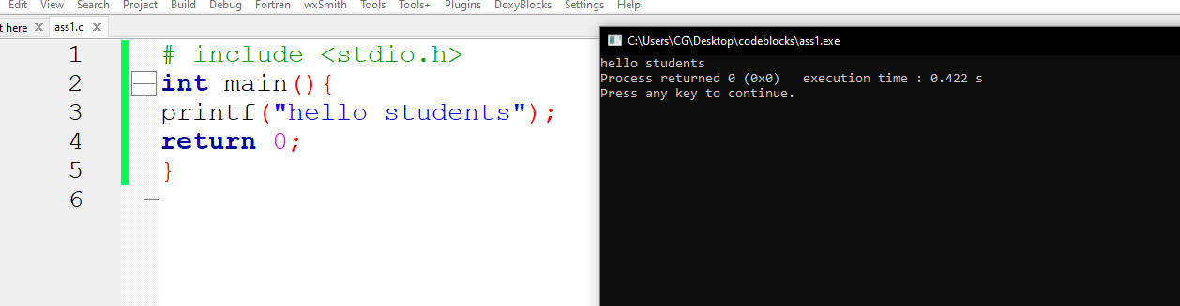

QUESTION 2

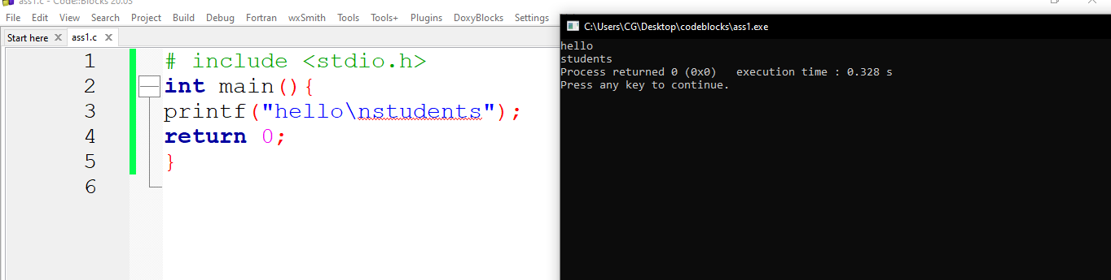

QUESTION 3

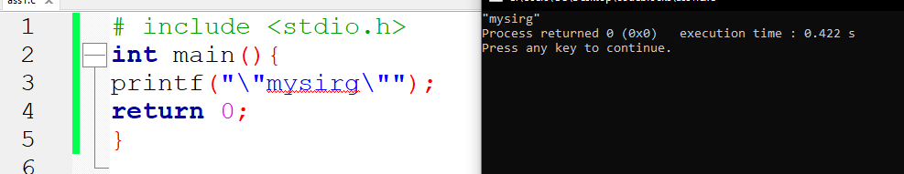

Question 4

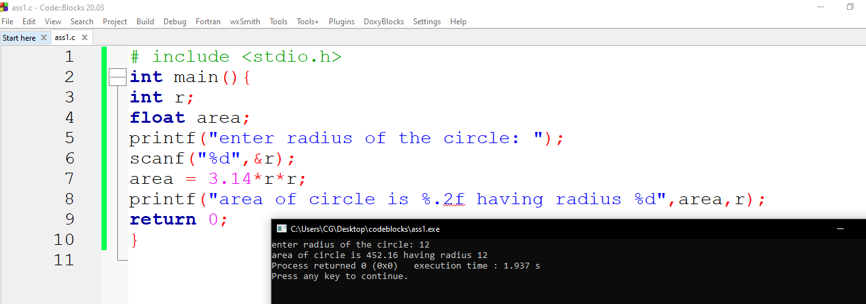

Question 5

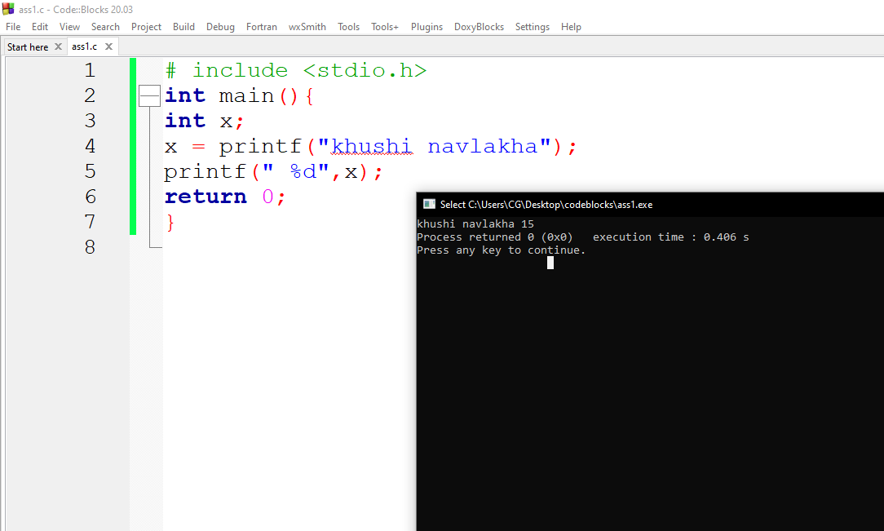

QUESTION 6

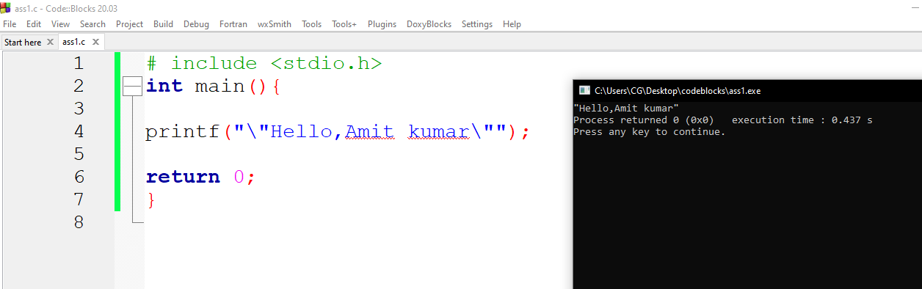

Question 7

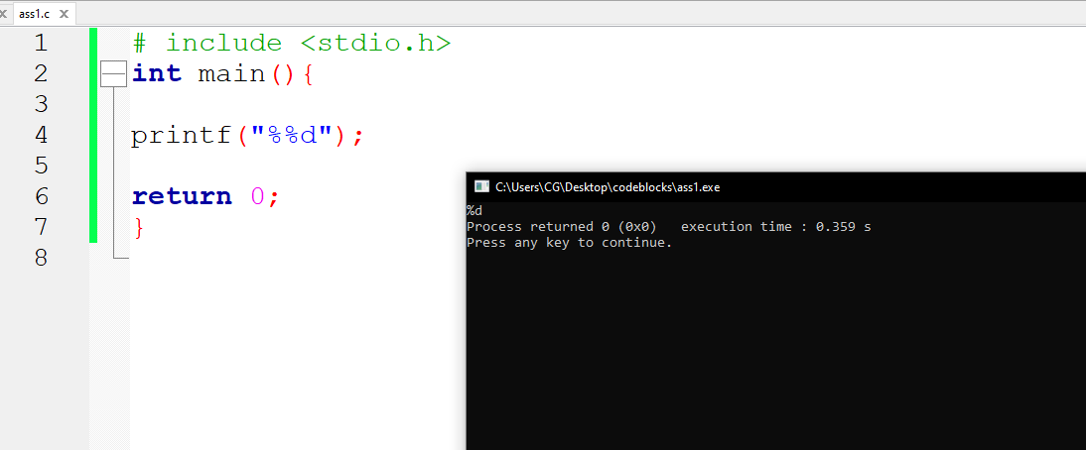

Question 8

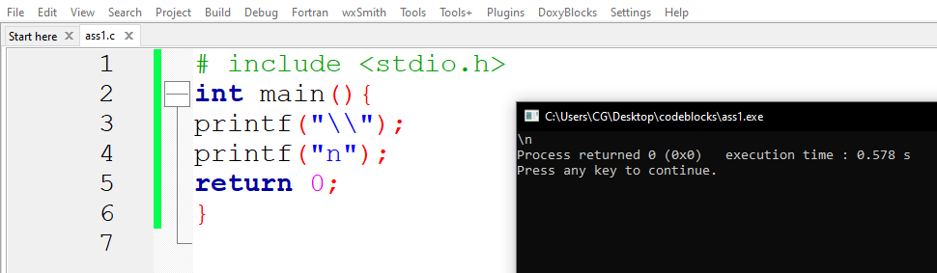

QUESTION 9

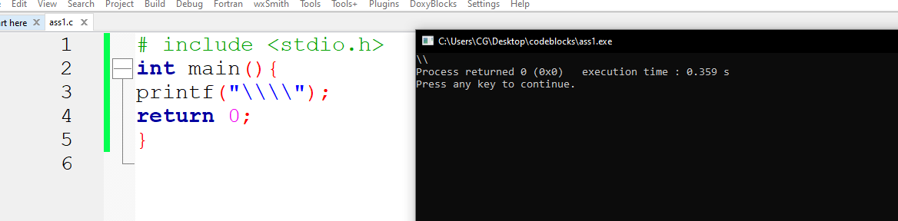

Question 10

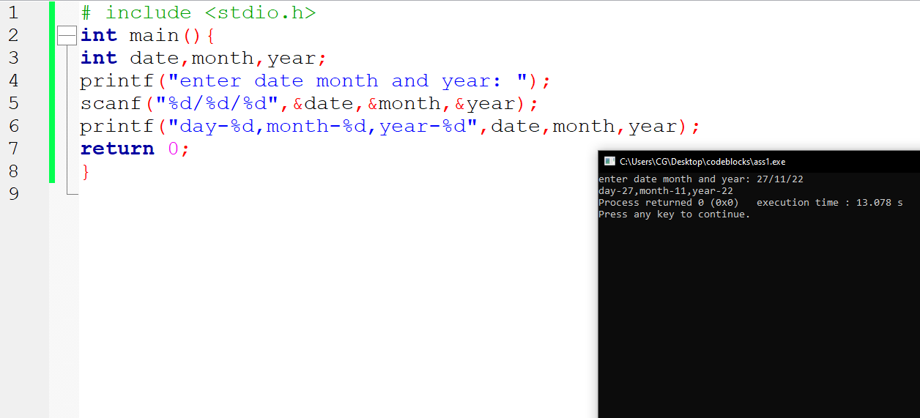

Question 11

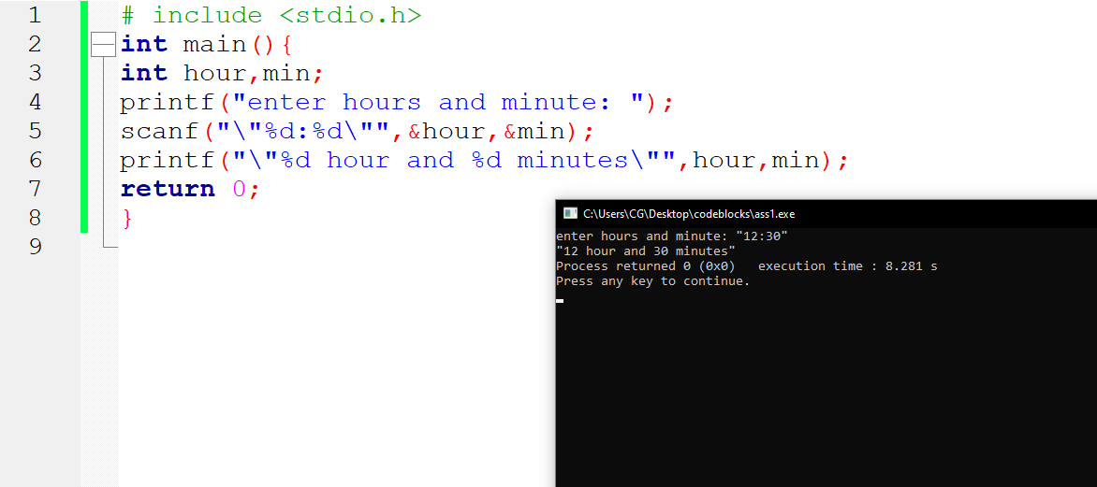

Question 12

Ans = 7 [as printf count and leave at its place]

So it will become x =7;

And value 7 will be printed on screen