ASSIGNMENT – 4

Question1

Write a program to print mysirg 5 times on screen

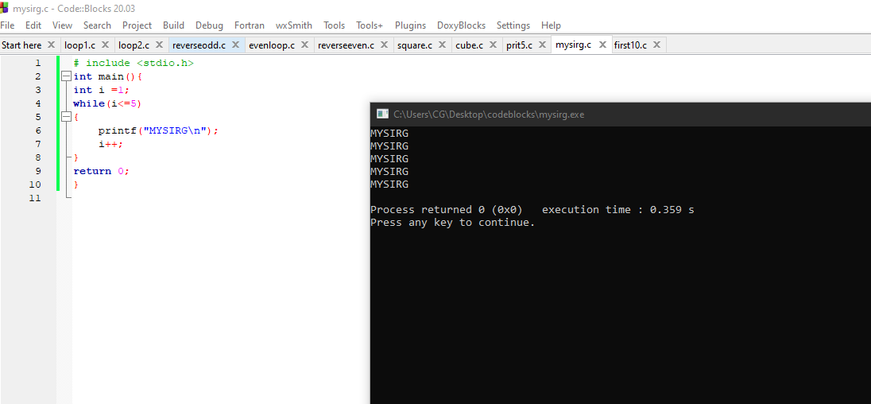

Question 2

Write a program to print the 10 first 10 natural numbers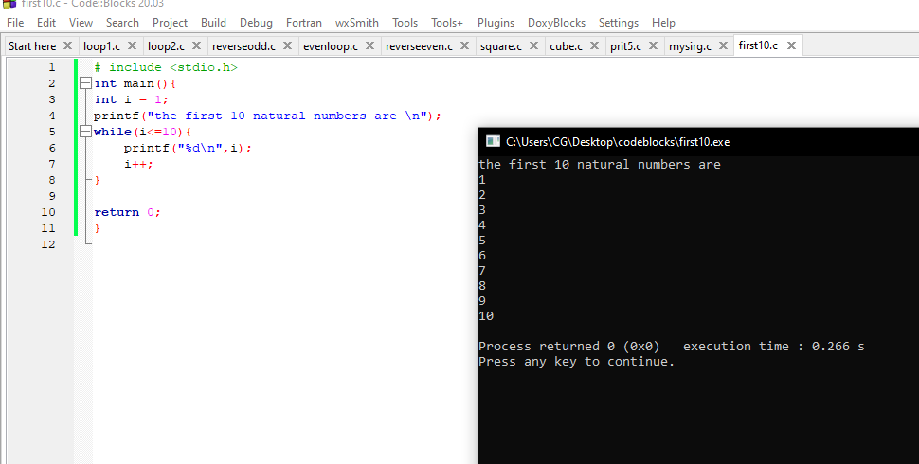

Question 3

Write a program to print first 10 natural numbers in reverse order

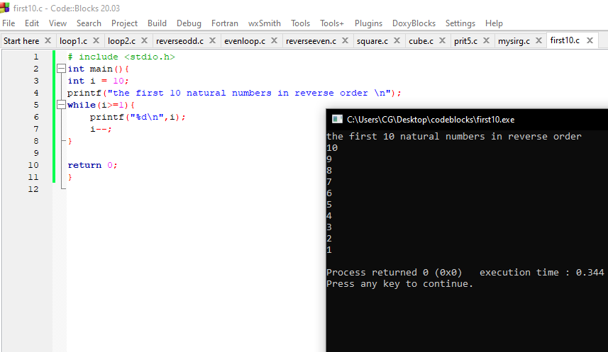

Question 4

Write a program to print first 10 odd natural numbers

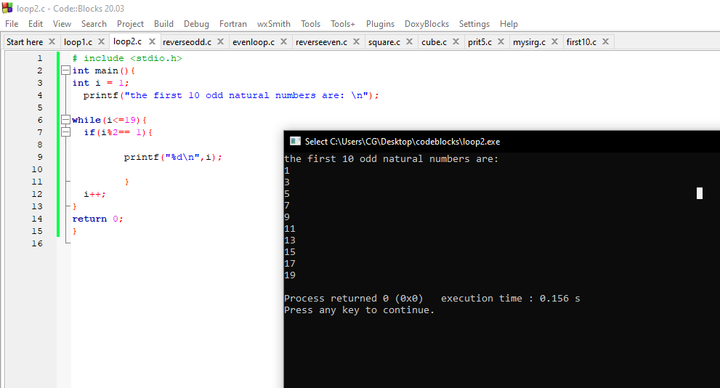

Question 5

Write a program to print first 10 odd natural numbers in reverse order

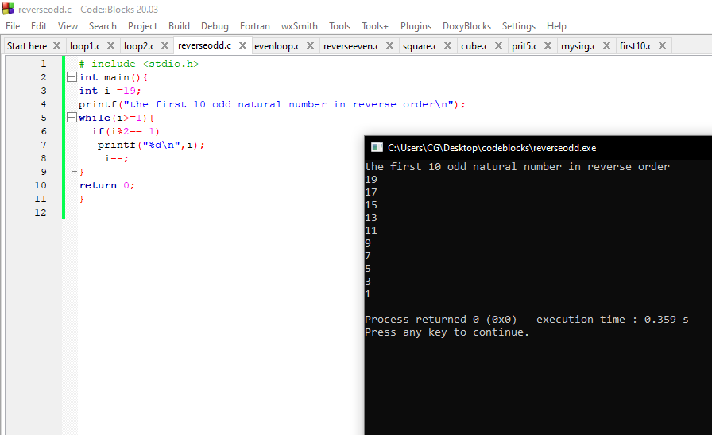

Question 6

Write a program to print first 10 even natural numbers

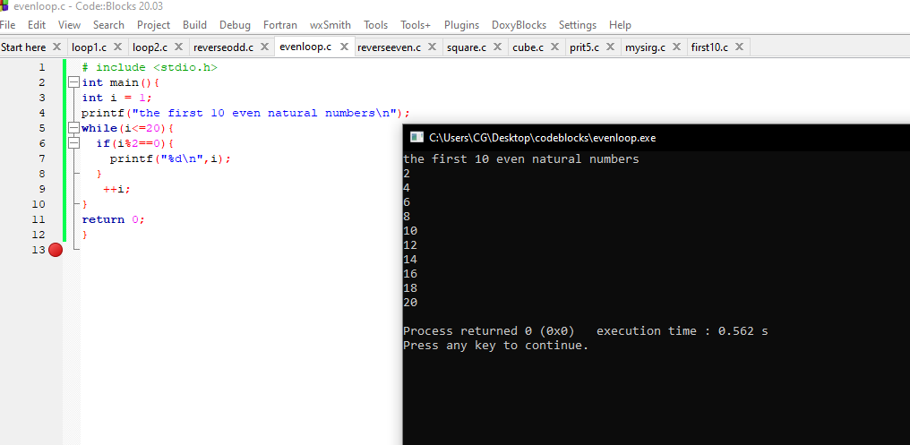

Question 7

Write a program to print first 10 even natural numbers in reverse order

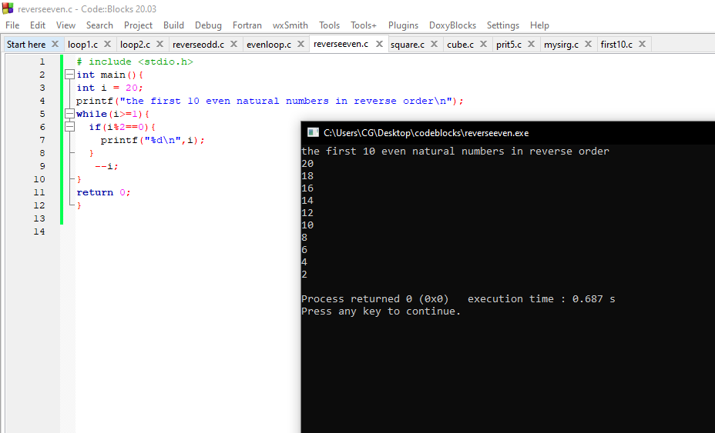

Question 8

Write a program to print squares of first 10 natural numbers

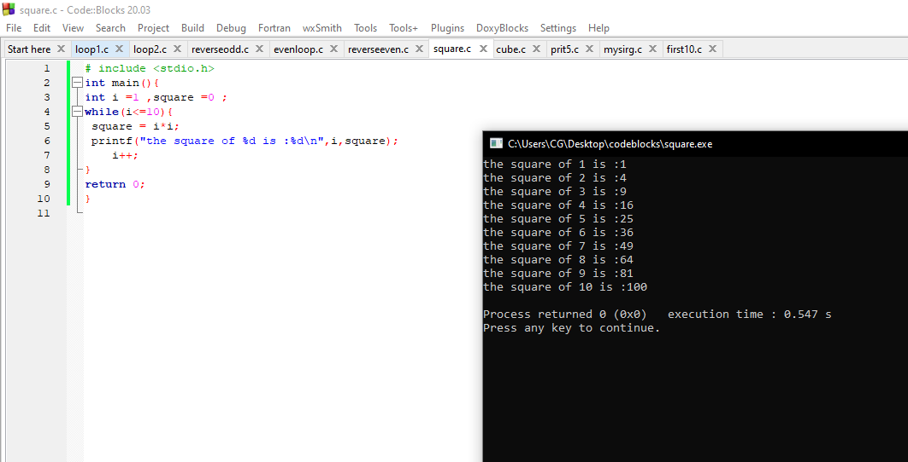

Question 9

Write a program to print cube of first 10 natural numbers

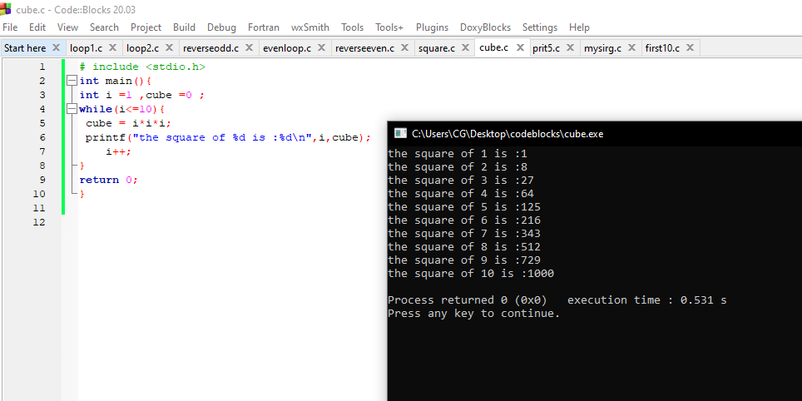

Question 9

Write a program to print a table of 5

