CureZone

Name= Acetaminophen

Disc= Acetaminophen is a widely used over-the-counter medication for reducing fever and relieving pain, commonly found in various brand names.

Relieve1= Headaches

Relieve2= Fever

Relieve3= Muscle pain

Relieve4= Colds and flu symptoms

Type1= Tablets

Type2= Liquid (for children)

Type3= Extended-release tablets

Intake= For adults, the usual dose is 500mg to 1000mg every 4 to 6 hours as needed, but no more than 4000mg in 24 hours. For children, follow the doctor's advice or the dosing guidelines on the packaging.

Side1= Allergic reactions (skin rash, swelling)

Side2= Liver damage with overdose & Kidney issues in prolonged use

Precaution1= Liver or kidney problems

Precaution2= Chronic alcohol use

Image=

Name= Advil

Disc= Advil is a brand of ibuprofen, a non-steroidal anti-inflammatory drug (NSAID) commonly used to treat pain, inflammation, and fever.

Relieve1= Headaches

Relieve2= Muscle and joint Pain

Relieve3= Menstrual cramps

Relieve4= Fever

Type1= Tablets

Type2= Chewable tablets (for children)

Type3= Liquid and gel capsules

Intake= For adults, the usual dose is 200mg to 400mg every 4 to 6 hours as needed, with a maximum of 1200mg in 24 hours unless directed by a doctor. For children, follow the doctor’s advice or the dosing guidelines on the packaging.

Side1= Stomach pain

Side2= Increased risk of heart attack or stroke with long-term use

Precaution1= Stomach ulcers or gastrointestinal problems

Precaution2= Asthma

Image=

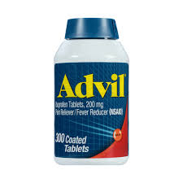

Name= Alvedon

Disc= Alvedon is a brand of paracetamol (acetaminophen) commonly used to reduce fever and relieve mild to moderate pain.

Relieve1= Fever

Relieve2= Headaches

Relieve3= Toothaches

Relieve4= Cold and flu symptoms

Type1= Tablets

Type2= Oral suspension (for children)

Type3= Suppositories

Intake= For adults, the usual dose is 500mg to 1000mg every 4 to 6 hours as needed, with a maximum of 4000mg in 24 hours. For children, follow the doctor's advice or dosing guidelines on the packaging.

Side1= Allergic reactions (rash, swelling)

Side2= Liver damage with overdose

Precaution1= Chronic alcohol use

Precaution2= Liver or kidney disease

Image=

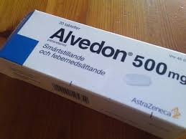

Name= Aspirin

Disc= Aspirin is a widely used non-steroidal anti-inflammatory drug (NSAID) that helps reduce pain, fever, and inflammation. It is also used in low doses to prevent blood clots.

Relieve1= Headaches

Relieve2= Fever

Relieve3= Inflammation

Relieve4= Muscle and Joint pain

Type1= Tablets

Type2= Enteric-coated tablets (to protect the stomach)

Type3= Chewable tablets

Intake= For pain or fever, the usual adult dose is 325mg to 650mg every 4 to 6 hours as needed, with a maximum of 4000mg in 24 hours. For children, aspirin is generally not recommended due to the risk of Reye’s syndrome, unless advised by a doctor.

Side1= Stomach pain

Side2= Nausea

Precaution1= Kidney or liver disease

Precaution2= Are pregnant or breastfeeding

Image=

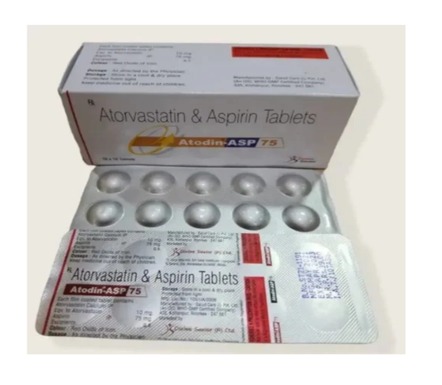

Name= Brufen

Disc= Brufen is a brand of ibuprofen, a non-steroidal anti-inflammatory drug (NSAID) used to relieve pain, reduce inflammation, and lower fever.

Relieve1= Fever

Relieve2= Back pain

Relieve3= Menstrual cramps

Relieve4= Muscle and Joint pain

Type1= Tablets

Type2= Oral suspension (for children)

Type3= Gel for topical application

Intake= For adults, the usual dose is 200mg to 400mg every 4 to 6 hours as needed, with a maximum of 1200mg in 24 hours unless prescribed by a doctor. For children, follow the doctor's advice or dosing guidelines on the packaging.

Side1= Dizziness

Side2= Risk of heart attack or stroke with long-term use

Precaution1= Stomach ulcers or gastrointestinal bleeding

Precaution2= Heart disease or high blood pressure

Image=

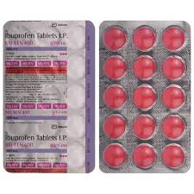

Name= Calpol

Disc= Calpol is a brand of paracetamol (acetaminophen) widely used to reduce fever and relieve mild to moderate pain, particularly in children.

Relieve1= Fever

Relieve2= Headaches

Relieve3= Cold and flu symptoms

Relieve4= Pain from vaccinations in children

Type1= Oral suspension (for infants and children)

Type2= Tablets

Type3= Fast-acting sachets (for children)

Intake= For children, the dose depends on the child’s age and weight. Always follow the doctor's advice or dosing instructions on the packaging. For adults, the usual dose is 500mg to 1000mg every 4 to 6 hours, with a maximum of 4000mg in 24 hours.

Side1= Allergic reactions (rash, swelling)

Side2= Liver damage with overdose

Precaution1= Liver or kidney disease

Precaution2= Chronic alcohol use

Image=

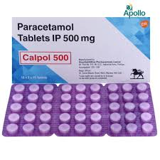

Name= Combiflam

Disc= Combiflam is a combination of ibuprofen and paracetamol (acetaminophen), commonly used to relieve pain, inflammation, and fever.

Relieve1= Fever

Relieve2= Menstrual cramps

Relieve3= Muscle and Joint pain

Relieve4= Back pain

Type1= Tablets

Type2= Suspension (for children)

Type3= For adults, the usual dose is one tablet every 6 to 8 hours, as needed, with a maximum of 3 tablets in 24 hours. For children, follow the doctor's advice or the dosing guidelines on the packaging.

Intake= For adults, the usual dose is one tablet every 6 to 8 hours, with a maximum of 3 tablets in 24 hours.

For children:

* **6 months to 12 years**: 5 to 10 ml of suspension every 6 to 8 hours, not exceeding 3 doses in 24 hours.

Side1= Allergic reactions (rash, swelling)

Side2= Increased risk of heart attack or stroke with prolonged ibuprofen use

Precaution1= Heart disease or high blood pressure

Precaution2= Liver or kidney disease

Image=

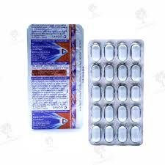

Name= Crocin

Disc= Crocin is a brand of paracetamol, commonly used to treat mild to moderate pain, such as headaches and body aches, as well as fever.

Relieve1= Headaches

Relieve2= Fever

Relieve3= Muscle pain

Relieve4= Joint pain

Type1= Tablets

Type2= Syrup (for children)

Type3= Rapid-release tablets

Intake= For adults, the usual dose is 500mg to 1000mg every 4 to 6 hours as needed, but no more than 4000mg in 24 hours. For children, follow the doctor's advice or the dosing guidelines on the packaging.

Side1= Allergic reactions (skin rash, swelling)

Side2= Liver damage with overdose

Precaution1= Liver or kidney problems

Precaution2= Chronic alcohol use

Image=

Name= Dolo

Disc= Dolo is a brand of paracetamol (acetaminophen) used to relieve pain and reduce fever.

Relieve1= Headaches

Relieve2= Fever

Relieve3= Cold and flu symptoms

Relieve4= Muscle and Joint pain

Type1= Tablets

Type2= Oral suspension (for children)

Type3=

Intake= For adults, the usual dose is 500mg to 1000mg every 4 to 6 hours, with a maximum of 4000mg in 24 hours.

For children:

* **1 to 12 years**: 5 to 10 ml of suspension every 4 to 6 hours, depending on age and weight.

Always consult a doctor for the exact dosage for children.

Side1= Allergic reactions (rash, swelling)

Side2= Liver damage with overdose

Precaution1= Chronic alcohol use

Precaution2= Liver or kidney disease

Image=

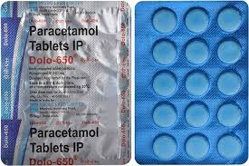

Name= Dynapar

Disc= Dynapar is a brand of diclofenac, a non-steroidal anti-inflammatory drug (NSAID) used to relieve pain, reduce inflammation, and lower fever.

Relieve1= Muscle and Joint pain

Relieve2= Back pain

Relieve3= Post-surgical pain

Relieve4=Fever

Type1= Tablets

Type2= Gel (for topical application)

Type3= Injection

Intake= For adults, the usual dose is 50mg to 100mg every 8 to 12 hours, depending on the severity of pain, with a maximum of 150mg in 24 hours.

For children:

* Dosage is based on the child's weight and should be determined by a doctor. Generally, for oral suspension, 1 to 2 mg per kg of body weight every 8 to 12 hours.

Side1= Stomach pain

Side2= Allergic reactions (rash, swelling)

Precaution1= Heart disease or high blood pressure

Precaution2= Asthma

Image=

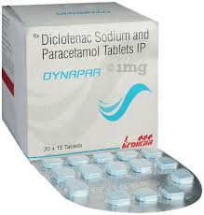

Name= Emetrol

Disc= Emetrol is an over-the-counter anti-nausea medication used to relieve nausea and vomiting, especially caused by an upset stomach, food, or motion sickness.

Relieve1= Nausea

Relieve2= Vomiting

Relieve3= Upset stomach

Relieve4=

Type1= Liquid solution (for both adults and children)

Type2=

Type3=

Intake= For adults, the usual dose is 15ml to 30ml every 15 minutes until nausea subsides. Do not take more than five doses in an hour.

For children:

* **2 to 12 years**: 5ml to 10ml every 15 minutes as needed, with a maximum of five doses in an hour.

Side1= Stomach discomfort

Side2= Diarrhea (in some cases)

Precaution1= Diabetes (Emetrol contains sugar)

Precaution2=

Image=

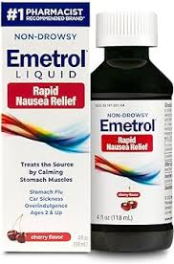

Name= Fexofenadine

Disc= Fexofenadine is an antihistamine used to relieve allergy symptoms such as runny nose, sneezing, itchy eyes, and skin reactions like hives.

Relieve1= Seasonal allergies (hay fever)

Relieve2= Sneezing

Relieve3= Runny or itchy nose

Relieve4= Skin hives (chronic urticaria)

Type1= Tablets

Type2= Oral suspension (for children)

Type3= Orally disintegrating tablets

Intake= For adults and children over 12 years, the usual dose is 120mg or 180mg once daily.

For children:

* **6 to 11 years**: 30mg twice daily.
* **2 to 5 years** (oral suspension): 15mg twice daily.

Side1= Headache

Side2= Drowsiness (rare)

Precaution1= Kidney problems

Precaution2= Are pregnant or breastfeeding

Image=

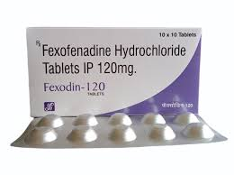

Name= Grilinctus

Disc= Grilinctus is a cough syrup commonly used to relieve symptoms of cough and throat irritation. It contains a combination of ingredients that work to suppress cough and clear mucus.

Relieve1= Dry cough

Relieve2= Productive cough (with mucus)

Relieve3= Throat irritation

Relieve4= Bronchitis-related cough

Type1= Cough syrup form (for both adults and children)

Type2=

Type3=

Intake= For adults, the usual dose is 10ml (2 teaspoons) three times a day, or as directed by a doctor.

For children:

* **2 to 12 years**: 5ml (1 teaspoon) two to three times a day.

Side1= Drowsiness

Side2= Dry mouth

Precaution1= Asthma or breathing problems

Precaution2= Liver or kidney disease

Image=

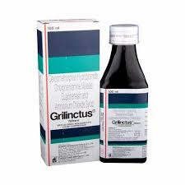

Name= Ibuprofen

Disc= Ibuprofen is a non-steroidal anti-inflammatory drug (NSAID) commonly used to reduce pain, inflammation, and fever.

Relieve1= Headaches

Relieve2= Fever

Relieve3= Menstrual cramps

Relieve4= Muscle, Joint and Back pain

Type1= Tablets

Type2= Oral suspension (for children)

Type3= Gel (for topical use)

Intake= For adults, the usual dose is 200mg to 400mg every 4 to 6 hours as needed, with a maximum of 1200mg in 24 hours.

For children:

* **6 months to 12 years**: 5 to 10 mg per kg of body weight, every 6 to 8 hours, not exceeding 3 doses in 24 hours.

Side1= Allergic reactions (rash, swelling)

Side2= Heartburn

Precaution1= Heart disease or high blood pressure

Precaution2= Stomach ulcers or gastrointestinal bleeding

Image=

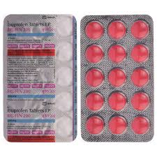

Name= Ibugesic

Disc= Ibugesic is a brand of ibuprofen, a non-steroidal anti-inflammatory drug (NSAID) used to relieve pain, reduce inflammation, and lower fever.

Relieve1= Headaches

Relieve2= Back pain

Relieve3= Fever

Relieve4= Menstrual cramps

Type1= Liquid Form

Type2= Oral suspension (for children)

Type3=

Intake= For adults, the usual dose is 200mg to 400mg every 4 to 6 hours, with a maximum of 1200mg in 24 hours.

For children:

* **6 months to 12 years**: 5 to 10 mg per kg of body weight, every 6 to 8 hours, not exceeding 3 doses in 24 hours.

Side1= Stomach pain

Side2= Allergic reactions (rash, swelling)

Precaution1= Are pregnant or breastfeeding

Precaution2= Kidney or liver disease

Image=

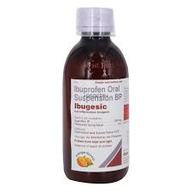

Name= Meftal forte

Disc= Meftal Forte is a combination medication that typically contains mefenamic acid, a non-steroidal anti-inflammatory drug (NSAID), used to relieve pain and reduce inflammation.

Relieve1= Menstrual pain (dysmenorrhea)

Relieve2= Headaches

Relieve3= Fever

Relieve4= Toothaches

Type1= Tablets

Type2=

Type3=

Intake= For adults, the usual dose is 500mg to 1000mg, taken every 8 hours as needed. Do not exceed 3000mg in 24 hours.

For children:

* Dosage should be determined by a doctor based on the child's weight and condition.

Side1= Stomach pain

Side2= Diarrhea

Precaution1= Stomach ulcers or gastrointestinal bleeding

Precaution2= Kidney or liver disease

Image=

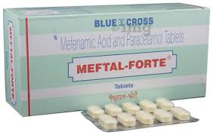

Name= Motrin

Disc= Motrin is a brand of ibuprofen, a non-steroidal anti-inflammatory drug (NSAID) used to relieve pain, reduce inflammation, and lower fever.

Relieve1= Headaches

Relieve2= Menstrual cramps

Relieve3= Fever

Relieve4= Back pain

Type1= Tablets

Type2= Chewable tablets

Type3= Liquid suspension (for children)

Intake= For adults, the usual dose is 200mg to 400mg every 4 to 6 hours as needed, with a maximum of 1200mg in 24 hours.

For children:

* **6 months to 12 years**: 5 to 10 mg per kg of body weight, every 6 to 8 hours, not exceeding 3 doses in 24 hours.

Side1= Stomach pain

Side2= Risk of heart attack or stroke with long-term use

Precaution1= Kidney or liver disease

Precaution2= Asthma

Image=

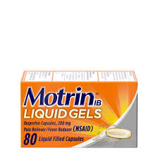

Name= Naproxen

Disc= Naproxen is a non-steroidal anti-inflammatory drug (NSAID) used to relieve pain, reduce inflammation, and lower fever.

Relieve1= Headaches

Relieve2= Menstrual cramps

Relieve3= Fever

Relieve4= Inflammation

Type1= Tablets

Type2= Delayed-release tablets

Type3= Oral suspension

Intake= For adults, the usual starting dose is 500mg, followed by 250mg every 6 to 8 hours as needed. The maximum daily dose is typically 1250mg for the first day, followed by 1000mg for subsequent days.

For children:

* **2 years and older**: Dosage should be based on weight and determined by a doctor.

Side1= Stomach pain

Side2= Dizziness

Precaution1= Heart disease or high blood pressure

Precaution2= Are pregnant or breastfeeding

Image=

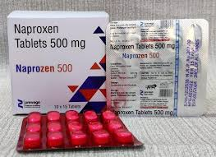

Name= Nicip

Disc= Nicip is a brand of nimesulide, a non-steroidal anti-inflammatory drug (NSAID) used to relieve pain and reduce inflammation.

Relieve1= Acute pain (such as headaches, toothaches, and muscle pain)

Relieve2= Joint pain (arthritis)

Relieve3= Post-surgical pain

Relieve4= Fever

Type1= Tablets

Type2= Suspension (for children)

Type3= Gel (for topical application)

Intake= For adults, the usual dose is 100mg twice daily, taken after meals. The maximum duration of treatment should not exceed 15 days.

For children:

* **2 to 12 years**: The dosage should be based on weight and determined by a doctor.

Always consult a doctor for exact dosing, especially for children.

Side1= Stomach pain

Side2= Diarrhea

Precaution1= Heart disease or high blood pressure

Precaution2= Liver or kidney disease

Image=

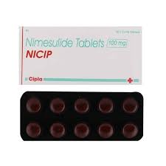

Name= Nurofen

Disc= Nurofen is a brand of ibuprofen, a non-steroidal anti-inflammatory drug (NSAID) used to relieve pain, reduce inflammation, and lower fever.

Relieve1= Headaches

Relieve2= Muscle pain

Relieve3= Menstrual cramps

Relieve4= Fever

Type1= Tablets

Type2= Liquid capsules

Type3= Oral suspension (for children)

Intake= For adults, the usual dose is 200mg to 400mg every 4 to 6 hours as needed, with a maximum of 1200mg in 24 hours.

For children:

* **3 months to 12 years**: 5 to 10 mg per kg of body weight every 6 to 8 hours, not exceeding 3 doses in 24 hours.

Side1= Stomach pain

Side2= Allergic reactions (rash, swelling)

Precaution1= Heart disease or high blood pressure

Precaution2= Asthma

Image=

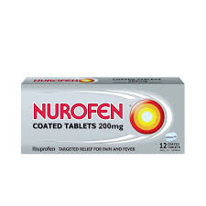

Name= Paracetamol

Disc= Paracetamol, also known as acetaminophen, is a widely used medication for pain relief and fever reduction.

Relieve1= Fever

Relieve2= Cold and flu symptoms

Relieve3= Headaches

Relieve4= Muscle and Joint pain

Type1= Tablets

Type2= Oral suspension (for children)

Type3= Effervescent tablets

Intake= For adults, the usual dose is 500mg to 1000mg every 4 to 6 hours as needed, with a maximum of 4000mg in 24 hours.

For children:

* **1 to 12 years**: 10 to 15 mg per kg of body weight every 4 to 6 hours, not exceeding 5 doses in 24 hours.

Side1= Allergic reactions (rash, swelling)

Side2= Liver damage with overdose

Precaution1= Liver or kidney disease

Precaution2= Chronic alcohol use

Image=

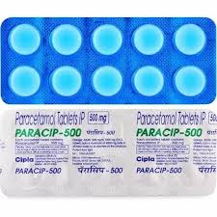

Name= Saridon

Disc= Saridon is a combination medication commonly used to relieve pain and headaches. It typically contains paracetamol, propyphenazone, and caffeine.

Relieve1= Headaches

Relieve2= Fever

Relieve3= Migraines

Relieve4= Menstrual cramps

Type1= Tablets

Type2=

Type3=

Intake= For adults, the usual dose is 1 to 2 tablets every 6 to 8 hours as needed, with a maximum of 6 tablets in 24 hours.

For children:

* Consult a doctor for appropriate dosing based on age and weight.

Side1= Dizziness

Side2= Nausea

Precaution1= Heart disease

Precaution2= A history of gastrointestinal bleeding

Image=



Name= Sinarest

Disc= Sinarest is a combination medication commonly used to relieve symptoms of cold and allergy, including pain and congestion. It typically contains paracetamol, chlorpheniramine, and phenylephrine.

Relieve1= Cold symptoms

Relieve2= Allergic rhinitis

Relieve3= Nasal congestion

Relieve4= Fever

Type1= Tablets

Type2= Syrup

Type3=

Intake= For adults, the usual dose is 1 to 2 tablets every 6 hours as needed, with a maximum of 8 tablets in 24 hours.

For children:

* **6 to 12 years**: 5 to 10 ml of syrup every 6 hours, not exceeding 4 doses in 24 hours.
* **2 to 6 years**: Consult a doctor for appropriate dosing.

Side1= Drowsiness

Side2= Nausea

Precaution1= Heart disease

Precaution2= Liver or kidney disease

Image=

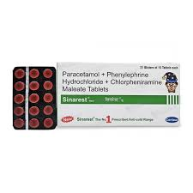

Name= Solpadeine

Disc= Solpadeine is a combination medication commonly used for pain relief. It typically contains paracetamol, codeine, and caffeine.

Relieve1= Migraines

Relieve2= Headaches

Relieve3= Back pain

Relieve4= Fever

Type1= Tablets

Type2= Effervescent tablets

Type3=

Intake= For adults, the usual dose is 1 to 2 tablets every 6 hours as needed, with a maximum of 8 tablets in 24 hours.

For children:

* Consult a doctor for appropriate dosing based on age and weight.

Side1= Dizziness

Side2= Constipation

Precaution1= Respiratory problems

Precaution2= A history of substance abuse

Image=

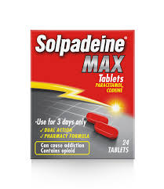

Name= Tamiflu

Disc= Tamiflu (oseltamivir) is an antiviral medication used to treat and prevent influenza (the flu).

Relieve1= Treat influenza in adults and children (typically within 48 hours of symptom onset)

Relieve2= Prevent influenza in individuals at high risk of complications

Relieve3=

Relieve4=

Type1= Capsules

Type2= Oral suspension (liquid form for children)

Type3=

Intake= For adults and children over 13 years, the usual dose is 75mg twice daily for 5 days.

For children:

* **1 to 12 years**: Dosage is based on weight and determined by a doctor.
* **Younger than 1 year**: Consult a doctor for appropriate dosing.

Side1= Diarrhea

Side2= Vomiting

Precaution1= Kidney problems

Precaution2= Are pregnant or breastfeeding

Image=

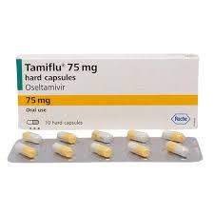

Name= Theraflu

Disc= Theraflu is a combination medication used to relieve symptoms of cold and flu. It typically contains ingredients like paracetamol, phenylephrine, and diphenhydramine.

Relieve1= Nasal congestion

Relieve2= Sinus pressure

Relieve3= Sore throat

Relieve4= Aches and pains

Type1= Powder for hot liquid (to be mixed with water)

Type2= Tablets

Type3=

Intake= For adults, the usual dose is 1 packet or 1-2 tablets every 4 to 6 hours as needed, with a maximum of 4 doses in 24 hours.

For children:

* Consult a doctor for appropriate dosing based on age and weight.

Side1= Drowsiness

Side2= Allergic reactions (rash, swelling)

Precaution1= Heart disease or high blood pressure

Precaution2= A history of asthma or breathing problems

Image=



Name= Tixylix

Disc= Tixylix is a cough syrup commonly used to relieve dry cough and throat irritation. It typically contains dextromethorphan as an active ingredient.

Relieve1= Dry cough

Relieve2= Throat irritation

Relieve3= Cough due to colds or flu

Relieve4=

Type1= Syrup form (available for both adults and children)

Type2=

Type3=

Intake= For adults, the usual dose is 10 to 20 ml every 4 to 6 hours as needed, not exceeding 60 ml in 24 hours.

For children:

* **2 to 6 years**: 5 ml every 6 to 8 hours, not exceeding 15 ml in 24 hours.
* **6 to 12 years**: 5 to 10 ml every 6 to 8 hours, not exceeding 30 ml in 24 hours.

Side1= Drowsiness

Side2= Nausea

Precaution1= Asthma or other breathing problems

Precaution2= Liver or kidney disease

Image=

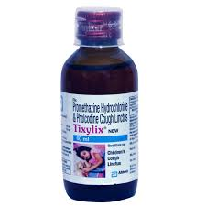

Name= Tylenol

Disc= Tylenol is a brand of paracetamol (acetaminophen) commonly used for pain relief and fever reduction.

Relieve1= Headaches

Relieve2= Toothaches

Relieve3= Fever

Relieve4= Cold and flu symptoms

Type1= Tablets

Type2= Liquid suspension (for children)

Type3= Chewable tablets

Intake= For adults, the usual dose is 500mg to 1000mg every 4 to 6 hours as needed, with a maximum of 4000mg in 24 hours.

For children:

* **1 to 12 years**: 10 to 15 mg per kg of body weight every 4 to 6 hours, not exceeding 5 doses in 24 hours.

Side1= Allergic reactions (rash, swelling)

Side2= Liver damage with overdose

Precaution1= Liver or kidney disease

Precaution2= Chronic alcohol use

Image=

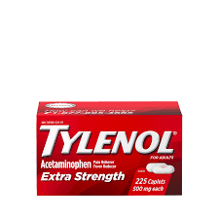

Name= Vicks action 500

Disc= Vicks Action 500 is a combination medication used to relieve symptoms of cold and flu. It typically contains paracetamol, phenylephrine, and caffeine.

Relieve1= Headaches

Relieve2= Sinus pressure

Relieve3= Aches and pains

Relieve4= Nasal congestion

Type1= Tablets

Type2=

Type3=

Intake= For adults, the usual dose is 1 to 2 tablets every 4 to 6 hours as needed, with a maximum of 8 tablets in 24 hours.

For children:

* Consult a doctor for appropriate dosing based on age and weight.

Side1= Drowsiness

Side2= Nausea

Precaution1= Heart disease or high blood pressure

Precaution2= A history of asthma or breathing problems

Image=

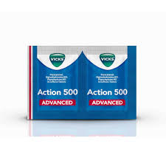

Name= Zincovit

Disc= Zincovit is a multivitamin and mineral supplement that typically contains zinc, vitamins, and other essential nutrients. It is commonly used to support overall health and immunity.

Relieve1= Support immune function

Relieve2= Improve general health and well-being

Relieve3= Aid in recovery from illness

Relieve4= Provide essential vitamins and minerals

Type1= Tablets

Type2= Syrup

Type3=

Intake= For adults, the usual dose is 1 tablet daily, taken with food. For syrup, follow the dosage instructions on the packaging.

For children:

* Consult a doctor for appropriate dosing based on age and weight.

Side1= Upset stomach

Side2= Nausea

Precaution1= Allergies to any of the ingredients

Precaution2= A history of kidney disease

Image=

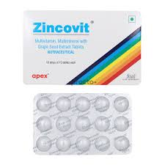

Name= Acebutolol

Disc= Acebutolol is a beta-blocker medication used primarily to treat high blood pressure and certain heart conditions.

Relieve1= Manage high blood pressure (hypertension)

Relieve2= Treat angina (chest pain)

Relieve3= Control heart rate in certain arrhythmias

Relieve4=

Type1= Tablets

Type2=

Type3=

Intake= For adults, the usual starting dose is 400mg once daily, which may be adjusted by a doctor based on individual needs. The typical maintenance dose ranges from 200mg to 800mg per day.

For children:

* Consult a doctor for appropriate dosing based on age and weight.

Side1= Fatigue

Side2= Cold hands or feet

Precaution1= Heart block or severe bradycardia

Precaution2= Diabetes (as it can mask hypoglycemia symptoms)

Image=

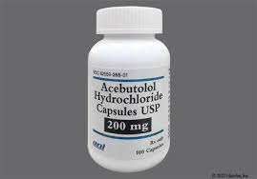

Name= Atenolol

Disc= Atenolol is a beta-blocker medication commonly used to treat high blood pressure and certain heart conditions.

Relieve1= Manage high blood pressure (hypertension)

Relieve2= Treat angina (chest pain)

Relieve3= Control heart rate in certain arrhythmias

Relieve4= Reduce the risk of heart attacks

Type1= Tablets

Type2=

Type3=

Intake= For adults, the usual starting dose is 50mg once daily. Depending on the response, it may be increased to a maximum of 100mg per day.

For children:

* Consult a doctor for appropriate dosing based on age and weight.

Side1= Slow heart rate

Side2= Cold hands or feet

Precaution1= Asthma or chronic obstructive pulmonary disease (COPD)

Precaution2= Are pregnant or breastfeeding

Image=

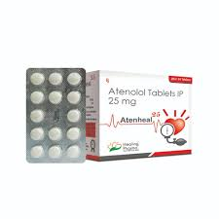

Name= Bisoprolol

Disc= Bisoprolol is a beta-blocker medication commonly used to treat high blood pressure and heart-related conditions.

Relieve1= Manage high blood pressure (hypertension)

Relieve2= Treat heart failure

Relieve3= Control heart rate in certain arrhythmias

Relieve4=

Type1= Tablets

Type2=

Type3=

Intake= For adults, the usual starting dose is 5mg once daily, which may be adjusted by a doctor based on individual response. The maximum recommended dose is typically 10mg per day.

For children:

* Consult a doctor for appropriate dosing based on age and weight.

Side1= Fatigue

Side2= Cold extremities

Precaution1= Heart block or severe bradycardia

Precaution2= Are pregnant or breastfeeding

Image=

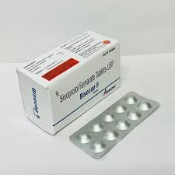

Name= Bupivacaine

Disc= Bupivacaine is a local anesthetic commonly used to numb specific areas of the body during surgical procedures or for pain management.

Relieve1= Provide local anesthesia during surgical procedures

Relieve2= Manage postoperative pain

Relieve3= Perform regional anesthesia (e.g., epidural or nerve block)

Relieve4=

Type1= Injectable solution

Type2=

Type3=

Intake= Bupivacaine is administered by a healthcare professional. The dosage and administration depend on the type of procedure, the area being numbed, and patient factors.

Side1= Local irritation at the injection site

Side2= Rarely, serious reactions such as cardiac issues or allergic reactions

Precaution1= Allergies to local anesthetics

Precaution2= Heart problems

Image=

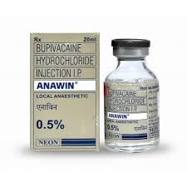

Name= captopril

Disc= Captopril is an ACE inhibitor medication commonly used to treat high blood pressure and heart failure.

Relieve1= Manage high blood pressure (hypertension)

Relieve2= Treat heart failure

Relieve3= Protect kidney function in patients with diabetes

Relieve4=

Type1= Tablets

Type2=

Type3=

Intake= For adults, the usual starting dose is 25mg two to three times daily, which may be adjusted by a doctor based on individual response. The maximum recommended dose is typically 150mg per day.

For children:

* Consult a doctor for appropriate dosing based on age and weight.

Side1= Cough

Side2= Low blood pressure

Precaution1= Kidney disease

Precaution2= History of angioedema (swelling)

Image=

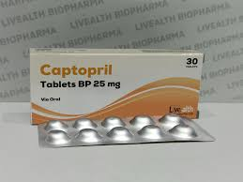

Name= Carvedilol

Disc= Carvedilol is a beta-blocker that is commonly used to treat high blood pressure and heart failure.

Relieve1= Manage high blood pressure (hypertension)

Relieve2= Treat heart failure

Relieve3= Reduce the risk of heart complications after a heart attack

Relieve4=

Type1= Tablets

Type2=

Type3=

Intake= For adults, the usual starting dose is 6.25mg twice daily, which may be adjusted by a doctor based on individual response. The typical maintenance dose ranges from 12.5mg to 50mg per day.

For children:

* Consult a doctor for appropriate dosing based on age and weight.

Side1= Weight gain

Side2= Low blood pressure

Precaution1= Asthma or chronic obstructive pulmonary disease (COPD)

Precaution2= Severe liver disease

Image=

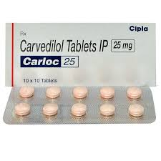

Name= Clonidine

Disc= Clonidine is a medication commonly used to treat high blood pressure and certain other conditions such as ADHD or withdrawal symptoms.

Relieve1= Manage high blood pressure (hypertension)

Relieve2= Treat attention deficit hyperactivity disorder (ADHD)

Relieve3= Aid in withdrawal symptoms from opioids or alcohol

Relieve4=

Type1= Tablets

Type2= Transdermal patches

Type3=

Intake= For adults, the typical dose for hypertension is 0.1mg to 0.3mg twice daily, with adjustments based on individual needs.

For children (for ADHD or other conditions):

* The dosage is determined by the doctor, typically starting at 0.05mg once or twice daily.

Side1= Drowsiness

Side2= Constipation

Precaution1= Heart disease

Precaution2= Depression or a history of mental health conditions

Image=

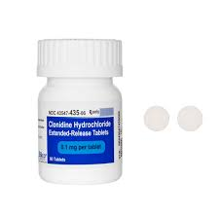

Name= Diltiazem

Disc= Diltiazem is a calcium channel blocker commonly used to treat high blood pressure and certain heart conditions.

Relieve1= Manage high blood pressure (hypertension)

Relieve2= Treat angina (chest pain)

Relieve3= Control heart rate in certain arrhythmias, such as atrial fibrillation

Relieve4=

Type1= Tablets

Type2= Extended-release capsules

Type3=

Intake= For adults, the usual starting dose is 180mg to 240mg once daily for extended-release formulations, or 30mg to 60mg three times daily for immediate-release tablets. Dosage may be adjusted based on individual response.

For children:

* Consult a doctor for appropriate dosing based on age and weight.

Side1= Headache

Side2= Slow heart rate

Precaution1= Low blood pressure

Precaution2= Heart block or severe heart conditions

Image=

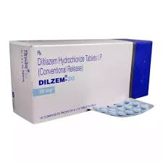

Name= Diovan

Disc= Diovan (valsartan) is an angiotensin II receptor blocker (ARB) commonly used to treat high blood pressure and heart failure.

Relieve1= Manage high blood pressure (hypertension)

Relieve2= Treat heart failure

Relieve3= Reduce the risk of heart failure-related complications following a heart attack

Relieve4=

Type1= Tablets

Type2=

Type3=

Intake= For adults, the typical starting dose is 80mg to 160mg once daily, which may be adjusted by a doctor based on individual response. The maximum recommended dose is typically 320mg per day.

For children:

* Consult a doctor for appropriate dosing based on age and weight.

Side1= Elevated potassium levels

Side2= Fatigue

Precaution1= A history of angioedema (swelling)

Precaution2= Are pregnant or breastfeeding

Image=

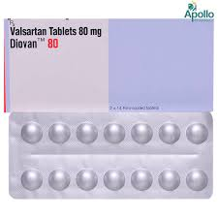

Name= Enalapril

Disc= Enalapril is an ACE inhibitor medication commonly used to treat high blood pressure and heart failure.

Relieve1= Manage high blood pressure (hypertension)

Relieve2= Treat heart failure

Relieve3= Help protect kidney function in patients with diabetes

Relieve4=

Type1= Tablets

Type2=

Type3=

Intake= For adults, the typical starting dose is 5mg to 10mg once daily, which may be adjusted by a doctor based on individual response. The maximum recommended dose is typically 40mg per day.

For children:

* Consult a doctor for appropriate dosing based on age and weight.

Side1= Elevated blood potassium levels

Side2= Rash

Precaution1= A history of angioedema (swelling)

Precaution2= Heart problems

Image=

