MAJOR PROJECT REPORT
on
AI-POWERED DECISION SUPPORT SYSTEM FOR A MOBILE SPARE (DISPLAY) PARTS WHOLESALE BUSINESS
Submitted in partial fulfilment of the requirements for the degree of
MASTER OF SCIENCE IN COMPUTER SCIENCE
(DATA SCIENCE & MACHINE LEARNING)
Submitted by
KHUSHI HEMIN SHAH
Enrollment No.: 25IC03CS026
Under the guidance of
Mr. Suman Pandit
[Designation], School of Engineering

SCHOOL OF ENGINEERING
P P SAVANI UNIVERSITY, SURAT, GUJARAT
October 2026

CERTIFICATE
This is to certify that the Major Project Report entitled “AI-Powered Decision Support System for a Mobile Spare (Display) Parts Wholesale Business”, submitted by Khushi Hemin Shah (Enrollment No. 25IC03CS026) in partial fulfilment of the requirements for the award of the degree of Master of Science in Computer Science (Data Science & Machine Learning) at P P Savani University, Surat, is a record of bona fide work carried out by the student under my guidance and supervision during the period 8 June 2026 to 3 October 2026.
To the best of my knowledge, the work embodied in this report has not been submitted to any other university or institution for the award of any degree or diploma.
______________________________
Mr. Suman Pandit
Project Guide, [Designation]
______________________________
Head / Dean
School of Engineering, P P Savani University
Place: Surat Date: ____________
DECLARATION
I, Khushi Hemin Shah, Enrollment No. 25IC03CS026, a student of the Master of Science in Computer Science (Data Science & Machine Learning) programme at the School of Engineering, P P Savani University, Surat, hereby declare that the Major Project Report entitled “AI-Powered Decision Support System for a Mobile Spare (Display) Parts Wholesale Business” is my own work carried out under the guidance of Mr. Suman Pandit.
The dataset used in the project is synthetic and was generated by me for this work, as stated in the report. All sources of information, tools and published work that I have used are acknowledged in the text and in the list of references. The use of an AI assistant during the project is stated in the Acknowledgement and in Appendix J. This report has not been submitted, in whole or in part, to any other university or institution for any degree or diploma.
______________________________
Khushi Hemin Shah
Enrollment No. 25IC03CS026
Place: Surat Date: ____________
ACKNOWLEDGEMENT
I express my sincere gratitude to my project guide, Mr. Suman Pandit, for his regular guidance, timely feedback and encouragement throughout this project. His weekly reviews shaped the scope of the work, pushed me to build a working prototype early, and led to the redesign of the dashboard presentation.
I thank the School of Engineering and the faculty of P P Savani University for the academic environment and resources, and the mobile spare parts wholesale business whose way of working with Tally accounting motivated the problem addressed here. I am also grateful to my family and friends for their support.
Use of AI assistance. An AI assistant (Claude, developed by Anthropic) was used during the project to help with drafting and debugging code, generating diagrams, planning and drafting progress reports and this report. The code was run and the results were produced on my own machine, and the content was reviewed with my project guide. The assistance is declared here and in Appendix J in line with the university’s requirements.
Khushi Hemin Shah
ABSTRACT
Small wholesalers of mobile spare (display) parts keep their accounts in software such as Tally, which records what has happened but does not forecast demand, rank customers or suppliers, or warn of stock-outs. This project designs, implements and validates a decision support system that turns a wholesaler’s transaction data into four analytical outputs and presents them in a six-page Power BI dashboard.
Because real business data was not available within the project period, the system was developed on a synthetic seven-entity dataset (179 products, 180 customers, 14 suppliers, 6,016 sales lines over 524 days) built around an authentic mobile-parts catalogue. A Python pipeline aggregates daily demand and compares six forecasting models (Linear Regression, Random Forest, XGBoost, ARIMA, SARIMA and Prophet) on a chronological 30-day hold-out; segments 179 customers into four groups with RFM analysis and K-Means; scores 14 suppliers with a composite of on-time delivery, cost and return rate; and flags products for reorder using stock, reorder level and recent demand velocity.
SARIMA gave the lowest forecast error (RMSE 40.66 units per day), although the four best models were within about 2.3 per cent of one another. The segmentation identified 23 at-risk customers, the supplier score changed the ranking obtained from delivery alone, and 35 of 179 products were flagged for reorder, two of them already out of stock. Ten automated validation checks and a user-acceptance walkthrough of all dashboard pages passed, and a script regenerates every output from updated data in one command. The system is a tested local prototype, not a hosted service; the main limitations are the synthetic data, aggregate-level forecasting and flat-file storage, and the next steps are real Tally data, a database and scheduled deployment.
Keywords: decision support system; demand forecasting; SARIMA; customer segmentation; RFM; supplier scoring; inventory alerts; Power BI.
TABLE OF CONTENTS
Chapter 1 — Introduction 1
1.1 Background and Context 1
1.2 Problem Statement 1
1.3 Need and Motivation 1
1.4 Aim and Objectives 2
1.5 Scope of the Project 2
1.6 Proposed Solution and Contribution 3
1.7 Methodology Overview 3
1.8 Organisation of the Report 3
Chapter 2 — Literature Review and Existing-System Study 5
2.1 Review Method and Sources 5
2.2 Review of Related Work 5
2.3 Comparative Summary 7
2.4 Gap Analysis 7
2.5 How This Project Addresses the Gap 7
2.6 Chapter Summary 8
Chapter 3 — System Analysis and Requirements 9
3.1 Preliminary Investigation 9
3.2 Study of the Existing System 9
3.3 Proposed System and Expected Benefits 9
3.4 Functional Requirements 9
3.5 Non-Functional Requirements 10
3.6 Hardware and Software Requirements 11
3.7 Feasibility Study 11
3.8 Assumptions, Constraints, Dependencies and Risks 11
3.9 Software Requirements Specification Summary 12
Chapter 4 — Project Planning and Methodology 13
4.1 Development Methodology 13
4.2 Project Phases and Deliverables 13
4.3 Work Breakdown Structure 13
4.4 Schedule (Gantt Chart) 14
4.5 Task Dependencies (PERT-style Network) 15
4.6 Roles and Responsibilities 16
4.7 Risk Register 16
4.8 Data Collection, Dataset Preparation and Ethics 16
Chapter 5 — System Design 18
5.1 Overall System Architecture 18
5.2 Module Decomposition and Responsibilities 19
5.3 Data Flow Diagrams 19
5.4 Use-Case Diagram 20
5.5 Activity Diagram 20
5.6 Entity-Relationship Diagram 21
5.7 Database Schema 22
5.8 Input and Output Design 24
5.9 Algorithms and Process Logic 25
5.10 Security, Privacy, Validation, Backup and Access Control 26
5.11 Design Decisions and Trade-offs 27
Chapter 6 — Implementation 28
6.1 Development Environment and Tool Versions 28
6.2 Project Folder Structure and Configuration 28
6.3 Module-wise Implementation 28
6.4 Important Algorithms and Code Excerpts 30
6.5 Database Implementation and Sample Records 32
6.6 API and External-Service Integration 32
6.7 Authentication, Validation and Error Handling 32
6.8 Screenshots of the Working System 33
6.9 Build, Run and Deployment Instructions 36
Chapter 7 — Testing and Validation 38
7.1 Test Strategy, Scope and Environment 38
7.2 Module-level Testing 38
7.3 Integration Testing 39
7.4 System and User-Acceptance Testing 39
7.5 Model Validation, Usability, Performance and Security Checks 40
7.6 Test Results Summary and Defects Found 40
7.7 Requirement Traceability 41
Chapter 8 — Results, Discussion and Limitations 42
8.1 Implemented Features and Evidence 42
8.2 Results Against Each Objective 42
8.3 Quantitative Evaluation 42
8.4 Comparison with Baseline or Existing Method 45
8.5 Interpretation of Results 45
8.6 Limitations 46
8.7 Mentor and User Feedback Incorporated 47
Chapter 9 — Conclusion and Future Scope 48
9.1 Summary of the Work 48
9.2 Achievement of Objectives 48
9.3 Key Contributions 48
9.4 Learning Outcomes 49
9.5 Future Scope and Recommendations 49
9.6 Closing Remarks 49
References 50
Appendix A — Approved Project Synopsis 52
Appendix B — Detailed Requirements and Use-Case Descriptions 53
Appendix C — Additional Diagrams 54
Appendix D — Detailed Test Cases and Evidence 55
Appendix E — User Manual 56
Appendix F — Source Code and Repository 57
Appendix G — Progress Reports Summary 59
Appendix H — Questionnaires, Interview Records and Consent Forms 60
Appendix I — Group Contribution Statement 61
Appendix J — Plagiarism Report and Declaration of AI-Assisted Contributions 62
LIST OF FIGURES
Figure 4.1: Gantt chart of the planned project phases (8 June to 3 October 2026) 14
Figure 4.2: Task dependency network; forecasting, segmentation and supplier scoring depend on the prepared data, and the dashboard depends on all four modules 15
Figure 5.1: Layered system architecture of the decision support system 18
Figure 5.2: Level 0 data flow diagram 19
Figure 5.3: Use-case diagram 20
Figure 5.4: Activity diagram of the analytical decision-support workflow 21
Figure 5.5: Entity-relationship diagram with keys and cardinalities 22
Figure 5.6: Dashboard page navigation map 24
Figure 6.1: Notebook execution order and output files 29
Figure 6.2: Home (landing) page with navigation cards, date filter, KPIs and segment donut 33
Figure 6.3: Overview page: KPIs, historical sales trend, sales by city and top 10 products 34
Figure 6.4: Demand Forecast page: 30-day SARIMA forecast with upper and lower bounds 34
Figure 6.5: Customer Segmentation page: segment chart and RFM detail table 35
Figure 6.6: Supplier Performance page: composite-score table and ranking chart 35
Figure 6.7: Inventory Alerts page: alert table, products-needing-reorder KPI and status donut 36
Figure 8.1: RMSE and MAPE of the six forecasting models (selected model highlighted for each metric) 43
Figure 8.2: Customers per segment and inventory alert status counts 44
Figure 8.3: Composite score compared with on-time delivery for the 14 suppliers 45
Figure C.1: Conceptual entity-relationship diagram (Chen notation) 54
LIST OF TABLES
Table 1.1: Objectives, expected outputs and verification evidence 2
Table 2.1: Comparison of the reviewed sources and their relevance 7
Table 3.1: Stakeholders and their information needs 9
Table 3.2: Functional requirements and acceptance criteria 9
Table 3.3: Non-functional requirements 10
Table 3.4: Hardware and software requirements 11
Table 4.1: Project phases, planned windows and status 13
Table 4.2: Risk register 16
Table 4.3: Composition of the dataset used for development 17
Table 5.1: Module specification 19
Table 5.2: Relationships between entities 23
Table 5.3: Data dictionary 23
Table 5.4: Dashboard page design 25
Table 5.5: Design decisions and their trade-offs 27
Table 6.1: Development environment 28
Table 6.2: Notebook summary 29
Table 6.3: Sample records from customer_segments.csv 32
Table 6.4: Sample records from inventory_alerts.csv 32
Table 7.1: Test levels and what each covers 38
Table 7.2: Automated test cases and results 38
Table 7.3: Integration tests 39
Table 7.4: User-acceptance checklist results 39
Table 7.5: Forecast validation configuration 40
Table 7.6: Defect log 40
Table 7.7: Traceability from requirements to objectives and evidence 41
Table 8.1: Implemented features and their evidence 42
Table 8.2: Forecast accuracy of the six models on the 30-day hold-out 43
Table 8.3: Segment centroids and sizes (mean values per cluster) 43
Table 8.4: Supplier scorecard with composite score 44
Table 9.1: Objective-wise status 48
Table B.1: Use-case descriptions 53
Table G.1: Progress reports submitted to the project guide 59
LIST OF ABBREVIATIONS
ARIMA Autoregressive Integrated Moving Average
SARIMA Seasonal ARIMA
BI Business Intelligence
CSV Comma-Separated Values
DAX Data Analysis Expressions
DFD Data Flow Diagram
DSS Decision Support System
EDA Exploratory Data Analysis
ER Entity-Relationship
FR / NFR Functional / Non-Functional Requirement
INR Indian Rupee
KPI Key Performance Indicator
MAPE Mean Absolute Percentage Error
RFM Recency, Frequency, Monetary
RMSE Root Mean Squared Error
SKU Stock-Keeping Unit
UAT User Acceptance Testing
XGBoost Extreme Gradient Boosting

Chapter 1 — Introduction

1.1 Background and Context
Mobile phone repair is a large and active small-business segment in Indian cities, and it is supplied by a layer of wholesalers who stock replacement parts and sell them to repair shops, retail stores and sub-dealers. The parts include display assemblies (LCD and OLED combos), touch digitisers, batteries, charging-port flex cables, back-glass panels, camera modules and speakers. A wholesaler of this kind carries a large and fast-changing catalogue: every handset model needs its own compatible parts, new models are released continuously and older models fade. The dataset built for this project, for example, contains 179 stock-keeping units (SKUs) across six brands (Apple, Samsung, Xiaomi, Oppo, Vivo and Realme), sold to 180 trade customers and bought from 14 suppliers.
The business that motivated this project keeps its accounts in Tally. Tally records vouchers (sales and purchases), stock items and ledgers accurately, but it is an accounting system: it reports what has already happened. It does not forecast demand, identify which customers are drifting away, compare suppliers on delivery and quality, or warn that a particular part is about to run out. Decisions about what to stock, whom to follow up and which supplier to rely on are therefore taken from memory and experience.

1.2 Problem Statement
Wholesalers of mobile spare (display) parts make three recurring decisions without systematic analytical support: how much of each part to hold, which customers to prioritise, and which suppliers to buy from. Manual, experience-based planning leads to stock-outs of fast-moving parts, capital locked in slow-moving parts, late recognition of customers who have stopped ordering, and inconsistent supplier selection. No single, easy-to-read system brings demand forecasting, customer insight, supplier performance and stock alerts together for a non-technical business owner.

1.3 Need and Motivation
The need is practical. A stock-out of a popular display assembly means a lost sale and a repair shop that may buy elsewhere next time; excess stock of an obsolete model ties up cash. Likewise, a supplier that is cheap but frequently late, or that supplies parts with a high return rate, is more expensive than it looks. The prototype built in this project illustrates the scale of the problem on its dataset: of 179 products, 35 (19.6 per cent) were flagged for reorder, two of them already at zero stock; supplier on-time delivery ranged from 60.0 to 78.9 per cent across 14 suppliers; and 23 of 179 customers fell into an “At Risk” segment. These figures come from a synthetic dataset (Section 4.8) and are not claims about any real business, but they show the kind of insight that the raw ledger does not expose.
The motivation for the author, as a student of data science and machine learning, was to apply forecasting, clustering and scoring techniques to a realistic small-business problem and to deliver the result as a dashboard that a non-technical person can use, rather than as a set of notebooks that only a developer can read.

1.4 Aim and Objectives
Aim. To design, implement and validate an AI-powered decision support system (DSS) that converts a mobile spare-parts wholesaler's transaction data into demand forecasts, customer segments, supplier scores and reorder alerts, presented through an interactive multi-page dashboard.
The objectives were stated as measurable outcomes so that their completion can be checked in Chapters 8 and 9.
Table 1.1: Objectives, expected outputs and verification evidence
ID | Objective | Expected output | Verification evidence
O1 | Forecast demand and select the best of six candidate models | Six models compared on a common hold-out; 30-day forecast with confidence bounds | RMSE and MAPE table (Table 8.2); demand_forecast.csv; Demand Forecast page
O2 | Segment customers using RFM analysis and K-Means clustering | Four labelled customer segments for all 179 ordering customers | customer_segments.csv; Customer Segmentation page; test TC-04, TC-05
O3 | Score suppliers on reliability, cost and quality | Scorecard for 14 suppliers with a weighted composite score | supplier_scorecard.csv; Supplier Performance page; tests TC-06 to TC-08
O4 | Flag products that need reordering | Alert status for every product (Stock OK / REORDER SOON / REORDER NOW) | inventory_alerts.csv; Inventory Alerts page; tests TC-09, TC-10
O5 | Design a unified seven-entity data schema | Schema with keys and relationships covering sales, inventory, customers, suppliers, purchases and returns | ER diagram (Figure 5.5); data dictionary (Table 5.3); seven-sheet workbook
O6 | Present all results in an integrated dashboard | Six-page Power BI report with landing-page navigation | Screenshots (Figures 6.2 to 6.7); UAT matrix (Table 7.4)

1.5 Scope of the Project
Included. The system covers the full analytical pipeline from a structured data workbook to a dashboard: data loading and cleaning; daily demand aggregation; comparison of six forecasting models and a 30-day forecast; RFM segmentation; supplier scoring with return-rate integration; inventory alerting; a six-page Power BI dashboard; automated output validation; and a script that regenerates all outputs from updated data. The intended users are the business owner and manager (readers of the dashboard) and a data analyst (who runs the pipeline).
Data. The real business's Tally data could not be obtained within the project timeline. The system was therefore developed on a synthetic dataset that was purpose-built around an authentic mobile-parts catalogue and realistic business patterns. This is disclosed throughout the report.
Boundaries (not included). The project does not include a live connection to Tally, a relational database server, hosting or scheduled refresh of the dashboard, forecasts at individual-product level, or a formal user study. These are discussed as limitations (Section 8.6) and future scope (Section 9.5).

1.6 Proposed Solution and Contribution
The proposed solution is a layered pipeline. Python notebooks load and clean the data and run four analytical modules; each module writes a CSV file; a Power BI report reads those files and presents them on six linked pages. The main contributions of the project are:
- an end-to-end, reproducible DSS pipeline for a mobile-parts wholesaler, from a seven-entity data workbook to a navigable dashboard;
- a like-for-like comparison of six forecasting models (Linear Regression, Random Forest, XGBoost, ARIMA, SARIMA and Prophet) on a chronological hold-out, with the selection justified from the measured results;
- a supplier composite score that combines on-time delivery, cost and product return rate, including the attribution of returns to suppliers through the purchase history;
- an inventory alert rule that combines the stock threshold with recent demand velocity;
- an automated validation suite and a one-command pipeline script, which together make the outputs checkable and repeatable.

1.7 Methodology Overview
The project followed an iterative, incremental approach with weekly mentor review: planning and requirements first, then data preparation, then one analytical module at a time, then dashboard integration, testing and documentation (Chapter 4). Each increment was committed to a Git repository and described in a progress report. Evaluation used chronological hold-out validation for forecasting, structural and range-based validation checks for the other modules, and a manual user-acceptance checklist for the dashboard (Chapter 7).

1.8 Organisation of the Report
Chapter 2 reviews the literature and existing systems. Chapter 3 analyses the problem and states the requirements. Chapter 4 describes planning, methodology and the data used. Chapter 5 presents the architecture and design. Chapter 6 describes the implementation. Chapter 7 reports testing and validation. Chapter 8 presents results, discussion and limitations. Chapter 9 concludes and outlines future work. References and appendices follow.

Chapter 2 — Literature Review and Existing-System Study

2.1 Review Method and Sources
The review covered five topics that correspond to the modules of the system: demand forecasting, customer segmentation, supplier evaluation, inventory control, and decision-support dashboards. Sources were standard textbooks, peer-reviewed articles on each technique, official software documentation, and publicly visible open-source projects and datasets found while searching for similar systems and for a suitable dataset (Kaggle datasets for auto-parts, mobile sales and wholesale orders; GitHub repositories on spare-parts forecasting and procurement analytics; and a 2026 journal article on AI-driven inventory and demand forecasting). Open repositories are cited only for what their own descriptions state, since they were not independently evaluated.

2.2 Review of Related Work

2.2.1 Demand forecasting
Autoregressive integrated moving average (ARIMA) models, formalised by Box and Jenkins and presented in their later editions (Box et al., 2015), model a series through its own past values and past errors after differencing, and their seasonal extension (SARIMA) adds seasonal terms at a fixed period. Hyndman and Athanasopoulos (2021) give the modern treatment of these models and of the evaluation of forecasts on a hold-out sample. Prophet (Taylor & Letham, 2018) fits an additive model of trend, seasonality and holidays and was designed for business series with strong seasonal patterns, which made it a natural candidate for this project.
Machine-learning regressors such as random forests (Breiman, 2001) and gradient-boosted trees (Chen & Guestrin, 2016) can also be applied to forecasting by turning calendar information and lagged values into features. Makridakis et al. (2018) compared statistical and machine-learning forecasting methods and reported that the statistical methods were more accurate on the series they studied and cheaper to compute, which is a useful caution against assuming that a more complex model will forecast better. For accuracy measurement, Hyndman and Koehler (2006) discuss the strengths and weaknesses of scale-dependent measures such as RMSE and percentage measures such as MAPE; in particular, percentage errors become unstable when actual values are close to zero. Spare-parts demand is often intermittent, with many zero-demand periods; Croston (1972) and Syntetos and Boylan (2005) address this with dedicated estimators. These are relevant to forecasting at individual-product level and are listed as future work in this project.

2.2.2 Customer segmentation
Recency, frequency and monetary value (RFM) summarise a customer's purchase history in three numbers; Fader et al. (2005) discuss RFM variables in customer-base analysis. K-Means clustering (MacQueen, 1967) partitions customers into a chosen number of groups by minimising within-group distance, and is implemented in scikit-learn (Pedregosa et al., 2011). Combining RFM variables with K-Means is a common, interpretable way to obtain customer segments whose centroids can be read in business terms.

2.2.3 Supplier evaluation
Dickson (1966) analysed the criteria purchasing managers use to select vendors and found quality, delivery and past performance to be the most important. Ho et al. (2010) reviewed multi-criteria decision-making approaches for supplier evaluation and selection and found that quality, delivery and price are the most frequently used criteria. Kraljic (1983) proposed classifying purchases by their profit impact and supply risk. These sources support a supplier score built from delivery reliability, cost and quality, which is the structure adopted here, with returns as the quality signal.

2.2.4 Inventory control
Silver et al. (2017) describe reorder-point policies, in which a replenishment order is triggered when stock falls to a level that covers expected demand during the replenishment lead time plus a safety margin. The alert module in this project uses a simplified form: a stored reorder level plus a check of recent demand velocity against current stock.

2.2.5 Decision-support systems and dashboards
Power (2002) defines decision support systems as computer-based systems that help decision makers use data and models to address unstructured problems. Few (2013) argues that a dashboard should present the most important information on a single screen so that it can be monitored at a glance, and should use visual encodings that can be read quickly. These principles guided the dashboard design, including the decision to keep each detail page to two visuals and a short explanation, and to add a landing page for navigation.

2.2.6 Existing open systems
Several public projects address parts of the same problem. An open repository for an AI procurement operating system describes a machine-learning portfolio spanning strategic sourcing, demand planning, inventory optimisation and supplier governance (ycc710, n.d.). A public repository on spare-parts inventory describes time-series analysis and forecasting for spare parts held in service centres (ajitsingh98, n.d.). A 2026 journal article describes an AI-driven inventory and demand-forecasting system with supplier communication and trend analysis (International Journal of Engineering Research & Technology, 2026). No suitable public dataset of mobile-display-parts wholesale transactions was found: the datasets inspected covered auto parts, generic smartphone sales or unrelated wholesale orders.

2.3 Comparative Summary
Table 2.1: Comparison of the reviewed sources and their relevance
Source | Problem addressed | Method | Main finding / contribution | Limitation for this project
Box et al. (2015) | Time-series forecasting | ARIMA / seasonal ARIMA | Systematic model identification, estimation and diagnostics | Needs parameter choice; not tuned here
Taylor & Letham (2018) | Forecasting business series at scale | Prophet additive model | Interpretable trend and seasonality components | Performance depends on enough history
Makridakis et al. (2018) | Statistical vs machine-learning forecasts | Empirical comparison | Statistical methods were more accurate on the series studied | Different data from this project
Hyndman & Koehler (2006) | Forecast accuracy measures | Analysis of error measures | Percentage errors unstable near zero | Informs reading of MAPE here
Syntetos & Boylan (2005) | Intermittent demand | Croston-type estimators | Corrects bias in Croston’s estimator | Not implemented; future work
Fader et al. (2005) | Customer-base analysis | RFM variables | RFM summarises purchase history | Used descriptively, not for lifetime value
Ho et al. (2010) | Supplier evaluation | Review of multi-criteria methods | Quality, delivery and price are the common criteria | Weights here are judgemental
Open repositories and 2026 article | Procurement, inventory and forecasting analytics | Machine learning and time-series methods (as described by their authors) | Show interest in integrated analytics | Not domain-specific; not evaluated by the author

2.4 Gap Analysis
Within the sources the author could find, forecasting, segmentation, supplier scoring and inventory alerting are usually treated separately, are demonstrated on large generic datasets, and are delivered as code rather than as a tool a business owner can navigate. For a small mobile-parts wholesaler whose only structured data is a Tally export, there is little accessible guidance on assembling these analyses into one low-cost, interpretable system. This statement is limited to the sources searched and is not a claim about all existing work.

2.5 How This Project Addresses the Gap
- It integrates four analytical modules and a navigable dashboard around one data schema.
- It uses only open-source Python libraries and Power BI Desktop, and file-based exports compatible with Tally output.
- It compares six forecasting models on identical data and reports the measured error rather than assuming a model.
- It builds supplier quality into the score by attributing returns to suppliers, and explains the score in plain language on the dashboard.

2.6 Chapter Summary
The literature supports each technical choice in this project (SARIMA and Prophet, tree-based regressors, RFM with K-Means, criteria-based supplier scoring, reorder-point thinking and glanceable dashboards) while also warning about the sensitivity of percentage errors, the cost of model complexity and the special nature of intermittent spare-parts demand. The next chapter turns these ideas into requirements.

Chapter 3 — System Analysis and Requirements

3.1 Preliminary Investigation
The problem was investigated from the point of view of the business that motivated the project: a mobile spare (display) parts wholesaler whose accounting is kept in Tally and whose purchasing, stocking and customer-follow-up decisions are made by experience. The needs below were derived from this described workflow and refined with the project guide during weekly reviews; no formal survey or interview programme was conducted.
Table 3.1: Stakeholders and their information needs
Stakeholder | Role | Main need
Business owner / manager | Primary dashboard reader and decision maker | See at a glance what to stock, whom to follow up and which suppliers to trust
Purchase staff | Places orders with suppliers | Know which products are below threshold and which suppliers are reliable
Sales staff | Serves repair shops and sub-dealers | Know which customers are high-value and which are at risk
Data analyst (the author) | Builds and runs the pipeline | Refresh outputs quickly when new data arrives and check that they are valid

3.2 Study of the Existing System
In the existing system, sales and purchase vouchers are entered in Tally, and reports such as the sales register, purchase register and stock summary are read manually. Strengths are accuracy of bookkeeping and familiarity. Weaknesses are that the reports are backward-looking, there is no forecasting, customer and supplier performance must be judged by memory, and stock decisions are reactive.

3.3 Proposed System and Expected Benefits
The proposed system takes exports of the same transactional data, runs the analytical modules automatically, and presents the results in a dashboard with a landing page. Expected benefits are earlier warning of stock-outs, a basis for prioritising customers, an evidence-based view of supplier performance, and less manual effort when data is refreshed.

3.4 Functional Requirements
Table 3.2: Functional requirements and acceptance criteria
ID | Requirement | Priority | Acceptance criterion
FR-01 | Load sales, purchase, inventory, customer, supplier, product and return data from the Excel workbook | Must | All seven sheets load; shapes match expected row counts
FR-02 | Clean and aggregate transactions into a daily demand series with missing dates filled with zero | Must | One row per calendar day in the data range
FR-03 | Compare six forecasting models on a chronological hold-out using RMSE and MAPE | Must | Results table produced for all six models
FR-04 | Produce a 30-day forecast with lower and upper bounds | Must | Exactly 30 rows; no negative demand; lower <= upper (TC-01 to TC-03)
FR-05 | Compute RFM values and assign each customer to one of four labelled segments | Must | Segment counts sum to the number of customers; no duplicates (TC-04, TC-05)
FR-06 | Compute a supplier scorecard with on-time %, average cost, return rate and a composite score | Must | All 14 suppliers present; percentages and scores in range (TC-06 to TC-08)
FR-07 | Assign an alert status to every product using stock, reorder level and recent demand | Must | REORDER NOW rows have stock <= reorder level; no duplicates (TC-09, TC-10)
FR-08 | Provide a Home page with navigation cards, a date quick filter and summary KPIs | Must | Each card opens the correct page (UAT)
FR-09 | Provide an Overview page with KPIs, sales trend, top products and sales by city | Must | KPI values agree with the raw data (UAT spot-check)
FR-10 | Provide one detail page per module with a short plain-language explanation | Must | Four detail pages, each with an explanation panel
FR-11 | Regenerate all outputs from updated data with one command | Should | run_pipeline.py completes all notebooks in order
FR-12 | Validate the module outputs automatically | Should | Ten validation checks run and report PASS / FAIL

3.5 Non-Functional Requirements
Table 3.3: Non-functional requirements
ID | Category | Requirement | How it is checked
NFR-01 | Usability | A non-technical reader can understand each page without help; each detail page carries an explanation | Manual walkthrough and mentor review
NFR-02 | Reliability | Module outputs are structurally valid and consistent | Automated validation, 10 of 10 checks passing
NFR-03 | Maintainability | Modular notebooks, version control and a documented folder structure | Repository inspection
NFR-04 | Portability | Runs on a standard Windows laptop with a conda environment and Power BI Desktop | Developed and run on such a machine
NFR-05 | Data protection | No real personal or business data is used or published | Dataset is synthetic; raw data folders excluded from version control
NFR-06 | Efficiency | The full pipeline runs on a laptop without specialised hardware | Executed locally throughout development

3.6 Hardware and Software Requirements
Table 3.4: Hardware and software requirements
Item | Requirement used
Hardware | Windows 11 laptop (8 logical processors); no GPU or server required
Operating system | Windows 11
Language and environment | Python 3.10.20 in a dedicated conda environment (conda 25.11.1)
Libraries | pandas, NumPy, scikit-learn, XGBoost, statsmodels, Prophet, openpyxl, matplotlib, seaborn, nbconvert, watchdog
Development tool | Jupyter Notebook
Visualisation | Microsoft Power BI Desktop
Version control | Git 2.54.0 (Windows) with a GitHub remote repository

3.7 Feasibility Study
Technical feasibility. All required techniques are available in free Python libraries, and the data volume (6,016 sales lines over 524 days) is small enough to process on a laptop. This was confirmed by building the system.
Operational feasibility. The input is a set of Excel or CSV exports that a Tally user can produce with standard reports, and the output is a dashboard in a familiar tool, so day-to-day use does not require programming. Supplier delivery-date tracking is not normally kept in Tally, which is why the project relies on purchase orders carrying promised and actual delivery dates and treats this as a data requirement for real deployment.
Economic feasibility. The software stack is free or free-to-use (Python libraries, Jupyter, Git, GitHub, Power BI Desktop), so the cost is the developer's time.
Schedule feasibility. The work was broken into weekly increments within the period 8 June to 3 October 2026 (Chapter 4), and each increment was kept small enough to complete and review within a week.

3.8 Assumptions, Constraints, Dependencies and Risks
- Assumption: the synthetic dataset is structurally representative of a Tally export for this business (same entities and fields) so that the pipeline can later run on real exports.
- Constraint: real data was not available; the project period was fixed (8 June to 3 October 2026); the tools had to be free.
- Dependency: Power BI Desktop for the dashboard; the Python libraries listed above; a working Jupyter and nbconvert installation for automation.
- Risks: absence of real data, limited history for forecasting, refresh problems in Power BI, and time pressure. The risk register is in Section 4.7.

3.9 Software Requirements Specification Summary
The purpose of the specification is to define a DSS that converts the wholesaler's structured exports into four analytical outputs and one dashboard. The product is a standalone, locally run pipeline plus a Power BI report; it has no external interfaces other than file import and Power BI's CSV connector. The functional and non-functional requirements above form the specification, and the traceability between requirements, tests and objectives is given in Table 7.7. A fuller requirements listing is in Appendix B.

Chapter 4 — Project Planning and Methodology

4.1 Development Methodology
An iterative and incremental approach was used. The system decomposes naturally into modules with a clear data dependency (cleaning, then forecasting, then inventory alerts, with segmentation and supplier scoring independent of forecasting), so each module could be built, checked and reviewed in turn. A strict waterfall plan was unsuitable because the dashboard design changed after mentor feedback (for example, the move to a landing page), and because model choice could only be decided after measurements were available. Weekly mentor reviews, each documented in a progress report, provided the iteration points.

4.2 Project Phases and Deliverables
Table 4.1: Project phases, planned windows and status
Phase | Planned start | Planned end | Deliverable / evidence | Status
1. Problem, literature, scope | 08 Jun 2026 | 16 Jul 2026 | Title approval, objectives, Progress Report 1 | Completed
2. Requirements and feasibility | 17 Jul 2026 | 23 Jul 2026 | Requirements, technology choice, Report 2 | Completed
3. Architecture, schema, environment | 24 Jul 2026 | 06 Aug 2026 | Design, dataset, environment and Git repository, Report 3 | Completed
4. Prototype and first modules | 07 Aug 2026 | 13 Aug 2026 | Notebooks 01–06, first dashboard, Report 4 | Completed
5. Module completion and code review | 14 Aug 2026 | 27 Aug 2026 | Model comparison, landing page, Reports 5–6 | Completed
6. Integration and testing strategy | 28 Aug 2026 | 03 Sep 2026 | Supplier returns integration, Report 7 | Completed
7. Testing, error handling, optimisation | 04 Sep 2026 | 10 Sep 2026 | Validation suite, UAT, Report 8 | Completed
8. Demonstration and documentation | 11 Sep 2026 | 17 Sep 2026 | Objective review, Report 9 | Completed
9. Final evaluation and submission | 18 Sep 2026 | 03 Oct 2026 | Pipeline automation, final report, Report 10 | Completed

The planned windows follow the mentor's reporting schedule; the actual content and dates of each cycle are recorded in the progress reports (Appendix G).

4.3 Work Breakdown Structure
- 1 Initiation: title and scope, literature review, objectives.
- 2 Analysis and design: requirements, feasibility, technology selection, architecture, schema, module planning.
- 3 Data: synthetic dataset generation, loading and exploratory analysis, cleaning and aggregation.
- 4 Modules: forecasting and model comparison, customer segmentation, supplier scoring with returns, inventory alerts.
- 5 Presentation: dashboard pages, landing-page navigation, formatting and consistency review.
- 6 Quality: validation suite, error handling, optimisation, user-acceptance walkthrough.
- 7 Delivery: automation script, documentation, demonstration preparation, final report.

4.4 Schedule (Gantt Chart)
Figure 4.1 shows the planned phase windows. Because the work followed weekly reviews, actual completion is documented by the dated progress reports rather than by a separate actual-date overlay.
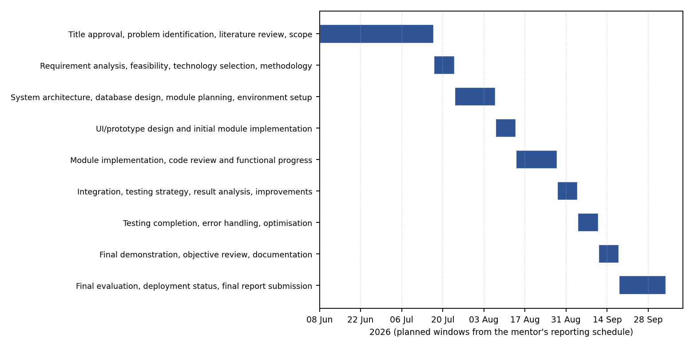
Figure 4.1: Gantt chart of the planned project phases (8 June to 3 October 2026)

4.5 Task Dependencies (PERT-style Network)
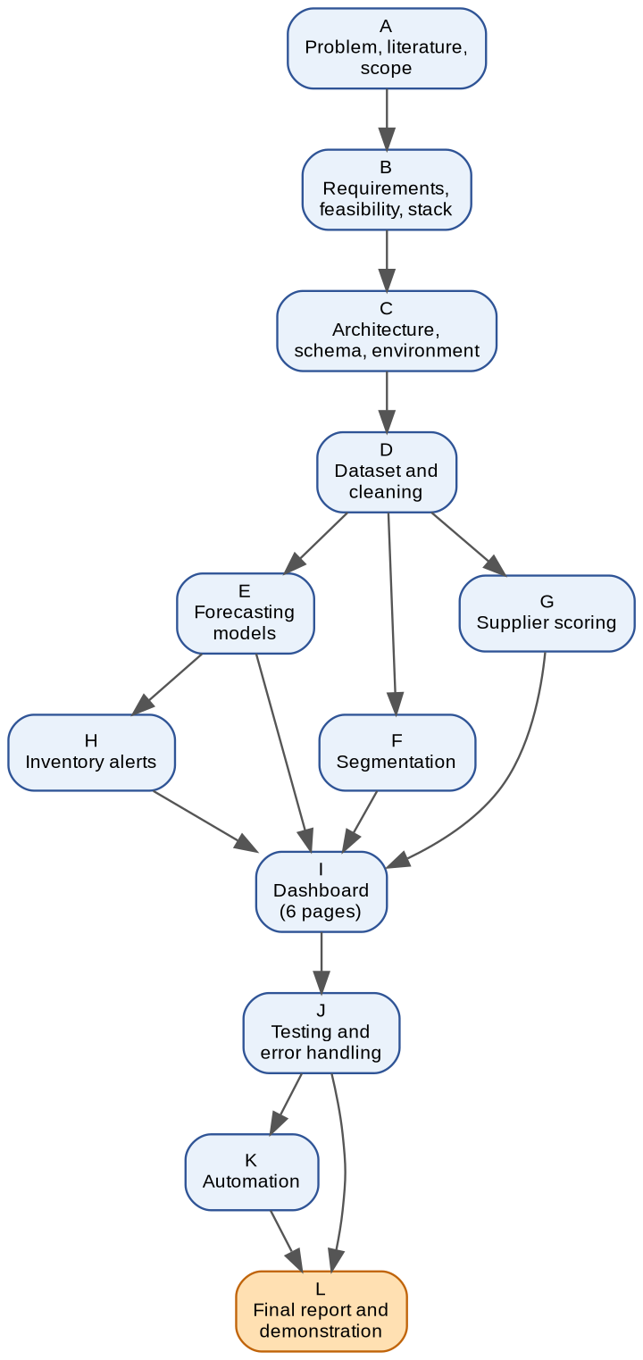
Figure 4.2: Task dependency network; forecasting, segmentation and supplier scoring depend on the prepared data, and the dashboard depends on all four modules
Tasks D to H can partly overlap, but the dashboard (I) cannot be completed until all four modules produce their outputs, and the final report (L) depends on testing (J) and automation (K). The longest path runs A, B, C, D, E, I, J, K, L.

4.6 Roles and Responsibilities
This is an individual project. The author carried out analysis, design, data preparation, implementation, testing and documentation. The project guide, Mr. Suman Pandit, reviewed progress weekly, gave feedback on scope and presentation, and approved the direction of each increment.

4.7 Risk Register
Table 4.2: Risk register
Risk | Likelihood | Impact | Mitigation | Outcome
Real business data not available in time | High | High | Build a synthetic dataset on an authentic product catalogue; keep the pipeline format-compatible with Tally exports | Occurred; mitigated (Section 4.8)
Forecast accuracy limited by short history | Medium | Medium | Compare six models; report errors honestly; avoid over-claiming | Occurred; reported in Chapter 8
Power BI refresh or cached-schema problems | Medium | Medium | Diagnose and reset the query source; document the fix | Occurred; resolved (Table 7.6)
Notebook order dependencies break automation | Medium | Medium | Fix execution order and test the full run | Occurred; resolved
Presentation judged unclear by users | Medium | Medium | Landing page, consistent two-visual layout, explanatory text | Addressed after mentor feedback
Scope creep (extra visuals, extra models) | Medium | Low | Keep each page to two visuals; defer extras to future work | Controlled

4.8 Data Collection, Dataset Preparation and Ethics

4.8.1 Data source and why it is synthetic
The intended source was the business's Tally data, exported as the sales register, purchase register, stock summary and customer and supplier ledgers. The business did not provide this data within the project timeline, and no public dataset of mobile-display-parts wholesale transactions was found (Section 2.2.6). A synthetic dataset was therefore generated with a Python script (Faker for names, NumPy and Python random for sampling, fixed random seed) so that the work could proceed (Shah, 2026).

4.8.2 Dataset design
The dataset follows the seven-entity schema of Chapter 5. The product catalogue is authentic in structure: 37 handset models across six brands and 12 part types (LCD and OLED display combos, touch digitiser, battery, charging-port flex, back glass, rear and front camera modules, speaker, microphone flex, power-button flex and SIM tray), giving 179 products with prices in Indian rupees. Transactions were generated with Poisson-distributed daily order counts and seasonal multipliers (higher demand in October to December, a lift in May and June, lower demand in January and February). Purchase orders were generated with promised and actual delivery dates in which about 70 per cent of deliveries are on time and the rest are one to six days late. Returns were sampled at about three per cent of sales lines with realistic reasons such as defective display or dead-on-arrival.
Table 4.3: Composition of the dataset used for development
Entity (sheet) | Rows | Notes
Customers | 180 | Gujarat cities (about 75%) plus Mumbai, Pune, Indore and Nagpur; four shop types
Suppliers | 14 | Mix of Indian and Chinese suppliers; lead times and payment terms
Products | 179 | Six brands, 12 part types; unit and cost prices
Sales_Transactions | 6,016 | 22 Jan 2025 to 29 Jun 2026 (524 calendar days)
Inventory | 179 | One snapshot row per product, with reorder level
Purchase_Orders | 298 | Six orders pending at the end of the period
Returns_Complaints | 180 | Linked to sales lines and products

4.8.3 Limitations and ethical position
Because the numbers are simulated, the results demonstrate that the pipeline works and show how its outputs read; they are not findings about a real business. In particular, the seasonality and noise in the data were put there by the generator, and the forecast errors in Chapter 8 partly reflect that built-in randomness. No real personal or commercial data was collected or used, so no consent or privacy issues arise, and the generated names are fictitious. The dataset is disclosed as synthetic wherever results are reported. For deployment, the same pipeline is intended to run on genuine Tally exports once access is obtained.

4.8.4 Data extension used to demonstrate automation
To demonstrate that the pipeline responds to new data, 1,912 further synthetic sales lines covering 30 June to 29 September 2026 were generated with the same seasonal logic, using identifiers in a separate range that cannot collide with existing orders, and appended to the Sales_Transactions sheet. The pipeline was then re-run to regenerate all outputs (Section 6.9).

Chapter 5 — System Design

5.1 Overall System Architecture
The system has five layers (Figure 5.1). The data layer is the Excel workbook with seven sheets, standing in for Tally exports. The processing layer is two Jupyter notebooks that load, explore, clean and aggregate the data. The model layer is four analytical modules implemented in notebooks. The output store is a set of CSV files in the reports folder, which is the only interface between Python and Power BI. The presentation layer is a six-page Power BI report read by the business owner. Two supporting components sit beside this chain: automation scripts that re-run the notebooks, and a validation notebook that checks the output files.
Using CSV files as the hand-off keeps the layers independent: the notebooks can be re-run without opening Power BI, and the dashboard can be refreshed without running Python. The system runs entirely on one local machine; there is no server, database engine or cloud service in the current architecture.
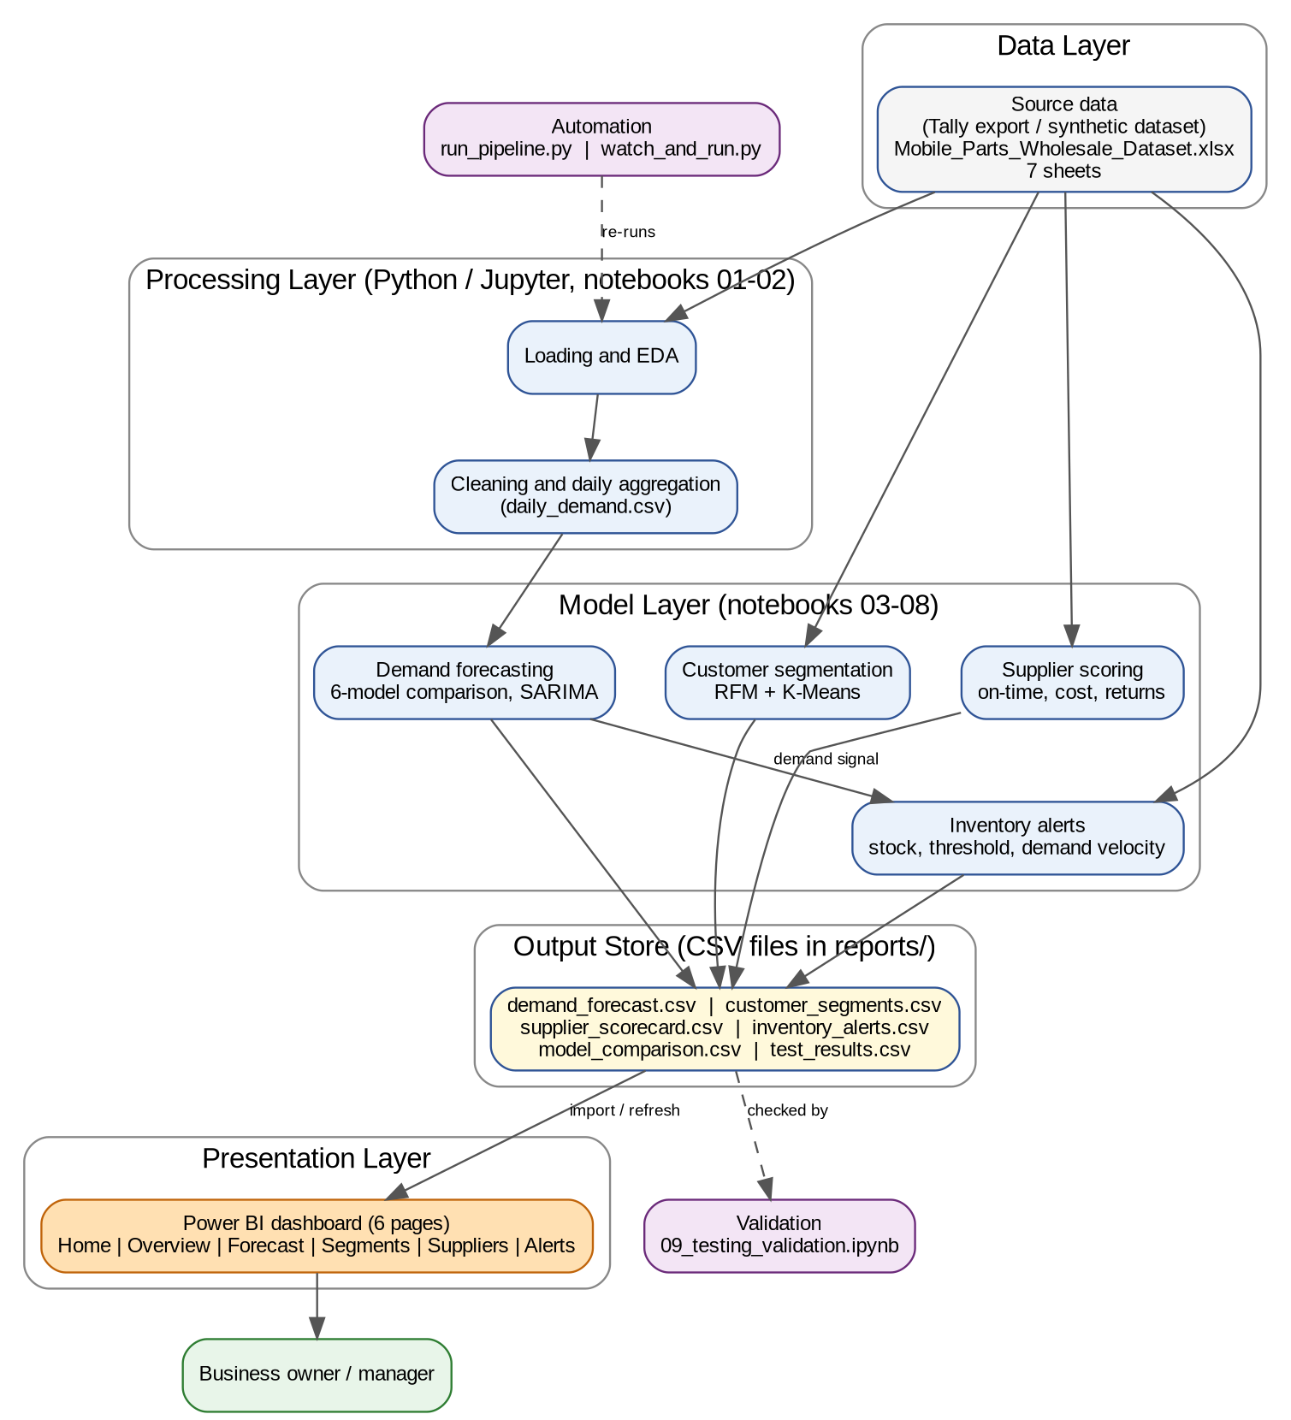
Figure 5.1: Layered system architecture of the decision support system

5.2 Module Decomposition and Responsibilities
Table 5.1: Module specification
Module | Responsibility | Inputs | Outputs
M1 Data loading and cleaning | Load seven sheets, check types and nulls, aggregate sales to a daily series | Excel workbook | daily_demand.csv
M2 Demand forecasting | Compare six models on a hold-out; forecast 30 days with bounds using SARIMA | daily_demand.csv | model_comparison.csv, demand_forecast.csv
M3 Customer segmentation | Compute RFM and cluster customers into four labelled segments | Sales_Transactions | customer_segments.csv
M4 Supplier scoring | Compute on-time %, average cost and return rate; combine into a composite score | Purchase_Orders, Suppliers, Returns_Complaints | supplier_scorecard.csv
M5 Inventory alerts | Compare stock with reorder level and recent demand velocity | Inventory, Sales_Transactions, Products | inventory_alerts.csv
M6 Dashboard | Present all outputs on six linked pages | Output CSVs and raw sheets | Power BI report (.pbix)
M7 Validation and automation | Check outputs; re-run the notebooks in order | Output CSVs; notebooks | test_results.csv; refreshed outputs

5.3 Data Flow Diagrams
Figure 5.2 is the Level 0 data flow diagram. Data enters from the accounting source (Tally export) into ingestion and cleaning, which writes the raw and cleaned business data store (D1). The four analytical processes read D1 and write results to the model-outputs and alert-results store (D2). The dashboard process reads D2 and presents KPIs, trends, forecasts and alerts to the business manager, who returns filters and analysis requests. The system administrator or analyst triggers the pipeline run and refresh.
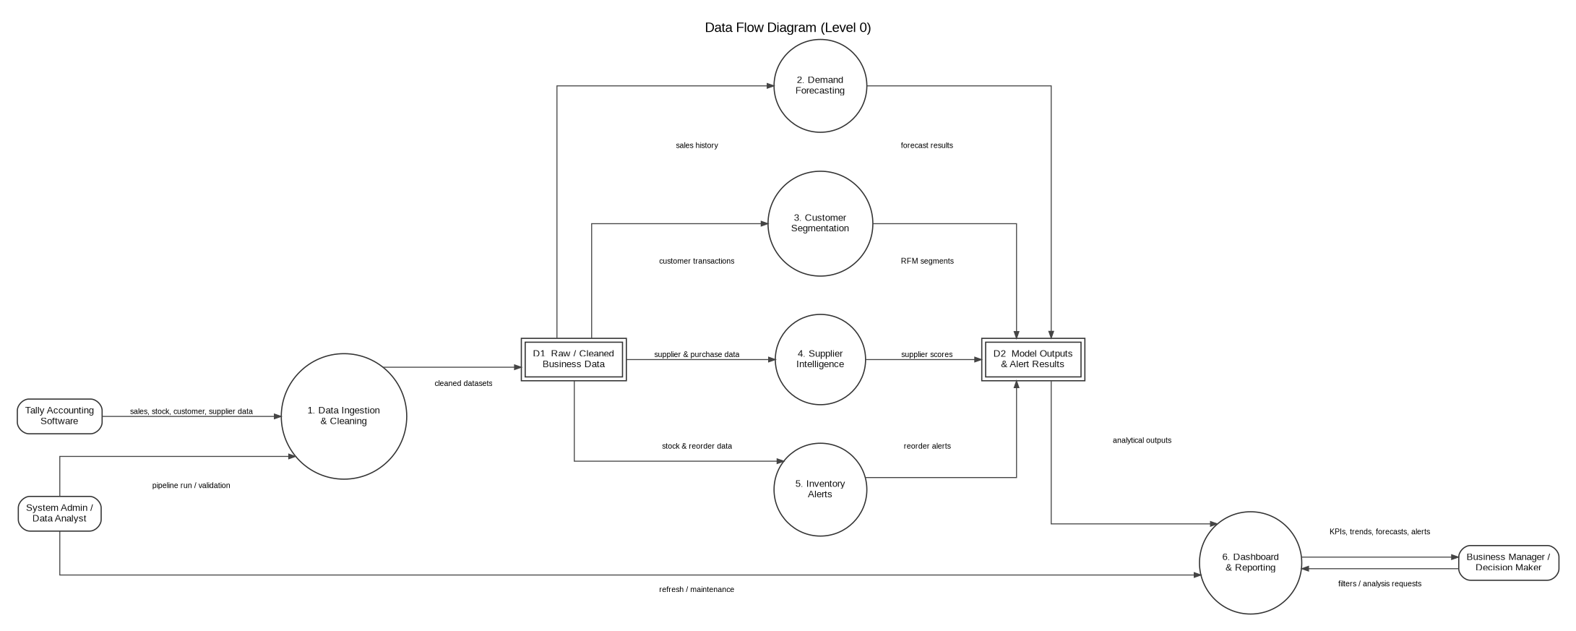
Figure 5.2: Level 0 data flow diagram

5.4 Use-Case Diagram
Two actors use the system (Figure 5.3). The Business Manager views executive KPIs, analyses the demand forecast, reviews customer segments, evaluates supplier performance and checks inventory alerts. The System Administrator / Data Analyst exports the latest data, runs the machine-learning pipeline and refreshes the Power BI dashboard. All manager use cases are reached from the landing page of the dashboard.
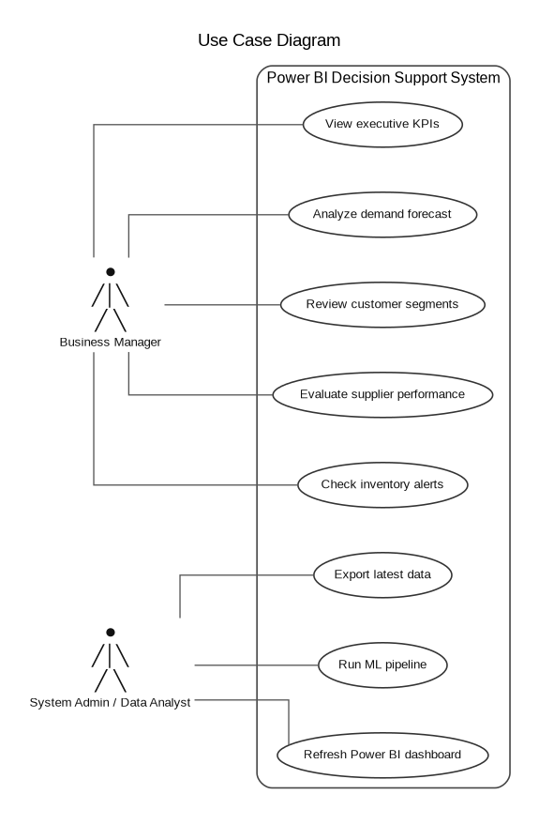
Figure 5.3: Use-case diagram

5.5 Activity Diagram
Figure 5.4 shows the analytical workflow. Data is extracted from Tally, loaded and cleaned; a data-quality decision either sends the data back for correction or allows the four analytical modules to run; their outputs are combined; the dashboard is refreshed; and the business manager reviews the insights.
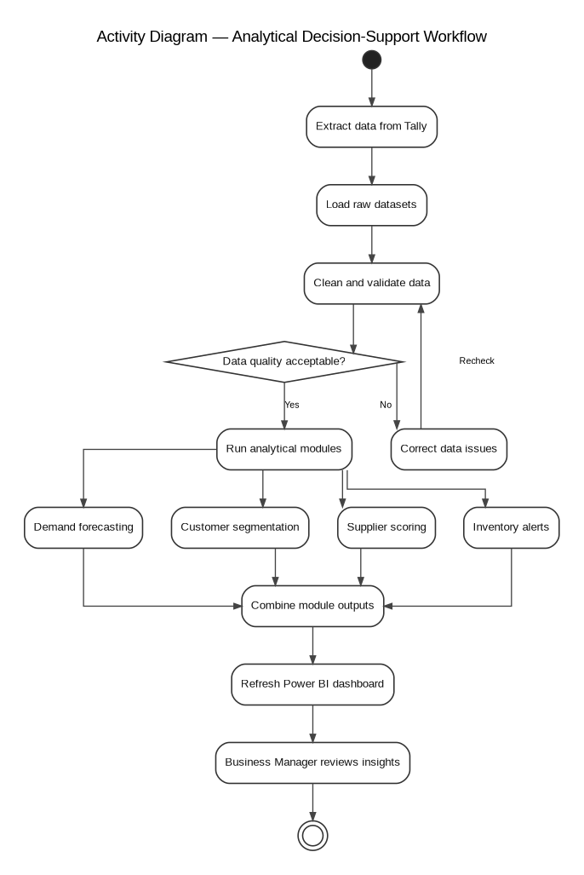
Figure 5.4: Activity diagram of the analytical decision-support workflow

5.6 Entity-Relationship Diagram
Figure 5.5 shows the seven entities with primary keys, foreign keys and cardinalities. A conceptual (Chen-notation) version of the same model is given in Appendix C.
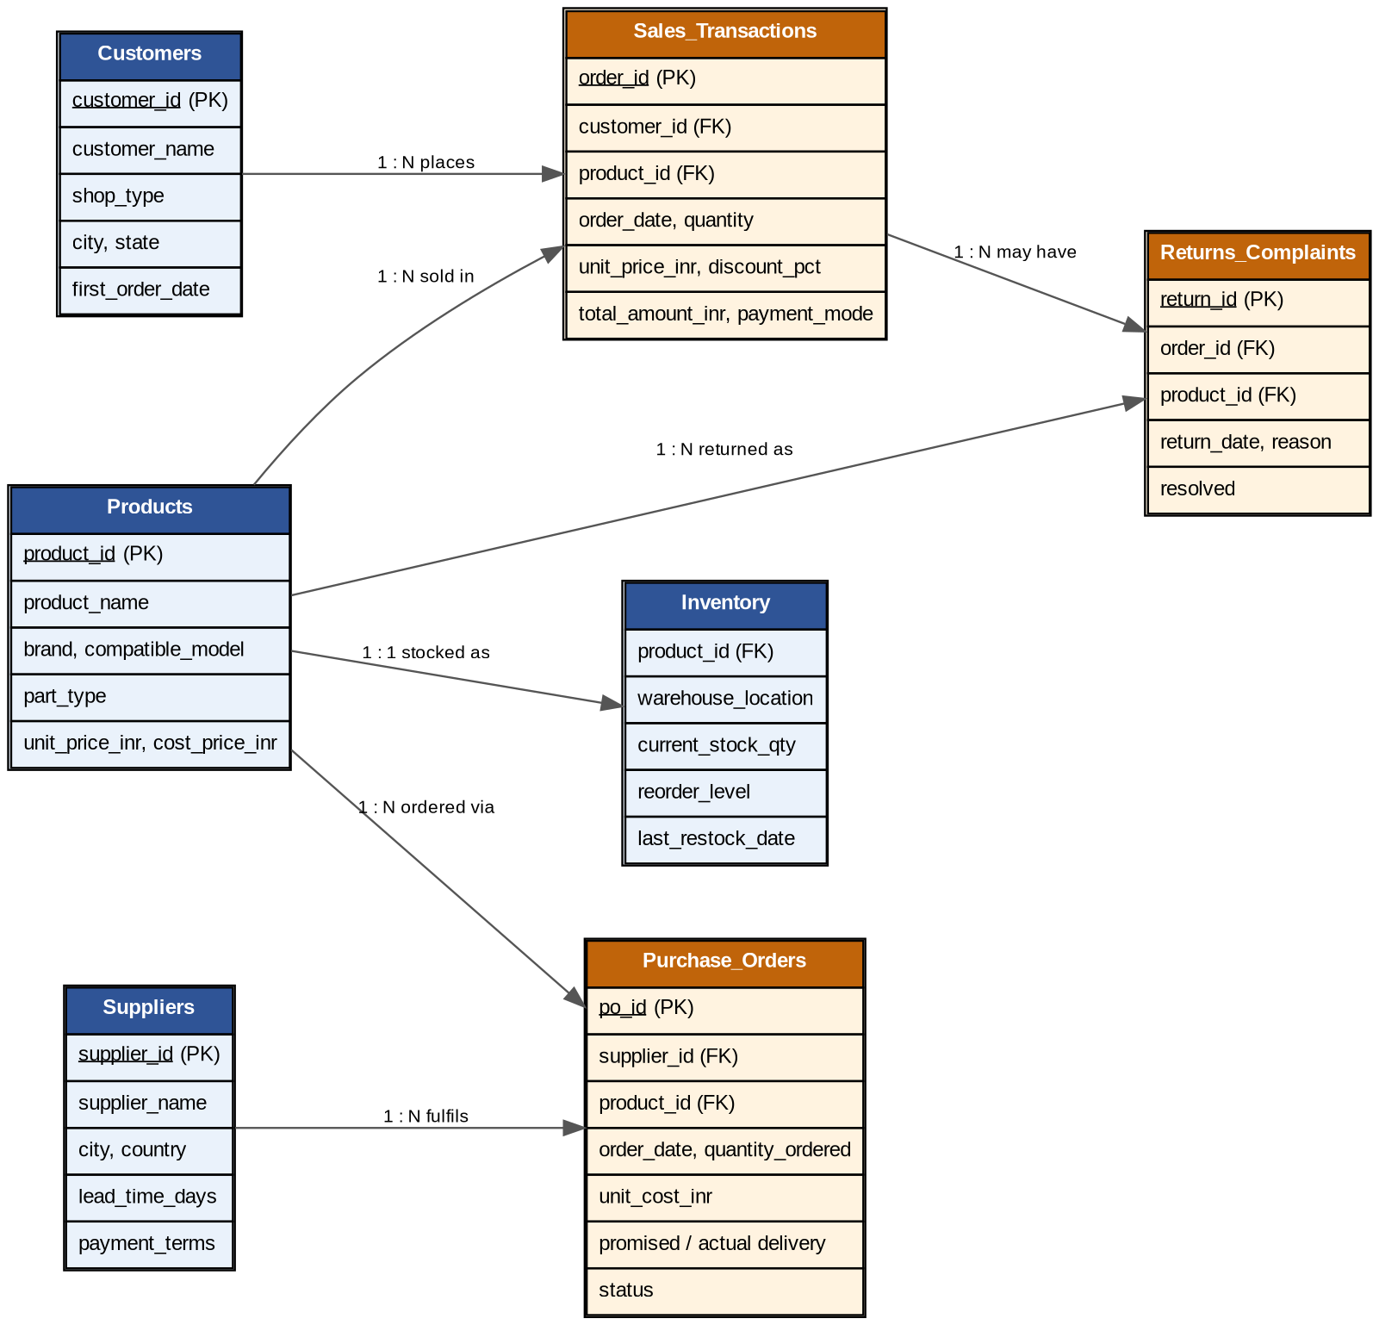
Figure 5.5: Entity-relationship diagram with keys and cardinalities

5.7 Database Schema
The schema is implemented as seven sheets of a single workbook rather than as tables in a database server (Section 6.5). The relationships are listed in Table 5.2 and the attributes in Table 5.3. One point matters for interpretation: in the generated data every sales line has its own order_id, so the order_id column identifies a sales line, and counts of distinct order_id values (used for total orders and for RFM frequency) count sales lines.
Table 5.2: Relationships between entities
Parent entity | Child entity | Key | Cardinality
Customers | Sales_Transactions | customer_id | 1 : N
Products | Sales_Transactions | product_id | 1 : N
Products | Inventory | product_id | 1 : 1
Suppliers | Purchase_Orders | supplier_id | 1 : N
Products | Purchase_Orders | product_id | 1 : N
Sales_Transactions | Returns_Complaints | order_id | 1 : N
Products | Returns_Complaints | product_id | 1 : N

Table 5.3: Data dictionary
Entity | Attribute | Type | Key / note
Customers | customer_id | Text | Primary key
 | customer_name, shop_type, city, state | Text
 | first_order_date | Date | Earliest order date
Suppliers | supplier_id | Text | Primary key
 | supplier_name, city, country, payment_terms | Text
 | lead_time_days | Integer | Promised lead time
Products | product_id | Text | Primary key
 | product_name, brand, compatible_model, part_type | Text
 | unit_price_inr, cost_price_inr | Integer | Rupees
Sales_Transactions | order_id | Text | Primary key (one per sales line)
 | customer_id, product_id | Text | Foreign keys
 | order_date | Date
 | quantity, unit_price_inr, discount_pct | Integer
 | total_amount_inr | Decimal | quantity x price x (1 - discount)
 | payment_mode | Text
Inventory | product_id | Text | Foreign key (one row per product)
 | warehouse_location | Text
 | current_stock_qty, reorder_level | Integer
 | last_restock_date | Date
Purchase_Orders | po_id | Text | Primary key
 | supplier_id, product_id | Text | Foreign keys
 | order_date, promised_delivery_date, actual_delivery_date | Date | Actual date empty if pending
 | quantity_ordered | Integer
 | unit_cost_inr | Decimal
 | status | Text | Delivered On Time / Delivered Late / Pending
Returns_Complaints | return_id | Text | Primary key
 | order_id, product_id | Text | Foreign keys
 | return_date | Date
 | reason, resolved | Text | resolved is Yes / No

5.8 Input and Output Design
Input. The only input is the workbook with the seven sheets and the column names of Table 5.3. Output. Each module writes one CSV file; the dashboard is the human-readable output. The dashboard has six pages linked as in Figure 5.6: a landing page with navigation cards and a back button on every other page. Table 5.4 lists the design of each page. Screenshots of the implemented pages are in Section 6.8.
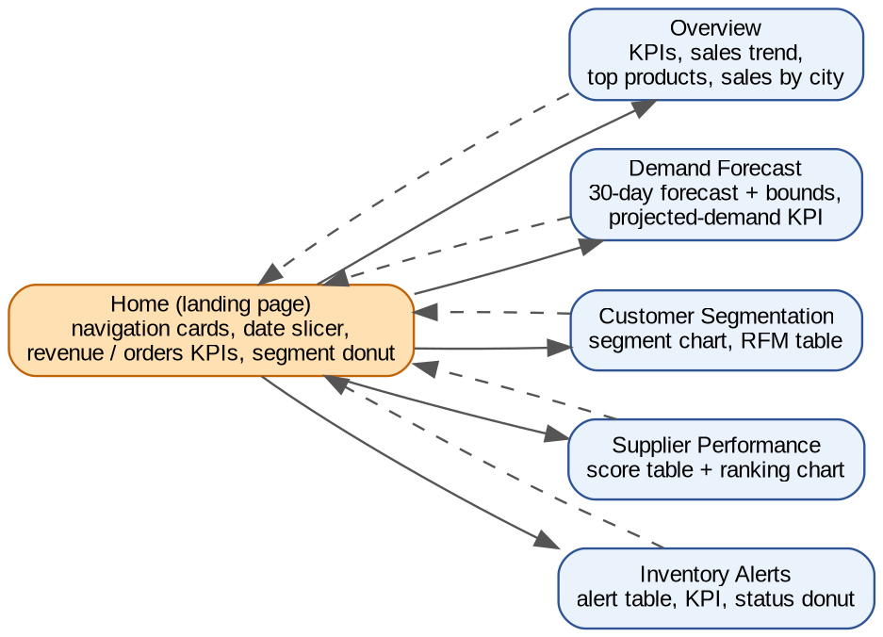
Figure 5.6: Dashboard page navigation map
Table 5.4: Dashboard page design
Page | Purpose | Visuals | Explanation element
Home | Entry point and quick pulse | Five navigation cards, date slicer, revenue and orders KPIs, segment donut | One-line description on each card
Overview | Business snapshot | Four KPI cards, daily sales trend, top 10 products, sales by city | Titles and axis labels
Demand Forecast | Expected demand for 30 days | Line chart (forecast with bounds), projected-demand KPI, date slicer | Text box on bounds
Customer Segmentation | Who to prioritise | Segment column chart, customer RFM table | Text box on each segment
Supplier Performance | Who to rely on | Score table, composite-score bar chart | Text box on score weights
Inventory Alerts | What to reorder | Filtered alert table, products-needing-reorder KPI, status donut | Text box on alert rules

5.9 Algorithms and Process Logic

5.9.1 Daily demand series
Sales lines are grouped by order date to give total quantity and total revenue per day, and the date range is reindexed to every calendar day with missing days filled with zero, giving 524 daily observations.

5.9.2 Forecasting models and evaluation
The last 30 days are held out as a test set and all models are trained on the preceding 494 days, so no model sees the future. Linear Regression, Random Forest (200 trees) and XGBoost (200 trees, learning rate 0.05) use three calendar features: day number, day of week and month. ARIMA uses order (5,1,2). SARIMA uses order (1,1,1) with seasonal order (1,1,1) and a seasonal period of 7 days:
SARIMA(1,1,1)(1,1,1)₇: φ(B) Φ(B⁷) (1−B)(1−B⁷) yₜ = θ(B) Θ(B⁷) εₜ
where B is the backshift operator and the φ, Φ, θ, Θ polynomials are the non-seasonal and seasonal autoregressive and moving-average terms. Prophet is fitted with yearly and weekly seasonality. Accuracy is measured by root mean squared error and mean absolute percentage error:
RMSE = √( (1/n) Σ (yᵢ − ŷᵢ)² ) MAPE = (100/n) Σ | (yᵢ − ŷᵢ) / yᵢ |

5.9.3 Customer segmentation
For each customer, recency is the number of days from the last order to one day after the last date in the data, frequency is the number of distinct order identifiers, and monetary value is the sum of order amounts. The three values are standardised and clustered with K-Means using four clusters, a fixed random state of 42 and ten initialisations. Each cluster is then given a business label by reading its centroid values (Section 8.5).

5.9.4 Supplier composite score
On-time delivery is the share of delivered purchase orders whose actual delivery date is on or before the promised date; pending orders are excluded. Returns are attributed to a supplier through the product: each product is mapped to the supplier from which it was purchased most often, and the return rate is returned sales lines per unit purchased from that supplier, in per cent. Cost and return rate are min-max scaled so that lower is better, and the three components are combined with judgemental weights:
Cost score = 100 − 100·(c − cₘᵢₙ)/(cₘₐₓ − cₘᵢₙ) Quality score = 100 − 100·(r − rₘᵢₙ)/(rₘₐₓ − rₘᵢₙ)
Composite = 0.5 × On-time % + 0.3 × Cost score + 0.2 × Quality score

5.9.5 Inventory alert rule
avg_daily_demand = units sold in last 60 days / 60
projected_30d_demand = avg_daily_demand x 30 (0 if no recent sales)
IF current_stock <= reorder_level THEN status = "REORDER NOW - Below threshold"
ELSE IF projected_30d_demand > current_stock THEN status = "REORDER SOON - Demand exceeds stock"
ELSE status = "Stock OK"

5.10 Security, Privacy, Validation, Backup and Access Control
- Privacy: the dataset is synthetic, so no real personal or commercial data is stored or published; names are fictitious.
- Repository hygiene: the .gitignore file excludes the raw and processed data folders, serialised model files and environment files from version control.
- Validation: ten automated checks test the output files (Section 7.2); file-loading and division errors are guarded in the notebooks (Section 6.7).
- Backup: all code, notebooks and outputs are versioned in a GitHub repository, with each module committed separately.
- Access control: the system is a local, single-user prototype with no login. Access is governed by the machine's file permissions. A multi-user deployment would require Power BI Service sharing controls and a protected data source, which are outside the current scope.

5.11 Design Decisions and Trade-offs
Table 5.5: Design decisions and their trade-offs
Decision | Alternative considered | Reason for choice | Trade-off accepted
Excel/CSV flat files as storage | MySQL or PostgreSQL | Fastest route to validate the analytics within the timeline; matches Tally export format | No concurrency, constraints or live queries
Power BI for the dashboard | Streamlit web app | Business-friendly visuals, filters and navigation without front-end code | Manual refresh; hosting needs Power BI Service
SARIMA as the forecast model | Prophet (first implemented) | Lowest RMSE on the hold-out and explicit weekly seasonality | Margin over other models is small (Section 8.5)
Four customer segments | Other values of k | Four groups gave interpretable labels | k was not validated with a statistical index
Weights 0.5 / 0.3 / 0.2 in the supplier score | Equal weights; AHP weighting | Delivery reliability judged most important, then cost, then quality | Weights are judgemental, not calibrated
Demand velocity for alerts | Per-product forecasts | Per-product forecasting of 179 SKUs was beyond the timeline | Alert uses recent history, not a forecast
Two visuals plus text per page | Add a scatter plot of cost versus reliability | Consistency and readability across pages | Fewer analytical views per page

Chapter 6 — Implementation

6.1 Development Environment and Tool Versions
Table 6.1: Development environment
Component | Detail
Operating system | Windows 11 (laptop, 8 logical processors)
Python | 3.10.20, in a dedicated conda environment named dss_project (conda 25.11.1)
Notebook tool | Jupyter Notebook (Jupyter Server 2.20.0)
Python libraries | pandas, NumPy, scikit-learn, XGBoost, statsmodels, Prophet, openpyxl, matplotlib, seaborn, nbconvert, watchdog (versions as installed in the environment; listed by running conda list in the activated environment). Libraries used: pandas (McKinney, 2010), NumPy (NumPy Developers, n.d.), scikit-learn (Pedregosa et al., 2011), statsmodels (Seabold & Perktold, 2010) and Prophet (Taylor & Letham, 2018)
Dashboard tool | Microsoft Power BI Desktop (Microsoft, n.d.)
Version control | Git 2.54.0 (Windows); remote repository on GitHub (khushi0321/DSS_project)

6.2 Project Folder Structure and Configuration
DSS_Project/
data/
raw/ Mobile_Parts_Wholesale_Dataset.xlsx (seven sheets)
processed/ daily_demand.csv
notebooks/ 01_data_loading_eda.ipynb ... 09_testing_validation.ipynb
scripts/ (reserved for reusable functions)
models/ (reserved for saved models)
reports/ demand_forecast.csv, customer_segments.csv, supplier_scorecard.csv,
inventory_alerts.csv, model_comparison.csv, test_results.csv
dashboard/ DSS_Prototype.pbix
run_pipeline.py runs notebooks 01-08 in order
watch_and_run.py re-runs the pipeline when the workbook changes
.gitignore excludes data/raw, data/processed, *.pkl, .env, checkpoints

Configuration consists of the conda environment, the registered Jupyter kernel named “Python (DSS Project)”, and relative paths from the notebooks folder (for example ../data/raw/Mobile_Parts_Wholesale_Dataset.xlsx), so that the project can be moved without editing paths.

6.3 Module-wise Implementation
The notebooks are numbered in the order in which they were built (Table 6.2). Figure 6.1 shows the execution order used by the automation script and the output file each notebook writes. Notebook 03 writes a baseline forecast with Prophet and notebook 07 later overwrites the same file with the selected SARIMA forecast; likewise notebook 08 overwrites the basic supplier scorecard of notebook 05 with the version that includes returns. The order therefore matters, and the script preserves it.
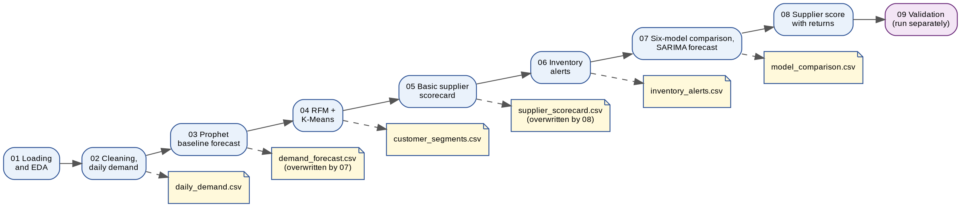
Figure 6.1: Notebook execution order and output files
Table 6.2: Notebook summary
Notebook | Purpose | Input | Output
01_data_loading_eda | Load seven sheets, check types and nulls, inspect the sales trend | Workbook | Shapes, dtype and null report
02_data_cleaning | Aggregate sales to daily totals and fill missing days | Sales_Transactions | daily_demand.csv
03_demand_forecasting | Prophet baseline, 30-day forecast | daily_demand.csv | demand_forecast.csv (baseline)
04_customer_segmentation | RFM and K-Means, four labelled segments | Sales_Transactions | customer_segments.csv
05_supplier_scorecard | On-time %, cost and orders per supplier | Purchase_Orders, Suppliers | supplier_scorecard.csv (basic)
06_inventory_alerts | Demand velocity and alert status | Inventory, Sales_Transactions, Products | inventory_alerts.csv
07_model_comparison | Six models on a 30-day hold-out; SARIMA forecast | daily_demand.csv | model_comparison.csv; demand_forecast.csv
08_supplier_score_with_returns | Attribute returns to suppliers; composite score | Purchase_Orders, Returns_Complaints, Products, Suppliers | supplier_scorecard.csv (final)
09_testing_validation | Ten automated output checks | All output CSVs | test_results.csv

6.3.1 Data loading and cleaning (M1)
The workbook is read with pandas into seven data frames. Data types are checked (dates are parsed as datetimes) and null counts are listed; the only nulls are the six pending purchase orders without an actual delivery date, which is expected. Sales are grouped by date and reindexed to every calendar day with zero fill, producing 524 daily rows saved as daily_demand.csv. The early days of the series are mostly zero because customers start ordering at different dates in the generated data.

6.3.2 Demand forecasting (M2)
A Prophet model was built first as a baseline and its forecast was shown on the dashboard. Notebook 07 then trained all six models on the first 494 days, evaluated them on the last 30 days, saved the comparison table, and regenerated the final 30-day forecast with SARIMA from the full series, keeping the same column names (date, predicted_qty, lower_bound, upper_bound) so that the dashboard needed no redesign.

6.3.3 Customer segmentation (M3)
RFM values are computed for the 179 customers who placed orders, standardised, and clustered with K-Means. Cluster centroids were inspected and labelled (High Value, Steady/Regular, New/Occasional, At Risk), and the labelled table was saved with the cluster number and the three RFM values.

6.3.4 Supplier scoring (M4)
The first version of the scorecard reported on-time percentage, average unit cost and order count. The final version maps each product to its most frequent supplier, counts returned sales lines against that supplier, expresses them per unit purchased, normalises the three components and combines them into the composite score (Section 5.9.4).

6.3.5 Inventory alerts (M5)
Units sold in the last 60 days are summed per product and scaled to a 30-day projection. This is merged with the inventory snapshot and product names, products without recent sales receive zero projected demand, and the alert status is assigned with the rule of Section 5.9.5 using a vectorised numpy.select call.

6.3.6 Dashboard (M6)
Power BI imports the four output CSV files and the Sales_Transactions, Customers and Products sheets. The Overview page uses a DAX measure for average order value, a Top N filter for the ten highest-revenue products, and the Customers relationship to chart revenue by city. The Home page uses rectangle and icon groups with page-navigation actions, a date slicer, two KPI cards and a donut chart. Detail pages carry a back button, titles and axis labels written in plain language, and a short explanatory text box. Conditional formatting colours the supplier and alert tables.

6.4 Important Algorithms and Code Excerpts
The excerpts below are taken from the working notebooks. Listing 1 shows the chronological split and the shared evaluation function used for all six models.
test_size = 30
train = daily_demand.iloc[:-test_size].copy()
test = daily_demand.iloc[-test_size:].copy()

def evaluate(name, actual, predicted):
rmse = np.sqrt(mean_squared_error(actual, predicted))
mape = mean_absolute_percentage_error(actual, predicted) * 100
results.append({"model": name, "RMSE": round(rmse, 2), "MAPE (%)": round(mape, 2)})

Listing 2 shows the final SARIMA forecast. The model is refitted on the full series and a 30-day forward forecast with a confidence interval is written in the same layout as the baseline file.
final_sarima = SARIMAX(daily_demand["total_qty"], order=(1,1,1), seasonal_order=(1,1,1,7))
final_sarima_fit = final_sarima.fit(disp=False)
forecast_result = final_sarima_fit.get_forecast(steps=30)
future_dates = pd.date_range(start=daily_demand["order_date"].max() + pd.Timedelta(days=1), periods=30)
sarima_forecast_df = pd.DataFrame({
"date": future_dates,
"predicted_qty": forecast_result.predicted_mean.values,
"lower_bound": forecast_result.conf_int()["lower total_qty"].values,
"upper_bound": forecast_result.conf_int()["upper total_qty"].values})
sarima_forecast_df.to_csv("../reports/demand_forecast.csv", index=False)

Listing 3 shows the RFM computation and K-Means clustering.
snapshot_date = sales["order_date"].max() + pd.Timedelta(days=1)
rfm = sales.groupby("customer_id").agg(
recency=("order_date", lambda x: (snapshot_date - x.max()).days),
frequency=("order_id", "nunique"),
monetary=("total_amount_inr", "sum")).reset_index()
rfm_scaled = StandardScaler().fit_transform(rfm[["recency", "frequency", "monetary"]])
kmeans = KMeans(n_clusters=4, random_state=42, n_init=10)
rfm["segment"] = kmeans.fit_predict(rfm_scaled)

Listing 4 shows the supplier composite score, and Listing 5 the vectorised alert rule.
scorecard["on_time_score"] = scorecard["on_time_pct"]
scorecard["cost_score"] = 100 - ((scorecard["avg_unit_cost"] - scorecard["avg_unit_cost"].min()) /
(scorecard["avg_unit_cost"].max() - scorecard["avg_unit_cost"].min()) * 100)
scorecard["quality_score"] = 100 - ((scorecard["return_rate_pct"] - scorecard["return_rate_pct"].min()) /
(scorecard["return_rate_pct"].max() - scorecard["return_rate_pct"].min() + 1e-9) * 100)
scorecard["composite_score"] = (scorecard["on_time_score"] * 0.5 +
scorecard["cost_score"] * 0.3 + scorecard["quality_score"] * 0.2).round(1)

conditions = [alerts["current_stock_qty"] <= alerts["reorder_level"],
alerts["projected_30d_demand"] > alerts["current_stock_qty"]]
choices = ["REORDER NOW - Below threshold", "REORDER SOON - Demand exceeds stock"]
alerts["alert_status"] = np.select(conditions, choices, default="Stock OK")

6.5 Database Implementation and Sample Records
The seven entities are implemented as the seven sheets of the workbook Mobile_Parts_Wholesale_Dataset.xlsx, with the columns of Table 5.3. Referential links are maintained by shared identifiers (for example customer_id and product_id) and are enforced by the generation logic and checked in analysis, not by a database engine. Migration to a relational database is future work (Section 9.5). Tables 6.3 and 6.4 show sample records from the actual output files.
Table 6.3: Sample records from customer_segments.csv
customer_id | recency (days) | frequency | monetary (INR) | segment_label
C0001 | 1 | 9 | 19,979.00 | New/Occasional
C0002 | 6 | 32 | 1,41,835.50 | Steady/Regular
C0003 | 19 | 10 | 36,461.00 | New/Occasional
C0004 | 43 | 59 | 2,57,908.50 | High Value
C0007 | 44 | 46 | 1,68,090.50 | At Risk

Table 6.4: Sample records from inventory_alerts.csv
Product | Brand | Current stock | Reorder level | Projected 30-day demand | Alert status
A54 Battery | Oppo | 1 | 39 | 32.00 | REORDER NOW
V23 Back Glass Panel | Vivo | 20 | 25 | 32.00 | REORDER NOW
Galaxy A32 Speaker Module | Samsung | 0 | 30 | 25.50 | REORDER NOW
iPad 9th Gen OLED Display Combo | Apple | 23 | 21 | 23.50 | REORDER SOON

6.6 API and External-Service Integration
The system uses no web API or cloud service. Integration with the accounting source is by file export: Tally can export the sales register, purchase register, stock summary and ledgers to Excel or CSV. Tally’s ODBC driver and XML-over-HTTP interface were studied as alternatives for automated extraction but were not implemented, because a pull-based connection to a live accounting installation adds risk and was outside the scope. Integration between Python and Power BI is through the CSV output files and Power BI’s file connector.

6.7 Authentication, Validation and Error Handling
Authentication is not applicable to a local single-user prototype. Validation and error handling were added as follows:
- a safe file-loading function raises a clear error if the workbook is missing, if a sheet cannot be read, and prints a warning if a sheet is empty;
- the supplier return-rate calculation returns 0.0 when a supplier has no purchased units, avoiding a division error;
- suppliers with no attributed returns receive a zero return count rather than a missing value, and products with no recent sales receive zero projected demand;
- pending purchase orders are excluded from on-time calculations because they have no actual delivery date;
- the automation script stops at the first notebook that fails and prints its error output, so a partial refresh is not mistaken for a complete one;
- ten validation checks examine the output files (Section 7.2).

6.8 Screenshots of the Working System
Figures 6.2 to 6.7 are screenshots of the implemented Power BI report. The Overview page uses a differentiated colour scheme (purple KPIs, orange trend line, green ranking) introduced during the presentation review.
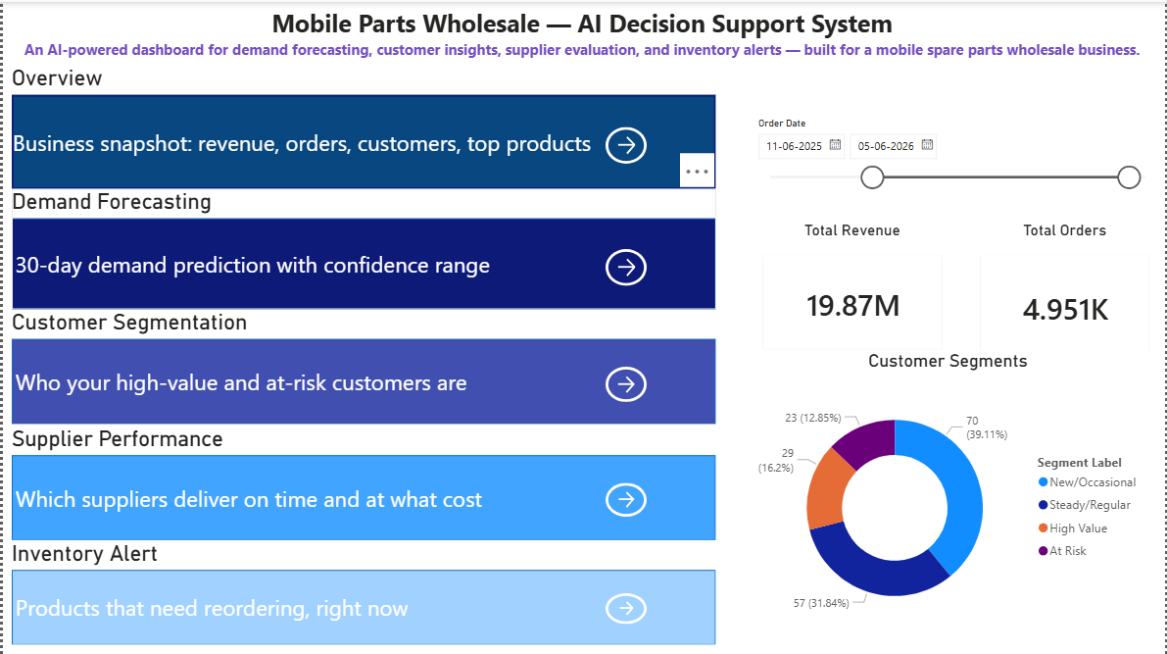
Figure 6.2: Home (landing) page with navigation cards, date filter, KPIs and segment donut
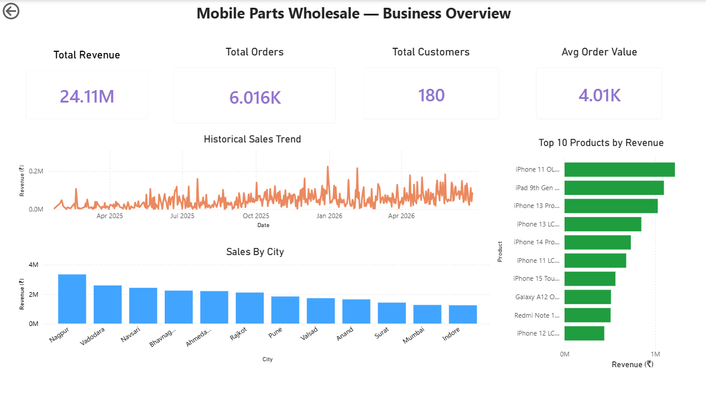
Figure 6.3: Overview page: KPIs, historical sales trend, sales by city and top 10 products
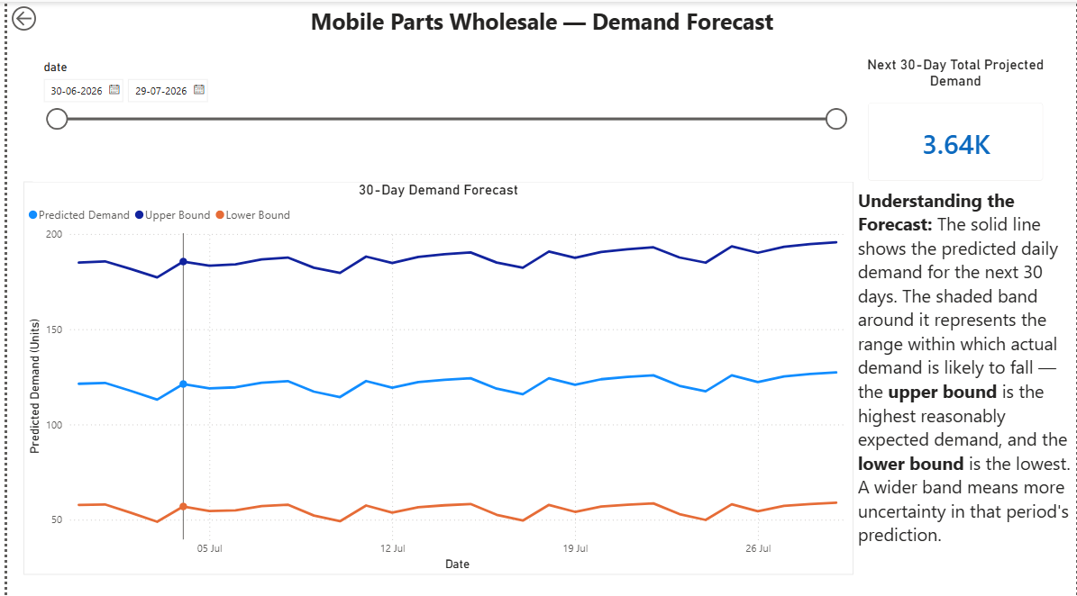
Figure 6.4: Demand Forecast page: 30-day SARIMA forecast with upper and lower bounds
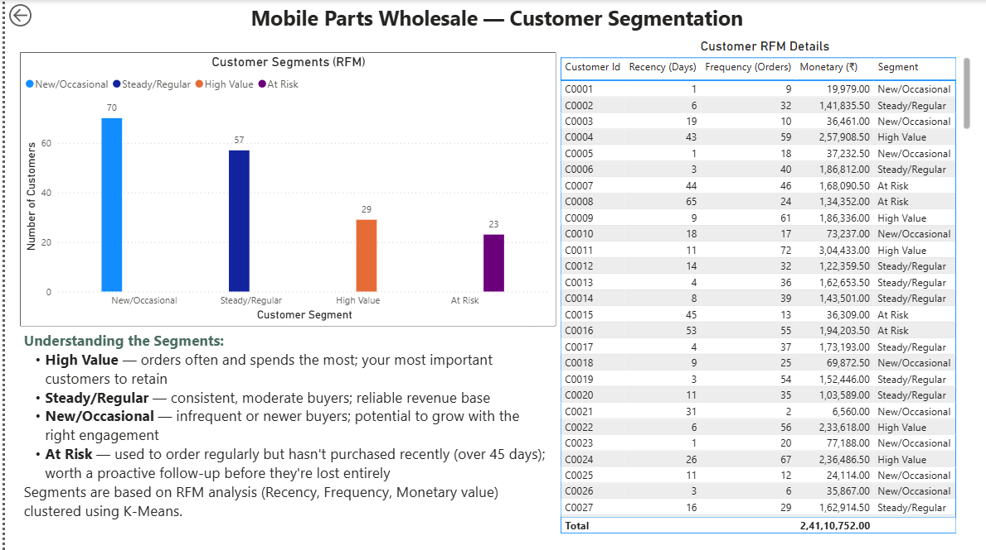
Figure 6.5: Customer Segmentation page: segment chart and RFM detail table
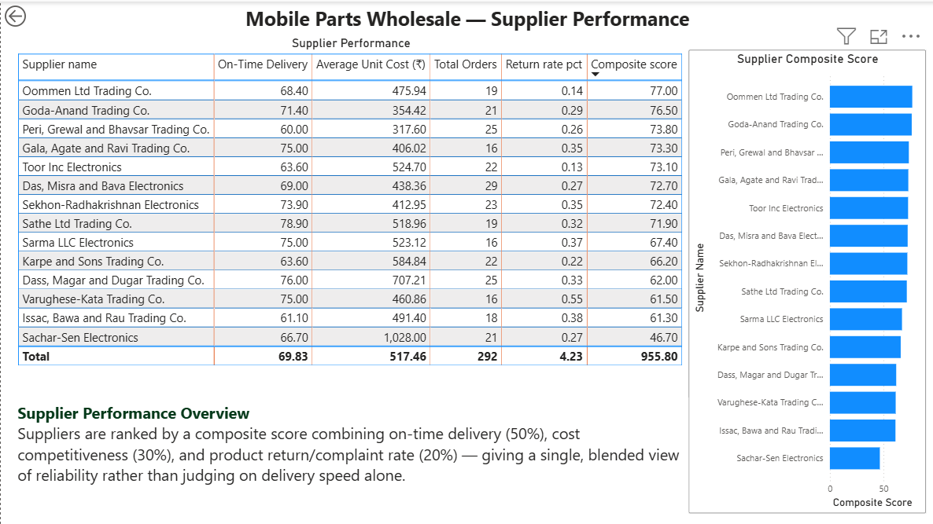
Figure 6.6: Supplier Performance page: composite-score table and ranking chart
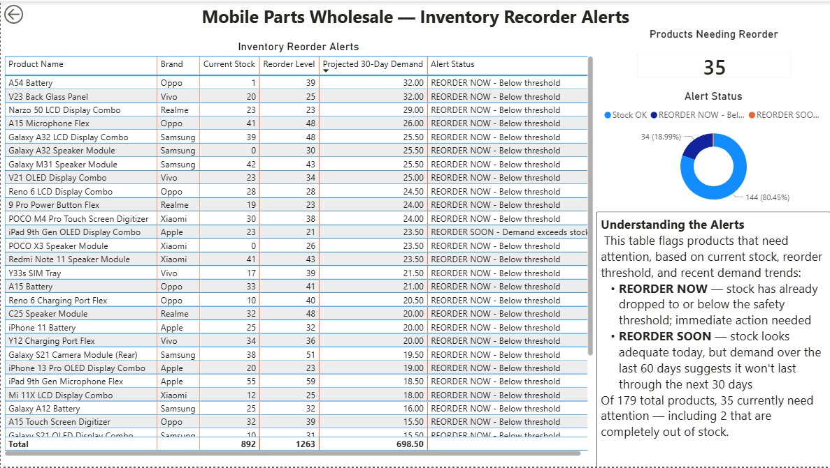
Figure 6.7: Inventory Alerts page: alert table, products-needing-reorder KPI and status donut

6.9 Build, Run and Deployment Instructions

6.9.1 Setup
- Create and activate the environment: conda create -n dss_project python=3.10 then conda activate dss_project.
- Install the packages: conda install pandas numpy scikit-learn matplotlib seaborn jupyter notebook and python -m pip install xgboost statsmodels prophet openpyxl nbconvert watchdog.
- Register the kernel: python -m ipykernel install --user --name dss_project --display-name "Python (DSS Project)".
- Clone or copy the repository and place the workbook in data/raw/.

6.9.2 Running the pipeline
- From the project root (not from the notebooks folder), run python run_pipeline.py. The script executes notebooks 01 to 08 in order using nbconvert and stops if any notebook fails.
- Optionally run python watch_and_run.py in a separate terminal; it watches the raw-data folder and re-runs the pipeline whenever the workbook is saved.
- Run notebook 09 to validate the outputs and read the PASS / FAIL report.
- Open dashboard/DSS_Prototype.pbix in Power BI Desktop and choose Home, then Refresh. If new columns do not appear after a change of file structure, delete and re-add the affected source in Power Query Editor.
Automation demonstration. After the 1,912 extension rows of Section 4.8.4 were appended to the workbook, the pipeline was re-run to regenerate every output from the extended data, and the dashboard was refreshed. Because the data now ends on 29 September 2026, the forecast horizon moves forward to the following 30 days.

6.9.3 Deployment status
The system is a fully working local prototype; it is not deployed as a hosted service. The data is a static workbook, the pipeline is run on demand (or on file change while the watcher is running), and the dashboard is a Power BI Desktop file. Genuine deployment would require a live or scheduled data feed from the accounting system, the pipeline running on a server on a schedule, and the report published to Power BI Service with a data gateway for scheduled refresh. These steps are listed as future scope.

Chapter 7 — Testing and Validation

7.1 Test Strategy, Scope and Environment
Testing combined four activities (Table 7.1). Because the forecasting, clustering and scoring outputs have no single “correct” value to compare against, the automated checks assert structural and logical properties (counts, ranges, bounds and internal consistency) rather than exact numbers, which is the appropriate way to test statistical pipelines. Forecast quality itself is assessed by hold-out validation (Section 7.5). All tests were run on the development laptop described in Section 6.1, on the synthetic dataset.
Table 7.1: Test levels and what each covers
Level | What is tested | Method | Where reported
Module-level (unit-style) | Each module’s output file in isolation | Ten automated checks in notebook 09 | Section 7.2, Table 7.2
Integration | Hand-offs between notebooks, CSV files and Power BI; automation | Pipeline runs, Power BI refreshes | Section 7.3, Table 7.3
System / user acceptance | All six dashboard pages end to end | Manual checklist | Section 7.4, Table 7.4
Model validation | Forecast accuracy on unseen data | Chronological hold-out, RMSE and MAPE | Section 7.5, Table 7.5

7.2 Module-level Testing
Notebook 09 loads the four module output files and runs ten checks. Each check prints PASS or FAIL and the results are written to test_results.csv. All ten checks passed (Table 7.2); the console output is reproduced in Appendix D.
Table 7.2: Automated test cases and results
ID | Module | Test | Req. | Result
TC-01 | Forecast | No negative predicted demand | FR-04 | PASS
TC-02 | Forecast | lower_bound <= upper_bound for every row | FR-04 | PASS
TC-03 | Forecast | Forecast covers exactly 30 days | FR-04 | PASS
TC-04 | Segmentation | Segment counts sum to the total customer count (179) | FR-05 | PASS
TC-05 | Segmentation | No customer appears in more than one segment | FR-05 | PASS
TC-06 | Supplier scorecard | On-time percentage between 0 and 100 | FR-06 | PASS
TC-07 | Supplier scorecard | Composite score between 0 and 100 | FR-06 | PASS
TC-08 | Supplier scorecard | All 14 suppliers present | FR-06 | PASS
TC-09 | Inventory alerts | Every REORDER NOW row has stock <= reorder level | FR-07 | PASS
TC-10 | Inventory alerts | No duplicate products in the alert list | FR-07 | PASS

A limitation of these checks is that TC-04 and TC-08 compare against fixed counts (179 customers and 14 suppliers) taken from the original dataset. If the underlying data changes, those expected values would need to be updated or derived from the data.

7.3 Integration Testing
Table 7.3: Integration tests
ID | Test | Observed result | Status
IT-01 | Run notebooks 01 to 08 in order with run_pipeline.py from the project root | All notebooks executed and outputs regenerated; first attempts failed when the script was run from the notebooks folder (D-08) and passed once run from the root | Pass
IT-02 | Power BI loads the four output CSV files and the three raw sheets | Tables loaded with expected columns | Pass
IT-03 | Replace the baseline forecast with the SARIMA forecast and refresh | Chart, KPI card and slicer updated without redesign, because column names were preserved | Pass
IT-04 | Regenerate the supplier scorecard with two new columns and refresh | Columns appeared only after the source was reset in Power Query (D-04); then passed | Pass
IT-05 | Append 1,912 extension rows to the workbook, re-run the pipeline and refresh | Outputs regenerated from the extended data and the dashboard refreshed | Pass

7.4 System and User-Acceptance Testing
Each dashboard page was walked through against six checks: the page loads without errors; navigation buttons and arrows work; slicers filter the visuals as expected; numbers on KPI cards match the raw data on a spot check; there is no truncated text, broken axis label or overlapping visual; and conditional formatting displays correctly. Table 7.4 records the outcome. N/A means the check does not apply to that page. Product names in the top-products chart are truncated on screen and readable through the hover tooltip, which was accepted.
Table 7.4: User-acceptance checklist results
Page | Page load | Navigation | Slicers | KPI accuracy | Visual rendering | Conditional formatting
Home | Pass | Pass | Pass | Pass | Pass | N/A
Overview | Pass | Pass | N/A | Pass | Pass | N/A
Demand Forecast | Pass | Pass | Pass | Pass | Pass | N/A
Customer Segmentation | Pass | Pass | N/A | N/A | Pass | N/A
Supplier Performance | Pass | Pass | N/A | N/A | Pass | Pass
Inventory Alerts | Pass | Pass | N/A | Pass | Pass | Pass

7.5 Model Validation, Usability, Performance and Security Checks
Model validation. The forecasting hold-out is configured as in Table 7.5. Because the series is chronological, the split keeps all test dates after all training dates; random splitting would leak future information into training.
Table 7.5: Forecast validation configuration
Item | Setting
Series | Daily total quantity, 524 days (22 Jan 2025 to 29 Jun 2026)
Training window | First 494 days (to 30 May 2026)
Test window | Last 30 days (31 May to 29 Jun 2026)
Models | Linear Regression, Random Forest, XGBoost, ARIMA, SARIMA, Prophet
Features for regression models | Day number, day of week, month
Metrics | RMSE (units per day) and MAPE (per cent)
Known limitations | One test window only; no rolling-origin evaluation; hyper-parameters not tuned; MAPE is unstable if actual values approach zero

Usability. A walkthrough was done by the author and reviewed with the project guide, and led to the landing page, consistent layout and explanatory panels. No formal usability study with business users was carried out. Performance. Execution time was not formally benchmarked; the full pipeline runs on the laptop without specialised hardware, and the heaviest steps are the SARIMA and Prophet fits. Security. Not applicable beyond the data-protection position in Section 5.10, since the prototype is local and uses synthetic data.

7.6 Test Results Summary and Defects Found
All ten automated checks, all five integration tests and all applicable user-acceptance checks passed in their final state. Table 7.6 lists the defects found during development and how each was resolved; none remained open at submission.
Table 7.6: Defect log
ID | Defect | Cause | Resolution
D-01 | Demand-forecast chart showed two yearly points with inflated totals | Power BI automatically grouped the date field into a date hierarchy and summed the values | Used the plain date field; disabled automatic date/time
D-02 | Sales-trend axis showed serial numbers (for example 45600) instead of dates | Order date column imported as a number | Changed the column data type to Date
D-03 | Refresh failed with OLE DB / ODBC errors on several tables | Source files locked by Excel, Jupyter or sync, or stale permissions | Closed programs holding the files, cleared permissions, restarted Power BI Desktop
D-04 | New supplier columns missing after the file was regenerated | Cached Power Query schema | Deleted and re-added the source, then re-linked visuals
D-05 | Arrow icons on navigation cards did not navigate | Action was set on the shape only | Grouped shape and icon and set one shared page-navigation action
D-06 | Table totals summed percentages and averages meaninglessly | Default Sum aggregation | Set Average or Don’t summarise as appropriate
D-07 | NameError for a data frame in the supplier notebook | Cells run out of order after a kernel restart | Restart and run all cells in order
D-08 | run_pipeline.py could not find notebooks / file not found | Script run from the notebooks folder; first saved as a notebook instead of a .py file | Saved as .py and run from the project root
D-09 | Alert table showed all 179 products after edits | Visual filter on alert status was cleared | Re-applied the filter to show only products needing action
D-10 | Return could not be linked to a supplier directly | Returns reference sales lines, not suppliers | Mapped each product to its most frequent supplier through purchase orders

7.7 Requirement Traceability
Table 7.7: Traceability from requirements to objectives and evidence
Requirement | Objective | Evidence | Result
FR-01 Load seven sheets | O5 | Notebook 01 loads all sheets with expected shapes | Met
FR-02 Daily aggregation | O1 | daily_demand.csv with 524 daily rows | Met
FR-03 Six-model comparison | O1 | model_comparison.csv; Table 8.2 | Met
FR-04 30-day forecast | O1 | TC-01 to TC-03; IT-03 | Met
FR-05 Segmentation | O2 | TC-04, TC-05 | Met
FR-06 Supplier scorecard | O3 | TC-06 to TC-08; IT-04 | Met
FR-07 Inventory alerts | O4 | TC-09, TC-10 | Met
FR-08 Home page | O6 | UAT, Home row | Met
FR-09 Overview page | O6 | UAT, Overview row | Met
FR-10 Detail pages | O6 | UAT, four detail rows | Met
FR-11 One-command regeneration | O6 (support) | IT-01, IT-05 | Met
FR-12 Automated validation | O6 (support) | Notebook 09, 10 of 10 passing | Met

Chapter 8 — Results, Discussion and Limitations

8.1 Implemented Features and Evidence
The results below come from the author’s own runs on the synthetic dataset described in Section 4.8. They show how the system behaves and what its outputs look like; they should not be read as findings about a real business.
Table 8.1: Implemented features and their evidence
Feature | Evidence
Seven-entity data schema and populated workbook | Figure 5.5, Table 5.3, seven-sheet workbook
Daily demand series (524 days) | daily_demand.csv
Six-model forecasting comparison and 30-day SARIMA forecast | Table 8.2, Figure 8.1, Figure 6.4
RFM and K-Means customer segmentation (four segments) | Table 8.3, Figure 6.5
Supplier composite score including returns | Table 8.4, Figure 8.3, Figure 6.6
Inventory reorder alerts | Figure 8.2, Figure 6.7
Six-page Power BI dashboard with landing page | Figures 6.2 to 6.7, Table 7.4
Automated validation and pipeline automation | Table 7.2, Section 6.9

8.2 Results Against Each Objective
O1 Demand forecasting. Six models were compared on the same 30-day hold-out. SARIMA gave the lowest RMSE (40.66 units per day) and was used for the dashboard forecast. The 30-day forecast shown on the Demand Forecast page totals about 3.64 thousand units, roughly 121 units per day, with an upper bound near 185–195 and a lower bound near 55–58 units per day.
O2 Customer segmentation. The 179 customers who ordered were placed in four segments: New/Occasional 70, Steady/Regular 57, High Value 29 and At Risk 23. O3 Supplier scoring. The 14 suppliers have composite scores between 46.7 and 77.0. O4 Inventory alerts. Of 179 products, 144 are Stock OK, 34 are REORDER NOW and 1 is REORDER SOON; two products (Galaxy A32 Speaker Module and POCO X3 Speaker Module) are at zero stock. O5 Schema. The seven-entity schema was designed and populated. O6 Dashboard. Six pages were built and tested. The Overview page shows total revenue of 24.11 million rupees, 6,016 sales lines, 180 customers and an average value per line of about 4.01 thousand rupees.

8.3 Quantitative Evaluation
Table 8.2 and Figure 8.1 give the forecasting results. RMSE and MAPE are defined in Section 5.9.2; lower is better for both.
Table 8.2: Forecast accuracy of the six models on the 30-day hold-out
Model | RMSE (units/day) | MAPE (%) | Rank by RMSE | Rank by MAPE
SARIMA | 40.66 | 32.96 | 1 | 4
Linear Regression | 41.00 | 32.89 | 2 | 3
Prophet | 41.41 | 39.10 | 3 | 5
ARIMA | 41.60 | 31.55 | 4 | 1
Random Forest | 45.70 | 32.77 | 5 | 2
XGBoost | 51.03 | 39.22 | 6 | 6

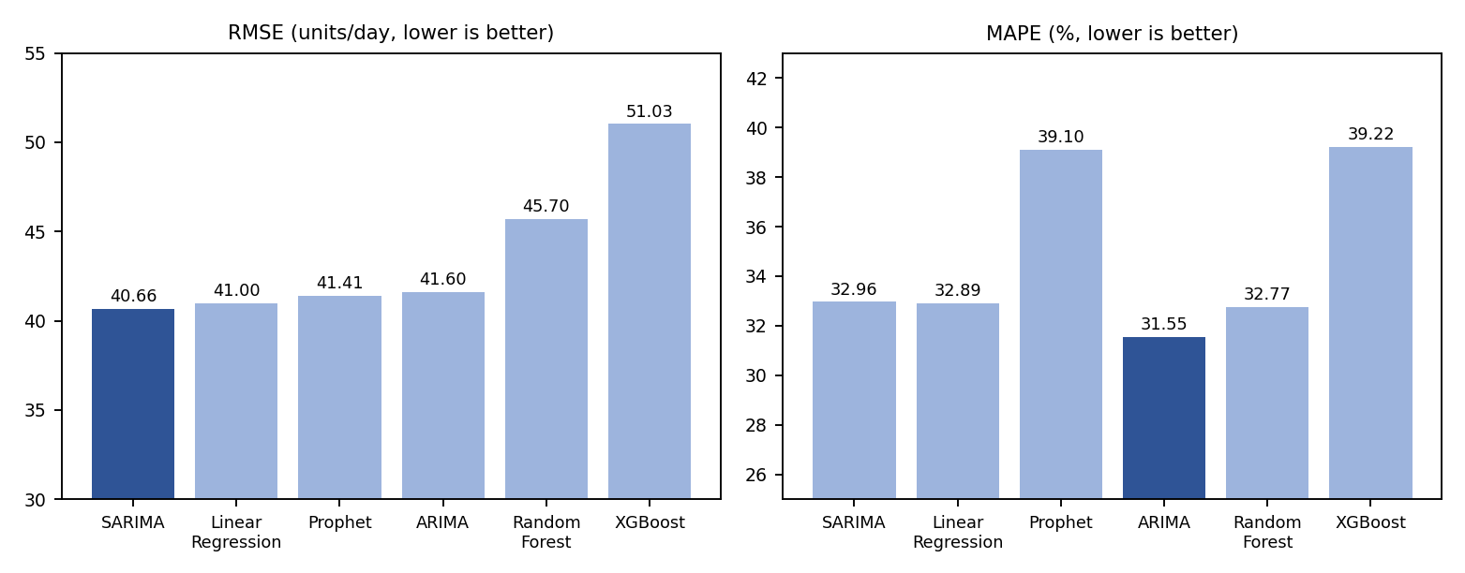
Figure 8.1: RMSE and MAPE of the six forecasting models (selected model highlighted for each metric)
Table 8.3 gives the K-Means cluster centroids that were used to label the segments, and Figure 8.2 shows the segment sizes and the inventory alert distribution.
Table 8.3: Segment centroids and sizes (mean values per cluster)
Segment (label) | Customers | Share | Recency (days) | Frequency | Monetary (INR)
High Value | 29 | 16.2% | 13.4 | 60.9 | 2,61,586
Steady/Regular | 57 | 31.8% | 8.4 | 39.9 | 1,60,289
New/Occasional | 70 | 39.1% | 13.6 | 17.1 | 65,361
At Risk | 23 | 12.8% | 46.3 | 33.9 | 1,22,305

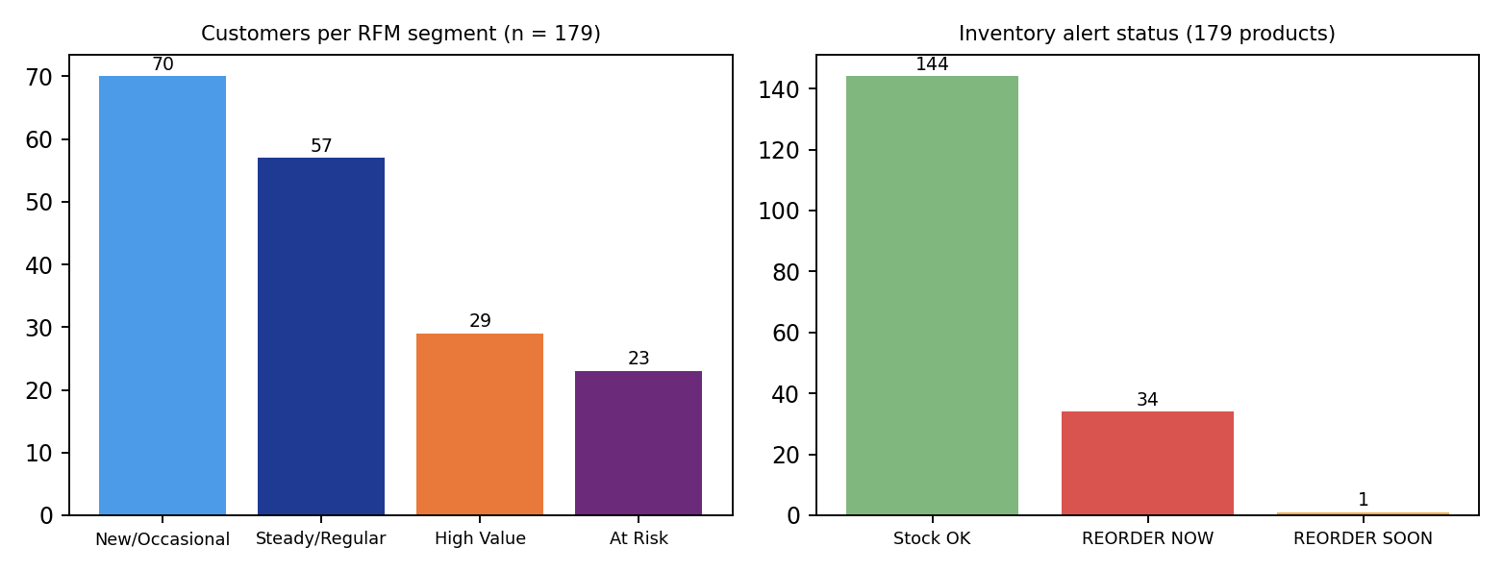
Figure 8.2: Customers per segment and inventory alert status counts
Table 8.4 lists the final supplier scorecard, ordered by composite score, and Figure 8.3 compares composite score with on-time delivery.
Table 8.4: Supplier scorecard with composite score
Supplier | On-time (%) | Avg unit cost (INR) | Orders | Return rate (%) | Composite
Oommen Ltd Trading Co. | 68.4 | 475.94 | 19 | 0.14 | 77.0
Goda-Anand Trading Co. | 71.4 | 354.42 | 21 | 0.29 | 76.5
Peri, Grewal and Bhavsar Trading Co. | 60.0 | 317.60 | 25 | 0.26 | 73.8
Gala, Agate and Ravi Trading Co. | 75.0 | 406.02 | 16 | 0.35 | 73.3
Toor Inc Electronics | 63.6 | 524.70 | 22 | 0.13 | 73.1
Das, Misra and Bava Electronics | 69.0 | 438.36 | 29 | 0.27 | 72.7
Sekhon-Radhakrishnan Electronics | 73.9 | 412.95 | 23 | 0.35 | 72.4
Sathe Ltd Trading Co. | 78.9 | 518.96 | 19 | 0.32 | 71.9
Sarma LLC Electronics | 75.0 | 523.12 | 16 | 0.37 | 67.4
Karpe and Sons Trading Co. | 63.6 | 584.84 | 22 | 0.22 | 66.2
Dass, Magar and Dugar Trading Co. | 76.0 | 707.21 | 25 | 0.33 | 62.0
Varughese-Kata Trading Co. | 75.0 | 460.86 | 16 | 0.55 | 61.5
Issac, Bawa and Rau Trading Co. | 61.1 | 491.40 | 18 | 0.38 | 61.3
Sachar-Sen Electronics | 66.7 | 1,028.00 | 21 | 0.27 | 46.7

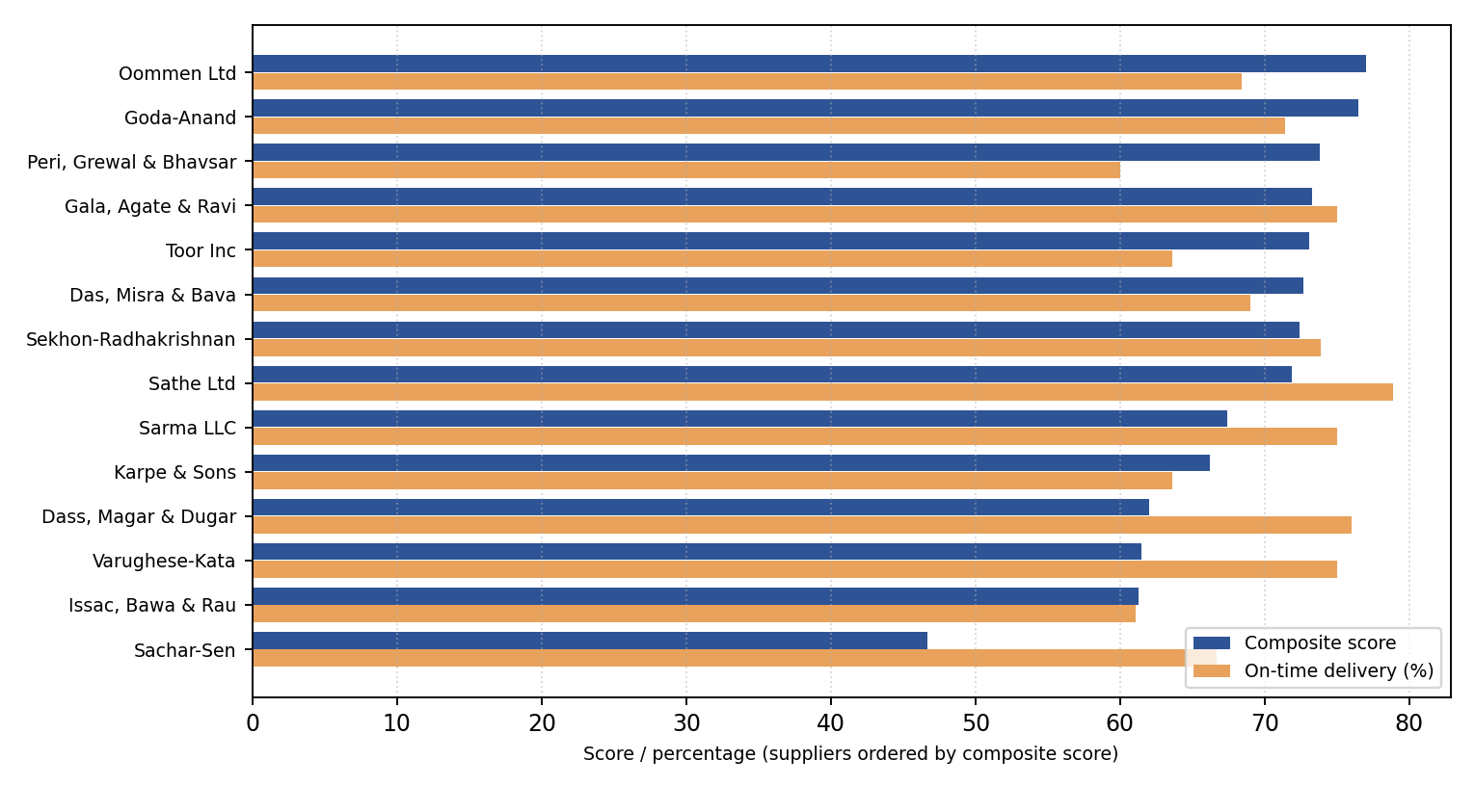
Figure 8.3: Composite score compared with on-time delivery for the 14 suppliers

8.4 Comparison with Baseline or Existing Method
No naive forecast (for example a seasonal-naive or moving-average baseline) was computed, and the existing manual method cannot be measured from the data, so a comparison with current practice is not available. Within the model set, Linear Regression with three calendar features acts as a simple baseline. SARIMA’s RMSE is 0.8 per cent lower than Linear Regression (40.66 against 41.00), 1.8 per cent lower than Prophet, 2.3 per cent lower than ARIMA, 11.0 per cent lower than Random Forest and 20.3 per cent lower than XGBoost.
For supplier scoring, the composite ranking differs from a ranking on delivery alone. Sathe Ltd has the highest on-time rate (78.9 per cent) but ranks eighth on the composite score (71.9) because its cost is above the median and its return rate is moderate, whereas Oommen Ltd ranks first with an on-time rate of 68.4 per cent because it combines a low return rate (0.14 per cent) with a mid-range cost.

8.5 Interpretation of Results
Forecasting. The top four models are close: their RMSE values lie between 40.66 and 41.60, a spread of about 2.3 per cent, and the ranking by MAPE is different (ARIMA first, SARIMA fourth). With a single 30-day test window this does not establish that SARIMA is better than ARIMA, Linear Regression or Prophet; it shows that SARIMA was the best on this window and has a principled reason to suit data with a weekly cycle. SARIMA was chosen on RMSE because RMSE penalises large misses, which matter most for stock-outs. Random Forest and XGBoost did worse, which is consistent with the finding of Makridakis et al. (2018) that complex machine-learning methods do not automatically beat statistical ones, and with the fact that only three calendar features and no lagged values were supplied. Prophet fitted the history visibly well but had, together with XGBoost, the two weakest MAPE values; the series contains only about 17 months of data, fewer than two yearly cycles, which limits yearly-seasonality estimation.
A further reason for the small differences is that the dataset is synthetic with randomly drawn daily order counts. Much of the day-to-day variation is therefore noise that no model can predict, which would put a floor under the achievable error. The wide forecast bounds (roughly 55 to 190 units per day around about 121) reflect this variability.
Segmentation. The centroids make the labels interpretable. High Value customers order often (about 61 lines) and spend the most (about ₹2.6 lakh). The At Risk cluster is distinguished by recency: its customers last ordered about 46 days before the end of the data, against 8 to 14 days for the other segments, even though their past frequency (about 34) and spend are substantial. That makes the 23 At Risk customers (12.8 per cent) the most actionable group for follow-up.
Supplier scoring. Sachar-Sen Electronics has the lowest composite score (46.7), driven by an average unit cost of 1,028 rupees, about twice the all-supplier mean of 517. The five suppliers with the highest composite scores are not the five with the highest on-time rates, which shows the effect of including cost and returns.
Inventory alerts. 35 of 179 products (19.6 per cent) need attention. The single REORDER SOON case (iPad 9th Gen OLED Display Combo, stock 23 above a reorder level of 21 but projected demand of 23.5) illustrates why the demand-velocity condition is useful: the threshold alone would not have flagged it.

8.6 Limitations
- Synthetic data. All results come from generated data; seasonality and noise are partly built in, and real data may behave differently.
- Aggregate forecasting. The forecast is for total daily units across all products, not for individual products. Spare-parts demand per product is often intermittent and would need dedicated methods.
- Single hold-out. Model comparison used one 30-day window, with no rolling-origin evaluation, no hyper-parameter tuning and no significance test; MAPE can be unstable near zero demand. No naive baseline was computed.
- Segmentation. The number of clusters (four) was chosen for interpretability and was not validated with a clustering index.
- Supplier score. The weights (0.5, 0.3, 0.2) are judgemental. Returns are attributed to each product’s most frequent supplier, and the return rate divides returned sales lines by units purchased, so it mixes units of measure.
- Order identifiers. In the generated data each sales line has a unique order_id, so “orders” and RFM frequency count sales lines rather than multi-line orders.
- Inventory. Stock levels are a snapshot generated independently of sales, and the reorder level is stored rather than computed from lead time and variability; alerts use recent sales velocity rather than the forecast.
- Storage and deployment. Data are flat files rather than a database; the dashboard is a local file and requires a manual refresh; no live data feed or hosting exists.
- Tests. The automated checks verify structure, not real-world correctness, and two of them use fixed expected counts.

8.7 Mentor and User Feedback Incorporated
No formal user study was conducted. The project guide’s feedback during weekly reviews shaped the work in these ways: a working prototype was requested early so that the intended deliverable was clear; development began on an authentic public-style dataset because real data was unavailable; progress reports were to describe what was actually built rather than follow a fixed day-wise checklist; and the dashboard presentation was redesigned from page-tab navigation to a landing page with clickable cards, with a consistent two-visual layout and explanatory text on each page. References were limited to documentation and academic sources.

Chapter 9 — Conclusion and Future Scope

9.1 Summary of the Work
This project designed and built a decision support system for a mobile spare (display) parts wholesaler. A seven-entity data workbook feeds a Python pipeline that prepares daily demand, compares six forecasting models and forecasts 30 days ahead with SARIMA, segments 179 customers with RFM and K-Means, scores 14 suppliers on delivery, cost and returns, and flags products that need reordering. A six-page Power BI dashboard with a landing page presents the results in plain language. Ten automated checks, a user-acceptance walkthrough and a one-command pipeline script support quality and repeatability.

9.2 Achievement of Objectives
Table 9.1: Objective-wise status
ID | Objective | Status | Comment
O1 | Forecast demand; select the best of six models | Achieved | SARIMA selected on lowest RMSE (40.66); margin over other models is small
O2 | Segment customers (RFM and K-Means) | Achieved | Four labelled segments; At Risk group of 23 customers identified
O3 | Score suppliers on reliability, cost and quality | Achieved | Composite score for 14 suppliers; weights are judgemental
O4 | Flag products needing reorder | Achieved | 35 of 179 products flagged, including 2 stock-outs
O5 | Unified seven-entity schema | Partially achieved | Designed and populated, but stored as flat files rather than a relational database
O6 | Integrated dashboard | Achieved | Six pages, tested; local prototype, not hosted

9.3 Key Contributions
- A reproducible end-to-end pipeline and dashboard for a small mobile-parts wholesaler, built from free tools and compatible with Tally-style exports.
- A transparent six-model forecasting comparison with the selection justified from measured error.
- A supplier score that includes product returns through a purchase-history attribution, and an alert rule that adds recent demand velocity to a stock threshold.
- A validation suite and automation script that make the outputs checkable and the refresh repeatable.

9.4 Learning Outcomes
The project developed skills in time-series modelling and evaluation, interpretation of unsupervised clustering, multi-criteria scoring, dashboard design for non-technical readers, testing statistical pipelines, and honest reporting of limitations. A practical lesson was that the evaluation protocol (a chronological hold-out) mattered as much as the choice of model, and that a result which looks good on a fitted chart can rank differently on unseen data, as happened with Prophet.

9.5 Future Scope and Recommendations
- Obtain genuine Tally exports (or connect through Tally’s ODBC or XML interface) and re-run the pipeline, then re-assess every result.
- Migrate the schema to a relational database (for example MySQL or PostgreSQL) with enforced keys, and read the dashboard directly from it.
- Forecast at product or product-family level and adopt methods for intermittent demand (Croston-type estimators, Syntetos & Boylan, 2005).
- Evaluate models with rolling-origin validation and a naive baseline, tune ARIMA and SARIMA orders, and add lagged features to the machine-learning models.
- Validate the number of customer segments with a clustering index and calibrate the supplier weights with a formal method such as AHP together with the business owner.
- Replace the stored reorder level with a computed reorder point and safety stock based on lead time and demand variability (Silver et al., 2017), and link inventory to sales movements.
- Deploy: run the pipeline on a schedule on a server, publish the report to Power BI Service with a data gateway for scheduled refresh, and add access control.
- Add a natural-language question facility for non-technical users and run a structured usability study.

9.6 Closing Remarks
The project met five of its six objectives fully and the sixth in part, and it did so on synthetic data that is disclosed as such. Its value is a working, tested and documented template: when real data becomes available, the same pipeline and dashboard can be applied to it, and the limitations listed in this report define the next steps.

References
ajitsingh98. (n.d.). Inventory-Management-Demand-Using-Time-Series-Analysis-and-Forecasting [Source code]. GitHub. https://github.com/ajitsingh98/Inventory-Management-Demand-Using-Time-Series-Analysis-and-Forecasting
Box, G. E. P., Jenkins, G. M., Reinsel, G. C., & Ljung, G. M. (2015). Time series analysis: Forecasting and control (5th ed.). Wiley.
Breiman, L. (2001). Random forests. Machine Learning, 45(1), 5–32. https://doi.org/10.1023/A:1010933404324
Chen, T., & Guestrin, C. (2016). XGBoost: A scalable tree boosting system. In Proceedings of the 22nd ACM SIGKDD International Conference on Knowledge Discovery and Data Mining (pp. 785–794). ACM. https://doi.org/10.1145/2939672.2939785
Croston, J. D. (1972). Forecasting and stock control for intermittent demands. Operational Research Quarterly, 23(3), 289–303.
Dickson, G. W. (1966). An analysis of vendor selection systems and decisions. Journal of Purchasing, 2(1), 5–17.
Fader, P. S., Hardie, B. G. S., & Lee, K. L. (2005). RFM and CLV: Using iso-value curves for customer base analysis. Journal of Marketing Research, 42(4), 415–430.
Few, S. (2013). Information dashboard design: Displaying data for at-a-glance monitoring (2nd ed.). Analytics Press.
Ho, W., Xu, X., & Dey, P. K. (2010). Multi-criteria decision making approaches for supplier evaluation and selection: A literature review. European Journal of Operational Research, 202(1), 16–24.
Hyndman, R. J., & Athanasopoulos, G. (2021). Forecasting: Principles and practice (3rd ed.). OTexts. https://otexts.com/fpp3/
Hyndman, R. J., & Koehler, A. B. (2006). Another look at measures of forecast accuracy. International Journal of Forecasting, 22(4), 679–688.
International Journal of Engineering Research & Technology. (2026). AI-driven inventory and demand forecasting system with automated supplier communication and trend analysis. https://www.ijert.org/ai-driven-inventory-and-demand-forecasting-system-with-automated-supplier-communication-and-trend-analysis-ijertv15is042201
Kraljic, P. (1983). Purchasing must become supply management. Harvard Business Review, 61(5), 109–117.
MacQueen, J. (1967). Some methods for classification and analysis of multivariate observations. In L. M. Le Cam & J. Neyman (Eds.), Proceedings of the Fifth Berkeley Symposium on Mathematical Statistics and Probability (Vol. 1, pp. 281–297). University of California Press.
Makridakis, S., Spiliotis, E., & Assimakopoulos, V. (2018). Statistical and machine learning forecasting methods: Concerns and ways forward. PLOS ONE, 13(3), Article e0194889. https://doi.org/10.1371/journal.pone.0194889
McKinney, W. (2010). Data structures for statistical computing in Python. In S. van der Walt & J. Millman (Eds.), Proceedings of the 9th Python in Science Conference (pp. 56–61).
Microsoft. (n.d.). Power BI documentation. Microsoft Learn. https://learn.microsoft.com/en-us/power-bi/
NumPy Developers. (n.d.). NumPy documentation. https://numpy.org/doc/
Pedregosa, F., Varoquaux, G., Gramfort, A., Michel, V., Thirion, B., Grisel, O., Blondel, M., Prettenhofer, P., Weiss, R., Dubourg, V., Vanderplas, J., Passos, A., Cournapeau, D., Brucher, M., Perrot, M., & Duchesnay, É. (2011). Scikit-learn: Machine learning in Python. Journal of Machine Learning Research, 12, 2825–2830.
Power, D. J. (2002). Decision support systems: Concepts and resources for managers. Quorum Books.
Seabold, S., & Perktold, J. (2010). Statsmodels: Econometric and statistical modeling with Python. In Proceedings of the 9th Python in Science Conference (pp. 92–96).
Shah, K. H. (2026). Synthetic mobile spare (display) parts wholesale dataset [Data set]. Generated by the author for this project; available from the author on request.
Silver, E. A., Pyke, D. F., & Thomas, D. J. (2017). Inventory and production management in supply chains (4th ed.). CRC Press.
Syntetos, A. A., & Boylan, J. E. (2005). The accuracy of intermittent demand estimates. International Journal of Forecasting, 21(2), 303–314.
Taylor, S. J., & Letham, B. (2018). Forecasting at scale. The American Statistician, 72(1), 37–45. https://doi.org/10.1080/00031305.2017.1380080
ycc710. (n.d.). AI-Procurement-Operating-System [Source code]. GitHub. https://github.com/ycc710/AI-Procurement-Operating-System

Appendix A — Approved Project Synopsis
The approved project synopsis (title approval, problem identification, objectives and scope as submitted with Progress Report 1) is to be attached here as a scanned copy before submission.

Appendix B — Detailed Requirements and Use-Case Descriptions
The functional and non-functional requirements are given in Sections 3.4 and 3.5. Table B.1 expands the use cases of Figure 5.3.
Table B.1: Use-case descriptions
ID | Use case (actor) | Pre-condition | Main flow | Post-condition
UC-01 | View business overview (Business Manager) | Outputs refreshed; report open | Home, then Overview; read KPIs, sales trend, top products, sales by city | Manager has a snapshot of the business
UC-02 | Analyse demand forecast (Business Manager) | Forecast file loaded | Home, then Demand Forecast; read forecast, bounds and projected demand; adjust date slicer | Manager knows expected demand range
UC-03 | Review customer segments (Business Manager) | Segment file loaded | Home, then Customer Segmentation; read segment counts and RFM table | Manager can identify high-value and at-risk customers
UC-04 | Evaluate supplier performance (Business Manager) | Scorecard loaded | Home, then Supplier Performance; read score table and ranking | Manager can compare suppliers
UC-05 | Check inventory alerts (Business Manager) | Alert file loaded | Home, then Inventory Alerts; read flagged products and KPI | Manager knows what to reorder
UC-06 | Refresh outputs (Data Analyst) | Updated workbook available | Replace workbook; run pipeline; run validation; refresh Power BI | Dashboard reflects the new data

Appendix C — Additional Diagrams
Figure C.1 is a conceptual entity-relationship diagram in Chen notation. It shows the main entities and relationships without data types, and is complementary to the key-level diagram in Figure 5.5. Derived attributes shown here (for example segment and reliability score) are produced by the analytical modules rather than stored in the raw workbook.
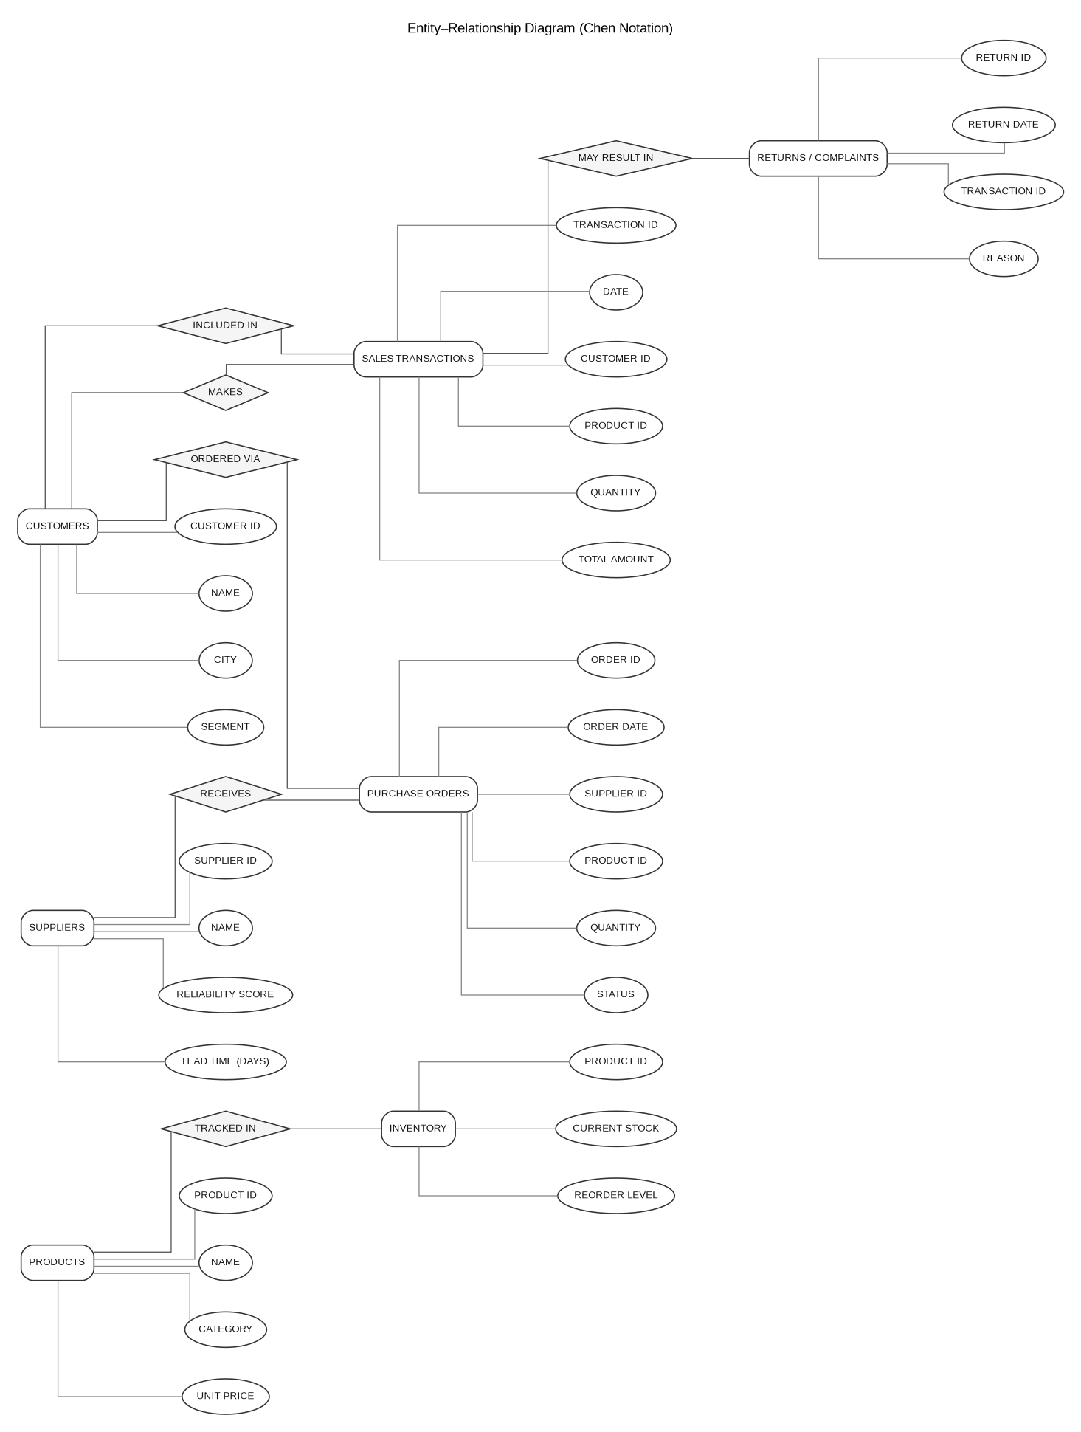
Figure C.1: Conceptual entity-relationship diagram (Chen notation)

Appendix D — Detailed Test Cases and Evidence
Console output of the validation notebook (notebook 09), as produced on the development machine:
[PASS] Forecast has no negative predicted demand
[PASS] Forecast lower_bound <= upper_bound for all rows
[PASS] Forecast covers exactly 30 future days
[PASS] Segment counts sum to total customer count
[PASS] No customer appears in more than one segment
[PASS] On-time delivery percentage is between 0 and 100
[PASS] Composite score is between 0 and 100
[PASS] All 14 suppliers present in scorecard
[PASS] REORDER NOW rows actually have stock <= reorder level
[PASS] No duplicate products in alert list

status
PASS 10

The results are saved in reports/test_results.csv with the columns test, status and details. The six user-acceptance criteria applied to each page were: page loads without errors; navigation buttons and arrows work; slicers filter the visuals as expected; KPI card values match the raw data on a manual spot check; no truncated text, broken axis labels or overlapping visuals; conditional formatting displays correctly. The outcome is in Table 7.4.

Appendix E — User Manual

E.1 For the business manager (reading the dashboard)
- Open the Power BI report; the Home page is the landing page. Use the date filter to narrow the quick summary if needed.
- Click a navigation card (or its arrow) to open Overview, Demand Forecast, Customer Segmentation, Supplier Performance or Inventory Alerts. Use the back arrow at the top left of each page to return to Home.
- Read the short explanation panel on each detail page before interpreting the visuals. Hover over a chart element to see its full label or value.
- On Inventory Alerts, products shown as REORDER NOW are at or below their reorder level; REORDER SOON products are not yet below the level but are projected to run short.

E.2 For the data analyst (refreshing the outputs)
- Save the updated workbook as data/raw/Mobile_Parts_Wholesale_Dataset.xlsx.
- Activate the environment and, from the project root, run python run_pipeline.py (or keep python watch_and_run.py running to start it automatically on save).
- Run notebook 09 and confirm that all checks pass.
- Open the Power BI file and choose Refresh. If new columns do not appear, delete and re-add the affected source in Power Query Editor.

Appendix F — Source Code and Repository
The complete source (notebooks, scripts and dashboard file) is in the GitHub repository https://github.com/khushi0321/DSS_project. The raw and processed data folders are excluded from version control. The two automation scripts are listed below.

run_pipeline.py
import subprocess
import sys
from pathlib import Path

NOTEBOOKS = [
"01_data_loading_eda.ipynb",
"02_data_cleaning.ipynb",
"03_demand_forecasting.ipynb",
"04_customer_segmentation.ipynb",
"05_supplier_scorecard.ipynb",
"06_inventory_alerts.ipynb",
"07_model_comparison.ipynb",
"08_supplier_score_with_returns.ipynb",
]

notebook_dir = Path("notebooks")

for nb in NOTEBOOKS:
nb_path = notebook_dir / nb
print(f"Running {nb} ...")
result = subprocess.run([
"jupyter", "nbconvert", "--to", "notebook", "--execute",
"--inplace", str(nb_path)
], capture_output=True, text=True)
if result.returncode != 0:
print(f"FAILED: {nb}")
print(result.stderr)
sys.exit(1)
print(f"Done: {nb}")

print("All notebooks executed successfully. CSV outputs refreshed.")

watch_and_run.py
from watchdog.observers import Observer
from watchdog.events import FileSystemEventHandler
import subprocess, time

class DataChangeHandler(FileSystemEventHandler):
def on_modified(self, event):
if event.src_path.endswith(".xlsx"):
print(f"Detected change in {event.src_path}, re-running pipeline...")
subprocess.run(["python", "run_pipeline.py"])

observer = Observer()
observer.schedule(DataChangeHandler(), path="data/raw", recursive=False)
observer.start()
print("Watching data/raw for changes... (Ctrl+C to stop)")
try:
while True:
time.sleep(1)
except KeyboardInterrupt:
observer.stop()
observer.join()

Appendix G — Progress Reports Summary
Table G.1: Progress reports submitted to the project guide
No. | Scheduled date | Focus of the report
1 | 16 Jul 2026 | Title, problem statement, objectives, scope and methodology
2 | 23 Jul 2026 | Requirement analysis, feasibility study, technology selection, methodology
3 | 06 Aug 2026 | System architecture, database design, module planning, environment setup, first prototype
4 | 13 Aug 2026 | Inventory alerts module; five-page dashboard restructuring
5 | 20 Aug 2026 | Six-model forecasting comparison and SARIMA selection; system diagrams and interface
6 | 27 Aug 2026 | Landing page and navigation; presentation consistency pass
7 | 03 Sep 2026 | Supplier scoring with returns integration; composite score
8 | 10 Sep 2026 | Testing (automated checks and UAT), error handling, optimisation
9 | 17 Sep 2026 | Final demonstration preparation, objective achievement, documentation
10 | 24 Sep 2026 | Final evaluation, deployment status, innovation, final report

The dates are those of the mentor’s reporting schedule; the reporting periods written on the individual reports may differ slightly.

Appendix H — Questionnaires, Interview Records and Consent Forms
Not applicable. No survey, interview or other study involving human participants was conducted, and no personal data was collected.

Appendix I — Group Contribution Statement
Not applicable. This is an individual project carried out by Khushi Hemin Shah.

Appendix J — Plagiarism Report and Declaration of AI-Assisted Contributions
Similarity report. The similarity report generated with the university-prescribed tool is to be attached here before submission.
AI-assisted contributions. An AI assistant (Claude, developed by Anthropic) assisted with code drafting and debugging, generation of diagrams, planning, and drafting of the progress reports and this report. All code was executed and all results were produced on the author’s own machine; the report content was reviewed with the project guide before submission. This declaration is made in line with the university’s policy on AI-assisted work.

