DETAILED DIAGNOSTIC REPORT (DDR)
Property Inspection Report | Prepared by AI DDR System

Inspection Date | See Additional Notes | Inspected By | See Additional Notes
Property Type | See Additional Notes | Areas Inspected | 1
Severity Items | 1 | Recommended Actions | 1

1. Property Issue Summary
AI analysis could not be completed due to Gemini API unavailability. A fallback DDR structure has been generated so documentation can proceed.
Inspection text length: 3756 chars. Thermal text length: 6496 chars.

2. Area-wise Observations

2.1 General
Negative Side (Interior) | Detailed inspection-side observation not available in fallback mode.
Positive Side (Source) | Detailed source-side observation not available in fallback mode.
Thermal Finding | Not Available
Image Reference | Not Available

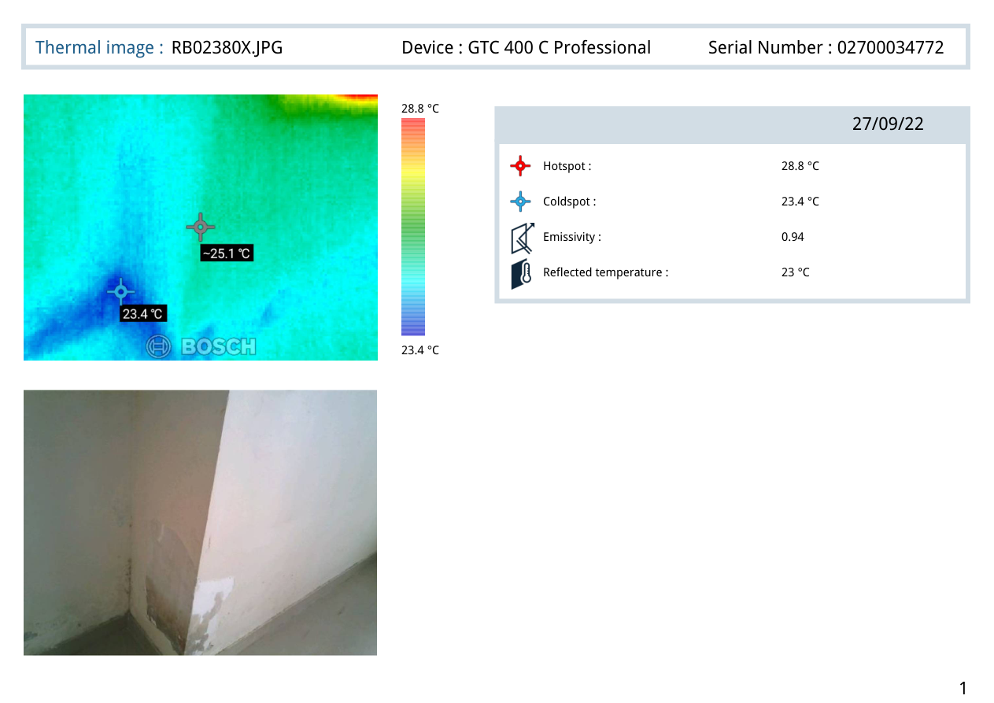
Thermal Image — General

3. Probable Root Cause
Root cause could not be reliably derived because Gemini analysis failed. Please rerun once API quota is available.

4. Severity Assessment
Area | Severity | Reasoning
General | Medium | Auto-assigned in fallback mode because Gemini analysis was unavailable.

5. Recommended Actions
Priority | Area | Action
Short-term | General | Re-run AI analysis after quota is restored and validate area-level details.

6. Additional Notes
Fallback reason: Gemini quota exceeded for this API key/project. Update billing/quota or use a different API key/project and retry.. Inspection excerpt: [PAGE 1] AI Generalist | Applied AI Builder - Assignment & Evaluation Guide Candidate Practical Assignment Objective We want to understand how you think, design, and build real AI workflows, not just theoretical knowledge. You may use any tools, models, frameworks, or languages. Time Limit: 24 Hours Submission Requirements Please submit the following: • Working output (project live link / repository / screenshots) • A 3–5 minute Loom video explaining: o What you built o How it works. Thermal excerpt: [PAGE 1] 28.8 °C 23.4 °C 27/09/22 Hotspot : 28.8 °C Coldspot : 23.4 °C Emissivity : 0.94 Reflected temperature : 23 °C Thermal image : RB02380X.JPG Device : GTC 400 C Professional Serial Number : 02700034772 1 [PAGE 2] 27.4 °C 22.4 °C 27/09/22 Hotspot : 27.4 °C Coldspot : 22.4 °C Emissivity : 0.94 Reflected temperature : 23 °C Thermal image : RB02386X.JPG Device : GTC 400 C Professional Serial Number : 02700034772 2 [PAGE 3] 27 °C 22 °C 27/09/22 Hotspot : 27 °C Coldspot : 22 °C Emi.

7. Missing or Unclear Information
- AI-generated detailed findings unavailable due to API quota/rate limit.
- Area-level thermal interpretation not available in fallback mode.
- Re-run with a working Gemini quota for full analysis.

— Generated by AI DDR System | Based on provided Inspection & Thermal Reports —

