 

# Department of Computer Technology

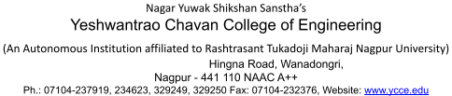

### Vision of the Department

To be a well-known centre for pursuing computer education through innovative pedagogy, value-based education and industry collaboration.

### Mission of the Department

To establish learning ambience for ushering in computer engineering professionals in core and multidisciplinary area by developing Problem- solving skills through emerging technologies**.**

## Session 2025-2026



**Program Educational Objectives of the program (PEO):** (broad statements that describe the professional and career accomplishments)

|  |  |  |  |
| --- | --- | --- | --- |
| PEO1 | **Preparation** | **P: Preparation** | **Pep-CL abbreviation pronounce as Pep-si-lL easy to recall** |
| PEO2 | **Core Competence** | **E: Environment (Learning Environment)** |
| PEO3 | **Breadth** | **P: Professionalism** |
| PEO4 | **Professionalism** | **C: Core Competence** |
| PEO5 | **Learning Environment** | **L: Breadth (Learning in diverse areas)** |

**Program Outcomes (PO):** (statements that describe what a student should be able to do and know by the end of a program)

## Keywords of POs:

Engineering knowledge, Problem analysis, Design/development of solutions, Conduct Investigations of Complex Problems, Engineering Tool Usage, The Engineer and The World, Ethics, Individual and Collaborative Team work, Communication, Project Management and Finance, Life-Long Learning

**PSO Keywords:** Cutting edge technologies, Research

“I am an engineer, and I know how to apply engineering knowledge to investigate, analyse and design solutions to complex problems using tools for entire world following all ethics in a collaborative way with proper management skills throughout my life.” *to contribute to the development of cutting-edge technologies and Research*.

**Integrity:** I will adhere to the Laboratory Code of Conduct and ethics in its entirety.



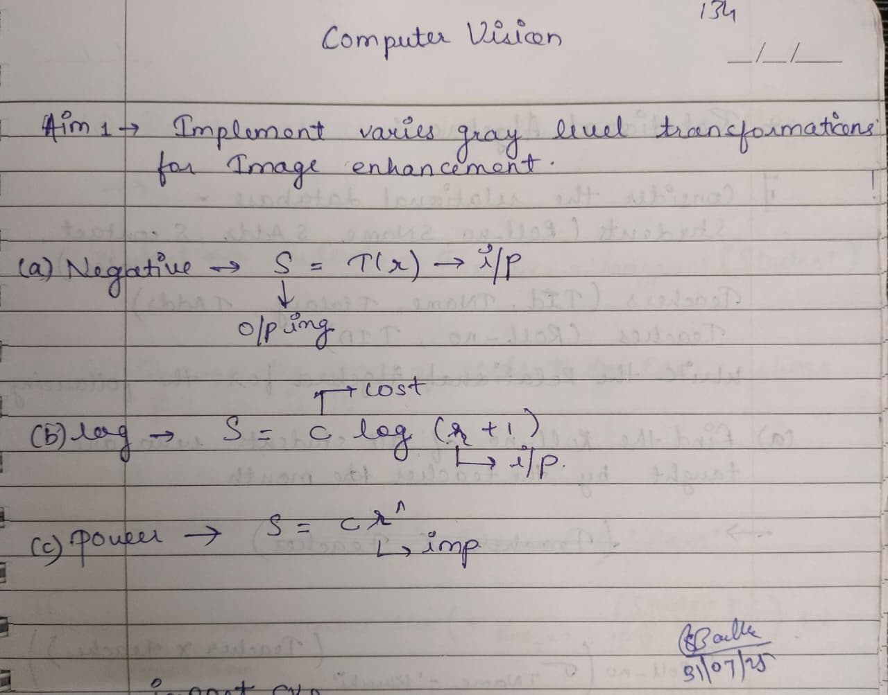

Khushi Deepak Raghorte

## Name and Signature of Student and Date

(Signature and Date in Handwritten)

 

# Department of Computer Technology



### Vision of the Department

To be a well-known centre for pursuing computer education through innovative pedagogy, value-based education and industry collaboration.

### Mission of the Department

To establish learning ambience for ushering in computer engineering professionals in core and multidisciplinary area by developing Problem- solving skills through emerging technologies**.**

|  |  |  |  |
| --- | --- | --- | --- |
| **Session** | **2024-25 (ODD)** | **Course Name** | **Computer vision Lab** |
| **Semester** | **5** | **Course Code** | **CT** |
| **Roll No** | **10** | **Name of Student** | **Khushi Raghorte** |

|  |  |
| --- | --- |
| Practical Number | 01 |
| Course Outcome | Apply image enhancement and smoothing techniques to improve image quality for further analysis. |
| Aim | Implement various gray level transformations for image enhancement. |
| Problem Definition |  |
| Theory  (100 words) | Image enhancement is the most fundamental and simple process of digital  image processing. In this process, the intensity level of an image is manipulated to get a better output image. For this purpose, we will use the mathematical operation  of grey level transformation, also known as intensity transformation.  The spatial domain process is denoted by g(x,y)=T [f(x,y)] where f(x,y) is the input image, g(x,y) is the output image and T is the operator on f defined over a neighbourhood of point (x,y). The operator can be applied to a single image or multiple images  Gray level transformation is one of the simplest image processing techniques. In digital image processing, the transformation functions are stored in a table. The mappings are implemented via table lookups. For an n-bit image, a lookup table will have 2n entries.  There are three basic types of intensity functions used in gray level transformation:   1. Negative Image: The negative of a image having intensity range [0, L   - 1] can be found using the following transformation:*s = T(r) = L - r - This technique is used to enhance white or light color detail in dark background, as dark color in light background is easily visible than light color in dark background. Here dark becomes light and light becomes dark*   1. Log Transformation:The log transformation is of the form: *s = T(r)*   *= c log (1 + r ):where, c is constant and r ≥ 0.* In log transformation, the higher range of intensity level is mapped to a lesser range of intensity level at the brighter side, whereas the lesser range of intensity level is mapped to  higher range of intensity level at the darker side. The log |



 

|  |  |
| --- | --- |
|  | transformation expands the dark pixels. Log transformation is applied when the intensity levels are very large, for example, 0 to 10^6. This is because transformation compresses the intensity levels of input level  3. Gamma Transformation:The power law (or gamma) transformation is of the form: *s = T(r) = c * r^γ where, c, γ are constants; c, γ > 0* For various values of γ, there exists a different power law transformation. At γ <  1, the higher range of intensity level is mapped to a lower range of intensity  level at the brighter side, while the lower range of intensity level is mapped to higher range of intensity level at the darker side. At γ > 1, the behaviour is opposite that of γ < 1. Here, the higher range of intensity level is mapped to a higher range of intensity level at the brighter side, while the lower range of intensity level is mapped to lower range of intensity level at the darker side. If γ = 1, then the transformation becomes identity transformation |
| Procedure and Execution  (100 Words) | Algorithm:   1. Load and convert image 2. Convert to grayscale by gray_img = rgb2gray(img) 3. Apply Negative transformation by neg_img = 1 - img and save it 4. Apply Logarithmic transformation by c = 1; log_img = c * log(1 + img);   Normalize by following log_img = mat2gray(log_img);   1. Apply power Image By Following gamma=0.9;   power_img=img.^gamma   1. Output The All Four Images |
| Code:clc; clear;  close all;  % Load and convert image  img = imread("C:\Users\HP\Downloads\1000008019.jpg ");  img = im2double(img); |



 

|  |  |
| --- | --- |
|  | % Convert to grayscale gray_img = rgb2gray(img);  % Negative transformation neg_img = 1 - img;  % Logarithmic transformation c = 1;  log_img = c * log(1 + img);  log_img = mat2gray(log_img); % Normalize for display  %power Image gamma=0.9; power_img=img.^gamma;  % Display all images in one figure  figure('Name','Original and Transformed Images','NumberTitle','off');  subplot(2,3,1); imshow(img); title('Original Image'); subplot(2,3,2); imshow(gray_img); title('Grayscale Image'); subplot(2,3,3); imshow(neg_img); title('Negative Image'); subplot(2,3,4); imshow(log_img);  title('Logarithmic Transform'); subplot(2,3,5); imshow(power_img); title('Power Law Transform'); |



 

|  |  |
| --- | --- |
|  | Output: |
| Output Analysis | Grayscale conversion remove color and retain intensity Negative Transformation Inverts brightness  Logarithmic Transformation Expands dark pixels, compresses bright ones Power-Law (Gamma) Transformation Adjusts contrast based on gamma |
| Link of student Github profile where lab assignment has been uploaded |  |



 

# Department of Computer Technology

### Vision of the Department

To be a well-known centre for pursuing computer education through innovative pedagogy, value-based education and industry collaboration.

### Mission of the Department

To establish learning ambience for ushering in computer engineering professionals in core and multidisciplinary area by developing Problem- solving skills through emerging technologies**.**

|  |  |
| --- | --- |
|  |  |
| Conclusion | Successfully Implement grey level image transformation by applying negative ,logarithmic and power-law transformation |
| Plag Report (Similarity index < 12%) | By plagiarismcheck.io **AI Detection Results** Detection Result: **Likely Human Written** AI Probability:**1%** Human Probability:**99%** Confidence Level:**99%** |
| Date | 18/08/2025 |