**A Project Report**

**On**

**Comparative Analysis of Disk Scheduling Algorithms**

**For**

# Operating Systems and System Programming Lab

**(15B17CI472)**



**Submitted by: Submitted to:**

|  |  |  |
| --- | --- | --- |
| Anya Rathi | 9920103001 | Dr. Anubhuti Roda Mohindra |
| Devansh Chugh | 9920103011 | Dr. Gaurav Kumar Nigam |
| Vaishali Ranjan | 9920103013 | Dr. Neeraj Jain |
| Aviral Gupta | 9920103021 | Dr. Charu |
| Khushi Kalra | 9920103025 |  |

**Department of CSE/IT**

**Jaypee Institute of Information Technology University, Noida**

**December, 2022**

**How to Compile and Run a C Program on Ubuntu Linux**

Step 1.

Open up a terminal Search for the terminal application in the Dash tool (located as the topmost item in the Launcher). Open up a terminal by clicking on the icon.

Step 2. Use a text editor to create the C source code. Type the command gedit filename.c and enter the C source code

Step 3. Compile the program.

Type the command gcc filename.c -lpthread

This command will invoke the GNU C compiler to compile the file

Step 4. Execute the program.

Type the command ./a.out This should result in the output

Step 5. Enter a number from 1-5 for the choice of algorithm to be executed

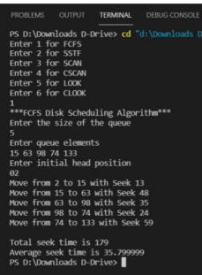

(in the above case 1 is chosen for fcfs algotithm)

Step 6. For each algorithm chosen enter the queue size, elements in the queue and the initial head position



Step 5. For options

3.Scan

4.C scan

5.Look

6.C look

chosen enter the direction



Step 6. Check the output

