Student Performance Analytics System
Python with AI-Mini Project Documentation

Submitted By-
Khushi Manoj Patel

Project Title
Student Performance Analytics System
This project is developed as part of the Python with AL course. It uses Python, Numpy and Pandas to analyze student academic performance.

Objective
The main objective of this project is to develop a Python-based system that analyses student marks and provides meaningful information about academic performance.
The system calculates total marks, average marks, grades, and pass/fail results. It also calculates overall class performance, compares subject-wise averages, and identifies the top-performing students.
This project helps demonstrate how Python can be used to process datasets and perform basic data analysis.

Technologies Used
The following technologies and tools are used in this project:
1. Python
Python is the main programming language used to develop the project. It is used for calculations, conditions, loops, functions, and data processing.
2. NumPy
NumPy is used for numerical calculations, including calculating averages and analysing numerical data.
3. Pandas
Pandas is used to read the CSV dataset, organise student records into a DataFrame, calculate totals and averages, sort records, and analyse results.
4. CSV File
A CSV file stores the student information, marks, and attendance records.
5. Visual Studio Code
Visual Studio Code is used to write, edit, and execute the Python program.

Dataset Description

The project uses a CSV dataset containing 20 student records.
The dataset includes the following columns:
Column Name
Description
Student_ID
Unique identification number of each student
Name
Name of the student
Department
Department of the student
Python
Marks obtained in Python
SQL
Marks obtained in SQL
Statistics
Marks obtained in Statistics
Attendance
Student attendance percentage
The dataset is stored in a file named students.csv.
The program reads this file using Pandas and processes the records to calculate student performance.

Implementation

The project is implemented using Python, NumPy, and Pandas. The program is divided into different functions to make the code organised and reusable.
5.1 Data Loading
The student dataset is loaded using Pandas.
data = pd.read_csv("students.csv")
This statement reads the CSV file and stores the records in a Pandas DataFrame.
5.2 Total Marks Calculation
The program calculates the total marks obtained by each student in Python, SQL, and Statistics.
data["Total"] = data[subjects].sum(axis=1)
The sum() function adds the marks of all three subjects for each student.
5.3 Average Marks Calculation
The average marks are calculated using Pandas and NumPy.
data["Average"] = np.round(
data[subjects].mean(axis=1), 2
)
The average is calculated by dividing the total marks by the number of subjects. The result is rounded to two decimal places.
5.4 Grade Assignment
The program assigns grades according to the student's average marks.
Average Marks
Grade
90 and above
A+
80–89.99
A
70–79.99
B
60–69.99
C
50–59.99
D
Below 50
F
The grading logic uses conditional statements such as if, elif, and else.
5.5 Pass/Fail Calculation
The program checks whether the student has obtained at least 35 marks in every subject.
If all three subject marks are at least 35, the result is Pass.
If any subject mark is below 35, the result is Fail.
A function and a loop are used to check the marks subject by subject.
5.6 Class Performance Analysis
The program calculates the overall class average and identifies the highest and lowest student averages.
NumPy and Pandas are used to perform these numerical calculations.
5.7 Subject-Wise Analysis
The program calculates the average marks for Python, SQL, and Statistics separately.
This helps compare student performance across the three subjects.
5.8 Top-Performing Students
The program sorts student records by average marks in descending order and displays the top five students.
5.9 Exporting Results
The final results are saved to a CSV file named student_performance_results.csv.

Key Features

The Student Performance Analytics System provides several features to analyse student academic performance.
6.1 Student Record Management
The system reads student information, including student ID, name, department, marks, and attendance, from a CSV file.
6.2 Total Marks Calculation
The system calculates the total marks obtained by each student in Python, SQL, and Statistics.
6.3 Average Marks Calculation
The system calculates the average marks of each student and rounds the result to two decimal places.
6.4 Grade Assignment
The system assigns grades based on the student's average marks using conditional statements.
6.5 Pass/Fail Analysis
The system determines whether each student passes or fails based on the marks obtained in individual subjects.
6.6 Class Performance Analysis
The system calculates the overall class average and identifies the highest and lowest student averages.
6.7 Subject-Wise Analysis
The system calculates the average marks for Python, SQL, and Statistics to help compare subject performance.
6.8 Top Five Students
The system identifies and displays the top five students based on their academic performance.
6.9 Results Export
The system saves the processed student results in a CSV file for future reference.

Output and Screenshots

The Student Performance Analytics System displays the processed student records and analysis results in the terminal.
The main outputs generated by the program include:
Student records containing marks and attendance.
Final student results, including total marks, average marks, grades, and pass/fail status.
Overall class performance statistics.
Subject-wise average marks.
Pass/fail summary.
Top five students based on their average marks.

Screenshots of Output:

Screenshot 1: Students Records

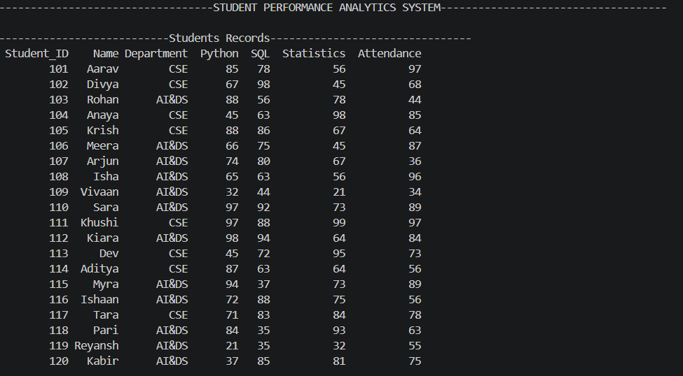

Screenshot 2: Final Student Results
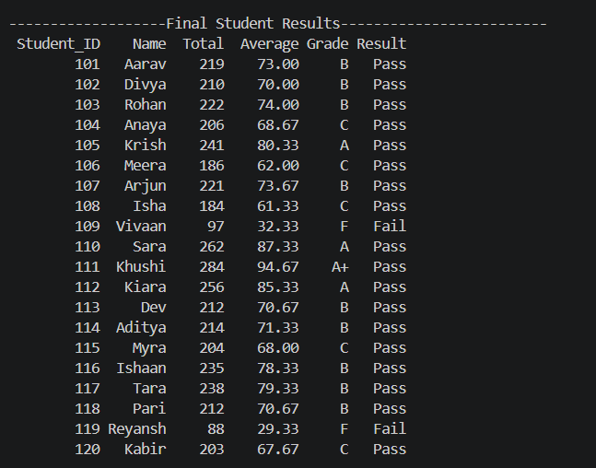
Screenshot 3: Class and Subject-Wise Analysis
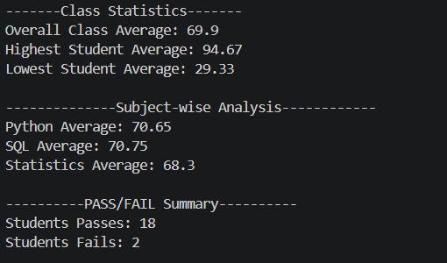
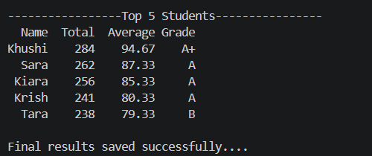
Screenshot 4: Top-5 Students
Final Outcome
The Student Performance Analytics System was successfully developed using Python, NumPy, and Pandas.
The project processes student records and calculates total marks, average marks, grades, and pass/fail results. It also analyses overall class performance, compares subject-wise averages, and identifies the top five students.
The system generates a results CSV file that allows the processed information to be stored and viewed later.
This project demonstrates the practical application of Python programming and data analysis techniques to student academic data.
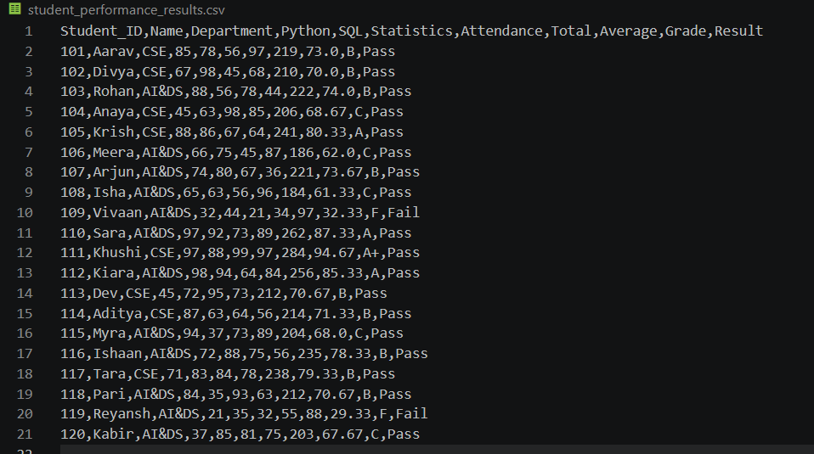

Challenges and Learning
During the development of this project, I encountered challenges related to data processing, function implementation, and error handling.
The main challenges and learning outcomes were:
9.1 Working with CSV Files
I learned how to load student data from a CSV file using Pandas and access individual columns.
9.2 Data Processing Using Pandas
I learned how to use DataFrames to organise student records and calculate totals and averages.
9.3 Numerical Calculations Using NumPy
I learned how to perform numerical calculations and round average marks to two decimal places.
9.4 Implementing Functions
I learned how to create reusable functions for calculating totals, averages, assigning grades, and determining results.
9.5 Using Conditional Statements
I learned how to use if, elif, and else statements to assign grades according to average marks.
9.6 Debugging Errors
During development, I encountered a column-name mismatch that caused a KeyError when displaying the top five students. I learned the importance of checking DataFrame column names and ensuring that the requested columns exist.
9.7 Analysing Student Performance
I learned how to calculate class statistics, compare subject-wise averages, and identify top-performing students.
Overall, this project improved my understanding of Python programming, data manipulation, debugging, and basic data analytics.

