SQS Data Pipeline: Documentation
This document provides a comprehensive overview of the SQS Data Pipeline project, detailing the architecture, implementation, Challenges and operational steps following the Software Development Life Cycle (SDLC) framework.

1. Project Overview & Objective
Objective:
Build a robust, scalable ETL (Extract, Transform, Load) tool that consumes real-time message data from an AWS SQS queue (emulated via LocalStack), transforms it into a unified "Trip" format, and persists it into a production-grade relational database.
Outcome:
A fully containerized data pipeline that can be launched with a single command, capable of handling varying message structures (e.g., location-based vs. route-based segments) with high reliability.

2. Architecture & Data Flow
The pipeline follows a decoupled, containerized architecture. The ETL tool acts as the intelligent bridge between the message source and the database sink.
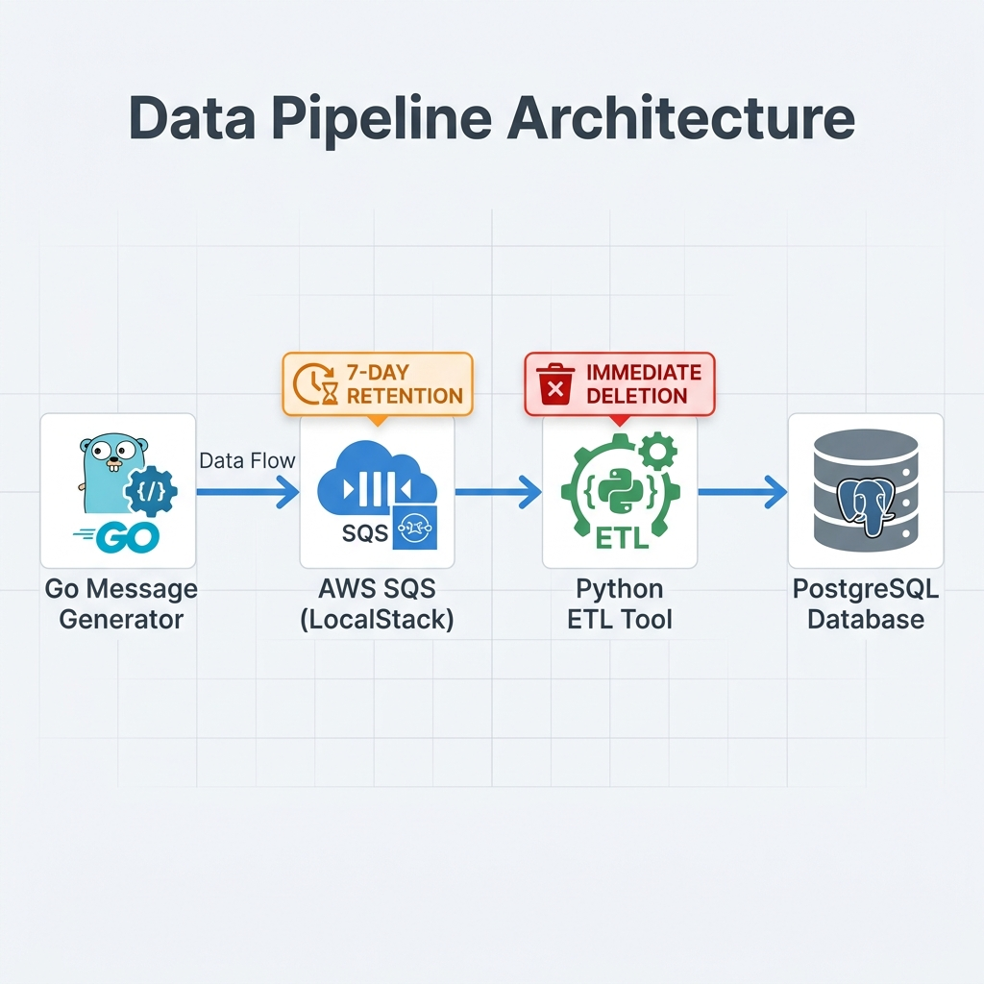

3. Tech Stack
Component | Technology | Role
Infrastructure | LocalStack | Emulator for AWS SQS
Database | PostgreSQL 15 | Relational storage for transformed records
ETL Logic | Python 3.11 | Core transformation and processing engine
Cloud SDK | Boto3 | AWS SDK for SQS integration
DB Adapter | Psycopg2-Binary | Database connectivity
Orchestration | Docker Compose | Unified environment management
Build System | Docker | Containerization of the ETL service

3. SDLC: Implementation Phases

Phase 1: Planning & Requirements Analysis
- Service Selection: Leveraged LocalStack to avoid AWS cloud costs while maintaining API parity.
- Data Schema Definition: Analyzed inputs from the `message_generator` (Go) to identify two distinct JSON schemas:
1. `route`-based (segment durations and start times).
2. `locations`-based (GPS coordinate timestamps).
- Target Structure: Standardized output to include: `id`, `mail/name`, `departure`, `destination`, `start_date`, and `end_date`.

Phase 2: Design & System Architecture
- Infrastructure Architecture: A three-container stack:
- `localstack`: The message source.
- `postgres`: The data sink.
- `etl-tool`: The processing bridge.
- Security Logic: Implemented mock AWS credentials (`access_key_id=test`) to bypass SDK validation without requiring real IAM keys.
- Communication: Used Docker internal DNS (e.g., `http://localstack:4566`) for secure service-to-service networking.

Phase 3: Implementation
- ETL Tool Logic:
- Built a robust transformation engine in Python using the `json` and `datetime` libraries.
- Implemented a mandatory 7-day Message Retention Period (604,800 seconds) on the SQS queue. This ensures the queue is automatically emptied of unprocessed messages older than 7 days.
- Implemented "Check & Skip" logic for malformed messages.
- Added automated SQS message deletion (ACK) only after successful DB commit to ensure data integrity.
- Database Schema: Created a `trips` table with indexing on `id` for optimized lookups.
- Containerization: Wrote a multi-stage `Dockerfile` to keep dependencies minimal and reproducible.

Phase 4: Integration & Testing
- Integration: Linked the ETL tool to wait for and depend on the `localstack` and `postgres` services.
- Data Generation: Executed cross-platform Go binaries in a controlled environment to populate the queue with realistic test data.
- Verification: Used `awslocal` CLI tools and `psql` queries to verify the full flow (SQS -> ETL -> DB).

Phase 5: Operations & Deployment
- Final deployment is achieved through a single `docker-compose up -d --build` command.
- Detailed logs are accessible via `docker logs`, providing visibility into processing latency and message counts.

4. Output & Transformation Format
The ETL tool transforms raw, variable JSON inputs into a standardized "Trip" format:
Example Standardized JSON Output:
{ "id": 1,
"mail": "example@email.com",
"name": "Full Name",
"trip": {
"depaure": "Origin Point",
"destination": "Destination Point",
"start_date": "2022-10-10 12:15:00",
"end_date": "2022-10-10 13:55:00"}}
Database Schema (`trips` table):
Field | Type | Description
id | SERIAL (PK) | Unique internal ID
user_id | INTEGER | Original ID from the message
mail | TEXT | User's email address
name | TEXT | Combined first and last name
departure | TEXT | Starting location name
destination | TEXT | Ending location name
start_date | TEXT | Formatted start timestamp
end_date | TEXT | Formatted end timestamp

5. Key Challenges & Resolutions

Challenge 1: Connection Security & Credentials
Issue: Newer versions of LocalStack require a specific acknowledgment of account requirements, and the AWS SDK throws `NoCredentialsError` if keys are completely missing.
Resolution: Implemented `LOCALSTACK_ACKNOWLEDGE_ACCOUNT_REQUIREMENT=1` and provided `test/test` mock credentials via environment variables to keep the SDK "happy" while remaining local.

Challenge 2: Handling Diverse Message Formats
Issue: The `message_generator` produces payloads with different structures (`route` vs `locations`).
Resolution: Implemented a "Polymorphic Transformation" layer in the ETL tool that detects the schema type and applies the appropriate mapping logic dynamically.

Challenge 3: Environment Reproducibility
Issue: Building Go binaries locally failed due to missing local toolchains.
Resolution: Containerized the build process using a `golang` Docker image, ensuring the binaries are identical across Windows, macOS, and Linux.

5. How to Run (Step-by-Step)

1. Prerequisites: Ensure Docker and Docker Compose are installed.
2. Setup: Run `docker-compose up -d --build` to launch the entire stack.
3. Generate Data: Execute the generator (e.g., `.\dist\message-generators\windows.exe`) from your host.
4. Monitor: Check ETL progress with `docker-compose logs -f etl-tool`.
5. Verify: Query the results from Postgres:
docker exec task-postgres-1 psql -U user -d sqs_data -c "SELECT * FROM trips;"

