***INTERNET AND WORLD WIDE WEB***

***Assessment Weightage & Type:***

***60% Portfolio Coursework***

***Year:2024***

* *Student Name:* ***Khushi Kumari***
* *UWE ID:* ***24030167***
* *Module code:* ***UFCFL1-15-0***
* *Level:* ***Level 3)***
* *Faculty:* ***Faculty of Environment & Technology***
* *Department:* ***FET Department of Computer Science & Creative***

***Technology***

**Internet Protocols**

The internet protocol, or IP, is the behind-the-scenes hero that keeps the internet running smoothly. It's a set of rules that devices use to talk to each other and send information. Here's the gist:

* **Think Addresses:** IP assigns unique addresses (like digital house numbers) to every device on the internet. This lets devices find each other and send data.
* **Packet Power:** IP breaks down information into smaller packets for travel. Imagine a large pizza being cut into slices for delivery – that's kind of what IP does with data!
* **Routing the Way:** IP acts like a traffic controller, directing these data packets along the best route to their destination device.
* **Putting it Back Together:** Sometimes, IP needs to break down large data packets. It then ensures all the pieces arrive and are put back together correctly at the other end.

IP is like an invisible mailman, ensuring information gets delivered efficiently from one device to another across the vast network of the internet.

**Transmission Control Protocol/Internet Protocol**

TCP/IP, which stands for Transmission Control Protocol/Internet Protocol, is the foundation of communication on the internet. It's like a two-part language that devices use to exchange information reliably. Here's a breakdown:

**1. Internet Protocol (IP):**

* Think of IP as the addressing and delivery system. It assigns unique addresses (IP addresses) to devices, acting like digital street addresses.
* IP breaks down information into smaller packets that travel independently across the network. Each packet has an IP address included, like a label, to ensure it reaches the correct destination device.
* IP acts like a traffic controller, directing these packets along the most efficient route.

**2. Transmission Control Protocol (TCP):**

* Imagine IP is the postal service, but sometimes mail gets lost! TCP is a reliable delivery person.
* TCP takes the data stream you want to send and breaks it into smaller, manageable pieces.
* TCP adds sequence numbers and error checks to each piece, ensuring they arrive in the right order and without corruption.
* TCP acts like a quality checker, acknowledging receipt of each piece and requesting retransmission if anything is missing or damaged.

**Working Together:**

* Think of sending a large document. IP breaks it down into pages (packets), labels them with addresses (IP addresses), and sends them off.
* TCP ensures the document arrives in full and error-free. It checks each page (packet) for completeness and requests missing or damaged ones to be resent.

**Benefits of TCP/IP:**

* Reliable data transmission: TCP ensures data arrives correctly at its destination.
* Flexible communication: TCP/IP allows different types of devices to communicate seamlessly.
* Scalability: The system can handle a vast number of devices on the internet.

**Analogy:**

Imagine sending a package across the country. IP is like the shipping label with the address, ensuring it gets to the right city. TCP is like the reliable delivery service that checks the package for damage and requests a replacement if needed.

**In essence, TCP/IP is the invisible handshake that allows devices to communicate and exchange information reliably across the vast network of the internet.**

**OSI Model**

The OSI model, short for Open Systems Interconnection model, is a conceptual framework used to describe how communication happens over a network. Imagine it like a seven-layer cake, with each layer representing a specific function in getting data from one device to another. Here's a quick breakdown of the layers, from bottom to top:

* **Physical Layer:** Deals with the physical transmission of data, like cables or Wi-Fi signals.
* **Data Link Layer:** Packages data into manageable chunks and ensures error-free transmission between devices on the same network segment.
* **Network Layer:** Routes data packets across different networks, figuring out the best path to take.
* **Transport Layer:** Oversees the reliable delivery of data between applications on different devices.
* **Session Layer:** Establishes, manages, and terminates communication sessions between applications.
* **Presentation Layer:** Prepares data for the application layer by handling things like encryption and decryption.
* **Application Layer:** The top layer where user applications like web browsers or email clients interact with the network services.

By understanding these layers, we can better understand how data flows across networks and troubleshoot any communication issues that might arise.

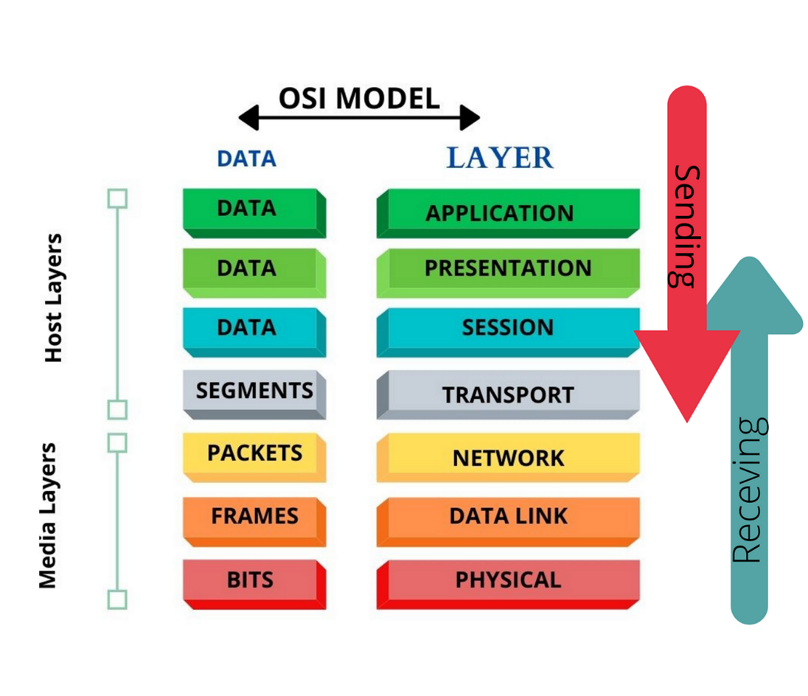

**Internet Message Access Protocol**

**IMAP, or Internet Message Access Protocol**, is a standard communication protocol (defined in RFC 5321) that governs how email clients access, manage, and manipulate email messages stored on a remote mail server. In simpler terms, it's a set of rules that lets your email program interact with your email on the server, unlike POP which just downloads them.

IMAP (Internet Message Access Protocol) is a game-changer for email management. Unlike POP (download-only), IMAP lets you be the boss of your inbox, even across multiple devices.

* **Server-Side Management:** Access, organize, and delete emails directly on the server, not just your device.
* **Multi-Device Nirvana:** Check your email on your phone, laptop, or tablet - IMAP keeps everything in sync.
* **Granular Control:** Download only specific parts of emails (like attachments) to save space and bandwidth.

**Search Engine**.

A search engine is a software system designed to search for information on the web. It acts like a giant library index, cataloging websites and their content to help users find relevant information quickly.

**How Do Search Engines Work?**

Here's a simplified breakdown of a search engine's inner workings:

1. **Crawling:** The search engine uses automated programs called "web crawlers" or "spiders" to constantly scan the internet, discovering and indexing new web pages.
2. **Indexing:** The crawlers analyze the content of each webpage, including text, titles, and meta descriptions. This information is then stored in a massive database called an "index."
3. **Ranking:** When you enter a search query, the search engine uses sophisticated algorithms to analyze your query, the indexed web pages, and various ranking factors. These factors might include the relevance of the webpage content to your query, the popularity of the website, and the freshness of the information. Based on this analysis, the search engine ranks the most relevant web pages and presents them to you in a list of search results.

**Popular Search Engines:**

* Google Search (the most widely used search engine)
* Bing
* DuckDuckGo (known for its focus on user privacy)

**Beyond Basic Search:**

Modern search engines offer various features to enhance your search experience:

* **Search operators:** These are special symbols or keywords that can refine your search queries for more precise results (e.g., using quotation marks for exact phrases).
* **Image and video search:** Search for specific images or videos by uploading a file or using keywords.
* **News search:** Find recent news articles related to your search query.
* **Local search:** Search for businesses, restaurants, or other local services in your area.

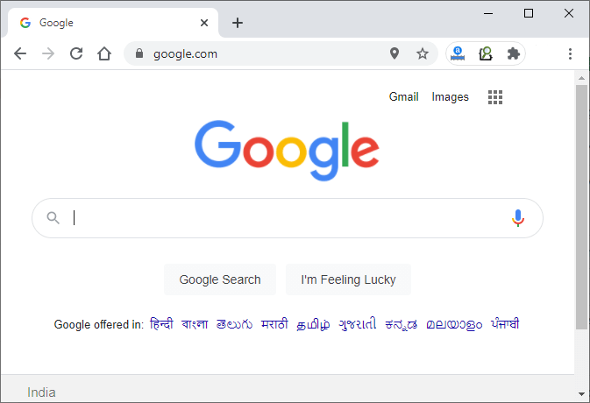

Figure: Search Engine

**Web Hosting**

Web hosting is the foundation of your online presence. It's essentially a service that provides the storage space and technology needed for your website to be accessible on the Internet. Just like renting an apartment gives you a physical space to live, web hosting provides the digital space for your website to exist.

**Types of Web Hosting:**

There are different types of web hosting plans available, each catering to specific website needs. Here's a breakdown of some common options:

* **Shared Hosting:** This is a cost-effective option for beginners with low to moderate-traffic websites. Multiple websites share server resources (storage space, processing power, memory) like roommates in an apartment. This makes it affordable but with limitations on customization and performance.
* **Cloud Hosting:** Offers scalability and reliability. Your website runs on a network of servers, ensuring uptime even if one server experiences an issue. Think of it like living in a large apartment complex with backup generators. Cloud hosting is ideal for websites with fluctuating traffic or those expecting growth.
* **VPS Hosting (Virtual Private Server):** Provides a dedicated portion of a server's resources, offering more control and performance than shared hosting but at a higher cost. Imagine having your own section in a shared apartment, with your own bathroom and kitchen. This is a good option for websites with moderate traffic that need more flexibility than shared hosting.
* **Dedicated Hosting:** Renting an entire server for your website's exclusive use. This offers maximum control, security, and performance but comes with the highest price tag. Think of it like having your own private house. Suitable for high-traffic websites or those with critical security needs.



**Management of Web Hosting:**

Most web hosting providers offer a control panel, a user-friendly interface for managing your website's files, databases, email accounts, and security settings. This control panel acts like the management office of your apartment building (shared hosting) or your own house (dedicated hosting). Some common tasks you can perform through the control panel include:

* Uploading website files (like text, images, and videos)
* Creating and managing email accounts
* Setting up databases (for storing website data)
* Installing applications (like content management systems)
* Managing security settings

**Working Mechanism of Web Hosting:**

1. **Client Devices:** When you access a website using a web browser on your computer, phone, or tablet, your device sends a request to the internet.
2. **Domain Name System (DNS):** The DNS translates the website's domain name (like [invalid URL removed]) into an IP address (a unique numerical identifier) that computers can understand.
3. **Web Server:** The request is then routed to the web server where your website's files are stored.
4. **Processing and Delivery:** The web server processes the request, retrieves the relevant files (like HTML code, and images), and sends them back to your device.
5. **Web Browser:** Your web browser interprets the received files and displays the website on your screen.

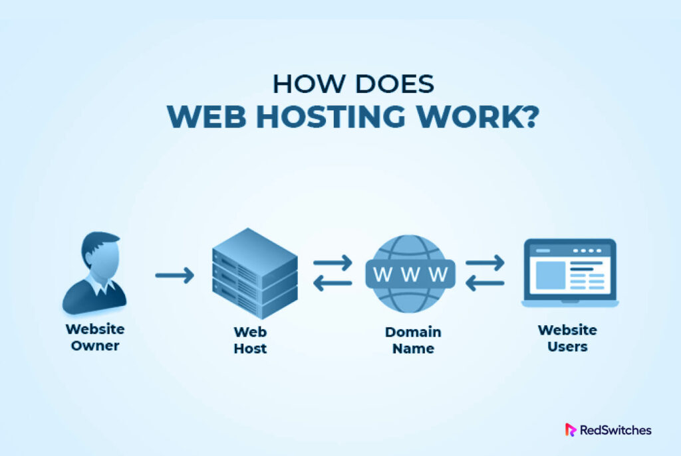

In essence, web hosting provides the storage space (server) and the technical infrastructure (software and network connectivity) to make your website accessible on the internet, allowing visitors to find and interact with your online content.

**Differences between web hosting and a domain name**

While both domain names and web hosting are crucial for your website's online presence, they serve distinct purposes. Think of your website like a house: the domain name is the address that allows people to find you, while web hosting is the land and building itself. You can purchase the address (domain name) from a registrar, and it's yours to renew as long as you pay the fees. Web hosting, on the other hand, is a rented space from a provider, where your website's files (code, images, videos) are stored and made accessible to visitors. In essence, you can have an address (domain name) without a physical house (web hosting), but you can't have a house without an address! Both elements work together to create your online identity.