Task 1 – Design the below like wireframe structure. Use your own creativity.

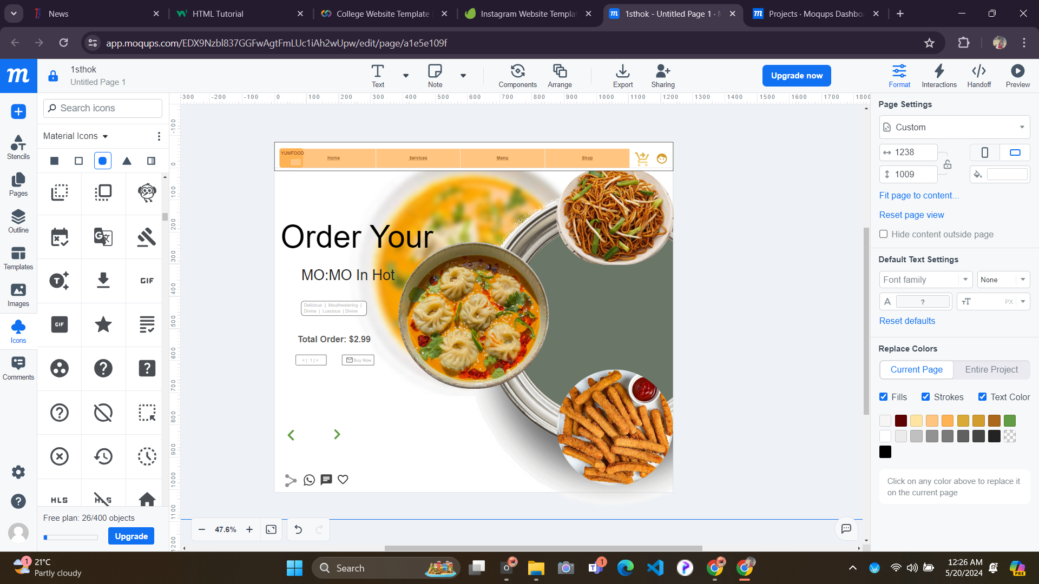

Task 2 – Create a mockup design like your college website’s Contact Us page. Use your own

creativity for this design.

