***INTERNET AND WORLD WIDE WEB***

***Assessment Weightage & Type:***

***60% Portfolio Coursework***

***Year:2024***

* *Student Name:* ***Khushi Kumari***
* *UWE ID:* ***24030167***
* *Module code:* ***UFCFL1-15-0***
* *Level:* ***Level 3)***
* *Faculty:* ***Faculty of Environment & Technology***
* *Department:* ***FET Department of Computer Science & Creative***

***Technology***

**Introduction**

Imagine a library vaster than any building, its shelves overflowing with knowledge on every subject imaginable. This information isn't confined by dusty tomes; it's constantly updated, and readily accessible from the comfort of your couch. This, my friend, is the magic of the internet.

A web of connections, woven from invisible threads of light, pulsates with information, entertainment, and the collective hum of humanity. This global network, a tapestry of millions of computers, transcends geographical borders, allowing instant communication with anyone, anywhere. Gone are the days of waiting for letters to cross oceans – the internet has revolutionized the way we connect.

But the internet's potential extends far beyond communication. It's a treasure trove of information, a gateway to educational resources, and a platform for business and commerce. Whether you seek the latest news, delve into the mysteries of history, or simply download a new song, the internet provides a universe of possibilities at your fingertips.

**How does the Internet work?**

The internet, a vast and interconnected web, functions thanks to a combination of technologies and protocols. Here's a breakdown of how it works:

**The Language of the Web: TCP/IP**

Imagine millions of computers speaking different languages. TCP/IP (Transmission Control Protocol/Internet Protocol) acts as the universal translator, ensuring everyone understands each other. Data is broken down into bite-sized packets, each containing an address (like a digital postal code), allowing them to travel independently across the network.

**Highways of Information: Infrastructure and Routers**

The Internet relies on a complex infrastructure built by telecommunication companies. Long-haul cables and data circuits form the information highways. Internet Service Providers (ISPs) act like tollbooth operators, leasing access and using routers to efficiently direct packets to their destinations.

**Information Powerhouses: Servers**

Think of servers as giant storehouses of information. Businesses and organizations maintain these servers, holding websites, emails, and other digital resources. When you request information, the server packages it into packets and sends them on their journey.

**The Packet Journey: A Dynamic Delivery System**

Unlike a traditional postal system, packets don't necessarily follow a single path. Routers, acting as intelligent traffic controllers, analyze each packet's destination address and choose the most efficient route at that moment. This dynamic system ensures smooth information flow despite heavy traffic.

**Putting the Pieces Together: Reassembly at the Destination**

Once the packets reach their intended recipient (your computer, for example), they're reassembled into the original message, image, or file you requested. Even though they might have taken different routes, the final destination receives the complete information.

**Connecting to the Web: Standalone vs. Networked Computers**

For a standalone computer, a modem translates the digital signal from your computer into a format compatible with the internet's infrastructure (often phone lines or cables). Some setups use a combination of a modem and router, with the router managing network traffic. If you're part of a network, the network's router likely handles the internet connection for all connected devices.

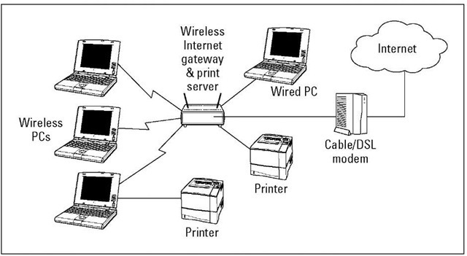

Figure: Connection of Internet with Standalone Computer or Networked Computers

**History of Internet**

* **The Birth of Networking (1970s): ARPANET and the Rise of TCP/IP**

The Internet's story begins with a project by the US Department of Defense called ARPANET. This early network aimed to connect computers across vast distances, ensuring communication even if parts of the network were damaged. A crucial development during this era was the creation of TCP/IP, a set of rules like a common language that allowed different computers to communicate seamlessly.

* **Beyond Research: The 1980s and Early Applications**

The 1980s saw the internet expand beyond research. The National Science Foundation's NSFNET opened the network to universities and research institutions, fostering collaboration across the country. This period also witnessed the rise of popular applications like email, newsgroups, and file transfer, allowing users to share information and connect in new ways.

* **The World Wide Web Revolution (1990s): Tim Berners-Lee and the Mosaic Browser**

The arrival of the World Wide Web (WWW) in the 1990s marked a dramatic shift. Developed by Tim Berners-Lee, the WWW introduced a system of hyperlinked documents, making information easily accessible and interconnected. Mosaic, the first user-friendly web browser created by Marc Andreessen, further revolutionized access. It allowed users to view not just text, but also images and sounds, making the web a truly engaging experience.

* **Conclusion**

From its humble beginnings as a research project, the internet has transformed into a global phenomenon. The collaborative efforts of organizations like ARPA and NSF, along with pioneering individuals like Berners-Lee and Andreessen, have woven a digital tapestry that connects billions of users worldwide. The internet's impact continues to grow, shaping communication, commerce, and every aspect of our lives.

**Uses of Internet**

The Internet has become an indispensable tool for a wide range of activities. Here's a look at some of the most common ways people use the internet:

* **Shopping and Business:**
  + E-commerce: Allows you to buy and sell products online, from books and clothes to electronics and furniture. (e.g., Amazon, eBay)
  + Online payments: Makes it easy to pay for goods and services electronically using credit cards or other online payment methods. (e.g., PayPal)
  + Outsourcing jobs: Businesses can use the internet to find and hire freelancers or agencies for specific tasks. (e.g., Upwork, Fiverr)
* **Communication and Entertainment:**
  + Social networking: Provides platforms to connect with friends, family, and like-minded people online. (e.g., Facebook, Twitter)
  + Video conferencing: Enables real-time communication with others through video and audio calls. (e.g., Zoom, Google Meet)
  + E-telephony: Offers voice and video calling services at a lower cost compared to traditional phone calls. (e.g., Skype)
* **Education and Research:**
  + E-learning courses: Provides online educational programs for various subjects and skill levels. (e.g., Coursera, EdX)
  + Online journals and research information: Offers access to a vast collection of academic articles and research papers.
* **Government Services:**
  + E-governance: Allows citizens to interact with government agencies electronically, such as filing tax returns or applying for permits. (e.g., Many government websites offer online services)
* **Entertainment and Leisure:**
  + Online ticket booking: Makes it convenient to purchase tickets for movies, concerts, flights, and other events. (e.g., Ticketmaster)
  + Accessing music and videos: Provides a platform to stream or download music and videos for entertainment. (e.g., Spotify, YouTube)

**Applications of Internet**

The internet has woven itself into the fabric of nearly every field imaginable. From businesses reaching a global audience to students exploring distant galaxies, its applications are vast and ever-growing. Let's delve into how different sectors leverage the Internet's power:

**Business: A Global Marketplace**

Imagine showcasing your products to millions without leaving your office! The internet makes this a reality. Businesses can create websites, and virtual storefronts teeming with information and products. E-commerce allows seamless online transactions, while email marketing keeps customers informed and engaged. It's a game-changer for businesses of all sizes.

**Education: Learning Without Limits**

The internet has revolutionized education. Students can access a universe of knowledge – from historical archives to interactive simulations. E-learning platforms offer online courses taught by renowned professors, while virtual universities provide flexible learning opportunities for anyone with an internet connection. Gone are the days of limited resources – the internet empowers independent learning and exploration.

**Communication: Connecting Instantly**

The internet has shrunk the world, making communication faster, cheaper, and more personal. E-mail allows sending messages across continents in seconds, while instant messaging lets you have real-time conversations. Video conferencing bridges geographical divides, allowing face-to-face meetings without the travel hassle. No matter the distance, the internet keeps us connected.

**Entertainment: A World of Fun at Your Fingertips**

The internet is a treasure trove of entertainment. Dive into a captivating novel, lose yourself in a thrilling game, or stream your favorite movie – all from the comfort of your couch. Music lovers can explore genres from around the world, while social media platforms connect you with friends and share life's moments. The internet caters to every taste, offering endless ways to unwind and have fun.

**Government: Transparency and Efficiency**

The internet has transformed governance. Many government agencies now have websites providing information on services, regulations, and policies, fostering transparency with citizens. E-governance initiatives allow for online applications, and streamlining processes like tax filing or passport renewals. This not only saves time for citizens but also improves government efficiency.

**The Future is Connected**

The internet's potential continues to blossom. As technology advances, we can expect even more innovative applications across all sectors. The internet is not just a tool; it's a driving force, shaping the way we work, learn, communicate, and entertain ourselves. It's a connected world, and the internet is the invisible thread tying it all together.

## **The Internet Architecture: A Decentralized Dance of**

## **Information**

The internet, a marvel of modern technology, isn't governed by a single, central authority. Instead, it thrives on a collaborative spirit, a web of interconnected networks functioning as a harmonious (well, mostly harmonious) whole. This intricate dance of data allows information to flow freely, even if one strand falters.

Imagine a vast labyrinth, not built of stone, but of information pathways. At the entry point stands your computer, eager to explore the vast digital realm. Here, local ISPs act as your initial guides, connecting you to the broader network. These could be familiar names like Nepal Telecommunication (NTC) or Broad-link, the friendly faces that usher you into the labyrinth.

As you delve deeper, regional ISPs emerge, like seasoned explorers leading the way. They utilize sophisticated tools called routers, capable of deciphering the language of different pathways and ensuring your data reaches its intended destination. These routers act as the language translators of the internet, ensuring smooth communication across diverse networks.

At the heart of this labyrinth lies the backbone, the information superhighways maintained by giants like AT&T. These high-speed arteries carry the lifeblood of the internet – data – across vast distances. Think of them as the express lanes of the information superhighway.

But what happens if a section of the labyrinth crumbles? The beauty of the internet's architecture lies in its inherent resilience. Network Access Points (NAPs) function as crucial intersections, allowing data to seamlessly switch between backbones. If a single path is blocked, your information can reroute, finding alternative pathways to reach its target.

This decentralized design is the very foundation of the internet's strength. It fosters innovation, adaptability, and a level of fault tolerance that ensures information keeps flowing, even in the face of challenges. The internet architecture is not merely a technical marvel; it's a testament to the power of collaboration and the elegance of distributed systems.

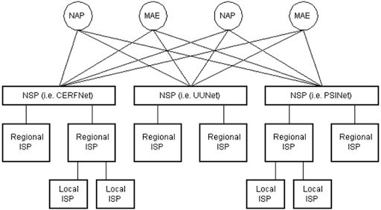

Figure: Internet Hierarchy

**Who Runs the Show? A Look at Internet Governance**

The internet isn't a Wild West – it's surprisingly well-coordinated! While there's no single ruler, several key organizations work together to keep things running smoothly. Let's meet some of these important players:

* **Internet Society (ISOC) & Internet Architecture Board (IAB):** Think of them as the information hubs, providing resources and promoting open standards for the Internet's technical foundation.
* **Internet Engineering Task Force (IETF):** This is where the magic happens! A global community of engineers and researchers brainstorm and develop the technical rules (protocols) that make the Internet work seamlessly.
* **Internet Engineering Steering Group (IESG):** They act as quality control, reviewing the proposals from the IETF to ensure they meet the internet's needs.
* **Internet Research Task Force (IRTF):** These forward-thinkers focus on long-term research, exploring ways to improve the internet's future.
* **Internet Assigned Numbers Authority (IANA):** Imagine them as the address book for the internet. They assign unique online addresses (IP addresses) to devices and websites, ensuring everyone has their place on the digital map.
* **World Wide Web Consortium (W3C):** They're the architects of the web, developing the technologies that make browsing the internet user-friendly. They're responsible for things like web page formatting and security.

These organizations work collaboratively to maintain a stable and innovative internet for everyone.

**Plugging into the Web: Your Essentials for an Internet Connection**

The internet, a vast ocean of information, is at your fingertips – but how do you dive in? Here's what you'll need to set sail on your web adventures:

* **Your PC:** You'll need a computer equipped with TCP/IP, a language that allows devices to communicate on the internet. Think of it as a universal translator for the digital world.
* **Navigation Tools (Software):** To explore the web's hidden treasures, you'll need software like a web browser. This acts as your map and compass, guiding you to websites and helping you interact with them.
* **Charting the Course (ISP Account):** An Internet Service Provider (ISP) is your guide on the information superhighway. They provide the connection between your computer and the broader internet. Think of them as the charting company that provides the maps and coordinates for internet navigation.
* **Setting Sail (Connection Line):** To establish a physical connection to your ISP, you'll need a dedicated line. This could be a telephone line, a coaxial cable, or a fiber optic connection. Imagine it as the actual cable or pathway that connects your computer to the vast internet infrastructure.
* **The Bridge (Modem/Network Interface Card):** This hardware acts as the bridge between your computer and the connection line. A modem translates the digital signals from your computer into a format that can travel through the cable and vice versa. A Network Interface Card (NIC) allows your computer to communicate directly with the network. Think of them as the translator between your computer's language and the language spoken on the internet cables.

With these essentials in place, you'll be well on your way to exploring the wonders of the internet.

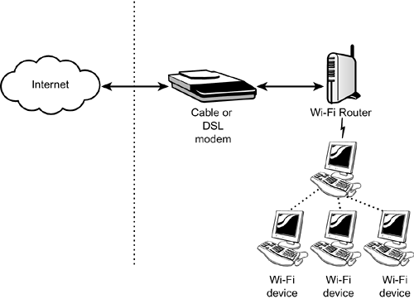

Figure: Connecting to the Internet

**Email: Your Digital Mailbox**

In today's digital age, email has become the go-to method for sending and receiving messages. It's like having a personal mailbox right on your computer or phone, offering several advantages over traditional mail:

* **Blast it Out:** Unlike snail mail, you can send an email to one person or a whole group at once. Perfect for sharing updates or announcements with a large audience.
* **Location Freedom:** No more waiting for the mailman! You can access your email from anywhere with an internet connection – your phone, your laptop, or even a public computer.
* **Speedy Delivery:** Gone are the days of waiting for days or weeks. Emails zip through the internet at lightning speed, delivering messages almost instantly.
* **24/7 Convenience:** Feeling inspired at 3 am? No problem! You can send emails anytime, day or night.
* **Record Keeper:** A copy of your sent emails is conveniently stored on your computer for future reference. No more digging through piles of paper!
* **Attachment Advantage:** Need to share a document, photo, or other file? Email lets you attach them to your message, sending them along in a digital breeze.
* **Familiar Features:** Email borrows the best aspects of traditional mail. You address your message to the recipient, compose your content, and hit send. The recipient can then read, forward, reply, store, or delete the email, just like with physical mail.

However, keep in mind that email can't deliver physical objects like a birthday card or a package. But for sending quick messages, documents, and information, email remains an unbeatable communication tool.

﻿**Your Unique Email Address: The Key to Your Digital Mailbox**

An email address is like your personal identification for the electronic mail world. It allows you to send and receive messages from anyone else with an email address, anywhere on the globe.

Here's how it works:

* **Two Parts, One Address:** An email address is made up of two parts separated by the "@" symbol (pronounced "at").
  + **Username:** This is the first part, chosen by you (or assigned by your email service provider). It's like your unique nickname in the email world. In the example, shrestha@gmail.com, "shrestha" is the username.
  + **Domain Name:** This is the second part, following the "@". It identifies the email service provider you use, like Gmail, Yahoo Mail, or Outlook.com. Think of it as the location of your digital mailbox. In the example, "gmail.com" is the domain name.

**Putting it Together:**

Imagine sending a physical letter. The recipient's address has two parts: their name (like "Shrestha") and their physical address (like "123 Main Street"). Similarly, your email address combines your username with your email service provider's domain name, creating a unique identifier for your digital mailbox.

**So, how does it work?**

When you send an email, you address it to the recipient's email address. The email travels through the internet and is delivered to the recipient's email service provider (like Gmail for "shrestha@gmail.com"). The email provider then stores the message in the recipient's mailbox, ready for them to access.

With your email address, you can start sending and receiving messages electronically, enjoying the speed and convenience of email communication.

## **Crafting Your Email: A Breakdown of the Format**

An email message, much like a traditional letter, has a specific structure to ensure clear communication. Here's a breakdown of the key parts:

* **The Header: Your Email's Information Panel**
  + **From:** This identifies the sender's email address, letting the recipient know who the message is coming from.
  + **To:** Here, you specify the email address of the primary recipient (or recipients, if sending to a group).
  + **Date:** This automatically shows the date and time the email was sent.
  + **Subject:** This is your email's headline, offering a summary of the message's content. A clear and informative subject line entices recipients to open your email.
  + **Cc (Carbon Copy):** Want to keep someone else informed? Use Cc to send a copy of the email to additional recipients. These recipients will see all the email addresses included in the "To" and "Cc" fields.
  + **Bcc (Blind Carbon Copy):** Need to send a copy to someone without revealing it to other recipients? Use Bcc! Recipients in the "To" and "Cc" fields won't see email addresses listed in the Bcc section.
* **The Body: Where Your Message Takes Shape**
  + This is the heart of your email, where you compose your message. Here, you can type your text, including greetings, the main content of your email, and a closing. You can also attach files like documents, photos, or presentations.

## **Choosing Your Email Platform: Application-Based vs. Web-Based**

The world of email offers two main choices for accessing and managing your messages: application-based email and web-based email. Let's explore the differences to help you pick the right platform for your needs.

**1. Application-Based Email (Like Microsoft Outlook):**

* **Installation:** This software is downloaded and installed on your personal computer.
* **Storage:** Emails are stored directly on your computer's hard drive.
* **Benefits:**
  + **Offline Access:** You can access and manage emails even without an internet connection (once downloaded).
  + **Customization:** Offers greater flexibility in customizing email appearance and functionalities.
  + **Security:** Some users prefer having their email data stored locally on their computer.
* **Drawbacks:**
  + **Limited Accessibility:** Emails are only accessible from the computer where the software is installed.
  + **Maintenance:** Requires software updates and potential troubleshooting for smooth operation.

**2. Web-Based Email (Like Gmail, Yahoo Mail):**

* **Accessibility:** Accessed through a web browser window, allowing you to check and manage emails from any device with an internet connection.
* **Storage:** Emails are stored on the email service provider's servers (e.g., Gmail servers).
* **Benefits:**
  + **Convenience:** Access your email from anywhere, anytime, with any internet-connected device.
  + **Automatic Updates:** No need to worry about software updates – the service provider takes care of them.
  + **Large Storage Capacity:** Webmail services typically offer much larger storage quotas compared to a personal computer's hard drive.
* **Drawbacks:**
  + **Offline Access:** Requires an internet connection to access emails.
  + **Security:** Some users are concerned about email data being stored on a third-party server.

Ultimately, the best choice depends on your needs. If you prioritize offline access and customization, application-based email might be a good fit. But for convenience, accessibility, and ample storage, web-based email is a strong contender.

**Email: A Behind-the-Scenes Adventure**

Ever hit "send" on an email and wondered how it magically appears in someone else's inbox? It's not magic, but a well-coordinated effort between two essential teams:

* **Your Email Client:** This is your familiar interface, like Outlook or Gmail, where you compose messages, manage contacts, and view received emails.
* **Email Servers:** These are powerful computers run by email service providers like Gmail or Yahoo Mail. Think of them as giant post offices, storing your emails, managing user accounts, and ensuring smooth delivery.

**The Teamwork:**

These two players work together using special languages to send and receive emails:

* **SMTP (Simple Mail Transfer Protocol):** Imagine it as the mail truck. SMTP carries your email from your email client (the sender) to the email server. It also acts as a relay service, passing emails between different servers on their journey to the recipient.
* **POP3 (Post Office Protocol 3) or IMAP (Internet Message Access Protocol):** These are like your mailbox access methods. POP3, used by email applications like Outlook, downloads emails to your device for offline access. IMAP, on the other hand, is ideal for webmail like Gmail. It lets you view and manage emails directly on the server, like visiting your mailbox online.

**The Delivery Journey:**

1. **Hitting Send:** When you click "send," your email client connects to the email server using a specific port (like a designated lane).
2. **The Email Voyage:** The email server, acting as the mail carrier, checks the recipient's address. If they're on the same server, the email gets delivered locally. Otherwise, it's relayed to another server closer to the recipient, continuing its journey until it reaches the destination server.
3. **Checking Your Mailbox:** When you check your email, your client connects to the server again. POP3 downloads the emails for you to read offline, while IMAP lets you browse them directly on the server.

**The Choice:**

POP3 is good if you prefer having emails stored on your device. IMAP is more flexible for webmail users who access emails from anywhere.

This collaboration between email clients and servers ensures your messages travel seamlessly across the internet, connecting you with the world. So, the next time you hit "send," remember the teamwork happening behind the scenes.

**Types of Email**

1.Webmail

2.Client mail

## **Webmail vs. Client Email: Picking Your Perfect Platform**

In the fast-paced world of communication, choosing the right email platform can significantly impact your workflow. Here's a breakdown of webmail and client email, along with the champion for specific needs:

* **Webmail:** The King of Convenience
  + **Ideal for:** Users who prioritize accessibility and ease of use. Perfect for busy professionals who need to access emails from anywhere, on any device, with an internet connection. Webmail also eliminates data loss worries as emails are securely stored on the provider's servers.
* **Client Email:** The Powerhouse for Control
  + **Ideal for:** Users who require advanced features and offline access. Client email programs offer extensive customization options and the ability to work with emails even without an internet connection (once downloaded). However, managing backups might be an additional responsibility.

**So, which is better?**

It depends on your priorities:

* **For on-the-go accessibility, ease of use, and automatic backups, webmail reigns supreme.**
* **For power users who need advanced features, offline access, and control over backups, client email takes the crown.**

**ISP and its Functions**

ISP, also called Internet access provider or IAP is a company that offers its customers access to the Internet. ISP connects to its customers using a data transmission technology appropriate for delivering Internet Protocol datagrams, such as dial-up, DSL, cable modem, or dedicated high-speed interconnects.

ISPs may provide Internet e-mail accounts to users, allowing them to communicate by sending and receiving electronic messages through their ISPs' servers. ISPs may provide other services such as remotely storing data files on their customers' behalf and other services unique to each particular ISP.

There are three kinds of services ISPs can provide. One is a shell account. This account is entirely text-based. This account is also becoming obsolete due to the fact that it is primitive and provides no security to its remote computers. Another is the ISP connection account. This account provides the user with a temporary IP address and has a full internet connection with the ISP. This account supplies the user with an ISP-supplied program in his client machine which is a commonly used access server provided by our ISPs. The third is a server-specific account. communicates with a personalized access server program via a serial line. The only advantage this account ensures over the ISP connection is that the IP address is standard every time the user accesses the internet.

**Domain Name and Domain Name Server**

Imagine the internet as a giant city, and every computer a unique building. Domain names are like user-friendly street addresses that help us find these online locations. Here's how it works:

* **Difficult Addresses:** Each computer on the internet has a unique numerical address called an IP address. But memorizing a string of numbers is no fun!
* **Enter the Domain Name:** Domain names act as friendly alternatives to IP addresses. They're easy-to-remember words or phrases, like "google.com" or "facebook.com".
* **Two Parts, One Address:** A domain name typically has two parts separated by a dot (.). The first part identifies the specific website (e.g., "Google" or "Facebook"). The second part is the Top-Level Domain (TLD), which indicates the website's category (e.g., ".com" for commercial, ".org" for non-profit).
* **The Translation Layer: DNS Servers** So, how do we access a website using its domain name? This is where Domain Name System (DNS) servers come in. They act like giant phone books for the internet, translating human-readable domain names into the numerical IP addresses that computers understand.
* **Behind the Scenes:** When you type a domain name into your web browser, your computer contacts a DNS server. The DNS server then looks up the domain name in its database and retrieves the corresponding IP address. With this IP address in hand, your computer can connect to the website's server and display the web page.
* **Types of Top-Level Domains (TLDs):** There are various TLDs that categorize websites. Some common ones include:
  + **.com:** Commercial organizations (e.g., businesses)
  + **.edu:** Educational institutions (e.g., schools, universities)
  + **.gov:** Government institutions
  + **.org:** Non-profit organizations
  + **.net:** Networking organizations

With domain names and DNS working together, navigating the internet becomes a breeze! You can simply remember a website's name and let the DNS servers handle the complex address translation behind the scenes.

**Internet Address**

An internet address, also known as a Uniform Resource Locator (URL), is a unique identifier used to locate resources on the internet. It's like a specific address that tells your web browser exactly where to go to find a particular website, file, image, or other online resource.

Here's how an internet address is typically structured:

* **Protocol:** This specifies the way information is transmitted. The most common protocol for web pages is **HTTP** (Hypertext Transfer Protocol), so a typical internet address will start with "http://" or the more secure version "https://".
* **Domain Name:** This is the user-friendly part of the address, like "google.com" or "wikipedia.org". It's easier to remember than a long string of numbers.
* **Subdomain (Optional):** Some websites have subdomains before the main domain name, like "mail.google.com" for accessing Gmail within Google's website.
* **Path (Optional):** This specifies the specific location of a file or resource within a website. For example, "<https://www.wikipedia.org/wiki/Internet>" leads to the Wikipedia page specifically about the internet.

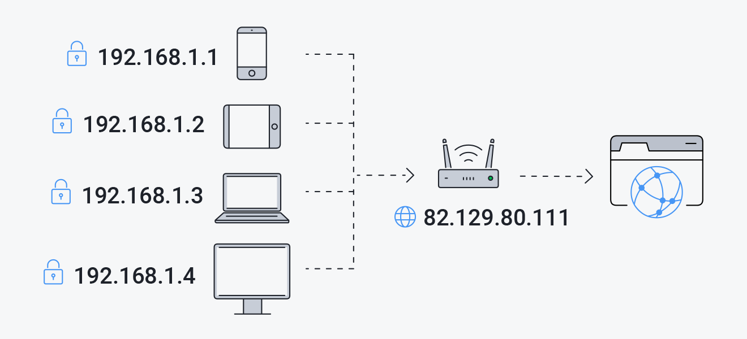

**IPv4 and IPv6**

IPv4 and IPv6 are the languages spoken by devices to find each other on the internet, kind of like IP addresses being their unique identification codes. Here's a super quick breakdown:

* **IPv4:** The OG (Original Gangster) of internet addresses. It uses 32 bits (like a 32-digit code) to identify devices, but it's running out of space!
* **IPv6:** The new sheriff in town. It uses 128 bits (way more digits!), offering a practically endless supply of addresses for all the new devices joining the internet party.

Think of it like a crowded apartment building. IPv4 is like having limited apartment numbers, while IPv6 allows for way more unique addresses for every tenant (device) in the building (internet).

**­**

**Hypertext Transfer Protocol (HTTP)**

Hypertext Transfer Protocol, or HTTP for short, is the language spoken between web browsers and servers when you visit a website. It's the rulebook that governs how information gets requested, delivered, and displayed on your screen. Here's a quick breakdown:

* **Think Conversation:** Imagine you asking a librarian for a book. HTTP acts like the conversation between you and the librarian.
* **Request and Response:** When you type a website address (URL) in your browser, it sends an HTTP request to the web server. The server then responds with the requested information (like the website's code and content) using HTTP.
* **Types of Requests:** There are different types of HTTP requests, like GET (to retrieve information) and POST (to submit data like filling a form).
* **Delivery Details:** HTTP doesn't just send the information in a big chunk. It specifies the format of the data (like HTML for webpages or images) and ensures it reaches your browser correctly.
* **Evolution:** HTTP has evolved over time. The most common version today is HTTP/1.1, but newer versions like HTTP/2 and HTTP/3 are being adopted for faster and more efficient communication.

**Analogy:** Think of a restaurant menu. The menu (website) is stored on the server (kitchen). When you order a dish (make an HTTP request), the waiter (HTTP) delivers the dish (website content) to your table (web browser).

In essence, HTTP is the invisible conversation that allows web browsers to retrieve and display information from web servers, making the web browsing experience possible.

**HTTP vs HTTPS: Safe Surfing Showdown**

Imagine you're sending a message. Would you write it on a postcard for everyone to see, or seal it in an envelope for only the recipient? That's the difference between HTTP and HTTPS!

* **HTTP:** The postcard. Quick and easy for basic browsing, but anyone can peek at the information you send or receive, like login details or messages. Not ideal for sensitive stuff!
* **HTTPS:** The secure envelope. It uses a special lock (SSL certificate) to scramble the data, making it unreadable to anyone trying to snoop. Perfect for online banking, shopping, or anywhere you enter passwords or personal information.

**We can spot the difference by:**

* **HTTP:** Look for "http://" at the start of the web address. No padlock symbol in your browser bar either.
* **HTTPS:** See "https://" and a reassuring padlock symbol. You're good to go!

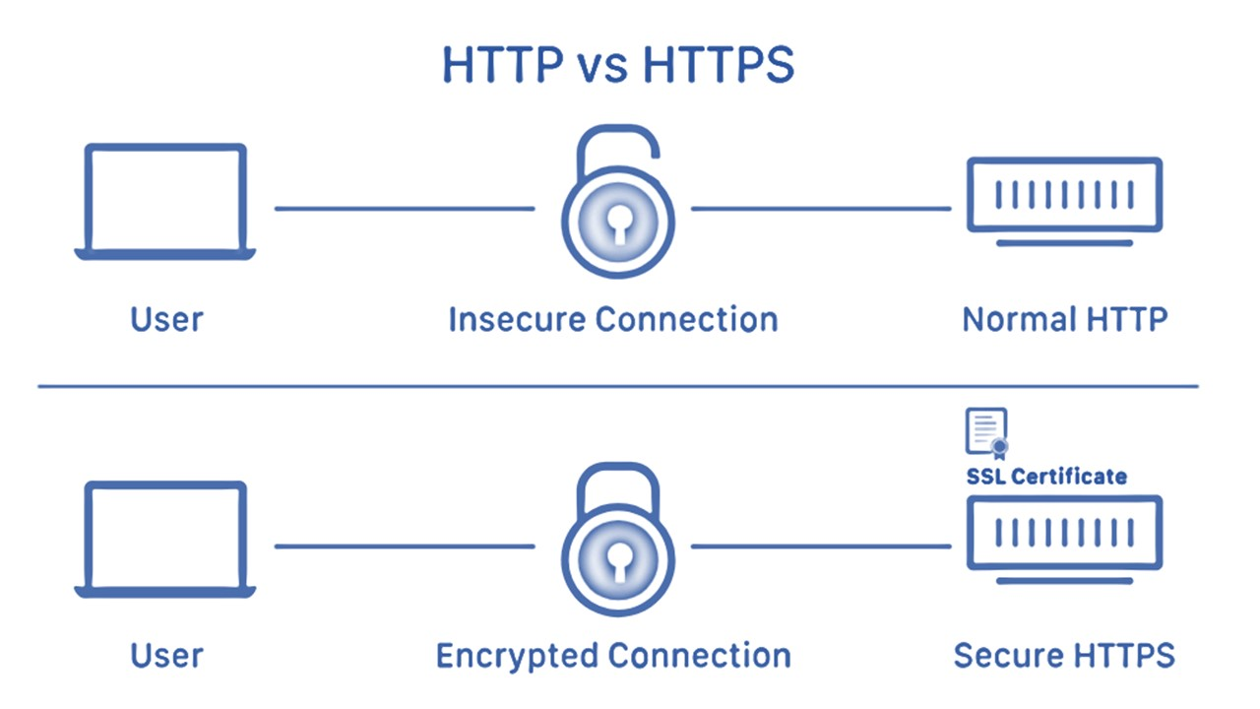

Figure: HTTP vs HTTPS

**File Transfer Protocol**

FTP, or File Transfer Protocol, is the unsung hero of the internet world. It's a set of rules that lets you securely move files between computers on a network.

Think of it as a dedicated delivery service for your digital documents. You can use FTP to upload files (send them) to a remote location or download files (receive them) from a server.

While cloud storage services offer a more user-friendly approach, FTP remains a powerful tool for:

* **Website Management:** Web developers use FTP to upload website files like code and images to web servers.
* **File Sharing:** Large files can be easily shared between individuals or businesses using FTP.
* **Backup and Storage:** Some users might utilize FTP servers for secure backup and storage of their data.

While its inner workings might be technical, FTP's role in transferring files efficiently remains crucial for many tasks online.

**How FTP works?**

• **Initiation:** You start by launching an FTP client program on your computer. This acts like your personal file transfer assistant.

• **Connection Establishment:** The client program connects to an FTP server, which is like a central storage location for the files you want to transfer.

• **Login Credentials:** To access the server, you'll need to provide login credentials (username and password), similar to entering a secure building.

• **File Navigation:** Once logged in, you can browse the server's file directory using your FTP client, just like exploring folders on your own computer.

• **Transferring Files:** Here's the magic! You select the files you want to upload (send) to the server or download (receive) from the server. The FTP protocol handles the data transfer process efficiently.

• **Closing the Connection:** When you're finished, you can disconnect from the server, like ending your visit to the secure storage location.

While convenient, traditional FTP relies on username and password for login, which can be a concern for sensitive data. However, secure versions like FTPS and SFTP address this by encrypting the entire communication between your computer and the server, adding an extra layer of protection.

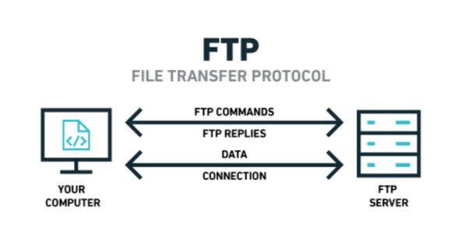

Figure:FTP

**Simple Mail Transfer Protocol (SMTP)**

The Simple Mail Transfer Protocol (SMTP) is a fundamental application layer protocol defined in RFC 5321 (successor to RFC 821) that governs the transmission of electronic mail (email) messages between Mail Transfer Agents (MTAs) on the internet. Here's a breakdown of its key functionalities:

**Core Function:**

* SMTP establishes a communication channel between sending and receiving MTAs, enabling the reliable and controlled transfer of email messages.

**Client-Server Model:**

* An email client program on your device acts as the User Agent (UA) and initiates communication with the sending MTA, typically located on your email provider's server.
* The sending MTA then uses SMTP to connect to the receiving MTA responsible for the recipient's email address domain.

**Message Transfer Process:**

1. **Session Initiation:** The sending MTA establishes a TCP connection (port 587) with the receiving MTA.
2. **Authentication (Optional):** Modern MTAs may require authentication (username and password) for the sending MTA to ensure authorized use.
3. **Message Transmission:** The sending MTA transmits the email message, including headers (sender, recipient, subject, etc.) and the message body, in a specific format defined by SMTP.
4. **Relaying and Delivery:** The receiving MTA may act as the final destination or relay the message to another MTA closer to the recipient's domain.
5. **Confirmation and Error Handling:** SMTP provides mechanisms for confirmation messages upon successful delivery and error messages if delivery fails (e.g., invalid address, full mailbox).
6. **Session Termination:** The connection between the MTAs is closed after the message exchange is complete.

**Security Considerations:**

While SMTP itself doesn't encrypt messages, secure versions like SMTPS (port 465) and STARTTLS provide encryption for improved security during email transmission.

**Importance of SMTP:**

SMTP is the backbone of email communication and is crucial for the reliable exchange of emails across the internet, regardless of the email provider used by the sender and recipient.

**Post Office Protocol (POP)**

The Post Office Protocol (POP) is a retrieval protocol defined in RFC 1939 that governs the download of electronic mail messages from a remote mail server to a local User Agent (UA), typically an email client program on a device. Here's a breakdown of its key functionalities:

POP establishes a connection between a UA and a Mail Transfer Agent (MTA) on the mail server, enabling the retrieval of email messages stored on the server.

**Limited Scope:**

Unlike protocols like IMAP, POP focuses solely on downloading email messages. It doesn't provide functionalities for managing emails on the server, such as deleting, organizing, or marking messages as read.

**Versions and Security:**

* **POP3 (Post Office Protocol Version 3):** The most widely used version, POP3 retrieves emails and typically leaves them on the server by default. However, users can configure deletion upon download, requiring caution to avoid permanent message loss.
* **POP2 (Post Office Protocol Version 2):** An older and less secure version, rarely used in contemporary email systems due to security vulnerabilities.

**Comparison and Usage:**

* POP is a good choice for users who prefer to download and store emails locally on their devices and don't need multi-device access.
* However, for users who require features like server-side management, synchronization across devices, and more granular control over emails, a protocol like IMAP (Internet Message Access Protocol) offers a more comprehensive and flexible solution.

**Terminal Network (Telnet)**

A terminal network refers to a system of interconnected devices that function as dedicated access points for users to interact with computers or networks. It enables user interaction with computers or networks via a dedicated pathway for sending commands and receiving information, often in a text-based format.

**Components:**

* **Access Points:** These can be either:

**Physical Terminals:** Dedicated keyboard and monitor devices used in legacy computer systems.

**Virtual Terminals:** Text-based command-line interfaces accessible within web browsers in modern cloud environments or developer tools.

**Applications:**

* System administration tasks
* Cloud-based development using virtual terminals
* Specialized tasks in data analysis or network troubleshooting

**Beyond TELNET:**

While historically associated with the TELNET protocol for remote terminal access, the concept of terminal networks encompasses a broader range of technologies and applications.

**Internet Message Access Protocol**

**IMAP, or Internet Message Access Protocol**, is a standard communication protocol (defined in RFC 5321) that governs how email clients access, manage, and manipulate email messages stored on a remote mail server. In simpler terms, it's a set of rules that lets your email program interact with your email on the server, unlike POP which just downloads them.

IMAP (Internet Message Access Protocol) is a game-changer for email management. Unlike POP (download-only), IMAP lets you be the boss of your inbox, even across multiple devices.

* **Server-Side Management:** Access, organize, and delete emails directly on the server, not just your device.
* **Multi-Device Nirvana:** Check your email on your phone, laptop, or tablet - IMAP keeps everything in sync.
* **Granular Control:** Download only specific parts of emails (like attachments) to save space and bandwidth.

## **Intranet and Extranet**

**Introduction:**

Effective communication and collaboration are crucial aspects of any organization's success. In the digital age, secure internal networks play a vital role in facilitating these processes. This explanation explores the concepts of intranet and extranet, highlighting their key differences, advantages, and disadvantages.

**Intranet:**

An intranet is a private network specifically designed for use within an organization. It functions as a secure and controlled digital environment, connecting employees, resources, and applications. Often referred to as a company's internal internet, an intranet offers a centralized platform for:

* **Communication and Collaboration:** Employees can share information, documents, and ideas, fostering teamwork and knowledge sharing across departments.
* **Resource Access:** Secured access to company-related documents, policies, and essential tools enhances productivity and streamlines workflows.
* **Information Sharing:** Intranets can serve as central repositories for company news, announcements, and important updates, ensuring all employees are informed.

**Advantages of an Intranet:**

* **Enhanced Communication:** Improved information flow within the organization leads to better collaboration and decision-making.
* **Increased Productivity:** Streamlined access to resources and tools empowers employees to work more efficiently.
* **Knowledge Management:** Centralized repositories facilitate knowledge sharing and foster a culture of continuous learning.
* **Improved Employee Engagement:** Intranets can be used to promote company culture, recognize achievements, and boost employee morale.

**Disadvantages of an Intranet:**

* **Limited Accessibility:** By design, intranets are restricted to internal users, hindering collaboration with external partners.
* **Implementation Costs:** Setting up and maintaining an intranet infrastructure requires initial investment and ongoing technical support.
* **Information Silos:** Intranets can inadvertently create silos of information if not properly managed, hindering collaboration across departments.

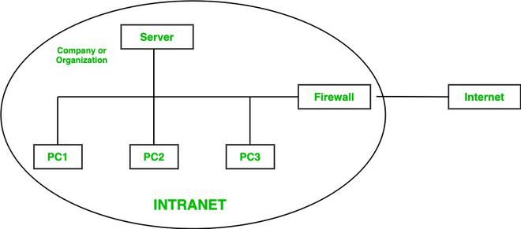

**Extranet:**

An extranet can be considered an extension of an organization's internal network (intranet) that provides controlled access to specific information and resources for authorized external users. Think of it as a secure bridge between an organization and its external partners, such as vendors, customers, or collaborators.

**Advantages of an Extranet:**

* **Streamlined Collaboration:** Enables secure and efficient collaboration with external partners on projects, documents, and workflows.
* **Improved Communication:** Provides a central platform for communication exchange with external parties, enhancing transparency and relationship management.
* **Enhanced Business Processes:** Streamlines information sharing and processes with external partners, leading to increased efficiency and cost savings.

**Disadvantages of an Extranet:**

* **Security Concerns:** Managing access control for external users necessitates stricter security measures compared to a traditional intranet.
* **Complexity of Management:** Assigning and managing user permissions for external users can be a complex task requiring ongoing attention.
* **Potential Security Risks:** If not properly secured and managed, extranets can introduce potential security vulnerabilities

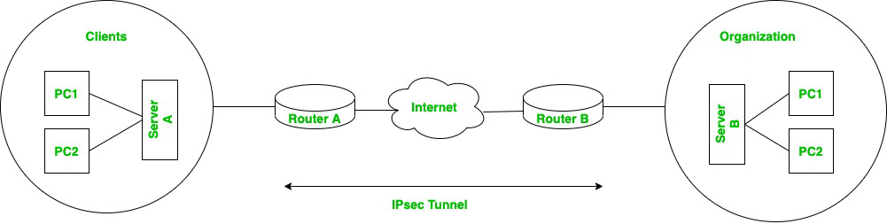

NOTE:

Intranet: Think company's internal office - Employees only, all resources, fosters internal culture and communication.

Extranet: Imagine a secure meeting room within - Access for authorized outsiders (partners, vendors) to specific information and project collaboration.

Both are private networks, but the intranet is for internal users and the extranet is for controlled access by external parties.

**World Wide Web**

**The World Wide Web (WWW), commonly shortened to WWW or simply the Web, is a revolutionary information retrieval system that has transformed how we access and interact with information on the internet.**

**Core Functionalities:**

* **Interconnected Documents:** The Web functions as a massive network of interconnected documents, or webpages, stored on servers around the globe.
* **Hypertext Navigation:** Hyperlinks embedded within these webpages act as digital pathways, allowing users to seamlessly navigate from one webpage to another, establishing a user-friendly exploration experience.
* **Web Browsers as Gateways:** Specialized software programs called web browsers serve as the primary tools for accessing the Web. These browsers translate underlying code into a visual and interactive interface, enabling users to interact with the information presented.
* **Beyond Text:** The Web extends beyond static text, encompassing multimedia elements like images, videos, and audio, enriching the user experience and offering a more engaging way to consume information.

**How does WWW work?**

The World Wide Web (WWW) operates through a client-server model and leverages specific technologies to deliver webpages to your device.

**Client-Server Model:**

* **Client (You and Your Browser):** You initiate the process by entering a website address (URL) into your web browser (e.g., Chrome, Firefox). The browser acts as your representative, communicating with the server on your behalf.
* **Server (Website Host):** Powerful computers called servers store webpages and associated resources. When your browser initiates a request, the server locates the requested information.

**Communication and Transformation:**

* **Hypertext Transfer Protocol (HTTP):** This specialized language governs how requests and responses are formatted and exchanged between your browser and the server.
* **Domain Name System (DNS):** Think of it as the internet's phonebook. It translates human-readable website addresses (URLs) into numerical IP addresses that computers can understand. This allows the browser to identify the specific server hosting the website.
* **Hypertext Markup Language (HTML):** This code structures and defines the content of a webpage. It tells the server how to format the information (text, images, links, etc.) for transmission.

**Delivering the Webpage:**

1. You enter a URL in your browser.
2. The browser translates the URL into an IP address using DNS.
3. The browser initiates an HTTP request to the server at the identified IP address.
4. The server locates the requested webpage and translates it from HTML into a format your browser can understand and display.
5. The server sends the formatted webpage back to your browser.
6. Your browser receives and interprets the information, rendering the webpage on your screen for you to interact with.

In essence, the WWW functions as a collaborative effort. Your browser acts as the client, initiating requests and receiving information. Servers store and deliver webpages, while protocols like HTTP and DNS facilitate communication and translation. HTML provides the structure for the webpage content.

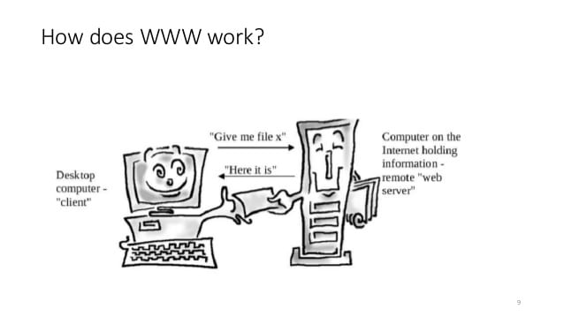

**URL**

A URL, which stands for Uniform Resource Locator, is the address of a specific resource on the internet. It's like a unique identification tag that tells your web browser exactly where to find a webpage, image, video, or any other online resource.

1. **Protocol:** This indicates the communication method used to access the resource. The most common protocol for webpages is **HTTP** (Hypertext Transfer Protocol), though you might also see **HTTPS** (which adds a layer of security).
2. **Domain Name:** This is the user-friendly name you type into your browser, like "[invalid URL removed]" or "wikipedia.org". It represents the website that hosts the resource.
3. **Subdomain (Optional):** Some websites use subdomains to further categorize content. For example, "mail.google.com" is a subdomain of "[invalid URL removed]" that specifically leads to the Gmail service.
4. **Path (Optional):** This specifies the location of a specific file or resource within the website's directory structure. For example, in "www.wikipedia.org/wiki/Cat", "wiki/Cat" is the path leading to the Wikipedia article about cats.
5. **Query String (Optional):** This part of the URL comes after a question mark (?) and is used to send specific information to a webpage, often for search queries or filtering results. For instance, "[invalid URL removed]" specifies a search for "books" on Amazon.

**URL Protocol**

URL protocols include HTTP (Hypertext Transfer Protocol) and HTTPS (HTTP Secure) for web resources, mail to for email addresses, FTP for files on a File Transfer Protocol (FTP) server, and telnet for a session to access remote computers.

**URI**

A Uniform Resource Identifier (URI) is a formal way of describing an address for a resource, like a webpage, image, video, or even an abstract concept. It acts like a unique label that distinguishes one resource from another, similar to a name tag.It includes key parts like:

* **Identification, not Location:** URIs focus on uniquely identifying a resource, not necessarily where it's located on the internet.
* **Beyond the Web:** While commonly used for web resources, URIs can theoretically identify any kind of resource, even abstract ideas.
* **Structured Format:** URIs follow a specific structure, often consisting of a scheme name (like "HTTP" for webpages) and a path that specifies the location within that scheme.

# **URI vs URL**

URI is like a **name tag** for any resource (webpage, image, etc.) while a URL is a specific URI that adds the **location** on the web (like a web address).

**WEBSITE**

A website, often referred to as a "web presence" or simply a "site," is a collection of interconnected web pages that share a single domain name. These web pages are publicly accessible, meaning anyone with an internet connection can potentially visit and interact with the information they contain.

Websites can be created and maintained by individuals, groups, businesses, or organizations for a diverse range of purposes. These purposes can encompass:

* **Information Dissemination:** Sharing knowledge, news, or educational content.
* **Service Provision:** Offering online services like banking, shopping, or social media interaction.
* **Branding and Marketing:** Establishing an online presence to promote a brand or organization.
* **Entertainment and Leisure:** Providing interactive experiences, games, or multimedia content.

**Types of Websites:**

There are two primary categories of websites, each catering to specific needs:

* **Static Websites:**
  + Simpler websites offering a fixed and unchanging user experience.
  + The content displayed on each webpage remains constant, akin to an online brochure.
  + Static websites are typically built using HTML, CSS, and JavaScript, with the content pre-defined within the code. This makes them easier to create and maintain.
* **Dynamic Websites:**
  + Dynamic websites offer a more interactive and adaptable user experience.
  + The content presented on these websites can change based on user input (like search queries) or data stored in a database (like product information in an online store).
  + Server-side scripting languages like PHP or Python and database management systems (DBMS) often power dynamic websites. This allows for features like user logins, personalized content recommendations, and e-commerce functionality. However, they require more complex development and maintenance.

**Web Browser**

A web server acts like a behind-the-scenes translator and delivery person for websites. Here's a breakdown:

* **Hardware & Software:** It's a combination of powerful computers and specialized programs.
* **The HTTP Whisperer:** Web servers speak a language called HTTP (Hypertext Transfer Protocol) to understand requests from your web browser (the client).
* **Content Delivery Hero:** When your browser asks for a website, the web server finds the requested webpage, translates it into a format your device can understand (like pictures and text), and delivers it to your browser.
* **More Than Webpages:** While web servers specialize in websites, they can also handle emails using SMTP and file transfers using FTP.

In essence, a web server is the middleman that ensures you see the website content you request from your browser.

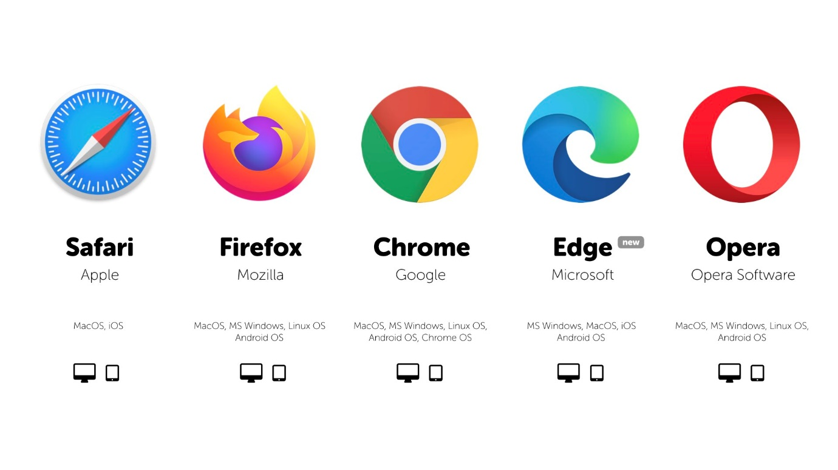

**Web Server**

A web server is a combination of hardware and software that works behind the scenes to deliver websites to your device. It acts as the middleman between your web browser (the customer) and the website (the restaurant).

**Here's how it works:**

1. **You request a website:** You type a web address (URL) into your web browser, like <https://www.google.com/>.
2. **The browser talks to the server:** Your browser uses a special language called HTTP (Hypertext Transfer Protocol) to send a request to the web server associated with the URL.
3. **The server finds the files:** The web server receives the request, locates the relevant website files (like HTML pages, images, etc.), and translates them into a format your device can understand.
4. **Delivery time!** The server sends the formatted webpage information back to your browser.
5. **You see the website:** Your browser interprets the information and displays the website on your screen, allowing you to see the content and interact with it.

**Different types of web servers include:**

* 1. Apache web server
  2. IIS web server
  3. Proxy Server

**Web site, Web Server, and Web Browser**

• The website is the content you see.

• The web server stores and delivers that content.

• The web browser is your tool to access and interact with the content.