Q8-homework excuses
Prompt used –
write a code in c++ which takes student name input and uses that name in a template which already has 10-15 stored excuses of why someone has not done homework and outputs it , it should be random selection , if no name entered theen display no name enetered and dont proceed

correct output working-
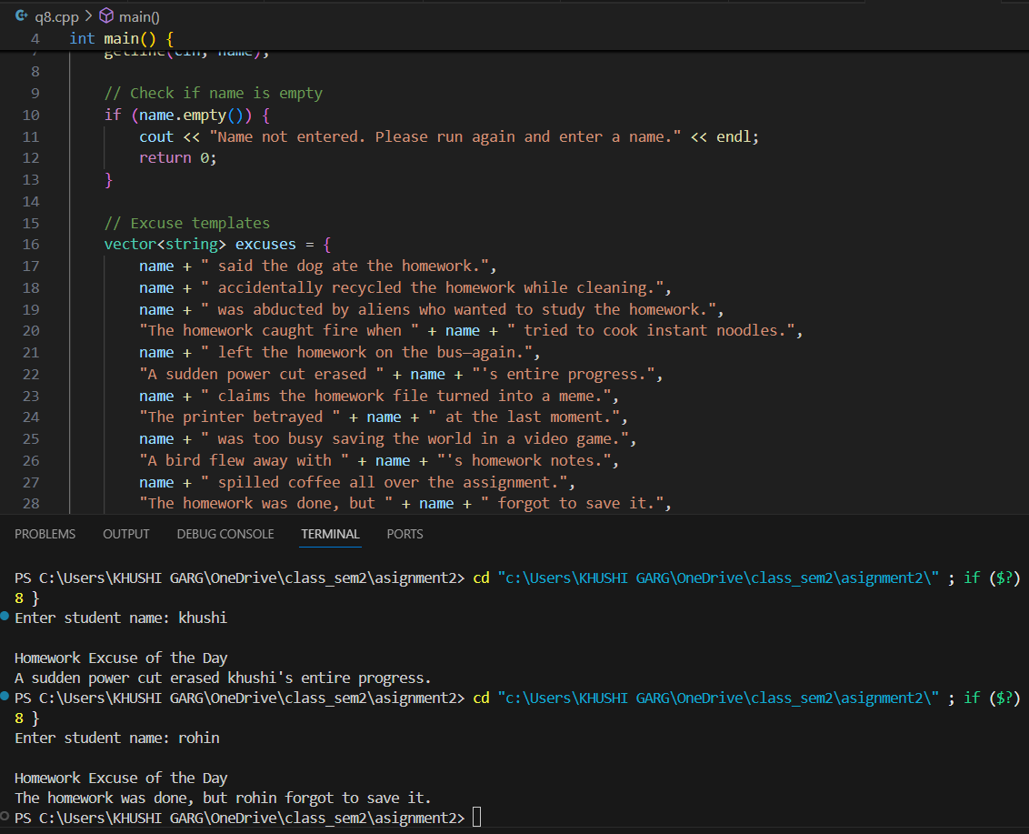
No bugs in the question
.

