Q7- AI roaster prompt –
1)write a code in c++ which takes a "your name" input from user and choses any one roast statement from existing teemplate and puts user name in it and displays output

2)improving code functioning -
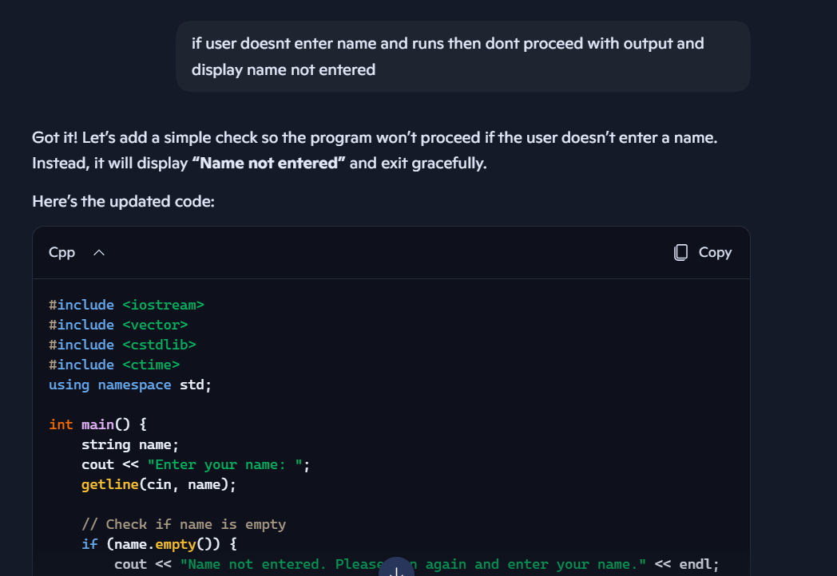

3) error with output fixed by using “/” before ‘ .
Error code -
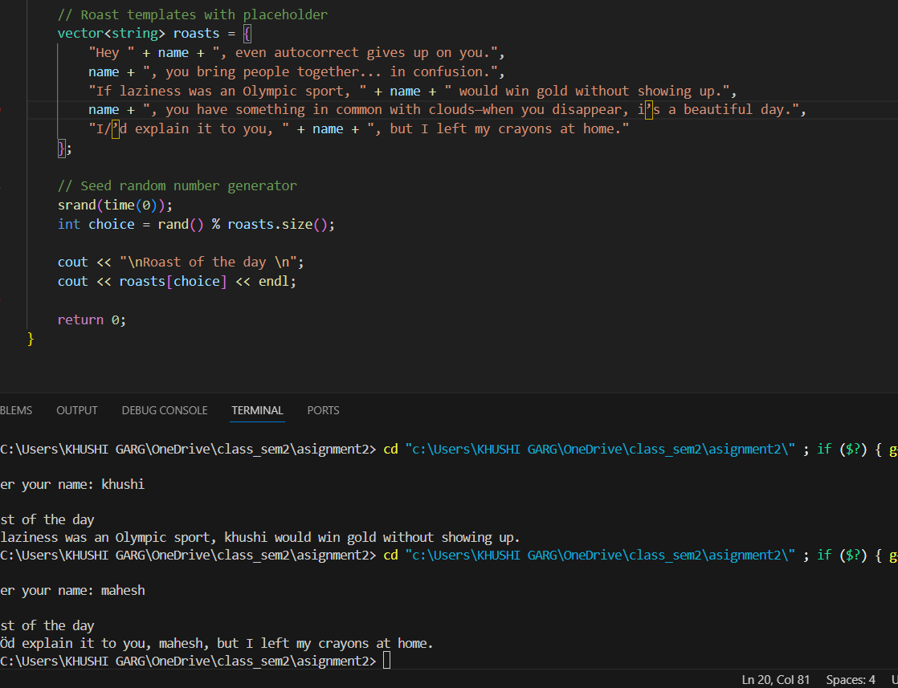

Correct code with output
