Follow this video for complete installation and setup
https://youtu.be/1ySM0dmm_uw
0 Update and Upgrade Woo Choice Plugin
Woo Choice Plugin Update and Upgrade Instruction

1 Upload Or Upgrade Extension files using respective FTP

1.1 “master_QCed_bhavesh_1” branch should be uploaded

1.2 New upload ke update karta hoie tyare .git folders upload nahi karvana

1.3 .gitignore file pan upload nahikarvani

1.4 React related koi pan folder hoy asset ke assets to e upload nathi karvanu

1.5 Upload sp_slick_ring_size extension and activate it from admin panel
- “master_QCed_bhavesh_1” branch should be uploaded

2. Follow the Git Submodule document
2.1 This extension has the below submodule dependency
- sp_ssm_themes
- “master_QCed_bhavesh_1” branch should be uploaded
- Sp_ssm_variations
- “master_QCed_bhavesh” branch should be uploaded

3. In the Admin panel, Go to Plugins

3.1 Find the uploaded or upgraded plugin by its name from the plugins list and ensure it is activated if it is newly uploaded or upgraded.

3.2 Click on the Admin Panel of the Find My Ring Size extension
3.2.1 In General Tab
Select Template - Slick Template
Ring's category - Setting
Ring Size Attribute - Size
Button Display Position - Above add to cart button
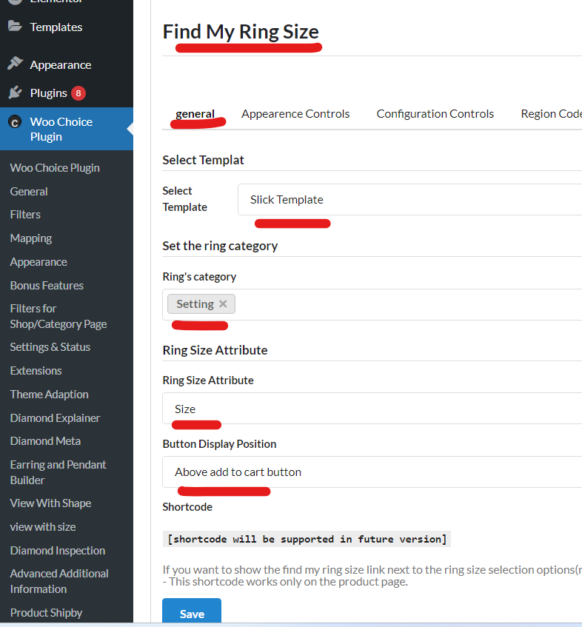
Note: Test properly for activated and setup plugin on the preview page of a ring or any other builder page respectively on the selected category.

How to configure_add custom ring size.docx

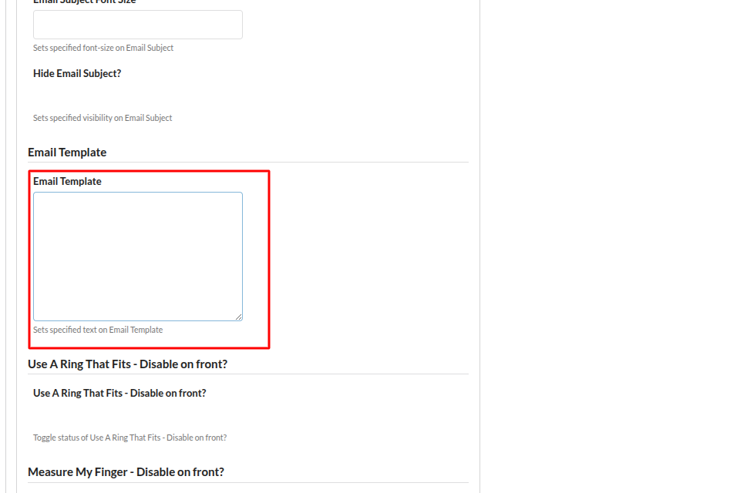

Hello Admin,{nl}{nl}I would like to request a free ring sizer at below address.{nl}{nl}Name: {ring_sizer_fname} {ring_sizer_lname} {nl}Email: {ring_sizer_email} {nl}Phone Number: {ring_sizer_phone} {nl}Gender: {ring_sizer_gender} {nl}Country: {ring_sizer_country} {nl}Address Line 1: {ring_sizer_address_line_1} {nl}Address Line 2: {ring_sizer_address_line_2} {nl}City: {ring_sizer_address_city} {nl}Zip Code: {ring_sizer_address_zip} {nl}State: {ring_sizer_address_state} {nl}Accepted Offer: {ring_sizer_accept_offer} {nl}{nl}Thanks.

