0 Update and Upgrade Woo Choice Plugin
Woo Choice Plugin Update and Upgrade Instruction

1 Upload Or Upgrade Extension files using respective FTP

1.1 “master_QCed_bhavesh_1” branch should be uploaded

1.2 New upload ke update karta hoie tyare .git folders upload nahi karvana

1.3 .gitignore file pan upload nahikarvani

1.4 React related koi pan folder hoy asset ke assets to e upload nathi karvanu

2. Follow the Git Submodule document
2.1 This extension has the below submodule dependency
- Sp_ssm_themes
- “master_QCed_bhavesh_1” branch should be uploaded
- Sp_ssm_variations
  - “master_QCed_bhavesh” branch should be uploaded

3. In the Admin panel, Go to Plugins

3.1 Find the uploaded or upgraded plugin by its name from the plugins list and ensure it is activated if it is newly uploaded or upgraded.

3.2 Click on the Admin Panel of the Product Shipby extension
3.2.1 In Product Shipby Tab
Select Display position(Below add to cart button) and Template(Slick) respectively in the
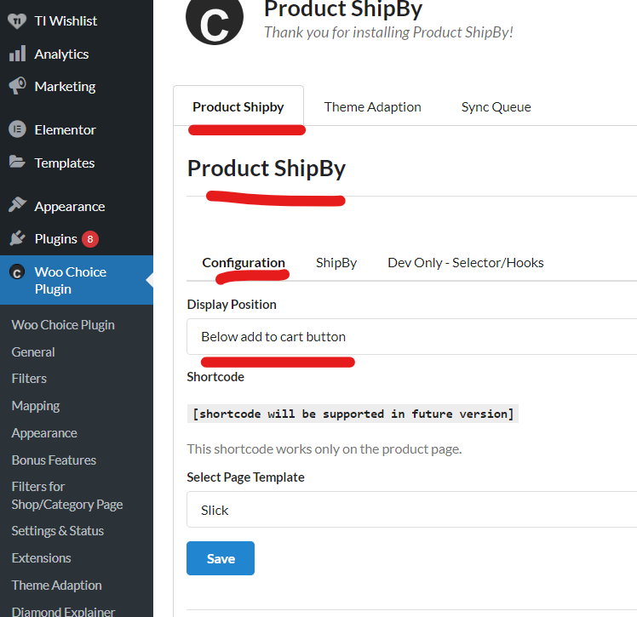Ship by tab
Select the shipping day type as the default
Select the Shipping date as the current date
Select Product category as Diamond and Setting respectively
Save the title as “SHIPS BY: {shipby}”
Save the description as “This diamond will be shipped by {shipby} if you order it max by tomorrow 6:00 AM.”
Select both entries and activate it
Note: Test properly for activated and setup plugins on the preview page of a ring or any other builder page respectively
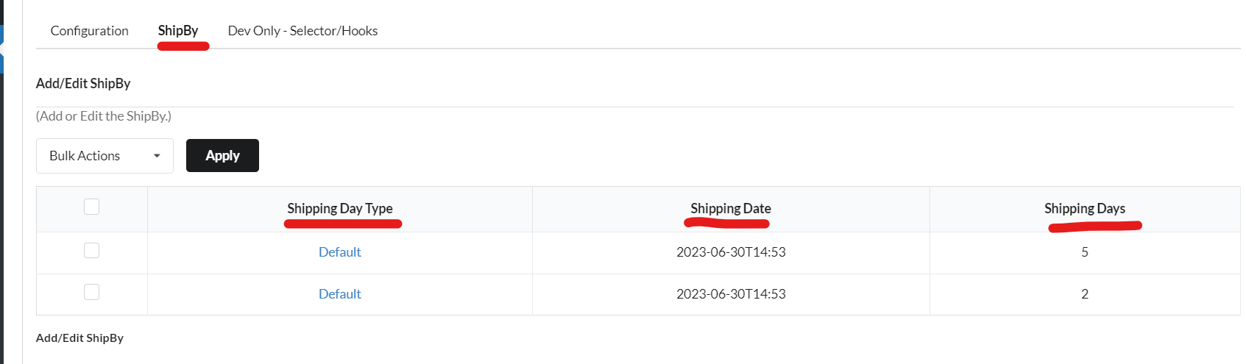

Note: Test properly for activated and setup plugin on the preview page of a ring or any other builder page respectively on the selected category.

User Documentations

Ship by on product page

