0 Update and Upgrade Woo Choice Plugin
Woo Choice Plugin Update and Upgrade Instruction

1 Upload Or Upgrade Extension files using respective FTP

1.1 “master_QCed_bhavesh” branch should be uploaded

1.2 New upload ke update karta hoie tyare .git folders upload nahi karvana

1.3 .gitignore file pan upload nahikarvani

1.4 React related koi pan folder hoy asset ke assets to e upload nathi karvanu

2. Follow the Git Submodule document
2.1 This extension has the below submodule dependency
- Sp_ssm_variations
- “master_QCed_bhavesh” branch should be uploaded

3. In the Admin panel, Go to Plugins

3.1 Find the uploaded or upgraded plugin by its name from the plugins list and ensure it is activated if it is newly uploaded or upgraded.

3.2 Click on the Admin Panel of the Metal Color Images

- On the configuration tab Select Default style Configure Color Images Extension tab
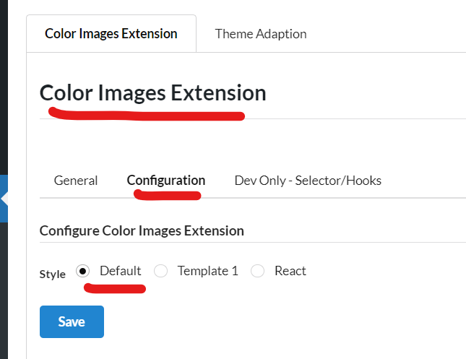

4. Go to Products -> Attributes
4.1 Find Metal Attribute and Edit it
4.2 Change the type to Metal Color Pro and Save the metal attribute
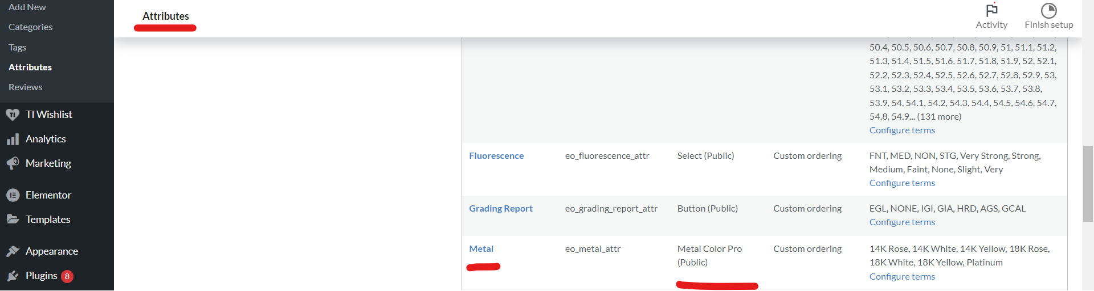
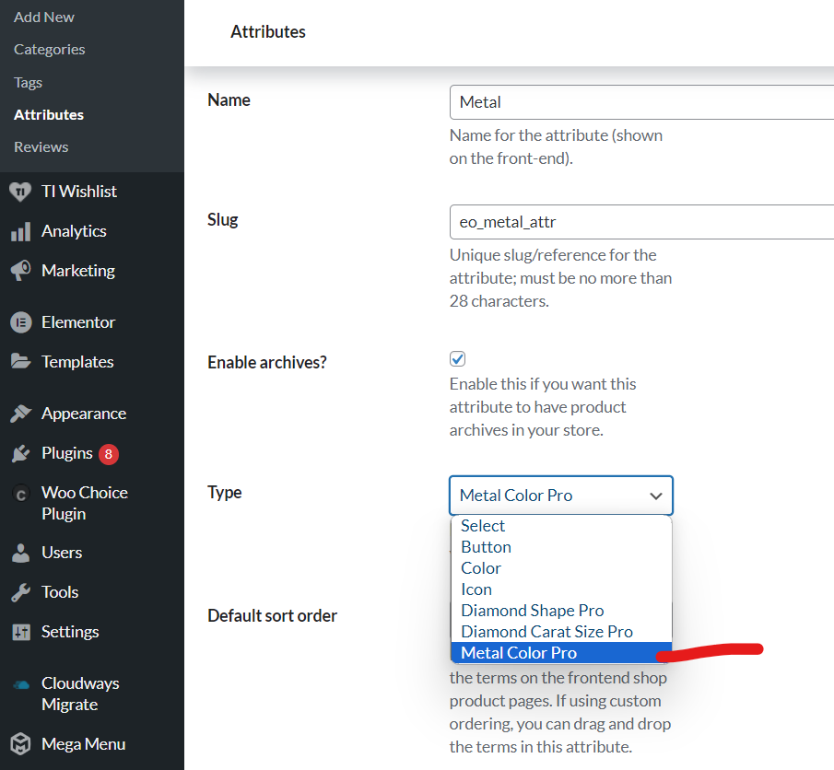

Note: Test properly for activated and setup plugin on the Loop box page of a ring or any Ring item page or category pages respectively

