0 Update and Upgrade Woo Choice Plugin
Woo Choice Plugin Update and Upgrade Instruction

1 Upload Or Upgrade Extension files using respective FTP

1.1 “master_QCed_ashish_1” branch should be uploaded

1.2 New upload ke update karta hoy tyare .git folders upload nahi karvana

1.3 .gitignore file pan upload nahi karvani

1.4 React related koi pan folder hoy asset ke assets to e upload nathi karvanu

2. Follow the Git Submodule document
2.1 This extension has the below submodule dependency
- Sp_ssm_variations
- “master_QCed_bhavesh” branch should be uploaded

3. In the Admin panel, Go to Plugins

3.1 Find the uploaded or upgraded plugin by its name from the plugins list and ensure it is activated if it is newly uploaded or upgraded.

3.2 Click on the Admin Panel of the Product 360 gallery

- On the configuration, tab Select Default template on Select Template field and set the configuration as per shown below screenshots

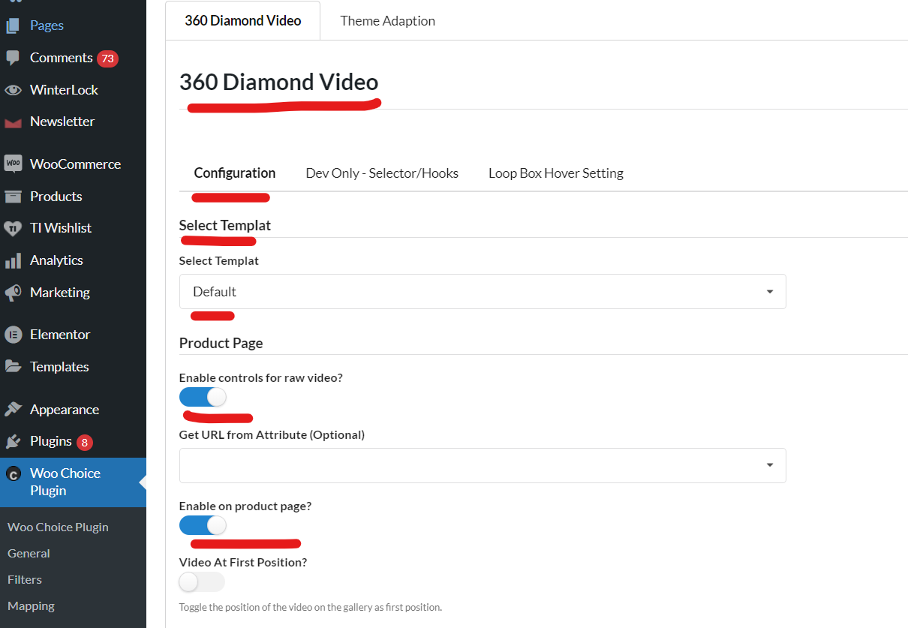
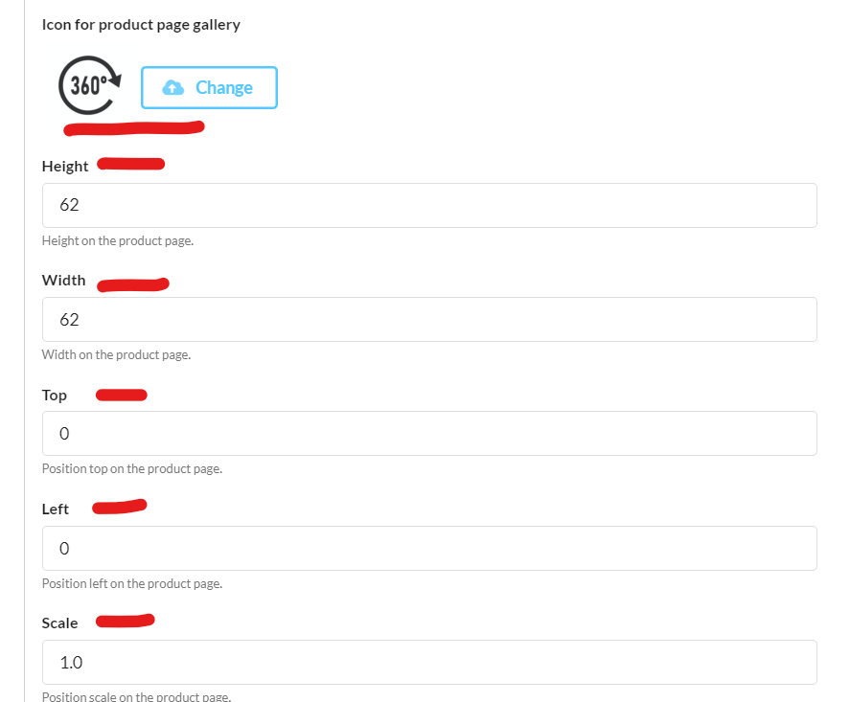
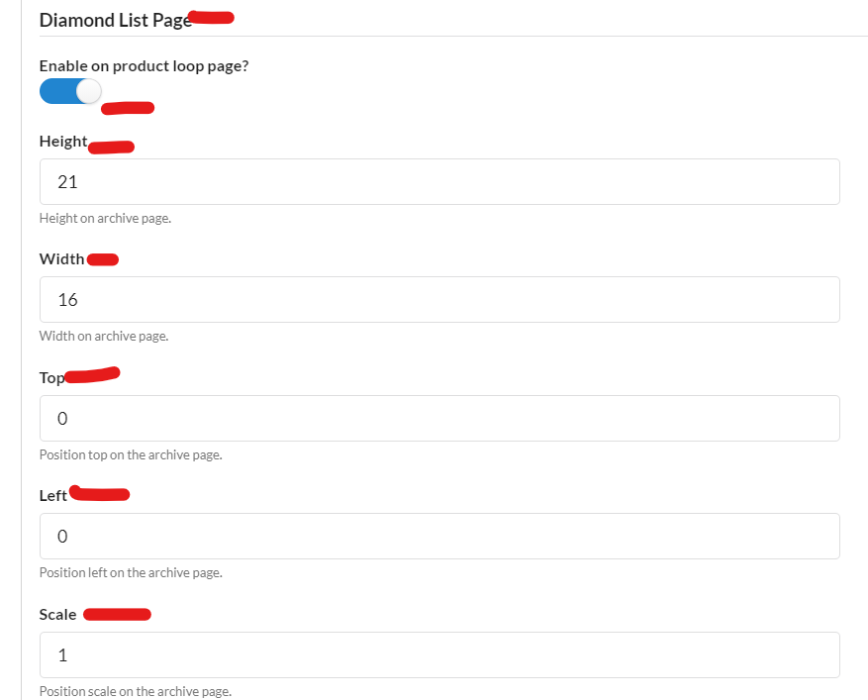
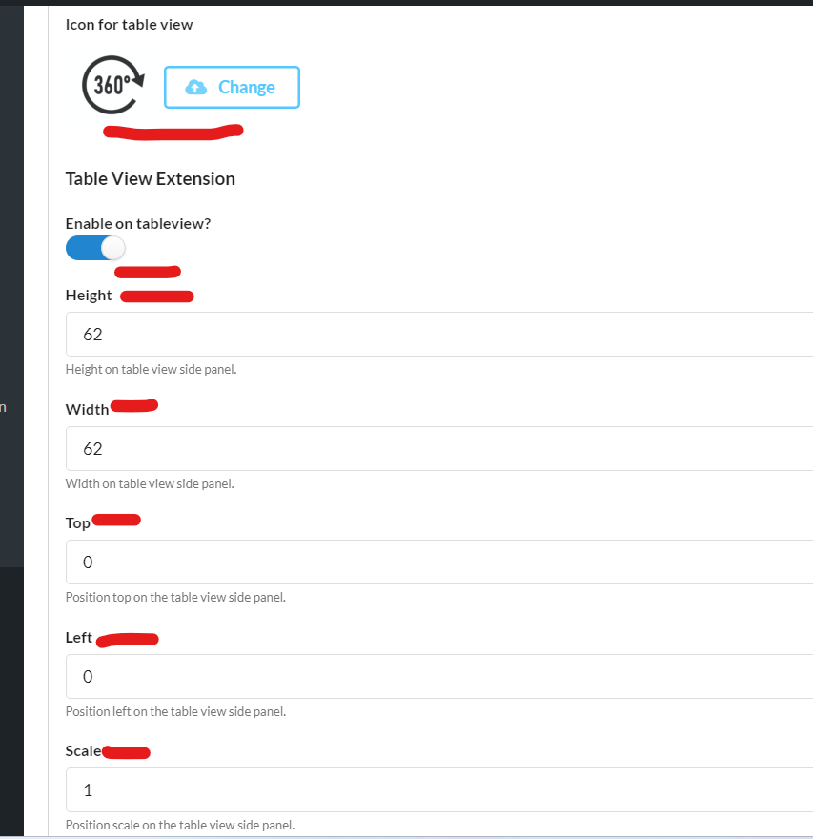
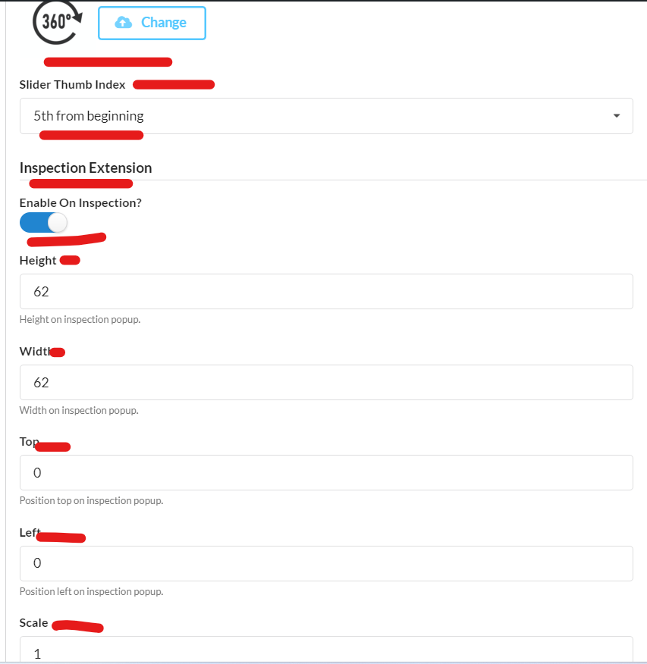
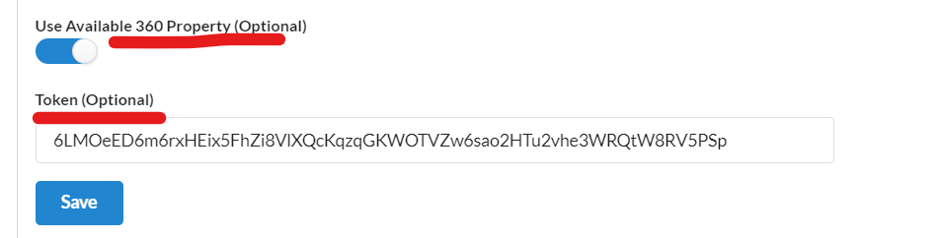
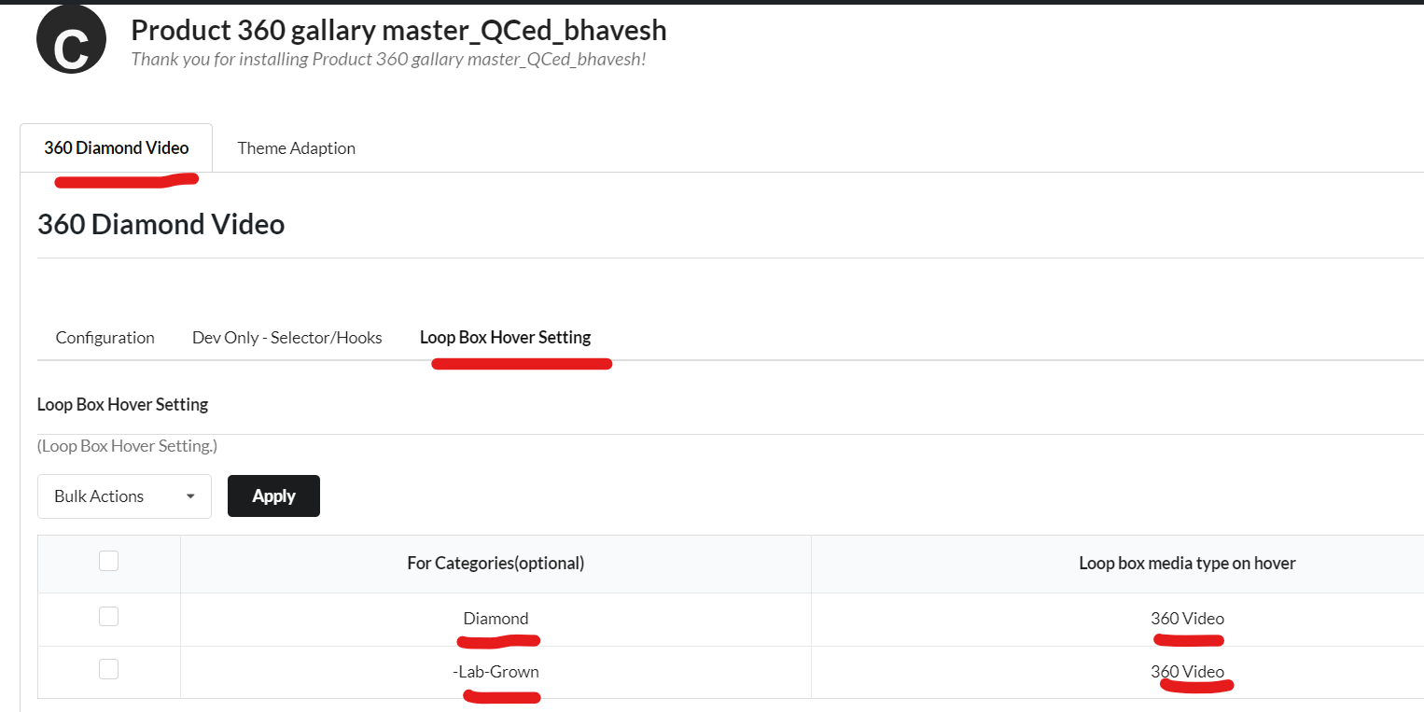

- Now go to Woo Choice Plugin
  - Bonus features tab
    - Product page
      - For the video icon on the product page
    - Archive/Shop
      - For the hover effect on the loop box
        - Image/Video/360 video
- 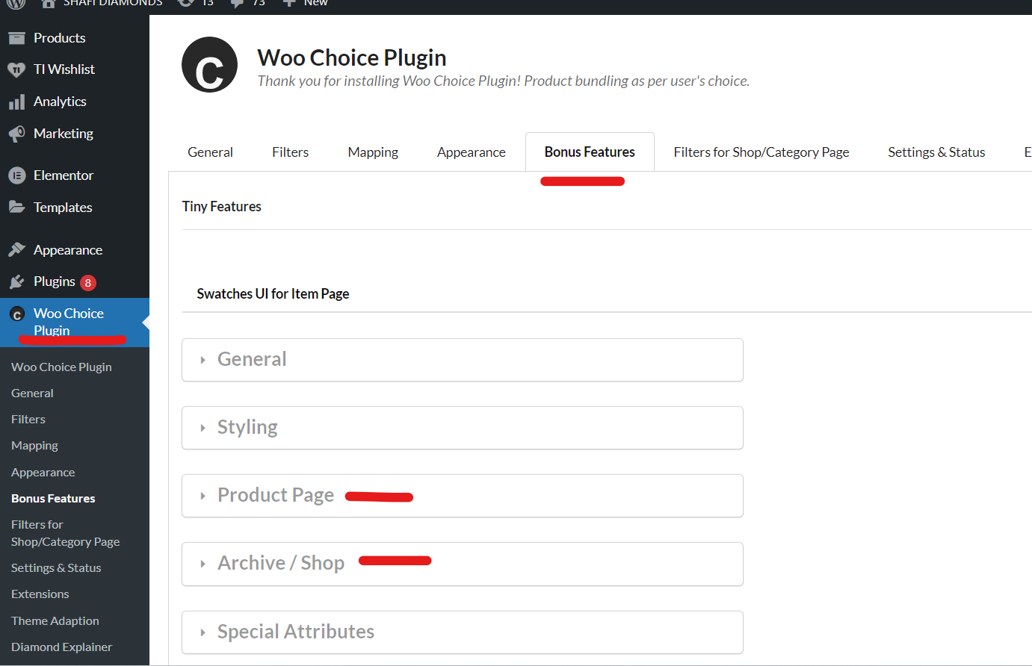
- 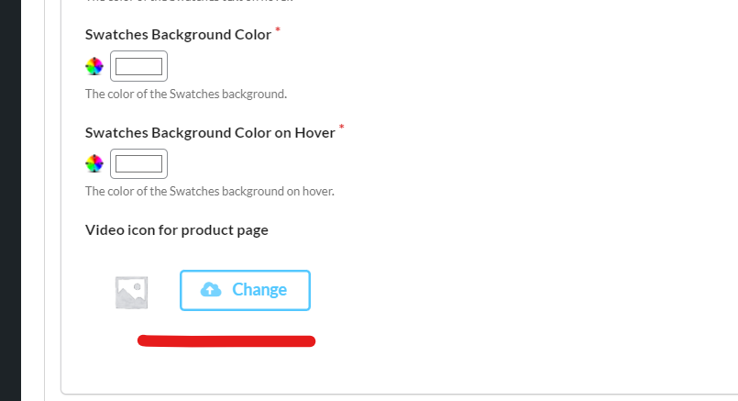
- 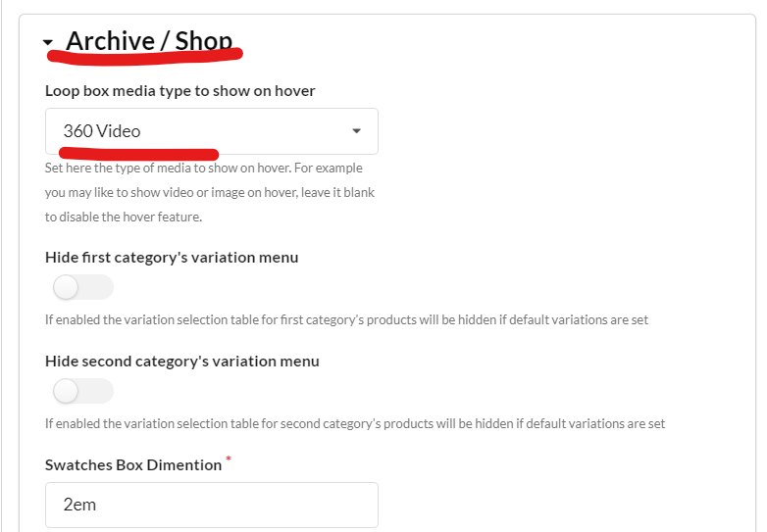

Note: Test properly for activated and set-up plugin on the Loop box page of a ring or any Ring/diamond item page, table view popup, loop box, inspection popup, and category pages respectively for video.

