0 Update and Upgrade Woo Choice Plugin
Woo Choice Plugin Update and Upgrade Instruction

1 Upload Or Upgrade Extension files using respective FTP

1.1 “master_QCed_bhavesh_1” branch should be uploaded

1.2 New upload ke update karta hoy tyare .git folders upload nahi karvana

1.3 .gitignore file pan upload nahi karvani

1.4 React related koi pan folder hoy asset ke assets to e upload nathi karvanu

1.5 Upload sp_slick_request_diamond extension and activate it from admin panel
- “master_QCed_bhavesh_2” branch should be uploaded

2. Follow the Git Submodule document
2.1 This extension has the below submodule dependency
- Sp_ssm_Themes
- “master_QCed_bhavesh_1” branch should be uploaded

3. In the Admin panel, Go to Plugins

3.1 Find the uploaded or upgraded plugin by its name from the plugins list and ensure it is activated if it is newly uploaded or upgraded.

3.2 Click on the Admin Panel of the Request a diamond extension
3.2.1 Alternate Filter Widget
- If there is no purple theme then you need to select template 2 and for the purple theme you need to select
Note :- This slick template shows only Purple Theme active.
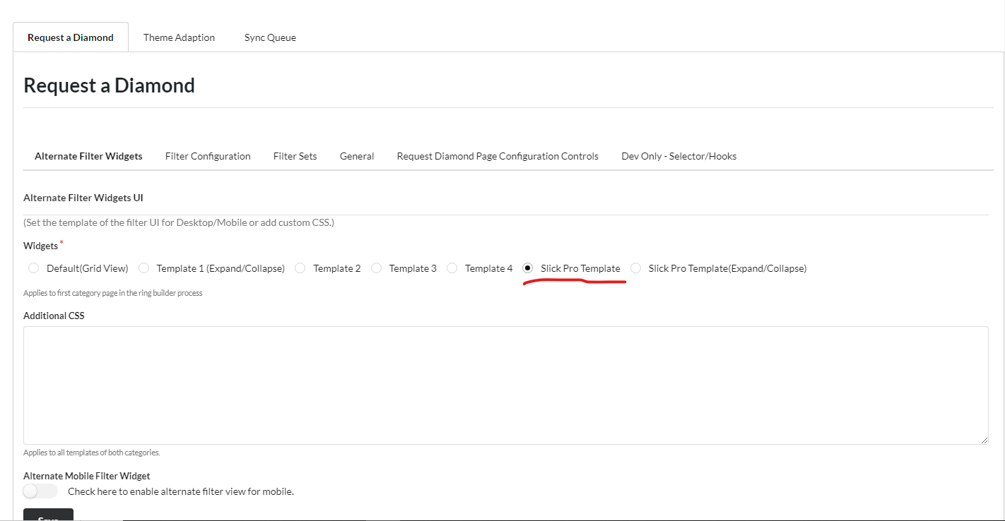

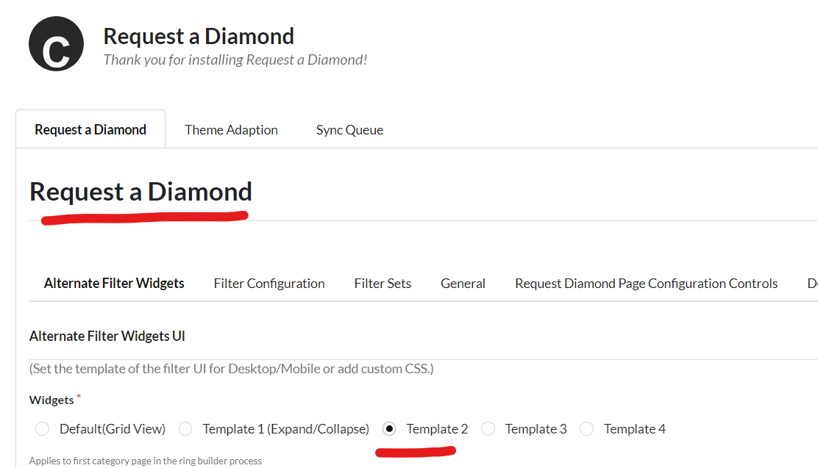
- For Filter Configuration
  - You need to create filters as shown in the below screenshot
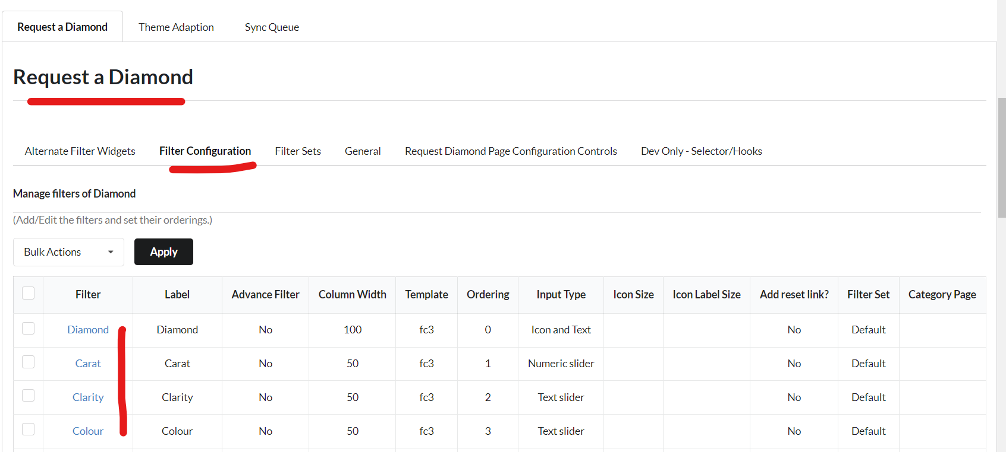

Note :- Another Theme like (astra, oceanwp)ex. You can Follow some settings below to the screenshot and then refresh the frontend you can see the Request Diamond page is workable.

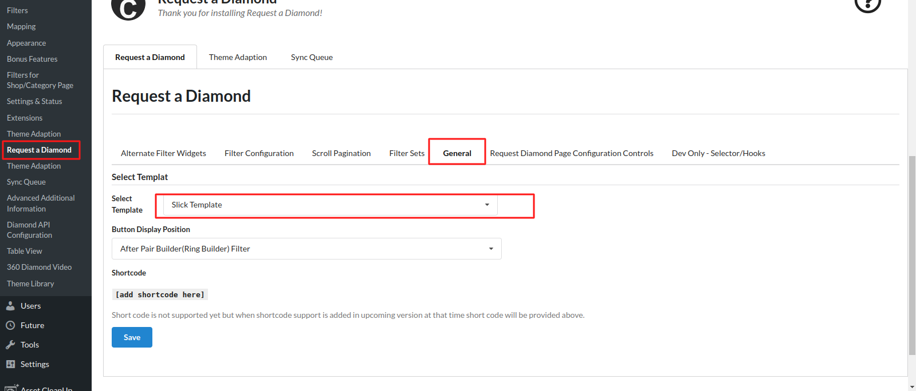

-> Request diamond ma Request Diamond Page Configuration Controls tab na niche Email Template ma aa placeholder use karavnu chhe aavashe

I would like to request a diamond with below details.{nl}{nl}First Name : {eorad_fname}{nl}Last Name: {eorad_lname}{nl}Phone Number: {eorad_tel}{nl}Email: {eorad_email}{nl}{nl}Diamond requirement criterias{filter_data}{nl}{nl}Thanks.
