0 Update and Upgrade Woo Choice Plugin
Woo Choice Plugin Update and Upgrade Instruction

1 Upload Or Upgrade Extension files using respective FTP

1.1 “master_QCed_bhavesh_1” branch should be uploaded

1.2 New upload ke update karta hoy tyare .git folders upload nahi karvana

1.3 .gitignore file pan upload nahi karvani

1.4 React related koi pan folder hoy asset ke assets to e upload nathi karvanu

2. Follow the Git Submodule document
2.1 This extension has the below submodule dependency
- Sp_ssm_variations
- “master_QCed_bhavesh” branch should be uploaded

3. In the Admin panel, Go to Plugins

3.1 Find the uploaded or upgraded plugin by its name from the plugins list and ensure it is activated if it is newly uploaded or upgraded.

3.2 Click on the Admin Panel of the view with size
3.2.1 In Configure Tab
- Select a template as Default
- Select Popup Template
- Popup Button Display Position as Below add to cart button
- Show Popup for category products such as Diamond and lab-grown or fancy

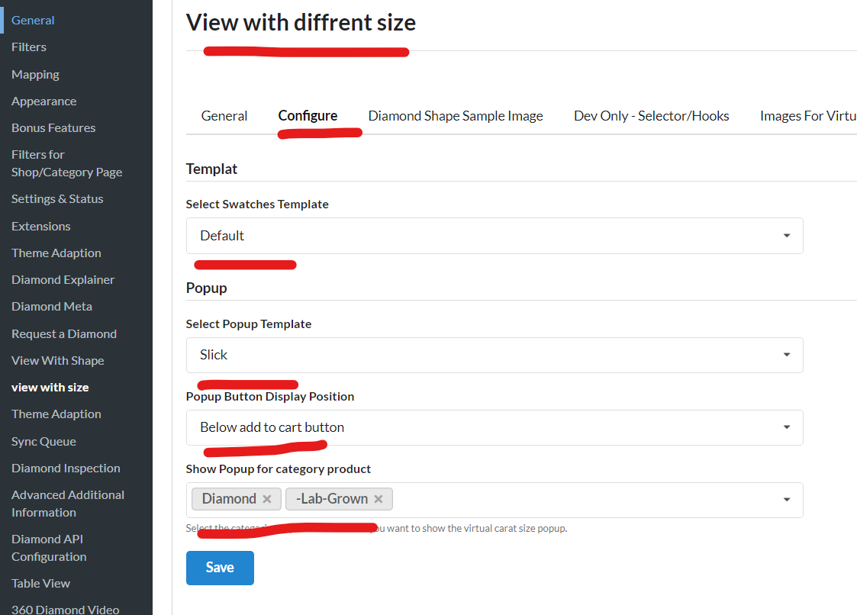
- Now Images For Virtual Size View, select the category and data source to see view with different sizes on the product page
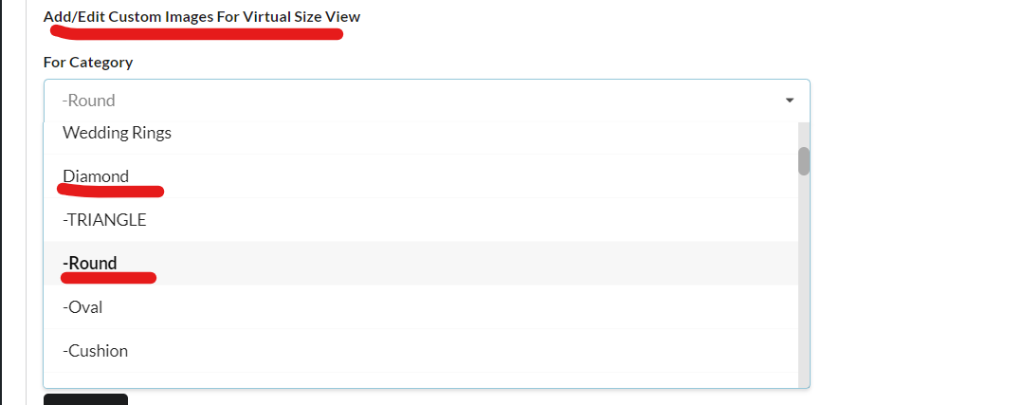
  - 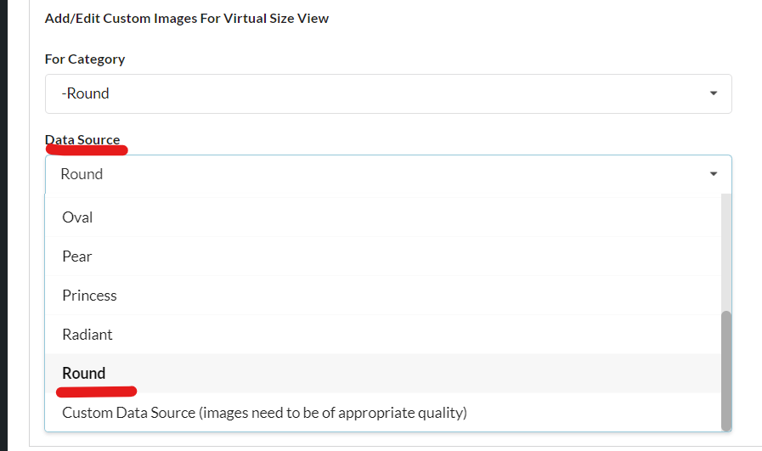
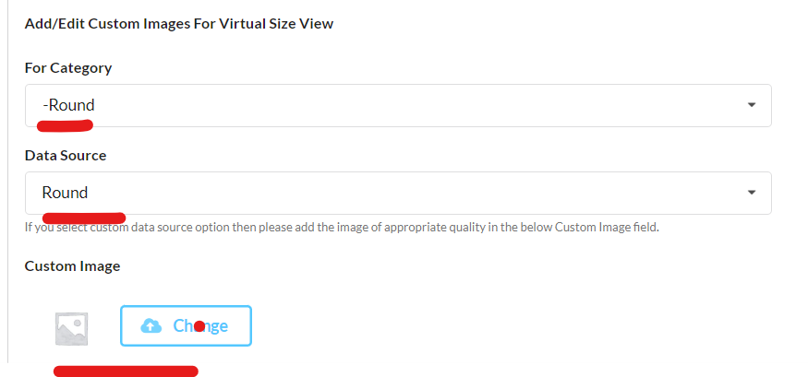
  - For lab-grown,
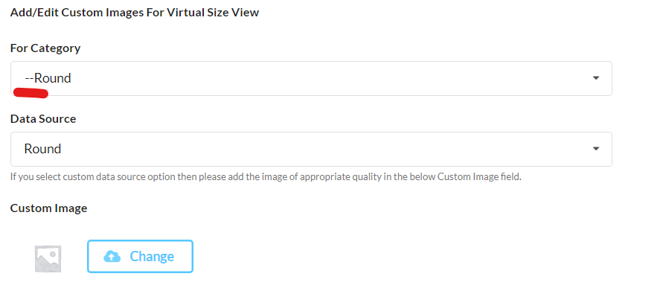
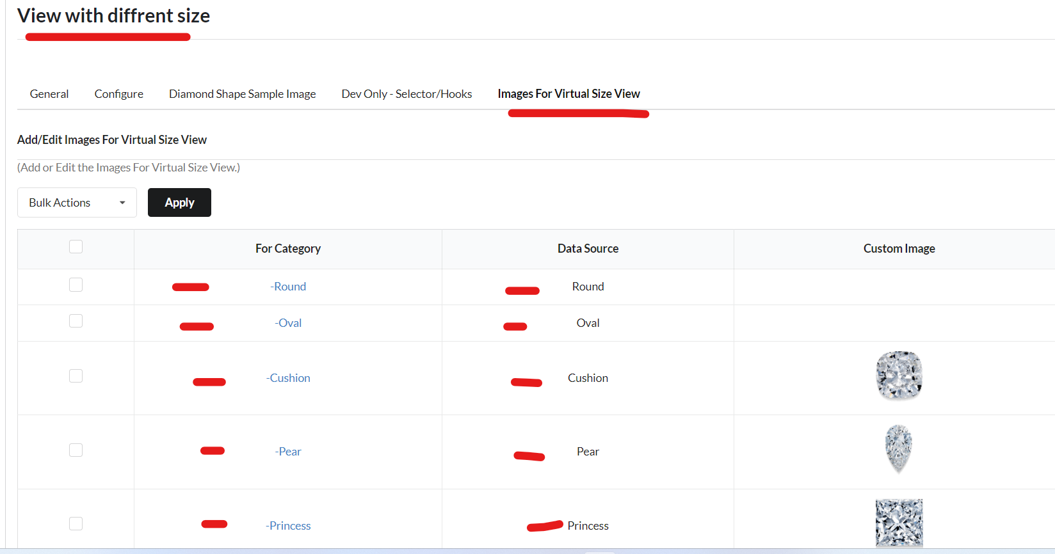
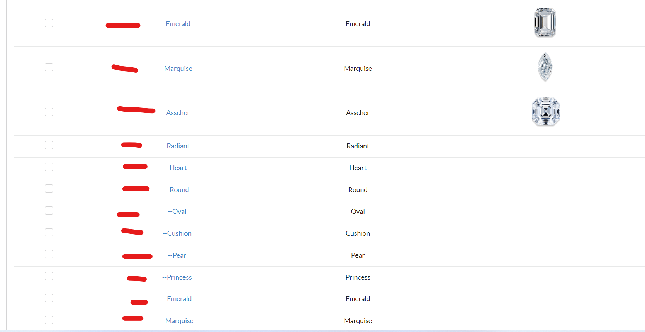

Note: Test properly for activated and setup plugins on the preview page of a ring or any other builder page respectively - If there is any issue on the front end then inform respective developer to fix it like CSS or Javascript

