0 Update and Upgrade Woo Choice Plugin
Woo Choice Plugin Update and Upgrade Instruction

1 Upload Or Upgrade Extension files using respective FTP

1.1 “master_QCed_bhavesh” branch should be uploaded

1.2 New upload ke update karta hoy tyare .git folders upload nahi karvana

1.3 .gitignore file pan upload nahi karvani

1.4 React related koi pan folder hoy asset ke assets to e upload nathi karvanu

2. Follow the Git Submodule document

2.1 This extension has the below submodule dependency
- sp_ssm_variations
- “master_QCed_bhavesh” branch should be uploaded

3. In the Admin panel, Go to Plugins

3.1 Find the uploaded or upgraded plugin by its name from the plugins list and ensure it is activated if it is newly uploaded or upgraded.

3.2 Click on the Admin Panel of the Advance additional information extension

3.2.1 On the configuration tab, Select Default template

3.2.2 Upload certificate icon on Certificate icon for thumbnail placeholder
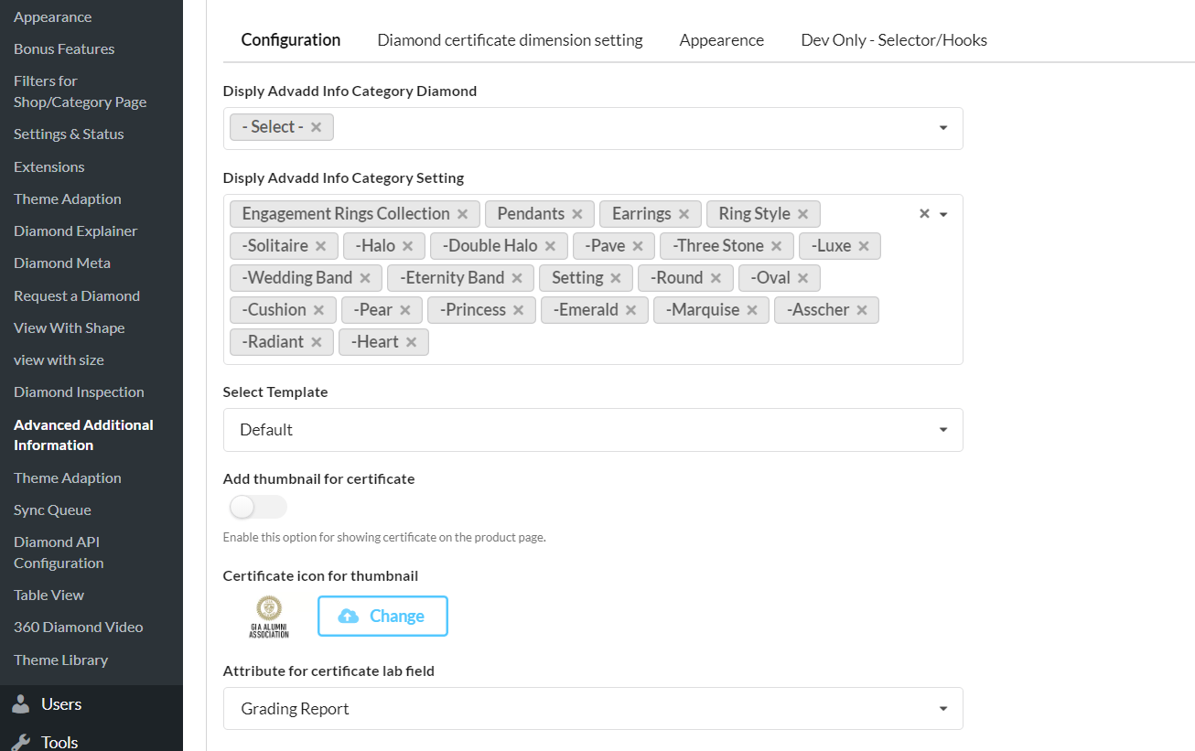

Can Be Set With Shape Attribute setting
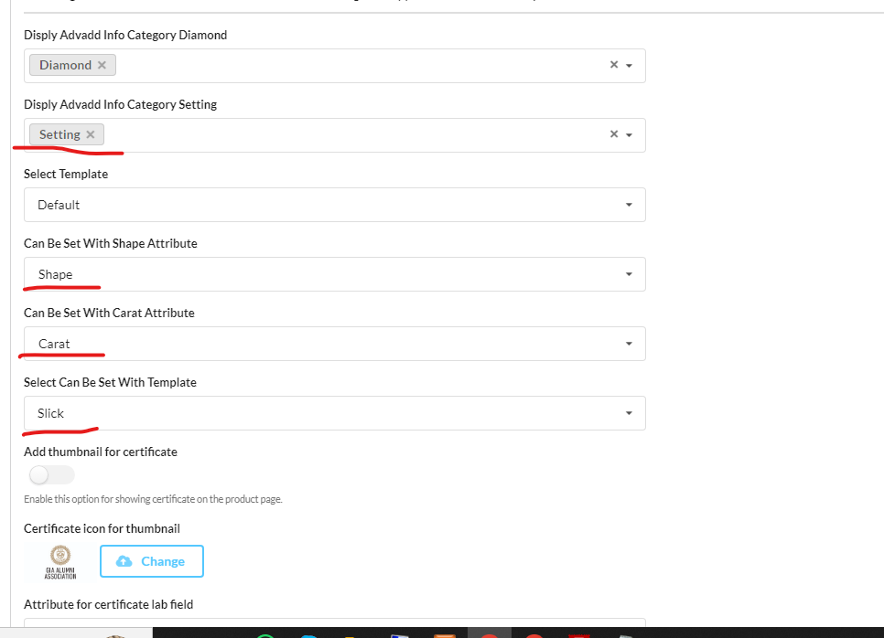
Select/choose all possible attributes as below based on mapping and woo-commerce attributes

Certificate, Cut, Clarity, Color, Carat, Depth, Height, Width, Symmetry, Table, Girdle, Culet, Polish and so on.
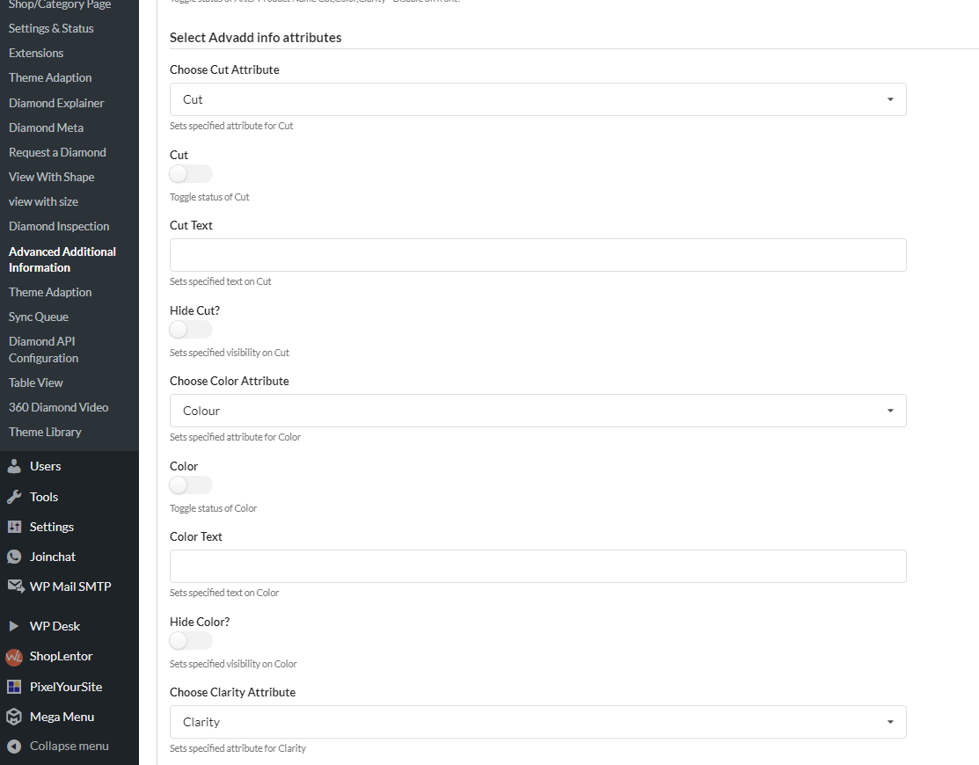
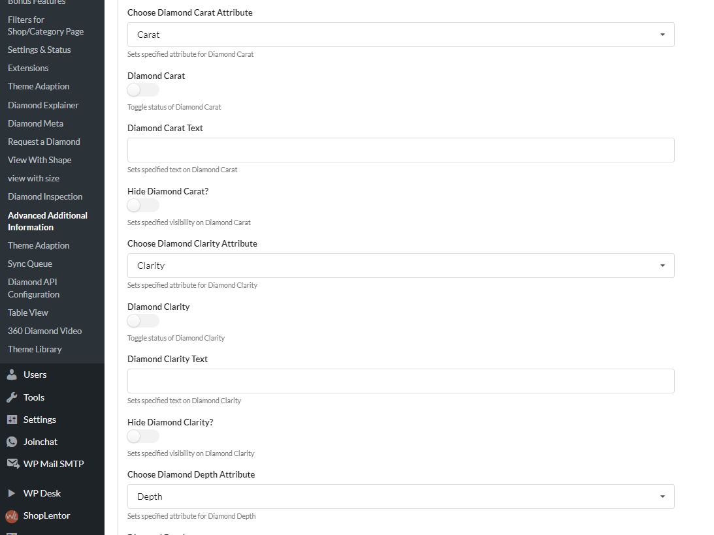
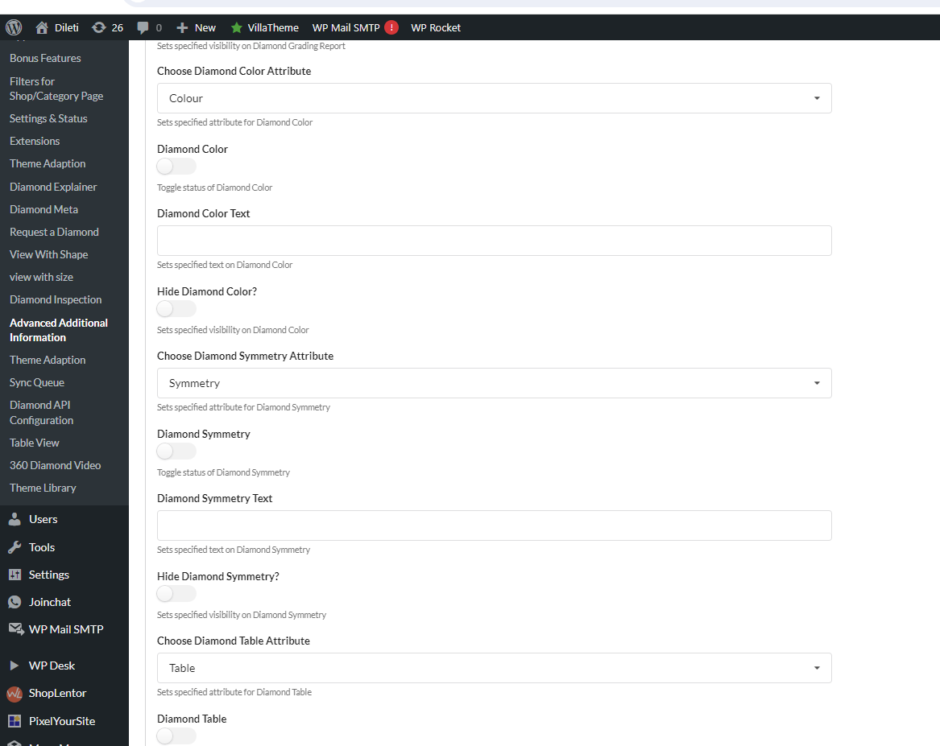
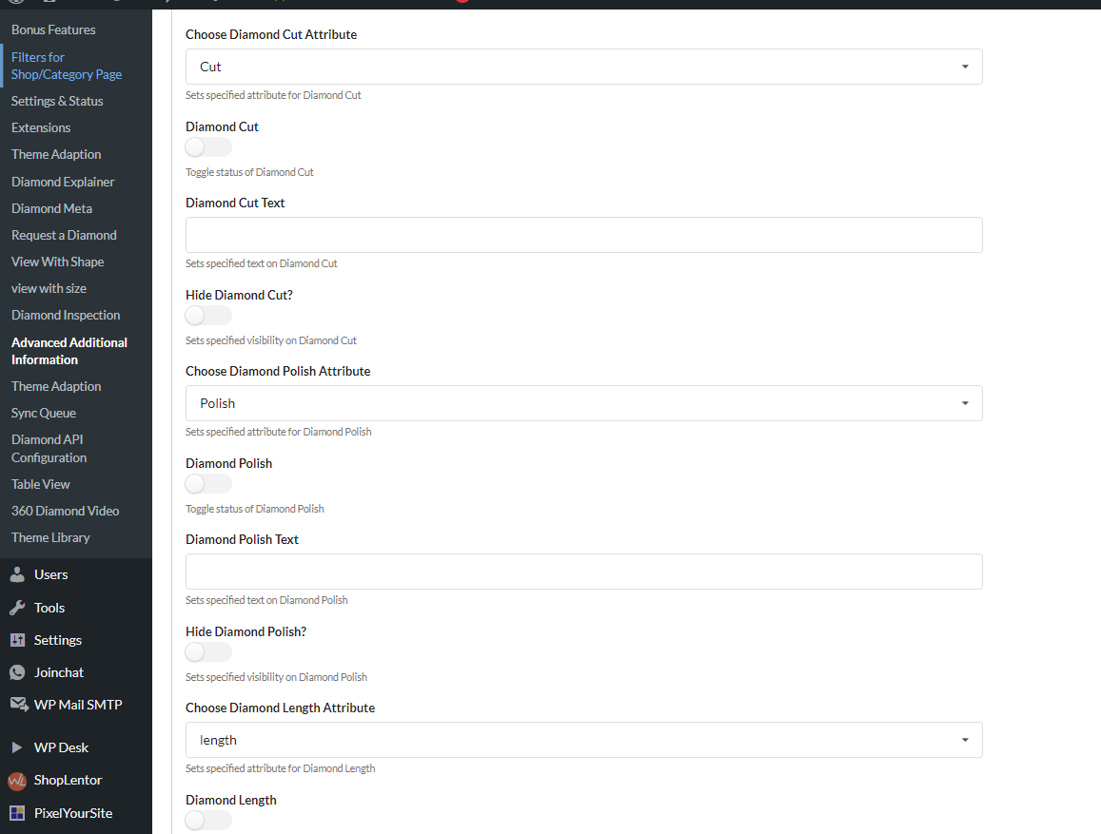
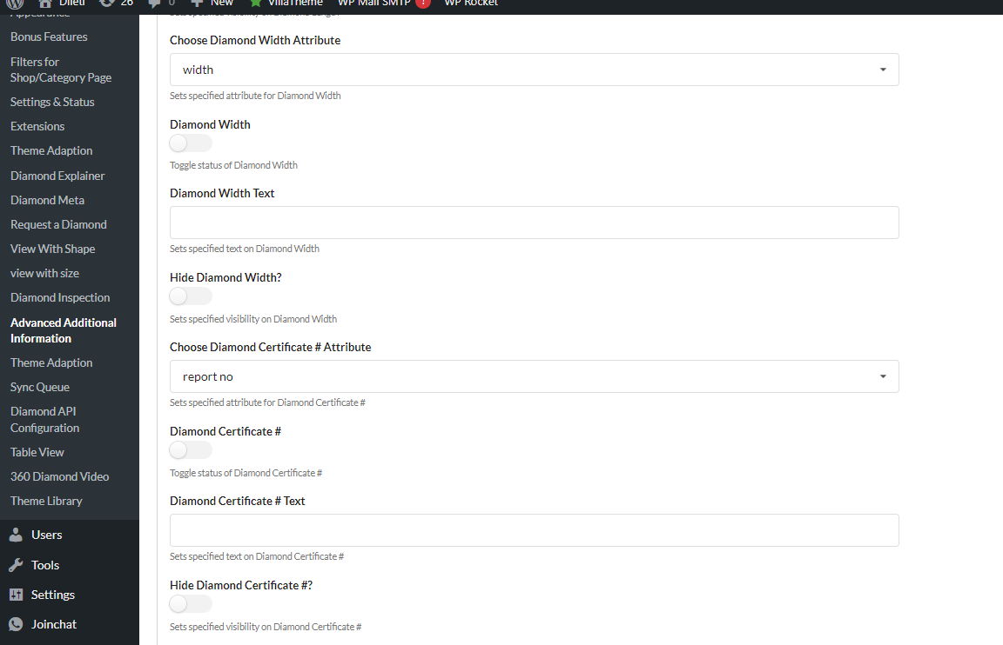
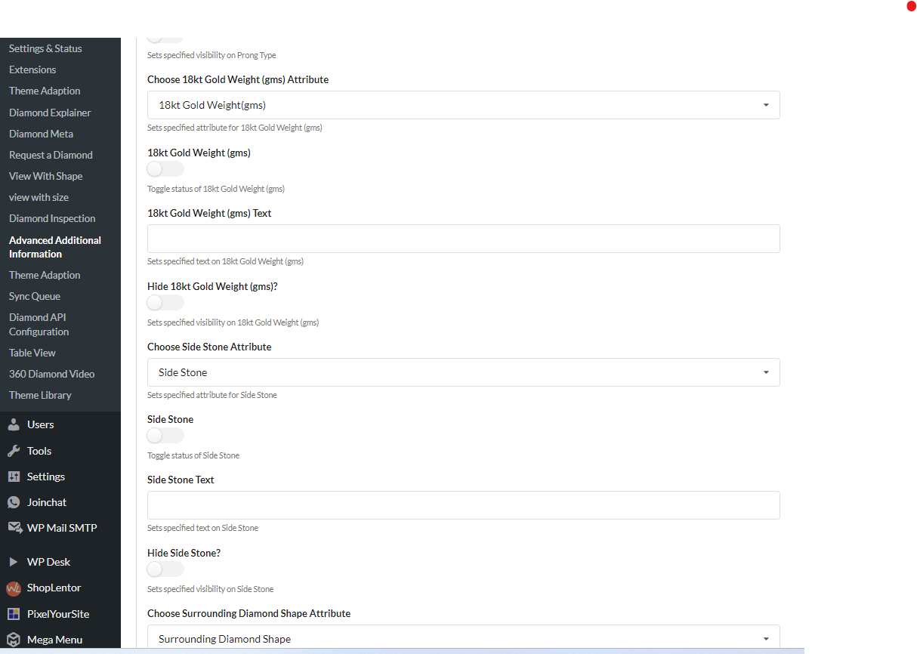
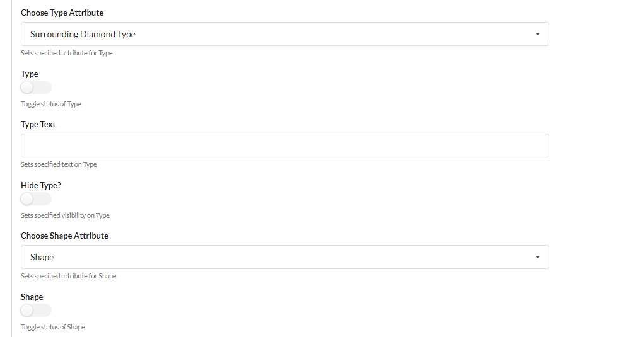
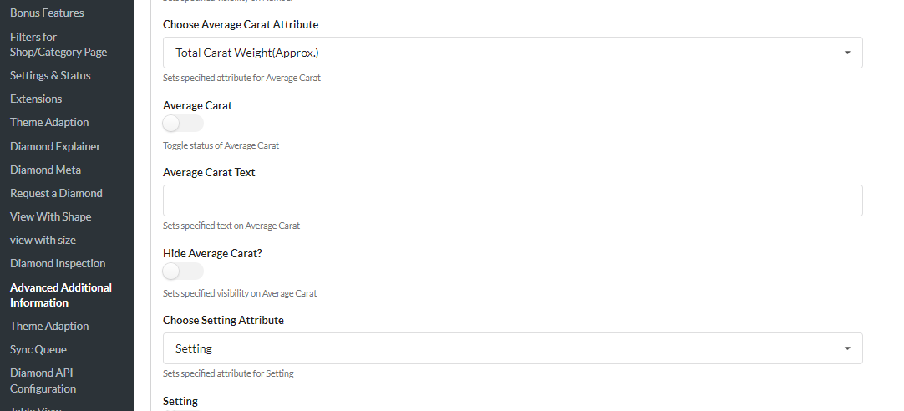

For Ring and other product

Metal, Ring Style

Also, it needs to select other custom attributes added to items like total carat weight, surrounding diamond weight, surrounding diamond shape Total Number of diamonds, and so on.
