0 Update and Upgrade Woo Choice Plugin
Woo Choice Plugin Update and Upgrade Instruction

1 Upload Or Upgrade Extension files using respective FTP

1.1 “master_QCed_bhavesh” branch should be uploaded

1.2 New upload ke update karta hoie tyare .git folders upload nahi karvana

1.3 .gitignore file pan upload nahikarvani

1.4 React related koi pan folder hoy asset ke assets to e upload nathi karvanu

2. Follow the Git Submodule document
2.1 This extension has the below submodule dependency
- sp_ssm_themes
- “master_QCed_bhavesh_1” branch should be uploaded

3. In the Admin panel, Go to Plugins

3.1 Find the uploaded or upgraded plugin by its name from the plugins list and ensure it is activated if it is newly uploaded or upgraded.

3.2 Click on the Admin Panel of the Darker lighter plugin

3.2.1 In the configuration tab, Select the category in which you want to show darker lighter feature

- Upload darker lighter hand images
- Select the default template on the template field
- Set the desired index on Slider Thumb Index which you want to show darker lighter thumb on the product page

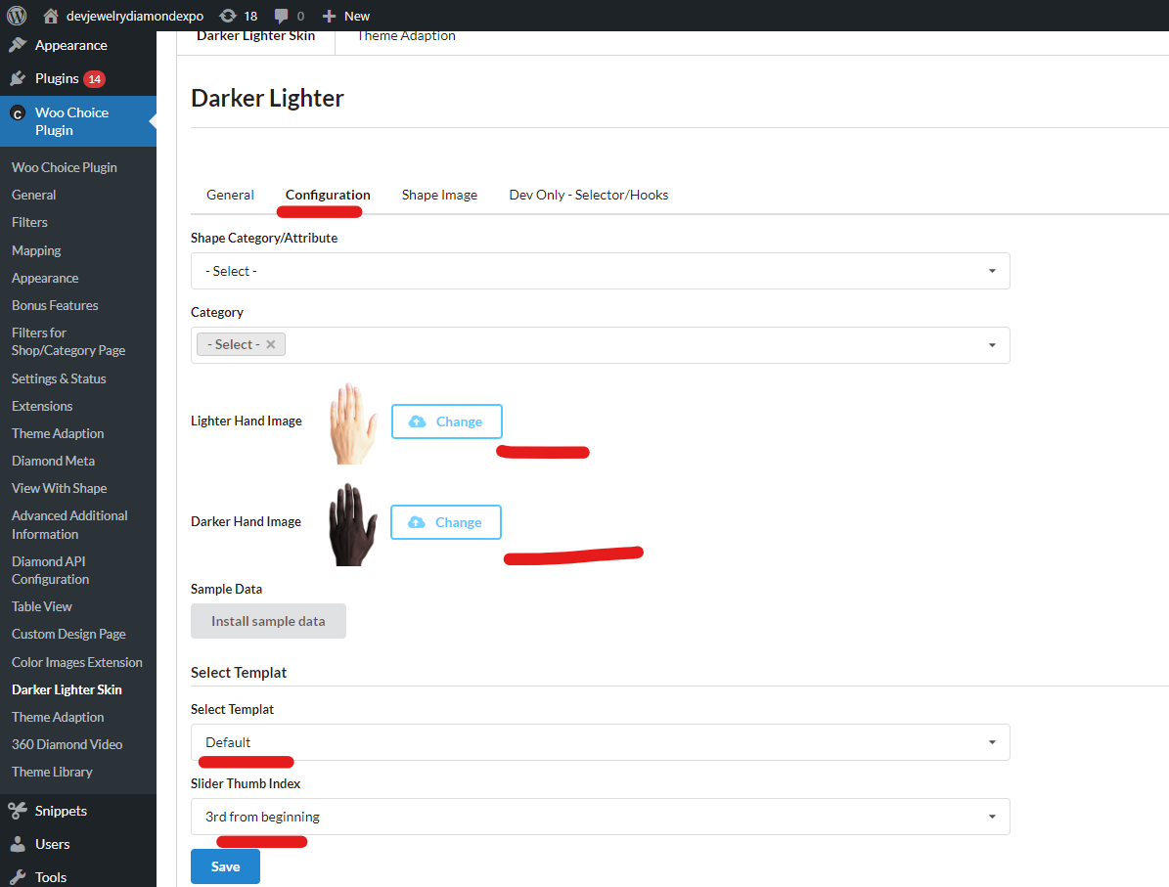

- Check the thumbnail on the front-end of the product page and click on it. Video should be rendered on the item page.

For preparing data setup of darker lighter please follow the below document

data prepration and setup for darkerlighter

