HOW TO SETUP API
@s basic steps mukavana
- Api ni admin panel ma Add/Edit APIs add tab ma api add karvani.
- Jo live api na hoy to cron ni switch on karvani and save to spdb ni switch pan on karvani.
- And jo live api hoy to save to spdb and cron ni switch on nai karvani.
- Tema badhi details proper fill karine save kari ne refresh karvananu
- And next data mapping tab ma configure karine data mapping karvanu.

HOW TO DETERMINE IF API REQUIRES ADDITIONAL CODE OR SOME CODE CHANGES

Random points

Connection settings callback functions
Parse response settings callback functions
Api connection or responses setting layers like
Api factory layers
How to create new api unique key
(for the reminder we have one hardcoded setting on vivek side)
How to put in temporary patches repo
One function in sp csv excel and
Some if layers in get data function.

When loop box images are not coming
Then enable variation swatches and
Edit attributes and select button type and hide loop box

How to do Detailed data mapping
And related code layers understanding for debugging and feature addition

How to set standard filters
And related code layers understanding for debugging and feature addition

How to set static and pre define filters
Show settings of rapnet and related curl payload that is sent on unique jewelry demo.
Show settings of vdb and related curl payload that is sent on unique jewelry demo.

Screenshots for static filters, predefine filters, data mapping and so on.
https://drive.google.com/drive/folders/1d2UFf-E2zCwrEEAXSYgV2549Ygwi4prV?usp=drive_link

Key and important notes of the asana tasks and docs.
Debug notes
Custom identifier notes
Filter notes https://app.asana.com/0/0/1203749126820901/f

FINALIZE API SETUP AND RUN AND TEST

PREPARING start with diamond page
How to setup sample image
Setting tabs(filter sets)
Setting up the filters
Setting up the tableview
Create tableview columns

Cron even minutes par j cron ni process ma jashe odd ma nai jay.

Flush and reset

Api na menu ma sync_queue ni tab ma javanu and sub tab ma je api ne flush and reset karvanu hoy eni key find karine e tab ma jaine flush and reset karvanu.

Manual cron run

- Api ma enable debugging ni switch on rakhavani
- Cron Configuration tab ma je cron ni url hoy e copy karine end ma &is_test=1 nakhi ne run karvanu.
- Cron ma first ma action = download jashe
- Next ma action = prepare index jashe
- Next ma action = deletes compare tahy
- And pachhi product save thashe and e confirm karva mate paged = ma page number jashe per page by default 100 product save thashe.
below diamond is skipped due to empty sku
manual cron peli var test kariye tyare 1 page , 2 page aapade run kraviye pachi menuali refresh kari ne jota hovi tyare paged 1 , aave paged 2 , aave paged 3 , aave tya sidhu scroll kari ne jovanu jo aavi koe red error paged par batave to motta font size ma batave to pachhi sku nu mapping api nu je reliable feeld chhe k kem tema javanu for EX. id feeld, stock id , diamond id , lot number,etc feeld aavata hoy to pela map karavana tobhi te na hoy and reliable map karelu hoy to aa error aavati hoy to pachhi sir sathe discuss karavnu and screenshot ni diteles sir ne aapi devani km k user ne batavanu rahshe. and aa error user ne jyare diamond ocha display thashe total count karata ocha aave to eloko ne daunt thay k system ma bug hashe etale sku skeep thata hoy to pela conform karavanu k sku aapade right map kariyo chhe jo right map karo hoy toy eshu aavato hoy to sir sate discuss karavanu.

NOTE: manual cron run thay tyare je sheet save thay e cron run na first step par j download thashe and tya path print thai ne aavashe e path and name thi ftp ma find karvanu tya download thayel sheet malashe.

Video ni link ;- https://youtu.be/tu1ZcETL8b8

Actual cron test

- FIRST TEST Cron setup thai gaya pachhi e cron ni jetali size hoy e for example size 155 hoy to (155*2)+8 = 358 to 358 minute na time gap cron update thashe.
- SECOND TEST Next test ma pan aa j time gap thi test karvanu aatla time period ma cron run thai javo joie and product pan update thavi joie.
- THIRD TEST Same second test ni jem j third test karvani.
- Uparni 3 test jo success thay to next batch ni size 500 kari devani.
- Batch size 500 karava mate.
- File path /sp_diamond_api_integrator/application/model/sp-dapii-queue.php aa file edit karine batch size 500 kari devani.vadhare details mate snap ma jovu.
- Niche snap ma je selected chhe eme $default = 500; kari devanu.
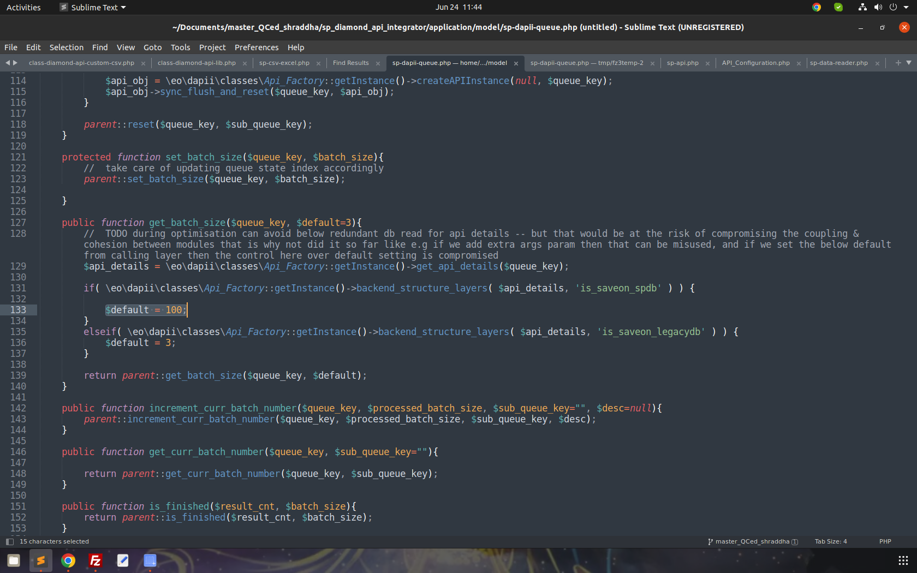
- And next test ma 1,2,3 point follow karavanu.
NOTE:
- jyare pan user ma site ma(live ma) cron setup karie and usr api ni feed na 10% thi vadhare diamond delete kare tyare admin mathi ek var flush and reset karvani reshe.
- Aa badha step ma cron proper run thay chhe ke nai e check karvan mate api ma sync queue tab ma jaine je api no cron run hoy eni tab ma jaine check karvanu k cron even minute par complete thay chhe
- 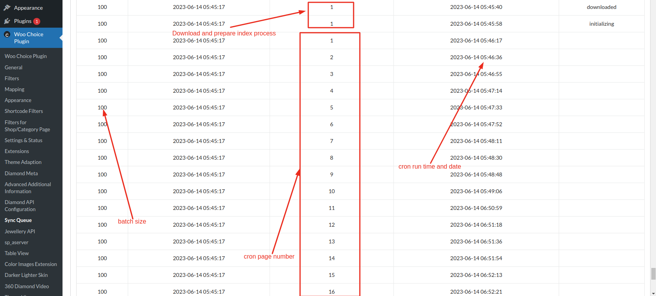

RANDOM SECTIONS:
csv gotavani rit:-
- jo json or any other curl respons to csv flow use karo hoy to
– to csv file aa folder FTP -> PLUGINS FOLDER -> “/sp_diamond_api_integrator/application/data/csvs” ma jovanu and tyathi letest csv pratiqular api ni hoy te lay levani
- jo other standard default csv implementation hoy to (like google spreadsheet and so on)
– to csv file php nu je default upload folder hoy tema jovanu, for example most of the users server ma upload folder nu name FTP -> “tmp” or look at wp upload folder like “/wp-content/uploads/2023/08” and replace year and month, to jo tmp folder hoy to tema jovanu nahi to je currect upload folder hoy te goti ne tema jovanu

KNOWN ISSUES:

- If images do not show on gallery archive view
=> then confirm that variation swatches feature is enabled for particular category page.
@s asana na run time issue ni details mukavani.

parent id empty ni error aave tyare cron flush and reset karavi devano and cron run karavano
spreadsheet type ni api (link always viewable)
jyare poling api no response proper nai aavto hoy tyare postman ma ajax url thi check karvanu and jo html no tag banato hoy to sp ssm dt model feed vali file manthi demo ma temp html echo thay chhe e comment maravanu
and demo ma gallary field mate gallary images valu filed extra map karel chhe
and database ma static 2 field add karel chhe
→ gallary
→ opts html data
tableview ma thumb vali column banvai devani jyare pan gallary vali error aave tyare check karavni
jyare query ma price ni error aave tyare
price filter normal page ma na aavatu hoy
ajax ma select query ma jyare price 0 aave tyrae woocommerce ma ek diamond ma price set karvai devani.
— ajax ma jyare no products found aave tyare aa point check karvano. => select query ma je price range set thaine jati hoy e price range ma jo data(sheet na data) na hoy to response empty ni error aave
mapping ma gallery images valu field simple type ma map nathi karvanu.
gallary field ni error aave tyare check karvanu k ajax ma chhe ke non ajax ma jo non ajax ma hoy to product ma ek diamond ma proper data set kari devana.
COMON_JSON_TEST_1 and COMON_JSON_TEST_3 variable api mate chhe.
api ma jayre mapping ma ya to sheet ma same name ni column nai rakhavano and api ni same column multiple time map nai karvani.
map karel hoy but null no issue aave to uparni note follow karvi.
Api demo dependency vali ma jyare response ma no product found aave and koi error throw na kare to wp_debug check akri levu ema jo e true hoy to response warning print thai ne jashe.
so response proper nai aave
setting and diamond ni banne api chalu hoy and koi b weird or unseen type na issue aave tyare diamonds api lib nu service wrapper function mathi je badha function na call lage chhe e check karvana and issue aave tyare aa type ni if for example =>
if( !\eo\sp_dapii\controller\publics\pages\Feed::instance()->is_api_category($api_details) ) {
return $data;
} mukavani and tena active todo start end sathe mukavanu and mukata pahela sir sathe double confirm karvanu
get_image_id vali error aave tyare tableview ma product image mate ek column banavi devani and e je category(step like eign or diamond) par aavati hoy tena mate specific set kari devanu.
Above issue seems fixed, so ignore it if nothing in particular

FOR TABLEVIEW SHOW COLUMN ON TWO TABS RELATED NOTES
show on categories nu and parent category nu dropdown use karvanu hoy tableview columns mate to other main diamond categories like the lab grown diamond, get stones etc should be created as grand child category of diamond category so we can create other diamonds category and make it child of diamond. while the lab grown, gemstone etc will be child of other diamond category.

jyare pan user ma site ma(live ma) cron setup karie and usr api ni feed na 10% thi vadhare diamond delete kare tyare admin mathi ek var flush and reset karvani reshe.
jyare api ma ek var con run thai jay and koi product woocommerce ma save thai jay pachhi admin mathi api ne flush and reset thai jay pacchi cron run karie tyare product page par error aave wbc-variation class ma
and e error na solution mate => je pahela woocommerce ma save thayel product delete karvi padashe
Below 2 task links are of above points in particular
https://app.asana.com/0/0/1203552875006563/f
https://app.asana.com/0/0/1204446657736629/f

When there is issue that cron url showing the home page at that time do following steps:
Step 1: first check if you have copied the latest url and if you still not have changed the cron key then first of fall change that and then copy the url
Step 2: if still the problem is not solved then flush all the cache from any caching plugin that is set up on wordpress site. So go to that plugin and purge all cache.
Step 3: if still problem persists then check if the breeze plugin is installed on the plugins page, even if it is deactivated then activate it and click on purge all.

JYARE CRON UPDATE MA DIAMOND GHATATA HOY TAY SHU KARAVU

STEP_1 :- is_test= 1 thi manual cron process fire kari ne mins update mode ma jay tyare fire karavani and parse_result_wrapper aanathi find karavano log, aama je filds dekhadata hoy , rows ma ema jo koe series field hoy je dar vakhate cheng thatu hoy to e type na field kadhi nakhavana, unset fildes ni meta property us kari ne (for example furqan nivoda api “id” fild issue)

Step 1.1 :- and jo to bhi issu aav to ho to je fild by difault add thata hoy to ene code mathi privent karava na raheshe. pan jya sudhi te no thay tya shudhi temprari patches sp-api-class ma maravano, means ke row to be upadated aakhi row update karava mate aapade patc implement karavani. for that discuss with @hirenbhai. default ma prices and name nu field furqan ma debug kariyu tema add thatu tu to ane mate thi aakhi row update karavani aavshe, jya sudhi difault fild ne priwent no kari shakiye tya sudhi. pan any way jo field unnecessary hoy te update force karatu hoy te pachi unset fields no use karavo tej betar chhe better performance mate and that is why je aapne temporary patches par depend revenue plan kariye chhiye so let’s think about it in details and figure out that we do not need to depend the temporary patches

STEP_2:- to bhi issue fix no thay to simply load and comper all data , wbc()->common->var_dump( "singletone sync -> sp_api -> load_and_compare" ); wbc()->common->var_dump( "singletone sync -> sp_api -> load_and_compare old_data" );wbc()->common->var_dump( "singletone sync -> sp_api -> load_and_compare rows_tobe_udpated" ); and load comper rows to be updated e badha log ne find karine analyze karavana

Some random matters which are now fundamental but still not in
practice/documentation
Rapnet ma static and predefined filter set karvana reshe
Rapnet ma jyare data mapping edit karie tyare payload ma / jay chhe e delete karine pachhi save karavanu.
Jyare pan rapnet ma setup thai gaya pachhi kai wired issue aave and data mapping work na kare tyare mapping edit karine joi levu ema / hashe to error aave chhe.
"No Diamond was found" aavo messag aave tyare pela bija usar na tokan no us kari api admin penal ma username and password naki ne chack karavanu and pachi Supplier nu user ne kevanu

Temporary patches ni detail.
Aa patches badha temporary patches vali repo ma mukel chhe. Path :- sp_temporary_patches_n_scripts->team-shraddha

NOTES:
- Api demo par flush everything karavu nahi.
- Badhe j flush and reset j karvanu, flush everything kyarey nai karvanu.
- Flush everything kyare karvanu?
- Jyare cron ma column no issue aave tyare j karvanu and e mate pahela sir sathe confirm kari levanu je column ma issue hashe e mate api ma changes karvana aavashe e changes sir karavshe.
- And e changes thai gaya pachhi flush everything karvanu.

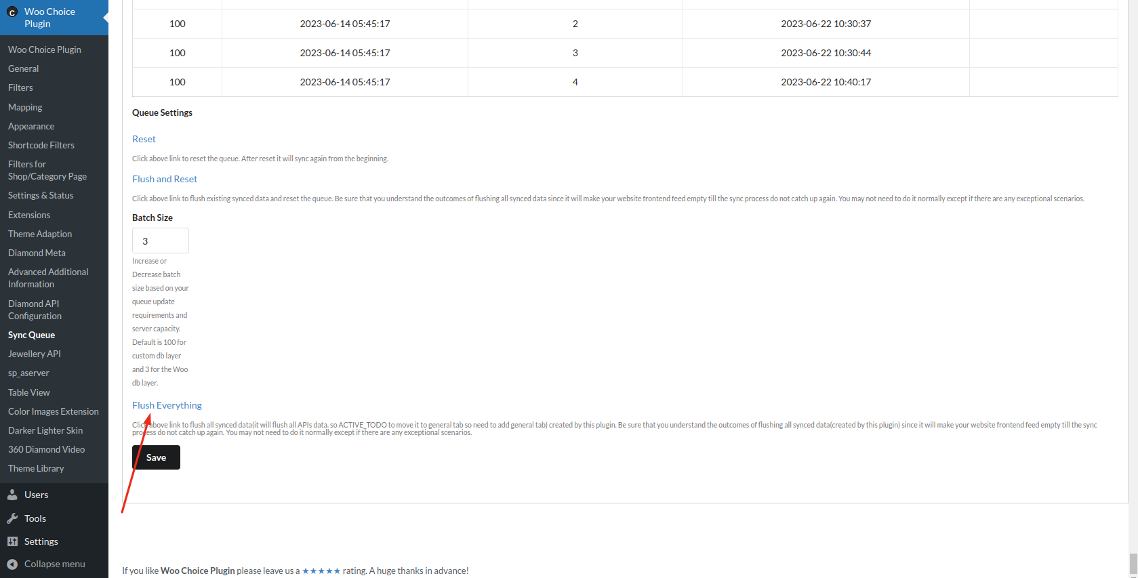

Generate Tokens till hierarchical api support is not implemented
Conner gemcloud
Token update 13 days na gap ma karvanau.

- Conner ma gemcloud ma token 13 days na gap ma update karvanu reshe.
  - E mate gemcloud ni api nu postmen collection ma je login ni api ne send karine new token create karavanu.
  - Postman ma create karel token ne diamond api ni repo ma common class(sp_diamond_api_integrator/lib/classes/api/class-diamond-api-common.php) ma set karvanu reshe.
    - 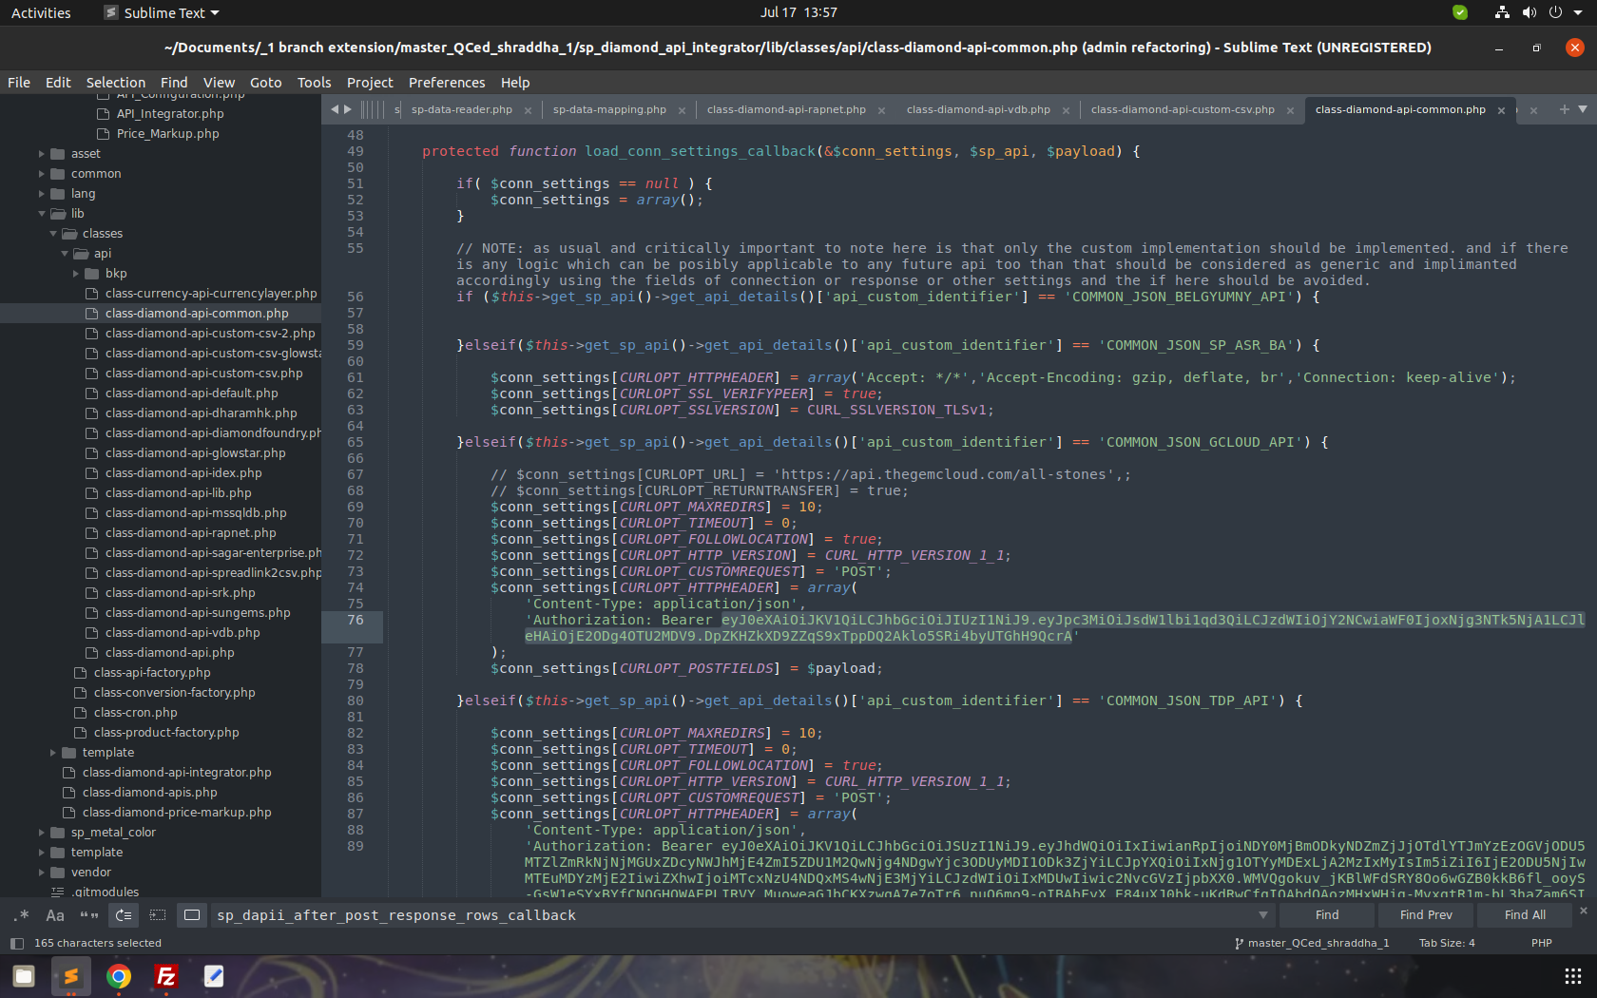
    - Upar image ma je part select karel chhe tya postman mathi copy karel token override kari devanu.
    - And aa file ftp ma upload kari devani.

Postman details
Postman collection link => https://drive.google.com/drive/folders/1S87DLgPq_mrlP7n64yOkBBiMP1t11LeR?usp=sharing

Note: create postman account using your emptyops.com email id and import and then try. Do not use others postman account as it will create confusion.

If item page of diamond is not opening then need to check below things
Attach &is_test=1 and hit enter then check the data by finding API_DATA and its response.
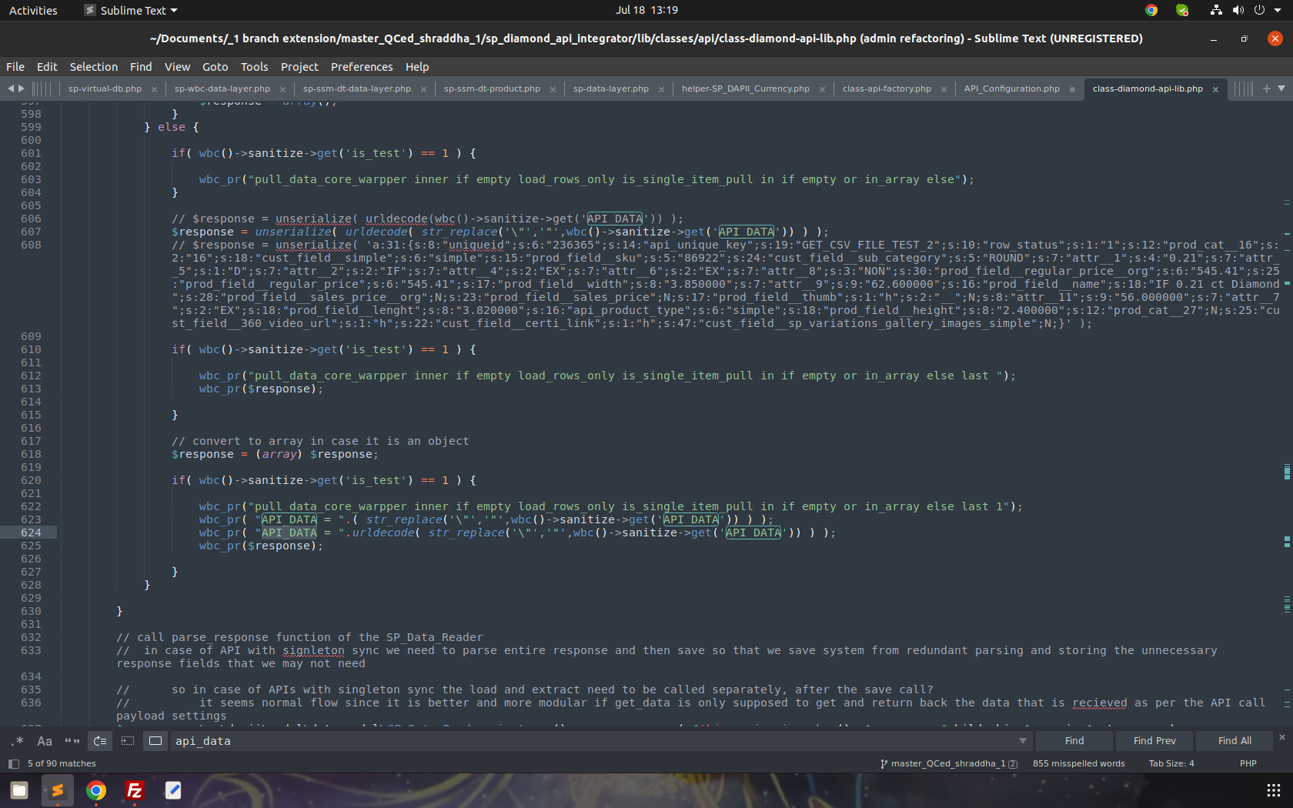

If there is no problem like (API_DATA)in the URL of the item page of diamond then simply check for diamond API's latest Update or Submodule even though it not working then need to check woocommerce Update and refresh the page
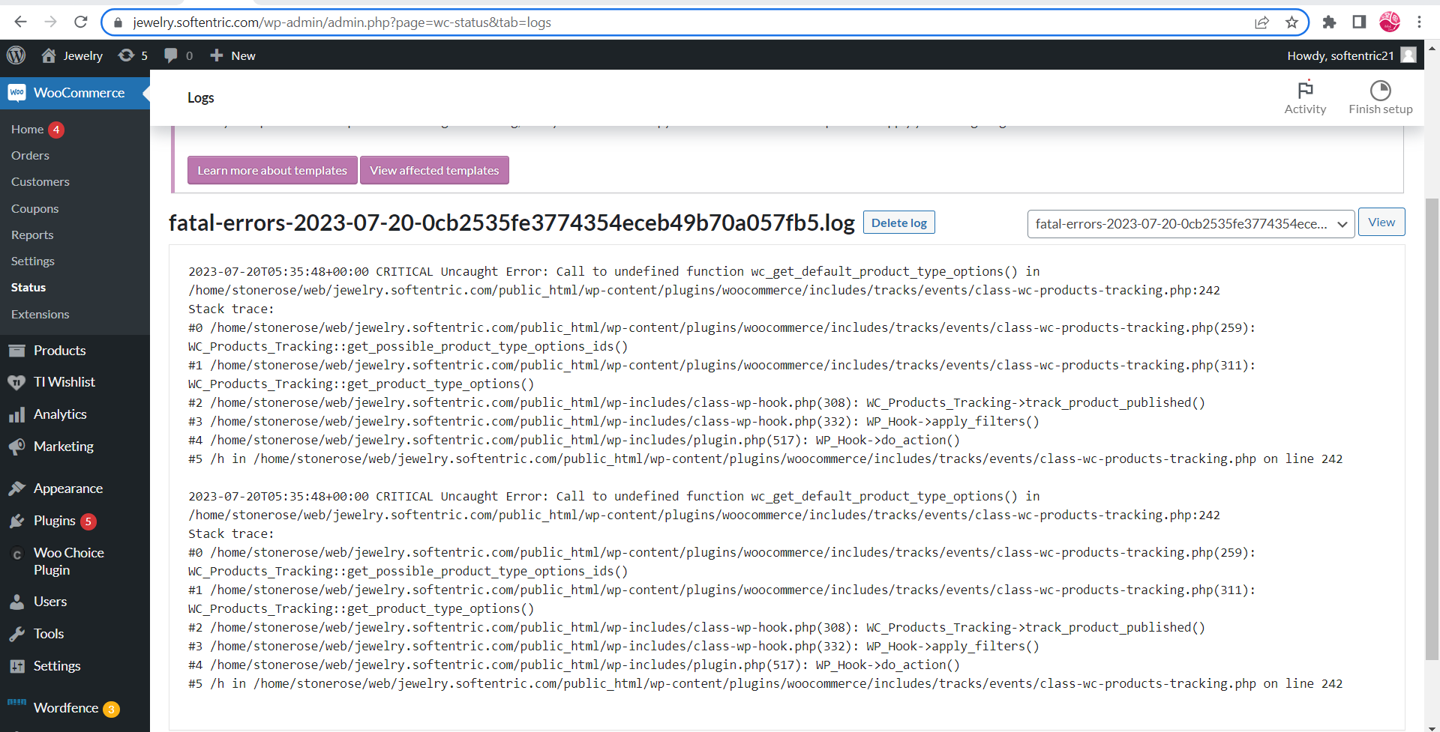

Media
Legacy dropdown(second dropdown) field names
- Product Image
- Video url(mp4 video)
- 360 video
- Certificate url
- Darker lighter skin
- For diamond meta make sure to map fields like length, height, width dimension fields and other attributes like table, depth, girdle, culet

OTHER RENDAM ASSANA POINTS

https://app.asana.com/0/0/1204144592871941/f
https://app.asana.com/0/0/1203749126820901/f
https://app.asana.com/0/0/1204225755220507/f

Setup process
- Setup process to increase batch size
  - Step 0: check API inventory size if it is below 25k then stop from here.
  - Step 1: Ask the user for server configuration especially the RAM size and the number of CPU courses so give users a message about that.
  - Step 2: And then follow below batch size as per the configuration.
    - Step 2.1: If ram size is a 2 gb then go up till 1500 records. (EXPERIMENTAL We need to revise it and increase or decrease it after it is being tested in 2 to 5 users.)
    - Step 2.2: If ram size is a 4 gb then go up till 3000 records. (EXPERIMENTAL We need to revise it and increase or decrease it after it is being tested in 2 to 5 users.)
    - Step 2.3: If ram size is a 8 gb then go up till 6000 records. (EXPERIMENTAL We need to revise it and increase or decrease it after it is being tested in 2 to 5 users.)

- NOTE: If the user asks to increase the batch size furtherthen give them this message “The batch size that we increase is our best recommendation as per the server resource capacity and limits means the ram size and so on. So we never recommend that you ask us to increase beyond the limit that we recommend and we will not increase it beyond that limit unless you force us to do that. Because the reason for this recommendation is that if the batch size is increased unnecessarily then it will make your frontend slow and your site will not look smooth whenever the background process is running and it is running at each minute so it is never recommended that you go beyond our recommended limit.”

- Setup process for inventory greater than 25k (EXPERIMENTAL and we need to revise and we need to confirm and give it a through thought to it after 2 to 5 tests are done to see if it is reliable and convenient for the user experience of everyone means for our setup experience and also to user communication experience and so on)
  - Step 0: check api inventory size if it is below 25k then stop from here.
  - Step 1: Notify the user that we will first set up with 25k records only, so tell hirenbhai to discuss that with the user first.
  - Step 2: After the discussion is done with the user then pehla 25k sudhi diamond manual auto browser cron thi save karavi levana and pachi detail data mapping kari ne tableview columns, search filter, badha lagu padta hoi e media conform kari levana ane aakhu setup complete kari ne aapi devanu.
  - Step 3: After user conformation aapi de te pachi kai bija koi issue nathi a joi levanu.
  - Step 4: Hve browser auto cron aakho run karavi devano means complete inventory na diamond save thy jai tya sudhi run karavi devano, aa step actual cron test pati jai ane actual cron run thato hoi pachi karvani.
  - Step 5: Hve detail data mapping kari levanu, aa step actual cron test pati jai ane actual cron run thato hoi pachi karvani.
  - Step 6: Pachi hve pachi aakho cron fari ek var run karavi levano, aa step actual cron test pati jai ane actual cron run thato hoi pachi karvani.

Things to cover while setting up API

Step 1

Diamond API na feed response ma jetla field hoy temathi je attribute ma save kari sakay teva hoy, teni mate woo-commerce ma attribute banavi ne te attribute ma map kari devana

Step 2

Media je map karvana lagu padta hoy te map kari devana. For ex. Image, 360 video(jo 360 extension hoy to), certificate(jo advance additional info extension hoy to), meta mate na 6 fields(for ex. Length, width, girdle, culet, depth, table… jo diamond meta extension hoy to)

Step 2.1 je user ma purple theme hoy and advance additional information extension hoy to advance additional information extension ma configure tab ma jai ne je pan attribute map karela hoy e select kari devana and diamond item page ma additional information section ma e values aavi javi joie (Note: aa process tyar sudhi j karvani jya sudhi code ma default value set na karvi tya sudhi aa step follow karvanu)

Step 2.2 at the time of detailed data mapping, give the 360 URLs list to mansi, along with API unique key(this API unique key parameter is certainly temporal)

Step 3

name, short description, long description map karvu. And sathe sathe global configuration tab ma jo name, short description, long description jo no nakhela hoy to nakhi devana.

Step 4

Baki ni general details jevi ke price and biji koi vastu je API na response ma aavti hoy and lagu padti hoy to map kari devani

Step 5

Table view ma Brilliant Earth (https://www.brilliantearth.com/design-your-own-engagement-ring/) ma je columns hoy te banavani ane aapdi default columns hoy te banavani like compare, wishlist and so on.

Step 6

Testing- Search filters - Search filters one by one test karvana means ek filter marvanu and pachi data feed check karvani and pachi filter reset(undo) kari devanu.

Step 6.1 Caret range nu filter marvu and teni sathe clarity nu filter marvanu and te range ma diamond na data e filter pramane aave che e check karvanu, aa jova mate gellery view ma javanu tya diamond na name ma aa badhi details batave che and randomly pagination ma pages check kari levana.

Step 7

Testing media - table view popup, gallery view, table view columns, diamond details page ma uper ma je uper na step 2 ma map karya hoy te badha media aave che ke nai and proper work kare che te confirm karvanu

Step 7.1 360 frame table view popup, loop box and product details page ma properly centre ma aave che te confirm karvanu. And jo controls aavta hoy to pan loop box ma nai batavana. And table view popup ma and product details page ma controls batavana pan controls fully visible and accessible hova joie.

Step 7.2 Jo diamond meta extension hoy to table view popup and product details page ma banne diamond meta chart ma badhi values aave che te check kari levanu means step 2 ma je 6 fields map karya hoy te proper ave che te check kari levanu. And jo 2 API athva vadhare hoy to product details page ma diamond meta ni thum no aavti hoy to Bhavesh.D ne kehvanu.
Step 8

Test Start with the diamond and start with the setting process add to cart sudhi test kari levani.

Step 8.1 And cart page ma je diamond and ring select kari hoy te aavi jaay che e check karvanu

Step 9

Woo-commerce ma diamond padela hoy e trash ma nakhi devana

Step 10

API ni Debug ni switch bandh karvani baki hoy to bandh kari devani

Step 10.1 Woochoice plugin not error log clear karvano and woo-commerce no error log pan flush kari devano

