0 Update and Upgrade Woo Choice Plugin
Woo Choice Plugin Update and Upgrade Instruction

1 Upload Or Upgrade Extension files using respective FTP

1.1 “master_QCed_bhavesh_2” branch should be uploaded

1.2 New upload ke update karta hoy tyare .git folders upload nahi karvana

1.3 .gitignore file pan upload nahi karvani

1.4 React related koi pan folder hoy asset ke assets to e upload nathi karvanu

2. Follow the Git Submodule document
2.1 This extension has the below submodule dependency
- sp_ssm_themes
- “master_QCed_bhavesh_1” branch should be uploaded
- Sp_ssm_variations
- “master_QCed_bhavesh” branch should be uploaded

3. In the Admin panel, Go to Plugins

3.1 Find the uploaded or upgraded plugin by its name from the plugins list and ensure it is activated if it is newly uploaded or upgraded.

3.2 Click on the Admin Panel of the Explainer widget

3.2.1 Terms Configuration Tab( Create and activate Carat, Clarity, Cut, Colour Terms as shown in the below screenshot.)
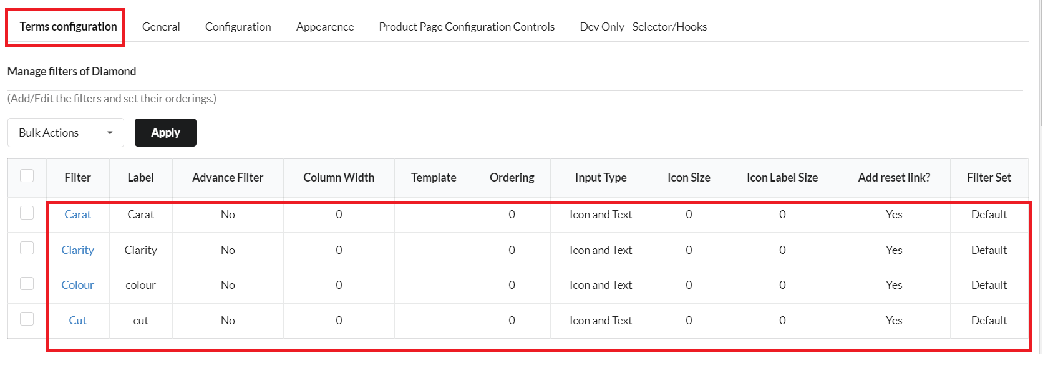
3.2.2 For Show Selected Only( We need to enter that value manually)
.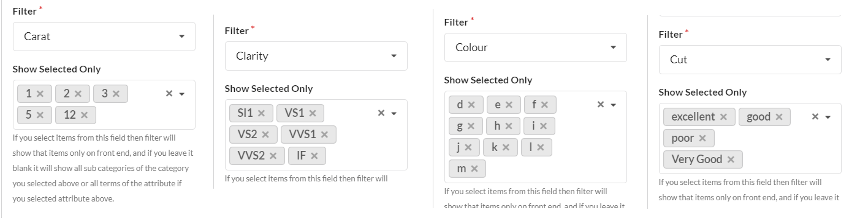

4. Configuration
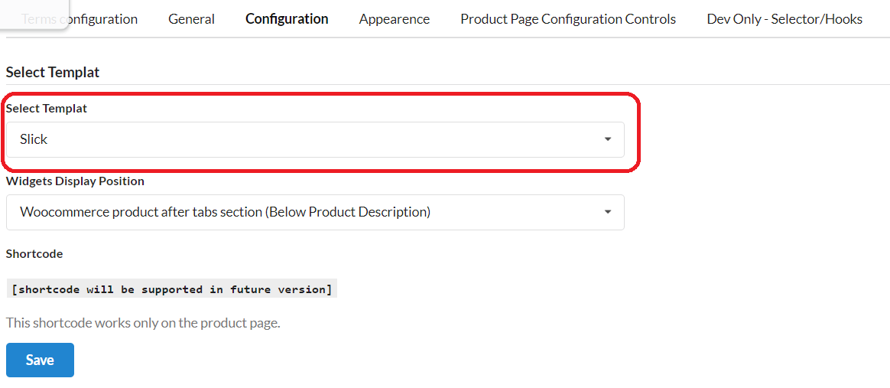

5. Product Page Configuration Controls
- (For the Origin attribute, there will not be any type of attribute so we need to create an Attribute in WooCommerce and configure its terms)
- After that, we need to set Attributes on the respective fields
- Now add Images and SVGs in terms of attributes like Diamond Size, Cut, Colour, Carat and Clarity from This_path
  - Go to Products in Attributes and search name ct
    - Then edit the Description and Diamond Explainer SVG path in Carat
    - Then edit Diamond Explainer SVG path in Cut
    - Then edit the Image in Colour

Issue something like irrelevant numbers are showing on the indicator if the slider explains the widget (It is because of an issue in the selection attribute field in the Product Page Configuration Page - So you need to select the proper field in extension configuration - Carat attribute)
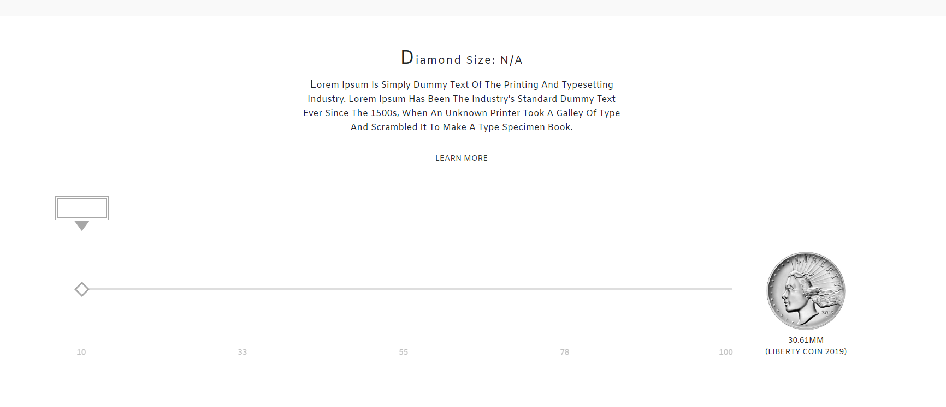
After setup all the configurations, if still there nothing displays for the explainer of a diamond then Change Widget Display Position from admin panel

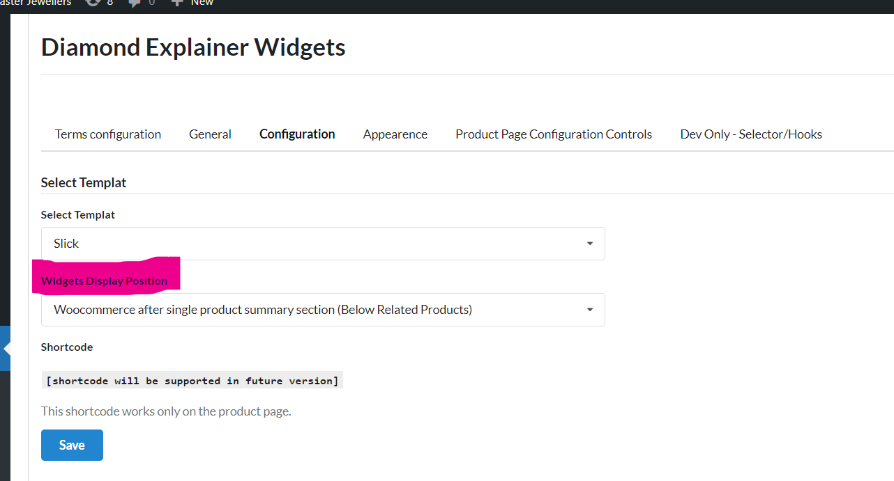

Additional Note: Delete the Controller Folder using FTP from sp_diamond_explainer/application path (MAKE SURE FOR NOT DELETE CONTROLLERS FOLDER)
And check for resolver_path and resolve it and save it
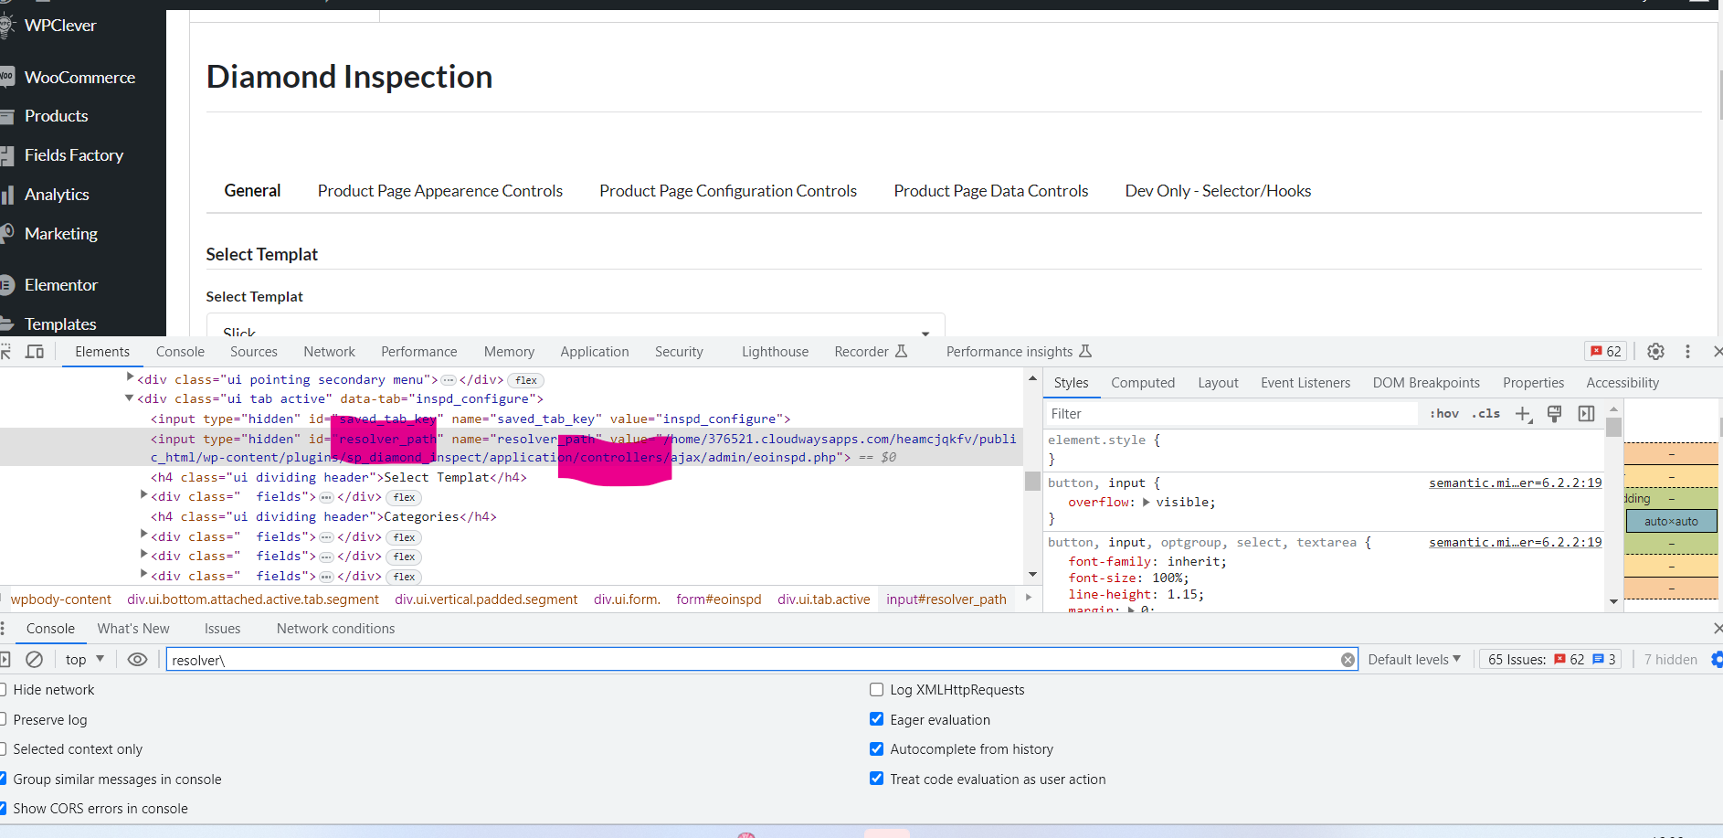

Absolute path
Print absolute path in root file of extension

<?php
$absolutePath = __FILE__;
echo "Absolute path of this file: " . $absolutePath;
?>

/home/u190182861/domains/ardordiamonds.com/public_html/staging/wp-content/plugins/sp_diamond_explainer/sp_diamond_explainer.php

After getting the absolute path of file, compare it with absolute path of admin controller by getting it from inspect element. And if the plugins folder path is different then copy the plugins folder path retrieved from file path and overwrite it on the inspect element path and then save. (only overwrite the path before the plugin folder means the path after the plugin folder is not need to be changed. It means the folders inside plugins folder and the php file name path will not be changed and only whatever is coming before plugin folder name will be changed. For more details look at the below example)
-> Example /home/u190182861/domains/ardordiamonds.com/public_html/staging/wp-content/plugins/sp_diamond_explainer/sp_diamond_explainer.php
In above example path the part need to be changed mean overwritten is “/home/u190182861/domains/ardordiamonds.com/public_html/staging/wp-content/plugins”

-> And make sure to overwrite in all inspect element where there is path in resolve field, if the resolver field is there but empty then you can skip that.
-> And during save make sure to save the tab that is general or configuration tab
If the user asks about these dummy text then need to follow the below steps to get it done

Origin
Diamonds are precious gemstones formed deep within the Earth`s mantle under immense pressure and heat. Over billions of years, carbon atoms have crystallized to create these dazzling gems. Volcanic eruptions then brought them closer to the Earth`s surface, where they were eventually discovered and mined, making diamonds one of the most sought-after and beautiful natural wonders on our planet.

Carat
A carat is the standard unit of measurement for a diamond`s weight, and it`s important to note that carat weight should not be confused with the physical size of the diamond. One carat is equivalent to 200 milligrams or 0.2 grams. The following scale provides a visual representation of how diamonds tend to increase in size as their carat weight goes up. It`s essential to keep in mind that although the size comparisons below are common, each diamond possesses its distinct characteristics.

Cut
The term `Cut` in the context of diamonds pertains to the precise angles and proportions of the gemstone. A diamond`s cut encompasses its shape, overall appearance, dimensions including depth and width, and the consistency of its facets. Essentially, the cut of a diamond plays a pivotal role in defining its aesthetic appeal. The level of expertise applied to a diamond`s cut is the key factor in how effectively it captures, reflects, and refracts light, ultimately determining its brilliance and visual allure.

Color
Color in a diamond refers to its inherent, unchanging hue. This natural coloration remains consistent throughout a diamond`s lifetime. Diamonds come in various colors, and the presence or absence of color significantly impacts their appearance. Colorless diamonds, in particular, permit a greater passage of light, resulting in heightened brilliance and a dazzling display of fire. When light enters a diamond, it acts as a prism, dispersing the light into a spectrum of colors and reflecting these colors as captivating flashes of brilliance, often referred to as fire.

Clarity
The clarity of a diamond pertains to the existence of imperfections both on the surface and within the stone. During the extraction of a raw diamond from deep within the Earth`s carbon-rich layers, minute traces of natural elements are invariably captured inside the gem. These internal and external imperfections are commonly known as inclusions.

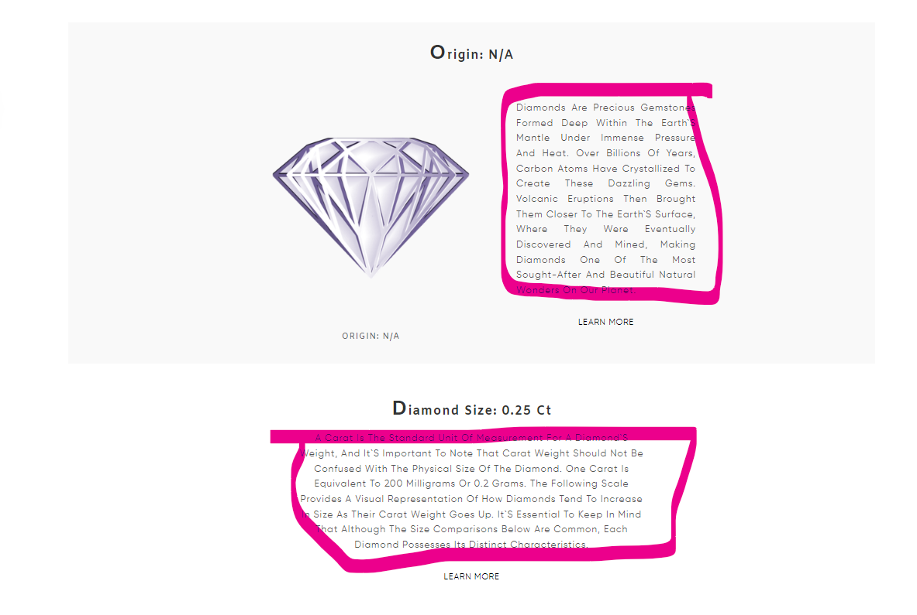
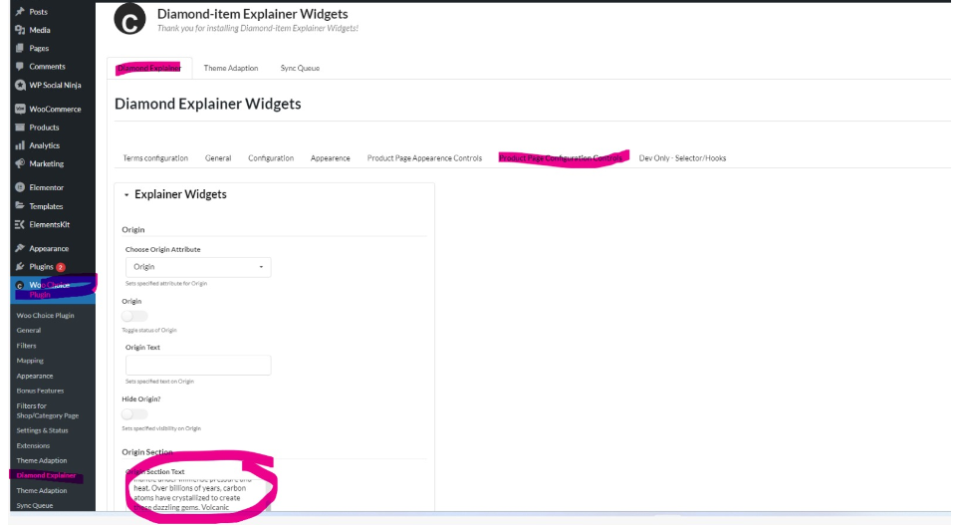
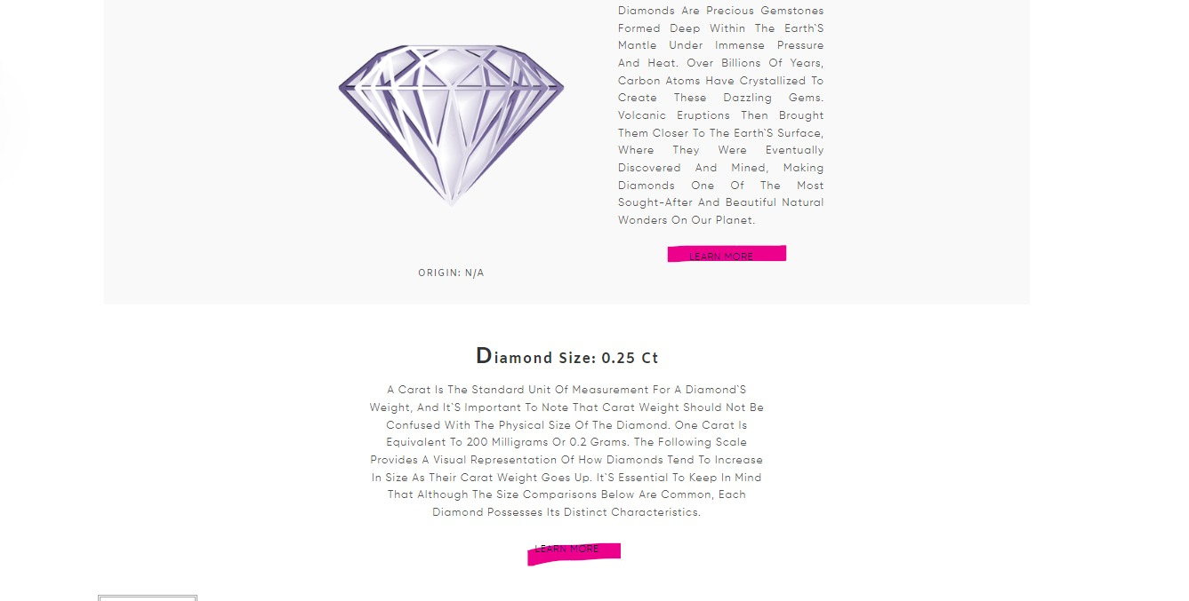
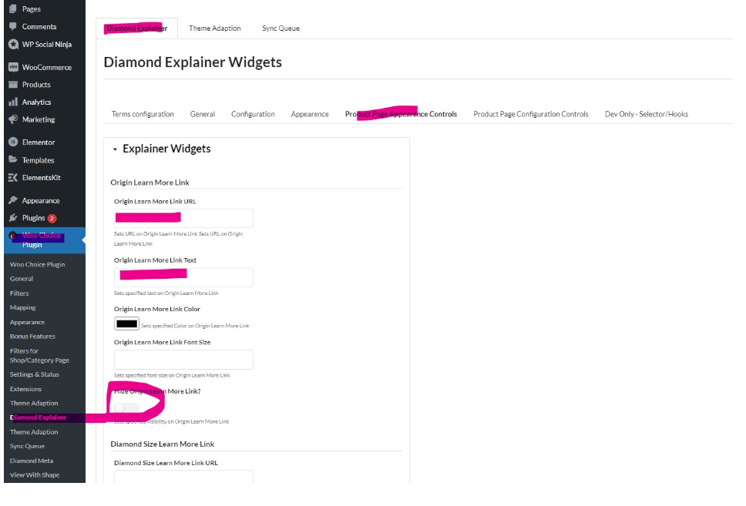

Origin Section Text

Diamonds are precious gemstones formed deep within the Earth`s mantle under immense pressure and heat. Over billions of years, carbon atoms have crystallized to create these dazzling gems. Volcanic eruptions then brought them closer to the Earth`s surface, where they were eventually discovered and mined, making diamonds one of the most sought-after and beautiful natural wonders on our planet.

Carat Section Text

A carat is the standard unit of measurement for a diamond`s weight, and it`s important to note that carat weight should not be confused with the physical size of the diamond. One carat is equivalent to 200 milligrams or 0.2 grams. The following scale provides a visual representation of how diamonds tend to increase in size as their carat weight goes up. It`s essential to keep in mind that although the size comparisons below are common, each diamond possesses its distinct characteristics.

Cut Section Text

The term `Cut` in the context of diamonds pertains to the precise angles and proportions of the gemstone. A diamond's cut encompasses its shape, overall appearance, dimensions including depth and width, and the consistency of its facets. Essentially, the cut of a diamond plays a pivotal role in defining its aesthetic appeal. The level of expertise applied to a diamond`s cut is the key factor in how effectively it captures, reflects, and refracts light, ultimately determining its brilliance and visual allure.

Color Section Text

Color in a diamond refers to its inherent, unchanging hue. This natural coloration remains consistent throughout a diamond`s lifetime. Diamonds come in various colors, and the presence or absence of color significantly impacts their appearance. Colorless diamonds, in particular, permit a greater passage of light, resulting in heightened brilliance and a dazzling display of fire. When light enters a diamond, it acts as a prism, dispersing the light into a spectrum of colors and reflecting these colors as captivating flashes of brilliance, often referred to as fire.

Clarity Section Text

The clarity of a diamond pertains to the existence of imperfections both on the surface and within the stone. During the extraction of a raw diamond from deep within the Earth`s carbon-rich layers, minute traces of natural elements are invariably captured inside the gem. These internal and external imperfections are commonly known as inclusions.

