0 Update and Upgrade Woo Choice Plugin
Woo Choice Plugin Update and Upgrade Instruction

1 Upload Or Upgrade Extension files using respective FTP

1.1 “master_QCed_bhavesh_1” branch should be uploaded

1.2 New upload ke update karta hoie tyare .git folders upload nahi karvana

1.3 .gitignore file pan upload nahikarvani

1.4 React related koi pan folder hoy asset ke assets to e upload nathi karvanu

2. Follow the Git Submodule document
2.1 This extension has the below submodule dependency
- sp_ssm_themes
- “master_QCed_bhavesh_1” branch should be uploaded
- Sp_ssm_variations
- “master_QCed_bhavesh” branch should be uploaded

3. In the Admin panel, Go to Plugins

3.1 Find the uploaded or upgraded plugin by its name from the plugins list and ensure it is activated if it is newly uploaded or upgraded.

3.2 Click on the Admin Panel of the Diamond Inspection
3.2.1 In General Tab
- Select Slick Template in “Select Appointment
- Select Diamond and Setting as Category

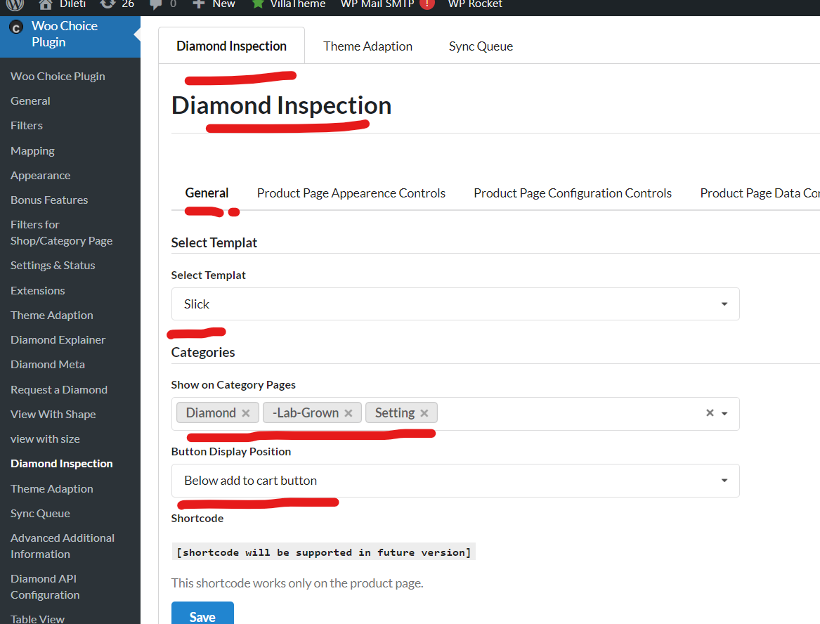
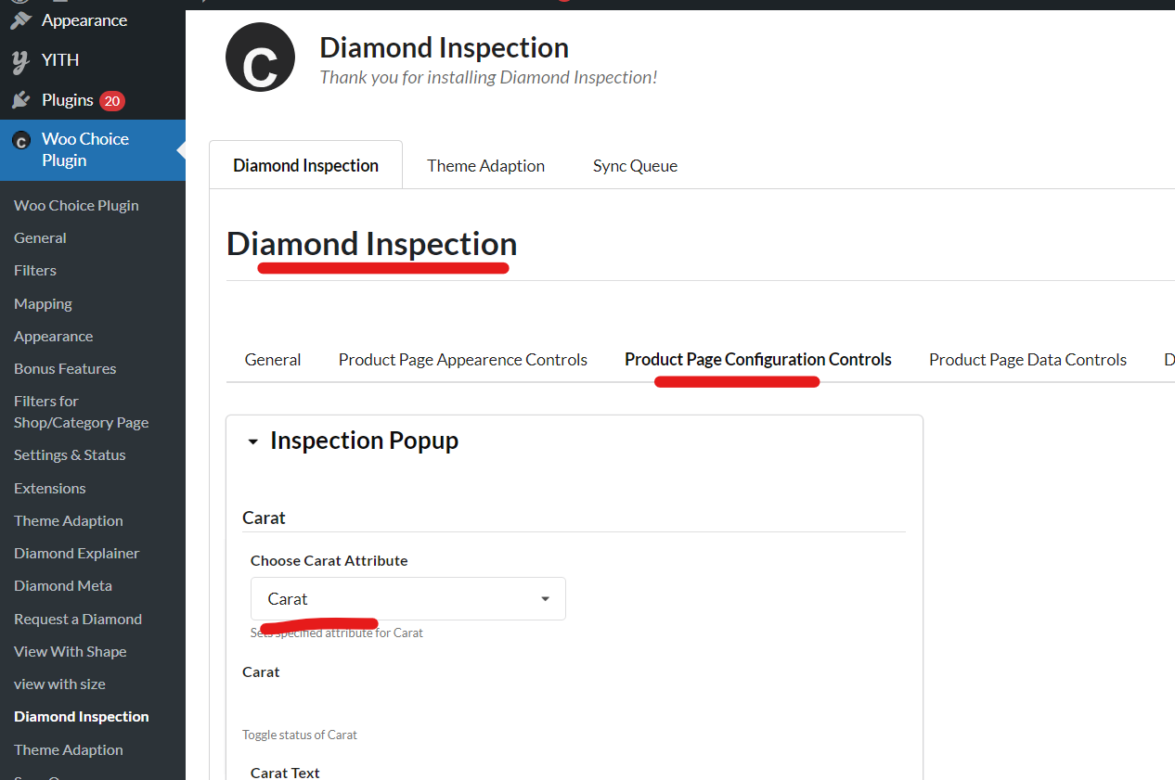
Note: Check if the error is due to wise chat then update the theme on the below path and extension’s submodule as well.
wp-content/themes/purple_theme/application/controllers/publics/pages/Content_Single_Product.php(4163):
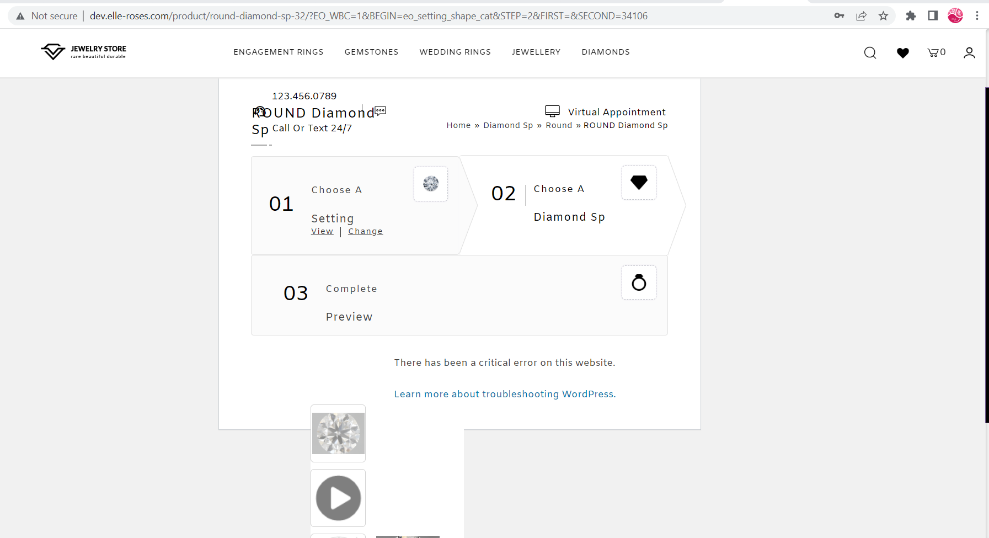

Note: Test properly for activated and setup plugin on the preview page of a ring or any other builder page respectively

Additional Note: Update product 360 using FTP

And check for resolver_path 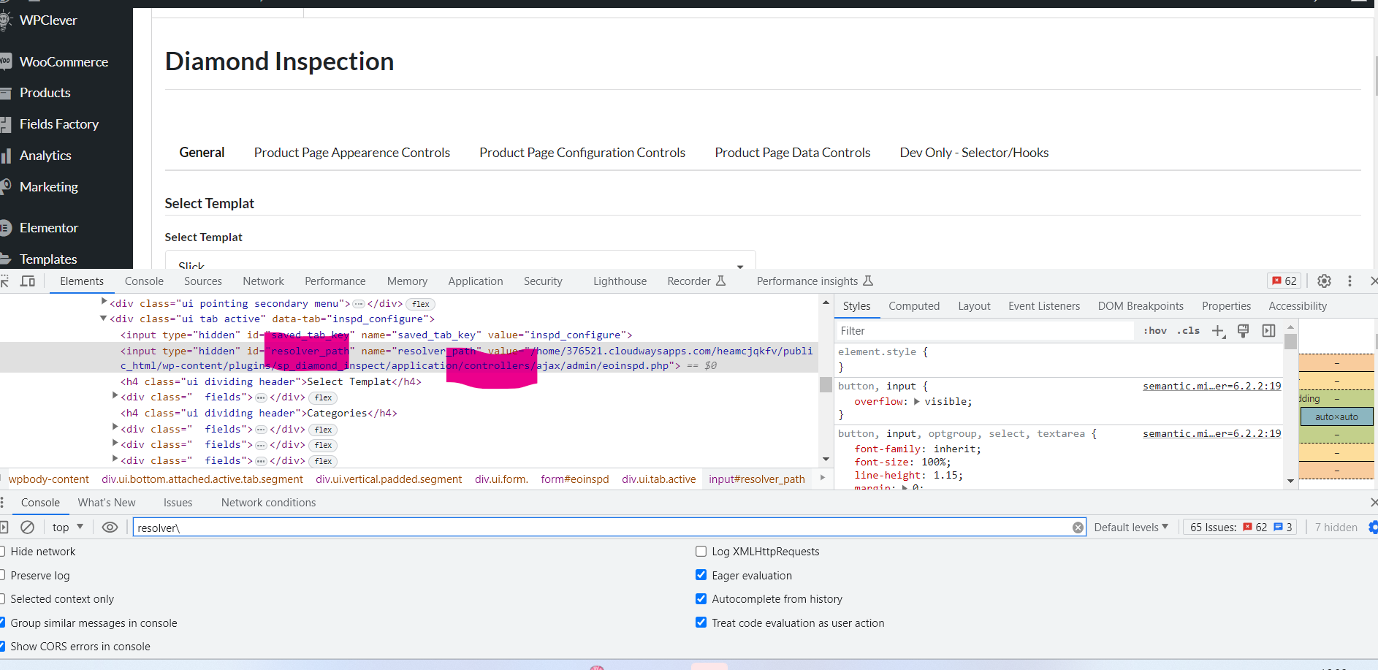and resolve it and save it

For the Login popup,
- You need to check the checkbox in admin from the below screenshot
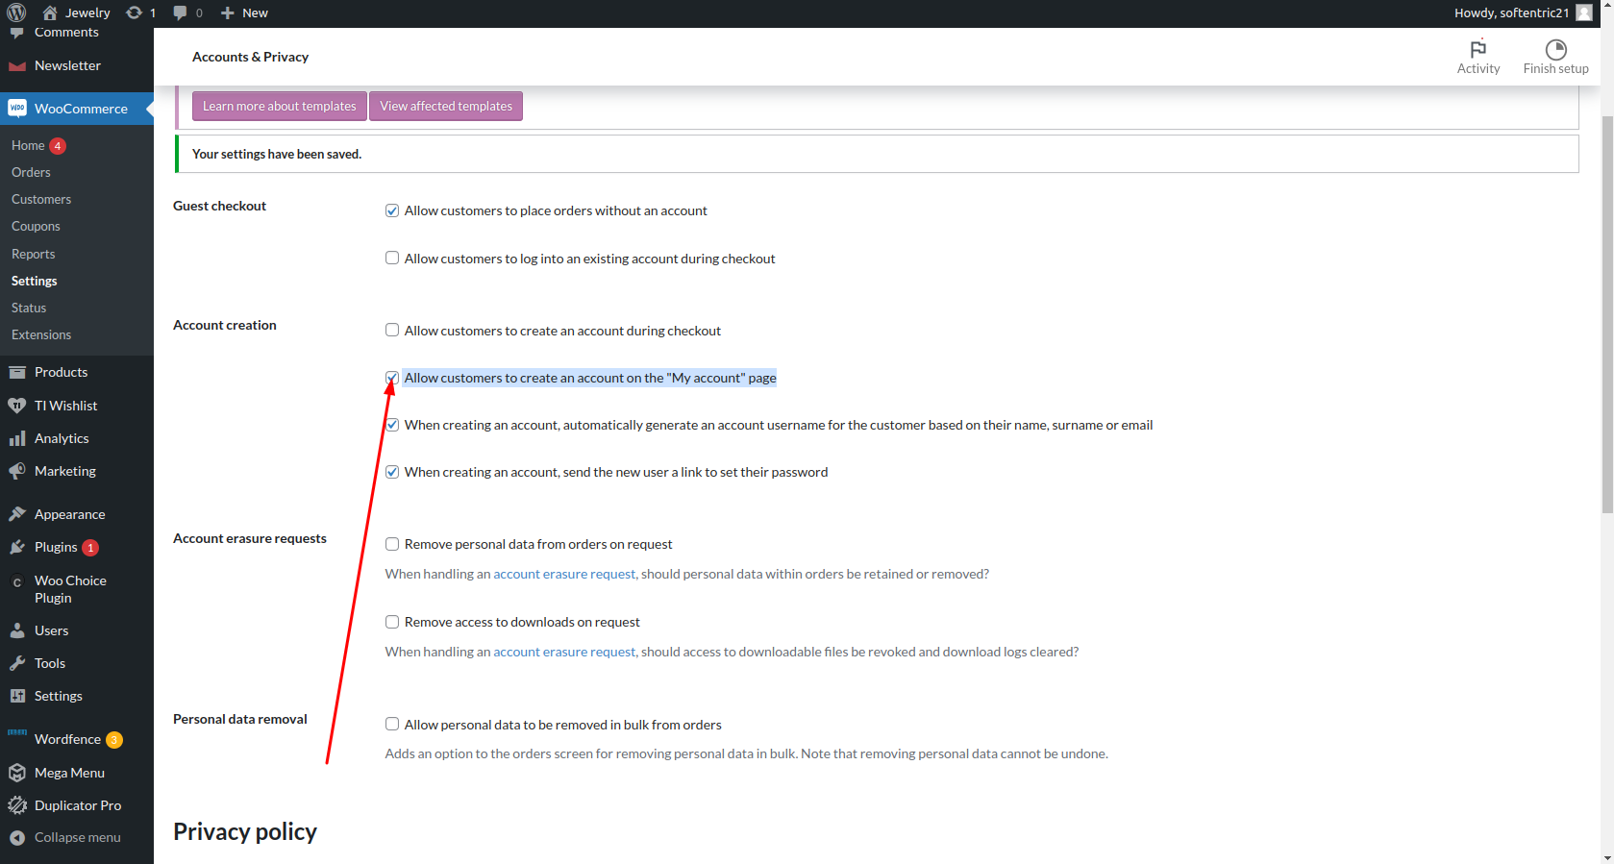

Note: Check for register flow

Diamond Inspection

check the Site folder for the plugin path
Check the Plugin file in which the issue was raised to the plugin path

inspect element ma Hidden input field ma s add karvano

If the server changes then we need to take the absolute path and replace it in resolver_path
Simply you need to dive into the root file of the extension
echo dirname(__FILE__);

"/home/1057263.cloudwaysapps.com/nnhqakfenh/public_html/wp-content/plugins/sp_diamond_inspect/application/controllers/ajax/admin/eoinspd.php"

Change it and try to save it from admin it will be resolved

If chat is not working in wise-chat in diamond/ring inspection extensions

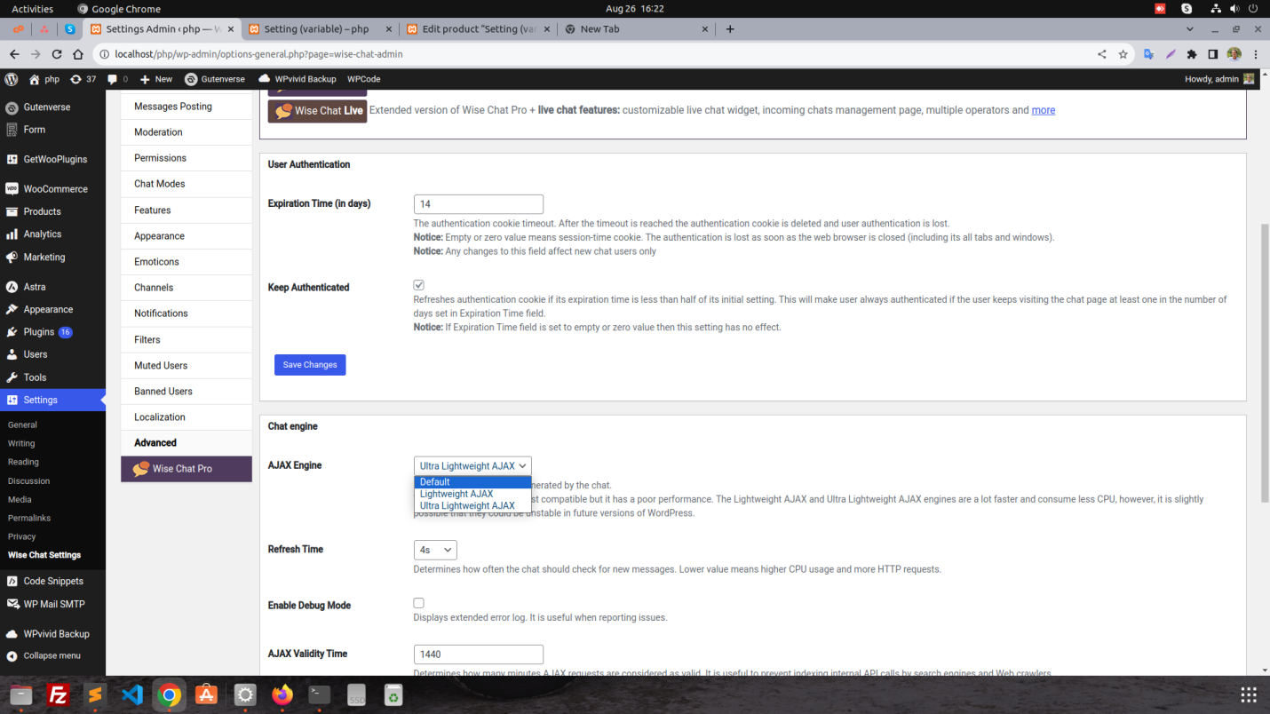
Login/Signup setting from admin panel for front-end

