Follow this video for complete installation and setup
https://youtu.be/gP5JfalDNEw

0 Update and Upgrade Woo Choice Plugin
Woo Choice Plugin Update and Upgrade Instruction

1 Upload Or Upgrade Extension files using respective FTP

1.1 “master_QCed_bhavesh_2” branch should be uploaded

1.2 New upload ke update karta hoy tyare .git folders upload nahi karvana

1.3 .gitignore file pan upload nahi karvani

1.4 React related koi pan folder hoy asset ke assets to e upload nathi karvanu

2. Follow the Git Submodule document
2.1 This extension has the below submodule dependency
- sp_ssm_variations
- “master_QCed_bhavesh” branch should be uploaded

3. In the Admin panel, Go to Plugins

3.1 Find the uploaded or upgraded plugin by its name from the plugins list and ensure it is activated if it is newly uploaded or upgraded.

3.2 Click on the Admin Panel of the Diamond Meta extension
- On configuration tab
You need to select relevant attributes or categories that are created in the admin panel or mapped in Diamond API from dropdown values as shown in the screenshot below and save the form from the admin panel and check on the front end on the diamond item page there are chart images on a thumbnail on the diamond item page
Select a template as the default
Diamond shape filed as Diamond
Select Table as Table
Select Girdle as Girdle
Select Culet as Culet
Select Depth as Depth
Select length as Length
Select width as width
Select Slider Thumb Index (length width) as 1st from the beginning
Slider Thumb Index (table depth) as 2nd from the beginning
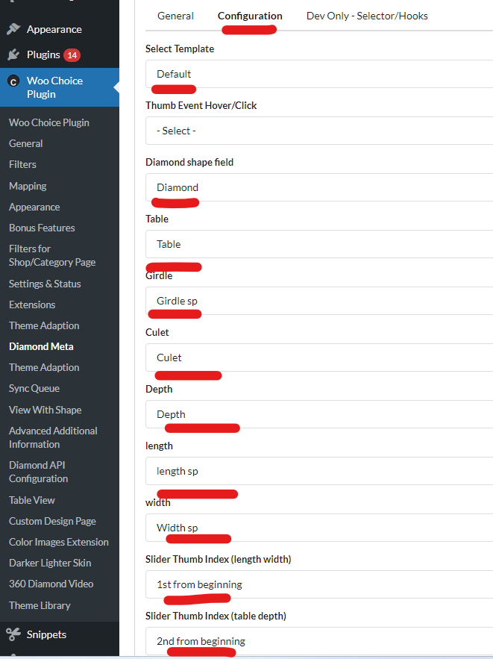

Note: For lab-grown/fancy diamonds follow the below instructions to see the diamond chart on the item page.

For chart images on lab-grown diamond
Diamond meta -> Diamond shape field and edit Lab-Grown(eo_lab_diamond_shape_cat)’s data category id remove 4 ____(underscore) and add - - - - with (eo_diamond_shape_cat) category id

