0 Update and Upgrade Woo Choice Plugin
Woo Choice Plugin Update and Upgrade Instruction

1 Upload Or Upgrade Extension files using respective FTP

1.1 “master_QCed_bhavesh_1” branch should be uploaded

1.2 New upload ke update karta hoie tyare .git folders upload nahi karvana

1.3 .gitignore file pan upload nahikarvani

1.4 React related koi pan folder hoy asset ke assets to e upload nathi karvanu

2. Follow the Git Submodule document
2.1 This extension has the below submodule dependency
- Sp_ssm_variations
- “master_QCed_bhavesh” branch should be uploaded

3. In the Admin panel, Go to Plugins

3.1 Find the uploaded or upgraded plugin by its name from the plugins list and ensure it is activated if it is newly uploaded or upgraded.

3.2 Click on the Admin Panel of the Earring Pendant builder extension
3.2.1 In General Tab
Select Slick Template
Enable Multi Builder Options
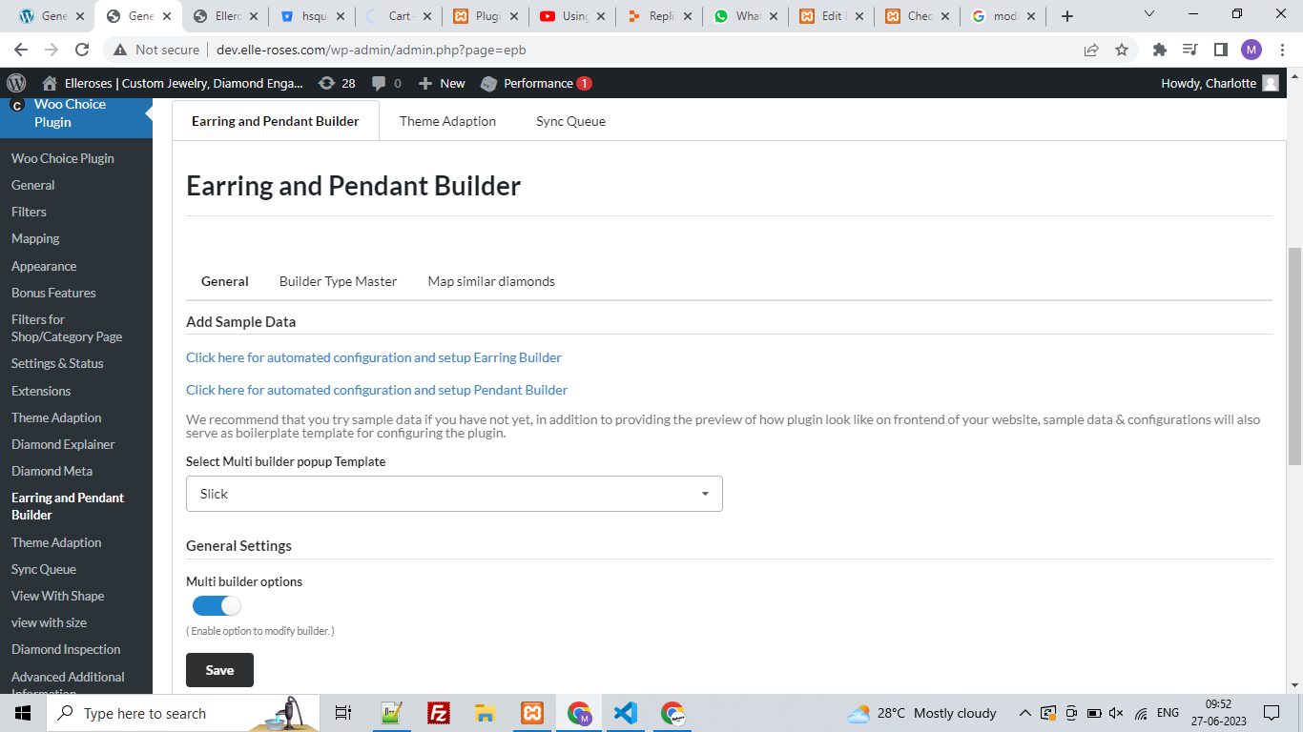
3.2.2 In Builder Type Master Tab
- Create 3 Builder Types as earrings, pendants, and bracelet
- Create Sample data of earrings, pendants, and bracelets one by one
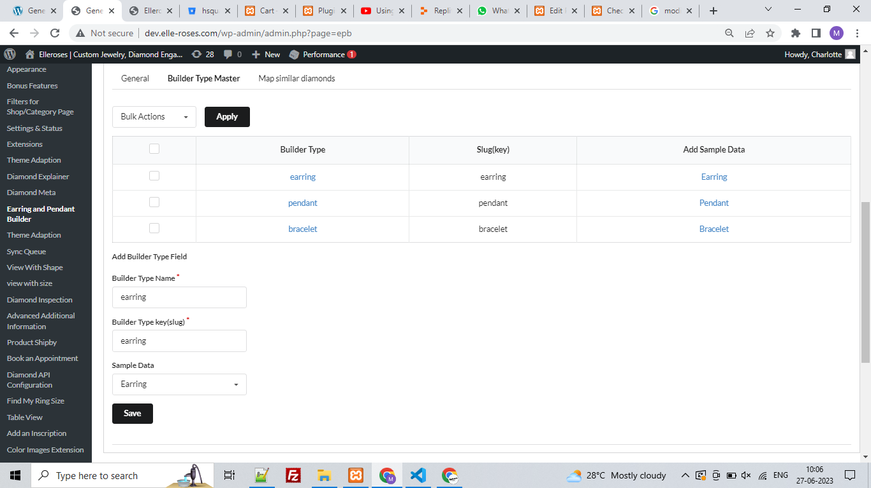
3.2 In Woo Choice Plugin
3.2.1 Go to the General Tab
- In Navigation Steps(earring Builder), Navigation Steps(Pendent Builder), Navigation Steps(Bracelet Builder) set name, icon and Template
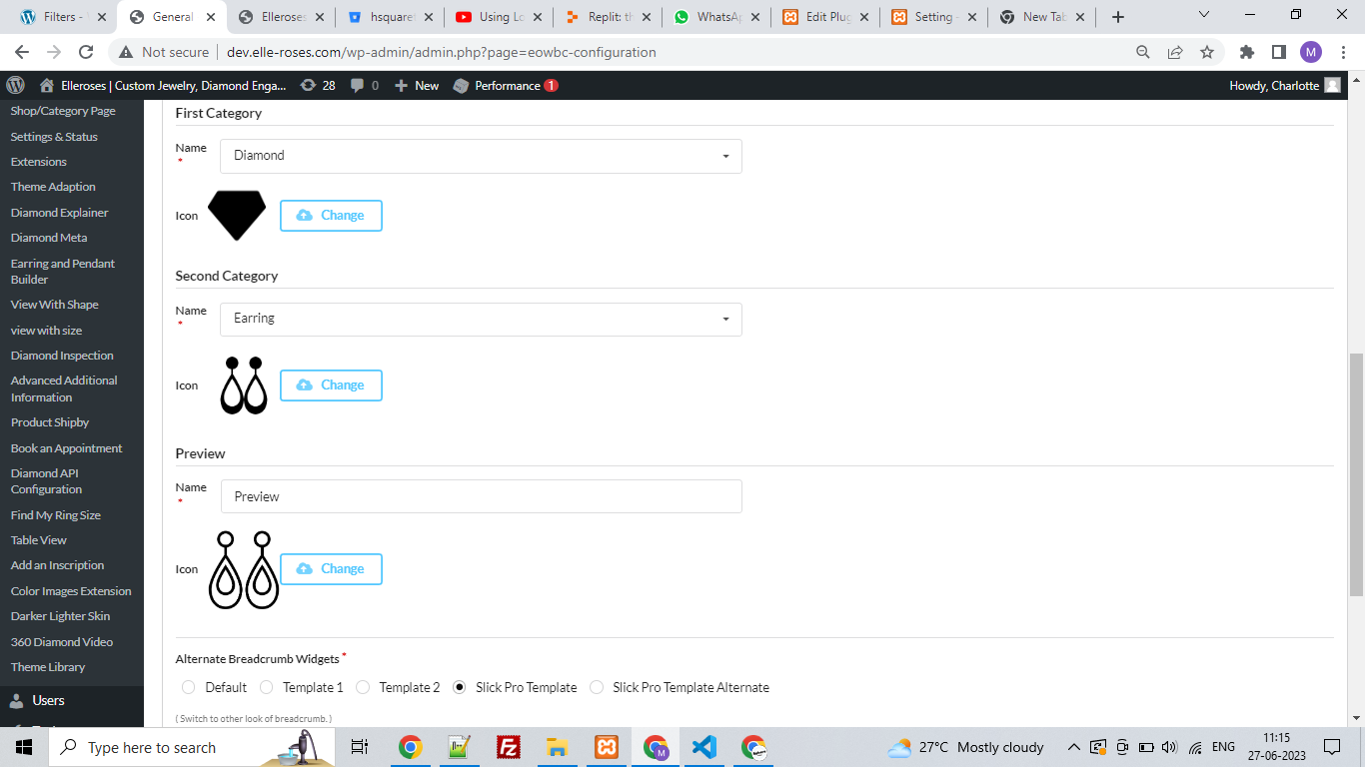
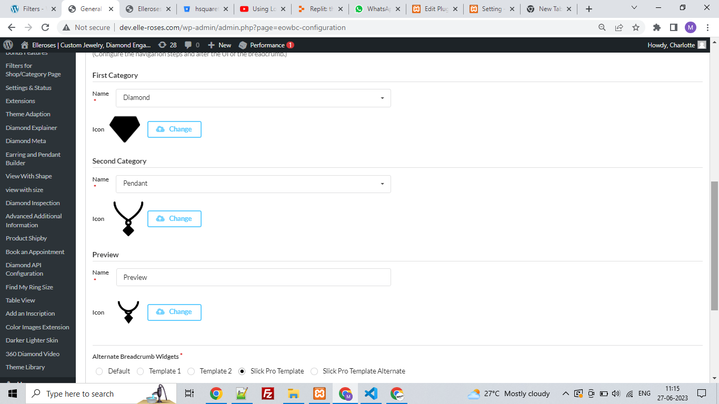
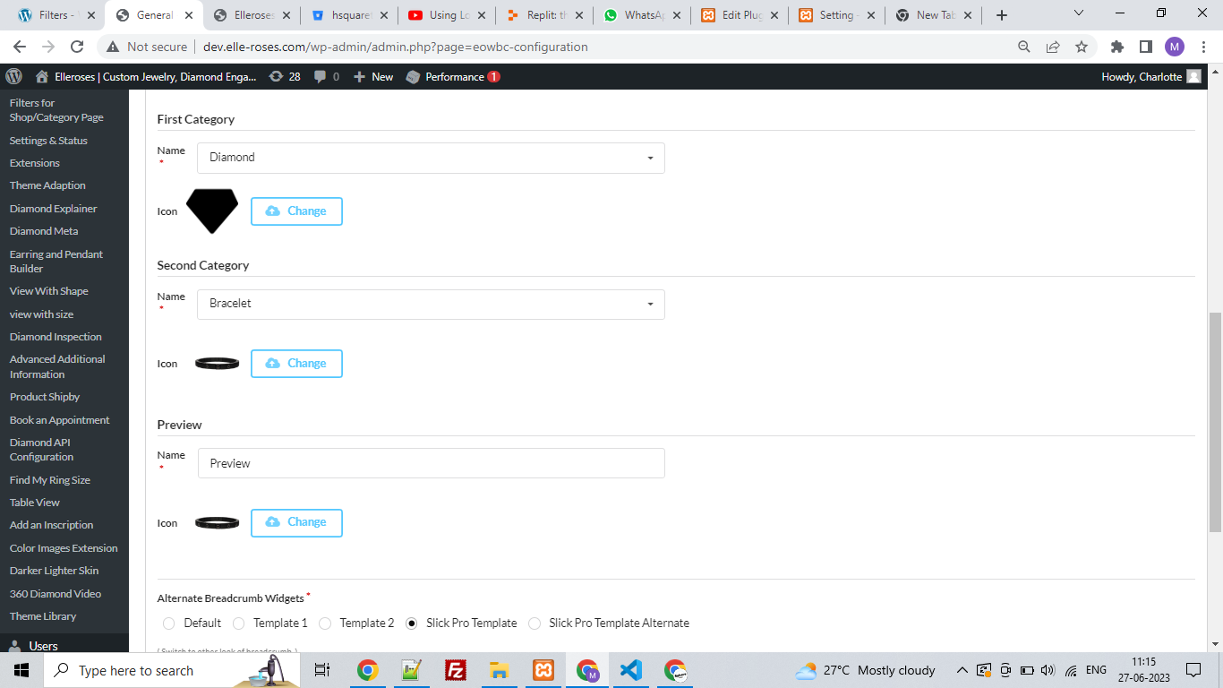
3.3.2 Go to Filters Tab
- In the Settings page Filter Configuration add filters
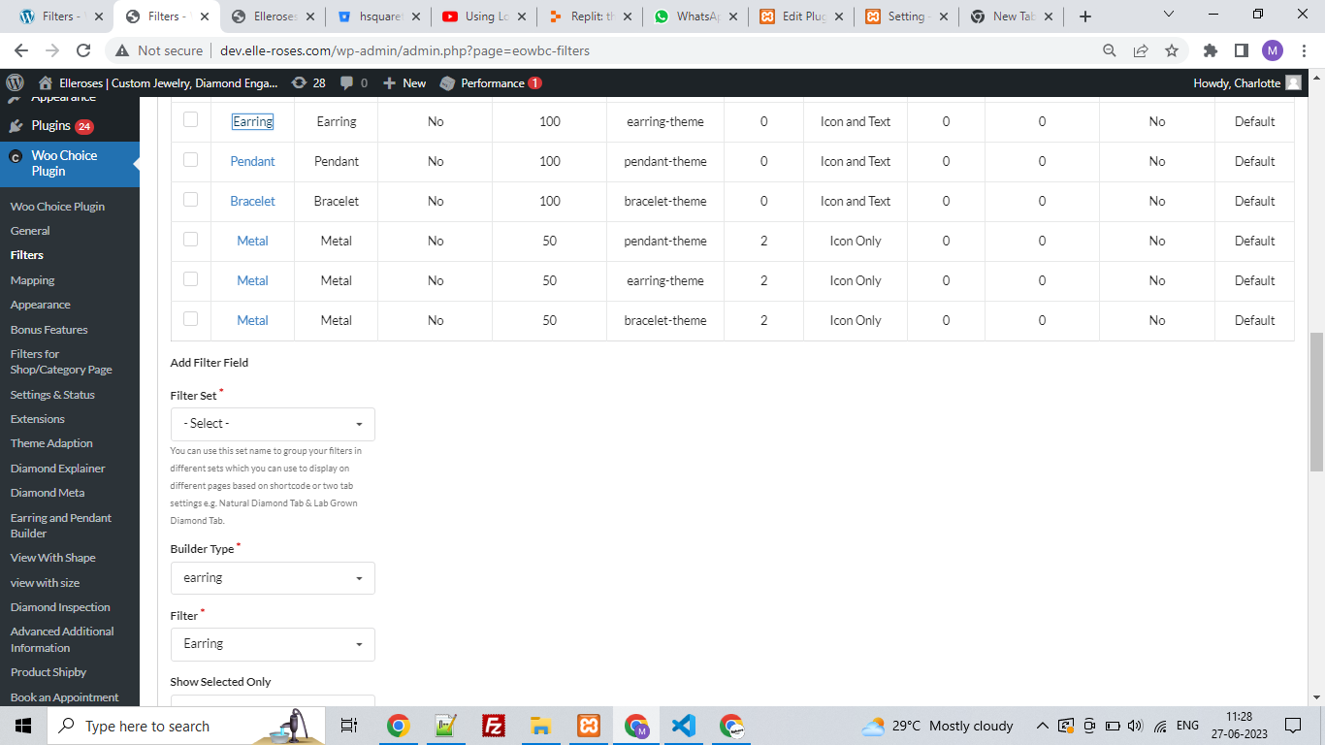
- In the Diamond page Filter Configuration add filters
- Polish, Symmetry, Fluorescence, Depth, Table, and Grading Reports are advanced Filters
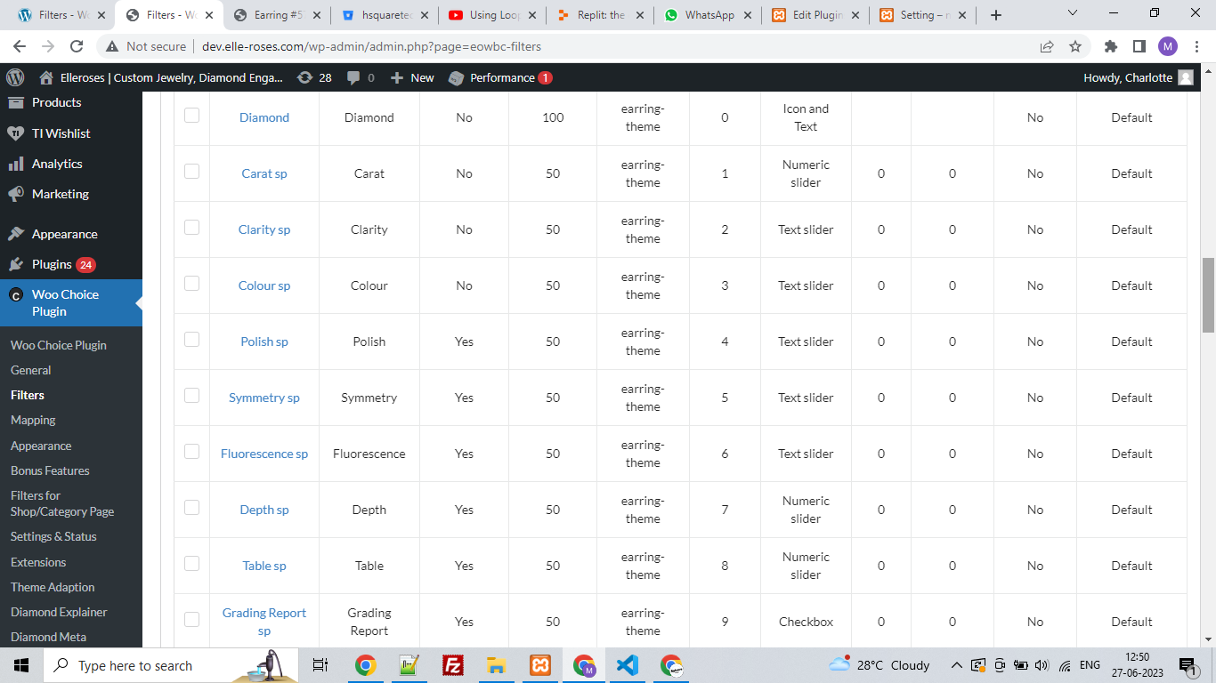
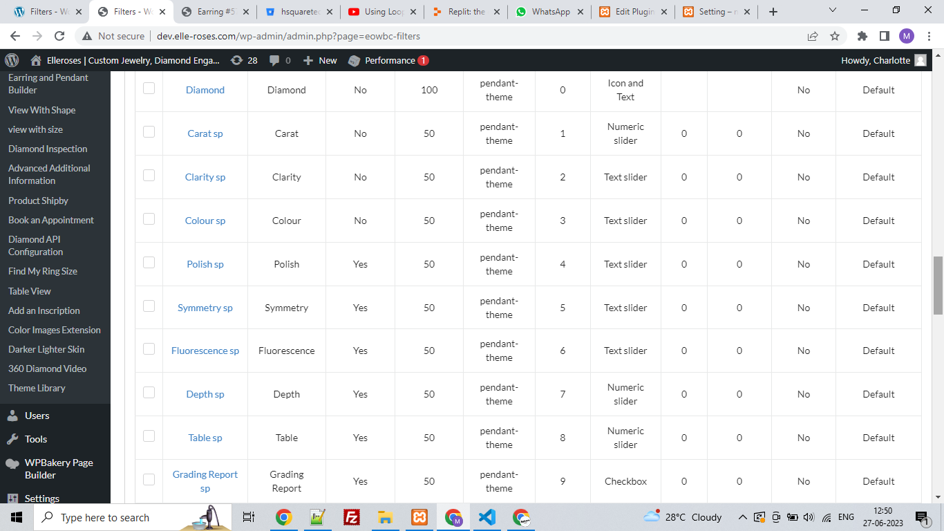
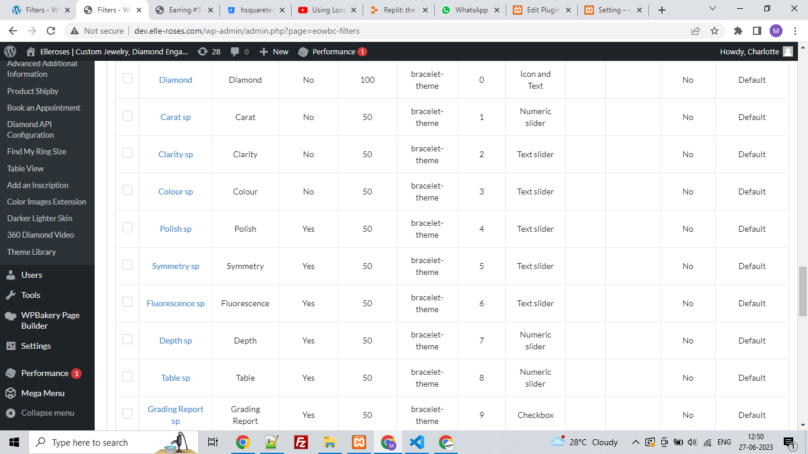

3.3.2 You need to set the respective builder in the mapping section in Woo bundle choice to set up the earring pendant bracelet builder properly function.
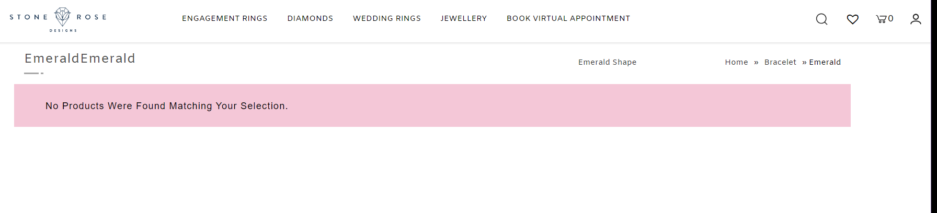

Note: Test properly for activated and setup plugin on the preview page of a ring or any other builder page respectively on the selected category.

Filters and not coming in in earring, pendant, bracelet builder process

After adding sample data of earrings, pendants, bracelets etc. builder, needs to set the builder type in respective mapping and update it vice-versa.

Jyare earring pendant builder setup thai jaay and product cart ma add na thati hoy toh neche na steps follow karvana

