STARTUP VALIDATION REPORT
BHUMIPUTRA
AI-Powered Smart Soil Analysis & Crop Recommendation Platform
Confidential | Prepared for Founder Review | July 2026
Prepared by: AI Startup Advisory & Market Research Desk
Methodology: Founder interview inputs, public market research (IMARC, Grand View Research, Research & Markets), and competitive intelligence on India's AgriTech sector

1. Executive Summary
Bhumiputra is an early-stage, pre-revenue AgriTech prototype built by a solo Computer Science Engineering student, applying AI-based image classification to solve a well-documented and economically significant problem in Indian agriculture: farmers' limited access to affordable, timely soil analysis and crop guidance. The core technology — soil image classification paired with crop, fertilizer, and organic pesticide recommendations — targets a real gap experienced by India's ~146 million farm holdings, over 85% of which are small and marginal.
The project has cleared technical validation (a working Streamlit prototype, a trained classification model, and positive academic review) but has not yet been tested with real farmers, has no paying or active users, and currently has one founder with strong AI/ML skills but limited agricultural domain expertise or distribution network. This places Bhumiputra at the pre-seed / pre-traction stage — technically credible, commercially unproven.

Key Findings
- Problem is validated by third-party market and government data (soil testing access gaps, fertilizer misuse, and yield losses are well-documented in India), but not yet validated directly with target farmers.
- The competitive landscape is active and well-funded (Plantix, AgroStar, DeHaat, CropIn, BharatAgri, Fasal), but concentrated on leaf/plant disease diagnosis and input marketplaces — a dedicated, low-cost, soil-first AI classification workflow remains a relatively open niche.
- Monetizing directly with smallholder farmers (B2C) is historically difficult in this market; most successful players monetize via input marketplaces, B2B/B2G data contracts, or freemium-to-services funnels, not subscription fees from farmers.
- Founder-Market Fit is moderate: high on technical capability and mission-driven motivation, but low on agricultural domain expertise, farmer trust, and distribution access — all of which are fixable through structured field validation.

Overall Verdict
CONDITIONAL GO — proceed to structured farmer validation and pilot testing before committing to fundraising or full-time build.

2. Problem Validation
The problem Bhumiputra addresses — poor soil-crop matching due to inaccessible or expensive testing — is well-supported by external evidence, even though Bhumiputra has not yet run its own farmer interviews.
Validation Type | Status
Secondary / Market Evidence | Strong. Government soil health card programs, precision-agriculture market reports, and agronomic literature confirm that soil testing access, cost, and turnaround time are systemic pain points for Indian smallholders.
Primary / Direct Farmer Evidence | Not yet collected. No farmer interviews, surveys, or usage data exist outside of academic demonstration.
Expert / Mentor Validation | Positive. Faculty mentors and academic reviewers have validated the technical approach and problem framing.
Product Validation | Partial. A functional prototype with a trained soil classification model exists, but has not been stress-tested on diverse, real-world field images.
Table 1: Validation status across evidence types
Recommendation: The single highest-leverage next step is not more building — it is running 20-30 structured conversations and live demos with real farmers (ideally across 2-3 soil-diverse regions) to test willingness-to-use, trust in AI recommendations, and willingness-to-pay, before further feature investment.

3. Founder-Market Fit Score
Founder-market fit measures how well-positioned the founder is to win in this specific market — combining skill, credibility, access, and motivation. Bhumiputra's founder brings strong technical capability and mission alignment, but not yet the agricultural network or resources that reduce execution risk.
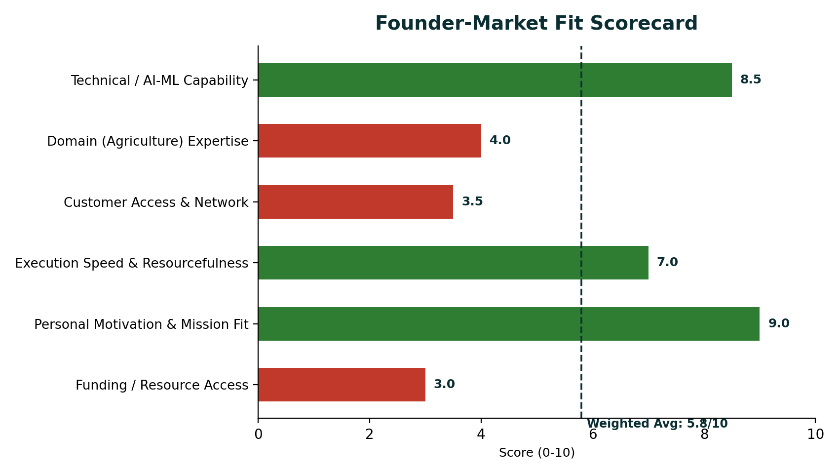
Figure 1: Weighted Founder-Market Fit score of 5.8 / 10 — technically strong, domain- and network-thin
Criterion | Score | Rationale
Technical / AI-ML Capability | 8.5 / 10 | Demonstrated ability to build and train an image classification model end-to-end and ship a working web app.
Domain (Agriculture) Expertise | 4.0 / 10 | No stated farming background; domain knowledge appears academic/research-based rather than lived experience.
Customer Access & Network | 3.5 / 10 | No existing farmer community, agri-dealer, or NGO relationships mentioned yet.
Execution Speed & Resourcefulness | 7.0 / 10 | Built a working AI prototype solo as a student project — strong evidence of shipping ability.
Personal Motivation & Mission Fit | 9.0 / 10 | Clear, genuine social-impact motivation tied to India's agricultural economy.
Funding / Resource Access | 3.0 / 10 | No funding, team, or institutional backing yet; single-founder, side-project resourcing.
Table 2: Scoring rationale by criterion
Interpretation: A 5.8/10 is typical and healthy for a technically-founded, pre-traction student project. The gap is not ability — it is farmer access and domain credibility, both of which can be closed within 60-90 days through structured field visits, partnerships with Krishi Vigyan Kendras (KVKs) or agricultural universities, and an advisory relationship with a practicing agronomist.

4. TAM, SAM, SOM Analysis
Market sizing below is built bottom-up from India's ~146 million agricultural operational holdings (Agriculture Census) and top-down from third-party AgriTech market valuations (IMARC Group, Grand View Research, Research & Markets). Figures should be treated as directional estimates for an early-stage plan, not audited projections.
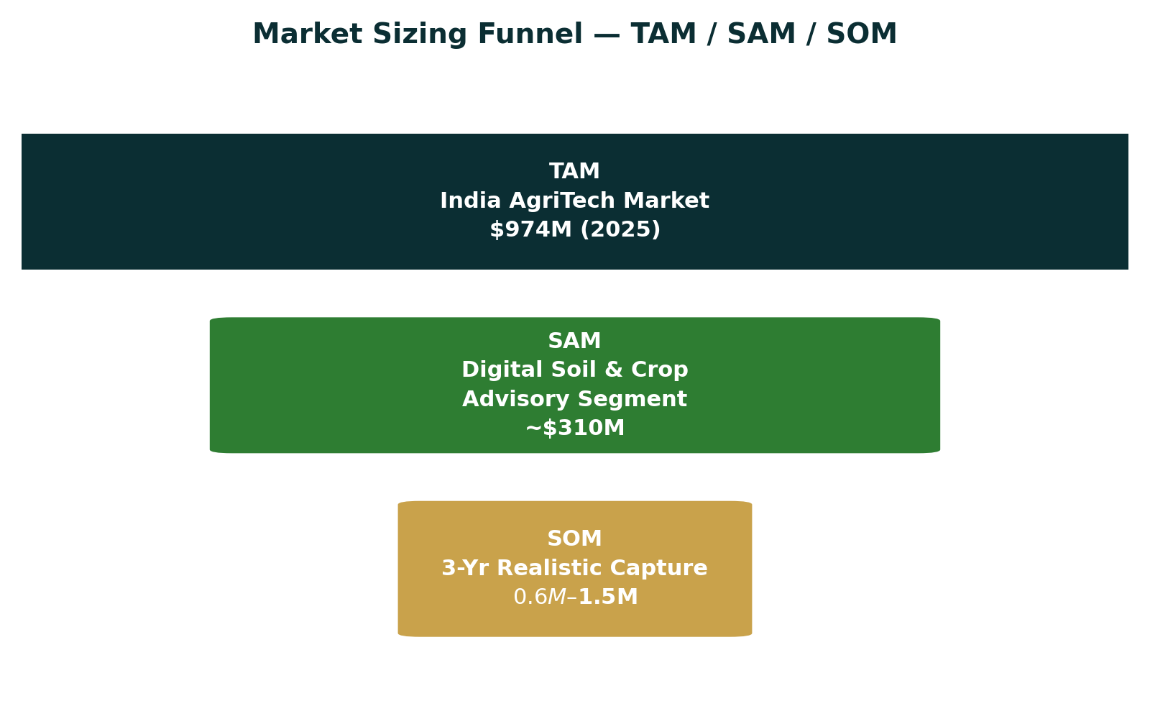
Figure 2: Market sizing funnel from total addressable market to realistic 3-year capture
Layer | Estimate | Basis
TAM | $974M (2025) → $2.52B by 2034 (10.6% CAGR) | Total India AgriTech market size, per IMARC Group — includes all digital agriculture spend (advisory, marketplaces, fintech, IoT).
SAM | ≈ $300–340M | Estimated 30–35% slice of TAM attributable to smartphone-based crop/soil advisory and precision-farming decision support relevant to smallholders — the segment Bhumiputra can realistically serve.
SOM | $0.6M – $1.5M ARR potential (Year 3) / ~50,000–150,000 active farmer users | A 0.1–0.3% capture of SAM within 3 years via freemium app adoption plus limited B2B/NGO pilot contracts — a realistic range for a bootstrapped early-stage entrant.
Table 3: Market sizing detail and assumptions
Context: India has approximately 146 million operational agricultural landholdings, of which over 85% are small and marginal (under 2 hectares) — precisely the segment least served by formal soil-testing infrastructure and most price-sensitive to paid advisory services. This scale is the opportunity; the fragmentation and low willingness-to-pay of this segment is the core monetization challenge (see Risk Assessment).

5. Competitor Analysis
India's AgriTech advisory space is active and includes several well-funded, high-user-count players. None currently lead with soil-image classification as the core entry point — most lead with leaf/plant disease detection or B2B farm-management SaaS.
Player | Core Offering | Strength | Gap vs. Bhumiputra | Scale
Plantix | AI plant disease/pest diagnosis from photos | Free, multi-language, 1M+ India users, strong brand trust | Diagnoses plant symptoms, not soil type; limited fertilizer/soil-specific guidance | Large
AgroStar | Crop advisory + input marketplace | 10M+ farmers, agronomist-backed advice, 11 languages | Advisory is human/agronomist-driven, not AI-soil-classification-led; revenue tied to input sales | Very Large
DeHaat | End-to-end platform: advisory, inputs, credit, market linkage | Full-stack rural commerce + fintech, deep field network | Broad platform play, not a focused soil-AI tool; high infrastructure cost | Very Large
CropIn | Enterprise/B2B farm data & satellite analytics SaaS | Strong in B2B/B2G contracts, satellite-based intelligence | Not farmer-facing B2C; not accessible to individual smallholders | Enterprise
BharatAgri | AI advisory bundled with agronomy consultancy | Personalized crop calendars, human-in-the-loop support | Service-heavy model, harder to scale cheaply; not soil-image-first | Mid
Fasal | IoT sensor-based microclimate & irrigation advisory | High precision for high-value/horticulture crops | Hardware-dependent, cost-prohibitive for small/marginal farmers | Niche
Bhumiputra | AI soil-image classification + crop, fertilizer & organic pesticide recommendation | Zero-hardware, instant, soil-first workflow purpose-built for smallholders | — | Pre-launch
Table 4: Competitive landscape summary
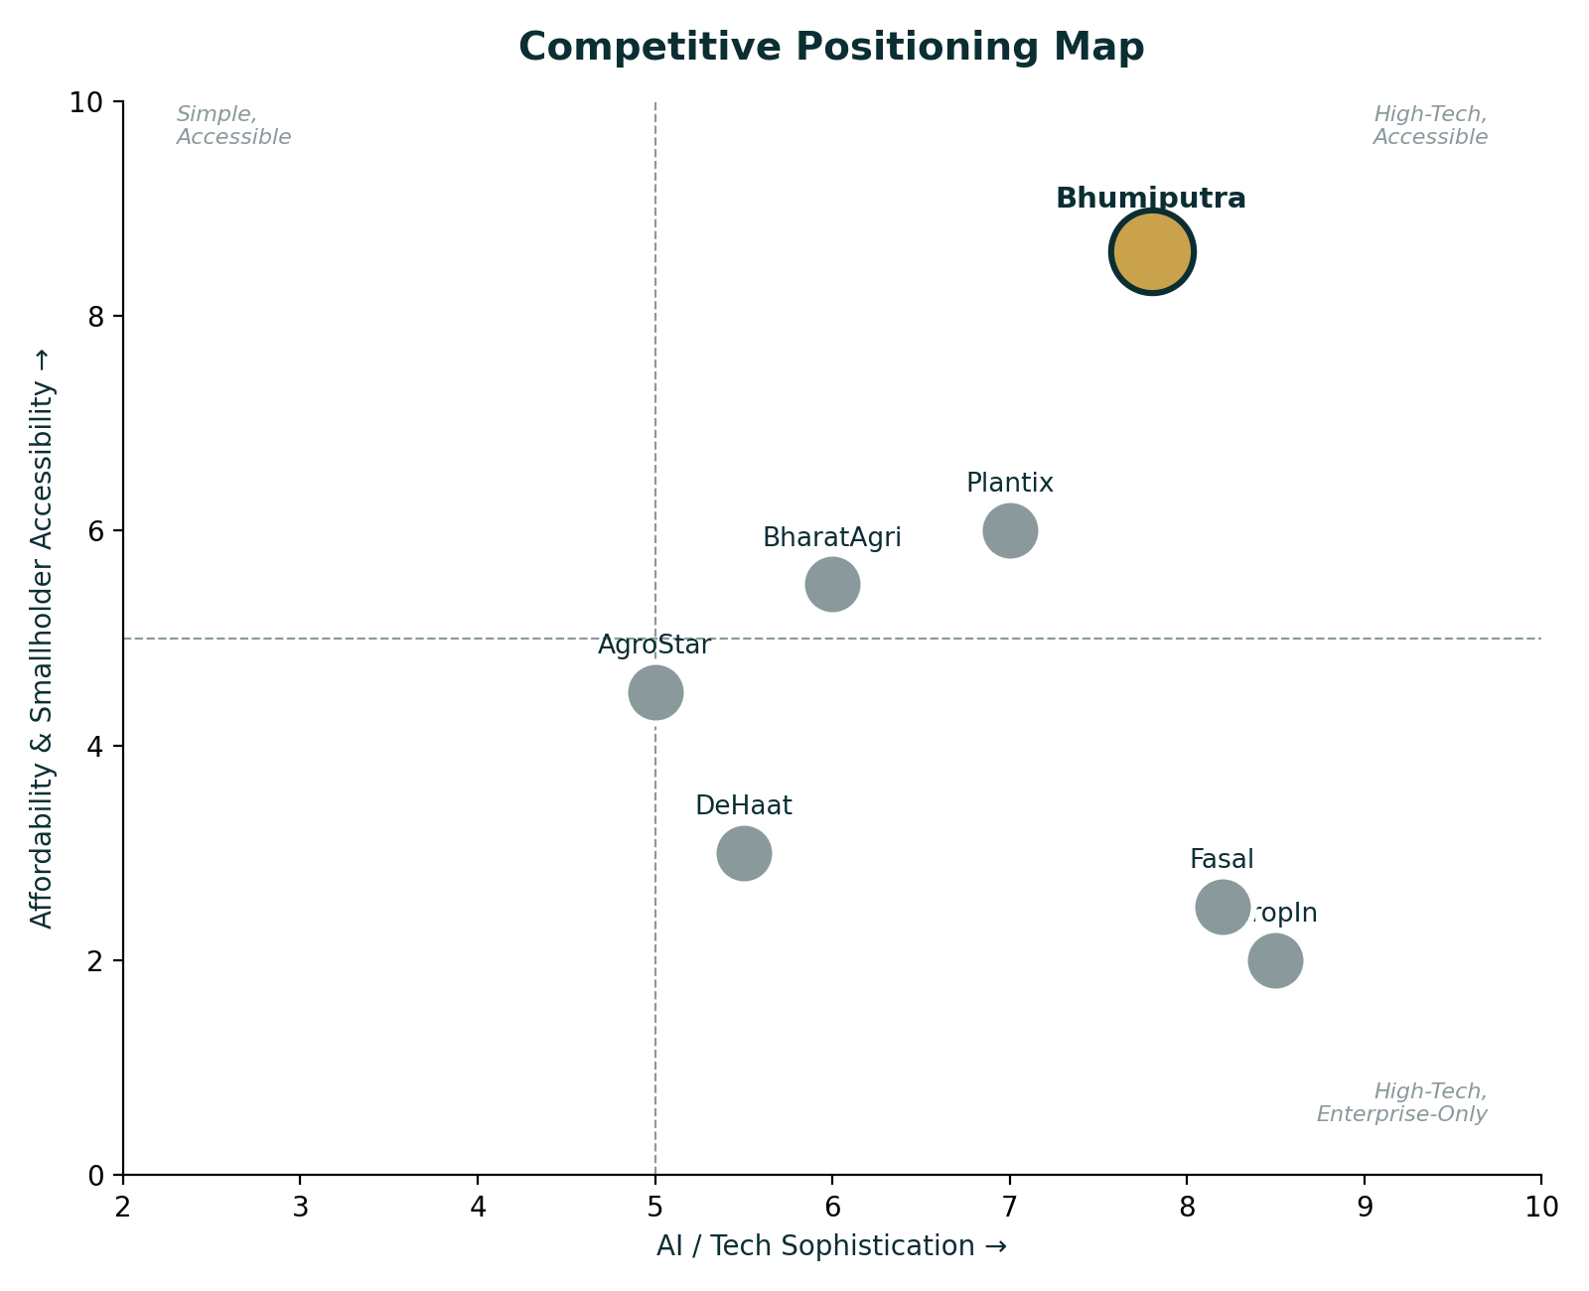
Figure 3: Competitive positioning — AI sophistication vs. affordability/accessibility for smallholders

6. Market Gap Analysis
- Soil-first, not symptom-first: Most AI agri-tools diagnose visible plant/leaf problems after they occur. Bhumiputra's soil-first approach is preventive — helping farmers choose the right crop and inputs before planting, reducing loss rather than reacting to it.
- Formal soil testing is scarce and slow: Government soil testing labs are unevenly distributed, and turnaround can take weeks — long enough to miss a planting window. An instant, photo-based alternative addresses a real infrastructure gap.
- Fertilizer misuse is a known, costly problem: Imbalanced or excessive fertilizer use — often due to guesswork rather than soil data — raises costs and degrades soil health over time; recommendation engines tied to actual soil type directly target this.
- Zero-hardware barrier to entry: Unlike IoT/sensor-based competitors (e.g., Fasal), a smartphone-camera-only approach removes the upfront hardware cost that excludes most small and marginal farmers.
- White space in organic/low-cost input guidance: Few incumbents combine soil analysis with organic pesticide guidance specifically, which is increasingly relevant given growing government and consumer interest in sustainable farming.

7. Ideal Customer Profile (ICP)
Attribute | Profile
Primary segment | Small and medium-scale farmers (0.5–4 hectares) in India, cultivating staple or cash crops (e.g., wheat, rice, cotton, vegetables)
Digital readiness | Owns or has household access to an Android smartphone; basic comfort with WhatsApp/YouTube-level apps; may need voice/vernacular support
Geography (initial) | States with strong smartphone penetration + active agri-extension ecosystems: e.g., Maharashtra, Uttar Pradesh, Punjab, Karnataka, Madhya Pradesh
Behavioral marker | Already seeks farming advice informally — from input dealers, WhatsApp groups, YouTube, or local Krishi Vigyan Kendra — signaling openness to new advisory channels
Pain intensity | Has experienced a yield loss, high input cost, or crop failure they attribute to wrong crop-soil match or fertilizer misuse in the last 1–2 seasons
Secondary segment | Agricultural consultants, agri-input retailers, NGOs, and university extension programs seeking a tool to scale their own advisory reach
Table 5: Ideal Customer Profile

8. Buyer Persona
Persona: “Ramesh, the Progressive Smallholder”
Age / Role | 34, owns and farms 2.5 acres; also helps manage his father's adjoining land
Location | Semi-rural village, ~20km from a district town, Maharashtra
Tech behavior | Owns a mid-range Android phone; uses WhatsApp daily, watches farming YouTube channels, part of 2–3 farmer WhatsApp groups
Goals | Increase yield and income per acre; reduce wasted spend on fertilizer and pesticide; be seen as “modern” and forward-thinking by peers
Frustrations | Last soil test took 3 weeks to return results and required a trip to a district office; local dealer's fertilizer advice is sales-driven, not soil-specific
Trust drivers | Peer recommendation, local language support, visible proof (photos/testimonials of other farmers' results), endorsement from a known agri-institution
Willingness to pay | Low for a standalone subscription; higher if bundled with tangible input savings, a free core tier, or delivered through a trusted intermediary (dealer, KVK, NGO)
Table 6: Primary buyer persona

9. Customer Pain Points
- Soil testing is slow, distant, and often inaccessible — labs are unevenly distributed and turnaround can exceed the planting window.
- Fertilizer and pesticide decisions are frequently guesswork or dealer-influenced, driving up costs and reducing soil health over time.
- Crop selection is often based on tradition or neighbor behavior rather than actual soil suitability, leading to yield underperformance.
- Access to a qualified agronomist is limited, especially for small and marginal farmers who cannot justify private consultancy costs.
- Language and literacy barriers make many existing digital tools difficult to use without local-language, visual-first design.
- Low trust in “black-box” AI advice without clear reasoning, local validation, or a trusted human touchpoint.

10. Buying Triggers & Objections

Buying Triggers
- A recent poor harvest or visible crop stress that the farmer cannot explain
- Rising input costs that make the farmer receptive to cost-saving guidance
- Seeing a neighboring or peer farmer achieve a visibly better yield using the tool
- Government or NGO-led digital literacy or precision-farming campaigns creating awareness and trust
- Start of a new planting season — the natural decision window for crop and input choices

Common Objections
Objection | Response Strategy
“I already know my soil from experience.” | Position as a second opinion / confirmation tool, not a replacement for farmer knowledge — reduces ego friction.
“Can I trust an app's advice over my dealer's?” | Combine AI output with transparent reasoning and third-party (KVK/university) endorsement to build credibility.
“Why would I pay when free apps like Plantix exist?” | Lead with a strong free tier; monetize via B2B/institutional channels rather than direct farmer subscriptions early on.
“I don't have reliable internet in my field.” | Design for offline capture + sync-when-connected, and keep the app lightweight for low-end devices.
Table 7: Objections and mitigation strategy

11. Customer Journey
Stage | Farmer State | Bhumiputra's Role
Awareness | Hears about the app via a KVK session, agri-dealer, NGO, or WhatsApp/YouTube | Distribute through trusted local intermediaries and simple, visual demo content
Consideration | Unsure whether an app can be trusted for something as important as soil/crop decisions | Offer a free, no-signup first scan to demonstrate value with zero risk
First Use | Takes a photo of soil, receives instant classification and recommendations | Deliver clear, local-language output with visual confidence indicators and simple next steps
Validation | Cross-checks advice with a local dealer, KVK officer, or peer farmer | Provide shareable, explainable reports that support (not replace) that conversation
Adoption | Applies recommended crop/fertilizer choice for the season | Follow up at key crop-cycle moments (sowing, mid-season, harvest) to stay relevant
Advocacy | Sees a positive outcome (cost savings or better yield) and shares with peers | Build in easy referral/sharing mechanics and testimonial capture
Table 8: End-to-end customer journey and product touchpoints

12. Risk Assessment
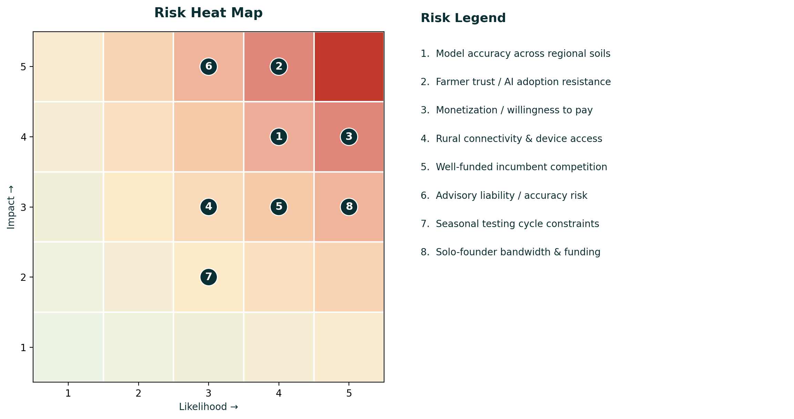
Figure 4: Risk heat map — likelihood vs. impact
# | Risk | Likelihood | Impact | Mitigation
1 | Model accuracy varies across India's diverse regional soil types | Medium | Medium | Expand training data across regions; add confidence scores and human-review fallback
2 | Farmer trust / resistance to AI-based advice | Medium | High | Pair AI output with explainable reasoning and trusted local endorsement (KVK, agronomist)
3 | Farmers unwilling or unable to pay directly | High | Medium | Freemium model; monetize via B2B/B2G/NGO channels rather than farmer subscriptions
4 | Rural connectivity and device constraints | Low-Med | Low-Med | Lightweight app, offline capture with sync, low-bandwidth image compression
5 | Competition from well-funded incumbents | Medium | Medium | Focus on the soil-first niche and underserved geographies rather than head-on competition
6 | Advisory liability if a recommendation leads to crop loss | Low-Med | High | Clear disclaimers, confidence thresholds, and positioning as decision support, not sole authority
7 | Seasonal agricultural cycles slow user-testing iteration speed | Medium | Low | Plan validation sprints around actual sowing seasons; use synthetic/archived data between cycles
8 | Solo-founder bandwidth and lack of funding/team | High | Medium | Seek co-founder/agronomist advisor; apply to student/AgriTech incubation and grant programs
Table 9: Detailed risk register

13. Pivot Opportunities
If direct B2C farmer monetization proves difficult after field validation, the underlying AI asset supports several viable adjacent paths:
- B2B White-Label: License the soil-classification engine to agri-input retailers and dealers as a value-added in-store tool that also drives their product sales.
- B2G / Institutional: Partner with state agriculture departments, Krishi Vigyan Kendras, or the Digital Agriculture Mission to deploy Bhumiputra as a free public-service tool, monetized via grants/contracts rather than user fees.
- Data & Insights Layer: Aggregate anonymized soil and crop data across regions and offer insights to fertilizer companies, insurers, or agri-research institutions.
- Vertical Specialization: Narrow focus to one high-value crop category or state (e.g., cotton belt or a horticulture cluster) to build deeper accuracy and a defensible regional brand before expanding.
- Hardware-Lite Bundle: Partner with a low-cost soil-sensor manufacturer to offer an optional accuracy-boosting add-on for a premium tier, without making hardware a requirement.

14. Go / No-Go Recommendation
Recommendation: CONDITIONAL GO
Bhumiputra should proceed — but into a structured 30–90 day validation phase, not directly into fundraising or full-time commercial build-out. The technology is credible, the problem is real and well-documented, and the market is large and growing (India AgriTech market: $974M in 2025, growing at ~10.6% CAGR). The primary open question is not “can this be built” — that is proven — but “will real farmers use, trust, and eventually pay for it (directly or via an intermediary).”

Why GO
- Large, well-documented, growing problem with government and market tailwinds (Digital Agriculture Mission, soil health initiatives)
- Technically validated prototype already built — de-risks the hardest engineering question early
- Clear, defensible product niche (soil-first AI) distinct from disease-detection-first incumbents
- Founder has genuine motivation and the technical skill to iterate quickly

Why CONDITIONAL
- Zero direct farmer validation to date — the biggest unproven assumption in the entire plan
- No monetization evidence, and direct B2C payment from smallholders is historically difficult in this market
- Solo founder with limited agricultural network, domain credibility, and funding
Conditions to convert this to a full GO: (1) complete 20-30 real farmer validation conversations/demos, (2) achieve visible, positive reactions to recommendation accuracy from at least one agronomist or KVK partner, (3) identify at least one viable, non-farmer-subscription monetization path (B2B/B2G/NGO), and (4) test the model's classification accuracy against a geographically diverse, real-world image set.

15. 30-Day Action Plan
Week | Focus | Key Actions
Week 1 | Farmer & Field Validation Setup | Identify 2-3 accessible farming communities or KVKs; prepare a simple demo script and feedback form; conduct first 5-8 farmer conversations/demos
Week 2 | Expand Validation & Model Stress-Test | Complete 20-30 total farmer interactions across varied soil types; collect real-world soil images to test classification accuracy beyond the academic dataset
Week 3 | Domain Credibility & Partnerships | Reach out to 3-5 agricultural university faculty, agronomists, or KVK officers for advisory input and potential pilot partnership; refine recommendation logic based on their feedback
Week 4 | Monetization Test & Roadmap Lock | Test at least one non-subscription monetization angle (e.g., a pilot conversation with an agri-input retailer or NGO); consolidate findings into a go-forward roadmap and decide on next-stage resourcing (co-founder, incubator, grant application)
Table 10: 30-day validation sprint plan
Success at the end of 30 days looks like: a validated understanding of real farmer trust and willingness-to-pay, at least one credible agronomy/institutional endorsement, an initial view on the most promising monetization channel, and a real-world-tested model accuracy benchmark — the concrete evidence needed to justify the next phase of investment, whether that is incubator applications, grant funding, or continued bootstrapped growth.

This report was generated using founder-provided inputs combined with public market research current as of July 2026. Market sizing figures are directional estimates intended to support early-stage decision-making, not investment-grade projections.

