BUSINESS STRATEGY & INVESTMENT REPORT
BHUMIPUTRA
AI Soil Analysis & Crop Recommendation Platform
Confidential | Prepared for Founder & Investor Review | July 2026
Prepared by: AI Co-Founder & Growth Strategy Desk
Source of truth: Bhumiputra Customer & MVP Blueprint (Day 23)

Table of Contents
Executive Summary 3
Business Reality Check 4
Business Strategy Report 5
Investment Scorecard 8
Visual Dashboard 9
Founder Action Sheet 10
Sustainability Verdict 10

Executive Summary

The Startup, in 8 Bullets
- Bhumiputra is an AI prototype that classifies soil type from a smartphone photo and generates crop, fertilizer, and organic-pesticide recommendations.
- Primary customer: small & medium Indian farmers (0.5–4 hectares), B2C. Secondary: agri-dealers, NGOs, KVKs, agricultural universities, and AgriTech firms (B2B/B2G).
- Currently pre-revenue and pre-launch — a working prototype with a trained classification model, but zero farmer interviews and zero paying users.
- Competitors (Plantix, AgroStar, DeHaat, CropIn, BharatAgri, Fasal) are well-funded, but none lead with soil-first AI classification — a genuine positioning gap.
- MVP scope is locked: photo → classify → recommend flow, offline capture, local-language UI, and a free no-signup first scan.
- Pricing hypothesis: freemium for farmers (no paywall) + paid B2B/B2G institutional pilots, directionally ₹10–30 per farmer per season — entirely untested.
- 30-day plan: lock scope → build → pilot with 25–30 real farmers → iterate and open 2 B2B/NGO pricing conversations.
- Blueprint verdict: “Promising but Unvalidated” — the problem and technology are validated; the customer and monetization are not.

Extracted Assumptions
Dimension | Assumption Extracted from the Blueprint
Customer | Primary B2C farmer + secondary B2B/B2G intermediaries — untested; zero direct farmer interviews to date
MVP | Single scan → classify → recommend flow is well-scoped, but model accuracy is unproven on diverse real-world regional soils
Value Proposition | Instant, free alternative to slow/costly formal soil testing — assumes farmers will trust AI output over dealer advice or tradition
Pricing | Institutions (dealers/NGOs/govt) will pay when individual farmers won’t — no institutional conversation has happened yet
Revenue | ₹10–30/farmer/season via B2B channel is a placeholder number, not derived from any real pricing conversation
GTM | Trusted intermediaries (KVK, NGO, dealer) will grant distribution access — no channel relationship is currently confirmed

Business Reality Check

Who Pays?
Not the farmer, at least not in the MVP. The real payer, if this becomes a business, is an institutional buyer: an agri-input dealer, an NGO running a farmer-development program, a KVK/government extension office, or an AgriTech company licensing the engine. This is a B2B2C/B2G revenue model wearing a B2C adoption strategy — a distinction the blueprint has not yet fully reasoned through, because no institutional conversation has happened yet.

Why Do They Pay?
- Dealers: a value-added tool that drives loyalty and cross-sells inputs (fertilizer, pesticide) — hypothesized, not confirmed
- NGOs / KVKs: a scalable extension tool to reach more farmers without proportionally more agronomists — hypothesized
- Government: a public-service deliverable aligned with precision-agriculture and Digital Agriculture Mission priorities — hypothesized
None of these “why” reasons have been tested with a real institutional buyer conversation. This is the single biggest revenue risk in the plan.

How Will They Discover the Product?
Planned channels are entirely intermediary-dependent: KVK/agri-university partnerships, agri-dealer relationships, NGO distribution, and organic reach via farmer WhatsApp groups and YouTube. Bhumiputra currently has no owned distribution and no confirmed relationship with any of these gatekeepers.

Biggest Growth Risks
- Zero existing relationships with any distribution gatekeeper — the entire GTM depends on cold outreach succeeding
- Solo founder, no funding or team to run parallel pilots across multiple regions
- Long, seasonal agricultural sales cycles will slow institutional pilot signing
- Trust deficit — farmers are skeptical of AI advice without a human or institutional stamp of approval

Biggest Monetization Risks
- No willingness-to-pay evidence at any layer — farmer, dealer, NGO, or government
- Government/NGO sales cycles are slow and often grant-dependent, not recurring revenue
- A free-only farmer experience may harden a permanent zero-cost expectation, complicating future B2C monetization
- Field accuracy failures could undermine institutional trust before any contract is signed

Weakest Assumptions to Validate Immediately
- That any institutional buyer will actually pay ₹10–30/farmer/season — an untested, unanchored price point
- That farmers will trust and act on AI soil advice without a human intermediary present
- That soil classification accuracy generalizes across diverse real-world regional soils, not just the curated academic dataset
- That KVKs/NGOs will grant pilot access to a solo student founder with no track record
- That free-scan adoption converts into institutional interest, rather than institutions seeing no reason to pay for something already free

Business Strategy Report

Business Model Canvas
Block | Detail
Key Partners | KVKs & agricultural universities · NGOs · agri-input dealers · state agriculture departments
Key Activities | Model training & accuracy improvement · farmer pilot operations · institutional partnership development
Key Resources | Trained soil-classification model · founder's AI/ML skillset · (future) regional soil-image dataset
Value Proposition | Instant, free, soil-first AI recommendation replacing slow, costly, inaccessible formal soil testing
Customer Relationships | Self-serve app for farmers · relationship-managed pilots for institutional partners
Channels | KVK/university pilots · agri-dealer co-marketing · NGO distribution · WhatsApp/YouTube organic reach
Customer Segments | Smallholder farmers (B2C, primary) · dealers/NGOs/government/AgriTech firms (B2B/B2G, secondary)
Cost Structure | Founder time (unpaid) · model training/compute · field pilot logistics · (future) hosting & support
Revenue Streams | ₹0 farmer tier (adoption) · B2B pilot license ≈ ₹10–30/farmer/season (hypothesis) · B2G grants/contracts (hypothesis)

Revenue & Pricing Strategy
Treat the free B2C tier as a distribution and data-collection engine, not a revenue engine. All near-term monetization validation should focus on one or two B2B/B2G pilot partners — proving one paying relationship is worth more than 10,000 free farmer downloads.
Stream | Hypothesis | Status
Farmer (B2C) | Free core scan, no paywall — adoption over monetization | Live in MVP, ₹0 revenue
Dealer / NGO (B2B) | Directional ₹10–30 per farmer per season, pilot license | Untested hypothesis
Government / KVK (B2G) | Grant-funded or contract-based deployment, not per-user fee | Untested hypothesis
Future: Data Layer | Aggregated, anonymized soil/crop insights licensed to input companies or insurers | Not yet in scope

Go-To-Market Strategy
Phase | Focus | Action
1 (Month 1) | Institutional Outreach | Cold-approach KVKs and agri-universities, framed as a free pilot for them — no ask, just access
2 (Month 2–3) | Farmer Pilot | Deploy through the institutional channel; capture usage, accuracy, and trust data
3 (Month 3–6) | Convert to Paid | Turn 1–2 successful pilot institutions into paying B2B/B2G relationships; use their endorsement to open the next round of doors
Core principle: distribution via trusted intermediaries, not paid farmer acquisition — paid CAC would be uneconomical against a near-zero ARPU at this stage.

Customer Acquisition Strategy
Channel | Approach
KVK / University Partnerships | Primary channel — institutional credibility substitutes for the founder's lack of track record
Agri-Dealer Co-Marketing | Position as a value-add that drives dealer foot traffic and loyalty, not a competitor to their input sales
NGO Distribution | Piggyback on existing farmer-development programs already running in target districts
WhatsApp / YouTube Organic | Low-cost farmer-facing awareness; supports but does not replace institutional channels
Referral Loop | Season-cycle check-ins and peer-proof prompts from early satisfied pilot farmers

First 100 Users Plan
- Partner with 2–3 KVKs or agri-universities for in-person demo days in one target district
- Co-market through 2–3 local agri-input dealers willing to host a demo counter
- Seed adoption via 3–5 village-level farmer WhatsApp groups with a simple video demo
- Distribute through 1–2 NGO field programs already active with smallholder farmers
- Provide printable/shareable recommendation reports to build trust where literacy or connectivity is low
- Turn the first 20–30 satisfied pilot farmers into a referral loop for the next 70

Competitive Position & Moat
Horizon | Position
Today | No defensible moat. Soil-first positioning is a choice, not a structural barrier — it could be replicated quickly by a well-funded incumbent like Plantix or AgroStar
6–12 Months | A proprietary regional soil-image dataset (improves with every scan), institutional trust relationships (KVK/university endorsement), and seasonal usage lock-in (check-ins across the crop cycle) are the moats to build deliberately
Reality check: at pre-launch stage, Bhumiputra has zero moat. The moat must be earned through the data and relationships accumulated over the next 6–12 months — it does not exist yet.

Reverse SWOT Analysis
A standard SWOT lists strengths and weaknesses in isolation. A reverse SWOT stress-tests each one — asking how a strength could backfire, and how a weakness could hide an opportunity.
Category | As Stated | Reverse Read
Strength | Working AI prototype, technically validated | Can create false confidence that the hard part is done — it isn't; the customer problem is unsolved
Weakness | No farmer validation, no revenue | Forces a disciplined 30-day pilot now, before capital or ego is committed to the wrong assumptions
Opportunity | Large underserved smallholder market ($974M India AgriTech market) | Size attracts incumbents fast — a visible soil-first niche can be copied by a funded competitor within a quarter
Threat | Well-funded incumbents (Plantix, AgroStar, DeHaat) | Their scale makes them slow to chase a niche this small today — a genuine window to build the moat first

Investor One-Liner
“Bhumiputra is Plantix’s blind spot — AI that scans soil, not symptoms, helping India’s smallholders choose the right crop before they plant, not after they’ve already lost the season.”

30-Second Founder Pitch
“Indian smallholder farmers lose yield and money every season because they can’t afford or access fast soil testing — so they guess on crops and fertilizer. Bhumiputra turns a smartphone photo into an instant, AI-powered soil analysis with crop and fertilizer recommendations, free for farmers. We’re not competing with disease-detection apps like Plantix — we’re solving the decision farmers make before they even plant. Right now we have a working model and a locked MVP; the next 30 days prove that KVKs, NGOs, and dealers will pay to put this in farmers’ hands.”

Investment Scorecard
Dimension | Score | Reasoning
Business Viability | 45 / 100 | Real, evidenced problem and working technology, but zero proven willingness-to-pay at any layer of the value chain
Revenue Potential | 40 / 100 | Large addressable population, but ARPU and pricing are entirely hypothetical; B2B/B2G sales cycles are slow
GTM Strength | 35 / 100 | The channel plan is logical, but zero distribution relationships are confirmed with any KVK, dealer, or NGO
Competitive Strength | 50 / 100 | A genuine soil-first positioning gap exists, but no moat yet against well-funded incumbents
Investor Readiness | 30 / 100 | Pre-seed: no team, no funding, no revenue, no users — right stage for grants/incubators, too early for institutional capital
Composite read: the technology and problem framing are ahead of the business. Every score above is capped by the same root cause — the absence of real customer and revenue validation — and every score should rise together once that gap closes.

Visual Dashboard
A single-view infographic summarizing the business model, revenue streams, go-to-market flow, first 100 users plan, competitive moat, key risks, investment scorecard, and final verdict.
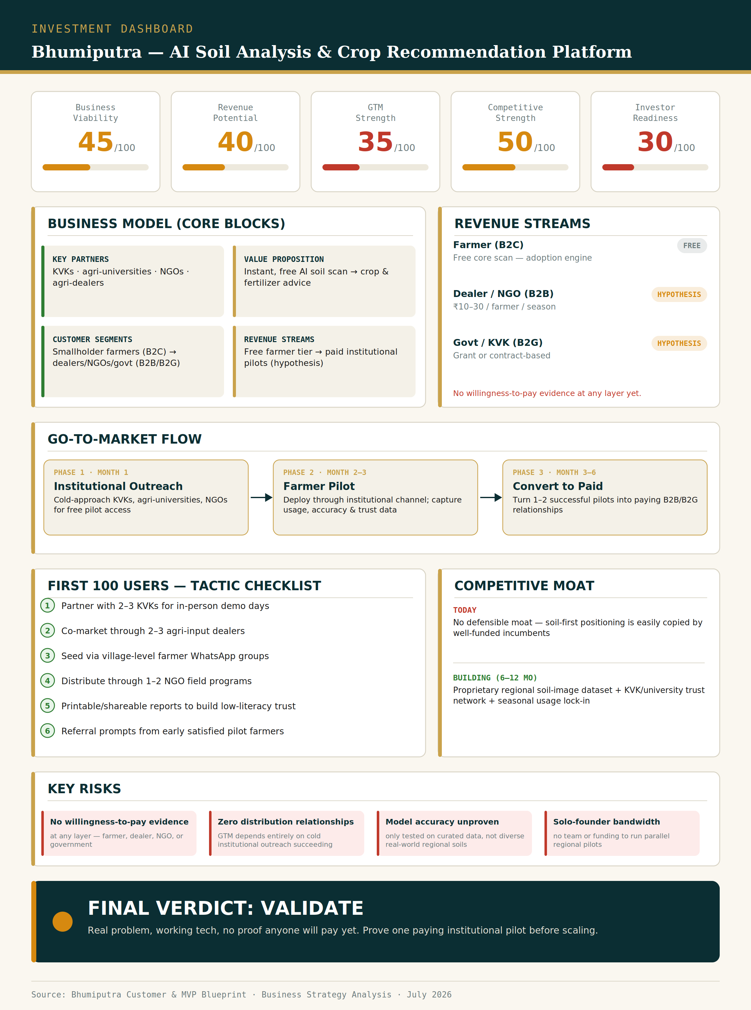
Figure 1: Bhumiputra Investment Dashboard — July 2026

Founder Action Sheet — Top 10 Next Actions
Business and distribution-focused (complements the product-focused action sheet already in the MVP Blueprint):
- Identify and contact 10 KVKs or agri-universities this week for pilot access
- Draft a 1-page institutional pilot pitch — written for a KVK/dealer/NGO decision-maker, not a farmer
- Run 3 real farmer field demos and capture video proof / testimonials
- Test the ₹10–30/farmer/season price point in one real conversation with a dealer or NGO
- Build a simple one-pager or deck for institutional buyers, distinct from the app itself
- Set up a WhatsApp-based farmer waitlist to demonstrate organic pull
- Identify one government precision-agriculture scheme to align with for a future B2G path
- Track and publish weekly farmer-scan and accuracy metrics to build partner and investor credibility
- Find a co-founder or advisor with agricultural distribution experience
- Apply to 2–3 relevant AgriTech incubators, accelerators, or grant programs for funding and credibility runway

Sustainability Verdict
🟡 VALIDATE
Bhumiputra has the ingredients of a sustainable business — a real, well-evidenced problem, a working product, and a defensible long-term positioning niche — but it is not yet a business, only a validated technology. Sustainability depends entirely on whether the next 30–90 days convert institutional interest from a KVK, dealer, or NGO into an actual paid pilot; without that, this remains a strong final-year project rather than a fundable startup. Recommended path: validate, not invest — prove one paying institutional relationship before scaling anything else.

