**`Institute of Management and Career Courses (IMCC), Pune**

**AUTONOMOUS**

**A.Y. 2024-25**

**S.Y. MCA Semester III - Course: ITP 11 - Mini Project**

**Project Title:**

Civil Engineer Portfolio Website

**Technology Used:**

* Frontend: HTML, CSS, JavaScript
* Backend: Firebase Fire store, Firebase Hosting
* Other Tools:Google Maps, EmailJS or Firebase Cloud Functions for email notifications

**Product Functions / Modules:**

1. Home Page  
   This page displays a dynamic background video, company logo, banner headline, and brief highlights like experience and project stats. It creates the first impression of the website.
2. About Us Page  
   Provides background information about the civil engineer or firm, including qualifications, certifications, mission, vision, and team members if any.
3. Projects Page  
   Dynamically fetches and displays a list of projects (Completed, Ongoing, Upcoming) from Firebase Fire store, with title, image, and description.
4. Services Page  
   Displays various services offered (e.g., Construction Supervision, Estimation, Site Analysis) using a dropdown. On selecting a service, a popup form appears where the user can request that service. Form data is submitted and stored in Firebase and optionally emailed to the portfolio owner.
5. Contact Page  
   Contains a contact form (Name, Email, Phone, Message) and Google Maps showing office location. Data from this form is saved in Fire store and can trigger email alerts.

**Users of the System:**

* Visitor/User: Can view information, request services, submit contact forms, and interact with the chatbot.
* Portfolio Owner (Civil Engineer): Receives form submissions and feedback data; manages content through Fire store database.

| Roll No | Name |
| --- | --- |
| 2401180 | Khushi Shah |

**Guide Name: DR. Minakshi More**

E_R Diagram

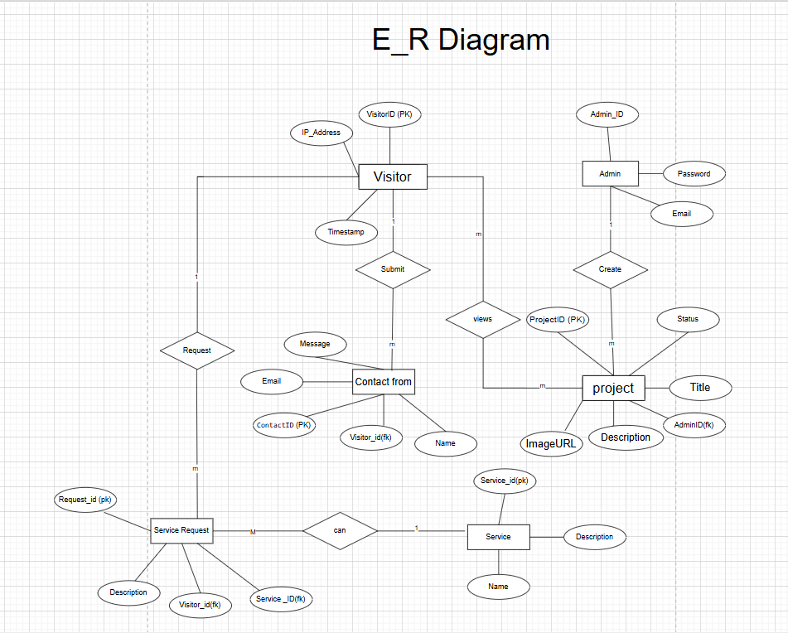

Use case Diagram

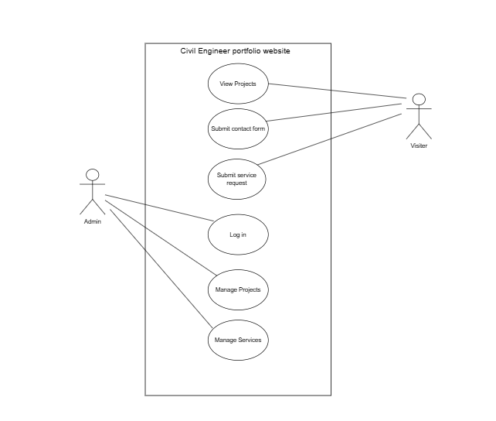

**Table Structure: -**

**🔹 1. Admin Table**

Stored in **Firebase Authentication**, not Fire store (except optional fields)

|  |  |  |
| --- | --- | --- |
| **Field** | **Type** | **Description** |
| AdminID | String | UID from Firebase Auth (PK) |
| Email | String | Admin email |

**2. Projects Table**

Fire store Collection: projects

|  |  |  |
| --- | --- | --- |
| **Field** | **Type** | **Description** |
| Project_ID | String | Fire store Document ID (PK) |
| Title | String | Project title |
| Description | String | Project description |
| Image URLs | Array | Array of image URLs (from Storage) |
| Status | String | upcoming, ongoing, completed |
| Created By | String | AdminID (FK → Admin) |

**3. Visitors Table**

Fire store Collection: visitors *(if tracking)*

|  |  |  |
| --- | --- | --- |
| **Field** | **Type** | **Description** |
| VisitorID | String | Auto-ID or Firebase Auth UID |
| Name | String | Visitor's name |
| Email | String | Visitor's email |

**4. Contact Forms Table**

Fire store Collection: contact Forms

|  |  |  |
| --- | --- | --- |
| **Field** | **Type** | **Description** |
| ContactID | String | Auto-generated ID (PK) |
| Name | String | Name of the visitor |
| Email | String | Visitor email |
| PhoneNo | String | Phone number |
| Message | String | Message content |
| VisitorID | String | FK to Visitors (optional) |

**5. Services Table**

Firestore Collection: services

|  |  |  |
| --- | --- | --- |
| **Field** | **Type** | **Description** |
| ServiceID | String | Firestore Document ID |
| Name | String | Service name |
| Description | String | Service description |

**6. Service Requests Table**

Firestore Collection: service Requests

|  |  |  |
| --- | --- | --- |
| **Field** | **Type** | **Description** |
| RequestID | String | Auto-generated ID (PK) |
| VisitorID | String | FK to Visitors |
| ServiceID | String | FK to Services |
| Description | String | Description of the request |