YUVA INTERN
Virtual Data Science with Python Apprentice Intern

Week 5 Project Report

Comprehensive Data Science Project Reporting and Strategic Recommendations

TOPIC- Heart Disease Prediction Using Machine Learning

Dataset Used
cleaned_merged_heart_dataset.csv

Submitted By: Submitted To:
NAME: Khushi Kapoor Yuva Intern
B.Tech-(CSE)
Quantum University, Roorkee
Data Science Intern – Yuva Intern

Submission Date : 22 AUG, 2026

DECLARATION

I hereby declare that the project report titled “Heart Disease Prediction Using Machine Learning” has been prepared as part of the Week 5 internship task under the Yuva Intern program. The report presents the analysis, methodology, machine learning models, evaluation results, strategic recommendations and conclusions developed during the project.
The work presented in this report is based on the project implementation and analysis performed during the internship period.
Name: [KHUSHI KAPOOR]
Date: [22-08-26]

LIST OF FIGURES
You can eventually have:
- Dataset Preview
- Dataset Dimensions
- Dataset Information
- Missing Value Analysis
- Heart Disease Distribution
- Correlation Heatmap
- Logistic Regression Model
- Random Forest Model
- Logistic Regression Confusion Matrix
- Classification Report
- ROC Curve
- Model Performance Comparison
- Random Forest Feature Importance

EXECUTIVE SUMMARY
This project presents a comprehensive data science and machine learning approach for predicting heart disease based on patient medical attributes. The project was developed as part of the Week 5 task of the Yuva Intern program and integrates the analytical and machine learning skills developed during the previous stages of the internship.
The project follows an end-to-end data science workflow beginning with dataset loading and inspection, followed by data quality assessment, duplicate removal, exploratory data analysis, feature preparation, train-test splitting, feature scaling, machine learning model development and performance evaluation. The dataset initially contains 1,888 observations and 14 columns. The variables include patient-related demographic, clinical and diagnostic attributes such as age, sex, chest pain type, resting blood pressure, cholesterol, maximum heart rate, exercise-induced angina, ST depression, slope, number of major vessels and thalassemia-related information. The target variable is used for binary heart disease classification.
Data preprocessing showed that there were no missing values in any of the dataset columns. However, 1,286 duplicate records were identified. These duplicates were removed before the machine learning stage to reduce the possibility of repeated observations influencing model development.
Two machine learning classification algorithms were implemented: Logistic Regression and Random Forest Classifier. Logistic Regression was used as a baseline classification model, while Random Forest was used as an ensemble-learning approach. Logistic Regression was trained using standardized features, while the Random Forest model was trained using the prepared feature matrix.
The models were evaluated using accuracy, precision, recall and F1-score. Logistic Regression achieved an accuracy of 69.42%, while Random Forest achieved an accuracy of 76.03%. Random Forest also achieved higher precision, recall and F1-score than Logistic Regression, making it the stronger-performing model among the two evaluated approaches.
Feature-importance analysis of the Random Forest model identified thal, cp, slope, thalachh, chol and age among the most important model-derived features. These values indicate the relative contribution of features to the Random Forest predictions and should not be interpreted as evidence of medical causation.
Based on these findings, the project recommends using machine learning as a supplementary decision-support mechanism rather than an autonomous diagnostic system. Future development should focus on larger and more diverse datasets, cross-validation, hyperparameter optimization, advanced algorithms, explainable AI and external validation.
Overall, the project demonstrates how data science can transform structured healthcare data into predictive insights while also highlighting the importance of responsible interpretation, validation and continuous improvement.

1. INTRODUCTION

1.1 Background
Heart disease prediction is an important application of machine learning in healthcare analytics. Healthcare datasets contain multiple patient characteristics that can potentially be analyzed to identify patterns associated with disease outcomes.
Traditional medical assessment depends on clinical expertise, patient history, diagnostic tests and professional judgment. Machine learning can complement these processes by analyzing multiple variables simultaneously and learning predictive patterns from historical data.
The objective of this project is to develop a machine learning classification system capable of predicting the presence of heart disease based on patient medical attributes.

1.2 Data Science Perspective
Data science combines data collection, preprocessing, statistical analysis, visualization and machine learning to generate useful insights from data.
In this project, data science techniques were applied throughout the entire workflow. The dataset was first inspected to understand its structure and quality. Data preprocessing was then performed to identify missing values and duplicate observations. Exploratory visualizations were subsequently used to examine the target distribution and relationships between variables. Finally, machine learning models were developed and evaluated.

1.3 Importance of Predictive Analytics
Predictive analytics can help identify patterns within historical data and estimate the likelihood of an outcome. In healthcare, such analytical systems may provide supplementary information that can assist professionals in prioritizing further investigation.
However, healthcare prediction requires careful validation because incorrect predictions can have significant consequences. Therefore, the model developed in this academic project should be considered a predictive analytics experiment and not a clinically validated diagnostic system.

2. PROBLEM STATEMENT
The problem addressed in this project is the development of a machine learning classification model capable of predicting whether a patient record corresponds to the presence or absence of heart disease.
The project uses patient medical attributes as input variables and the target variable as the classification outcome. The challenge involves preparing the dataset appropriately, identifying patterns within the available variables, developing suitable classification algorithms and evaluating their ability to make predictions on unseen data.
The final objective is not only to determine which model performs better but also to interpret the results and develop strategic recommendations based on the analytical findings

3. PROJECT OBJECTIVES
To develop and evaluate a machine learning classification system for heart disease prediction using patient medical attributes.
- To load and inspect the heart disease dataset.
- To understand the dataset structure and variables.
- To identify missing values.
- To identify duplicate records.
- To remove duplicate observations.
- To perform descriptive statistical analysis.
- To analyze the target-variable distribution.
- To examine feature correlations.
- To separate input features from the target variable.
- To divide the data into training and testing sets.

4. PROJECT SCOPE
The scope of this project covers the complete machine learning workflow for a binary heart disease classification problem. The project includes data preparation, exploratory data analysis, supervised machine learning, model evaluation and interpretation.
The project specifically evaluates Logistic Regression and Random Forest Classifier. The analysis includes accuracy, precision, recall, F1-score, confusion matrix, classification report, ROC analysis and Random Forest feature importance.
The project does not include clinical deployment, medical diagnosis, patient treatment recommendations or real-world healthcare integration. Such applications would require additional clinical validation, regulatory consideration, privacy protection and professional oversight.
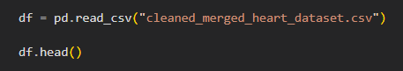

The dataset used in the project is cleaned_merged_heart_dataset.csv. The initial dataset contains 1,888 observations and 14 columns. The dataset contains patient-related medical attributes and a target variable used for classification.

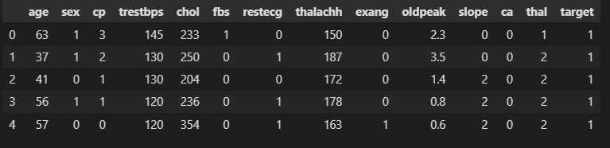

Figure 1: Sample Records from the Heart Disease Dataset
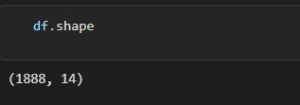

Figure 2: Initial Dataset Dimensions
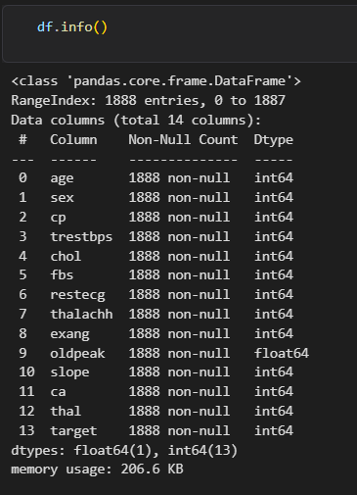

Figure 3: Dataset Structure and Data Types

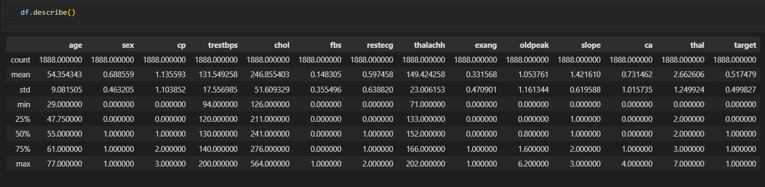
Figure 4: Descriptive Statistical Summary

Descriptive statistics were used to understand the central tendency and variation of the dataset. The average age in the initial dataset is approximately 54.35 years. The average resting blood pressure is approximately 131.55, while the average cholesterol measurement is approximately 246.86. The mean maximum heart rate is approximately 149.42 and the mean oldpeak value is approximately 1.05.

6. TOOLS AND TECHNOLOGIES
Create a table.
Tool / Library | Purpose
Python | Programming language
Pandas | Data manipulation and analysis
NumPy | Numerical operations
Matplotlib | Data visualization
Seaborn | Statistical visualization
Scikit-Learn | Machine learning
Logistic Regression | Classification
Random Forest | Ensemble classification
StandardScaler | Feature scaling
Jupyter Notebook | Development and experimentation

7. METHODOLOGY

Dataset
↓
Data Loading
↓
Data Inspection
↓
Data Quality Analysis
↓
Duplicate Removal
↓
Exploratory Data Analysis
↓
Feature / Target Separation
↓
Train-Test Split
↓
Feature Scaling
↓
Model Development
↓
Model Evaluation
↓
Feature Importance
↓
Strategic Interpretation

7.1 Data Loading
The dataset was loaded into a Pandas DataFrame using the read_csv() function. The head() method was then used to inspect the first few records and verify that the dataset had been loaded correctly.

7.2 Data Inspection
Initial inspection involved examining the dataset shape, data types and descriptive statistics. This step helped establish the size, structure and numerical characteristics of the data before preprocessing.

7.3 Data Quality Analysis
Data quality analysis focused on missing values and duplicate observations. Missing-value analysis showed zero missing values across all columns, while duplicate analysis identified 1,286 duplicate records.

7.4 Exploratory Data Analysis
Exploratory analysis was performed using visualizations. A count plot was used to examine the target distribution and a correlation heatmap was used to examine relationships among variables.

7.5 Machine Learning
Two supervised classification algorithms were implemented: Logistic Regression and Random Forest Classifier.

7.6 Evaluation
The models were evaluated using accuracy, precision, recall and F1-score. The project also includes a confusion matrix, classification report, ROC analysis and feature-importance analysis.

8. DATA PREPROCESSING
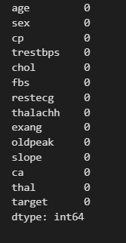

8.1 Missing Value Analysis

Missing values were examined using df.isnull().sum(). The result showed zero missing values for every column. Therefore, no missing-value imputation or replacement was necessary for this dataset.

8.2 DUPLICATE RECORDS
1,286 duplicates.
Duplicate records were identified using df.duplicated().sum(). The result showed 1,286 duplicate observations. These records were removed using df.drop_duplicates(inplace=True). Removing duplicates was necessary to prevent repeated observations from unnecessarily influencing subsequent analysis and model training
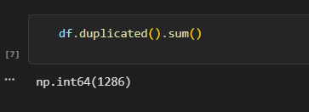

8.3 FEATURE AND TARGET SEPARATION

X = df.drop("target", axis=1) y = df["target"]

After data cleaning, the dataset was divided into independent variables and the target variable. The feature matrix X contains the patient attributes used for prediction, while y contains the target variable representing the classification outcome.

8.4 TRAIN-TEST SPLIT

train_test_split(
X,
y,
test_size=0.2,
random_state=42
)
The cleaned dataset was divided into training and testing subsets using an 80:20 ratio. The training subset was used to fit the machine learning models, while the testing subset was reserved for evaluating performance on unseen observations. The random state was fixed at 42 to support reproducibility.

8.5 FEATURE SCALING

StandardScaler()

Feature scaling was performed for Logistic Regression using StandardScaler. The scaler was fitted using the training data and subsequently applied to both training and testing data. Standardization places numerical features on comparable scales, which is useful for models such as Logistic Regression.

9.1 Target Distribution
Heart Disease Distribution
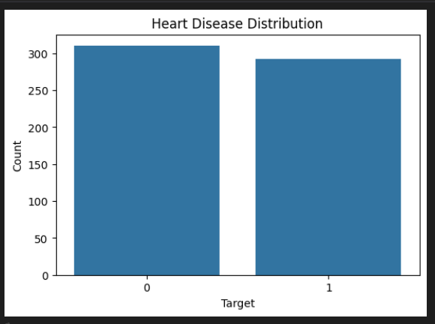
using a Seaborn count plot

The target distribution visualization shows the number of observations belonging to the two target classes. This analysis is useful for understanding the structure of the classification problem and checking whether the classes are represented relatively evenly.
Understanding the target distribution is important because severe class imbalance can affect the interpretation of classification metrics.

9.2 CORRELATION ANALYSIS
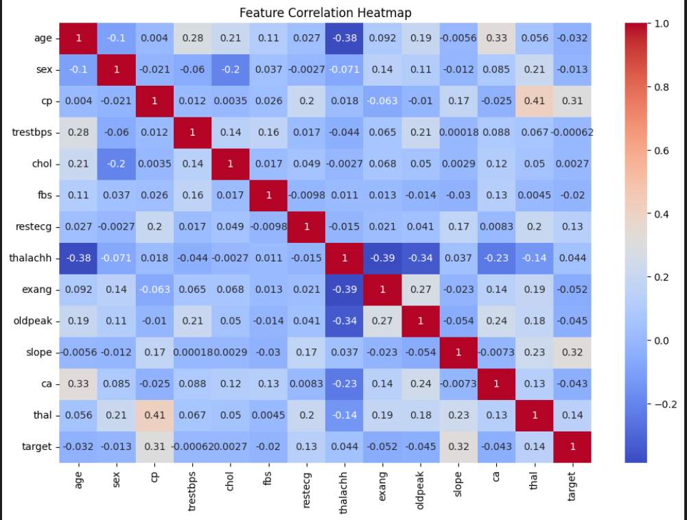
Take the actual heatmap.
A correlation heatmap was used to visualize the pairwise correlations among the numerical variables. Correlation analysis provides an overview of the degree to which variables move together and can help identify potentially informative relationships.
The heatmap should be interpreted as an exploratory statistical visualization rather than evidence of causal relationships. Correlation does not establish that one variable directly causes another.

10. MACHINE LEARNING MODEL DEVELOPMENT
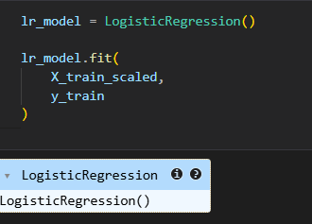
10.1 Logistic Regression

Logistic Regression was selected as the first classification algorithm and serves as a baseline model for the project. It is suitable for binary classification and produces predictions based on the estimated probability of class membership.
In this project, the Logistic Regression model was trained using standardized training features. Predictions and class probabilities were then generated for the testing dataset.
10.2 Random Forest
RandomForestClassifier(
n_estimators=100,
random_state=42
)
Random Forest Classifier was implemented as the second machine learning algorithm. Random Forest is an ensemble-learning method that combines multiple decision trees to produce a classification result.
The project uses 100 trees (n_estimators=100) and a random state of 42. The Random Forest model was then used to generate predictions for the test dataset.

11. MODEL EVALUATION

11.1 Evaluation Metrics

Accuracy
Accuracy represents the proportion of all predictions that were correctly classified.

Precision
Precision represents the proportion of observations predicted as positive that were actually positive.

Recall
Recall represents the proportion of actual positive observations that were correctly identified by the model.

F1-score
F1-score combines precision and recall into a single measure and is useful when both metrics are important.

11.2 Logistic Regression Results
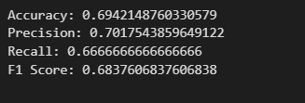

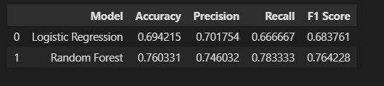
11.3Overall Model Comparison

Table 1: Comparison of Machine Learning Model Performance

11.4 Interpretation
The model comparison shows that Random Forest achieved better performance across all four reported evaluation metrics.
Random Forest achieved an accuracy of 76.03%, compared with 69.42% for Logistic Regression. Its precision was 74.60%, recall was 78.33%, and F1-score was 76.42%. Logistic Regression achieved 70.18% precision, 66.67% recall and 68.38% F1-score.
Therefore, among the two models evaluated in this project, Random Forest is the stronger-performing model based on the reported test-set metrics.
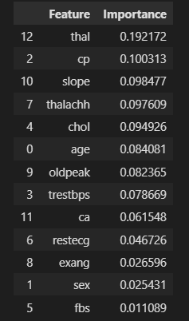
Model Performance Comparison

12. CONFUSION MATRIX ANALYSIS
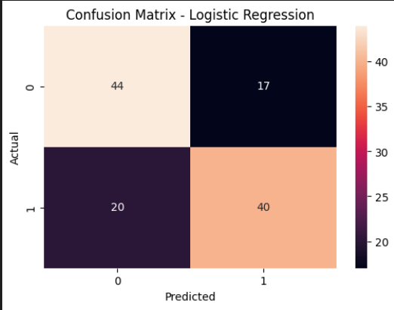

The confusion matrix provides a detailed view of the classification outcomes generated by Logistic Regression. It separates predictions into true positives, true negatives, false positives and false negatives.
This analysis is important because overall accuracy alone does not show the types of errors made by the model. In a healthcare-related classification problem, false-negative predictions deserve particular attention because they represent positive cases that the model fails to identify.
Therefore, recall is an important metric to monitor alongside accuracy, precision and F1-score
13. CLASSIFICATION REPORT
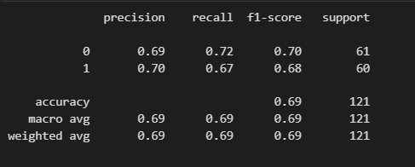

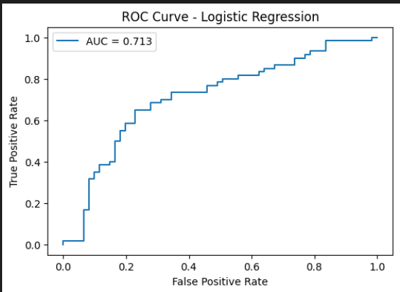

ROC CURVE ANALYSIS
Figure 13: Classification Report for Logistic Regression
The classification report presents precision, recall and F1-score separately for each class. The support values indicate the number of test observations belonging to each class. The test set contains 121 observations in total, with 61 observations in class 0 and 60 observations in class 1.

The Receiver Operating Characteristic curve evaluates the classification model across different decision thresholds. It compares the true-positive rate against the false-positive rate.
The ROC curve provides additional information about the model's discrimination ability beyond a single accuracy value. The Area Under the Curve can be used as a summary measure of classification discrimination.

15. RANDOM FOREST FEATURE IMPORTANCE

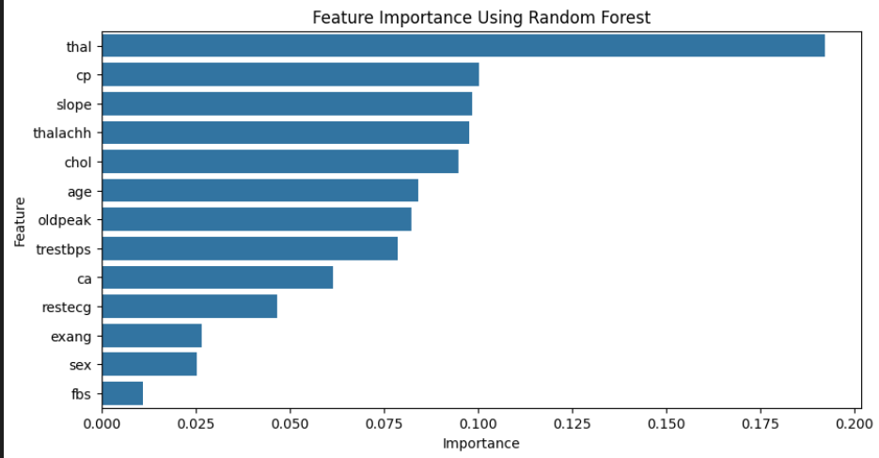

Figure 15: Feature Importance Using Random Forest

The Random Forest feature-import

Finding 1 — Dataset Structure
The initial dataset contains 1,888 observations and 14 columns. All 14 columns were available for the initial analysis.

Finding 2 — No Missing Values
Missing-value analysis showed zero missing values across all columns. Therefore, no imputation method was required.

Finding 3 — Large Number of Duplicates
The dataset contained 1,286 duplicate observations. These were removed before model development.

Finding 4 — Random Forest Performed Better
Random Forest achieved 76.03% accuracy compared with 69.42% for Logistic Regression and also achieved higher precision, recall and F1-score.

Finding 5 — Recall
Random Forest achieved a recall of 78.33%, which was higher than Logistic Regression's recall of 66.67%.
This indicates that, on the evaluated test set, Random Forest identified a larger proportion of positive cases than Logistic Regression.

18. BUSINESS AND RESEARCH IMPACT

18.1 Healthcare Organization Impact
A validated predictive analytics system could potentially support healthcare organizations by providing automated analysis of structured patient information. Such systems could assist with preliminary screening workflows and prioritization of records for further review.

18.2 Healthcare Professional Impact
Machine learning can provide an additional source of analytical information to healthcare professionals. Instead of manually analyzing every variable independently, a predictive system can process multiple variables simultaneously and produce a model-generated classification.

18.3 Patient-Level Impact
If properly validated and responsibly deployed, predictive analytics could potentially support earlier identification of records requiring further evaluation. This could contribute to more structured monitoring and personalized healthcare workflows.

18.4 Research Impact
The project establishes a baseline for future experimentation in healthcare machine learning. The Random Forest model can serve as a benchmark for evaluating more advanced algorithms such as XGBoost and neural networks.

19. LIMITATIONS
- Limited dataset size
- Need for more diverse patient data
- Missing lifestyle factors

19.1 Dataset Size
The available dataset may not be sufficiently large to represent all possible patient populations and clinical conditions. Model performance can vary when applied to datasets with different characteristics.

19.2 Patient Diversity
The model should be evaluated on more diverse patient populations before any practical deployment. Differences in demographics, healthcare settings and data collection practices may affect predictive performance.

19.3 Missing Lifestyle Factors
The current dataset does not include every potential factor associated with health outcomes. Lifestyle and environmental factors may provide additional information but are not currently represented in the available feature set.

19.4 Academic Nature of the Model
The model was developed as an academic machine learning project. It has not undergone clinical validation or prospective evaluation. Therefore, its predictions should not be interpreted as medical diagnoses.

20. CONCLUSION
This project successfully demonstrated an end-to-end machine learning workflow for heart disease prediction using structured patient medical attributes. The project began with dataset loading and inspection and progressed through data-quality analysis, duplicate removal, exploratory data analysis, feature preparation, machine learning model development and evaluation.
The initial dataset consisted of 1,888 observations and 14 columns. Data-quality analysis showed no missing values, while duplicate analysis identified 1,286 duplicate observations. These duplicate records were removed before model development.
Two classification algorithms were developed: Logistic Regression and Random Forest Classifier. Logistic Regression achieved 69.42% accuracy, 70.18% precision, 66.67% recall and 68.38% F1-score. Random Forest achieved 76.03% accuracy, 74.60% precision, 78.33% recall and 76.42% F1-score.
Based on these evaluation metrics, Random Forest performed better than Logistic Regression on the test dataset. The Random Forest feature-importance analysis identified thal, cp, slope, thalachh, chol and age among the higher-ranked features.
The project demonstrates that machine learning can identify useful predictive patterns within structured healthcare data. However, the current results should be interpreted within the limitations of the dataset and experimental setup. The model is not clinically validated and should not be considered an autonomous diagnostic system.
Future development should focus on hyperparameter tuning, cross-validation, larger and more diverse datasets, XGBoost, neural networks and explainable AI. These improvements could help determine whether stronger and more generalizable predictive performance can be achieved.
Overall, this project demonstrates the potential of data science to transform healthcare data into predictive insights while emphasizing the importance of data quality, model evaluation, responsible interpretation and continuous improvement.

